Supporting Information
Device Physics and Design Principles of Mixed-Dimensional Perovskite Solar Cells
Yuqi Zhang ^{a,b}, Zhenhai Yang ^{a,b, *}, Tianshu Ma ^{a,b}, Zhenhai Ai ^{a,b}, Yining Bao ^{a,b}, Luolei Shi ^{a,b}, Linling Qin ^{a,b}, Guoyang Cao ^{a,b}, Changlei Wang ^{a,b}, and Xiaofeng Li ^{a,b, *}
ªSchool of Optoelectronic Science and Engineering & Collaborative Innovation Center of Suzhou Nano Science and Technology, Soochow University, Suzhou 215006, China
^{b}Key Lab of Advanced Optical Manufacturing Technologies of Jiangsu Province & Key Lab of Modern Optical Technologies of Education Ministry of China, Soochow University, Suzhou 215006, China
*Corresponding Authors:
Z. Y. (yangzhenhai@nimte.ac.cn)
X. L. (xfli@suda.edu.cn)

Table S1. A summary of the representative 2D/3D PSCs.
Year | Institution | Type | Spacer Cation  Compound | Structure | PCE | Ref.
2019.03 | KRICT | n-i-p | HTAB | FTO/d-TiO₂/mp-TiO₂/(FAPbI₃) _{0.95}(MAPbBr₃)_{0.05}/HTAB/Spiro-OMeTAD/Au | 23.30% | [1]
2019.04 | CAS | n-i-p | PEAI | ITO/SnO₂/FA_{0.92}MA_{0.08}PbI₃/PEAI/Spiro-OMeTAD/Au | 23.32% | [2]
2019.06 | MIT | n-i-p | C₆Br | FTO/c-TiO₂/m-TiO₂/(FAPbI₃)_{0.92}(MAPbBr₃)_{0.08} /C₆Br/Spiro-OMeTAD/Au | 23.40% | [3]
2020.10 | KAUST | p-i-n | Oam | ITO/PTAA/Cs_{0.05}(FA_{0.92}MA_{0.08})_{0.95}Pb(I_{0.92}Br_{0.08})₃/Oam/C₆₀/Cu | 23% | [4]
2020.11 | ANU | n-i-p | DIAC | FTO/m-TiO₂/PMMA/Cs_{0.07}Rb_{0.03}FA_{0.765}MA_{0.135}PbI_{2.55}Br_{0.45}/DIAC/Spiro-OMeTAD/Au | 23.27% | [5]
2021.01 | KU | n-i-p | BA | FTO/SnO₂/(FAPbI₃)_{0.95}(MAP bBr₃)_{0.05}/BA/Spiro-OMeTAD/Au | 24.59% | [6]
2021.01 | CAS | n-i-p | oFPEAI | FTO/SnO₂/FA_{0.92}MA_{0.08}Pb(I_{0.92}Br_{0.08})₃ /oFPEA/Spiro-OMeTAD/Ag | 23.80% | [7]
2021.01 | ISM-CNR | n-i-p | CEAI | ITO/TiO₂/Cs_{0.05}MA_{0.1}FA_{0.85}PbI_{2.9}Br_{0.1}·0.05PbI₂/CEAI/Spiro-OMeTAD/Au | 23.57% | [8]
2021.04 | RECAST | n-i-p | PhFACl | ITO/SnO₂/FAMAPbICl/PhFACl/Spiro-OMeTAD/Au | 23.36% | [9]
2021.05 | SNNU | n-i-p | CF₃PEAI | FTO/TiO₂/FA_{0.85}MA_{0.15}PbI₃/CF₃PEAI/Spiro-OMeTAD/Au | 23.10% | [10]
2021.07 | RISE | n-i-p | BABr | ITO/SnO₂/Cs_{0.03}(FA_{0.97}MA_{0.03})_{0.97}Pb(I_{0.97}Br_{0.03})₃/BABr/Spiro-OMeTAD/Au | 23.78% | [11]
2021.09 | POSTECH | n-i-p | CHMAI | FTO/SnO₂/FAPbI₃/CHMAI/Spiro-OMeTAD/Au | 23.91% | [12]
2021.09 | POSTECH | n-i-p | CHAI | FTO/SnO₂/FAPbI₄/CHAI/Spiro-OMeTAD/Au | 23.10% | [12]
2021.11 | CAS | n-i-p | MT-Im | ITO/SnO₂/(Cs_{0.03}FA_{0.97}PbI₃)_{0.95}(MAPbBr₃)_{0.05}/MT-Im/Spiro-OMeTAD/Au | 24.07% | [13]
2021.11 | EPFL | n-i-p | PDEAI₂ | FTO/TiO₂/SnO₂/CsFAMAPbIBrCl/PDEAI₂/Spiro-OMeTAD/Au | 23.90% | [14]
2021.12 | CDLCEM | n-i-p | neoPACl | ITO/SnO₂/FA_{1-x}MA_{x}PbI₃/neoPACl/Spiro-OMeTAD/Au | 23.35% | [15]
2022.01 | NREL | n-i-p | BDAI₂ | FTO/SnO₂/FA_{0.97}MA_{0.03}PbI_{2.91}Br_{0.09}/BDAI₂/Spiro-OMeTAD/Au | 24.70% | [16]
2022.02 | KAUST | p-i-n | RT | ITO/2PACz/Cs_{0.03}(FA_{0.90}MA_{0.10})_{0.97}PbI₃/RT/C₆₀/Ag | 24.30% | [17]
2022.03 | RECAST | p-i-n | NpMAI | ITO/SnO₂/FA_{0.85}MA_{0.15}PbI₃/NpMAI/ Spiro-OMeTAD/MoO_{x}/Ag | 24.37% | [18]
2022.03 | KAIST | n-i-p | CEPA | FTO/SnO₂/FAMAPbBrI/CEPA/PTAA/Au | 23.60% | [19]
2022.03 | UofT | p-i-n | 3F-PEA | ITO/NiO_{x}/Cs_{0.05}FA_{0.85}MA_{0.1}PbI₃/3F-PEA/C₆₀/Ag | 23.30% | [20]
2022.09 | Rice | n-i-p | BA | ITO/SnO₂/Cs_{0.05}(MA_{0.10}FA_{0.85})Pb(I_{0.90}Br_{0.10})₃/BA/Spiro-OMeTAD/Au | 24.50% | [21]

Table S2. The key parameters used for this simulation [21-23].
Parameters | SnO₂ | 3D PSCs | 2D/3D PSCs |  | Spiro-OMeTAD
Parameters | SnO₂ | PSK | 3D PSK | 2D PSK | Spiro-OMeTAD
Relative permittivity | 9 | 25 | 25 | 25 | 3
Electron affinity (eV) | 4 | 3.79 | 3.79 | 3.32 | 2.05
Bandgap (eV) | 3.6 | 1.58 | 1.58 | 2.04 | 3.17
Thickness (nm) | 50 | 450 | 430 | 20 | 150
Doping conc. (cm^{‒3}) | 10¹⁹ | 3.5×10¹⁶ | 3.5×10¹⁶ | 10¹⁷ | 5×10¹⁸
Mobility of electron (cm²/Vs) | 0.01 | 12.5 | 12.5 | 0.1 | 0.0003
Mobility of hole (cm²/Vs) | 0.01 | 7.5 | 7.5 | 0.1 | 0.0003
SRH life time (μs) | 1 | / | / | / | 1
Bulk defect conc. (cm^{‒3}) | / | 10¹⁵ | 10¹⁵ | 10¹⁶ | /
Radiative recombination coefficient (cm³/s^{‒1}) | 0 | 3.27×10^{‒11} | 3.27×10^{‒11} | 3.27×10^{‒11} | /

Table S3. The photovoltaic parameters of the related devices extracted from Figure 1b.
Parameters | J_{sc} (mA/cm²) | V_{oc} (V) | FF (%) | PCE (%)
2D/3D PSC (Experiment) | 24.34 | 1.20 | 84.0 | 24.5
2D/3D PSC (Simulation) | 24.36 | 1.20 | 83.4 | 24.4
3D PSC (Simulation) | 24.39 | 1.18 | 80.9 | 23.3

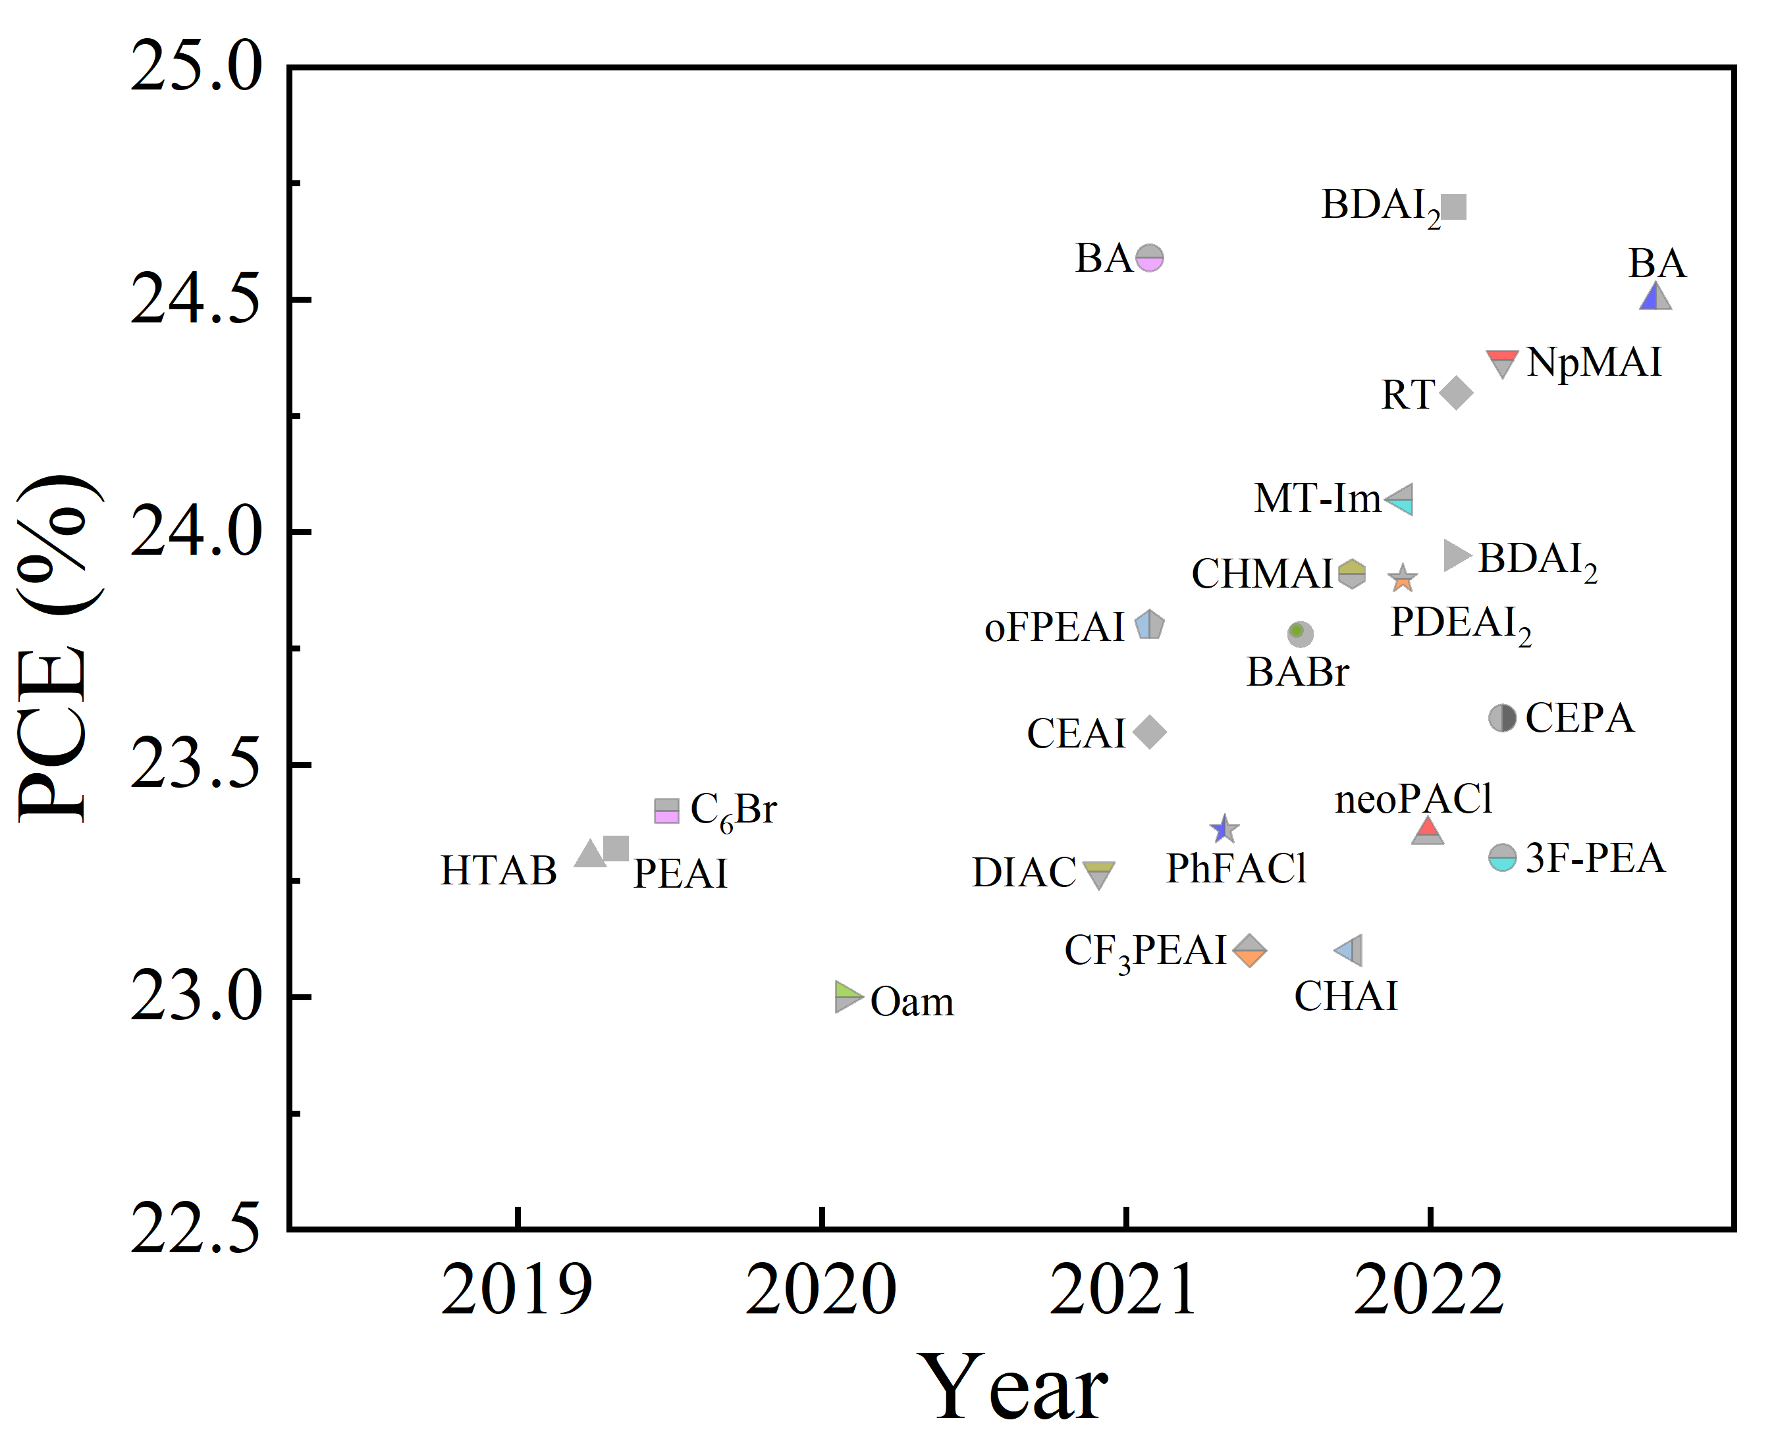
Figure S1. Statical graph of efficiency and the corresponding 2D materials of 2D/3D PSCs extracted from Table S1.

Figure S2. Current losses contributed from the different sources for (a) 3D and (b) 2D/3D PSCs, respectively.

Figure S3. (a)/(d) Electric-field and (b)/(e) bulk recombination distributions, and (c)/(f) current density losses of bulk and HTL/perovskite interface for the 3D and 2D/3D PSCs under N_{t} = 10¹⁴/10¹⁶ cm^{‒3}.

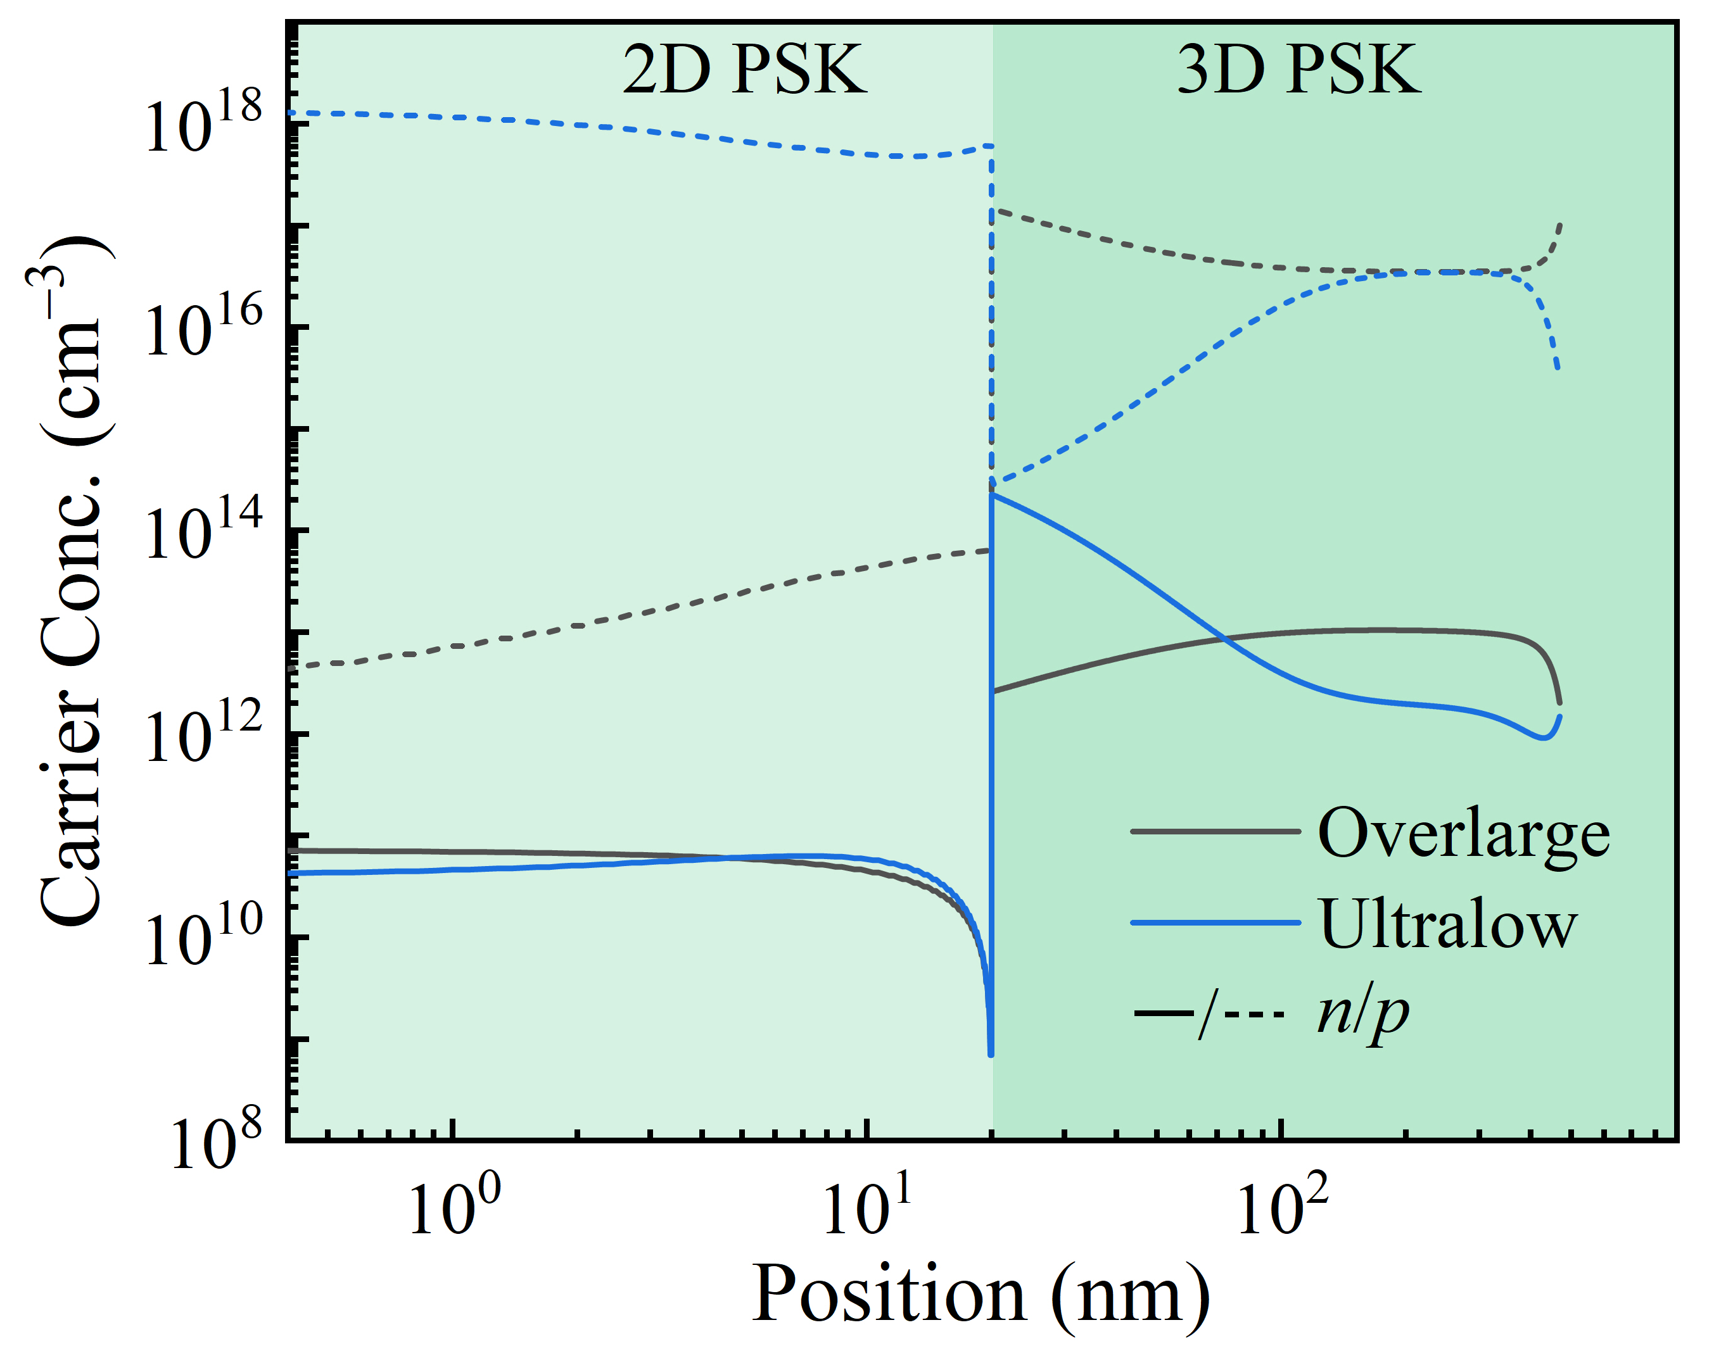
Figure S4. Carrier distributions of the 3D and 2D/3D PSCs under the overlarge and ultralow VBO conditions.

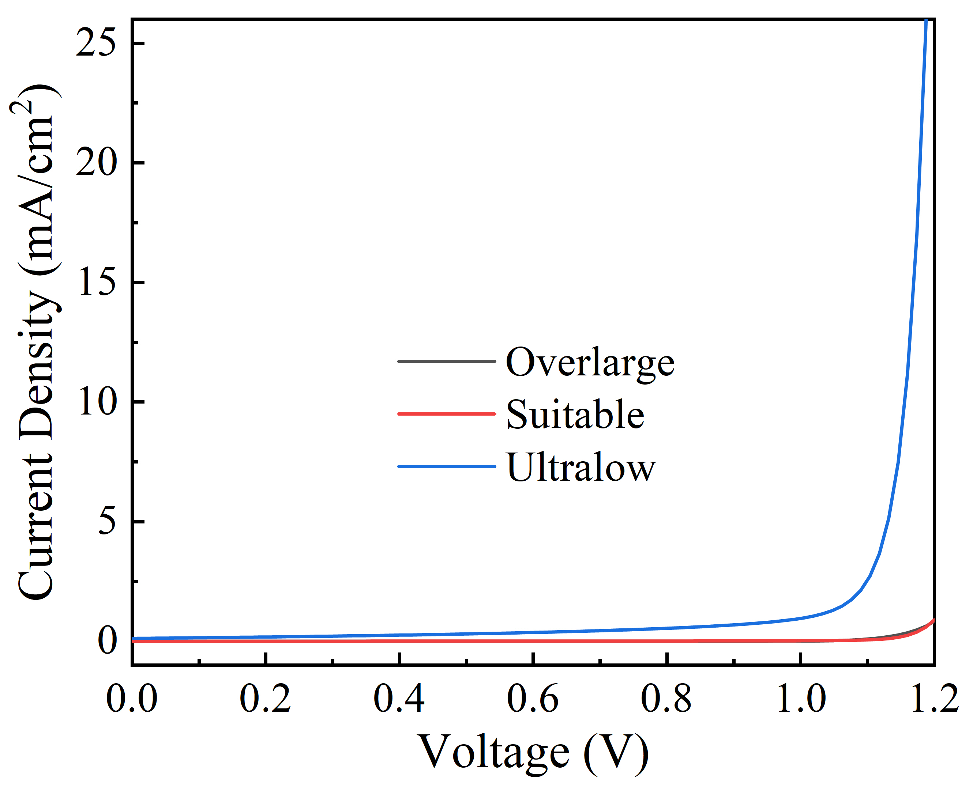
Figure S5. Current density losses at 2D/3D interface for 2D/3D PSCs under the different VBO conditions.

Figure S6. Dependence of mobility and thickness of 2D perovskite on PCE for the (a) overlarge, (b) suitable and (c) ultralow VBO cases.

Figure S7. Energy diagrams of (a) 3D and (b) 2D/3D PSCs under equilibrium condition.

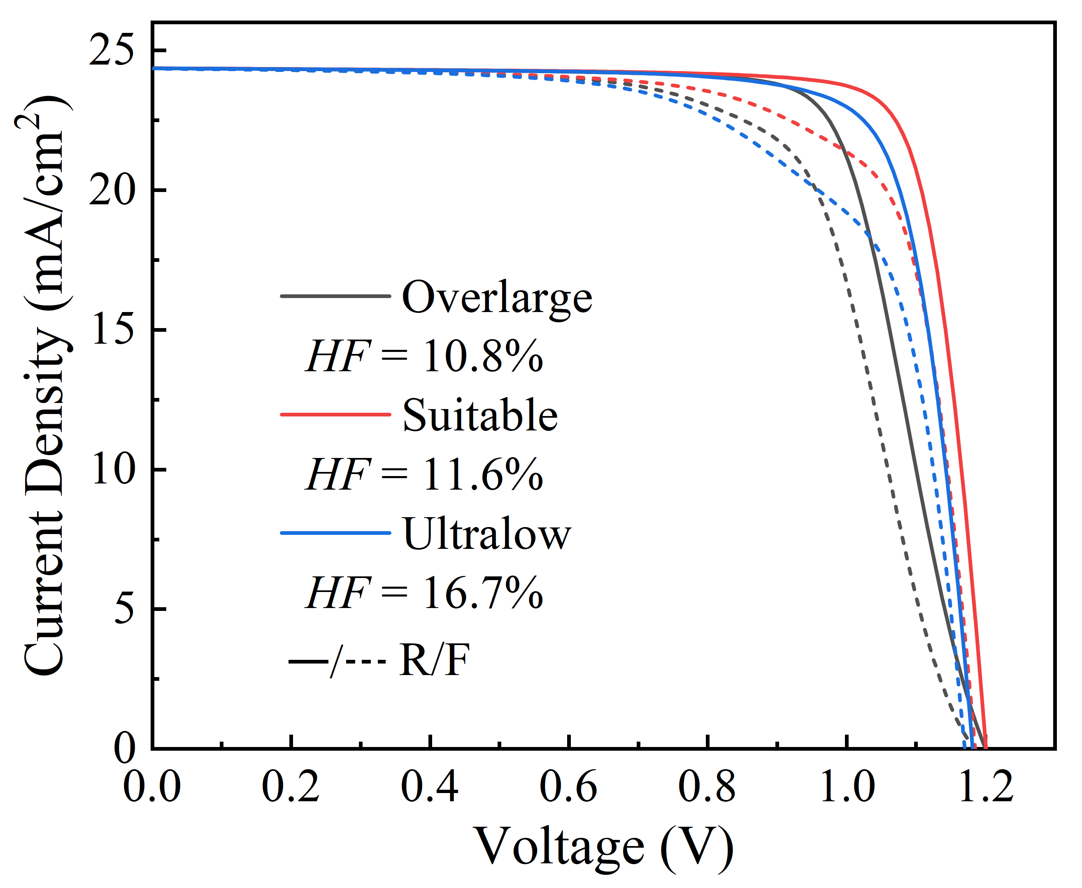
Figure S8. J-V curves with hysteresis effect under the different VBO conditions, where N_{ion} and scan rate are fixed at 3×10¹⁶ cm^{‒3} and 0.4 V/s, respectively.

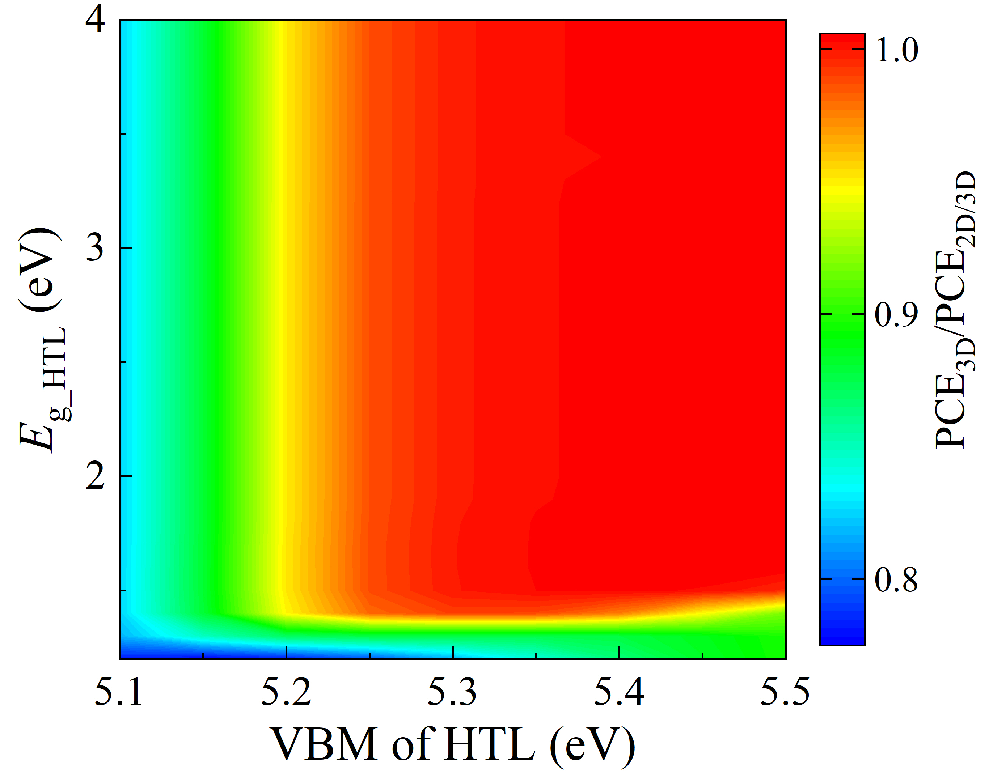
Figure S9. The ratio of PCE values between 2D/3D and 3D PSCs in Figure 4b and 4c.

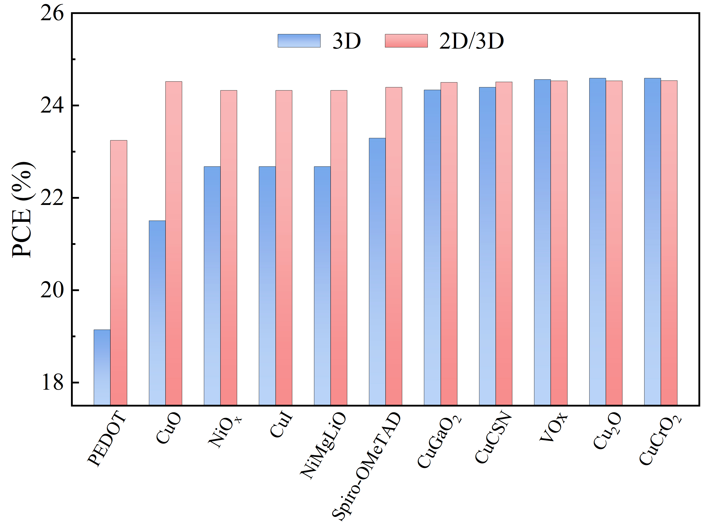
Figure S10. The histogram of PCE values of 3D and 2D/3D PSCs with the typical HTLs.

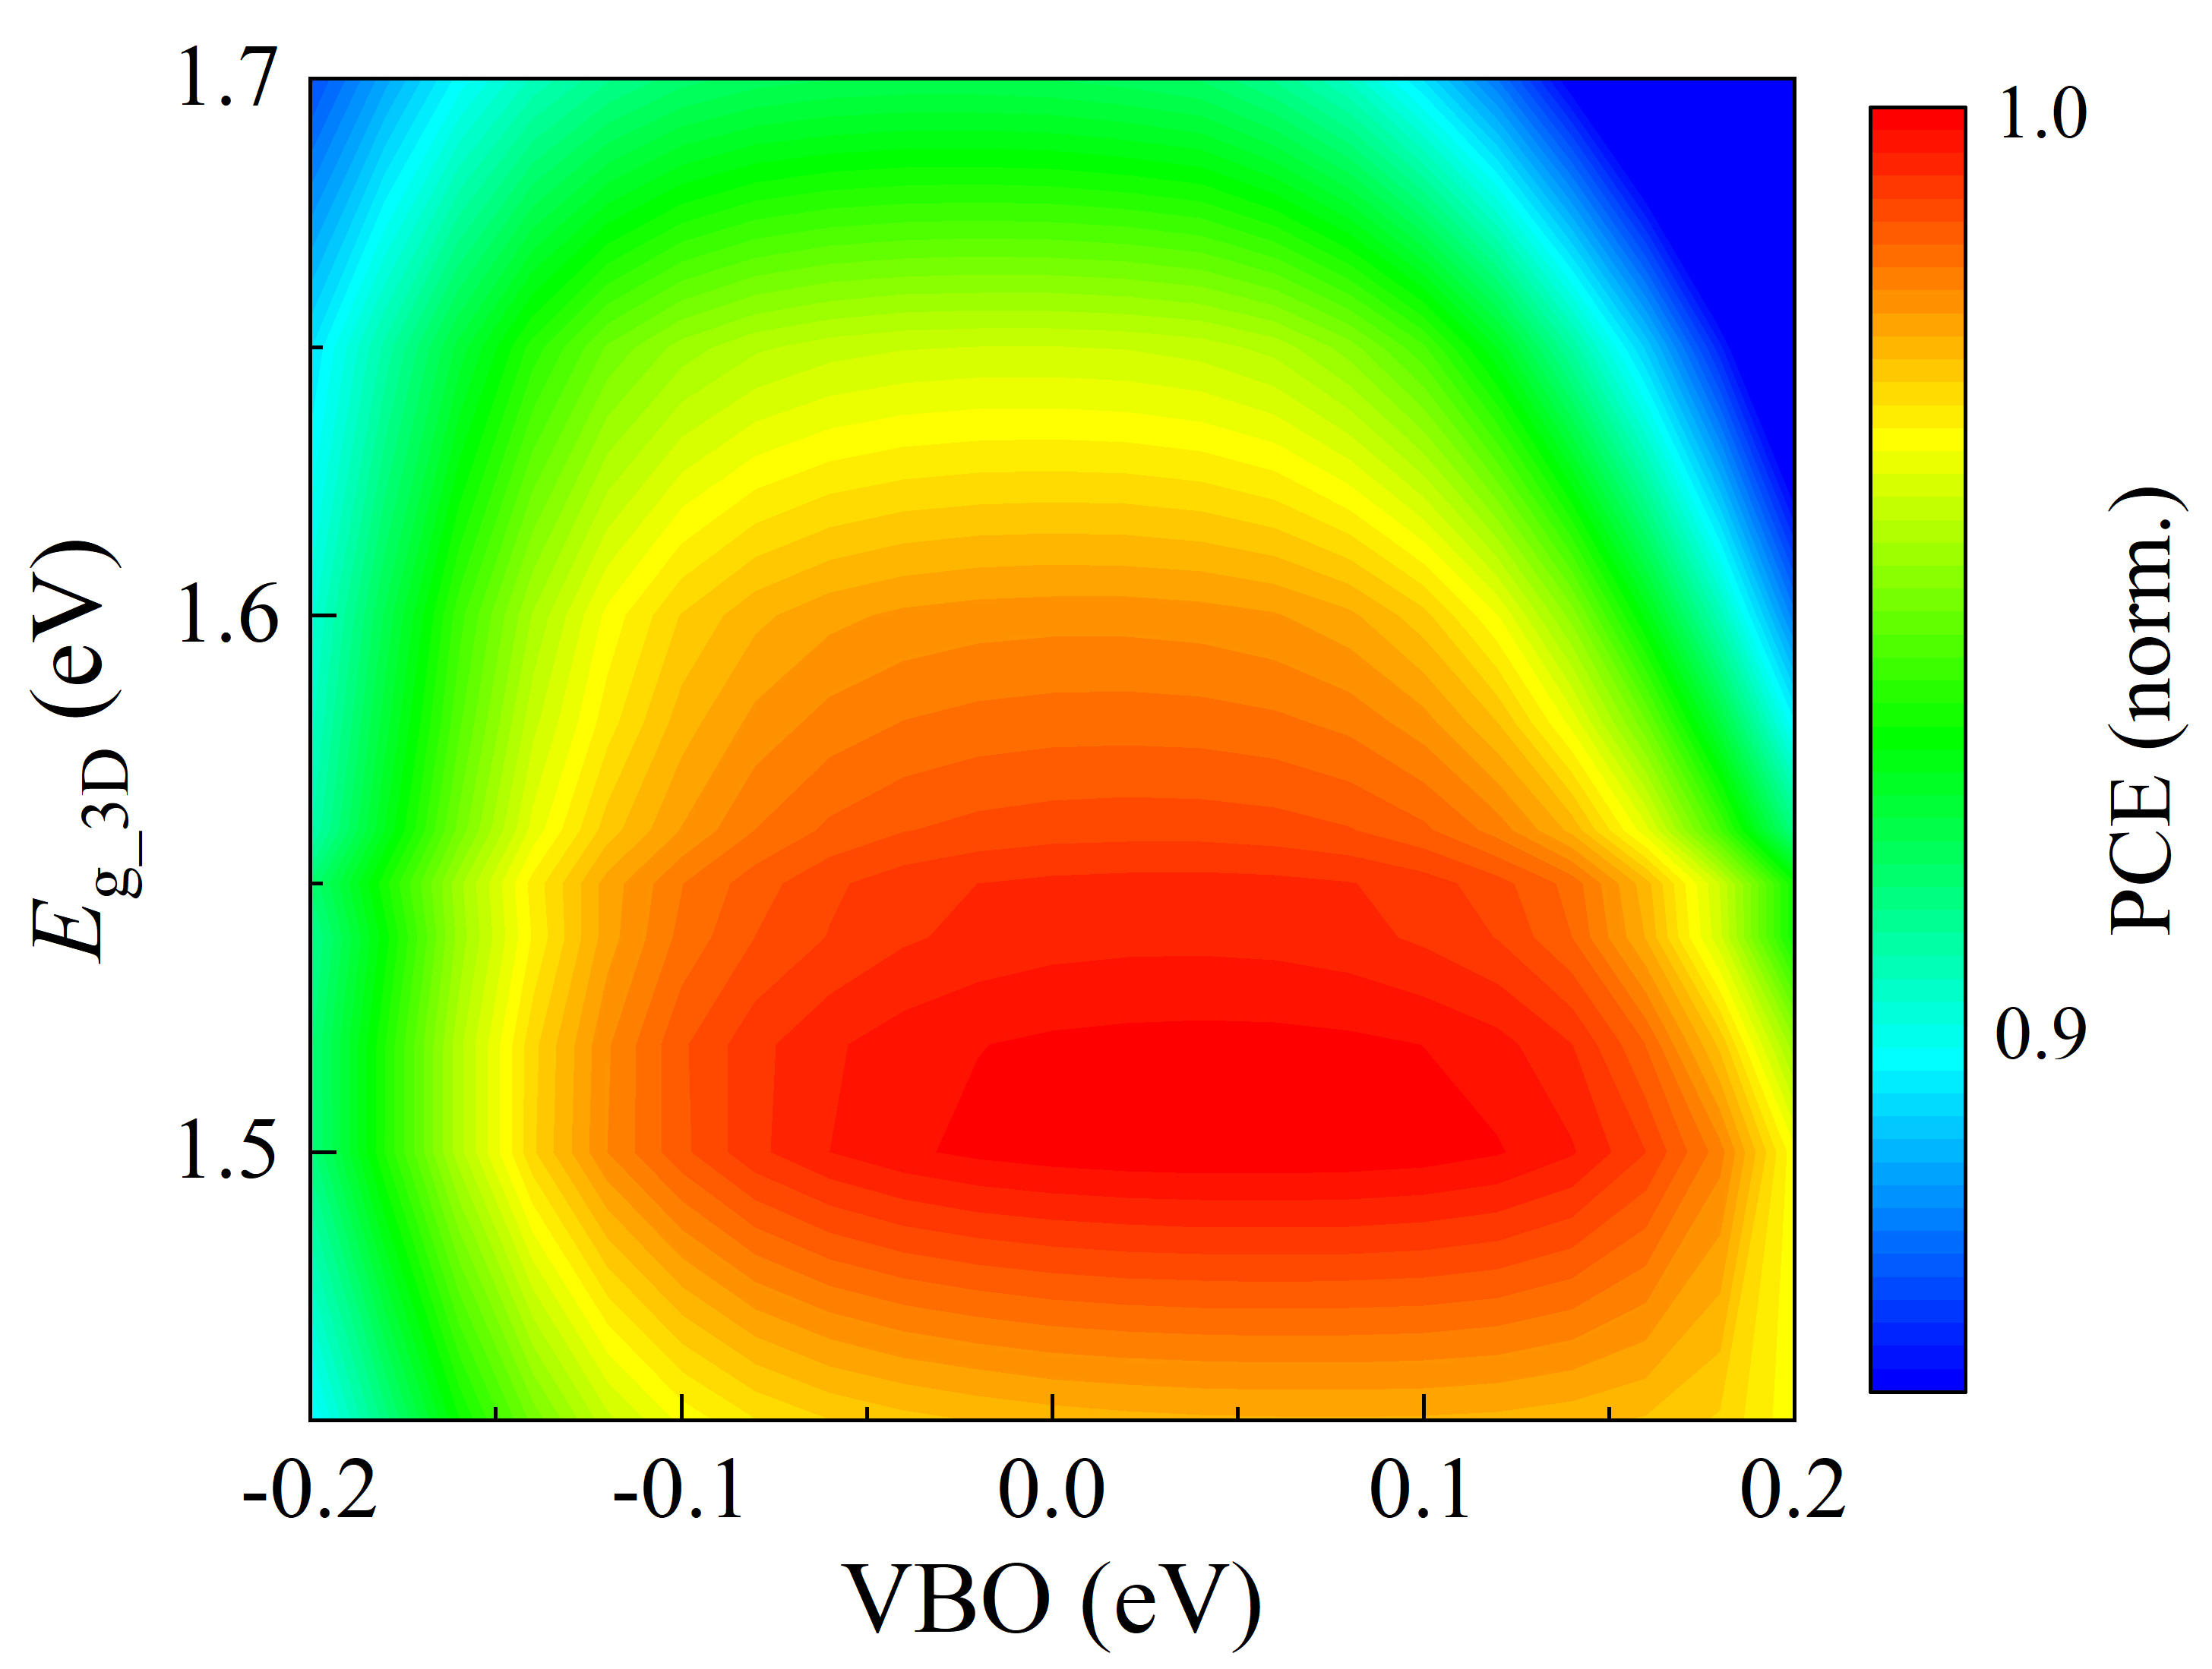
Figure S11. PCE contour of 2D/3D PSCs normalized by 3D PSCs under the various VBO of 2D/3D perovskite and 3D perovskite bandgap.

Figure S12. (a)-(b) Energy band structures, and (c)-(d) carrier concentrations under the 3D perovskite bandgap of 1.50 and 1.70 eV for 3D and 2D/3D PSCs.

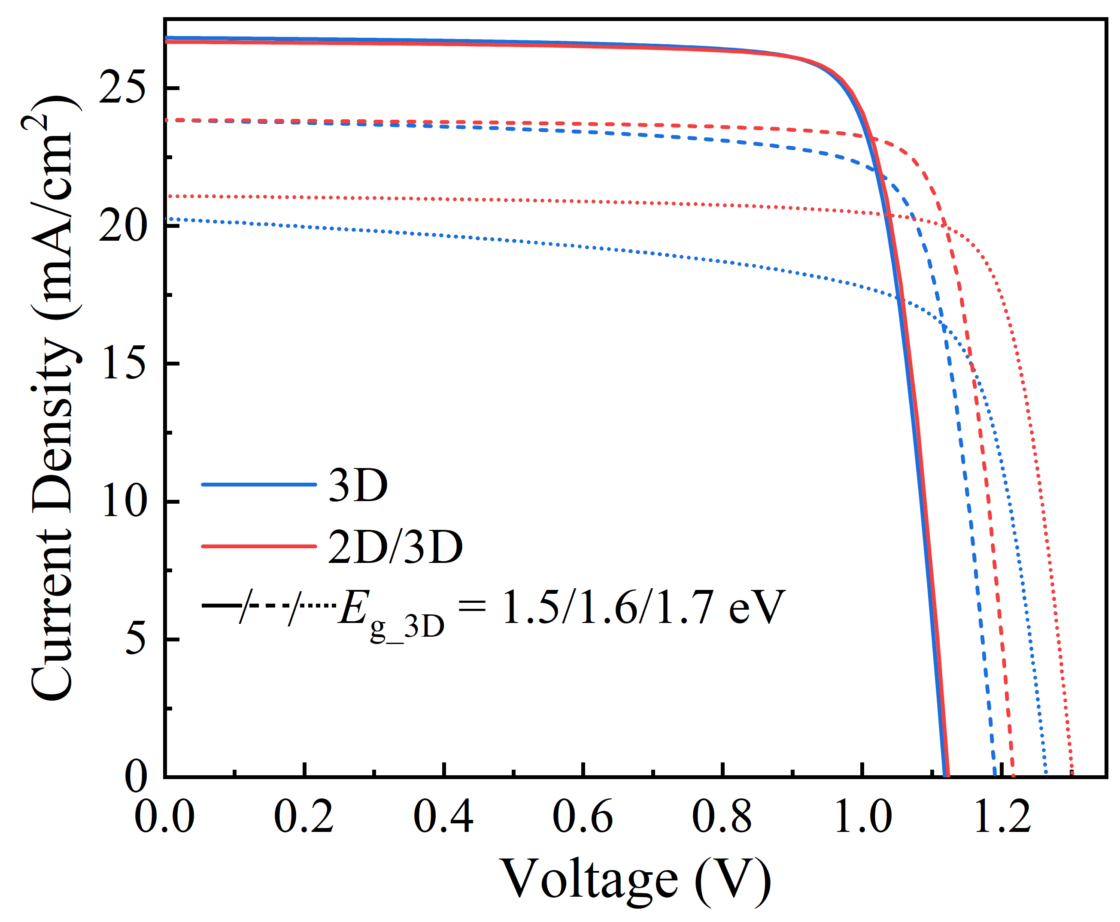
Figure S13. J-V curves of 3D and 2D/3D PSCs under the 3D perovskite bandgap of 1.5, 1.6 and 1.7 eV in Figure 5c (where the 2D perovskite bandgap is fixed at 2.40 eV).

Figure S14. (a) V_{oc} and (b) FF of 3D and 2D/3D PSC as a function of E_{g_3D}.

Figure S15. (a) J-V curves, (b) energy band structures, and (c) carrier concentrations of 2D/3D PSs under the 2D perovskite bandgap of 1.71, 2.40 and 2.80 eV, where the 3D perovskite bandgap is fixed at 1.70 eV.

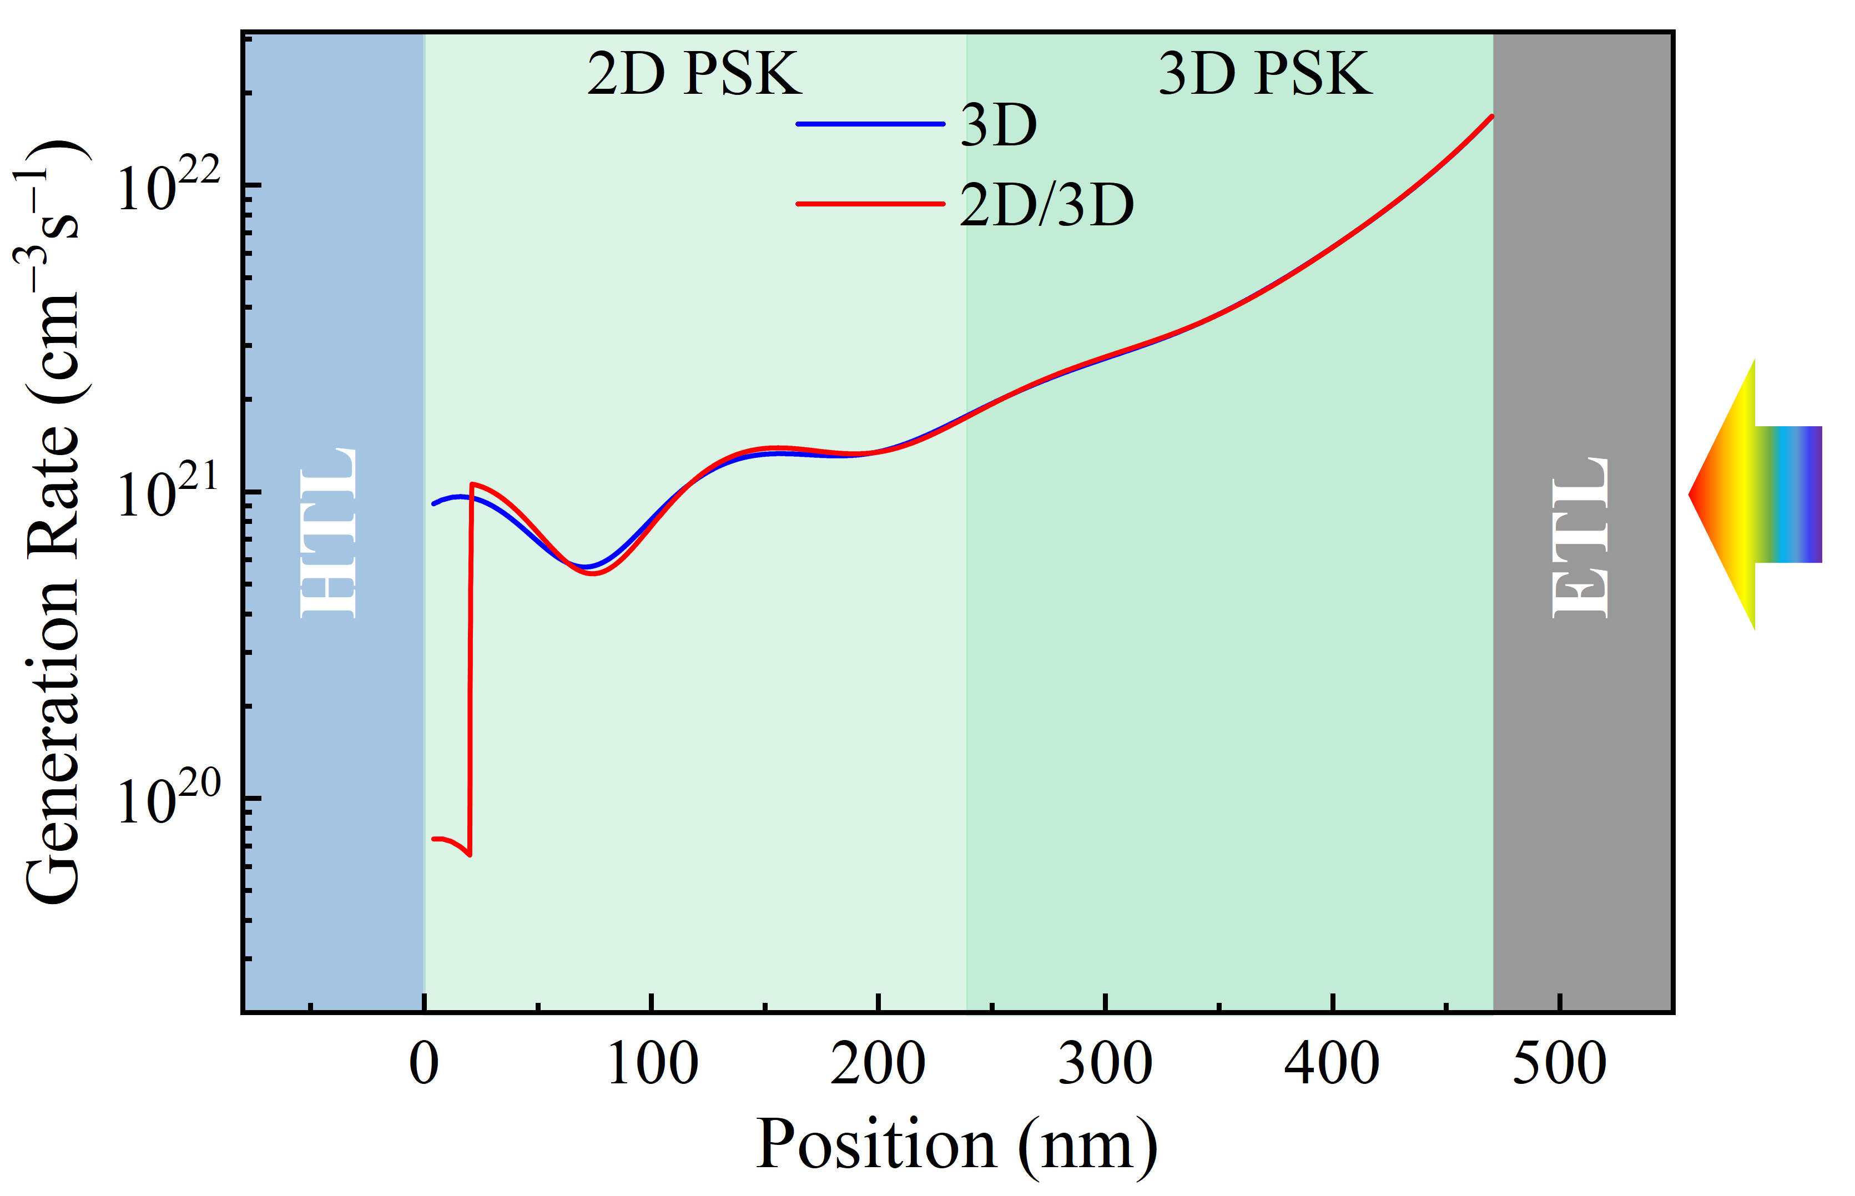
Figure S16. Carrier generation rates within perovskite for 3D and 2D/3D PSCs.

References
- Jung E H, et al. Efficient, stable and scalable perovskite solar cells using poly(3-hexylthiophene). Nature. 2019;567:511‒5.
- Jiang Q, et al. Surface passivation of perovskite film for efficient solar cells. Nat Photonics. 2019;13:460‒6.
- Yoo J J, et al. An interface stabilized perovskite solar cell with high stabilized efficiency and low voltage loss. Energy Environ Sci. 2019;12:2192‒9.
- Zheng X, et al. Managing grains and interfaces via ligand anchoring enables 22.3%-efficiency inverted perovskite solar cells. Nat Energy. 2020;5:131‒40.
- Mahmud M A, et al. In Situ Formation of Mixed-Dimensional Surface Passivation Layers in Perovskite Solar Cells with Dual-Isomer Alkylammonium Cations. Small. 2020;16:e2005022.
- Jang Y-W, et al. Intact 2D/3D halide junction perovskite solar cells via solid-phase in-plane growth. Nat Energy. 2021;6:63‒71.
- Zhou Q, et al. Dually-Passivated Perovskite Solar Cells with Reduced Voltage Loss and Increased Super Oxide Resistance. Angew Chem Int Ed. 2021;60:8303‒12.
- Yang B, et al. Interfacial Passivation Engineering of Perovskite Solar Cells with Fill Factor over 82% and Outstanding Operational Stability on n-i-p Architecture. ACS Energy Lett. 2021;6:3916‒23.
- Liu T, et al. Spacer Engineering Using Aromatic Formamidinium in 2D/3D Hybrid Perovskites for Highly Efficient Solar Cells. ACS Nano. 2021;15:7811‒20.
- Cai Y, et al. Graded 2D/3D (CF3-PEA)2FA0.85MA0.15Pb2I7/FA0.85MA0.15PbI3 heterojunction for stable perovskite solar cell with an efficiency over 23.0%. J Energy Chem. 2022;65:480‒9.
- Yang G, et al. Stable and low-photovoltage-loss perovskite solar cells by multifunctional passivation. Nat Photonics. 2021;15:681‒9.
- Jeong S, et al. Cyclohexylammonium‐Based 2D/3D Perovskite Heterojunction with Funnel‐Like Energy Band Alignment for Efficient Solar Cells (23.91%). Adv Energy Mater. 2021;11:2102236.
- Liu G, et al. Mixed-Phase Low-Dimensional Perovskite-Assisted Interfacial Lead Directional Management for Stable Perovskite Solar Cells with Efficiency over 24%. ACS Energy Lett. 2021;6:4395-404.
- Liu C, et al. Tuning structural isomers of phenylenediammonium to afford efficient and stable perovskite solar cells and modules. Nat Commun. 2021;12:6394.
- Liu X, et al. Influence of Halide Choice on Formation of Low‐Dimensional Perovskite Interlayer in Efficient Perovskite Solar Cells. Energy Environ Mater. 2022;5:670‒82.
- Zhang F, et al. Metastable Dion-Jacobson 2D structure enables efficient and stable perovskite solar cells. Science. 2022;375:71‒6.
- Azmi R, et al. Damp heat-stable perovskite solar cells with tailored-dimensionality 2D/3D heterojunctions. Science. 2022;376:73‒7.
- Zhou T, et al. Crystal Growth Regulation of 2D/3D Perovskite Films for Solar Cells with Both High Efficiency and Stability. Adv Mater. 2022;34:e2200705.
- Sung S J, et al. Molecular Engineering for Function‐Tailored Interface Modifier in High‐Performance Perovskite Solar Cells. Adv Energy Mater. 2022;12:2200758.
- Chen H, et al. Quantum-size-tuned heterostructures enable efficient and stable inverted perovskite solar cells. Nat Photonics. 2022;16:352‒8.
- Sidhik S, et al. Deterministic fabrication of 3D/2D perovskite bilayer stacks for durable and efficient solar cells. Science. 2022;377:1425‒1430.
- An Y, et al. Perovskite Solar Cells: Optoelectronic Simulation and Optimization. Sol RRL. 2018;2:1870227.
- An Y, et al. Heterojunction Perovskite Solar Cells: Opto-Electro-Thermal Physics, Modeling, and Experiment. ACS Nano. 2020;14:5017‒26.

