Supplementary Information
A new GNSS-acoustic positioning software implementing multiple positioning functions considering nadir total delays
F. Tomita¹, M. Kido¹
¹International Research Institute of Disaster Science, Tohoku University

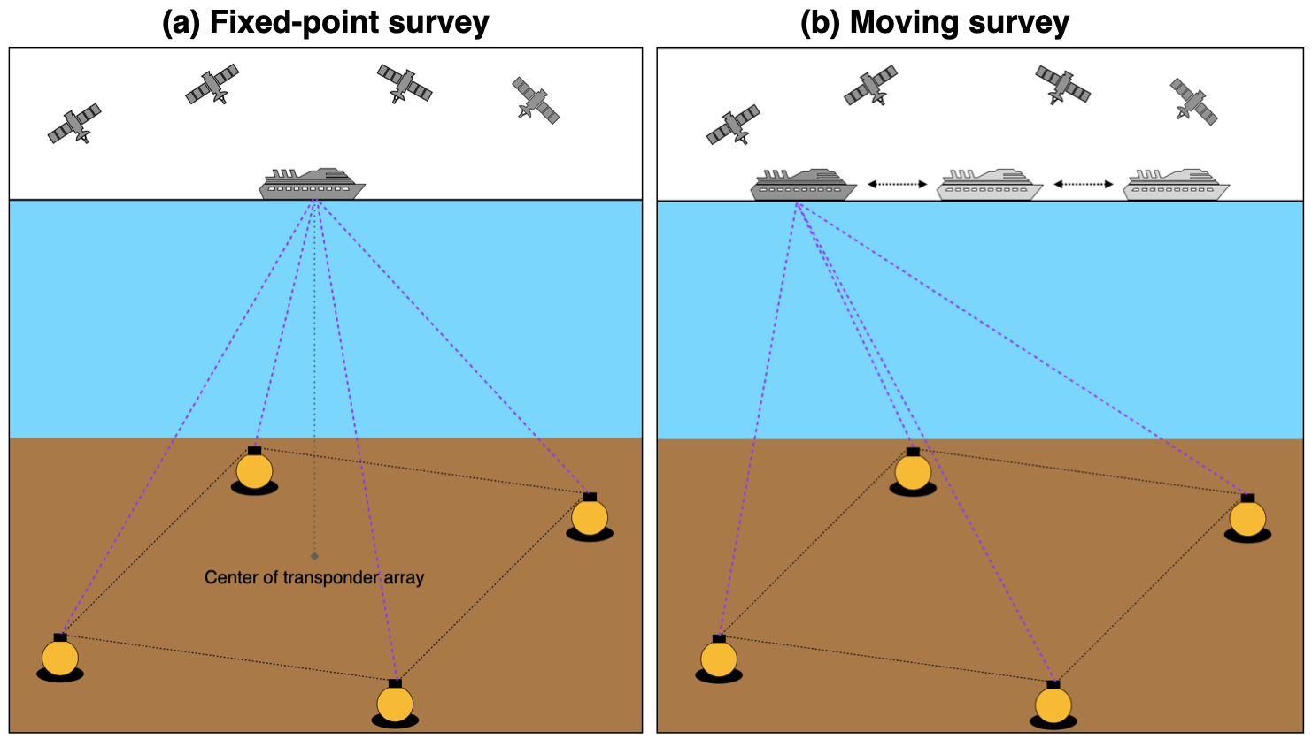Figure S1. Schematic images of a fixed-point survey (a) and a moving survey (b)

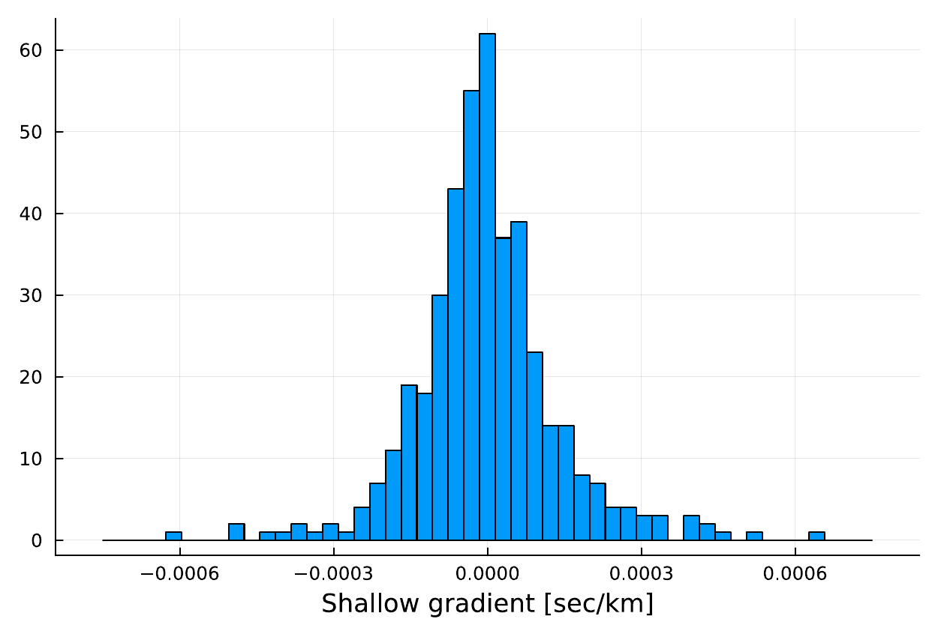
Figure S2. Histogram of the shallow gradients obtained by Tomita and Kido (2022).

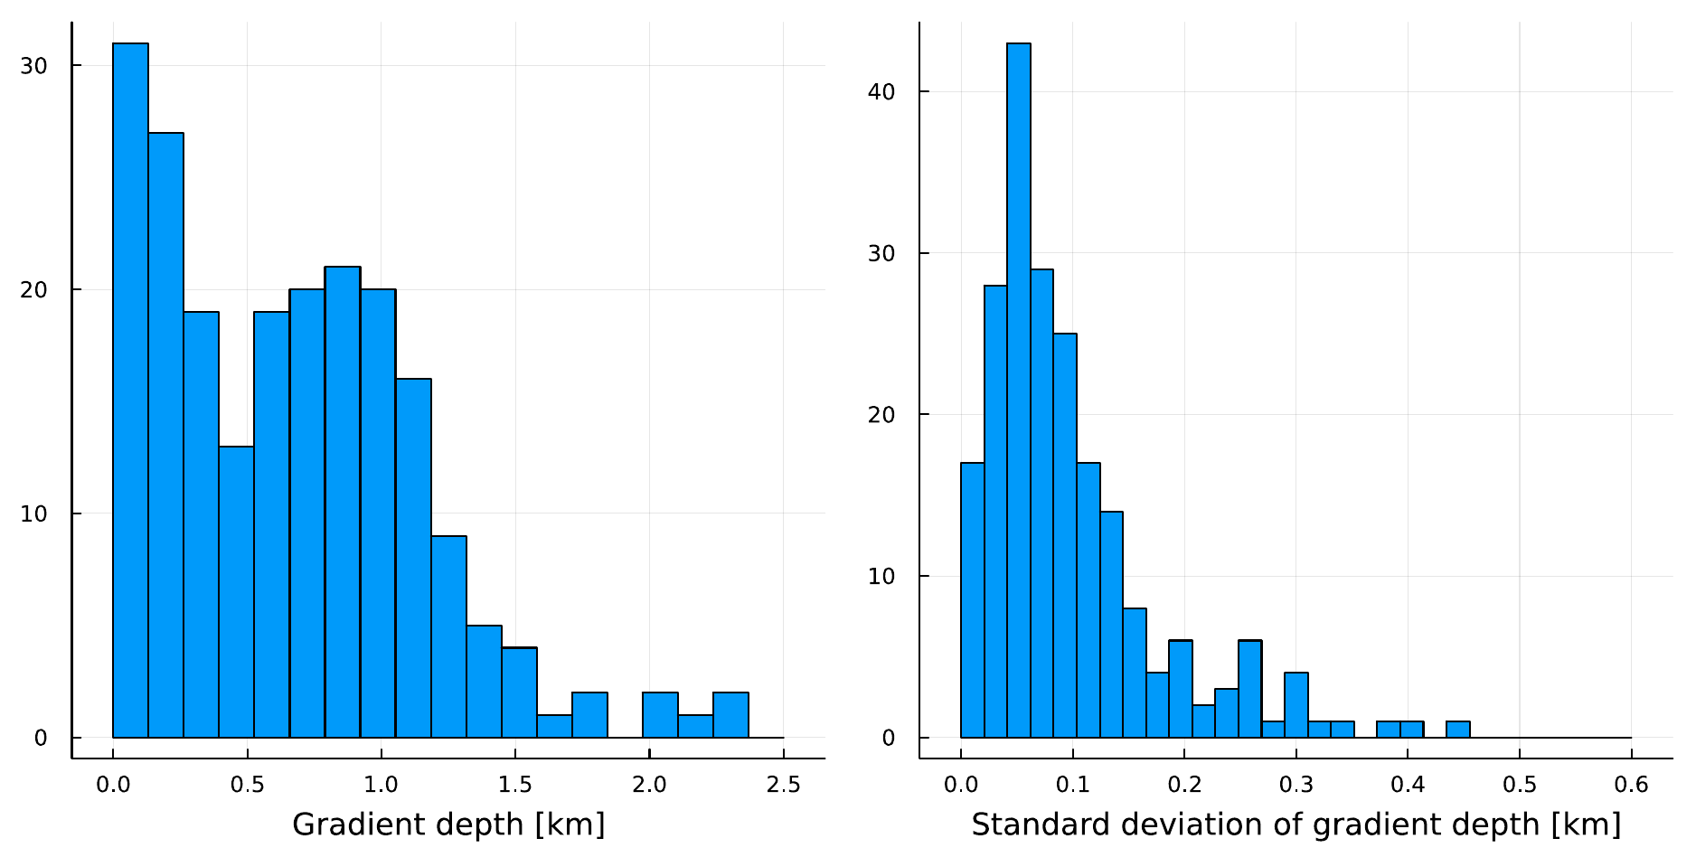

Figure S3. Histograms of the gradient depths (left panel) and the standard deviations of the individual gradient depths (right panel) obtained by Tomita and Kido (2022).

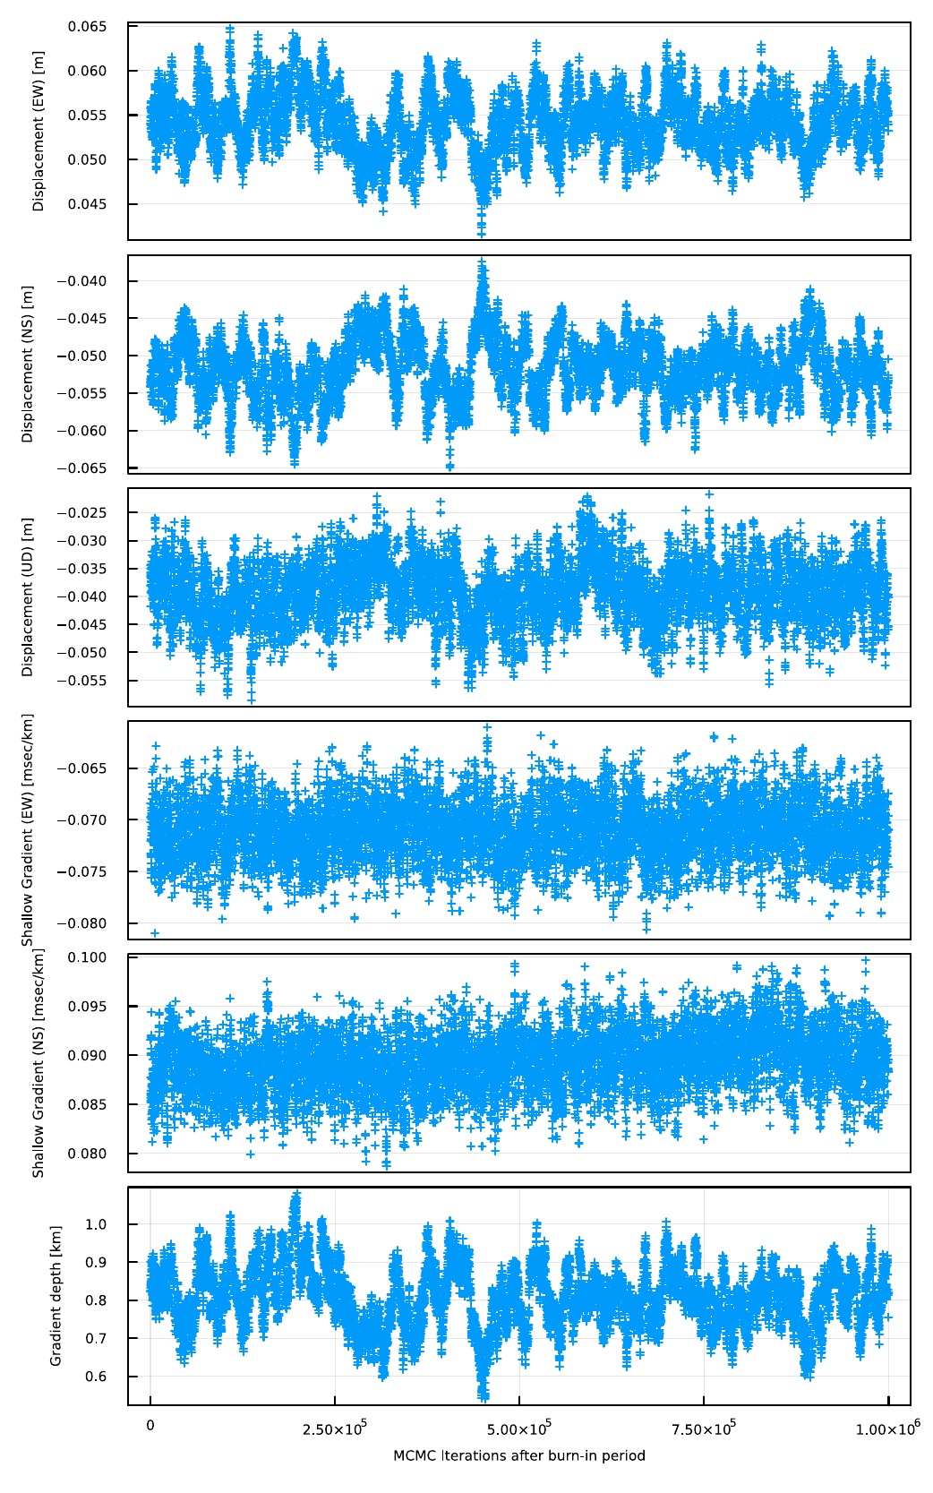
Figure S4. Sampled primary unknown parameters during the MCMC iterations after the burn-in period. They are the EW, NS and UD array displacements, the EW and NS shallow gradients, and the gradient depth.

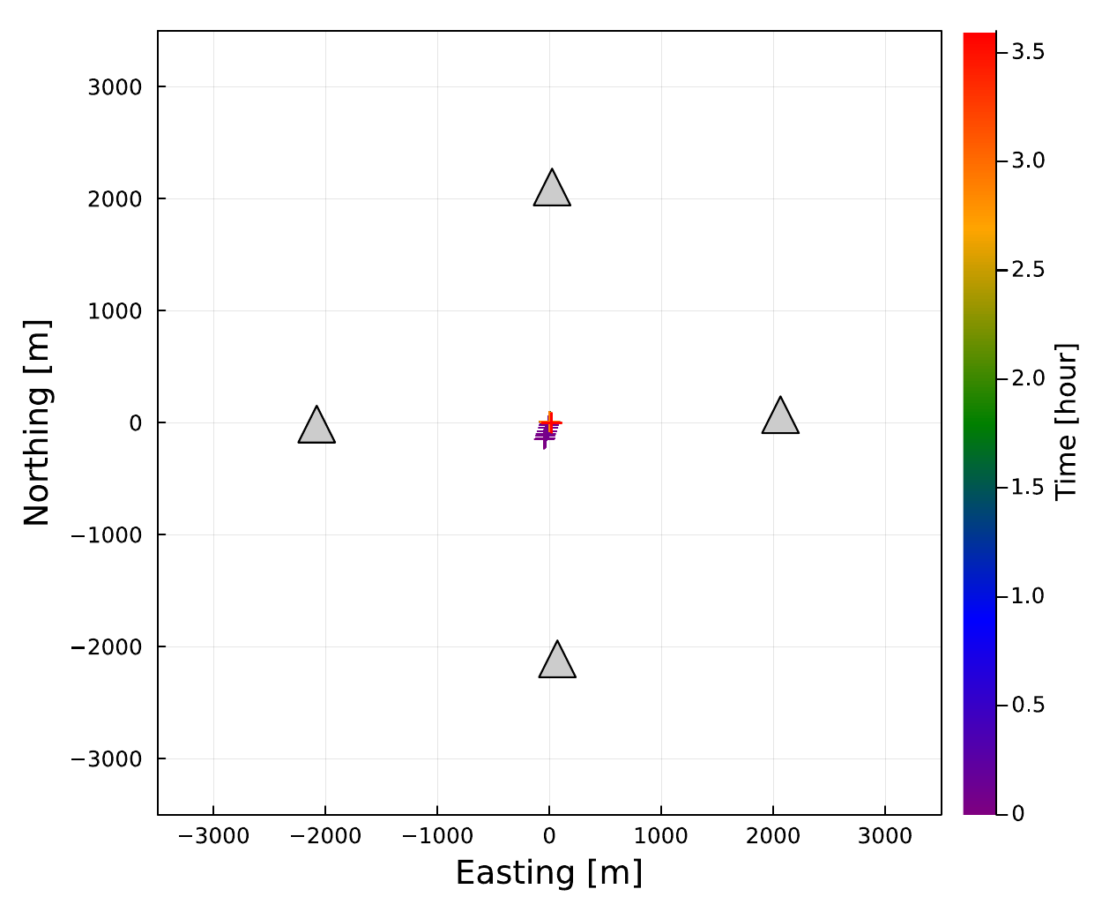
Figure S5. Track of a sea-surface platform of the observational data obtained at G20 on November 13, 2015 is shown by the cross symbols. The color represents the observational time. Gray triangles show the seafloor transponder positions.

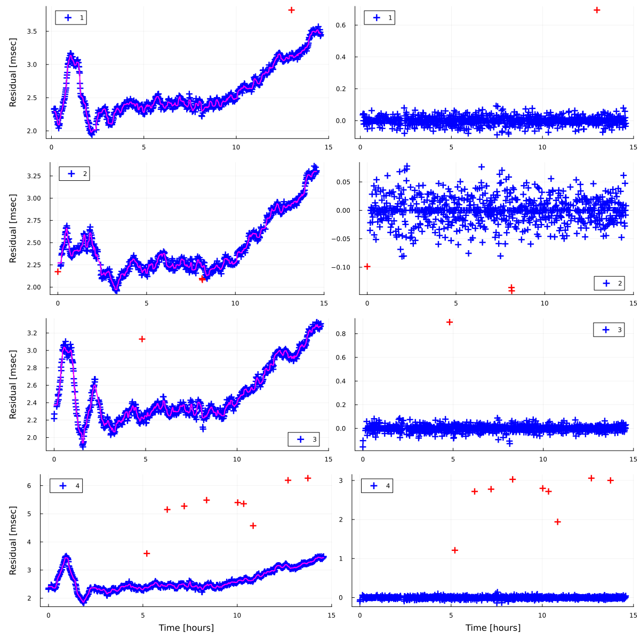
Figure S6. Each line of panels shows the projected travel-time residuals in the nadir direction for a seafloor transponder. (Left-sided panels) Blue cross symbols show the projected travel-time residuals. Red cross symbols also show the same ones but are identified as outliers. Red curve shows smoothed travel-time residuals generated by a running median filter. (Right panels) Blue cross symbols show the projected travel-time residuals after removing the smoothed travel-time residuals. Red cross symbols also show the same ones but are identified as outliers.

Table S1 List of SeaGap’s GNSS-A positioning functions. “Method” column means the inversion method: NLLS (non-linear least squares method) or MCMC (Markov Chain Monte Carlo).

Function name | Contents | Method
kinematic_array | Perform kinematic positioning for horizontal array positions of individual acoustic shot groups | NLLS
static_array | Perform static positioning for a 3d array position using the whole campaign datum | NLLS
static_array_TR | Perform "static_array" simultaneously solving a sea-surface transponder position relative to a GNSS antenna | NLLS
static_array_grad | Perform "static_array" simultaneously solving temporally-constant deep gradients | NLLS
static_individual | Perform static positioning for individual transponder positions using the whole campaign datum | NLLS
static_array_mcmcgrad | Perform static positioning for a 3d array position simultaneously solving a gradient depth and temporally-constant shallow gradients, using the whole campaign datum | MCMC
static_array_mcmcgradc | Perform "static_array_mcmcgrad" with additional prior distributions on the gradient depth and the shallow gradients | MCMC

