Supplementary data

Internal validation and discrimination, ROC curve (Receiver operating characteristic) and c- statistic at D3
Se: sensitivity; Sp: specificity; 1-6: assigned prognostic scale rating

Scale rating at D3 | Number of individuals with fatal outcome at D6 | Number of individuals without fatal outcome at D6 |  | Se | Sp | 1-Sp
> x | a | b |  | a/(a+c) | d/(b+d) | 1- d/(b+d)
≤ x | c | d
> 1 | 14 | 11 |  | 1.00 | 0.92 | 0.08
= 1 | 0 | 1
> 2 | 14 | 7 |  | 1.00 | 0.42 | 0.58
≤ 2 | 0 | 5
> 3 | 12 | 3 |  | 0.86 | 0.75 | 0.25
≤ 3 | 2 | 9
> 4 | 6 | 0 |  | 0.43 | 1.00 | 0.00
≤ 4 | 8 | 12
> 5 | 4 | 0 |  | 0.29 | 1.00 | 0.00
≤ 5 | 10 | 12
> 6 | 1 | 0 |  | 0.07 | 1.00 | 0.00
≤ 6 | 13 | 12

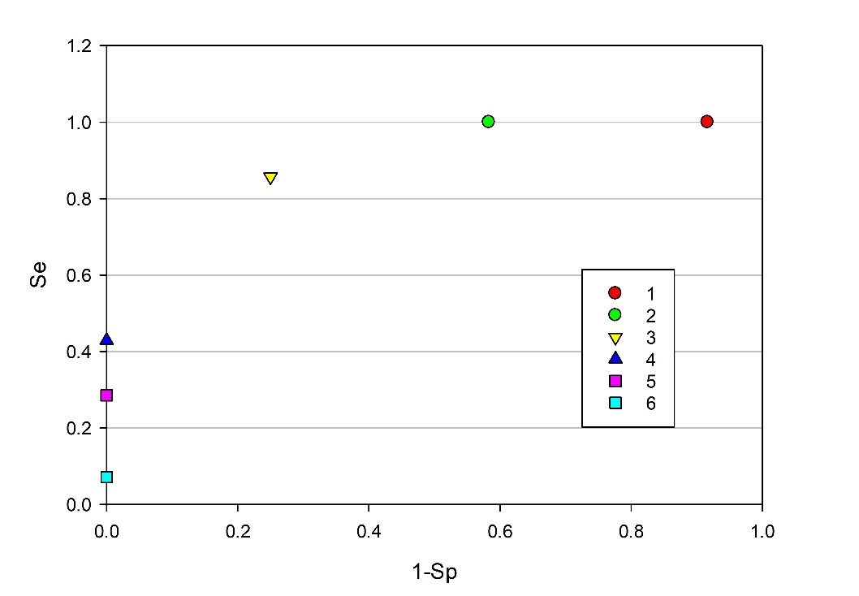
C-statistic = (num. concordant pairs + [0.5*num. equal pairs] / (total num. pairs)
Concordant pair = pair in which the individual with a fatal outcome presents, on the day considered D3, a higher scale rating than that of the individual without a fatal outcome.
Equal pair = pair in which the individual with a fatal outcome presents, on the day considered D3, a scale rating equal to that of the individual without a fatal outcome.
14 individuals with fatal outcome
 | Number of the individual with fatal outcome at D6 | Scale rating at D3 |  | Number of the individual without fatal outcome at D6 | Scale rating at D3
 | 1 | 4 |  | 2 | 2
 | 3 | 5 |  | 9 | 1
 | 4 | 6 |  | 11 | 3
 | 5 | 4 |  | 14 | 3  12 individuals without fatal outcome
 | 6 | 4 |  | 15 | 3
 | 7 | 4 |  | 16 | 4
 | 8 | 7 |  | 18 | 4
 | 10 | 4 |  | 19 | 2
 | 12 | 5 |  | 20 | 4
 | 13 | 3 |  | 22 | 2
 | 17 | 6 |  | 24 | 3
 | 21 | 6 |  | 26 | 2
 | 23 | 3
 | 25 | 4

Example: Individual 13 composed of concordant pairs with individuals 2, 9, 19, 22 and 26 (red lines); it forms equal pairs with individuals 11, 15 and 24 (green lines).

 | Scale rating at D3 | Equal pairs | Concordant pairs
 | 1 | 0 | 0
 | 2 | 0 | 0
 | 3 | 8 | 10
 | 4 | 18 | 54
 | 5 | 0 | 24
 | 6 | 0 | 36
 | Clinical death | 0 | 12
 |  | Σ=26 | Σ=136

C-statistic (D3) = (136+[0.5*26])/(14*12)= 0.89

