Thickness of hydrogel for nitrifying biomass entrapment determines the free ammonia susceptibility differently in batch and continuous modes

Minsu Song^{a, 1}, Meng Yuan^{a, 1}, Sanghyun Jeongª, Hyokwan Bae^{b, c,} *

ªDepartment of Civil and Environmental Engineering, Pusan National University, 63 Busandeahak-ro, Geumjeong-Gu, Busan 46241, Republic of Korea
^{b}Department of Urban and Environmental Engineering, Ulsan National Institute of Science and Technology (UNIST), 50 UNIST-gil, Eonyang-eup, Ulju-gun, Ulsan 44919, Republic of Korea
^{c}Graduate School of Carbon Neutrality, Ulsan National Institute of Science and Technology (UNIST), 50 UNIST-gil, Eonyang-eup, Ulju-gun, Ulsan 44919, Republic of Korea

*Corresponding author: Hyokwan Bae, Ph.D.
Department of Urban and Environmental Engineering, Ulsan National Institute of Science and Technology (UNIST), 50 UNIST-gil, Eonyang-eup, Ulju-gun, Ulsan 44919, Republic of Korea
E-mail: hyokwan.bae@unist.ac.kr
Tel: +82-52-217-2801
Fax: +82-52-217-2859
ORCID: 0000-0002-2422-9411

¹These authors contributed equally to this work

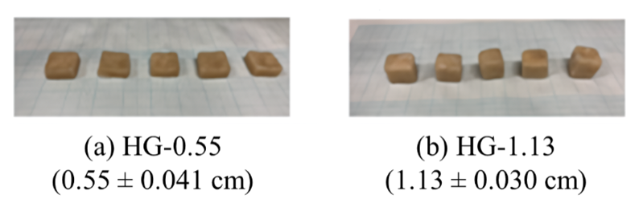
Fig. S1. The average thicknesses of (a) HG-0.55 and (b) -1.13 entrapping nitrifying bacteria.

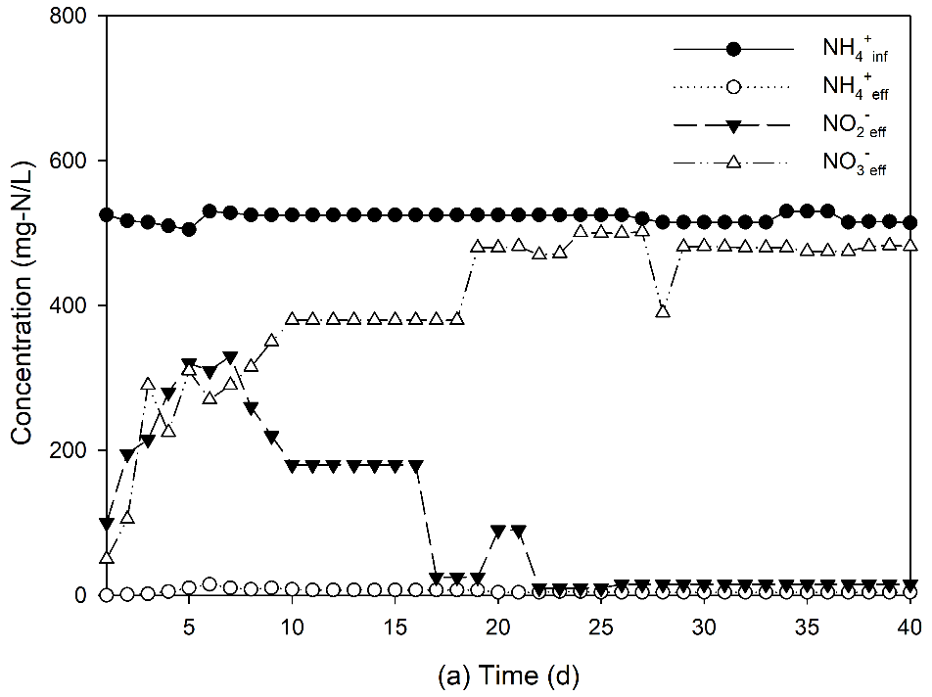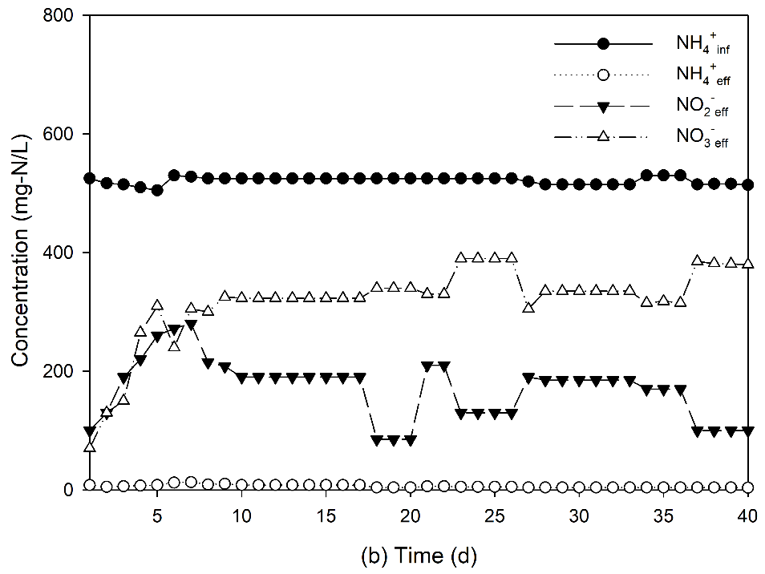
Fig. S2. Nitrifying efficiency of (a) HG-0.55 and (b) -1.13 during the enrichment period.

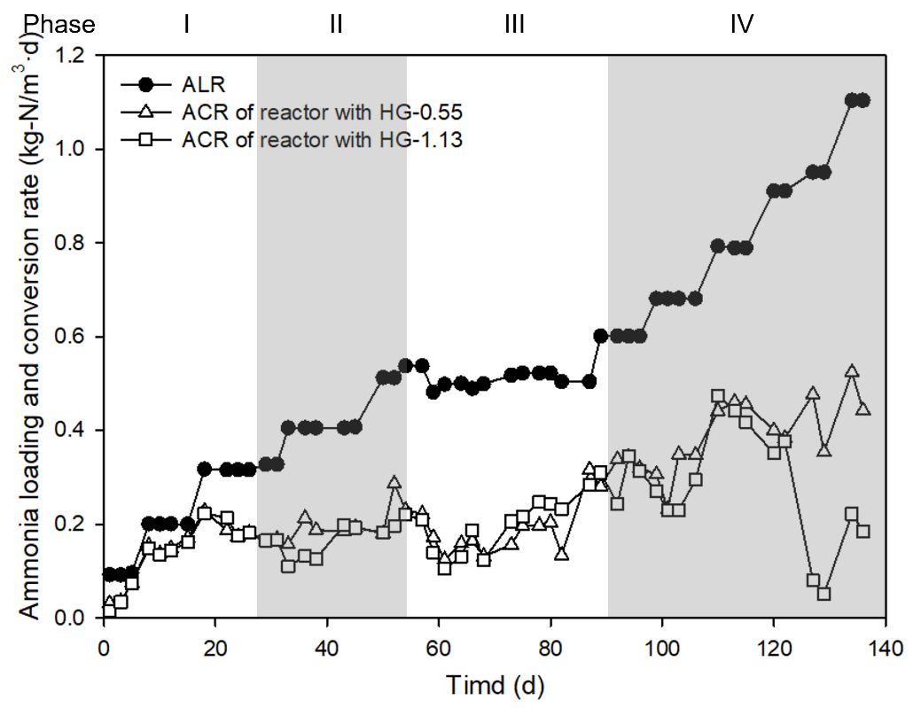
Fig. S3. Ammonia and nitrite conversion rate of nitrifying bioreactors for evaluating the PN performance of reactors with HG-0.55 and -1.13.

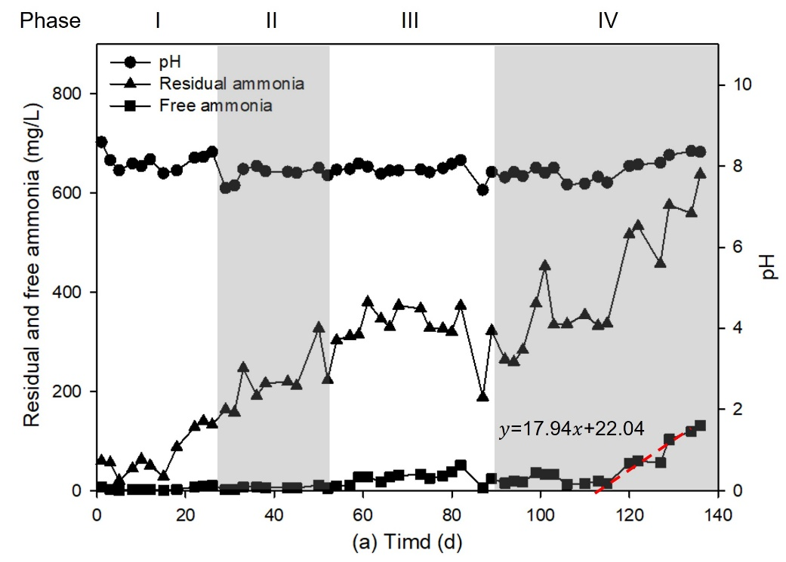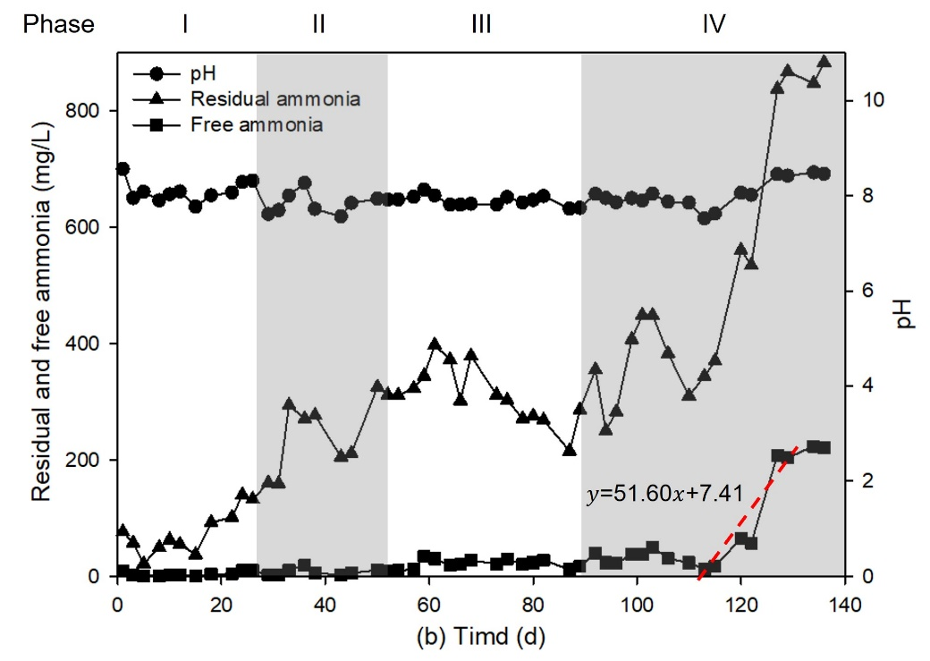
Fig. S4. pH, residual, and free ammonia concentration of nitrifying bioreactors for evaluating the PN performance of reactors with (a) HG-0.55 and (b) -1.13 (including regression equations for calculating the rate of FA increase during the 115–129 days period).

