A quantitative method for determination of colistin E2 methanesulphonate in human plasma by ¹⁵N-labeled colistin E2

1. Instruments and Materials
The following instruments and materials were applied to this method.
Name | Manufacturer | Specifications and models
Column | Phenomenex | Kinetex 2.6 μm, XB-C18, 100A, (50*2.1 mm)
LC-MS/MS | Sciex | Sciex Exion LC-Sciex Triple quad 5500
Pipette | Eppendorf | 0.5-10 μL
Pipette | Eppendorf | 2-20 μL
Pipette | Eppendorf | 10-100 μL
Pipette | Eppendorf | 20-200 μL
Pipette | Eppendorf | 100-1000 μL
Pipette | Eppendorf | Electronic dispenser
Pipette | Rainin | 10-100 μL LTS
Pipette | Rainin | 20-200 μL LTS
Pipette | Rainin | 100-1 mL LTS
Multichannel adjustable pipette | Rainin | 20-300 μL LTS
Multichannel pipette | Rainin | L8-300XLS
Multichannel pipette | Eppendorf | 30-300 μL
Ultrapure water machine | Millipore | Advantage A10
Ultrasonic cleaning machine | Kunshan Hechuang Ultrasound Instrument Co., Ltd | KH-300DE
Ultrasonic cleaning machine | Kunshan Hechuang Ultrasound Instrument Co., Ltd | KQ-300E
Nitrogen blowing instrument | Stuart | F7210\SBHCONC\SBH130D
96-well nitrogen blowing instrument | Hangzhou Miou Instrument Co., Ltd | NKD200-1A
96-well nitrogen blowing instrument | Biotage | Turbo-vap 96
Electronic balances | METTLER TOLEDO | XPE105
Electronic balances | METTLER TOLEDO | XPE26
Vortex oscillator | Shanghai Qingpu Huxi Instrument Factory | XW-80A
Vortex oscillator | Nanjing Maipu Instrument Co., Ltd | Vortexgenie2
Vortex oscillator | IKA | Vortex 3
Vortex oscillator | DLAB | MX-S
Microplate thermostatic oscillator | Hangzhou Miou Instrument Co., Ltd | ST70-2
Multi-tube vortex oscillator | Hangzhou Miou Instrument Co., Ltd | DMT-2500
Multi-tube vortex oscillator | VWR | VX-2500
High-speed refrigerated centrifuges | Eppendorf | 5810R
Cooler | Thermo Scientific | REL1204V
Cooler | Thermo Scientific | UGL2320V
Ultra-low temperature freezer | Haier Group Corporation | DW-86L728J
Ultra-low temperature freezer | Thermo | 88400V
Biosafety cabinets | Suzhou Antai Air Technology Co., Ltd | BSC-1004IIA2
Biosafety cabinets | Suzhou Antai Air Technology Co., Ltd | BSC-1304IIA2
Graduated cylinder | KIMBLE | 1000 mL
Graduated cylinder | KIMBLE | 500 mL
Graduated cylinder | KIMBLE | 250 mL
Graduated cylinder | KIMBLE | 50 mL
Graduated cylinder | KIMBLE | 100 mL
Oasis WCX 96-well Plate | Waters | 30mg/96-well
Positive pressure device | Waters | 186006961

2. Method
The volume and weight used to prepare the solution can be adjusted proportionally.

2.1 Solution and matrix preparation

2.1.1 Solution 1: 5% ammonia solution
2 mL 30% ammonia was added to 10 mL water, and then mixed well.

2.1.2 Solution 2: acetonitrile/water (3: 7, containing 2% ammonia) solution
5 mL 30% ammonia, 22.5 mL acetonitrile and 47.5 mL water were mixed well.

2.1.3 Solution 3: 0.5% formic acid aqueous solution
0.5 mL formic acid was added to 99.5 mL water, and then mixed well.

2.1.4 Solution 4: 6% formic acid aqueous solution
6 mL formic acid was added to 94 mL water, and then mixed well.

2.1.5 Eluate: acetonitrile/water (3: 7, containing 6% formic acid)
30 mL acetonitrile, 6 mL formic acid and 64 mL water were mixed well.

2.1.6 Mobile phase A: 0.1% formic acid aqueous solution
1 mL formic acid was added to 999 mL water, and then mixed well.

2.1.7 Mobile phase B: methanol: acetonitrile (1: 1)
500 mL acetonitrile and 500 mL methanol were mixed well.

2.1.8 2% hemolytic plasma
Blank whole blood (anticoagulant EDTA-K2) was placed at -20°C to break all blood cells. 2 mL was added to 98 mL of blank plasma (anticoagulant EDTA-K2), and then mixed well.

2.1.9 High-fat plasma (containing fat emulsion 300 mg/dL)
Appropriate volume of the structural fat emulsion injection was added to the blank plasma (anticoagulant EDTA-K2), and mixed well to prepare high-fat plasma with a concentration of 300 mg/dL.

2.1.10 Methanol: water (1: 1)
100 mL methanol was mixed with 100 mL water.

2.1.11 Needle wash solution 01 (Port): methanol: acetonitrile: isopropanol: water: formic acid = 3: 3: 3: 1: 0.2
300 mL methanol, 300 mL acetonitrile, 300 mL isopropanol and 2.0 mL formic acid were added to 100 mL water, then mixed well and stored at room temperature.

2.1.12 Needle wash solution 02 (Pump): isopropanol aqueous solution (1: 9)
10 mL isopropanol was added to 90 mL water, and then mixed well.

2.1.13 2 mol/L sodium hydroxide solution
1.6 g sodium hydroxide was dissolved in 20 mL water.

2.1.14 1 mol/L sulfuric acid solution
27.8 mL sulfuric acid (98%) was dropped into 472.2 mL water in a breaker, gently stirred with a glass stick.

2.1.15 Methanol: water (9: 1)
900 mL methanol was mixed with 100 mL water.

2.2 Preparation of internal standard solutions
Both IS-A and IS-D were kept at -20°C.

2.2.1 Internal standard stock solution A (IS-A)
The isotope-labeled colistin E2 was precisely weighed, dissolved with an appropriate amount of methanol: water (1: 1), and prepared IS-A with a concentration of 1.5 mg/mL.

2.2.2 Internal standard working solution D (IS-D)
100 μL IS-A was added to 9.9 mL of methanol: water (1: 1), and mixed well to prepare 15 μg/mL IS-D.

2.3 Preparation of colistin E2 stock and working solution
The standard curve stock solution and the quality control stock solution for colistin E2 need to be prepared from different weighing. All solutions were kept at -20°C.

2.3.1 Colistin E2 Stock Solution A (SS-A)
The colistin E2 reference was accurately weighed and dissolved with an appropriate amount of methanol: water (1: 1) to prepare a stock solution SS-A with a concentration of 3 mg/mL.

2.3.2 Colistin E2 Stock Solution B (SS-B)
1.2 mL SS-A was added to 1.8 mL of methanol: water (1: 1) to prepare a 1200 μg/mL stock solution SS-B.

2.3.3 Colistin E2 Stock Solution C (SS-C)
100 μL SS-B was added to 1.9 mL of methanol: water (1:1) to prepare a 60 μg/mL stock solution SS-C.

2.3.4 Colistin E2 standard curve and quality control working solution
Quality control working solution was prepared using methanol: water (1: 1) according to the following table:
Working solution | Source solution |  |  | solvent | Working solution
Name | Name | Colistin E2 concentration (μg/mL) | Volume  (μL) | Volume  (μL) | Volume  (μL) | Colistin E2 concentration (μg/mL)
W-STD_8 | SS-B1 | 1200 | 500 | 500 | 1000 | 600
W-STD_7 | SS-B1 | 1200 | 450 | 550 | 1000 | 540
W-STD_6 | SS-B1 | 1200 | 250 | 750 | 1000 | 300
W-STD_5 | SS-B1 | 1200 | 125 | 875 | 1000 | 150
W-STD_4 | SS-C1 | 60 | 500 | 500 | 1000 | 30
W-STD_3 | SS-C1 | 60 | 100 | 900 | 1000 | 6
W-STD_2 | SS-C1 | 60 | 20 | 980 | 1000 | 1.2
W-STD_1 | SS-C1 | 60 | 10 | 990 | 1000 | 0.6
W-QCD | SS-A2 | 3000 | 800 | 200 | 1000 | 2400
W-QCH | SS-B2 | 1200 | 400 | 600 | 1000 | 480
W-QCM2 | SS-B2 | 1200 | 200 | 800 | 1000 | 240
W-QCM1 | SS-C2 | 60 | 80 | 920 | 1000 | 4.8
W-QCL | SS-C2 | 60 | 30 | 970 | 1000 | 1.8
Note: W-STDs and W-QCs (including W-LLOQ and W-QCD) are formulated from different SSs.

2.3.5 Colistin E2 standard curve and plasmatic samples
The standard curve of colistin E2 and quality control plasma samples were prepared according to the table below, and then stored at -20°C:
Working solution |  |  | Standard curve and quality controlled plasma samples
Name | Colistin E2 (μg/mL) | Volume  (µL) | Human plasma volume (µL) | Total volume (µL) | Colistin E2 (μg/mL) | Name
W-STD_8 | 600 | 50 | 950 | 1000 | 30 | STD_8
W-STD_7 | 540 | 50 | 950 | 1000 | 27 | STD_7
W-STD_6 | 300 | 50 | 950 | 1000 | 15 | STD_6
W-STD_5 | 150 | 50 | 950 | 1000 | 7.5 | STD_5
W-STD_4 | 30 | 50 | 950 | 1000 | 1.5 | STD_4
W-STD_3 | 6 | 50 | 950 | 1000 | 0.3 | STD_3
W-STD_2 | 1.2 | 50 | 950 | 1000 | 0.06 | STD_2
W-STD_1 | 0.6 | 50 | 950 | 1000 | 0.03 | STD_1
W-QCD | 2400 | 50 | 950 | 1000 | 120 | QCD
W-QCH | 480 | 50 | 950 | 1000 | 24 | QCH
W-QCM2 | 240 | 50 | 950 | 1000 | 12 | QCM2
W-QCM1 | 4.8 | 50 | 950 | 1000 | 0.24 | QCM1
W-QCL | 1.8 | 50 | 950 | 1000 | 0.09 | QCL

2.3.6 Colistin E2 diluted quality control samples
Matrix dilution (5-fold): 50 μL of QCD sample was mixed with 200 μL of blank human plasma and then extracted.

2.4 Preparation of CMS E2 stock solution and working solution
The quality control stock solution of CMS E2 should be stored at -20 °C, and the concentration of all CMS E2 solutions should be calculated as hydrolyzed free colistin E2.

2.4.1 CMS E2 stock solution A (SS-A_CMS E2)
CMS E2 reference was accurately weighed and dissolved with an appropriate amount of methanol: water (9: 1) to prepare a stock solution SS-A_CMS E2 with a concentration of 2 mg/mL (the correction factor should be calculated as free colistin E2).

2.4.2 Colistin E2 stock solution B (SS-B_CMS E2)
1.2 mL SS-A was added to 0.8 mL of methanol: water (9: 1) and mixed to prepare 1200 μg/mL stock solution SS-B_CMS E2.

2.4.3 Colistin E2 stock solution C (SS-C_CMS E2)
100 μL SS-B was added to 1.9 mL of methanol: water (9: 1) and mixed to prepare a 60 μg/mL stock solution SS C_CMS E2.

2.4.4 CMS E2 quality control working solution
The working solution for quality control was prepared using methanol: water (9: 1) according to the following table:
Working solution | Source solution |  |  | solvent | Working solution
Name | Name | CMS E2 concentration (μg/mL) | Volume  (μL) | Volume  (μL) | Volume  (μL) | CMS E2 concentration (μg/mL)
W-QCD_CMS E2 | SS-A | 2000 | 600 | 400 | 1000 | 1200
W-QCH_CMS E2 | SS-B | 1200 | 200 | 800 | 1000 | 240
W-QCM2_CMS E2 | SS-B | 1200 | 100 | 900 | 1000 | 120
W-QCM1_CMS E2 | SS-C | 60 | 80 | 920 | 1000 | 4.8
W-QCL_CMS E2 | SS-C | 60 | 30 | 970 | 1000 | 1.8

2.4.5 CMS E2 standard curve and quality control plasma samples
Quality control plasma samples of CMS E2 were prepared according to the table below, and stored at -20°C (all plasma samples prepared with CMS E2 were measured at free colistin E2):
Working solution |  |  | Standard curve and quality controlled plasma samples
Name | CMS E2 (μg/mL) | Name | CMS E2 (μg/mL) | Name | CMS E2 (μg/mL) | Name
W-QCD_CMS E2 | 1200 | 50 | 950 | 1000 | 60 | QCD_CMS E2
W-QCH_CMS E2 | 240 | 50 | 950 | 1000 | 12 | QCH_CMS E2
W-QCM2_CMS E2 | 120 | 50 | 950 | 1000 | 6 | QCM2_CMS E2
W-QCM1_CMS E2 | 4.8 | 50 | 950 | 1000 | 0.24 | QCM1_CMS E2
W-QCL_CMS E2 | 1.8 | 50 | 950 | 1000 | 0.09 | QCL_CMS E2

2.4.6 CMS E2 diluted quality control samples
Matrix dilution (5-fold): 50 μL of QCD_CMS E2 sample was mixed with 200 μL of blank human plasma and then extracted.

2.5 System Adaptability Sample (SVS)
One sample or solution should be prepared at the appropriate concentration (LLOQ concentration level) for use as a system-adapted sample.

2.6 Preparation of quality control samples containing CMS E2/colistin E2
The method was used for the stability study, and all the following medicinal solutions and plasma samples were prepared and used in an ice water bath and stored at -20 °C after use.

2.6.1 CMS E2 stock solution A (SS-A_CMS E2)
CMS E2 reference was accurately weighed and dissolved with an appropriate amount of methanol: water (9: 1) to prepare a stock solution SS-A_CMS E2 with a concentration of 2 mg/mL (the correction factor should be calculated as free colistin E2).

2.6.2 CMS E2 working solution (W_CMS E2)
0.96 mL SS-A was added to 1.04 mL of methanol: water (9: 1) and mixed well to make a 960 g/mL working solution W_CMS E2.

2.6.3 Colistin E2 working solution (W_E2)
96 μL W-QCM2 was added to 1.104 mL of methanol: water (1: 1) and mixed well to prepare a 19.2 μg/mL working solution W_E2.

2.6.4 Preparation of plasma quality control sample QC_mix for CMS E2/Colistin E2
Working solution |  |  | Standard curve and quality controlled plasma samples
Name | CMS E2/ Colistin E2 (μg/mL) | Volume  (µL) | Human plasma  Volume (µL) | Total volume  (µL) | CMS E2/ Colistin E2 (μg/mL) | Name
W_CMS E2/ W_E2 | 960/19.2 | 10/10 | 380 | 400 | 24/0.48 | QC_mix

2.7 Instrument Conditions
The followings are the mass spectrometry conditions.

2.7.1 Mass spectrometry systems
Mass spectrometer: Sciex 5500 triple quadrupole mass spectrometer
Ionization mode: (+) ESI
Scan Mode: Multi-Reaction Monitoring Mode (MRM)
Parameter | Optimize the value
Ion Spray (IS) | 5500
Curtain Gas (CUR) | 30
Temperature (TEM) | 550
Entrance Potential (EP) | 10
Collision Gas (CAD) | 9
Collision Cell Exit Potential (CXP) | 10
Dwell Time (ms) | 100
Gas 1 | 40
Gas 2 | 40

2.7.2 Precursor ions, fragment ions, declustering voltage (DP) and collision energy (CE)
Compound | Precursor ions (m/z) | fragment ions (m/z) | CE  (eV) | DP
Colistin E2 | 386.2 | 101.1 | 20 | 120
IS | 391.4 | 103.1 | 20 | 120

3 Atlas
Figure S1. Lower limit of colistin E2 quantification in human plasma (LLOQ, 0.03 g/mL) chromatogram (A: colistin E2 and B: IS)
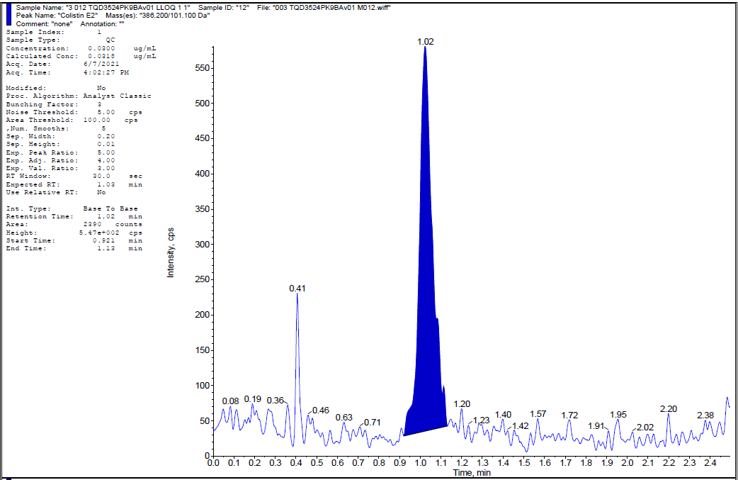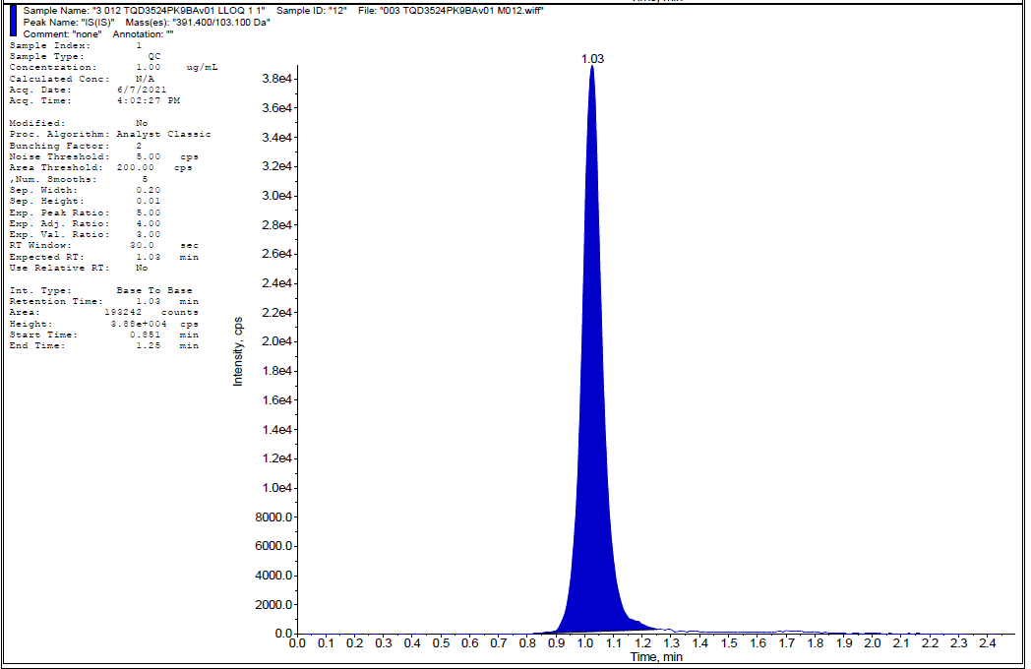
(B)
(A)
Figure S2. Low-concentration plasma-controlled plasma samples (QCL, 0.09 g/mL) from human plasma with CMS E2 hydrolyzed by sulfuric acid (A: colistin E2 and B: IS)
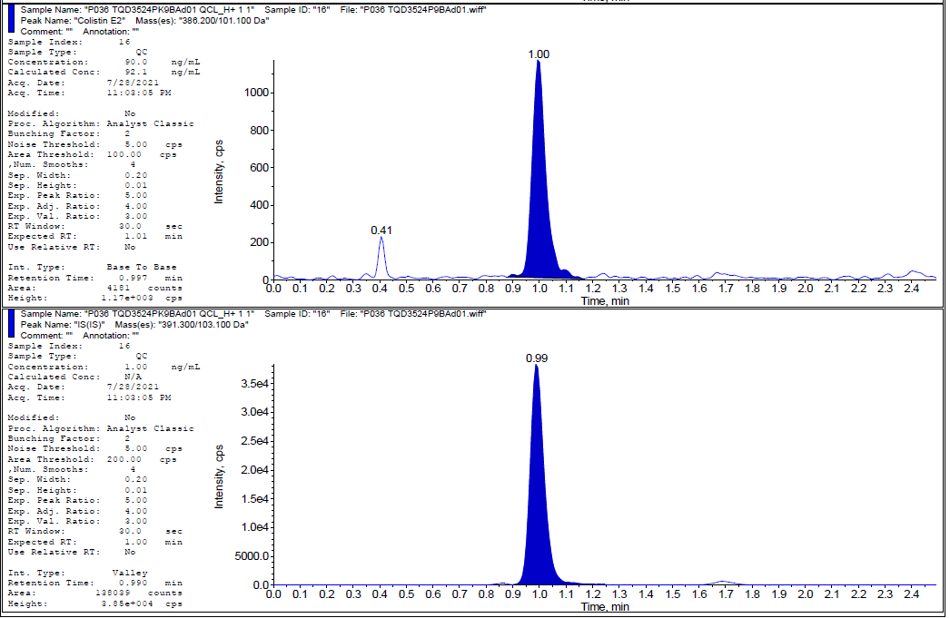

Figure S3. Full scan (A) and fragment ion scan (B) of colistin E2
(B)
(A)
[M+H]⁺

Figure S4. Full scan (A) and fragment ion scan (B) of IS
(A)
(B)
[M+H]⁺

