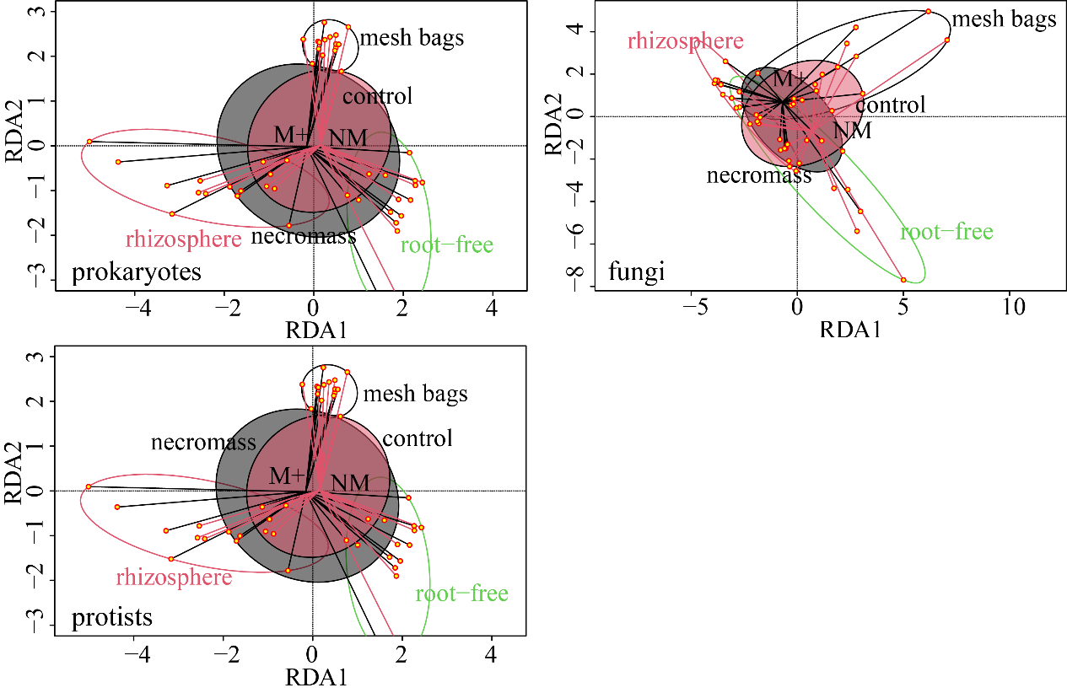
Fig. S1 Redundancy ordinations of Bray-Curtis dissimilarities at the operational taxonomic unit (OTU) level for prokaryotes, protists and fungal communities in the potting substrate of the different pot compartments as affected by compartment identity (rhizosphere, root-free compartment, and mesh bags), inoculation with living arbuscular mycorrhizal (AM) fungus (NM, nonmycorrhizal treatment; M+, mycorrhizal treatment) and the AM fungal necromass amendment (control, no addition of mycorrhizal necromass; necromass, AM fungal necromass added). Compartments are delineated by Ordiellipse (rhizosphere – red, root-free compartment – green, and mesh bags – black). Ordispider is showing mycorrhizal inoculation (red lines indicate NM; black lines indicate M+). Polygons indicate mycorrhizal necromass amendment (control - red polygons; necromass – gray polygons).

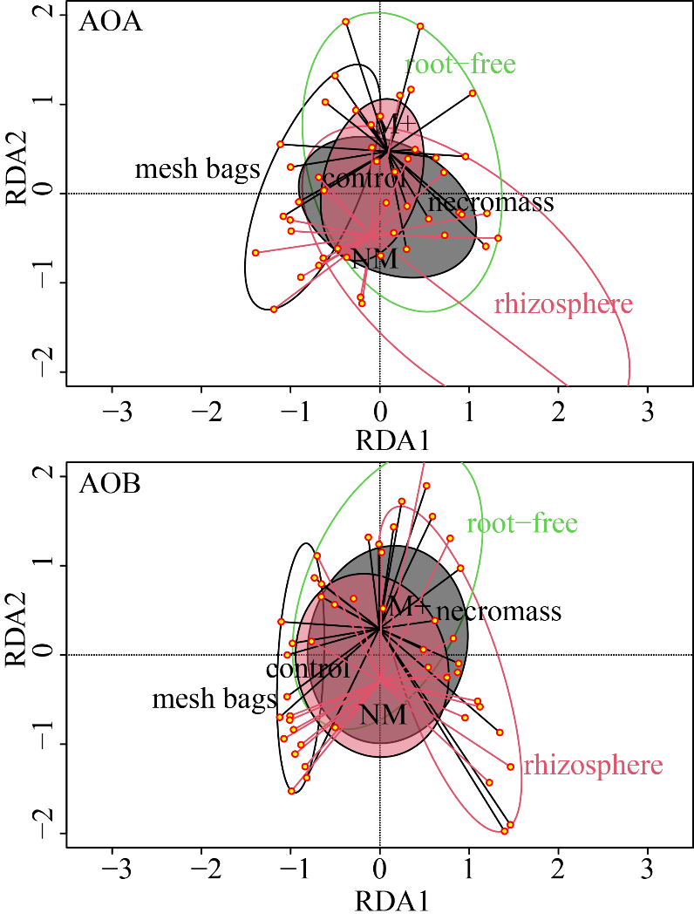
Fig. S2 Redundancy ordinations of Bray-Curtis dissimilarities at the operational taxonomic unit (OTU) level for ammonia-oxidizing archaea (AOA) and ammonia-oxidizing bacteria (AOB) communities in the potting substrate of the different pot compartments as affected by compartment identity (rhizosphere, root-free compartment, and mesh bags), inoculation with living arbuscular mycorrhizal (AM) fungus (NM, nonmycorrhizal treatment; M+, mycorrhizal treatment) and the AM fungal necromass amendment (control, no addition of mycorrhizal necromass; necromass, AM fungal necromass added). Compartments are delineated by Ordiellipse (rhizosphere – red, root-free compartment – green, and mesh bags – black). Ordispider is showing mycorrhizal inoculation (red lines indicate NM; black lines indicate M+). Polygons indicate mycorrhizal necromass amendment (control - red polygons; necromass – gray polygons).

