Supplementary Materials for:
Setback distance between coastal cities and wetlands to protect waterbirds
Rong-Bo Luo and Hong-Gang Ni*

School of Urban Planning and Design, Peking University Shenzhen Graduate School, Shenzhen 518055, China

Corresponding Author
Phone: +86-755-26033017. Fax: +86-755-26033254. E-mail: nihg@pkusz.edu.cn

Calculation of setback distance
Studies have shown that tidal flats with vegetation cover can purify sewage 19133.1 t/(hm²*a). Coastal wetland area S (classified area of various types) of 48 coastal cities in China (hm²) is derived from the second Wetland Survey Report of China (2013). The annual sewage discharge data X (10000 t) of 48 coastal cities are obtained from the statistical yearbooks of provinces and cities in 2013, as shown in Table S3. The Monte Carlo simulation method is used to predict the setback distance with Eq. (S1):

X*C_{discharge}*(1-3.46%)^{d}=(WEC+L_{plant})*S_{water}+196133.3*C_{V}*S_{tidal flat} (S1)

where X is the annual sewage discharge data of 48 coastal cities; C_{discharge} is the national sewage plant discharge standard (TN concentration is 15 mg/L); C_{V} is the Grade V Water Quality Standard of China (TN concentration is 2 mg/L); S_{water} and S_{tidal flat} are the area of water body and the area of tidal flat wetland of 48 coastal cities (hm²), respectively; 3.46% indicates that TN presents an average decrease of 3.46% for every 1000 m of sewage flowing in the pipelines (Ren, 2015). Therefore, the setback distance can be calculated using Eq. (S2):

$d=\frac{LN（(WEC+L_{plant})*S_{water}+196133.3*C_{V}*S_{tidal flat}）-LN(X*C_{discharge})}{LN(1-3.46\%)}$ (S2)

Crystal Ball was used to conduct the Monte Carlo simulation, and the obtained results are not consistent with the actual observations (Fig. 2). The reasons are provided below:
(1) The statistical calibration of the area data for coastal wetlands in 48 coastal cities was performed on a large scale, and the water depth and water area data cannot be confirmed;

(2) The statistical methods applied for the sewage discharge data obtained from the statistical yearbook differ, and the discharge standard may not be completely in accordance with the national standard, which may have led to large deviations in the data;

(3) The influence of rainfall, river transportation and other factors was not considered, and the sewage discharged by coastal cities was not completely purified by coastal wetlands.

Therefore, based on the improvement of the above research methods, the calculation equation and method in the next section can be obtained by improving Eq. (S2) The pollutant treatment proportion of coastal wetlands to the pollution discharge of urban sewage was considered. In addition, the content of other typical pollutants in sewage, such as the chemical oxygen demand (COD), biochemical oxygen demand (BOD) and suspended solids (SS), can be considered to ensure that the calculated setback distance of coastal constructions is more comprehensive.

Table S1 Range of noise produced by different human activities.
Type | Activity | Secondary classification | Noise (decibel)
Type | Activity | Secondary classification | min | max
Traffic | Walk |  | 20 | 65
Traffic | Run |  | 20 | 65
Traffic | Bike |  | 20 | 65
Traffic | Electric bicycle |  |  | 62
Traffic | Boat | Diesel engine | 100 | 100
Traffic | Boat | Pedal boat | 20 | 65
Traffic | Boat | Electric boat | 50 | 75
Traffic | Boat | Rowboat | 20 | 65
Traffic | Car |  | 80 | 100
Explore & Experience | Angling |  | 10 | 20
Explore & Experience | Exhibitions |  | 20 | 65
Explore & Experience | Catching fish (shrimp & crab) |  | 20 | 65
Explore & Experience | Aquaculture |  | 20 | 65
Leisure | Setting up exercise |  | 20 | 65
Leisure | Singing |  | 60 | 70
Leisure | Square dancing | Megaphone | 70 | 90
Leisure | Dragon boat race | Noise during the race | 70 | 110
Leisure | Dragon boat race | Cheers from the audience | 120 | 120
Leisure | Catering |  | 20 | 65
Leisure | Shopping |  | 70 | 80
Leisure | Light exhibition |  | 20 | 65
Leisure | Children playing loudly |  | 90 | 90
Management & maintenance | Fitness |  | 70 | 80
Management & maintenance | Construction |  | 70 | 80
Management & maintenance | Construction site |  | 80 | 110

Table S2. Simulation results for the setback distance (km) assume that the proportion (W/C) is a normal distribution of 0%-100% and 60% - 100%. Mode Value is the value that occurs most frequently in the probability distribution (0%-100%); and Min and Max mean the minimum and maximum in the probability distribution (60%-100%).
Pollutant Index | 0% - 100% | 60% - 100%
Pollutant Index | Mode Value |  | Min | Max
COD | 3.06 |  | 0.35 | 18.1
BOD | 0.19 |  | 0.02 | 1.13
SS | 0.47 |  | 0.05 | 2.83
TN | 2.52 |  | 0.29 | 14.9

Table S3. Coastal wetland area S (classified area of various types) of 48 coastal cities (hm²) and annual sewage discharge data X (10000 t) of 48 coastal cities (2013).
Province | Coastal city | S_{water} (including estuarine waters and coastal salt water lake) (hm²) | S_{tidal flat} (including muddy beach, intertidal brine marshes and delta) (hm²) | X (annual sewage discharge) (10000 t)
Liaoning | Dalian | 9108 | 4129 | 57494
Liaoning | Dandong | 26202 |  | 11010
Liaoning | Jinzhou | 12042 | 863 | 16222
Liaoning | Yingkou | 894 | 958 | 10339
Liaoning | Panjin | 36313 | 16240 | 9706
Liaoning | Huludao | 1720 | 455 | 8872
Hebei | Tangshan | 8914 | 940 | 51008
Hebei | Qinhuangdao | 872 | 202 | 17693
Hebei | Cangzhou |  |  | 12585
Shandong | Qingdao | 15041 | 9120 | 51557
Shandong | Dongying | 74651 | 5090 | 20695
Shandong | Yantai | 5482 | 2610 | 32667
Shandong | Weifang | 20241 | 8237 | 54107
Shandong | Weihai | 4821 | 5628 | 11474
Shandong | Rizhao | 1580 | 368 | 15557
Shandong | Binzhou | 13306 | 2669 | 27315
 | Tianjin | 11474 | 1681 | 84210
Jiangsu | Lianyungang | 19027 | 6062 | 22287
Jiangsu | Nantong | 165886 | 73331 | 44478
Jiangsu | Yancheng | 308786 | 7650 | 45270
 | Shanghai | 74848 | 308483 | 222636
Zhejiangª (including Ningbo, Wenzhou, Jiaxing, Taizhou) |  | 175165 | 102581 | 182058
Fujian | Fuzhou | 40337 | 35505 | 37010
Fujian | Xiamen | 8578 | 834 | 50212
Fujian | Putian | 15574 | 1463 | 11603
Fujian | Quanzhou | 12268 | 5998 | 55625
Fujian | Zhangzhou | 18281 | 11156 | 42290
Fujian | Ningde | 37314 | 5608 | 10204
Guangdong | Zhanjiang | 25718 | 11610 | 24600
Guangdong | Zhuhai | 9337 | 85359 | 23500
Guangdong | Jiangmen | 6779 | 4464 | 38100
Guangdong | Yangjiang | 6440 | 1554 | 9900
Guangdong | Guangzhou | 671 | 24129 | 156700
Guangdong | Maoming | 977 | 3238 | 20000
Guangdong | Shanwei | 7359 | 9865 | 12700
Guangdong | Huizhou | 637 | 2912 | 39600
Guangdong | Zhongshan | 217 | 15935 | 40600
Guangdong | Shantou | 3112 | 10316 | 25600
Guangdong | Shenzhen | 426 | 31940 | 155400
Guangdong | Chaozhou | 1101 | 2831 | 13000
Guangdong | Dongguan | 80 | 6456 | 103700
Guangdong | Jieyang | 558 | 744 | 24700
Guangxi | Beihai | 12633 | 5009 | 7380
Guangxi | Fangchenggang | 4407 | 4326 | 7902
Guangxi | Qinzhou | 7097 | 6294 | 9768
ª Because the statistical data of Zhejiang Province are only obtained at the province scale, this part will include the cities overall.

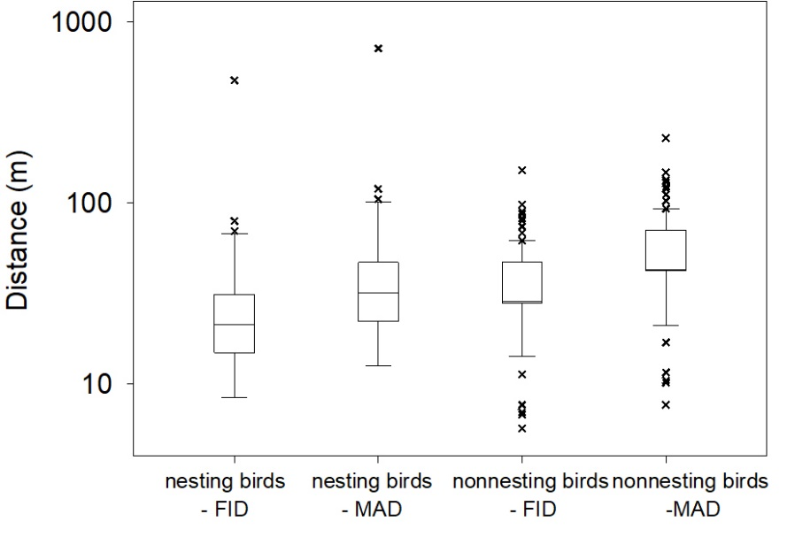
Fig. S1. Distribution of bird FID and MAD data.
Fig. S2. Histogram showing the distribution (statistical analysis) of setback distances (m) calculated by noise.

Reference：
Ren W.A. The study of migration characteristics and transforming discipline of Nitrogen compounds in the transportation and treatment process of urban wastewater (in Chinese) Municipal Engineerin. Ph.D. Xi’an University of Architecture and Technology, Xian, 2015, pp. 123.

