 | Forward sequence | Reversed sequence
miR146a-5p | CTGAGAACTGAATTCCATGGGTT
Human
β-actin | CATGTACGTTGCTATCCAGGC | CTCCTTAATGTCACGCACGAT
U6 | CTCGCTTCGGCAGCACA | AACGCTTCACGAATTTGCGT
ALP | CCAACTCTTTTGTGCCAGAGA | GGCTACATTGGTGTTGAGCTTTT
Col1a1 | GAGGGCCAAGACGAAGACATC | CAGATCACGTCATCGCACAAC
OPN | CTCCATTGACTCGAACGACTC | CAGGTCTGCGAAACTTCTTAGAT
OSX | CAGCAGCTAAACTTGGAAGGA | TGCTTTCGCTTGTCTGAGTC
RUNX2 | TGGTTACTGTCATGGCGGGTA | TCTCAGATCGTTGAACCTTGCTA
Mouse
β-actin | GGCTGTATTCCCCTCCATCG | CCAGTTGGTAACAATGCCATGT
U6 | CTCGCTTCGGCAGCACA | AACGCTTCACGAATTTGCGT
IL-1β | GAAATGCCACCTTTTGACAGTG | TGGATGCTCTCATCAGGACAG
Arg-1 | CTCCAAGCCAAAGTCCTTAGAG | AGGAGCTGTCATTAGGGACATC
IL-10 | GCTCTTACTGACTGGCATGAG | CGCAGCTCTAGGAGCATGTG
Table S1. Sequences of miR146a-5p and qPCR primers

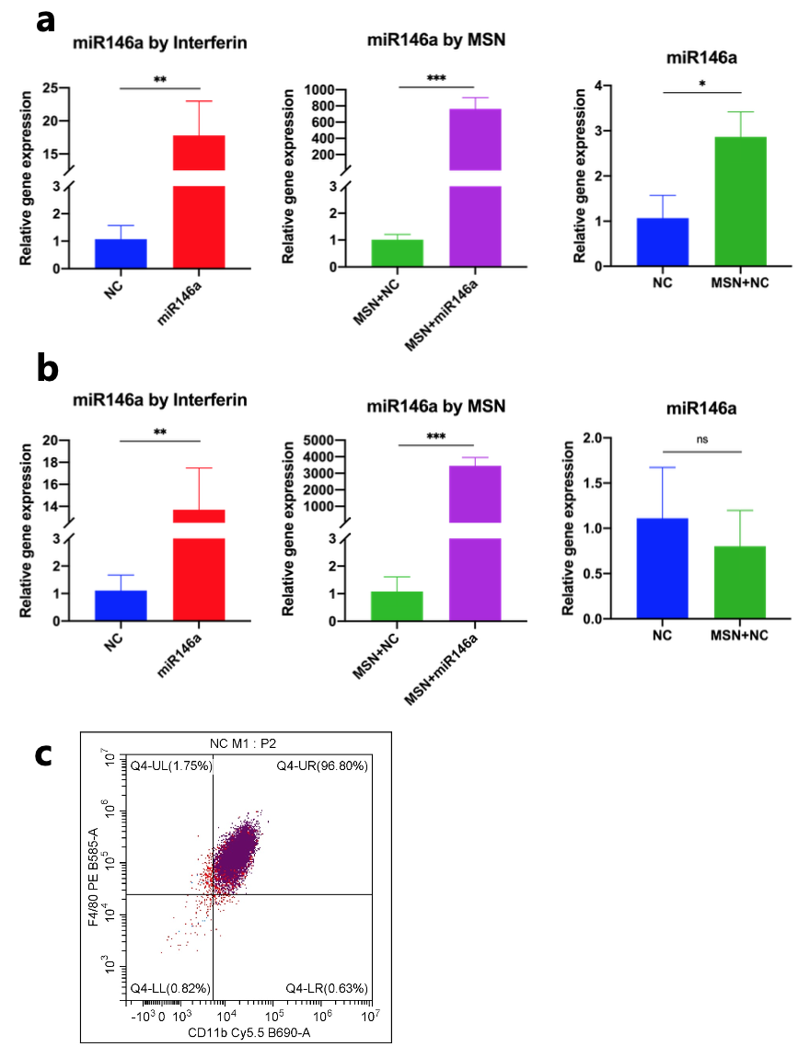

Fig. S1 miR146a transfection efficiancy of MSN and purity of mouse BMMs. a, b The levels of miR146a after transfection by Interferin or MSN as well as the endogenous miR146a expression in hDPSCs after 7 d osteogenic culture (a) and in BMMs after 24 h LPS stimulation (b). c Flow cytometry of mouse macrophage in BMMs as F4/80^{high} and CD11b^{high} cells (c). * P<0.05, ** P<0.01, *** P<0.001.

