Appendix A
Table A1
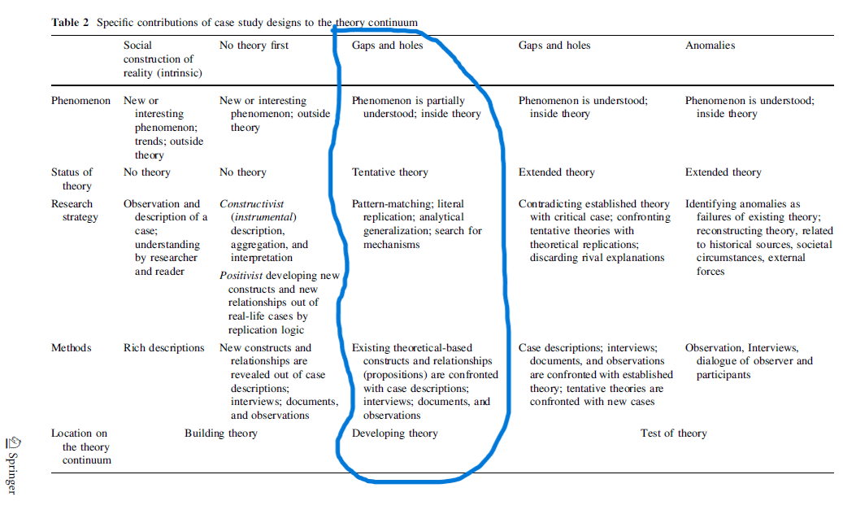

Appendix B
Figure B1

Figure B2
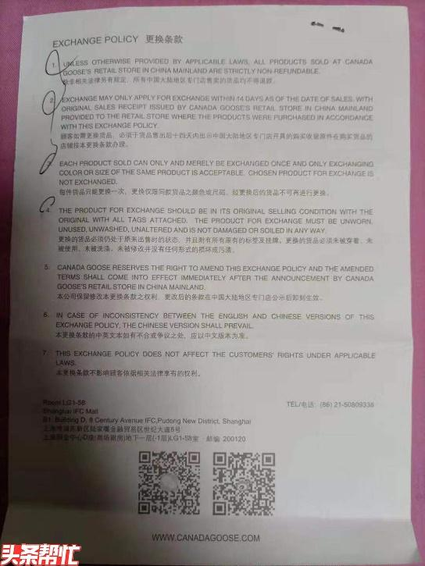

Figure B3


Figure B4

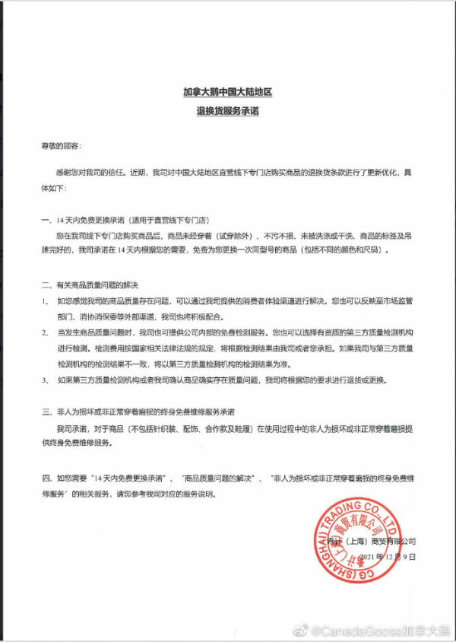

Appendix C
Figure C1
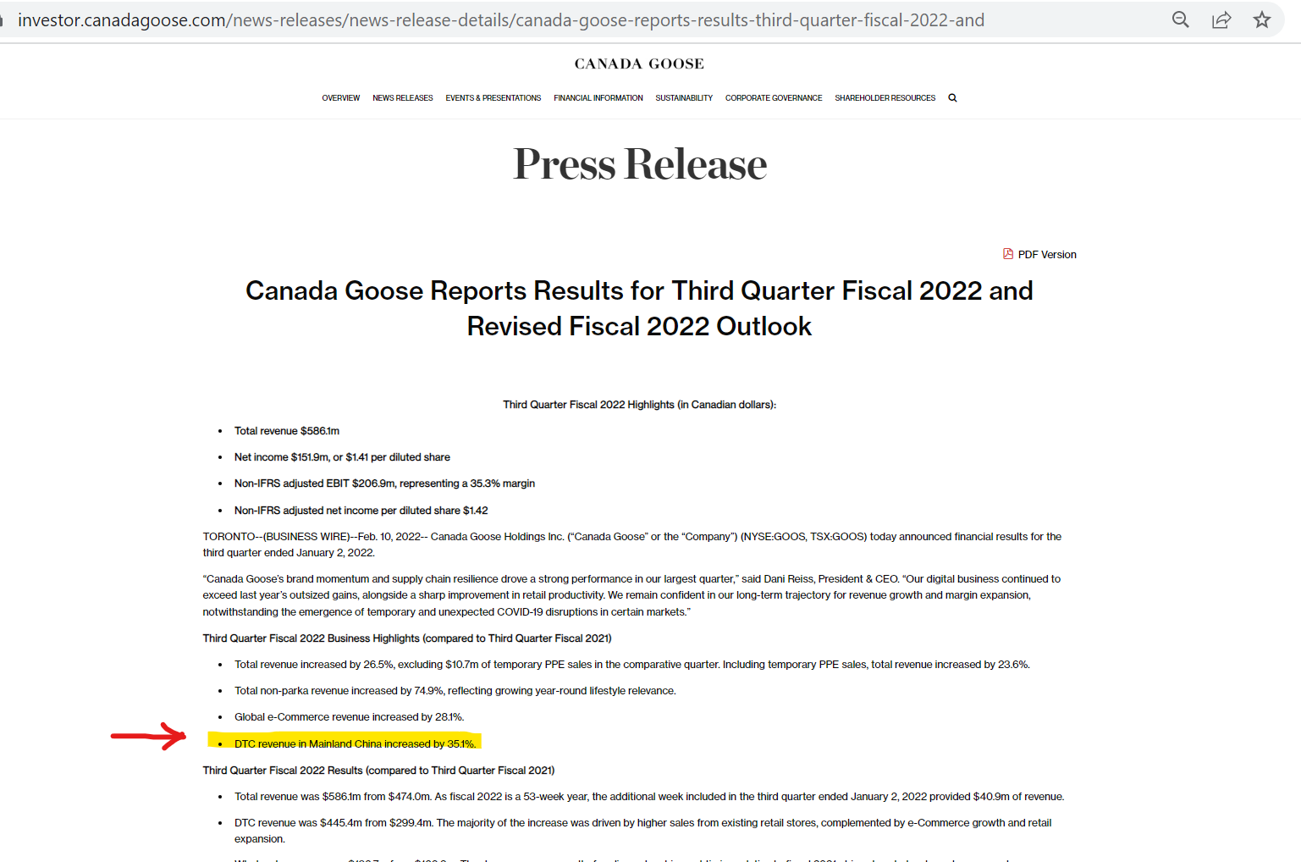
Figure C2

Figure C3
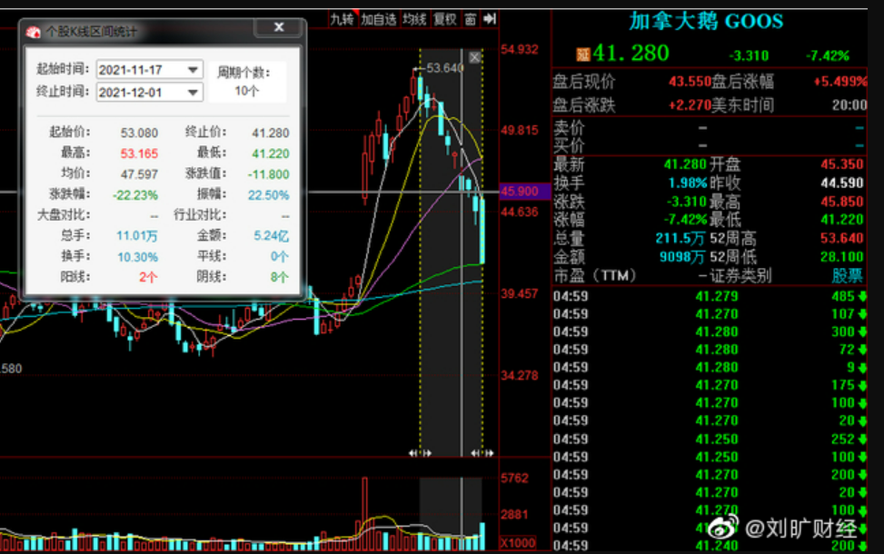
Figure C4
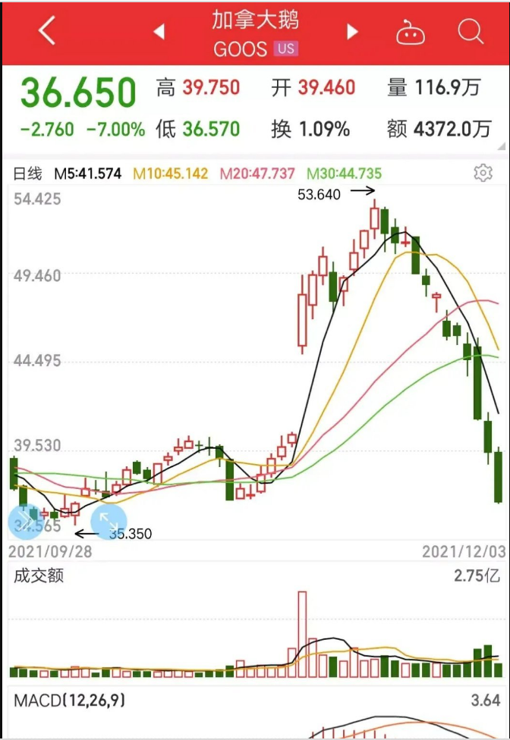

Appendix D
Figure D1
(Source: FORM 20-F, Canada Goose, filed with UNITED STATES SECURITIES AND EXCHANGE COMMISSION Washington, D.C. 20549, For the Year ended April 2022)


Appendix E
(December 2018)
Figure E1.


Figure E2.

Figure E3


Appendix F
(Coding Scheme)

Figure F1: Coding Scheme- Names for the initial codes

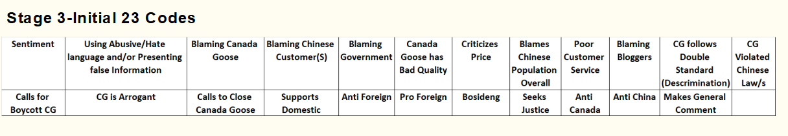
Figure F2: Coding Scheme- Code Definitions

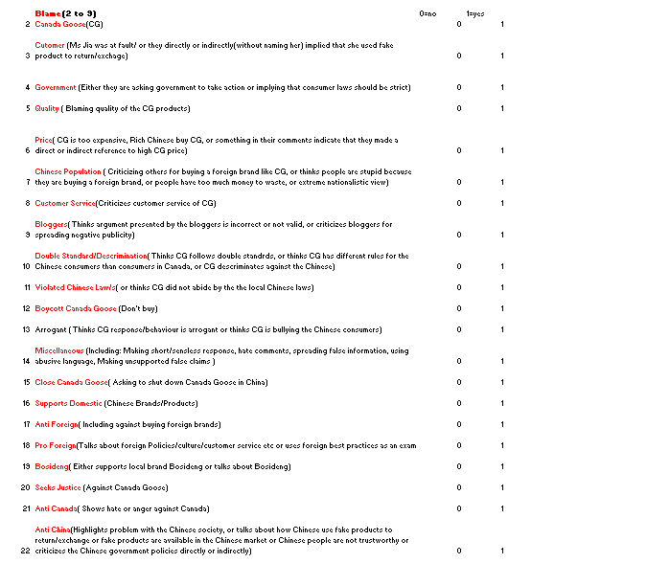

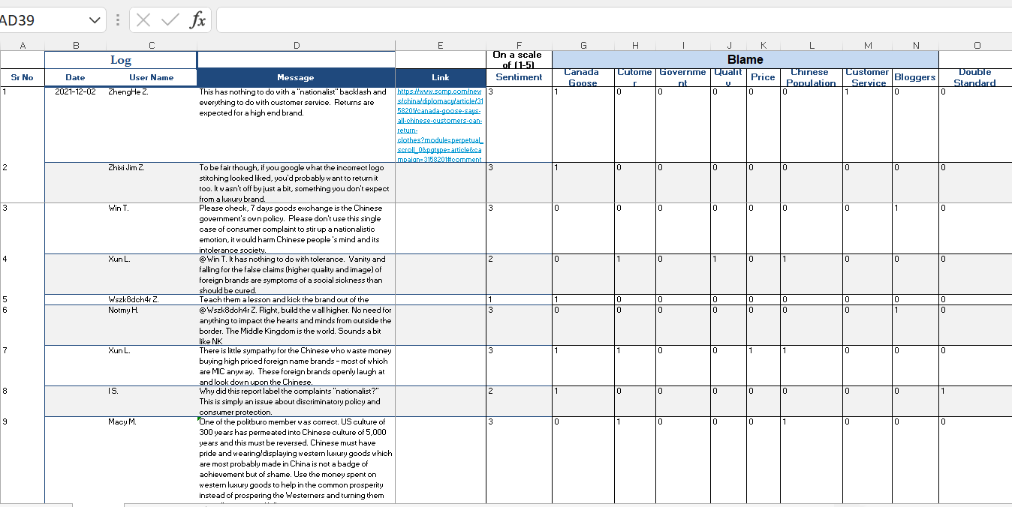
Figure F3: Coding Scheme- Coded Sample

Figure F4. Coding Scheme- Example of excluded material

Figure F5. Coding Scheme- Example of included material



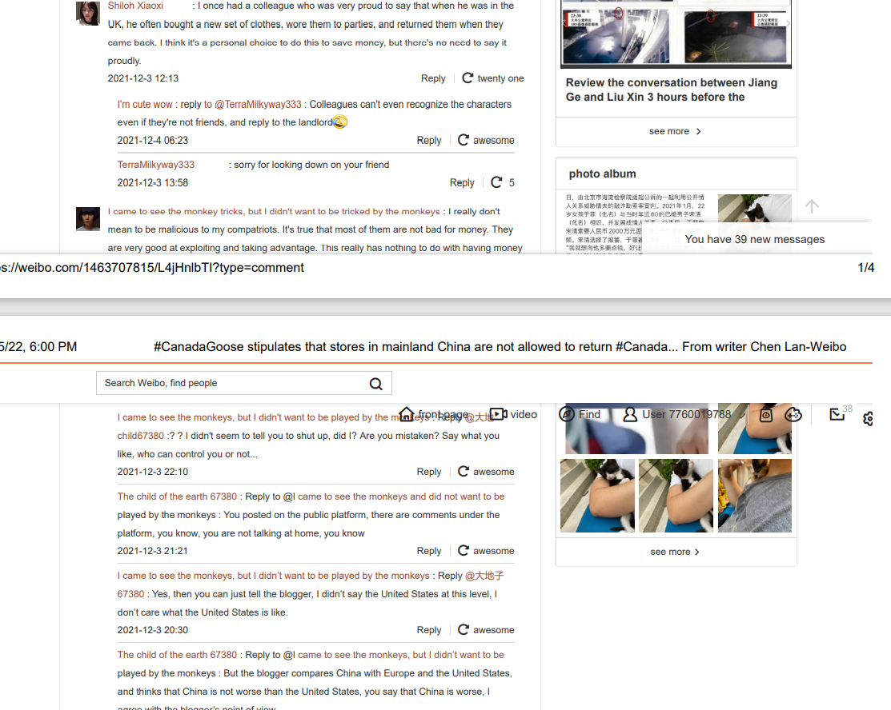

Figure F6: Coding Scheme- How to identify a theme & Perform Analysis
Strategy of analysis
Based not on a formal coding procedure, but more on direct interpretation of the research materials
  - Interested in the themes, categories, activities and patterns that I have find out and extracted from the natural variation of the empirical data, not from a pre-given theoretical framework
  - More inductive-oriented strategy of case material analysis
  - Theoretical concepts will be used to sensitise empirical data to give ‘a general sense of reference’ into the analysis
  - Sensitising concepts- Using abductive logic theoretical concepts from prior research will be used to describe and analyse the central organising features of empirical data and the meanings invested in them.
(Eriksson & Kovalainen, 2008)

Coding Scheme- Analysis
  - Pattern matching- Finding patterns from empirical data and comparing them with the propositions pre-developed based on existing theory
  - Time-series analysis- It focuses on detailed tracing of events over time. Building chronologies

Appendix G

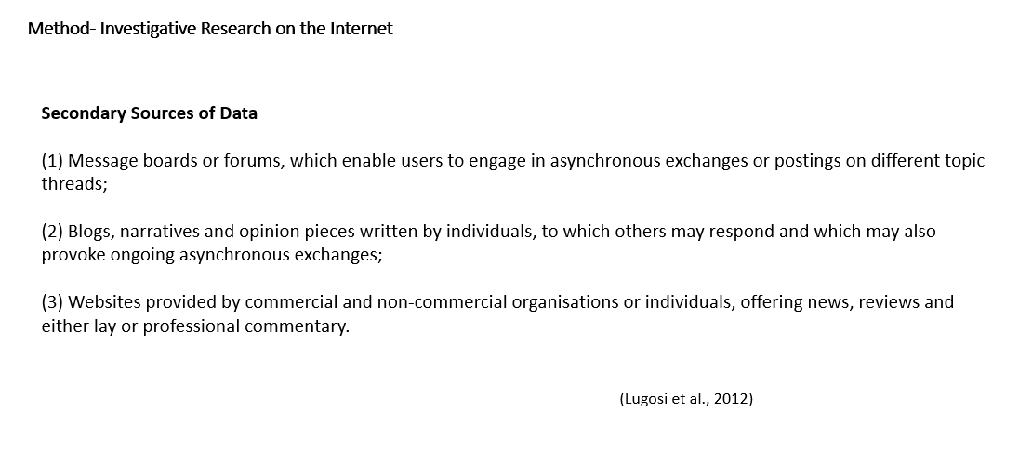

Appendix H
Figure H1
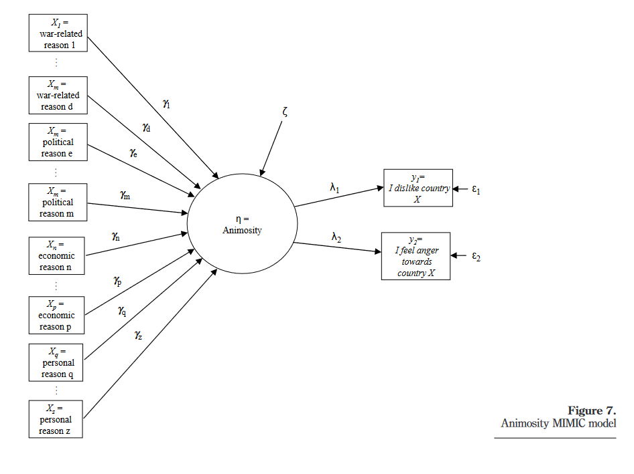
(Riefler & Diamantopoulos, 2007)

