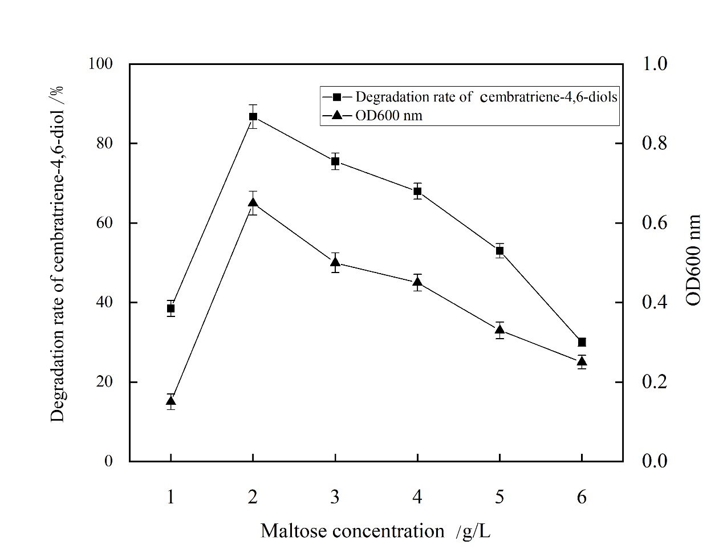Tab S1. Effect of different concentrations of maltose on cembratriene-4,6-diol degradation rate and OD_{600 nm}.

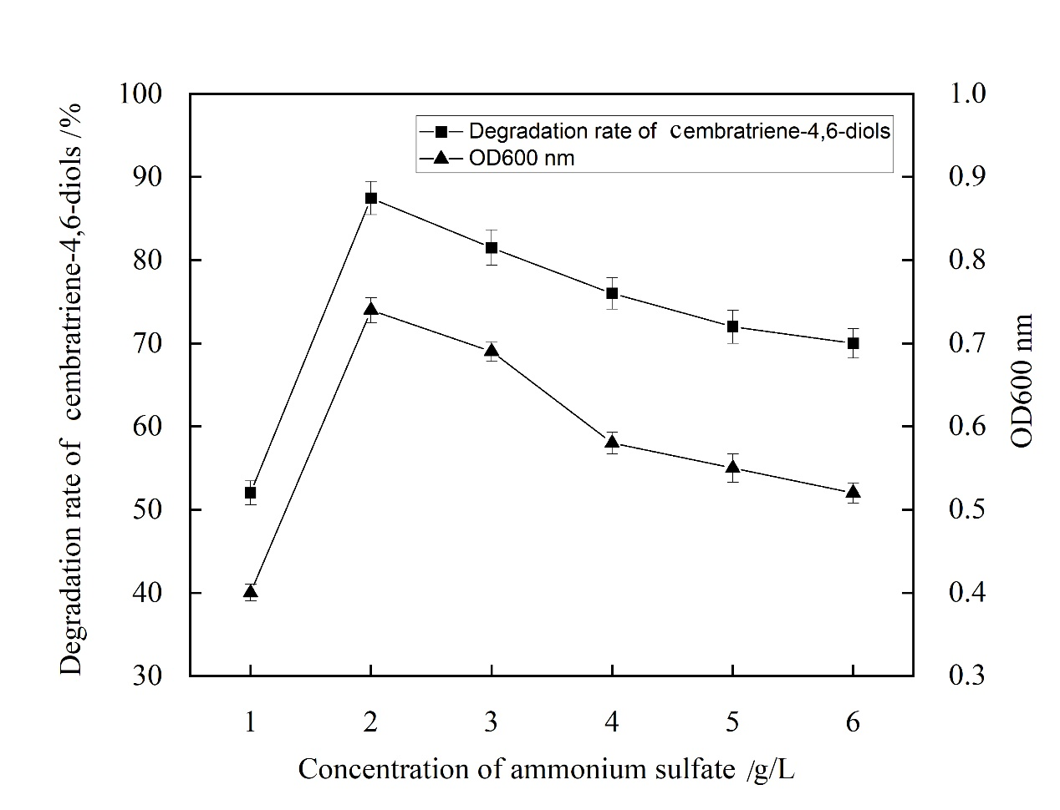
Tab S2. Effect of different concentrations of ammonium sulphate on the cembratriene-4,6-diol degradation rate and OD_{600nm}.

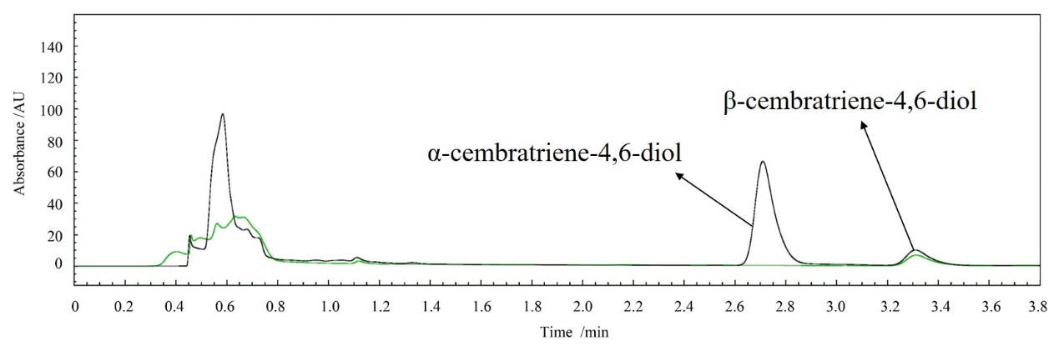
Tab S3. Comparison between membrane protease and blank.

