Supplementary Information
Metabolic and cell cycle shift induced by the deletion of Dnm1l attenuates the dissolution of pluripotency in mouse embryonic stem cells

Bong Jong Seoª, Seung Bin Naª, Joonhyuk Choiª, Byeongyong Ahnª, Omer Habib^{b}, Chankyu Parkª, Kwonho Hongª, and Jeong Tae Do^{a, *}

ªDepartment of Stem Cell and Regenerative Biotechnology, Konkuk Institute of Technology, Konkuk University, Seoul 05029, Republic of Korea
^{b}Department of Chemistry, Hanyang University, Seoul 04763, Republic of Korea

*Correspondence should be addressed to J.T. Do
E-mail: dojt@konkuk.ac.kr
Tel: 82-2-450-3673, Fax: 82-2-455-1044

Supplementary Figure 1. (A) Information regarding the mutated sequence of the targeted region in Dnm1l knockout embryonic stem cells (ESC line) (red; protospacer adjacent motif (PAM) sequence, blue; guide RNA target sequence, orange; inserted sequences, light gray; deleted sequences, gray background; targeted sequence). (B) Whole genome sequencing result representing on-target effects (red square; on-target site). (C) Whole genome sequencing results representing off-target effects (red square; off-target sites).
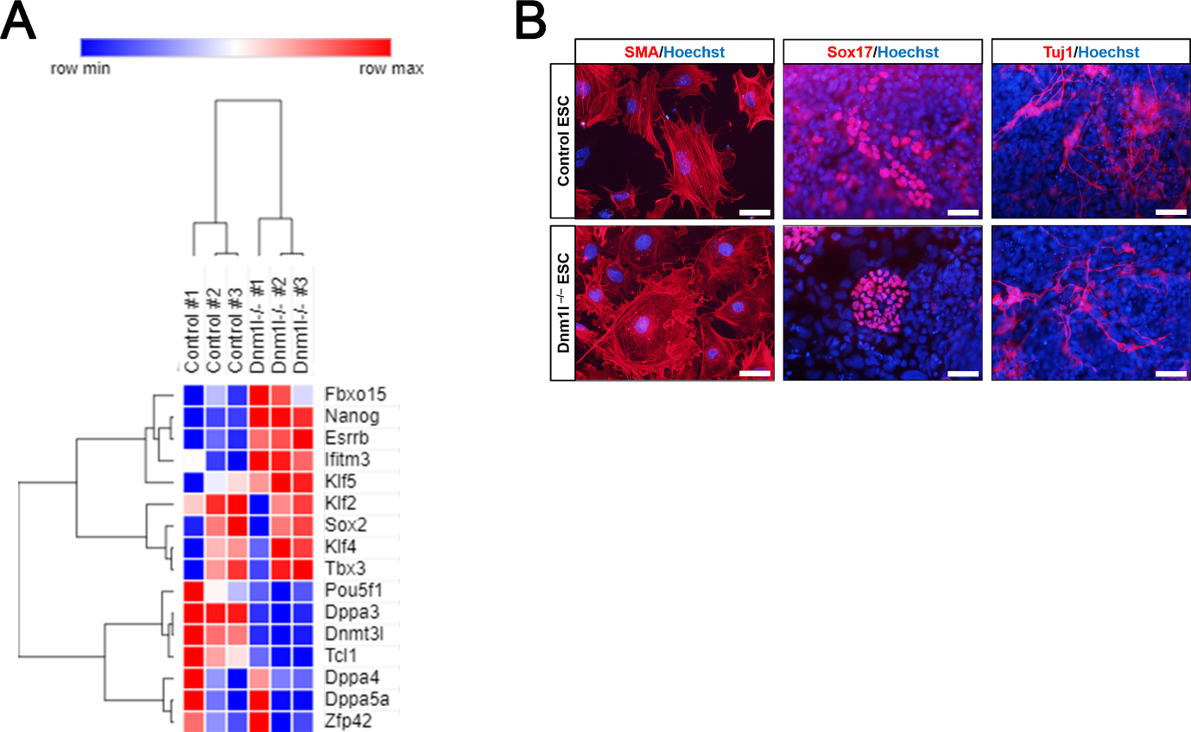
Supplementary Figure 2. (A) Heatmap of pluripotent genes expression patterns in control and Dnm1l^{-/-} ESCs. (B) In vitro differentiation via embryoid body formation in control and Dnm1l^{-/-} ESCs. All ESC lines could differentiate into mesoderm (smooth muscle actin, SMA), endoderm (Sox17), and ectoderm (neuron-specific class III beta-tubulin, Tuj1) lineages. Scale bars: 50 µm.

Supplementary Figure 3. (A) Measurement of the energy phenotype in control and Dnm1l^{-/-} embryonic stem cells (ESCs). The empty square represents the basal cell state. The filled square represents the cell state response to oxygen stress. (B) Direct measurement of ATP production in control and Dnm1l^{-/-} ESCs. An unpaired t-test: *p < 0.05.

Supplementary Figure 4. (A) Representative image of control embryonic stem cells (ESCs) observed after 3 days of cell expansion in mES medium with RO-3306 (10 µM) or ABT-751 (500 nM). Scale bars: 200 µm. (B) Representative image of control ESCs observed after 3 days of cell expansion in mES medium with various concentrations of dichloroacetate (DCA) stained with dichlorofluorescin diacetate (DCF-DA).

Supplementary Figure 5. Gene ontology and pathway analyses of differentially expressed gene (DEG) downregulated between control and Dnm1l^{-/-} ESCs.

