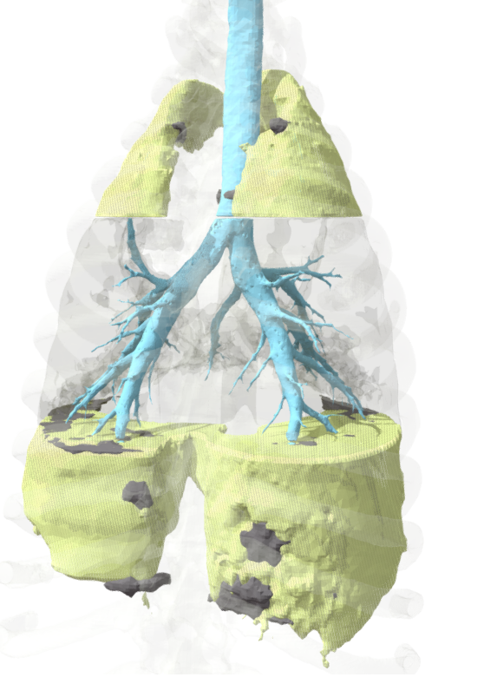
Supplementary Figure. Lung image reconstruction from a representative pig. The portion of lung included in the EIT belt is shown as transparent tissue.

