SUPPLEMENTARY INFORMATION

BONE CHAR: SYNTHESIS, CHARACTERIZATION AND AGRONOMIC APPLICATION AS AN ALTERNATIVE SOURCE OF PHOSPHORUS

Table 1 - Soil pH as a function of applied rates of P (triple superphosphate, bone char, and Bayóvar) after the first and second cultivation.
Source | Rate of phosphorus (mg dm⁻³)
Source | 0 | 25 | 50 | 100 | 200
Triple superphosphate  Bayóvar  Bone char  Triple superphosphate  Bayóvar  Bone char | Soil pH after the first cultivation
 | 4.53  4.58  4.75 | 4.72  4.89  4.87 | 4.57  4.58  4.44 | 4.81  4.68  4.63 | 5.13  5.10  5.11
 | Soil pH after the second cultivation
 | 4.27  4.41  4.41 | 4.47  4.49  4.45 | 4.58  4.67  4.66 | 4.87  4.95  4.84 | 5.04  5.09  5.13
The results of the soil pH value were statistically equal (p < 0.01) for sources, rates and interaction between the sources and rates.

Table 2 - Soil available Ca as a function of applied rates of P (triple superphosphate, bone char, and Bayóvar) after the first and second cultivation, and total cultivation.
Source | Rate of P (mg dm⁻³)
Source | 0 | 25 | 50 | 100 | 200
Triple superphosphate  Bayóvar  Bone char  Triple superphosphate  Bayóvar  Bone char  Triple superphosphate  Bayóvar  Bone char | Soil available Ca after the first cultivation (cmol_{c} dm⁻³)
 | 6.91  6.97  6.73 | 6.57  7.57  7.03 | 6.77  7.07  7.24 | 6.20  7.58  6.86 | 8.24  8.63  8.09
 | Soil available Ca after the second cultivation (cmol_{c} dm⁻³)
 | 5.36  5.81  4.45 | 5.33  4.88  4.62 | 4.27  4.27  4.51 | 4.43  4.84  4.48 | 4.64  5.08  4.84
 | Total soil available Ca (cmol_{c} dm⁻³)
 | 12.26  12.78  11.18 | 11.90  12.44  11.64 | 11.04  11.34  11.75 | 10.63  12.42  11.34 | 12.87  13.70  12.93

Fig. 1 Shoot Ca uptake as a function of P rates as triple superphosphate, bone char, and Bayóvar of corn cultivation. *, and ** Significant at p < 0.05, and p < 0.01 by t test, respectively

Fig. 2 Shoot Ca uptake as a function of P rates as triple superphosphate, bone char, and Bayóvar of black oat cultivation
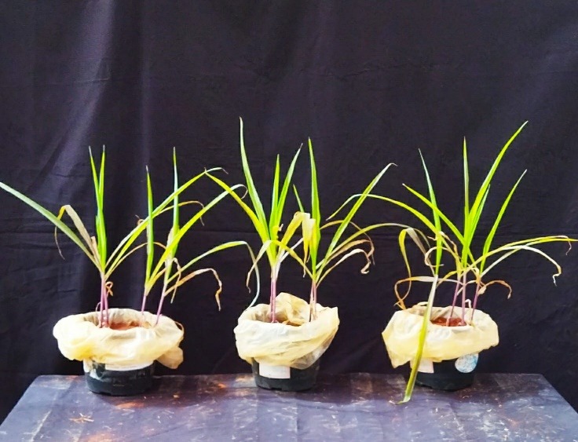  (a) | 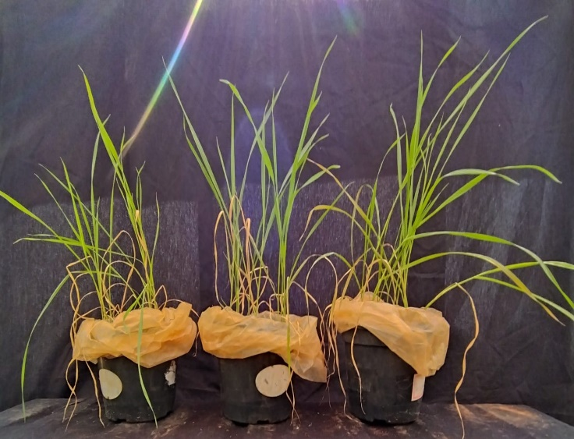  (e)
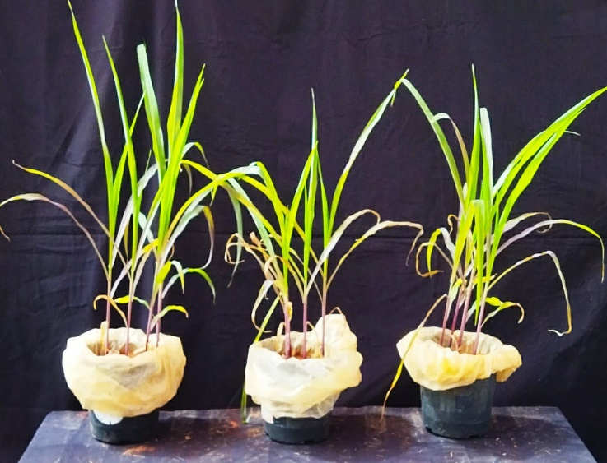  (b) | 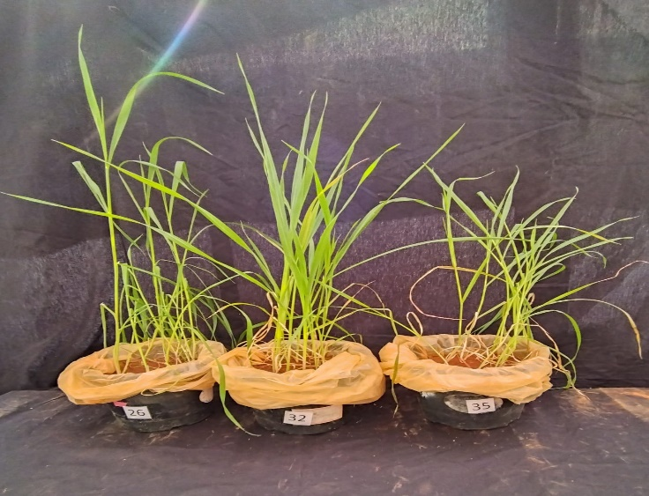  (f)
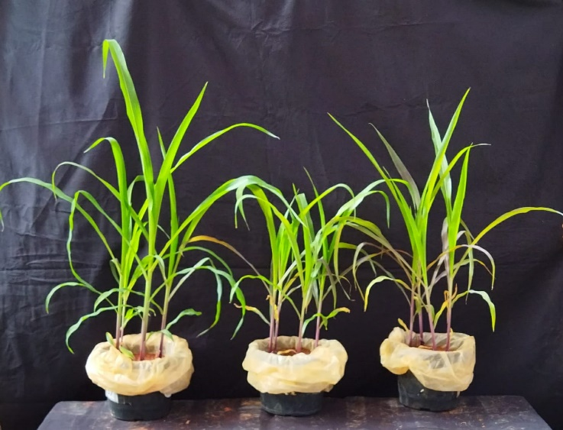  (c) | 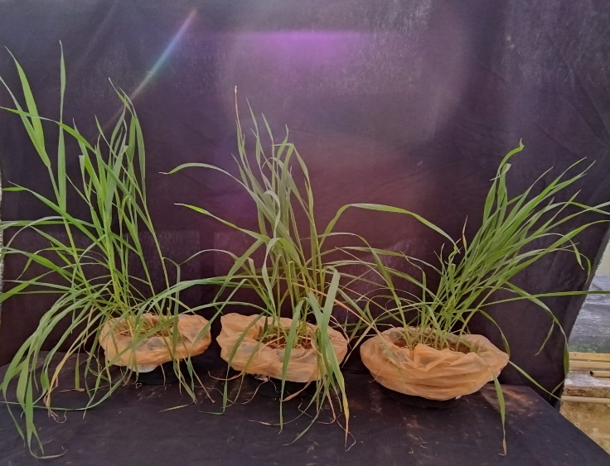  (g)
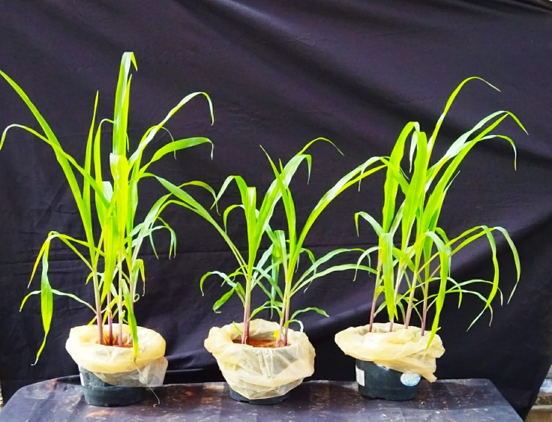  (d) | 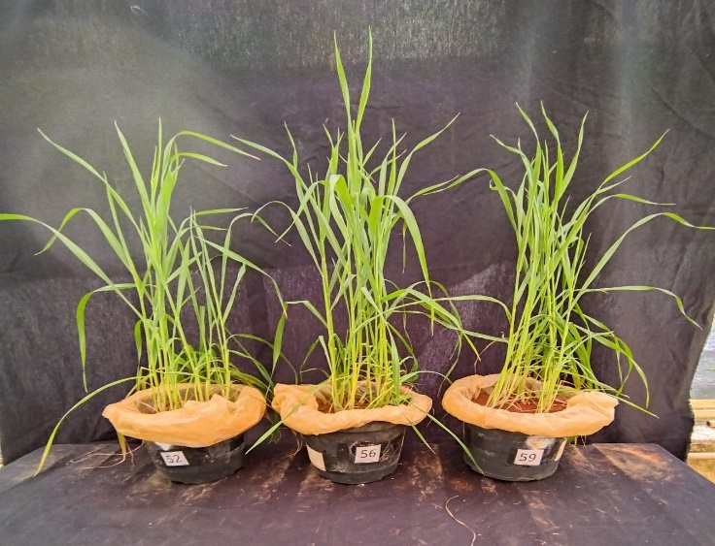  (h)
Fig. 3 Response of the maize (a, b, c, and d) and black oat (e, f, g, and h) plants as a function of the applied P rates: 25 mg dm⁻³ of P (a and e), 50 mg dm⁻³ of P (b and f), 100 mg dm⁻³ of P (c and g), and 200 mg dm⁻³ of P (d and h). From left to right, the pots correspond to triple superphosphate, Bayóvar, and bone char sources.
(a)
(b)

