Supplemental

Supplemental Table 1. Number of individuals include in genetic association analyses by cohort and ancestry group
Cohort |  | Ancestry groups
Cohort | AFR | AMR | EAS | EUR | SAS
Geisinger Health System MyCode | 4821 | 1967 | 436 | 157129 | -
Indiana University School of Medicine | 1312 | - | - | 3424 | -
Malmö Diet and Cancer Study | - | - | - | 28935 | -
Mount Sinai BioMe Biobank | 11746 | 3899 | - | 10390 | -
U.K. Biobank | 9083 | 611 | 2213 | 430825 | 10340
Penn Medicine Biobank | 10869 | 682 | 656 | 28515 | 533
AFR, African; AMR, Admixed American; EAS, East Asian; EUR, European; SAS, South Asia.

Supplemental Table 2. NPR1 protein-altering variants identified as presumed loss- or gain-of-function based on their directional association with systolic or diastolic blood pressure
Mask | Variant |  | Systolic blood pressure |  |  | Diastolic blood pressure
Mask | Variant | N (Ref/Het/Alt) | Beta SD (95% CI) | P-value | N (Ref/Het/Alt) | Beta SD (95% CI) | P-value
LOF | 1:153679356:G:A | 277309/11/0 | 0.80 (0.28 to 1.31) | 0.0024 | 277123/11/0 | 0.49 (−0.06 to 1.05) | 0.082
 | 1:153686154:G:A | 208328/18/0 | 0.55 (0.14 to 0.95) | 0.0084 | 208328/18/0 | 0.31 (−0.12 to 0.7)] | 0.157
 | 1:153686175:G:A | 297370/35/0 | 0.35 (0.06 to 0.64) | 0.016 | 297184/35/0 | 0.41 (0.10 to 0.72) | 0.0088
 | 1:153688056:T:A* | 293712/147/0 | 0.37 (0.23 to 0.51) | 3.10E-07 | 293526/147/0 | 0.31 (0.16 to 0.46) | 5.30E-05
 | 1:153688208:C:T | 288459/64/0 | 0.34 (0.13 to 0.55) | 0.0019 | 288273/64/0 | 0.27 (0.04 to 0.50) | 0.02
 | 1:153689947:G:A* | 308442/9891/97 | 0.06 (0.05 to 0.08) | 1.2E-13 | 308252/9880/97 | 0.05 (0.04 to 0.07) | 9.8e-09
 | 1:153690280:C:T | 277308/12/0 | 0.58 (0.09 to 1.07) | 0.021 | 277122/12/0 | 0.59 (0.06 to 1.12) | 0.028
 | 1:153693174:C:T* | 307977/477/0 | 0.12 (0.05 to 0.20) | 0.0016 | 307775/478/0 | 0.12 (0.03 to 0.20) | 0.0064
 | 1:153693367:C:T | 292857/42/0 | 0.34 (0.08 to 0.61) | 0.011 | 292671/42/0 | 0.19 (−0.09 to 0.47) | 0.188
GOF | 1:153683428:G:A | 11962/11/0 | −0.60 (−1.11 to −0.10) | 0.02 | 11948/11/0 | −0.70 (−1.24 to −0.16) | 0.011
 | 1:153685067:C:T | 300752/23/0 | −0.39 (−0.74 to −0.03) | 0.032 | 300564/23/0 | −0.28 (−0.66 to 0.10) | 0.151
 | 1:153685821:G:A** | 315707/2169/2 | −0.07 (−0.10 to −0.03) | 0.00031 | 315507/2168/2 | −0.07 (−0.11 to −0.03) | 0.00035
 | 1:153686205:T:C | 288466/60/0 | −0.23 (−0.45 to −0.01) | 0.041 | 288280/60/0 | −0.12 (−0.35 to 0.12) | 0.323
 | 1:153686649:C:T | 292706/30/0 | −0.32 (−0.63 to −0.01) | 0.046 | 292520/30/0 | −0.33 (−0.67 to 0.00) | 0.051
*Previously identified as LOF¹. **Previously identified as GOF¹.
Alt, alternative allele; CI, confidence interval; Freq, frequency; GOF, gain-of-function; Het, heterozygous allele; LOF, loss-of-function; Ref, reference allele; SD, standard deviation.

Supplemental Table 3. Summary of kinetic binding parameters for the interaction of REGN5381 with NPR1 at pH 7.4
Protein injected over surface-captured REGN5381 | Kinetic binding parameters (37°C)
Protein injected over surface-captured REGN5381 | k_{a} (M⁻¹s⁻¹) | k_{d} (s⁻¹) | K_{D} (M) | t_{½} (min)
hNPR1.mmH | 5.92E+04 | 4.15E-04 | 7.00E-09 | 28
hNPR1.mmH + 10xANP | 5.19E+04 | 1.74E-04 | 3.35E-09 | 66
hNPR1.mmH + 10xBNP | 5.65E+04 | 3.13E-04 | 5.53E-09 | 37
mfNPR1.mmH | 6.08E+04 | 3.87E-04 | 6.36E-09 | 30
cNPR1.mmH | 4.11E+04 | 2.40E-04 | 5.85E-07 | 0.5
mNPR1.mmH | NB
Surface plasmon resonance-binding assays were performed by injecting varying concentrations of NPR1 proteins over captured REGN5381 sensor surfaces at pH 7.4. hNPR1 was tested alone and following preincubation with 10xANP and 10xBNP.
ANP, atrial natriuretic peptide; BNP, brain natriuretic peptide; cNPR1, dog NPR1; hNPR1, human NPR1; k_{a}, association rate constant; k_{d}, dissociation rate constant; K_{D}, equilibrium dissociation constant; mfNPR1, cynomolgus monkey NPR1; mmH, C-terminal myc-myc-hexahistidine tag; mNPR1, mouse NPR1; NB, no detectable binding observed; NPR1, natriuretic peptide receptor 1; NT, not tested; t_{½}, dissociative half-life.

Supplemental Table 4. Definition of heart failure for genetic association analyses
Data source | Definition of heart failure cases
ICD-9 (GHS only) | 428 (Heart failure)  40201 (Malignant hypertensive heart disease with heart failure)  40211 (Benign hypertensive heart disease with heart failure)  40291 (Unspecified hypertensive heart disease with heart failure)
ICD-10 codes (all cohorts) | I50 (Heart failure)  I110 (Hypertensive heart disease with heart failure)  I130 (Hypertensive heart and chronic kidney disease with heart failure and stage 1 through stage 4 chronic kidney disease, or unspecified chronic kidney disease)  I132 (Hypertensive heart and chronic kidney disease with heart failure and with stage 5 chronic kidney disease, or end stage renal disease)
OPCS4 procedure codes (UKB only) | K733 (Renewal of intravenous biventricular cardiac pacemaker)  K607 (Implantation of intravenous biventricular cardiac pacemaker system)  K617 (Implantation of biventricular cardiac pacemaker system)  K596 (Implantation of cardioverter defibrillator using three electrode leads)  K597 (Renewal of cardioverter defibrillator using three electrode leads)
Self-report by interview (UKB only) | 1076 (heart failure/pulmonary oedema)
NOMESCO v.1 (MDCS only) | FQA (Transplantation of heart)  FPE26 (Implantation of transvenous cardiac pacemaker with biventricular electrodes)  FPG36 (Implantation of transvenous cardioverter-defibrillator with generator and with biventricular electrodes)
NOMESCO v.6 (MDCS only) | 3085 (Heart transplant)  0034 (Left ventricle assist device or right ventricle assist device)
ICD10 indicates the 10th revision of the International Statistical Classification of Diseases and Related Health Problems, corresponding ICD9 codes were mapped to ICD10 when possible; OPCS4 indicates Office of Population Censuses and Surveys (OPCS) Classification of Interventions and Procedures version 4; NOMESCO indicates Nordic Medico-Statistical Committee procedure codes.
GHS, Geisinger Health System MyCode; ICD, International Classification of Diseases; MDCS, Malmö Diet and Cancer Study; UKB, U.K. Biobank.

Supplemental Figure 1. REGN5381 bound and activated dog cNPR1-mediated calcium mobilization.
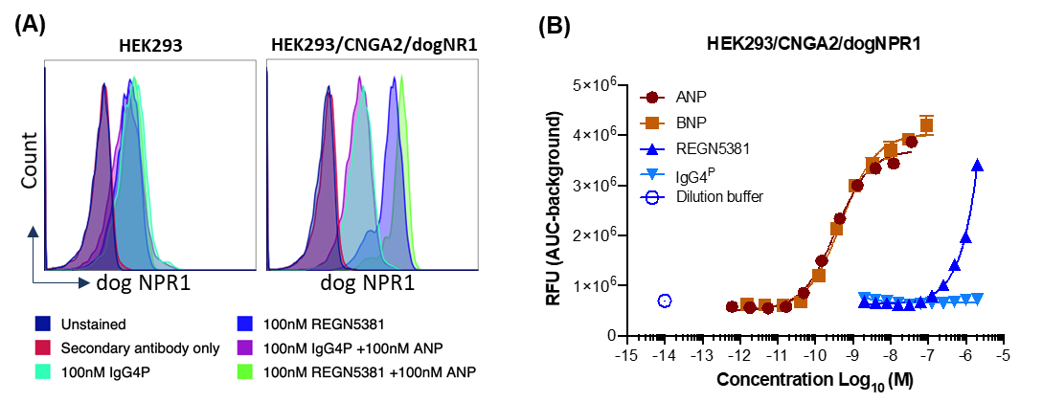
A, Specific binding of REGN5381 to cNPR1 was tested with HEK293 or HEK293/CNGA2/cNPR1 cells at 100 nM in the absence or presence of 100 nM ANP by flow cytometry. B, Dog cNPR1 activity was evaluated with HEK293/CNGA2/cNPR1 cells that were treated with ANP (dark brown solid circles), BNP (brown solid squares), REGN5381 (blue solid triangles), IgG4^{P} (light blue triangles) or control (dilution buffer, blue open circles) by calcium flux assay. Open symbols indicate assay conditions when no test article was added, and closed symbols indicate assay conditions when the test article was added in a range of concentrations.
ANP, atrial natriuretic peptide; AUC, area under the curve; BNP, brain natriuretic peptide; CNGA2, cyclic nucleotide gated channel alpha 2; cNPR1, dog NPR1; IgG4^{P}, non-binding immunoglobulin G control; NPR1, natriuretic peptide receptor 1; RFU, relative fluorescence units.

Supplemental Figure 2. REGN5381 activated human NPR1 mediated cGMP production.
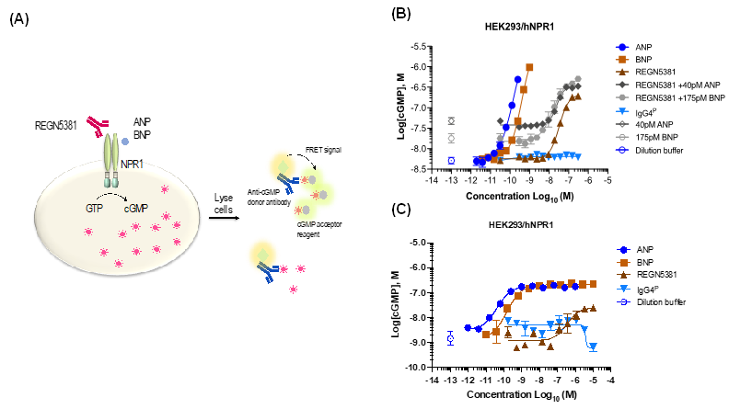
A, Schematic diagram of cGMP accumulation assay measuring hNPR1 activation induced cGMP production. B,C, The activity of REGN5381 and ligand at hNPR1 was measured with HEK293/hNPR1 cells using different conditions due to the limit of quantitation for ligand at high concentrations. B, REGN5381 activated hNPR1 in the absence or presence of ligand (ANP or BNP) as measured by cGMP accumulation assays with HEK293/hNPR1 cells. Activation at higher ligand concentrations was seen, but cGMP level was not calculated due to the limit of quantitation. C, The full activity of ligand was evaluated with optimized conditions, where REGN5381 exhibited partial agonism compared to the ligand. Open symbols indicate assay conditions when no test article was added, and closed symbols indicate assay conditions when the test article was added in a range of concentrations. Key: blue solid circles, ANP; light brown solid square, BNP; brown solid triangle, REGN5381; dark grey solid diamond, REGN5381 + 40 pM ANP; grey solid circle, REGN5381 + 150 pM BNP; blue solid triangle, IgG4P; dark grey open diamond, 40 pM ANP; grey open circle, 150 pM BNP; blue open circle, dilution buffer control.
ANP, atrial natriuretic peptide; BNP, brain natriuretic peptide; cGMP, cyclic guanosine monophosphate; FRET, fluorescence resonance energy transfer; GTP, guanosine triphosphate; hNPR1, human NPR1; IgG4^{P}, non-binding immunoglobulin G control; NPR1, natriuretic peptide receptor 1.

Supplemental Figure 3. Cryo-electron microscopy structure of antibody-bound NPR1 suggests that REGN5381 is an allosteric activator.
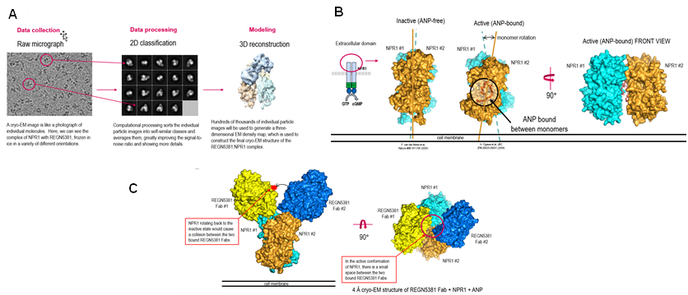
A, The process by which a raw micrograph is processed to result in a 3D reconstruction of the structure. B, Structure of the NPR1 dimers (light blue and gold shading) in the inactive (ANP-free) and active (ANP-bound) conformation (ANP shown in dark orange shading). C, Structure of two REGN5381 Fab domains (yellow and dark blue shading) bound to an NPR1 dimer (light blue and gold shading).
ANP, atrial natriuretic peptide; Fab, antigen-binding fragment; NPR1, natriuretic peptide receptor.

Supplemental Figure 4. Molar mass and distribution of REGN5381:NPR1:ANP complexes analyzed by asymmetric flow field-flow fractionation coupled to multi-angle light scattering (A4F-MALS).
A.
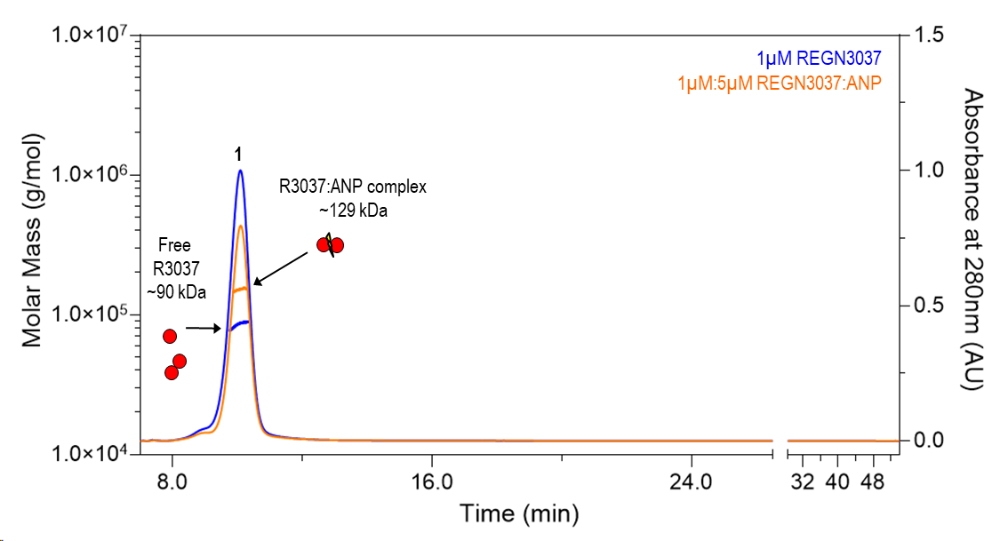
B.
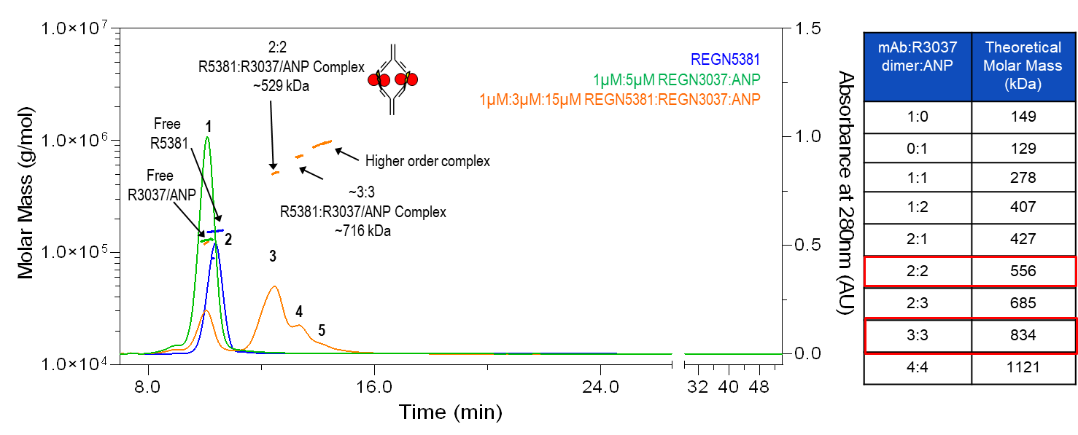
Relative UV absorbance at 215 nm as a function of retention time is shown for each sample and the measured molar masses of resolved peaks are indicated. A, The A4F-MALS chromatograph of NPR1 (blue), and 1 μM:5 μM NPR1:ANP molar ratio complex (orange). It demonstrates that NPR1 might be weakly associated, ANP binding caused dimerization of the hNPR1. B, Representative fractograms of free REGN5381 (blue), free hNPR1/ANP dimer (green), and complexes of REGN5381, hNPR1, and ANP combined in a 1 μM:3 μM:15 μM molar ratio (orange) are overlaid. Peaks 1 and 2 correspond to free hNPR1/ANP dimer ( ~129 kDa) and free REGN5381 (~149 kDa), while peaks 3–5 correspond to REGN5381:NPR1/ANP complexes. Based on the calculated molar masses of the individual components, peak 3 likely corresponds to a 2:2 REGN5381:NPR1/ANP dimer complex, whereas peaks 4 and 5 likely represent higher order complexes comprised of at least 3 molecules of REGN5381 bound to three or more hNPR1/ANP dimers.
ANP, atrial natriuretic peptide; hNPR1, human natriuretic peptide receptor; NPR1, natriuretic peptide receptor.

Supplemental Figure 5. Effect of REGN5381 on blood pressure, pulse pressure, and heart rate in normotensive NPR1^{hu/hu} mice.
B.
A.
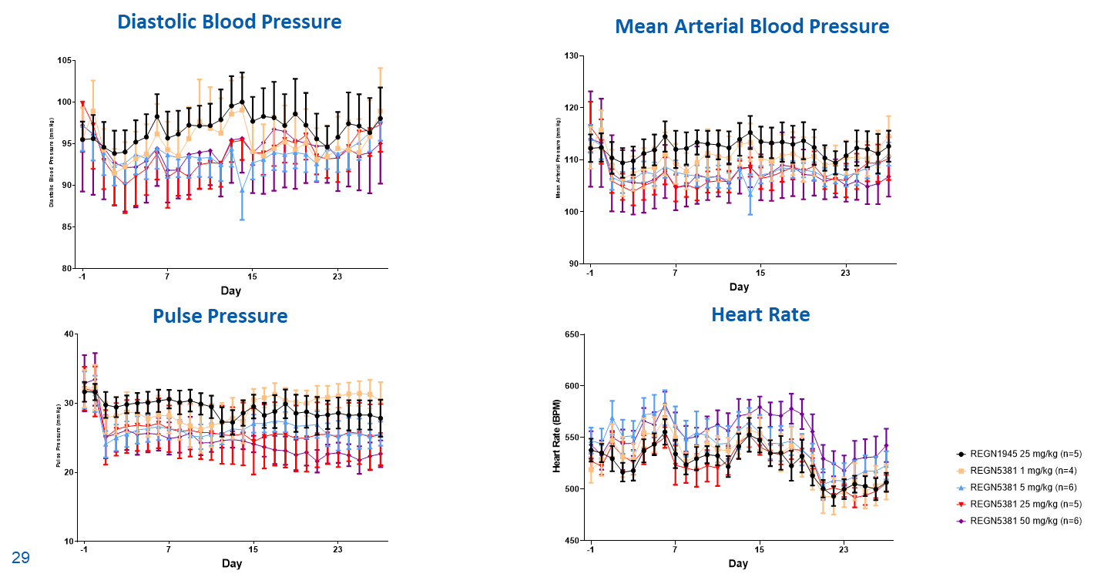
D.
C.
A, change in diastolic blood pressure. B, change in mean arterial blood pressure. C, change in pulse pressure. D, change in heart rate. Key: black circles, REGN1945 25 mg/kg (IgG4 isotype control; n = 5); yellow squares, REGN5381 1 mg/kg (n = 4); light blue triangles, REGN5381 5 mg/kg (n = 6); red triangles, REGN5381 25 mg/kg (n = 5); purple diamonds, REGN5381 50 mg/kg (n = 6).
Ig, immunoglobulin; NPR1, natriuretic peptide receptor; NPR1^{hu/hu}, NPR1 humanized.

Supplemental Figure 6. Hydrodynamic DNA delivery of ANP and BNP expression vectors in normotensive mice induced a sustained reduction in systolic blood pressure.
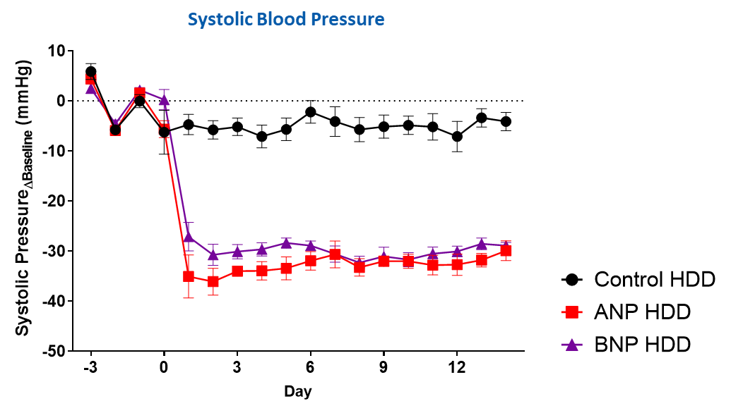
ANP and BNP overexpression resulted in systolic pressure reduction of over 30 mmHg. Key: black circles, control; red squares, ANP; purple triangles, BNP.
ANP, atrial natriuretic peptide; BNP, brain natriuretic peptide; HDD, hydrodynamic delivery.

Supplemental Figure 7. REGN5381 reduces systolic blood pressure similar to SOC, with additive effects observed upon combination with some but not all SOC therapies.
The reduction in systolic blood pressure was assessed in telemetered normotensive NPR1^{hu/hu} mice administered a single subcutaneous dose of REGN5381 either alone or in combination with SOC agents for the treatment of HF and hypertension at therapeutically relevant doses. (n=5-7 per treatment group; pooled placebo n=36).
ARNi, angiotensin receptor/neprilysin inhibitor; HF, heart failure; NPR1, natriuretic peptide receptor; NPR1^{hu/hu}, NPR1 humanized; PDE, phosphodiesterase; RAAS, renin-angiotensin-aldosterone system; SGLT2, sodium-glucose cotransporter-2; SOC, standard of care.

Supplemental Figure 8. A single dose of REGN5381 induced sustained blood pressure lowering in normotensive cynomolgus monkeys with decreased mean arterial pressure.
B.
A.
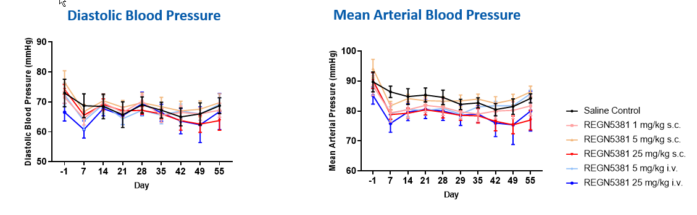
A, Change in diastolic blood pressure following administration of single-dose REGN5381. B, Change in mean arterial blood pressure following administration of single-dose REGN5381 in normotensive cynomolgus monkeys. Key: black line, saline control; pink line, subcutaneous REGN5381 1 mg/kg; red line, subcutaneous REGN5381 25 mg/kg; light blue line, intravenous REGN5381 5 mg/kg; dark blue link, intravenous REGN5381 25 mg/kg.
IV, intravenous; SC, subcutaneous.

Supplemental Figure 9. Both REGN5381 full-length antibody and Fab fragment activated human NPR1-mediated calcium mobilization.
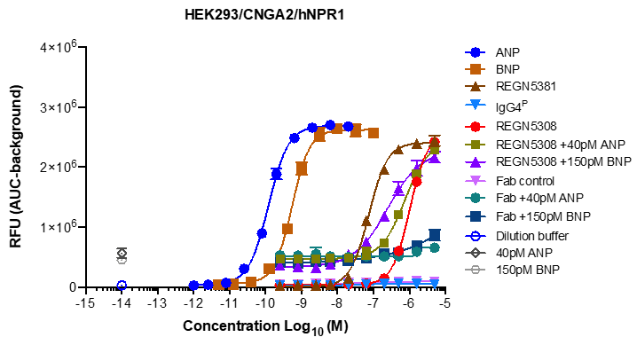
The ability of anti-NPR1 full antibody, REGN5381, or Fab fragment, REGN5308, to activate human NPR1 was tested with HEK293/CNGA2/hNPR1 cells as measured by calcium flux through CNGA2 channels. Open symbols indicate conditions when no test article was added, and closed symbols indicate conditions when the test article was added in a range of concentrations (blue solid circles, ANP; brown solid squares, BNP; dark brown solid triangles, REGN5381; light blue solid triangles, IgG4^{P}; red solid circles, REGN5308; green solid squares, REGN5308 + 40 pM ANP; purple solid triangles, REGN5308 + 150 pM BNP; pink solid triangles, Fab control; green solid circles, Fab + 40 pM ANP; dark blue solid squares, Fab + 150 pM BNP; open blue circles, dilution buffer; open dark grey diamonds, 40 pM ANP; open light grey circles, 150 pM BNP).
ANP, atrial natriuretic peptide; AUC, area under curve; BNP, brain natriuretic peptide; CNGA2, cyclic nucleotide gated channel alpha 2; IgG4^{P}, non-binding immunoglobulin G control; NPR1, natriuretic peptide receptor 1; RFU, relative fluorescence units.

Supplemental Text. Banner author list and contribution statements
Regeneron Genetics Center (RGC)
RGC management and leadership team
Goncalo Abecasis, PhD , Aris Baras, M.D. , Michael Cantor, M.D. , Giovanni Coppola, M.D., Andrew Deubler, M.S., Aris Economides, Ph.D., Luca A. Lotta, M.D., Ph.D., John D. Overton, Ph.D., Jeffrey G. Reid, Ph.D., Katherine Siminovitch, M.D., Alan Shuldiner, M.D.
Sequencing and lab operations
Christina Beechert, Caitlin Forsythe, M.S., Erin D. Fuller, Zhenhua Gu, M.S., Michael Lattari, Alexander Lopez, M.S., John D. Overton, Ph.D., Maria Sotiropoulos Padilla, M.S., Manasi Pradhan, M.S., Kia Manoochehri, B.S., Thomas D. Schleicher, M.S., Louis Widom, Sarah E. Wolf, M.S., Ricardo H. Ulloa, B.S.
Clinical informatics
Amelia Averitt, Ph.D., Nilanjana Banerjee, Ph.D., Michael Cantor, M.D., Dadong Li, Ph.D., Sameer Malhotra, M.D., Deepika Sharma, MHI, Jeffrey Staples, Ph.D.
Genome informatics
Xiaodong Bai, Ph.D., Suganthi Balasubramanian, Ph.D., Suying Bao, Ph.D., Boris Boutkov, Ph.D., Siying Chen, Ph.D., Gisu Eom, B.S., Lukas Habegger, Ph.D., Alicia Hawes, B.S., Shareef Khalid, Olga Krasheninina, M.S., Rouel Lanche, B.S., Adam J. Mansfield, B.A., Evan K. Maxwell, Ph.D., George Mitra, B.A., Mona Nafde, M.S., Sean O’Keeffe, Ph.D., Max Orelus, B.B.A., Razvan Panea, Ph.D., Tommy Polanco, B.A., Ayesha Rasool, M.S., Jeffrey G. Reid, Ph.D., William Salerno, Ph.D., Jeffrey C. Staples, Ph.D., Kathie Sun, Ph.D.
Analytical genomics and data science
Goncalo Abecasis, D.Phil., Joshua Backman, Ph.D., Amy Damask, Ph.D., Lee Dobbyn, Ph.D., Manuel Allen Revez Ferreira, Ph.D., Arkopravo Ghosh, M.S., Christopher Gillies, Ph.D., Lauren Gurski, B.S., Eric Jorgenson, Ph.D., Hyun Min Kang, Ph.D., Michael Kessler, Ph.D., Jack Kosmicki, Ph.D., Alexander Li, Ph.D., Nan Lin, Ph.D., Daren Liu, M.S., Adam Locke, Ph.D., Jonathan Marchini, Ph.D., Anthony Marcketta, M.S., Joelle Mbatchou, Ph.D., Arden Moscati, Ph.D., Charles Paulding, Ph.D., Carlo Sidore, Ph.D., Eli Stahl, Ph.D., Kyoko Watanabe, Ph.D., Bin Ye, Ph.D., Blair Zhang, Ph.D., Andrey Ziyatdinov, Ph.D.
Therapeutic area genetics
Ariane Ayer, B.S., Aysegul Guvenek, Ph.D., George Hindy, Ph.D., Giovanni Coppola, M.D., Jan Freudenberg, M.D., Jonas Bovijn M.D., Katherine Siminovitch, M.D., Kavita Praveen, Ph.D., Luca A. Lotta, M.D., Manav Kapoor, Ph.D., Mary Haas, Ph.D., Moeen Riaz, Ph.D., Niek Verweij, Ph.D., Olukayode Sosina, Ph.D., Parsa Akbari, Ph.D., Priyanka Nakka, Ph.D., Sahar Gelfman, Ph.D., Sujit Gokhale, B.E., Tanima De, Ph.D., Veera Rajagopal, Ph.D., Alan Shuldiner, M.D., Bin Ye, Ph.D., Gannie Tzoneva, Ph.D., Juan Rodriguez-Flores, Ph.D.
Research program management & research initiatives
Esteban Chen, M.S., Marcus B. Jones, Ph.D., Michelle G. LeBlanc, Ph.D., Jason Mighty, Ph.D., Lyndon J. Mitnaul, Ph.D., Nirupama Nishtala, Ph.D., Nadia Rana, Ph.D., Jaimee Hernandez, M.S., Jennifer Rico Varela, Ph.D.
Penn Medicine BioBank
PMBB leadership team
Daniel J. Rader, M.D., Marylyn D. Ritchie, Ph.D.
Contribution: All authors contributed to securing funding, study design and oversight. All authors reviewed the final version of the manuscript.
Patient recruitment and regulatory oversight
JoEllen Weaver, Nawar Naseer, Ph.D., M.P.H., Afiya Poindexter, Khadijah Hu-Sain, Yi-An Ko, Ph.D.
Contributions: JW manages patient recruitment and regulatory oversight of study. NN manages participant engagement, assists with regulatory oversight, and researcher access. AP, KH, YK perform recruitment and enrollment of study participants.
Lab operations
JoEllen Weaver, Meghan Livingstone, Fred Vadivieso, Stephanie DerOhannessian, Teo Tran, Julia Stephanowski, Monica Zielinski, Ned Haubein, Joseph Dunn
Contribution: JW, ML, FV, SD conduct oversight of lab operations. ML, FV, AK, SD, TT, JS, MZ perform sample processing. NH, JD are responsible for sample tracking and the laboratory information management system.
Clinical informatics
Anurag Verma, Ph.D., Colleen Morse Kripke, M.S. DPT, MSA, Marjorie Risman, M.S., Renae Judy, B.S.
Contribution: All authors contributed to the development and validation of clinical phenotypes used to identify study subjects and (when applicable) controls.
Genome informatics
Anurag Verma Ph.D., Shefali S. Verma, Ph.D., Yuki Bradford, M.S., Scott Dudek, M.S., Theodore Drivas, M.D., Ph.D.
Contribution: A.V., S.S.V. are responsible for the analysis, design, and infrastructure needed to quality control genotype and exome data. Y.B. performs the analysis. T.D. and A.V. provides variant and gene annotations and their functional interpretation of variants.
Geisinger personnel
Lance J. Adams, Jackie Blank, Dale Bodian, Derek Boris, Adam Buchanan, David J. Carey, Ryan D. Colonie, F. Daniel Davis, Dustin N. Hartzel, Melissa Kelly, H. Lester Kirchner, Joseph B. Leader, David H. Ledbetter, Ph.D., J. Neil Manus, Christa L. Martin, Raghu P. Metpally, Michelle Meyer, Tooraj Mirshahi, Matthew Oetjens, Thomas Nate Person, Christopher Still, Natasha Strande, Amy Sturm, Jen Wagner, Marc Williams.

References
1 Vandenwijngaert, S. et al. Blood Pressure-Associated Genetic Variants in the Natriuretic Peptide Receptor 1 Gene Modulate Guanylate Cyclase Activity. Circ Genom Precis Med 12, e002472 (2019). https://doi.org:10.1161/CIRCGEN.119.002472.

