Spaced Out Data No More: Genomic Harmonization Meets Machine Learning in Murine Livers

Hari Ilangovan¹, Prachi Kothiyal², Katherine A. Hoadley³, Robin Elgart⁴, Greg Eley², Parastou Eslami⁵
¹Science Applications International Corporation (SAIC), Reston, VA 20190, USA
²Scimentis LLC, Statham, GA 30666, USA
³ Department of Genetics, Computational Medicine Program, Lineberger Comprehensive Cancer Center, University of North Carolina at Chapel Hill, Chapel Hill, NC 27599, USA
⁴University of Houston, Houston, TX 77204, USA
⁵Universal Artificial Intelligence Inc, Boston, MA 02130, USA

Supplementary Information

Supplementary Figures
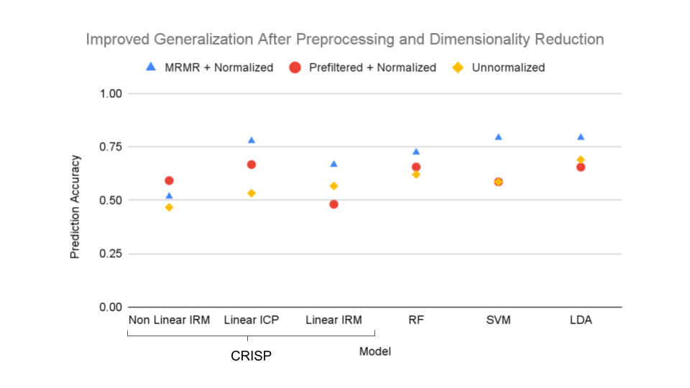
Supplementary Fig. 1: Improved performance using preprocessed data for SVM, RF, LDA and invariant methods from CRISP The mRMR subset and standardized data show better performance on the testing set than unnormalized data across all methods. The mRMR and normalized dataset showed the best performance for RF, SVM, LDA, linear ICP, and linear IRM. IRM: invariant risk minimization; ICP: invariant causal prediction ; CRISP, causal reasoning and inference search platform; RF: random forest, SVM: support vector machine; LDA: linear discriminant analysis

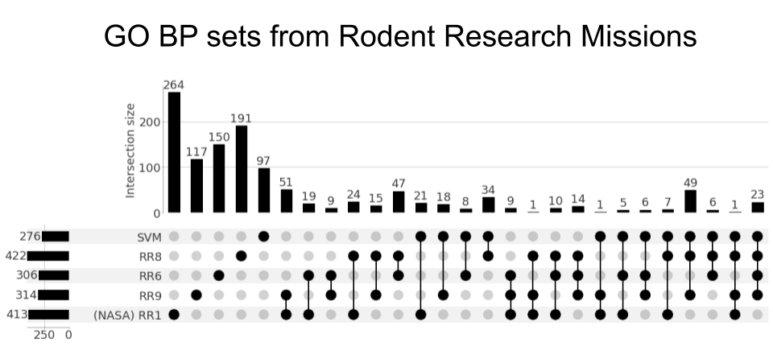
Supplementary Fig. 2: Fold change-based ranking metric at single-study level and SVM-based ranking at merged-study level show strong overlapping GO BPs Sets included in the UpSet plot shows the Gene Ontology biological processes returned from DESeq2 analysis at an individual study level versus SVM analysis from the merged-study harmonized analysis. The rows indicate rodent mission titles for the study-level analysis and SVM for the combined study analysis. The columns indicate intersection sets that are based upon the filled-in dots.
RR, rodent research; SVM, support vector machine; GO gene ontology; BP biological process;

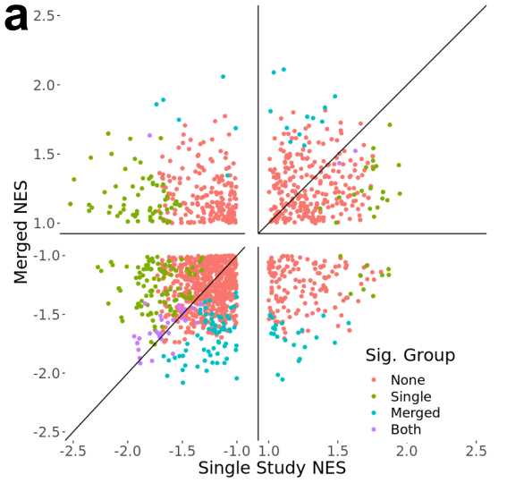 | 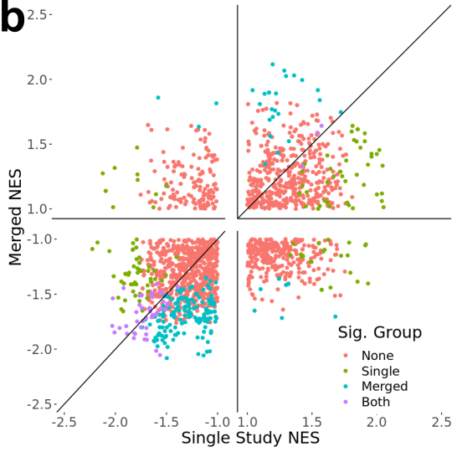
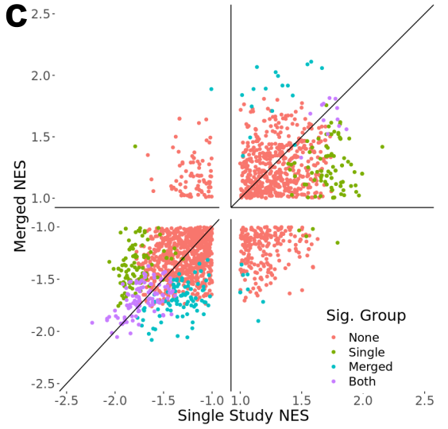 | 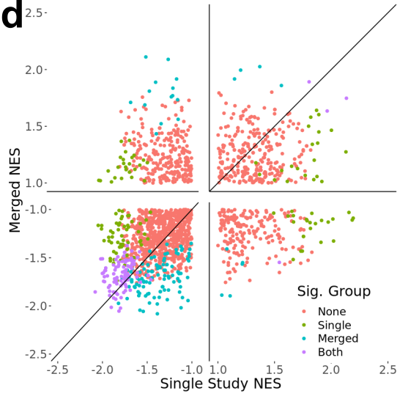
Supplementary Fig. 3: Normalized enrichment score from GSEA compares between single mission analysis versus merged SVM analysis.
a: The gene ontology biological processes (GO BPs) returned from GSEA for single-study analysis and the SVM merged study analysis with each point on the normalized enrichment score (NES) scatter plot representing a GO BP returned from both the single-study and SVM merged study analysis. Each GO BP is labeled based on its significance (p-value ≤ 0.1) in both single study and merged analysis, significance in the SVM merged analysis only, significance in the single study analysis only, and not significant (p-value > 0.1) in either analysis for RR1 (NASA) b: RR6 c: RR8, d: RR9.
NES, Normalized Enrichment Score; GO, Gene Ontology; BP, Biological Process; GSEA, Gene Set Enrichment Analysis; SVM, support vector machine

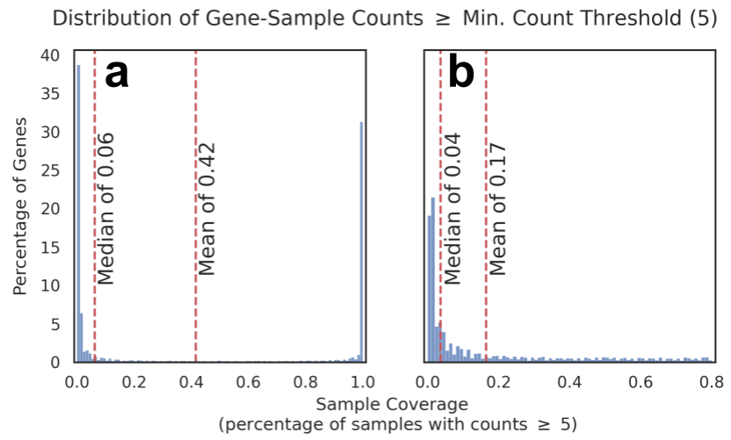
Supplementary Fig. 4: a: Histogram of the gene count measurements exceeding the minimum count threshold of 5 across all samples. The y-axis corresponds to the percentage of genes that belong to the percentile of sample coverage denoted by the x-axis (bin size = 1%). The observations corresponding to no coverage (sample coverage = 0%) and high coverage (sample coverage ≥ 80%) are referred to as tails. The distribution with tails and b: without tails are included with median and mean calculations overlaid. The median indicates sample coverage percentage associated with the 50th percentile of genes. The mean indicates the average sample coverage across all gene count measurements.

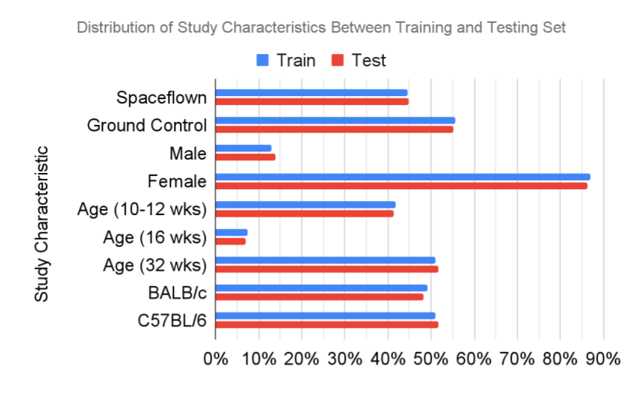
Supplementary Fig. 5: The percent composition of study characteristics in the training and testing set for spaceflown status, sex, age, and strain. The spaceflown status, sex, age at launch, and strain for NASA Rodent Research missions 1, 3, 6 ,8, and 9 for n=13. An 80% training and 20% testing split is used to determine the relative composition between study characteristics, which are within 5% across each characteristic. The age refers to the age at launch in weeks.

Supplementary Tables
Supplementary tables are provided as a xlsx worksheet with separate tabs for each table described below:

Supplementary Table S1: Feature counts at each dimensionality reduction step
Supplementary Table S2: Top 60 features selected from Harmonized Dataset using mRMR
Supplementary Table S3: Gene Ontology Biological Processes Identified from SVM Merged-Study Analysis
Supplementary Table S4: Top genes identified from the SVM merged-study gene set enrichment analysis
Supplementary Table S5: Overlapping significant gene ontology (GO) biological processes (BP) from GSEA between single-study analysis of RR1 (NASA), RR6, RR8, RR9, and merged-study SVM analysis

