Identification of novel ferroptosis biomarkers predicts the prognosis of hepatocellular carcinoma

Siqian Wu¹, Meiliang Liu¹, Suyang Xiao¹, Mingshaung Lai¹, Liling Wei¹, Deyuan Li¹, Lijun Wang¹, Xiaoyun Zeng ^{1,3}* and Fuqiang Yin^{2,3}*
¹ Department of Epidemiology and Health Statistics, School of public health, Guangxi Medical University, 22 Shuangyong Road, Nanning 530021, Guangxi, China; wusiqian@126.com
² Life Sciences Institute, Guangxi Medical University, 22 Shuangyong Road, Nanning 530021, Guangxi, China;
³ Key Laboratory of High-Incidence-Tumor Prevention and Treatment (Guangxi Medical University), Ministry of Education, Nanning, China;
*Correspondence: Zeng: zengxiaoyun@gxmu.edu.cn; Tel.: +86-0771-5352512; Yin: yinfq@mail2.sysu.edu.cn; Tel: +86-0771-5358354.

Supplementary materials：
Table S1 Ferroptosis-related and associated with liver cancer prognosis candidate genes from Coremine database
Table S2 Ferroptosis-related and associated with liver cancer prognosis candidate genes from Ferroptosis database
Table S3 Grouping methods of genes combinations for survival analysis
Table S4 Abstracts associated with MeSH terms and their combinations in PubMed search engine
Table S5 Patient characteristics for qRT-PCR
Table S6 qRT-PCR primers
Table S7 Patient characteristics for IHC
Figure S1 Comparison of 1st, 3rd, 5th year ROC curve with other clinical characteristics in TCGA cohort

Table S1 Ferroptosis-related and associated with liver cancer prognosis candidate genes from Coremine database
AKR1C3 | ALB | ALDH2 | ALDH3A1 | ALOX12 | ALOX15 | ANGPT2 | ANGPTL4 | ANGPTL7 | ANPEP | ANXA5 | APAF1 | APEX1 | APOA4 | APP | AR | ARCN1 | ARHGEF26-AS1 | ASL | ATF2 | ATF3 | ATF4
ATG12 | ATG3 | ATG4B | ATG5 | ATG7 | ATIC | ATL1 | ATM | ATOH7 | AURKA | BACH1 | BAK1 | BAP1 | BAX | BBC3 | BBS9 | BCL2 | BCL2L1 | BCLAF1 | BDNF | BDNF-AS | BECN1
BEX1 | BEX2 | BGLAP | BID | BIRC5 | BMND7 | BMND8 | BRAF | BSG | CA1 | CA9 | CAD | CADM1 | CASP3 | CASP7 | CASP8 | CASP9 | CAT | CAV1 | CCL20 | CCL4 | CCNA2
CCND1 | CCND3 | CCNY | CD177 | CD274 | CD276 | CD4 | CD44 | CD47 | CD82 | CD83 | CDC123 | CDC20 | CDH1 | CDH17 | CDH2 | CDK16 | CDK7 | CDKN1A | CDKN2A | CDO1 | CEACAM1
CFTR | CHAC1 | CHAT | CHMP5 | CHPT1 | CISD1 | CISD2 | CISH | CLU | CNBP | COL11A2 | COPD | CP | CPT1A | CPT2 | CREB1 | CRYZ | CTGF | CTLA4 | CTSB | CXCL5 | CXCR2
CXXC1 | CYCS | CYP1A1 | CYP2E1 | DAND5 | DDIT3 | DDX53 | DIABLO | DIANPH | DKK1 | DNAH8 | DRD2 | DUSP1 | DUSP10 | DUSP12 | DUSP6 | E2F1 | ECH1 | EGF | EGFR | EGFR-AS1 | EGLN1
EGR1 | EHMT2 | EIF2AK3 | EIF2S1 | EIF4E | EIF4EBP1 | ELAVL1 | ELOVL6 | ENO2 | ENPP2 | EPO | EPPK1 | ERBB2 | ESR1 | ETS1 | ETV4 | F2 | FADD | FAM83A-AS1 | FANCD2 | FASN | FBP1
FBXL2 | FBXL5 | FBXW7 | FDFT1 | FGFR2 | FHIT | FN1 | FNDC3B | FOXA1 | FOXA2 | FOXA3 | FOXM1 | FOXO1 | FOXO4 | FTH1 | FTL | FZD7 | FZR1 | G6PD | GABPA | GALNT5 | GAPDH
GCLC | GCLM | GDF15 | GFAP | GGTLC1 | GLMP | GLS | GLS2 | GLUL | GMPS | GOLT1A | GOLT1B | GOT1 | GPX1 | GPX2 | GPX4 | GSDMA | GSK3B | GSTZ1 | H3F3AP6 | HAMP | HAVCR1
HDAC9 | HELLS | HFE | HGF | HIC1 | HIF1A | HK2 | HMGA1 | HMGB1 | HMGCR | HMOX1 | HNF4A | HOOK2 | HOTAIR | HP | HPSE | HPX | HSD17B6 | HSF1 | HSP90AA1 | HSPA4L | HSPA5
HSPB1 | HSPB3 | HTT | ICAM1 | ID1 | IFI27 | IFNA1 | IFNB1 | IFNG | IGF1 | IL13 | IL1B | IL4 | IL6 | IL6R | INS | IREB2 | ISG20L2 | ITGA6 | ITGB8 | JUN | JUND
KCNA5 | KDR | KEAP1 | KHDRBS1 | KIF20A | KIT | KLF4 | KLHL1 | KRAS | LAG3 | LAMTOR5 | LARP6 | LDHA | LDLR | LEP | LINC00324 | LINC01093 | LINC01352 | LINC01503 | LONP1 | LPAR1 | LPCAT3
LRPPRC | MAGI1 | MAP1LC3A | MAP1LC3B | MAP3K12 | MAP3K13 | MAP3K5 | MAPK1 | MAPK3 | MAPK8 | MAPK9 | MAPT | MARK2 | MB | MBD2 | MCL1 | MDM2 | MDM4 | MELK | MEN1 | METTL3 | MGMT
MIR137 | MIR17HG | MIR21 | MIR22HG | MIR503 | MIR503HG | MIR7-3HG | MMP2 | MMP9 | MPO | MPV17 | MS | MT1DP | MT1G | MTDH | MTF1 | MTOR | MTRNR2L3 | MUC1 | MUL1 | MYBL2 | MYC
MYCN | NADK2 | NANOG | NANOGP8 | NBL1 | NCOA3 | NCOA4 | NDRG1 | NEAT1 | NELFE | NFE2L2 | NFKB1 | NFKBIA | NOS3 | NOTCH1 | NOTCH2 | NOX4 | NQO1 | NR5A2 | NRAS | NRF1 | NT5DC2
NUAK1 | NUP62 | NUPR1 | OTUD1 | OXCT1 | PAK3 | PARK2 | PARP1 | PCBP1 | PCBP2 | PCNA | PDCD1 | PDK4 | PEBP1 | PHB | PHB2 | PHKG2 | PIK3CA | PKLR | PKM | PLIN2 | PMAIP1
POLR2E | POMC | POSTN | PPARA | PPFIA1 | PPIA | PPP1R1A | PPP2R4 | PRC1 | PRDX1 | PRDX5 | PRIM1 | PRKAA1 | PRKAA2 | PRKAB1 | PRKDC | PRNP | PROM1 | PROM2 | PSG1 | PSMB10 | PSMB4
PTBP1 | PTEN | PTGS2 | PVT1 | QSOX1 | RAF1 | RALBP1 | RB1 | RBMS3 | RELA | RET | RHEBP1 | RHOA | RIMS2 | RIPK1 | RIPK3 | RNANC | RNF2 | RPL17 | RRM2 | S100A4 | SAT1
SBF2-AS1 | SCARB1 | SCARB2 | SCD | SENP1 | SERPINE1 | SESN2 | SETD2 | SIRT1 | SIRT3 | SIRT6 | SKP2 | SLC10A1 | SLC10A5 | SLC11A2 | SLC13A1 | SLC13A2 | SLC13A5 | SLC15A5 | SLC16A11 | SLC16A3 | SLC16A4
SLC18A1 | SLC1A1 | SLC1A4 | SLC1A5 | SLC22A1 | SLC22A11 | SLC23A1 | SLC24A1 | SLC24A5 | SLC25A10 | SLC25A11 | SLC25A21 | SLC25A5 | SLC26A11 | SLC27A5 | SLC28A1 | SLC28A2 | SLC2A1 | SLC2A3 | SLC30A1 | SLC31A1 | SLC38A1
SLC38A11 | SLC38A5 | SLC38A6 | SLC39A11 | SLC39A14 | SLC39A5 | SLC40A1 | SLC41A1 | SLC43A1 | SLC44A1 | SLC44A5 | SLC45A1 | SLC45A2 | SLC46A1 | SLC48A1 | SLC4A2 | SLC50A1 | SLC6A11 | SLC7A1 | SLC7A10 | SLC7A11 | SLC7A13
SLC7A14 | SLC7A4 | SLC7A5 | SLC7A6 | SLC9A5 | SLC9A6 | SLC9C1 | SLC9C2 | SLCO1B1 | SLCO3A1 | SLU7 | SMAD2 | SMAD3 | SMAD4 | SMAD7 | SNAI2 | SNAI3-AS1 | SNHG16 | SNHG18 | SOAT1 | SOCS1 | SOCS3
SOD2 | SOX2 | SP1 | SPP1 | SQSTM1 | SREBF1 | SREBF2 | SSRP1 | STAT1 | STAT3 | STAT5A | STEAP3 | STK11 | SUV39H1 | SYP | SYT1 | TCEAL1 | TCF3 | TCF4 | TCF7L2 | TCHP | TF

Table S2 Ferroptosis-related and associated with liver cancer prognosis candidate genes from Ferroptosis database
ABCC1 | ACO1 | ACSF2 | ACSL4 | ACVR1B | ALOX12 | ALOX12B | ALOX15 | ALOX15B | ALOX5 | ALOXE3 | ANO6 | ATF3 | ATG13 | ATG16L1 | ATG3 | ATG4D | ATG5 | ATG7 | ATM | ATP5MC3 | BACH1
BAP1 | BECN1 | BID | CARS1 | CDKN2A | CDO1 | CHAC1 | CS | CYBB | DNAJB6 | DPP4 | DUOX1 | DUOX2 | EGFR | EGLN2 | ELAVL1 | EMC2 | EPAS1 | FBXW7 | FLT3 | G6PD | G6PDX
GABARAPL1 | GABARAPL2 | GLS2 | GOT1 | HIF1A | HILPDA | HMGB1 | HMOX1 | HRAS | IDH1 | IFNG | IREB2 | KEAP1 | KRAS | LINC00472 | LONP1 | LPCAT3 | LPIN1 | MAP1LC3A | MAPK1 | MAPK14 | MAPK3
MAPK8 | MAPK9 | MIOX | MIR6852 | MTDH | MYB | NCOA4 | NOX1 | NOX3 | NOX4 | NOX5 | NRAS | PANX1 | PEBP1 | PGD | PHKG2 | PIK3CA | PRKAA1 | PRKAA2 | RPL8 | SAT1 | SCP2
SIRT1 | SLC1A5 | SLC38A1 | SNX4 | SOCS1 | TAZ | TF | TFR2 | TFRC | TGFBR1 | TLR4 | TNFAIP3 | TP53 | ULK1 | ULK2 | VDAC2 | WIPI1 | WIPI2 | YY1AP1 | ZEB1 | PTGS2 | DUSP1
NOS2 | NCF2 | MT3 | UBC | ALB | TXNRD1 | SRXN1 | GPX2 | BNIP3 | OXSR1 | SELENOS | ANGPTL7 | SLC7A11 | DDIT4 | LOC284561 | ASNS | TSC22D3 | DDIT3 | JDP2 | SESN2 | SLC1A4 | PCK2
TXNIP | VLDLR | GPT2 | PSAT1 | LURAP1L | SLC7A5 | HERPUD1 | XBP1 | SLC3A2 | CBS | ATF4 | ZNF419 | KLHL24 | TRIB3 | ZFP69B | ATP6V1G2 | VEGFA | GDF15 | TUBE1 | ARRDC3 | CEBPG | SNORA16A
RGS4 | BLOC1S5-TXNDC5 | LOC390705 | EIF2S1 | KIM-1 | IL6 | CXCL2 | RELA | HSD17B11 | AGPAT3 | SETD1B | FTL | MAFG | IL33 | FTH1 | SLC40A1 | GPX4 | HAMP | HSPB1 | NFE2L2 | STEAP3 | DRD5
DRD4 | MAP3K5 | SLC2A1 | SLC2A3 | SLC2A6 | SLC2A8 | SLC2A12 | GLUT13 | SLC2A14 | EIF2AK4 | TFAP2C | SP1 | HBA1 | NNMT | PLIN4 | HIC1 | STMN1 | RRM2 | CAPG | HNF4A | NGB | YWHAE
GABPB1 | AURKA | MIR4715 | RIPK1 | PRDX1 | MIR30B | AKR1C1 | AKR1C3 | CAV1 | SRC | MT1G | OTUB1 | AKR1C2 | ARNTL | CDKN1A | ISCU | JUN | ZFP36 | CA9 | CD44 | CISD2 | MUC1
NQO1 | PRDX6 | PROM2 | ACSL3 | AIFM2 | BRD4 | CHMP5 | CHMP6 | CISD1 | ENPP2 | FADS2 | FANCD2 | FH | FTMT | GCH1 | GCLC | HELLS | HSF1 | HSPA5 | LAMP2 | MTOR | NF2
NFS1 | PLIN2 | PML | RB1 | SCD | SQSTM1 | STAT3 | TMBIM4 | TP63 | Fer1HCH | LINC00336 | MIR137 | MIR17 | MIR212 | MIR9-1 | MIR9-2 | MIR9-3

Table S3 Grouping methods of genes combinations for survival analysis
 | Two-gene-combination |  |  |  |  | Three-gene-combination
 | Same direction |  | Reverse direction |  |  | Same direction |  | Reverse direction
 | Group1 | Group2 | Group1 | Group2 |  | Group1 | Group2 | Group1 | Group2 | Group1 | Group2 | Group1 | Group2
Symbol1* | High | Low | High | Low | Symbol1* | High | Low | Low | High | High | Low | High | Low
Symbol2* | High | Low | Low | High | Symbol2* | High | Low | High | Low | Low | High | High | Low
 |  |  |  |  | Symbol3* | High | Low | High | Low | High | Low | Low | High
*The direction of gene expression was determined by single gene Kaplan-Meier with poor prognosis.
Table S4 Abstracts associated with MeSH terms and their combinations in PubMed search engine
- Gene Official Symbol [Title/Abstract] OR Official Full Name[Title/Abstract] provided by HGNC*
- ((((((((((((((((((((1990/01/01:2500/12/31[Date - Publication] NOT "retraction of publication"[Publication Type]) NOT "newspaper article"[Publication Type]) NOT "Editorial"[Publication Type]) NOT "Bibliography"[Publication Type]) NOT "News"[Publication Type]) NOT "Directory"[Publication Type]) NOT "Autobiography"[Publication Type]) NOT "practice guideline"[Publication Type]) NOT "published erratum"[Publication Type]) NOT "Guideline"[Publication Type]) NOT "video audio media"[Publication Type]) NOT "Interview"[Publication Type]) NOT "retracted publication"[Publication Type]) NOT "Biography"[Publication Type]) NOT "historical article"[Publication Type]) NOT "comment"[Publication Type]) NOT "commentary"[Title]) NOT "comment"[Title]) NOT "Erratum"[Title]) NOT "Retracted"[Title])
(C) ("prognosis"[MeSH Terms] OR "prognosis"[Title/Abstract] OR "outcome"[Title/Abstract] OR "survival"[Title/Abstract] OR "prognostic"[Title/Abstract])
(D) ("Liver Neoplasms"[MeSH Terms] OR "Liver Neoplasms"[MeSH Terms] OR "carcinoma, hepatocellular"[MeSH Terms] OR "carcinoma, hepatocellular"[MeSH Terms] OR "carcinoma, hepatocellular"[MeSH Terms] OR "Liver Neoplasms"[MeSH Terms] OR "carcinoma, hepatocellular"[MeSH Terms] OR "Liver Neoplasms"[MeSH Terms])
*HGNC: HUGO Gene Nomenclature Committee

Table S5 Patient characteristics for qRT-PCR
Characteristic |  |  | mean (SD)/n (%)
Age (Years) |  |  | 52.3(11.1)
Sex |  | male/female | 14/5(26.3/73.7)
Ethnicity |  | Han | 15(78.9)
 |  | Zhuang | 4(21.1)
Cirrhosis |  | yes/no | 16/3(84.2/15.8)
AFP (ng/ml) |  | <400 | 11(57.9)
 |  | >400 | 8(42.2)
Tumor number |  | single | 18(94.7)
 |  | mutiple | 1(5.3)
Largest diameter(cm) |  |  | 9.3(2.2)
Satellite nodule |  | yes/no | 1/18(5.3/94.7)
Edmondson grade |  | Ⅰ-Ⅱ | 11(57.9)
 |  | Ⅲ -Ⅳ | 8(42.1)
BCLC stage |  | A | 12(63.2)
 |  | B | 3(15.8)
 |  | C | 4(21.1)
Table S6 qRT-PCR primers
 | Forward |  |  | Reverse
GLMP | GGCTGGAGGTAGCCACATTG |  |  | CCGGTGCATATTCATCGTCG
SLC38A6 | GCTTTTGACAGTCCCTCTAATCC |  |  | TTGATGTACTGGCACCAACTAC
WDR76 | GCAAGCCAAGTAGTAAGAACACT |  |  | GGTTGCTGGGTCAAATCACAAA

Table S7 Patient characteristics for IHC
characteristics |  | mean (SD)/median (IQR)/n (%)
Age (Years) |  | 52.3（11.9)
Sex | male/female | 74/16（82.2/17.8)
Tumor number | single | 74（82.2)
 | multiple | 16(17.8)
Largest diameter(cm) |  | 5[3,7]
Edmondson grade | Ⅰ-Ⅱ | 58(75.5)
 | Ⅲ -Ⅳ | 32(35.5)
Cirrhotic nodules | ≤3cm | 38（42.2)
 | >3cm | 40（44.4)
 | no nodules | 12（13.3)
Clinical stages | Stage I | 61（67.8)
 | Stage II | 29（32.2)
AFP (ng/ml) | ≤400 | 57(63.3)
 | >400 | 33(36.7)
Overall survival status | alive/dead | 41/49(45.6/54.4)
Overall survival time(months) |  | 51[21.5, 59]
The clinical stages were classified according to the AJCC TNM staging system (7th edition).

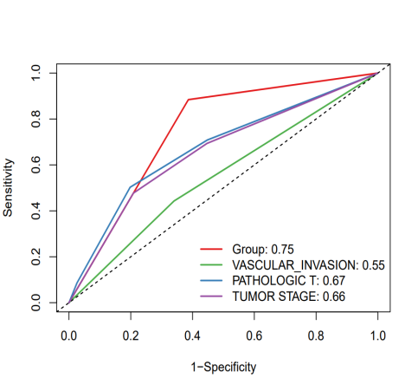
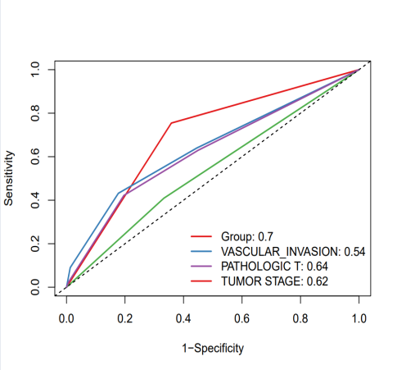
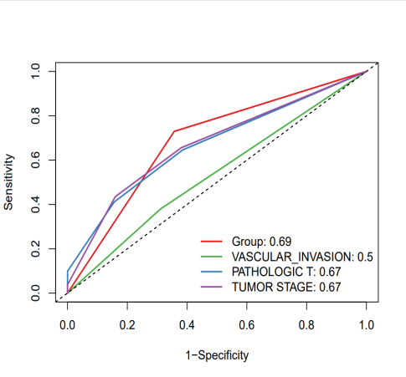
Supplementary Figure S1. (A) Comparison of the 1st year ROC curve with other clinical characteristics. (B) Comparison of the 2nd years ROC curve with other clinical characteristics. (C) Comparison of the 3rd years ROC curve with other clinical characteristics.
A
B
C

