Supplementary Materials
Contents

Supplementary Figure 1. Literature screening flow chart. 1
Supplementary Figure 2. Number of publications by year on publication ethics. 1
Supplementary Figure 3. Cooperation network of countries on publication ethics. 2
Supplementary Figure 4. Cooperation network of institutions on publication ethics. 2
Supplementary Figure 5. Cooperation network of authors on publication ethics. 3
Supplementary Figure 6. Cooperation network of co-cited journals on publication ethics. 3
Supplementary Figure 7. Dual-map overlay of journals. 4
Supplementary Figure 8. The top keywords with the strongest citation bursts on publication ethics. 4
Supplementary Figure 9. Thematic map about publication ethics on publication ethics. 5
Supplementary Figure 10. The network map of co-cited references on publication ethics. 5
Supplementary Table 1. The top ten authors contributed to publications in publication ethics. 6
Supplementary Table 2. The top ten journals and co-cited journals contributed to publications in publication ethics. 6
Supplementary Table 3. The top twenty keywords in publication ethics. 7
Supplementary Table 4. The top ten co-cited references related to publication ethics. 7

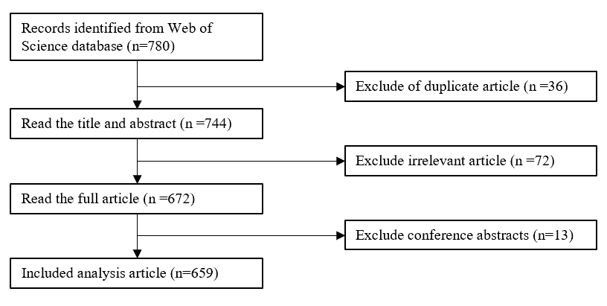

Supplementary Figure 1. Literature screening flow chart.
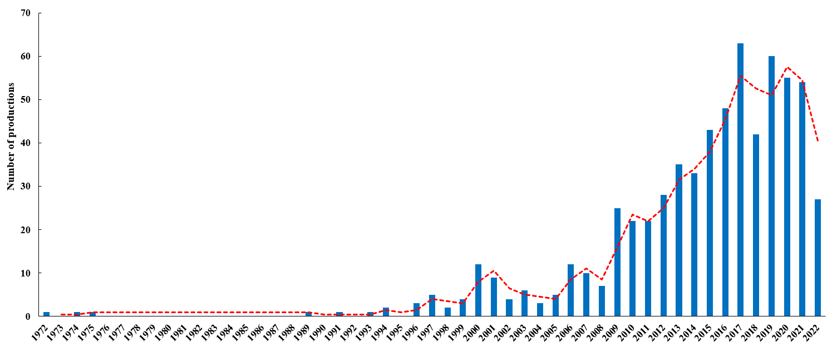

Supplementary Figure 2. Number of publications by year on publication ethics.

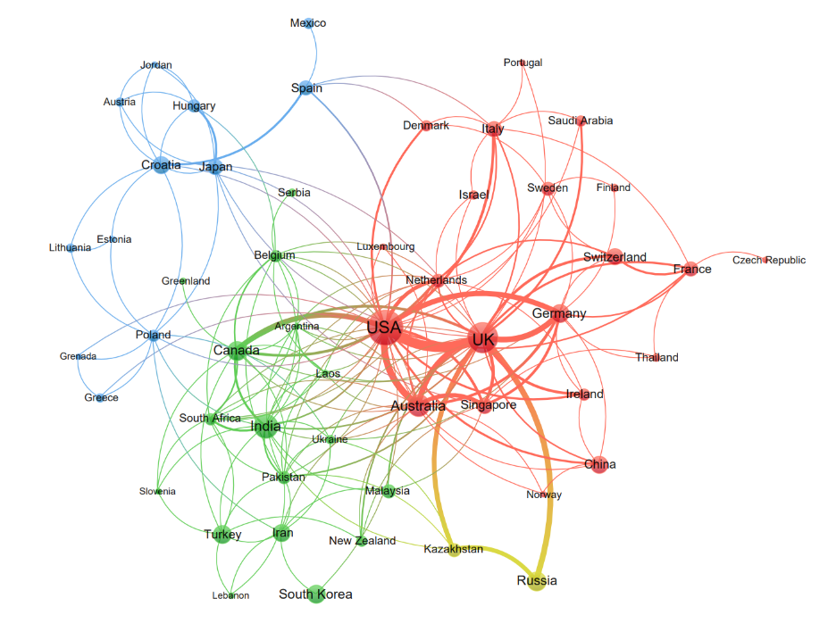

Supplementary Figure 3. Cooperation network of countries on publication ethics.

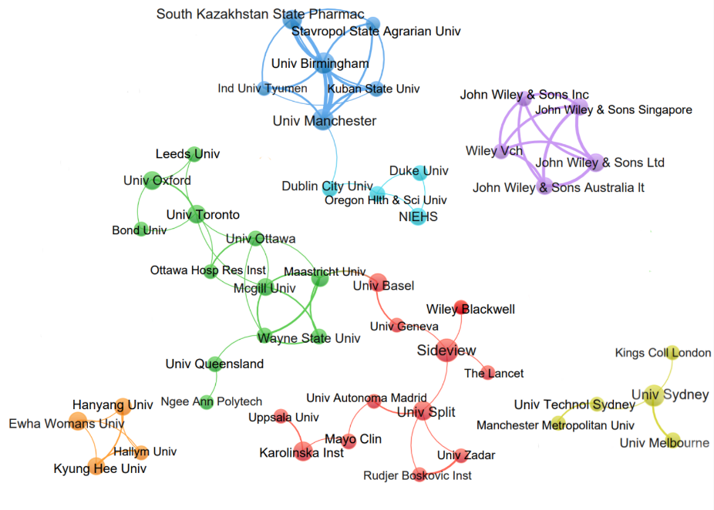

Supplementary Figure 4. Cooperation network of institutions on publication ethics.

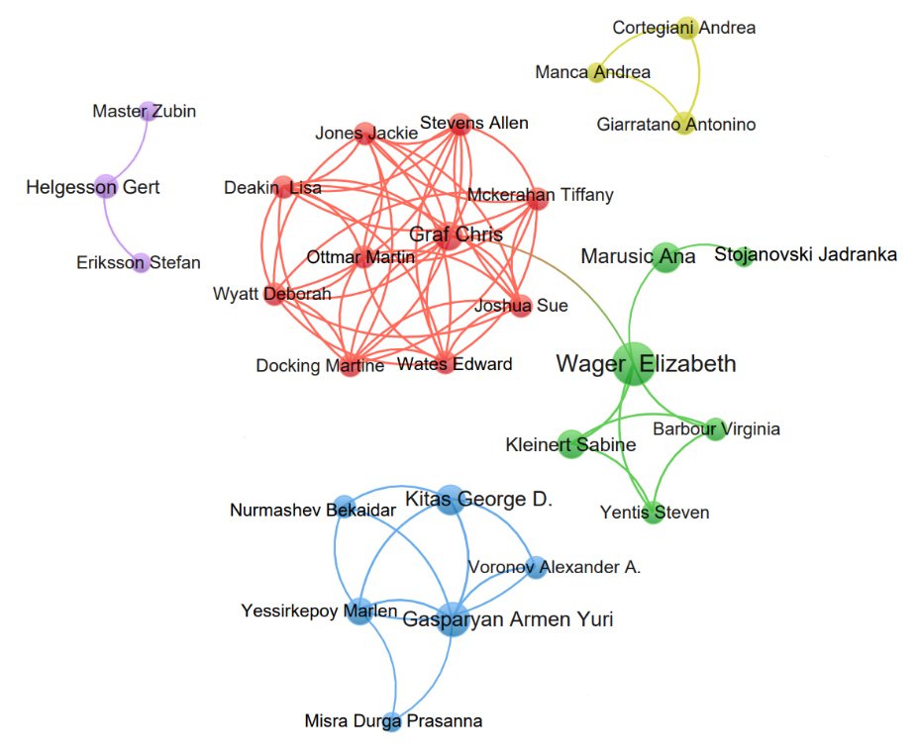

Supplementary Figure 5. Cooperation network of authors on publication ethics.

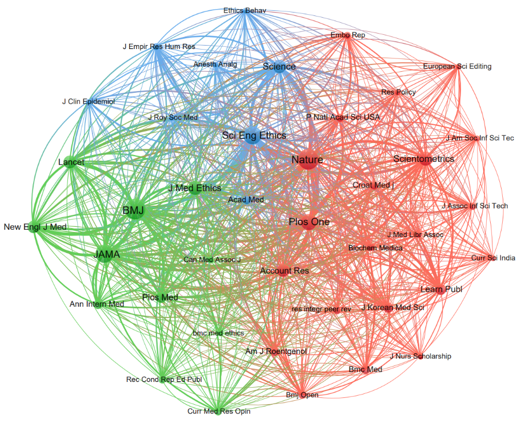

Supplementary Figure 6. Cooperation network of co-cited journals on publication ethics.

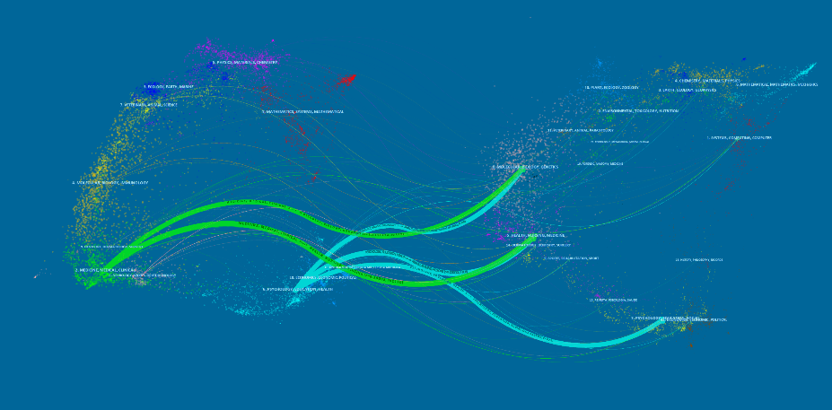

Supplementary Figure 7. Dual-map overlay of journals.
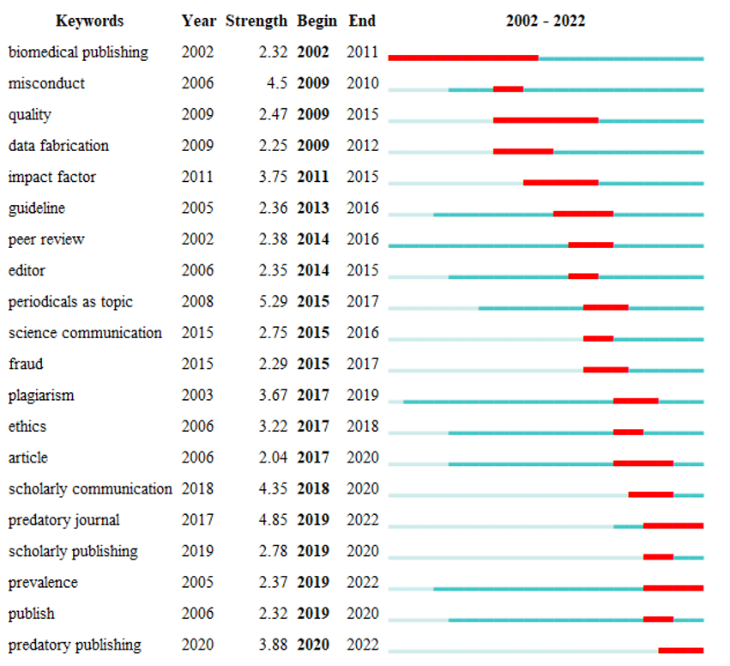

Supplementary Figure 8. The top keywords with the strongest citation bursts on publication ethics.

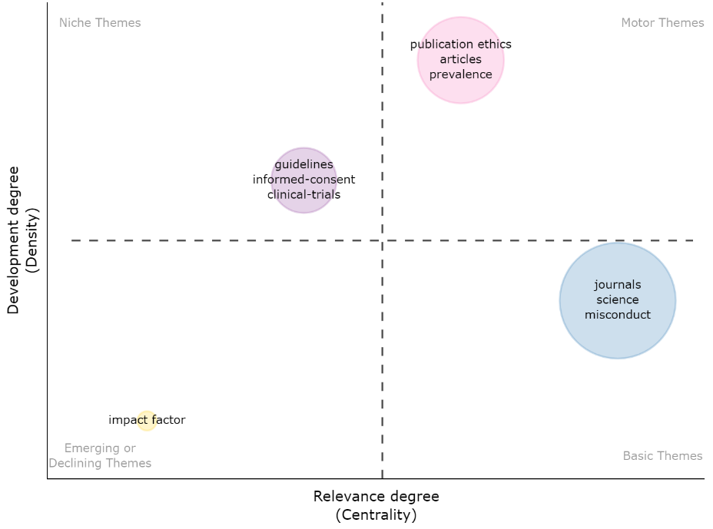

Supplementary Figure 9. Thematic map about publication ethics on publication ethics.

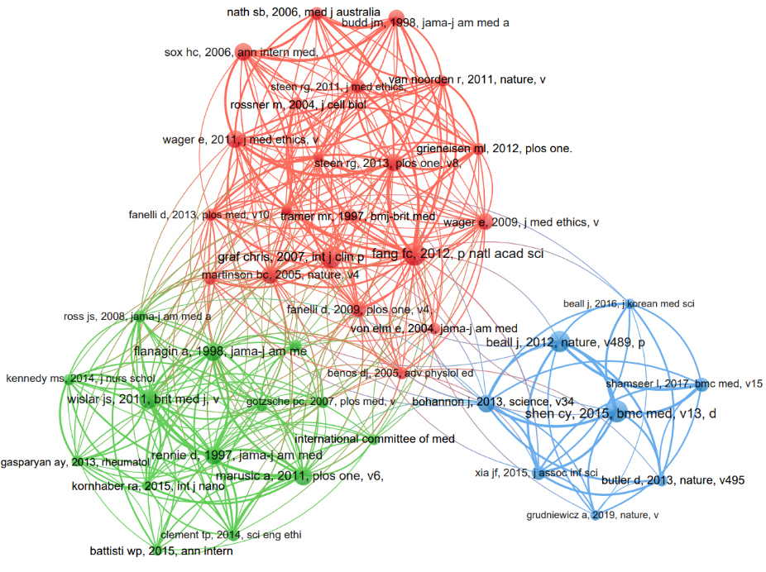

Supplementary Figure 10. The network map of co-cited references on publication ethics.

Supplementary Table 1. The top ten authors contributed to publications in publication ethics.
Rank | Author | Institution | Number | Citations
1 | Wager Elizabeth | Sideview | 19 | 400
2 | Gasparyan Armen Yuri | University of Birmingham | 11 | 227
3 | Marusic Ana | University of Split | 11 | 341
4 | Da Silva Jaime A Teixeira | Miki-cho Post Office | 10 | 147
5 | Kitas George D | University of Birmingham | 8 | 211
6 | Graf Chris | Blackwell Publishing Ltd | 7 | 46
7 | Kleinert Sabine | The Lancet | 7 | 96
8 | Barbour Virginia | Queensland University of Technology | 6 | 93
9 | Yessirkepov Marlen | University of Birmingham | 6 | 127
10 | Dobranszki Judit | University of Debrecen | 5 | 110

Supplementary Table 2. The top ten journals and co-cited journals contributed to publications in publication ethics.
Rank | Journal | Number | Citations | Country | Co-Cited Journal | Citations | Country
1 | Sci Eng Ethics | 29 | 441 | Netherlands | BMJ | 420 | UK
2 | Account Res | 27 | 142 | UK | Nature | 413 | UK
3 | J Korean Med Sci | 19 | 394 | Korea | JAMA | 333 | USA
4 | J Med Ethics | 13 | 214 | UK | Sci Eng Ethics | 333 | Netherlands
5 | Biochem Medica | 10 | 127 | Croatia | Plos One | 261 | USA
6 | Learn Publ | 9 | 40 | USA | J Med Ethics | 203 | UK
7 | Sci Editing | 9 | 16 | Korea | Scientometrics | 197 | Hungary
8 | Scientometrics | 7 | 71 | Hungary | Science | 188 | USA
9 | Am J Roentgenol | 6 | 30 | USA | Account Res | 163 | USA
10 | Bioethics | 6 | 93 | UK | Lancet | 160 | UK

Supplementary Table 3. The top twenty keywords in publication ethics.
Rank | Keyword | Number | Total link strength | Rank | Keyword | Number | Total link strength
1 | publication ethics | 59 | 279 | 11 | open-access | 15 | 30
2 | misconduct | 48 | 170 | 12 | quality | 15 | 65
3 | journal | 44 | 197 | 13 | conflict-of-interest | 13 | 69
4 | science | 42 | 178 | 14 | editor | 13 | 67
5 | publishing | 39 | 163 | 15 | guidance | 13 | 61
6 | author | 32 | 151 | 16 | impact | 13 | 92
7 | clinical-trial | 23 | 141 | 17 | issue | 13 | 57
8 | plagiarism | 23 | 108 | 18 | policy | 13 | 49
9 | article | 17 | 95 | 19 | prevalence | 13 | 98
10 | integrity | 15 | 77 | 20 | credit | 12 | 76

Supplementary Table 4. The top ten co-cited references related to publication ethics.
Rank | Co-cited reference | Co-citation
1 | Fang, FC, Steen, RG, Casadevall, A. Misconduct accounts for the majority of retracted scientific publications. Proceedings of the National Academy of Sciences. 2012;109(42):17028-17033. | 30
2 | Shen C, Björk BC. ‘Predatory’ open access: a longitudinal study of article volumes and market characteristics. BMC Medicine. 2015;13(1):230-. | 28
3 | Beall J. Predatory publishers are corrupting open access. Nature. 2012;489(7415):179-179. | 27
4 | Graf C, Wager E, Bowman A, Fiack S, Scott-Lichter D, Robinson A. Best Practice Guidelines on Publication Ethics: a publisher's perspective. Int J Clin Pract Suppl. 2007;61(152):1-26. | 27
5 | Wislar JS, Flanagin A, Fontanarosa PB, DeAngelis CD. Honorary and ghost authorship in high impact biomedical journals: a cross sectional survey. BMJ. 2011;343(oct25 1): d6128-d6128. | 24
6 | Flanagin A. Prevalence of Articles With Honorary Authors and Ghost Authors in Peer-Reviewed Medical Journals. JAMA. 1998;280(3):222-. | 22
7 | Marušić A, Bošnjak L, Jerončić A. A Systematic Review of Research on the Meaning, Ethics and Practices of Authorship across Scholarly Disciplines. PLoS ONE. 2011;6(9), e23477. | 22
8 | Rennie D, Yank V, Emanuel L. When authorship fails. A proposal to make contributors accountable. JAMA. 1997;278:579-85. | 22
9 | Wager E, Williams P. Why and how do journals retract articles? An analysis of Medline retractions 1988-2008. Journal of Medical Ethics 2011;37(9):567-570. | 21
10 | Bohannon J. Who's Afraid of Peer Review. Science. 2013;342(6154):60-65. | 20

