Additional file 6
Forest plots of comparisons
Quality of life, various scales
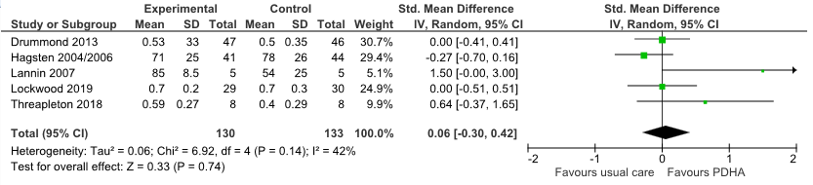
Quality of life, EQ-5D
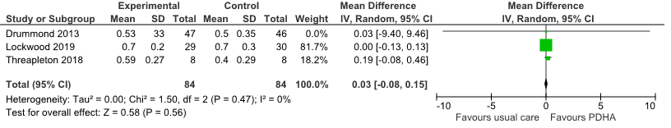
Risk of falling
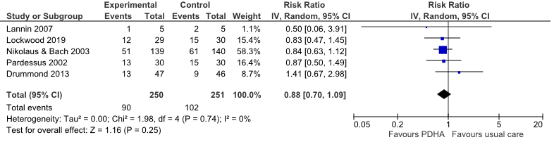
Risk of readmission
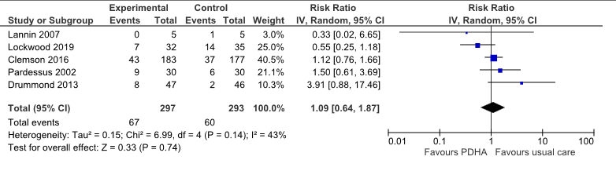

IADL, NEADL
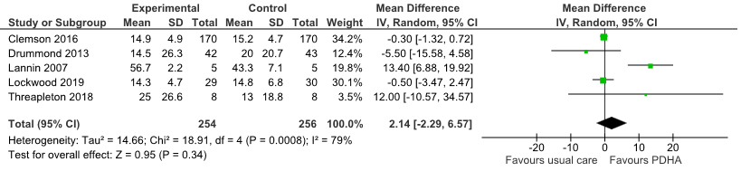
IADL/ADL, various scales
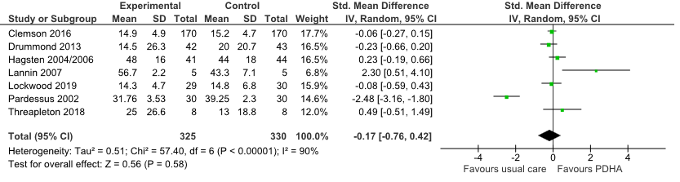
Fear of falling
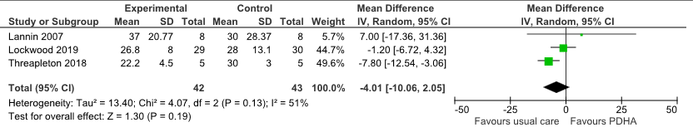
Mobility
