SUPPLEMENTAL MATERIALS

Supplementary Figure 1. Core assumptions of Mendelian randomization.
Supplementary Table 1. Summary data sources of the study
Supplementary Method 1. Detail definition of outcomes.
Supplementary Table 2. Additional participants characteristics for cohort included in the GWAS on tHcy.
Supplementary Table 3. Associations of genetic instruments for Hcy levels with AAs
Supplementary Table 4. Associations of genetic instruments for Hcy levels with TAA
Supplementary Table 5. Associations of genetic instruments for Hcy levels with AAA
Supplementary Table 6. MR estimates from each method of assessing the causal effect of Hcy on the risk of AAs, TAA and AAA.
Supplementary Figure 2. Funnel plot to assess the robustness of Hcy on AAs.
Supplementary Figure 3. Funnel plot to assess the robustness of Hcy on TAA.
Supplementary Figure 4. Funnel plot to assess the robustness of Hcy on TAA.
Supplementary Figure 5. Scatter plot of SNPs associated with Hcy and the risk of AAs.
Supplementary Figure 6. Scatter plot of SNPs associated with Hcy and the risk of TAA.
Supplementary Figure 7. Scatter plot of SNPs associated with Hcy and the risk of AAA.
Supplementary Figure 8. Forest plot for leave-one-out analysis for the casual effect of Hcy on AAs.
Supplementary Figure 9. Forest plot for leave-one-out analysis for the casual effect of Hcy on TAA.
Supplementary Figure 10. Forest plot for leave-one-out analysis for the casual effect of Hcy on AAA.

Supplementary Figure 1. Core assumptions of Mendelian randomization
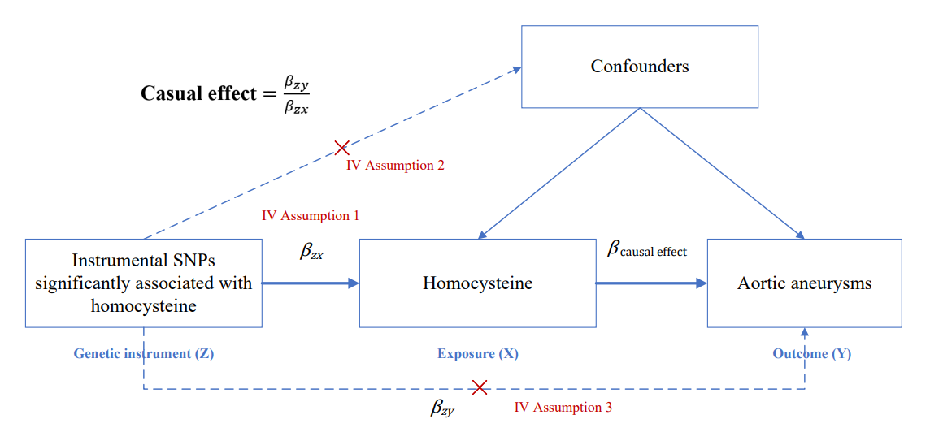
Supplementary Table 1. Summary data sources of the study
Exposure or Outcome | Data source | Participants included in analysis | Covariates adjusted in research | Unit
Hcy | PMID: 23824729 | 44,147 individuals of European  descent | Age and sex, and principal components in individual studies where applicable | SD
AAs | https://r8.finngen.fi/pheno/I9_AORTANEUR | 317899 individuals of European  descen | - | -
TAA | https://r8.finngen.fi/pheno/I9_THAORTANEUR | 317899 individuals of European  descen | - | -
AAA | https://r8.finngen.fi/pheno/I9_ABAORTANEUR | 317899 individuals of European  descen | - | -
Hcy: Homocysteine; AAs: Aortic aneurysms; TAA: Thoracic aortic aneurysm; AAA: Abdominal aortic aneurysm.
Supplementary Appendix 1. Detail definition of outcomes.
Aortic aneurysms: It was defined as “a ruptured aneurysm located in the wall of the proximal portion of the descending aorta proceeding from the arch of the aorta.” in the Finngen Study. Patients diagnosed with “thoracic aortic aneurysm, ruptured”, “thoracic aortic aneurysm, without mention of rupture”, “abdominal aortic aneurysm, ruptured”, “abdominal aortic aneurysm, without mention of rupture”, “thoracoabdominal aortic aneurysm, ruptured”, “thoracoabdominal aortic aneurysm, without mention of rupture”, “aortic aneurysm of unspecified site, ruptured”, “aortic aneurysm of unspecified site, without mention of rupture”, with ICD-10 code I71.1, I71.2, I71.3, I71.4, I71.5, I71.6, I71.8, and I71.9 respectively after hospital discharge or death. Total case number was 7603.
Thoracic aortic aneurysm: Patients diagnosed with “aneurysm of descending aorta”, “thoracic aortic aneurysm, ruptured”, “thoracic aortic aneurysm, without mention of rupture”, “(ruptured)aneurysm of sinus Valsalva”, with ICD-10 code I71.01, I71.1, I71.2 and Q25.43 after hospital discharge or death. Total case number was 7321.
Abdominal aortic aneurysm: Patients diagnosed with “abdominal aortic aneurysm, ruptured”, “abdominal aortic aneurysm, without mention of rupture”, with ICD-10 code I171.3 and I171.4 after hospital discharge or death. Total case number was 3201.
Supplementary Table 2. Additional participants characteristics for cohort included in the GWAS on tHcy
Cohort | Country | N | Women  (%) | tHcy‡  (median, range) | Age†  (mean, SD) | Weight  (mean, SD) | Height  (mean, SD) | Folate  (mean, SD)
CoLAUS | Switzerland | 5434 | 53% | 9.6  (3.2-67.1) | 53.5 (10.8) | 73.6 (15.2) | 168.5 (9.3) | NA
RS I | Netherlands | 3414 | 58% | 14.3  (5.3-129.3) | 66.1 (7.2) | 74.5 (11.6) | 168.1 (9.2) | NA
RS II | Netherlands | 2122 | 54% | 13.0  (5.6-81.5) | 64.8 (8.0) | 77.6 (13.2) | 168.6 (9.3) | NA
NBS | Netherlands | 550 | 51% | 9.8  (4.6 - 46.2) | 62.8 (5.4) | 78.6 (13.1) | 171.0 (8.1) | 17.5 (15.0)
TUK I | UK | 1601 | 100% | 12.2  (3.7-92.6) | 60.4 (9.1) | 70.1 (26.9) | 161.58 (6.09) | 12.70  (6.10)
TUK II | UK | 549 | 100% | 7.99  (2.6-72.1) | 47.5 (14.3) | 67.4 (13.2) | 162.0 (6.1) | 12.32  (6.15)
InCHIANTI | Italy | 1208 | 55% | 15.2  (5.4-95.9) | 68.2 (15.5) | 69.7 (12..9) | 160.1 (9.9) | 7.5 (4.6)
WGHS | USA | 23,294 | 100% | 10.5  (1.6-136.2) | 54.7 (7.1) | 70.0 (14.2) | 164.34 (6.27) | NA
FHS | USA | 3105 | 53% | 9.1  (3.4-82.4) | 58.6 (9.7) | NA | NA | 7.19
CHS | USA | 574 | 46.90% | 10.2  (3.7-38.8) | 74.4 (5.9) | 72.0 (14.2) | 166.2 (9.5) | 23.6 (19.0)
BLSA | USA | 638 | 45.60% | 9.5  (2.5-114.9) | 67.7 (13.9) | 77.6 (16.3) | 168.8 (9.5) | 15.7 (8.5)
NHS | USA | 1658 | 100% | 10.6 | 58.92 (6.2) | NA | NA | 10.2 (9.03)
†Age is presented in years;
‡ tHcy denotes total plasma homocysteine levels in µmol/L;
Abbreviations: GWAS, genome-wide association study; tHcy, total homocysteine; N, number of participants; NA, not available.

Supplementary Table 3. Associations of genetic instruments for Hcy levels with AAs
SNP | Chr | Position | Effect_allele | Other_allele | EAF | Exposure (Hcy) |  |  | Outcome (AAs)
 |  |  |  |  |  | Beta | Se | P | Beta | Se | P
rs12780845 | 10 | 17181245 | A | G | 0.65 | 0.053 | 0.009 | 7.80E-10 | -0.022 | 0.020 | 0.254
rs154657 | 16 | 89641688 | A | G | 0.47 | 0.096 | 0.007 | 1.74E-43 | -0.027 | 0.017 | 0.123
rs1801222 | 10 | 17114152 | A | G | 0.34 | 0.045 | 0.007 | 8.43E-10 | 0.000 | 0.018 | 0.986
rs42648 | 7 | 90348446 | A | G | 0.4 | -0.040 | 0.007 | 1.97E-08 | -0.004 | 0.017 | 0.807
rs4660306 | 1 | 45513003 | T | C | 0.33 | 0.044 | 0.007 | 2.33E-09 | -0.034 | 0.018 | 0.054
rs7130284 | 11 | 89415204 | T | C | 0.07 | 0.124 | 0.013 | 1.88E-20 | 0.005 | 0.025 | 0.829
rs838133 | 19 | 48756272 | A | G | 0.45 | 0.042 | 0.007 | 7.48E-09 | 0.015 | 0.017 | 0.403
rs9369898 | 6 | 49414480 | A | G | 0.62 | 0.045 | 0.007 | 2.17E-10 | -0.001 | 0.017 | 0.965
Abbreviations: Hcy, homocysteine; AAs: aortic aneurysms; SNP, single nucleotide polymorphism; Chr, chromosome; EAF, effect allele frequency;
Supplementary Table 4. Associations of genetic instruments for Hcy levels with TAA
SNP | Chr | Position | Effect_allele | Other_allele | EAF | Exposure (Hcy) |  |  | Outcome (TAA)
 |  |  |  |  |  | Beta | Se | P | Beta | Se | P
rs12780845 | 10 | 17181245 | A | G | 0.65 | 0.053 | 0.009 | 7.80E-10 | -0.026 | 0.020 | 0.184
rs154657 | 16 | 89641688 | A | G | 0.47 | 0.096 | 0.007 | 1.74E-43 | -0.026 | 0.018 | 0.138
rs1801222 | 10 | 17114152 | A | G | 0.34 | 0.045 | 0.007 | 8.43E-10 | 0.000 | 0.018 | 0.984
rs42648 | 7 | 90348446 | A | G | 0.4 | -0.040 | 0.007 | 1.97E-08 | 0.004 | 0.018 | 0.831
rs4660306 | 1 | 45513003 | T | C | 0.33 | 0.044 | 0.007 | 2.33E-09 | -0.031 | 0.018 | 0.086
rs7130284 | 11 | 89415204 | T | C | 0.07 | 0.124 | 0.013 | 1.88E-20 | 0.007 | 0.025 | 0.775
rs838133 | 19 | 48756272 | A | G | 0.45 | 0.042 | 0.007 | 7.48E-09 | 0.011 | 0.018 | 0.527
rs9369898 | 6 | 49414480 | A | G | 0.62 | 0.045 | 0.007 | 2.17E-10 | -0.004 | 0.017 | 0.829
Abbreviations: Hcy, homocysteine; TAA: Thoracic aortic aneurysm; SNP, single nucleotide polymorphism; Chr, chromosome; EAF, effect allele frequency.

Supplementary Table 5. Associations of genetic instruments for Hcy levels with AAA
SNP | Chr | Position | Effect_allele | Other_allele | EAF | Exposure (Hcy) |  |  | Outcome (AAA)
 |  |  |  |  |  | Beta | Se | P | Beta | Se | P
rs12780845 | 10 | 17181245 | A | G | 0.65 | 0.053 | 0.009 | 7.80E-10 | -0.000 | 0.030 | 0.987
rs154657 | 16 | 89641688 | A | G | 0.47 | 0.096 | 0.007 | 1.74E-43 | -0.072 | 0.027 | 0.007
rs1801222 | 10 | 17114152 | A | G | 0.34 | 0.045 | 0.007 | 8.43E-10 | -0.001 | 0.028 | 0.981
rs42648 | 7 | 90348446 | A | G | 0.40 | -0.040 | 0.007 | 1.97E-08 | -0.006 | 0.027 | 0.832
rs4660306 | 1 | 45513003 | T | C | 0.33 | 0.044 | 0.007 | 2.33E-09 | -0.017 | 0.027 | 0.537
rs7130284 | 11 | 89415204 | T | C | 0.07 | 0.124 | 0.013 | 1.88E-20 | 0.079 | 0.038 | 0.038
rs838133 | 19 | 48756272 | A | G | 0.45 | 0.042 | 0.007 | 7.48E-09 | 0.022 | 0.027 | 0.406
rs9369898 | 6 | 49414480 | A | G | 0.62 | 0.045 | 0.007 | 2.17E-10 | -0.019 | 0.026 | 0.477
Abbreviations: Hcy, homocysteine; AAA: Abdominal aortic aneurysm; SNP, single nucleotide polymorphism; Chr, chromosome; EAF, effect allele frequency.
Supplementary Table 6. MR estimates from each method of assessing the causal effect of Hcy on the risk of AAs, TAA and AAA.
 | SNPs | Beta | SE | OR (95%CI) | P value
AAs
MR Egger | 8 | -0.13 | 0.26 | 1.19(0.63-2.24) | 0.63
Inverse variance weighted | 8 | -0.14 | 0.10 | 0.85(0.67-1.10) | 0.19
Weighted median | 8 | -0.02 | 0.13 | 1.01(0.74-1.38) | 0.88
MR RAPS | 8 | -0.15 | 0.10 | 0.86(0.70-1.05) | 0.75
MR PRESSO | 8 | -0.14 | 0.10 | 0.87(0.72-1.06) | 0.21
TAA
MR Egger | 8 | -0.07 | 0.26 | 0.93(0.56- 1.54) | 0.78
Inverse variance weighted | 8 | -0.15 | 0.11 | 0.86(0.70- 1.05) | 0.15
Weighted median | 8 | -0.09 | 0.14 | 0.91(0.70- 1.19) | 0.49
MR RAPS | 8 | -0.17 | 0.09 | 0.85(0.71-1.02) | 0.07
MR PRESSO | 8 | -0.15 | 0.09 | 0.86(0.72-1.03) | 0.14
AAA
MR Egger | 8 | -0.03 | 0.56 | 0.97(0.32-2.92) | 0.95
Inverse variance weighted | 8 | -0.09 | 0.21 | 0.91(0.60-1.39) | 0.68
Weighted median | 8 | -0.01 | 0.26 | 0.99(0.59-1.65) | 0.95
MR RAPS | 8 | 0.02 | 0.14 | 1.02(0.77-1.35) | 0.89
MR PRESSO | 8 | -0.09 | 0.21 | 0.91(0.60-1.39) | 0.69
Abbreviations: MR: mendelian randomization; Hcy, homocysteine; AAs: aortic aneurysms; TAA: thoracic aortic aneurysm; AAA: abdominal aortic aneurysm; SNP, single nucleotide polymorphism; OR, odd ratio; CI, confidence interval; MR RAPS, mendelian randomization robust adjusted profile score; MR PRESSO, mendelian randomization Pleiotropy Residual Sum and Outlier.
Supplementary Figure 2. Funnel plot to assess the robustness of Hcy on AAs.
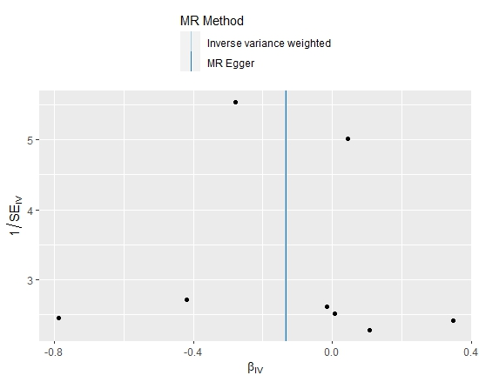

Supplementary Figure 3. Funnel plot to assess the robustness of Hcy on TAA.
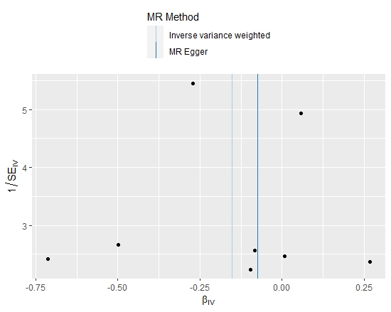

Supplementary Figure 4. Funnel plot to assess the robustness of Hcy on TAA.
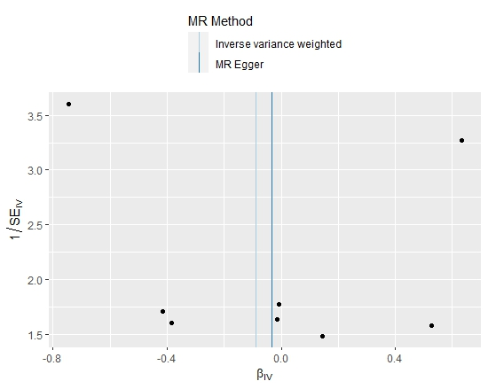

Supplementary Figure 5. Scatter plot of SNPs associated with Hcy and the risk of AAs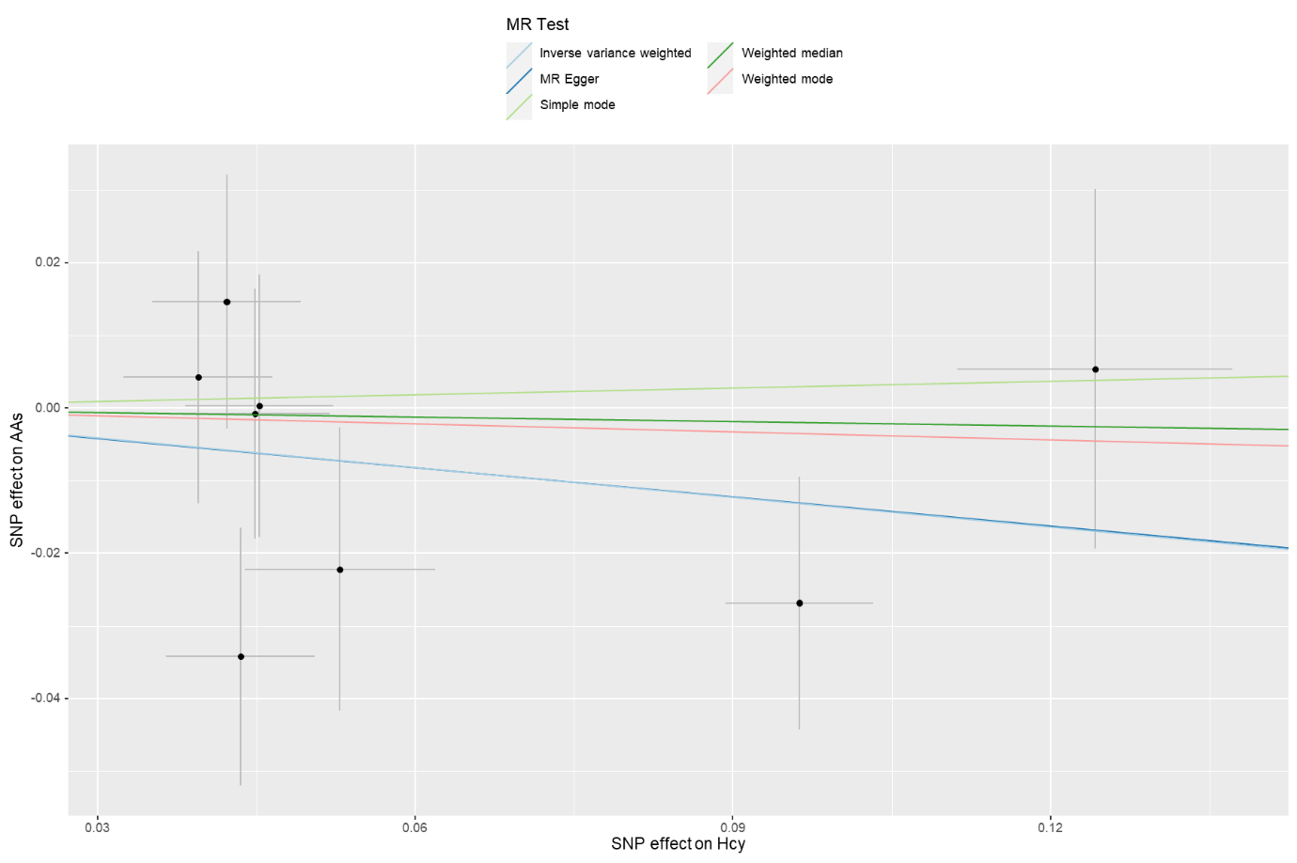
The plot related the effect sizes of the SNP−Hcy association (x−axis, SD units) and the SNP−AAs associations (y−axis, log (OR)) with 95% confidence intervals.

Supplementary Figure 6. Scatter plot of SNPs associated with Hcy and the risk of TAA.
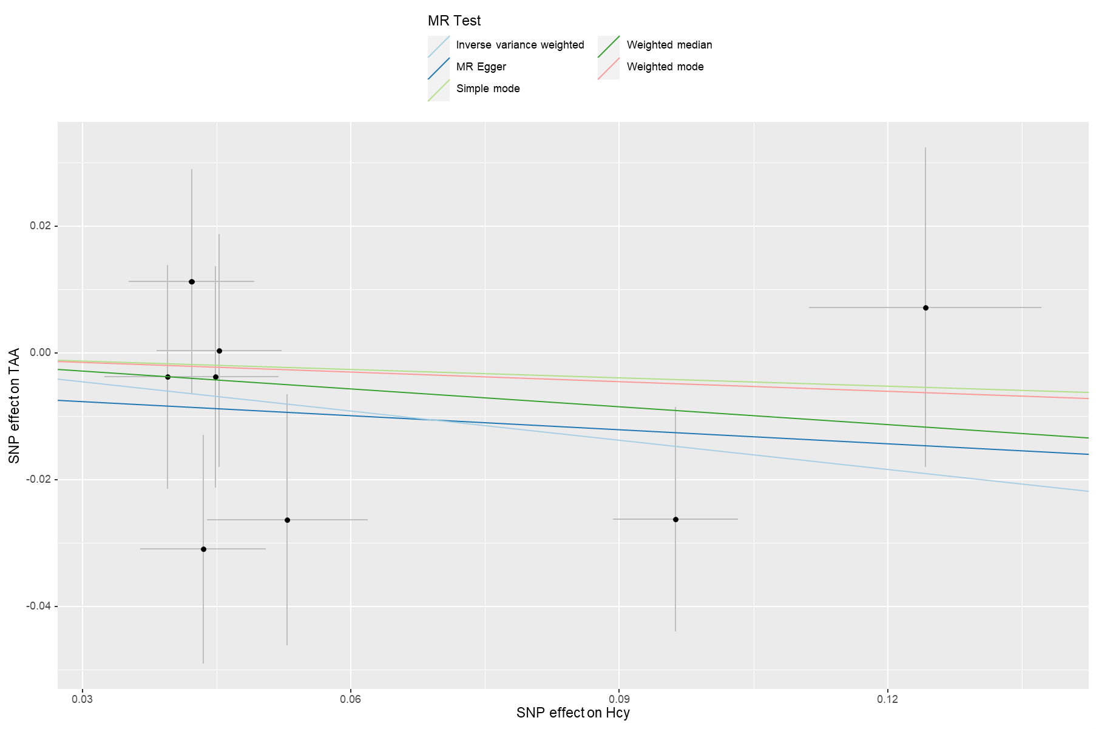
The plot related the effect sizes of the SNP-Hcy association (x-axis, SD units) and the SNP-TAA associations (y-axis, log (OR)) with 95% confidence intervals.

Supplementary Figure 7. Scatter plot of SNPs associated with Hcy and the risk of AAA.
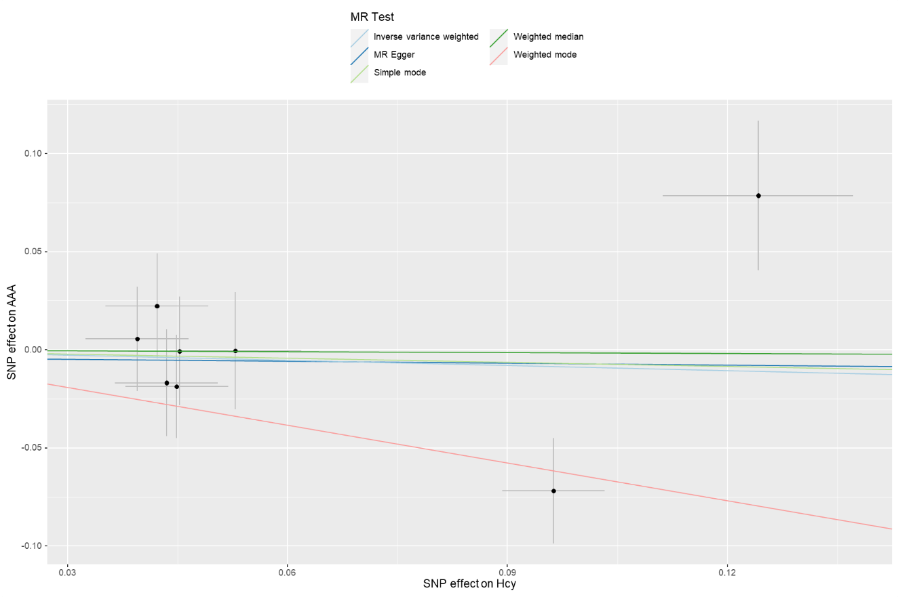
The plot related the effect sizes of the SNP-Hcy association (x-axis, SD units) and the SNP-AAA associations (y-axis, log (OR)) with 95% confidence intervals.

Supplementary Figure 8. Forest plot for leave-one-out analysis for the casual effect of Hcy on AAs
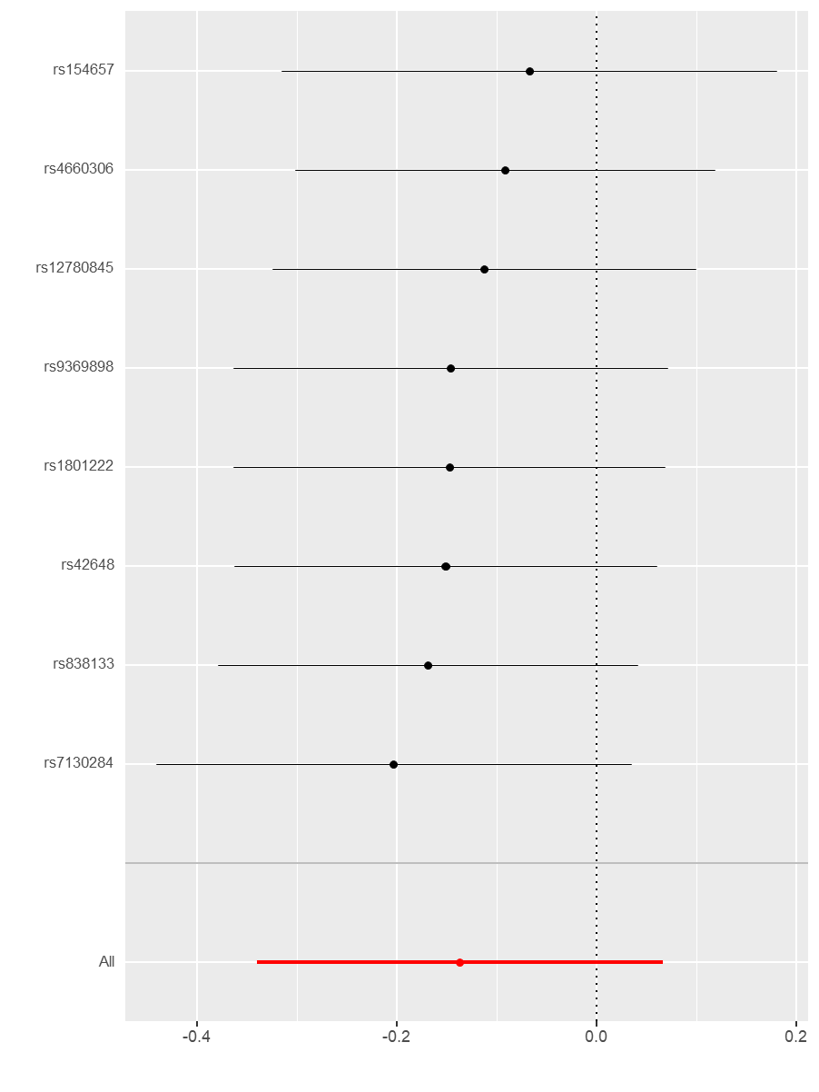
Supplementary Figure 9. Forest plot for leave-one-out analysis for the casual effect of Hcy on TAA
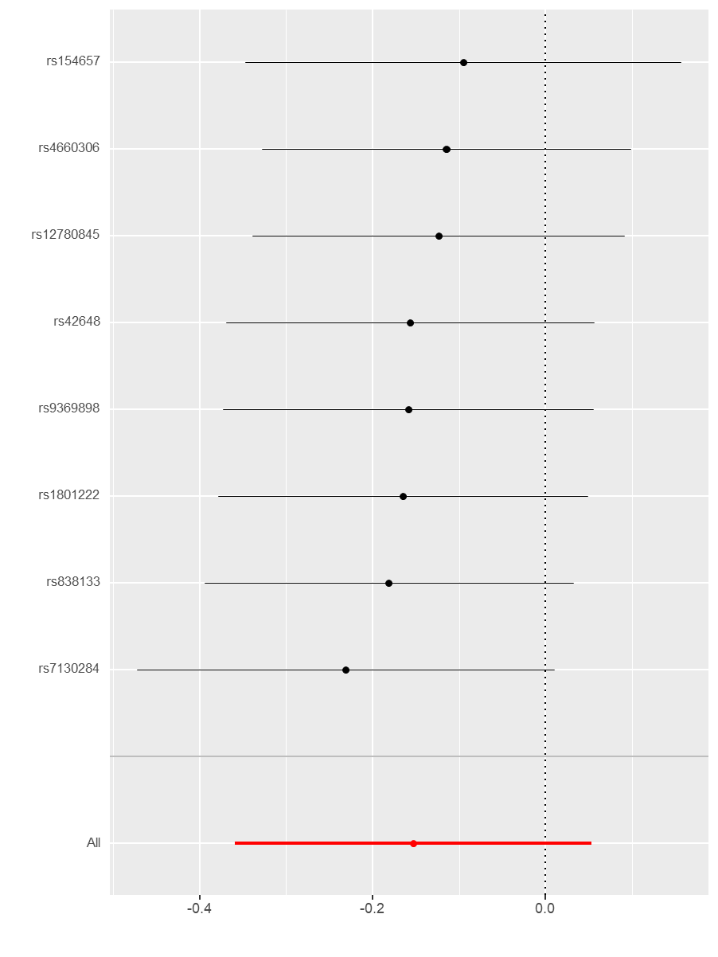

Supplementary Figure 10. Forest plot for leave-one-out analysis for the casual effect of Hcy on AAA
