Table 3: Potential risk factors for requiring analgesics level 2 or 3 - multivariate analysis

Risk factor | Non adjusted OR  [95% CI]  p-value | Adjusted OR  [95% CI]  p-value
VAS (4-10) at 8am D1 | 3.31 [1.18 – 9.26]  0.023⁽¹⁾ | 3.91 [1.24 – 12.32]  0.020⁽²⁾ | 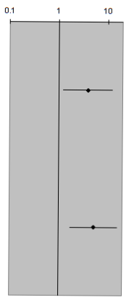
Synchronous PC | 3.00 [1.18 – 7.66]  0.022⁽¹⁾ | 5.16 [1.71 – 15.58]  0.004⁽²⁾
 |  |  | Decreased risk | Increased risk
Age | 0.97 [0.93 – 1.01]  0.144⁽¹⁾ | -
PCI score | 1.03 [0.98 – 1.09]  0.226⁽¹⁾ | -
Sex (Female) | 0.58 [0.26 – 1.27]  0.173⁽¹⁾ | -
Type of PIPAC treatment  Oxaliplatin | 1.43 [0.65 – 3.18]  0.374⁽¹⁾ | -
Origin  Colorectal  Stomach | 1.70 [0.59 – 4.90]  0.326⁽¹⁾  0.61 [0.24 – 1.55]  0.296⁽¹⁾ | -  -
BMI  <18.5  [25-29.9]  ≥30 | 0.75 [0.26 – 2.17]  0.592⁽¹⁾  2.01 [0.68 – 5.94]  0.206⁽¹⁾  0.64 [0.11 – 3.78]  0.622⁽¹⁾ | -  -  -
Odds ratio [95% Confidence Interval], Univariate logistic regression ⁽¹⁾, Multivariate logistic regression ⁽²⁾

