Article
A Potential Molecular Inhibitor of the SARS-COV-2 Main Protease Obtained by Virtual Screening
Nanxin Liu ¹, Zeyu Yang ¹, Yuying Liu ¹, Xintao Dang ¹, Qingqing Zhang ¹, Jin Wang ¹, Xueying Liu ², Jie Zhang ¹ and Xiaoyan Pan ^{1,}*
¹ School of Pharmacy, Health Science Center, Xi'an Jiaotong University, Xi’an, 710061, China.
² School of Pharmacy, The Fourth Military Medical University, Xi'an, 710032, China.
* Correspondence: panxy2016@xjtu.edu.cn.

Table S1. Docking Score of All Compounds
Title | SMILE | docking binding energy(ΔG, kcal/mol)
V1 |  | -6.626
V2 |  | -6.472
V3 |  | -6.52
V4 |  | -6.527
V5 |  | -6.36
V6 |  | -6.86
V7 |  | -6.711
V8 |  | -6.221
V9 |  | -6.475
V10 |  | -6.533
V11 |  | -6.466
V12 |  | -7.192
V13 |  | -6.733
V14 |  | -6.682
V15 |  | -6.136
V16 |  | -6.321
V17 |  | -6.407
V18 |  | -6.411
V19 |  | -6.101
V20 |  | -6.529
V21 |  | -6.763
V22 |  | -6.061
V23 |  | -6.659
V24 |  | -5.908
V25 |  | -5.956
V26 |  | -5.842
V27 |  | -6.12
V28 |  | -5.487
V29 |  | -6.303
V30 |  | -6.415
V31 |  | -6.799
V32 |  | -5.602
V33 |  | -6.088
V34 |  | -6.715
V35 |  | -6.282
V36 |  | -6.126
V37 |  | -6.401
V38 |  | -5.925
V39 |  | -6.62
V40 |  | -6.268
V41 |  | -5.188
V42 |  | -5.813
V43 |  | -6.381
V44 |  | -6.525
V45 |  | -6.403
V46 |  | -5.05
V47 |  | -6.01
V48 |  | -5.521
V49 |  | -6.328
V50 |  | -5.535
V51 |  | -6.039
V52 |  | -5.586
V53 |  | -6.355
V54 |  | -6.813
V55 |  | -6.767
V56 |  | -6.645
V57 |  | -5.978
V58 |  | -7.013
V59 |  | -6.951
V60 |  | -7.261
V61 |  | -6.346
V62 |  | -6.572
V63 |  | -6.43
V64 |  | -6.551
V65 |  | -6.611
V66 |  | -6.883
V67 |  | -6.629
V68 |  | -5.99
V69 |  | -5.648
V70 |  | -7.299
V71 |  | -6.066
V72 |  | -6.833
V73 |  | -6.759
V74 |  | -7.225
V75 |  | -7.331
V76 |  | -6.335
V77 |  | -5.902
V78 |  | -6.866
V79 |  | -6.627
V80 |  | -6.066
V81 |  | -6.061
V82 |  | -5.21
V83 |  | -6.68
V84 |  | -6.903
V85 |  | -5.975
V86 |  | -7.085
V87 |  | -6.971
V88 |  | -4.961
V89 |  | -6.948
V90 |  | -6.195
V91 |  | -6.571
V92 |  | -6.089
V93 |  | -5.944
V94 |  | -6.336
V95 |  | -6.179
V96 |  | -6.921
V97 |  | -7.138
V98 |  | -6.929
V99 |  | -6.541
V100 |  | -6.713
V101 |  | -5.911
V102 |  | -5.655
V103 |  | -7.535
V104 |  | -6.66
V105 |  | -6.812
V106 |  | -6.927
V107 |  | -6.807
V108 |  | -5.975
V109 |  | -7.567
V110 |  | -6.331
V111 |  | -7.195
V112 |  | -7.29
V113 |  | -5.688
V114 |  | -6.728
V115 |  | -6.622
V116 |  | -6.331
V117 |  | -5.895
V118 |  | -6.412
V119 |  | -5.765
V120 |  | -7.081
V121 |  | -5.925
V122 |  | -7.095
V123 |  | -6.219
V124 |  | -6.607
V125 |  | -6.991
V126 |  | -6.89
V127 |  | -6.773
V128 |  | -7.264
V129 |  | -6.636
V130 |  | -6.44
V131 |  | -7.876
V132 |  | -6.415
V133 |  | -8.379
V134 |  | -5.713
V135 |  | -6.087
V136 |  | -6.662
V137 |  | -6.378
V138 |  | -6.75
V139 |  | -7.422
V140 |  | -6.773
V141 |  | -6.33
V142 |  | -6.301
V143 |  | -6.433
V144 |  | -7.195
V145 |  | -6.482
V146 |  | -6.017
V147 |  | -7.364
V148 |  | -6.25
V149 |  | -6.896
V150 |  | -7.145
V151 |  | -6.441
V152 |  | -6.778
V153 |  | -6.788
V154 |  | -7.26
V155 |  | -7.113
V156 |  | -6.984
V157 |  | -6.881
V158 |  | -6.892
V159 |  | -7.091
V160
V161 |  | -6.514
V162 |  | -6.545
V163 |  | -7.052
V164 |  | -6.587
V165 |  | -7.051
V166 |  | -6.978
V167 |  | -6.702
V168 |  | -7.182
V169 |  | -6.611
V170 |  | -7.085
V171 |  | -6.902
V172 |  | -7.403
V173 |  | -7.138
V174 |  | -7.369
V175 |  | -7.538
V176 |  | -6.275
V177 |  | -6.861
V178 |  | -6.171
V179 |  | -5.036
V180 |  | -6.406
V181 |  | -5.335
V182 |  | -5.516
V183 |  | -6.283
V184 |  | -5.509
V185 |  | -6.401
V186 |  | -6.067
V187 |  | -6.328
V188 |  | -5.094
V189 |  | -6.027
V190 |  | -6.42
V191 |  | -5.786
V192 |  | -6.034
V193 |  | -5.887
V194 |  | -6.209
V195 |  | -5.696
V196 |  | -5.185
V197 |  | -5.434
V198 |  | -6.823
V199 |  | -5.635
V200 |  | -5.655
V201 |  | -5.182
V202 |  | -6.075
V203 |  | -6.661
V204 |  | -7.89
V205 |  | -7.501
V206 |  | -6.213
V207 |  | -6.222
V208 |  | -6.951
V209 |  | -6.811
V210 |  | -6.676
V211 |  | -6.714
V212 |  | -7.688
V213 |  | -6.946
V214 |  | -5.958
V215 |  | -7.032
V216 |  | -6.946
V217 |  | -6.482
V218 |  | -5.841
V219 |  | -7.212
V220 |  | -6.013
V221 |  | -6.943
V222 |  | -7.305
V223 |  | -6.69
V224 |  | -6.764
V225 |  | -7.068
V226 |  | -7.141
V227 |  | -6.403
V228 |  | -8.122
V229 |  | -7.509
V230 |  | -7.314
V231 |  | -7.372
V232 |  | -6.088
V233 |  | -6.277
V234 |  | -6.263
V235 |  | -6.649
V236 |  | -6.902
V237 |  | -6.847
V238 |  | -7.134
V239 |  | -6.542
V240 |  | -7.211
V241 |  | -7.108
V242 |  | -6.218
V243 |  | -7.68
V244 |  | -6.494
V245 |  | -7.401
V246 |  | -6.602
V247 |  | -8.538
V248 |  | -7.565
V249 |  | -6.568
V250 |  | -6.449
V251 |  | -5.414
V252 |  | -7.416
V253 |  | -8.832
V254 |  | -7.286
V255 |  | -5.04
V256 |  | -6.19
V257 |  | -7.37
V258 |  | -3.553
V259 |  | -5.516
V260 |  | -6.287
V261 |  | -6.367
V262 |  | -5.971
V263 |  | -4.862
V264 |  | -5.369
V265 |  | -5.701
V266 |  | -5.966
V267 |  | -5.793
V268 |  | -5.227
V269 |  | -5.781
V270 |  | -5.137
V271 |  | -6.034
V272 |  | -6.007
V273 |  | -6.396
V274 |  | -5.773
V275 |  | -5.466
V276 |  | -6.569
V277 |  | -4.427
V278 |  | -5.387
V279 |  | -4.871
V280 |  | -4.957
V281 |  | -5.4
V282 |  | -7.481
V283 |  | -7.532
V284 |  | -6.727
V285 |  | -6.488
V286 |  | -7.432
V287 |  | -6.09
V288 |  | -6.442
V289 |  | -6.649
V290 |  | -6.502
V291 |  | -8.071
V292 |  | -6.936
V293 |  | -7.205
V294 |  | -6.207
V295 |  | -6.849
V296 |  | -5.938
V297 |  | -6.48
V298 |  | -6.864
V299 |  | -6.747
V300 |  | -6.622
V301 |  | -6.43
V302 |  | -5.789
V303 |  | -7.458
V304 |  | -7.878
V305 |  | -6.156
V306 |  | -7.335
V307 |  | -6.666
V308 |  | -6.237
V309 |  | -6.923
V310 |  | -6.808
V311 |  | -6.514
V312 |  | -6.785
V313 |  | -6.472
V314 |  | -6.415
V315 |  | -6.398
V316 |  | -6.937
V317 |  | -6.556
V318 |  | -5.716
Nilotinib |  | -7.026

Table S2. The interaction between molecule and M^{pro} (based on the IFD docking results)
Compound | Molecular Interactions | Nature of Interactions | Distance (Å)
V247 | Lig:N1 - Glu166:OE2 | Salt bridge | 3.81
V247 | Asn142:HD21 - Lig:O4 | Hydrogen Bond | 2.10
V247 | Lig:H15 - His164:O | Hydrogen Bond | 3.26
V247 | Lig:H11 - Glu166:O | Hydrogen Bond | 1.96
V247 | Lig:H36 - Glu166:O | Hydrogen Bond | 2.69
V247 | Gln189:HE21 - Lig:O1 | Hydrogen Bond | 1.96
V247 | Gln192:HE21 - Lig:N3 | Hydrogen Bond | 2.60
V253 | Lig:N1 - Glu166:OE2 | Salt bridge | 3.17
V253 | Lig:H19 - Leu141:O | Hydrogen Bond | 1.97
V253 | Gly143:H - Lig:O4 | Hydrogen Bond | 2.15
V253 | Ser144:H - Lig:O4 | Hydrogen Bond | 2.68
V253 | Cys145:H - Lig:O4 | Hydrogen Bond | 2.17
V253 | Lig:H15 - His164:O | Hydrogen Bond | 1.78
V253 | Lig:H28 - Glu166:OE2 | Hydrogen Bond | 2.43
V253 | Lig:H11 - Glu166:O | Hydrogen Bond | 2.62
V253 | Gln189:HE21 - Lig:O2 | Hydrogen Bond | 2.91
V253 | Gln192:H – Lig:N3 | Hydrogen Bond | 3.17
V253 | Gln192:HE21 – Lig:N3 | Hydrogen Bond | 2.73
V253 | His41 - Lig | Hydrophobic (Pi-Pi Stacking) | 5.47
V253 | His41 - Lig | Hydrophobic (Pi-Pi Stacking) | 5.43
V133 | Lig:N3 - Glu166:OE2 | Salt bridge | 3.23
V133 | Gly143:H - Lig:O2 | Hydrogen Bond | 1.91
V133 | Cys145:H – Lig:O2 | Hydrogen Bond | 3.33
V133 | Lig:H28 - Glu166:OE2 | Hydrogen Bond | 2.36
V133 | Lig:H24 – Glu166:O | Hydrogen Bond | 2.00
V133 | Lig:H5 - Arg188:O | Hydrogen Bond | 2.71
V133 | Gln189:HE21 - Lig:O1 | Hydrogen Bond | 1.98
V109 | Lig:N1 – Glu166:OE2 | Salt bridge | 2.77
V109 | His41:HD1 – Lig:O2 | Hydrogen Bond | 2.21
V109 | Asn142:HD21 – Lig:O3 | Hydrogen Bond | 2.13
V109 | Gly143:H – Lig:O3 | Hydrogen Bond | 2.12
V109 | Lig:H11 – Glu166:O | Hydrogen Bond | 2.30
V109 | Lig:H30 – Glu166:OE2 | Hydrogen Bond | 1.82
V109 | Gln192:H – Lig:N3 | Hydrogen Bond | 2.04
V109 | His41 - Lig | Hydrophobic (Pi-Pi Stacking) | 5.29
V131 | Lig:H19 – His41:NE2 | Hydrogen Bond | 3.19
V131 | Gly143:H – Lig:O3 | Hydrogen Bond | 1.82
V131 | Ser144:H – Lig:O3 | Hydrogen Bond | 2.49
V131 | Cys145:H – Lig:O3 | Hydrogen Bond | 2.65
V131 | Lig:H14 – His164:O | Hydrogen Bond | 1.86
V131 | Lig:H8 – Glu166:O | Hydrogen Bond | 2.09
V131 | Gln192:HE21 – Lig:N2 | Hydrogen Bond | 3.14
V131 | Gln192:H – Lig:N2 | Hydrogen Bond | 3.36
V131 | Thr26:H – Lig:Cl1 | Halogen Bond | 2.40
V254 | Gly143:H – Lig:O3 | Hydrogen Bond | 2.23
V254 | Ser144:H – Lig:O3 | Hydrogen Bond | 2.29
V254 | Cys145:H – Lig:O3 | Hydrogen Bond | 1.98
V254 | Lig:H18 – His163:NE | Hydrogen Bond | 2.02
V254 | Gln182:HE21 – Lig:O1 | Hydrogen Bond | 1.99
V254 | Thr190:H – Lig:N2 | Hydrogen Bond | 2.87
V254 | Thr26:H – Lig:Cl1 | Halogen Bond | 2.65
V282 | Lig:H22 – Met49:O | Hydrogen Bond | 3.16
V282 | Lig:H14 – Phe140:O | Hydrogen Bond | 2.27
V282 | Asn142:HD22 – Lig:O1 | Hydrogen Bond | 2.42
V282 | Lig:H11 – Asp187:O | Hydrogen Bond | 3.31
V282 | Gln189:HE21 – Lig:O2 | Hydrogen Bond | 1.77
V282 | Gln192:H – Lig:Cl1 | Halogen Bond | 2.27
V139 | Cys44:HG – Lig:O3 | Hydrogen Bond | 2.97
V139 | Lig:H12 – His164:O | Hydrogen Bond | 2.35
V139 | Gln189:HE21 – Lig:O2 | Hydrogen Bond | 2.08
V139 | Thr26:O – Lig:Cl1 | Halogen Bond | 3.32
V139 | Thr26:H – Lig:Cl1 | Halogen Bond | 3.48
V231 | Lig:H23 – His164:O | Hydrogen Bond | 3.36
V231 | Glu166:H – Lig:O1 | Hydrogen Bond | 2.59
V231 | Gln189:HE21 – Lig:O3 | Hydrogen Bond | 1.87
V231 | Lig:H7 – Gln192:O | Hydrogen Bond | 2.06
V128 | Thr26:H – Lig:O2 | Hydrogen Bond | 2.14
V128 | Gly143:H- Lig:N3 | Hydrogen Bond | 2.06
V128 | Lig:H19 – Glu166:O | Hydrogen Bond | 1.60
V128 | Glu166:H – Lig:O1 | Hydrogen Bond | 1.87
V128 | Lig:H5 – Gln189:OE1 | Hydrogen Bond | 1.87
V160 | Thr26:H – Lig:O2 | Hydrogen Bond | 2.23
V160 | Gly143:H – Lig:O2 | Hydrogen Bond | 1.85
V160 | Cys145:H – Lig:O1 | Hydrogen Bond | 3.14
V160 | Lig:H4 – Glu166:O | Hydrogen Bond | 2.10
V163 | Thr26:H – Lig:O2 | Hydrogen Bond | 2.27
V163 | Gly143:H – Lig:O1 | Hydrogen Bond | 1.79
V163 | Cys145:H – Lig:O1 | Hydrogen Bond | 3.02
V174 | Thr26:H – Lig:O2 | Hydrogen Bond | 2.89
V174 | His41:HD1 – Lig:N3 | Hydrogen Bond | 2.13
V174 | Gly143:H – Lig:O1 | Hydrogen Bond | 1.99
V174 | Cys145:H – Lig:O1 | Hydrogen Bond | 3.12
V174 | Gln192:H – Lig:Cl2 | Halogen Bond | 1.98
V174 | Gln192:O – Lig:Cl2 | Halogen Bond | 3.37
V174 | His41 - Lig | Hydrophobic (Pi-Pi Stacking) | 4.11
V243 | Asn142:HD21 - Lig:O3 | Hydrogen Bond | 1.91
V243 | Gly143:H - Lig:O4 | Hydrogen Bond | 2.14
V243 | Glu166:H - Lig:O1 | Hydrogen Bond | 2.14
V243 | Lig:H1 - Arg188:O | Hydrogen Bond | 2.31
V243 | Lig:H24 - Thr26:O | Hydrogen Bond | 2.02
V243 | His41 - Lig | Hydrophobic (Pi-Pi Stacking) | 4.06
V229 | Lig:H23 – His:164 | Hydrogen Bond | 3.18
V229 | Glu166:H – Lig:O1 | Hydrogen Bond | 2.92
V229 | Gln189:HE21 – Lig:O4 | Hydrogen Bond | 1.74
V229 | Gln192:H – Lig:N2 | Hydrogen Bond | 2.41
V204 | Thr26:H – Lig:O2 | Hydrogen Bond | 1.91
V204 | Gly143:H – Lig:O1 | Hydrogen Bond | 1.92
V204 | Cys145:H – Lig:O1 | Hydrogen Bond | 2.66
V204 | His164:O – Lig:H2 | Hydrogen Bond | 2.39
V204 | Lig:H3 – Arg188:O | Hydrogen Bond | 2.03
V204 | Thr24:HG1 – Lig:Cl1 | Halogen Bond | 3.31
V204 | Thr45:H – Lig:Cl2 | Halogen Bond | 2.22
V204 | Thr45:OG1 – Lig:Cl2 | Halogen Bond | 3.09
V291 | Lig:N2 - Glu166:OE2 | Salt bridge | 4.88
V291 | Lig:H14 - Thr26:O | Hydrogen Bond | 1.94
V291 | Thr26:H – Lig:N7 | Hydrogen Bond | 2.92
V291 | Lig:H12 - His41:O | Hydrogen Bond | 2.24
V291 | Lig:H19 - Asn142:OD1 | Hydrogen Bond | 2.21
V291 | Asn142:H - Lig:O1 | Hydrogen Bond | 2.62
V291 | Gly143:H - Lig:N5 | Hydrogen Bond | 2.13
V291 | Cys145:H – Lig:N5 | Hydrogen Bond | 3.00
V291 | Lig:H2 - Glu166:OE1 | Hydrogen Bond | 1.89
V291 | Lig:H2 - Glu166:OE2 | Hydrogen Bond | 3.07
V291 | His41 – Lig | Hydrophobic (Pi-Pi Stacking) | 4.40
V291 | His41 – Lig | Hydrophobic (Pi-Pi Stacking) | 4.58
V291 | His163 - Lig | Hydrophobic (Pi-Pi Stacking) | 5.26
V228 | Lig:H1 - His41:NE2 | Hydrogen Bond | 2.63
V228 | Asn142:H - Lig:O2 | Hydrogen Bond | 2.57
V228 | Lig:H10 - Asn142:OD1 | Hydrogen Bond | 1.98
V228 | Lig:H1 - His164:O | Hydrogen Bond | 3.10
V228 | Lig:H21 - Glu166:OE1 | Hydrogen Bond | 1.68
V228 | His172:HE2 – Lig:O3 | Hydrogen Bond | 3.14
V228 | Gln189:HE21 - Lig:O1 | Hydrogen Bond | 1.91
V170 | Thr26:H – Lig:O2 | Hydrogen Bond | 1.94
V170 | Gly143:H – Lig:O1 | Hydrogen Bond | 1.97
V170 | Cys145:H – Lig:O1 | Hydrogen Bond | 2.88
V170 | Lig:H12 – Glu166:O | Hydrogen Bond | 2.32
V170 | Thr24:HG1 – Lig:Cl1 | Hydrogen Bond | 3.21
V170 | His41 - Lig | Hydrophobic (Pi-Pi Stacking) | 5.36
V75 | Thr26:H – Lig:O2 | Hydrogen Bond | 1,99
V75 | Gly143:H – Lig:O3 | Hydrogen Bond | 1.95
V75 | Cys145:H – Lig:O3 | Hydrogen Bond | 2.53
V75 | Lig:H15 – Glu166:O | Hydrogen Bond | 1.99
V75 | Gln189:HE21 – Lig:O4 | Hydrogen Bond | 1.90
V75 | His41 - Lig | Hydrophobic (Pi-Pi Stacking) | 5.41
V120 | Asn142:HD21 – Lig:O1 | Hydrogen Bond | 2.20
V120 | Gly143:H – Lig:O1 | Hydrogen Bond | 2.04
V120 | Cys145:HG – Lig:N4 | Hydrogen Bond | 2.50
V120 | Lig:H9 – Glu166:O | Hydrogen Bond | 2.09
V120 | Lig:H14 – Glu166:O | Hydrogen Bond | 1.97
V120 | Gln192:HE21 – Lig:O2 | Hydrogen Bond | 2.00
V120 | His41 - Lig | Hydrophobic (Pi-Pi Stacking) | 4.21
V245 | Thr25:HG1 – Lig:O1 | Hydrogen Bond | 1.95
V245 | Thr26:H – Lig:O1 | Hydrogen Bond | 1.93
V245 | Gly143:H – Lig:N2 | Hydrogen Bond | 1.99
V245 | Cys145:H – Lig:N2 | Hydrogen Bond | 3.24
V245 | Glu166:H – Lig:O3 | Hydrogen Bond | 3.28
V245 | His41 - Lig | Hydrophobic (Pi-Pi Stacking) | 5.12
V226 | His41:HD1 – Lig:O1 | Hydrogen Bond | 1.79
V226 | Asn142:HD21 – Lig:N2 | Hydrogen Bond | 2.20
V226 | Lig:H25 – Glu166:O | Hydrogen Bond | 2.25
V226 | Gln189:HE21 – Lig:O3 | Hydrogen Bond | 2.07
V226 | His41 - Lig | Hydrophobic (Pi-Pi Stacking) | 5.26
V252 | Lig:H17 - Leu141:O | Hydrogen Bond | 2.17
V252 | Asn142:HD21 - Lig:O1 | Hydrogen Bond | 2.08
V252 | Gly143:H - Lig:O1 | Hydrogen Bond | 2.07
V252 | Gly143:H - Lig:O2 | Hydrogen Bond | 2.33
V252 | Cys145:H - Lig:O2 | Hydrogen Bond | 2.40
V252 | Lig:H9 - His164:O | Hydrogen Bond | 1.99
V252 | Gln189:HE21 - Lig:O3 | Hydrogen Bond | 2.85
V252 | Gln192:H - Lig:O4 | Hydrogen Bond | 1.95
V154 | Thr26:H – Lig:O2 | Hydrogen Bond | 2.25
V154 | Gly143:H – Lig:O1 | Hydrogen Bond | 1.74
V154 | Cys145:H – Lig:O1 | Hydrogen Bond | 2.99
V154 | Gln192:H – Lig:Br1 | Halogen Bond | 2.34
V154 | His41 – Lig | Hydrophobic (Pi-Pi Stacking) | 4.28
V304 | Lig:N1 - Glu166:OE2 | Salt bridge | 4.49
V304 | Lig:H7 – Thr25:OG1 | Hydrogen Bond | 2.19
V304 | Ser144:HG – Lig:N3 | Hydrogen Bond | 2.53
V304 | Ser144:H – Lig:N4 | Hydrogen Bond | 2.93
V304 | Cys145:H – Lig:N4 | Hydrogen Bond | 2.89
V304 | Glu166:H – Lig:O1 | Hydrogen Bond | 1.83
V304 | Lig:H2 – Glu166:OE1 | Hydrogen Bond | 2.01
V304 | His41 – Lig | Hydrophobic (Pi-Pi Stacking) | 4.98
V304 | His41 – Lig | Hydrophobic (Pi-Pi Stacking) | 5.17
V304 | His41 – Lig | Hydrophobic (Pi-Pi Stacking) | 5.37
V172 | Thr26:H – Lig:O2 | Hydrogen Bond | 1.90
V172 | Lig:H4 – Gln189:OE1 | Hydrogen Bond | 1.85
V172 | Gly143:H – Lig:O1 | Hydrogen Bond | 2.07
V172 | Ser144:H – Lig:O1 | Hydrogen Bond | 2.32
V172 | Cys145:H – Lig:O1 | Hydrogen Bond | 2.34
V97 | His41:HD1 – Lig:O2 | Hydrogen Bond | 1.84
V97 | Thr26:H – Lig:O3 | Hydrogen Bond | 2.06
V97 | Glu166:H – Lig:N2 | Hydrogen Bond | 2.15
V97 | Lig:H1 – Glu166:O | Hydrogen Bond | 2.32
V97 | Gln189:HE21 – Lig:O1 | Hydrogen Bond | 1.84
V97 | His41 – Lig | Hydrophobic (Pi-Pi Stacking) | 4.92
V111 | Thr26:H – Lig:O2 | Hydrogen Bond | 2.07
V111 | Lig:H6 – His41:NE2 | Hydrogen Bond | 2.58
V111 | Asn142:HD21 – Lig:O1 | Hydrogen Bond | 2.11
V111 | Gly143:H – Lig:O1 | Hydrogen Bond | 1.91
V111 | Lig:H2 – His164:O | Hydrogen Bond | 2.86
V111 | Lig:H3 – Val186:O | Hydrogen Bond | 3.44
V111 | Arg188:O – Lig:H3 | Hydrogen Bond | 2.10
V111 | Ser46:H – Lig:Br1 | Halogen Bond | 2.71
V238 | His41:HD1 – Lig:O2 | Hydrogen Bond | 2.02
V238 | Asn142:HD21 – Lig:O3 | Hydrogen Bond | 1.98
V238 | Gly143:H – Lig:O3 | Hydrogen Bond | 2.26
V238 | Gln192:HE21 – Lig:N2 | Hydrogen Bond | 3.15
V238 | His41 – Lig | Hydrophobic (Pi-Pi Stacking) | 4.73
V60 | Thr26:H – Lig:O3 | Hydrogen Bond | 2.15
V60 | Gly143:H – Lig:O2 | Hydrogen Bond | 2.00
V60 | Cys145:H – Lig:O2 | Hydrogen Bond | 2.96
V60 | His41:HD1 – Lig:N3 | Hydrogen Bond | 1.96
V60 | Lig:H6 – Arg188:O | Hydrogen Bond | 2.76
V60 | His41 – Lig | Hydrophobic (Pi-Pi Stacking) | 4.17
V103 | Thr24:O – Lig:H8 | Hydrogen Bond | 2.19
V103 | Ser46:H – Lig:N2 | Hydrogen Bond | 2.37
V103 | Gly143:H – Lig:O2 | Hydrogen Bond | 1.74
V103 | Cys145:H – Lig:O2 | Hydrogen Bond | 3.37
V103 | Glu166:H – Lig:O3 | Hydrogen Bond | 1.85
Nilotinib | Asn142:HD22 - Lig:O1 | Hydrogen Bond | 2.56
Nilotinib | Asn142:HD21 - Lig:N6 | Hydrogen Bond | 2.33
Nilotinib | Cys145:HG - Lig:N5 | Hydrogen Bond | 2.48
Nilotinib | Lig:H16 - His164:O | Hydrogen Bond | 2.58
Nilotinib | Lig:H9 - Glu166:OE2 | Hydrogen Bond | 1.96
Nilotinib | Gln189:HE21 – Lig:N6 | Hydrogen Bond | 2.01
Nilotinib | Gln189:HE22 - Lig:O1 | Hydrogen Bond | 2.06

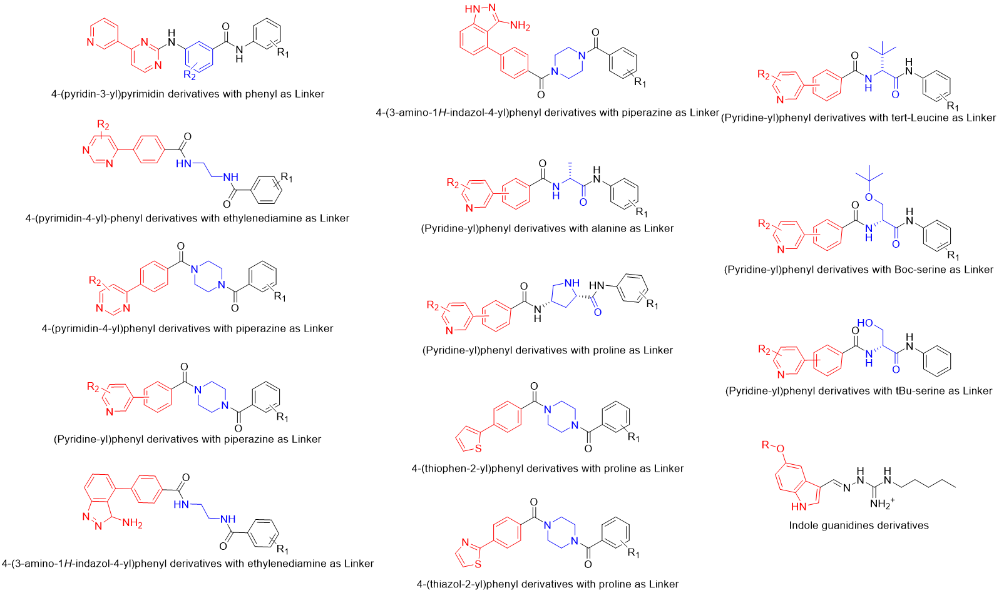
Figure S1. Structure types of all compounds.

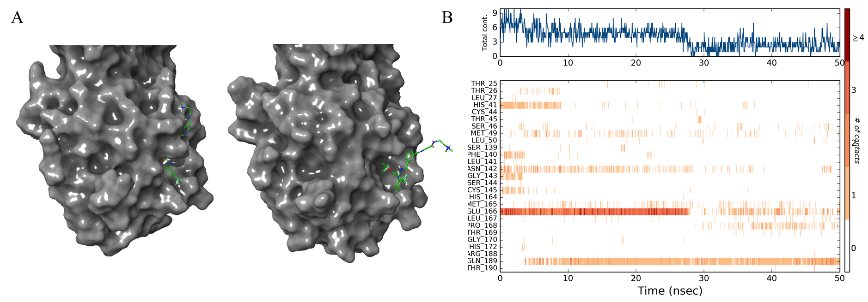
Figure S2. (A) Spatial structure of V247-M^{pro} complex at different times during dynamic simulation. At 1ns, the molecule binds closely to the protein (left); at 28ns, N-(2-dimethylamino)ethyl)nicotinamide of ligand structure has separated from the protein surface (right). (B) The interaction between V247 and the residues of the M^{pro} during 20 ns. Top panel shows the total number of specific contacts the protein makes with the ligand over the course of the trajectory, and bottom panel shows which residues interact with the ligand in each trajectory frame.

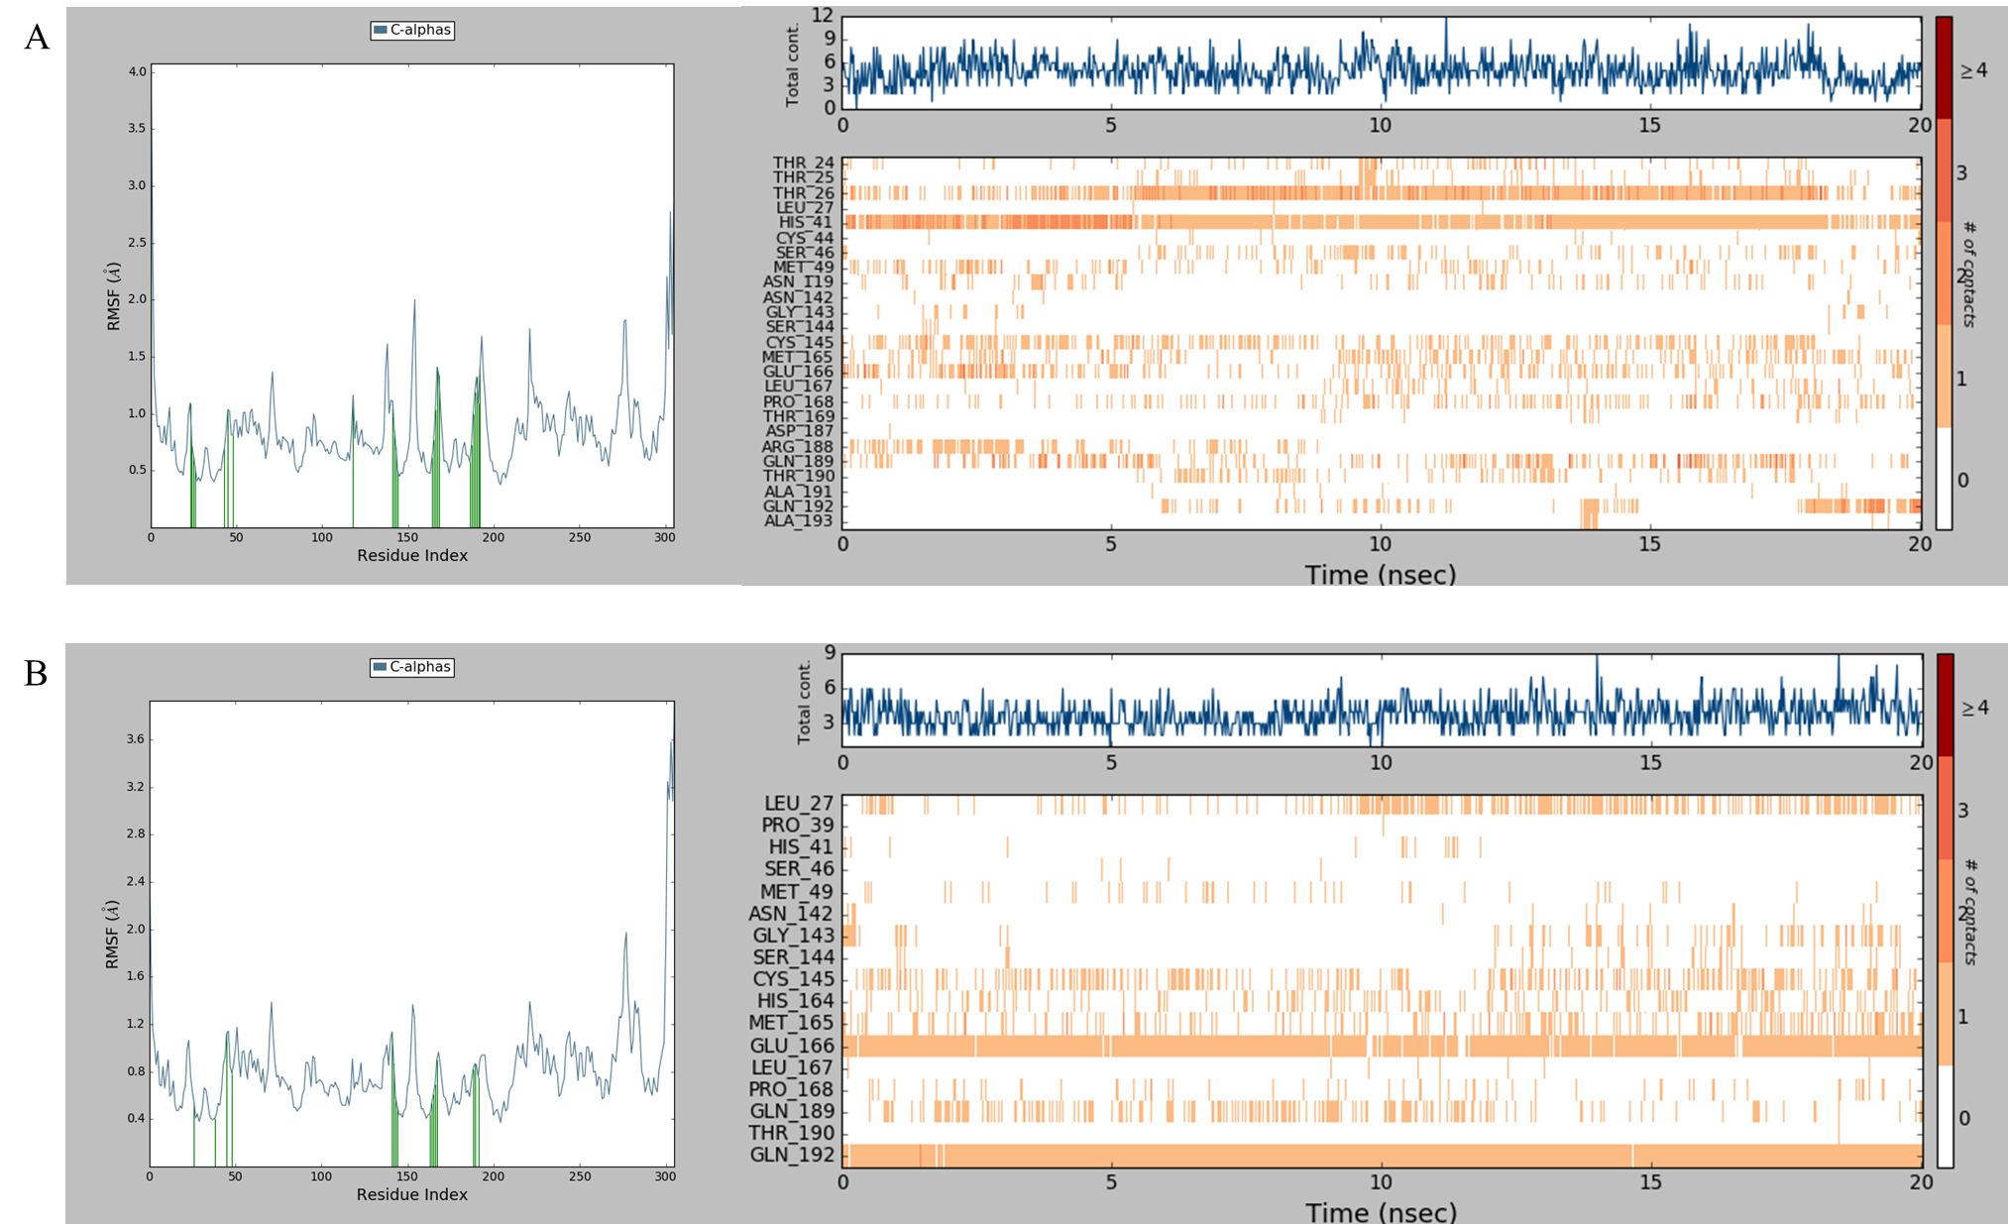
Figure S3. Protein RMSF plot (left) and Protein-Ligand Contacts (right) of V75-M^{pro} complex (A) and V97-M^{pro} complex (B)
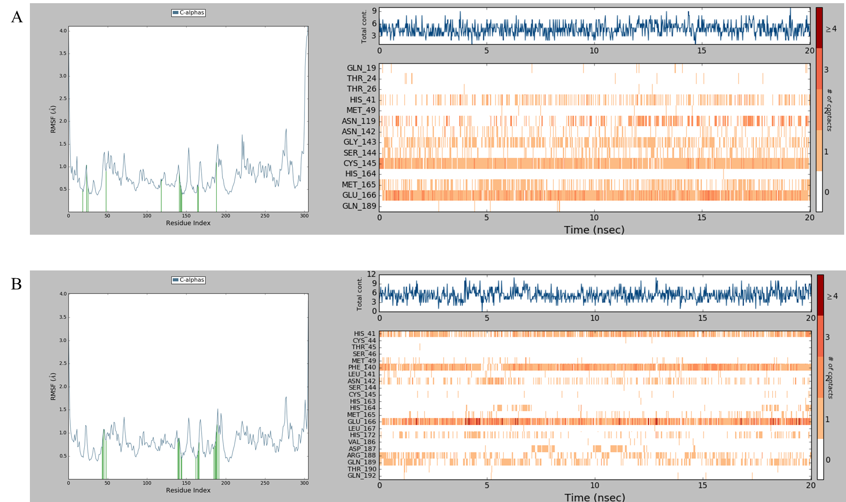
Figure S4. Protein RMSF plot (left) and Protein-Ligand Contacts (right) of V111-M^{pro} complex (A) and V139-M^{pro} complex (B)
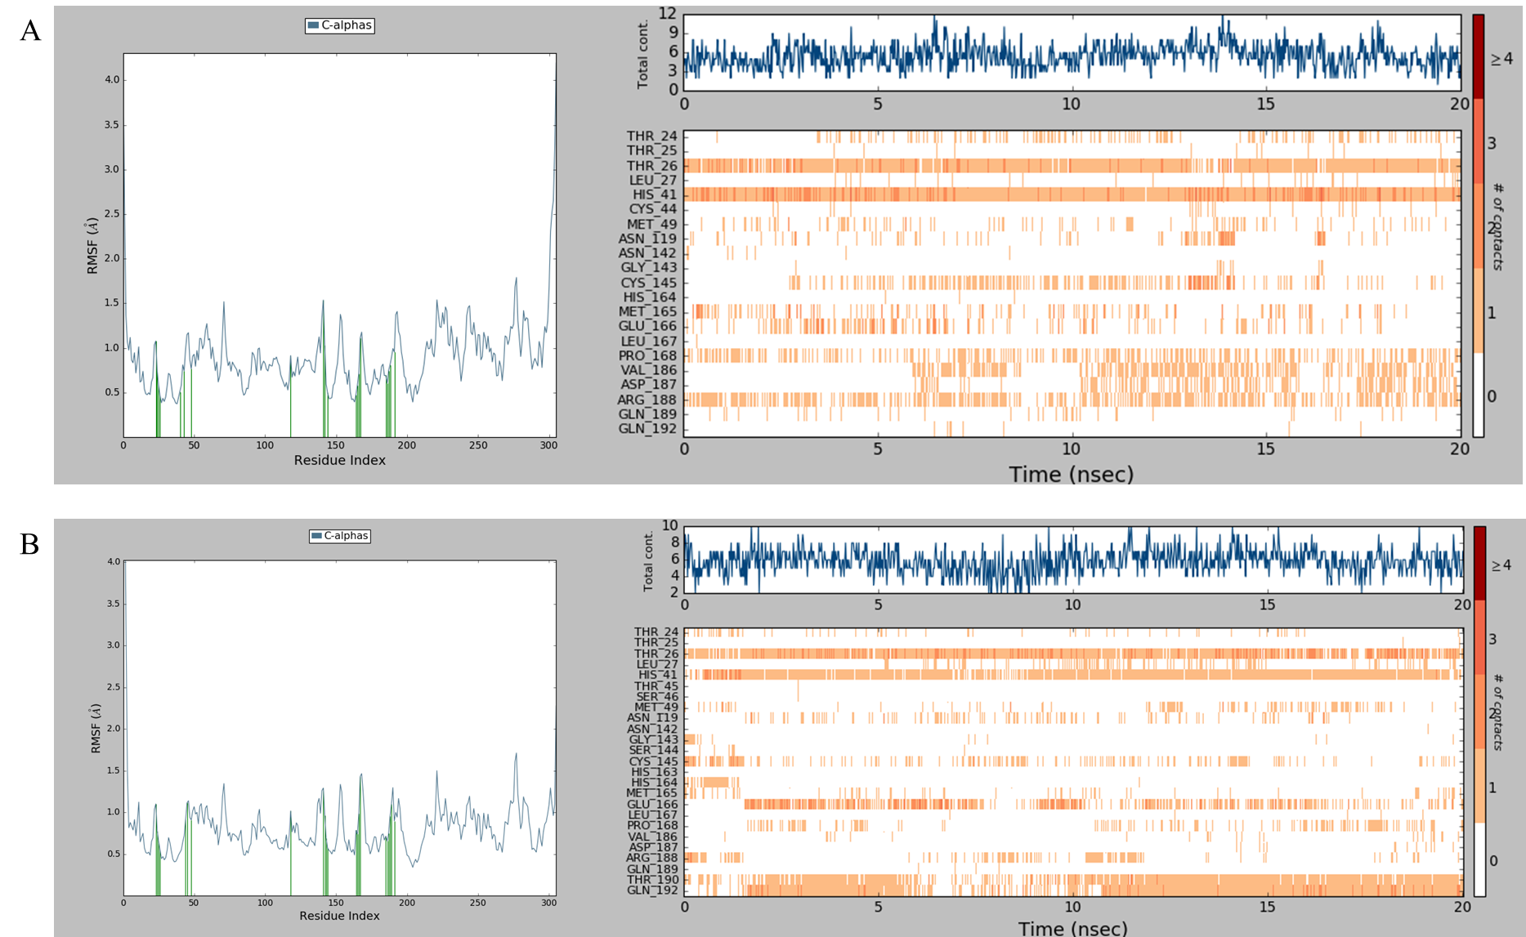
Figure S5 Protein RMSF plot (left) and Protein-Ligand Contacts (right) of V159-M^{pro} complex (A) and V205-M^{pro} complex (B)
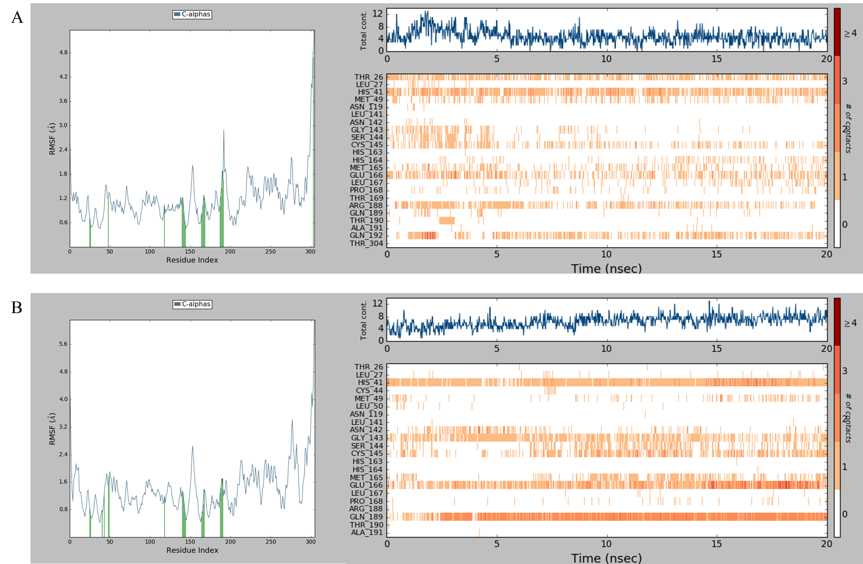
Figure S6. Protein RMSF plot (left) and Protein-Ligand Contacts (right) of V222-M^{pro} complex (A) and V226-M^{pro} complex (B)
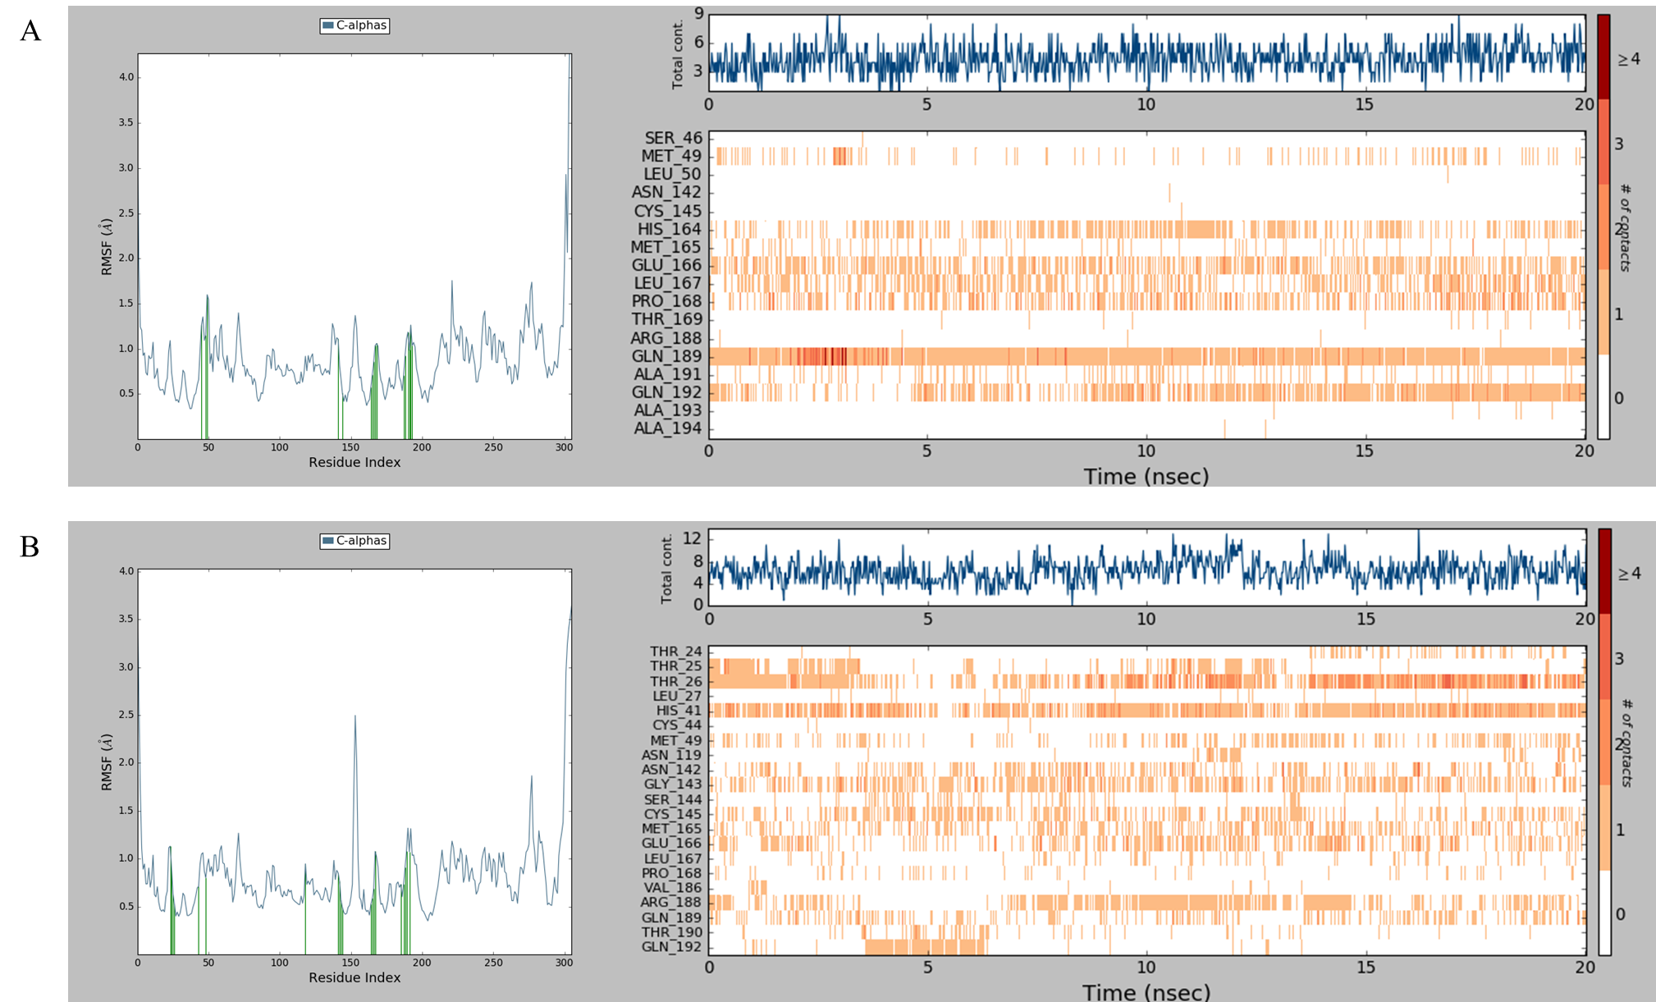
Figure S7. Protein RMSF plot (left) and Protein-Ligand Contacts (right) of V231-M^{pro} complex (A) and V243-M^{pro} complex (B)
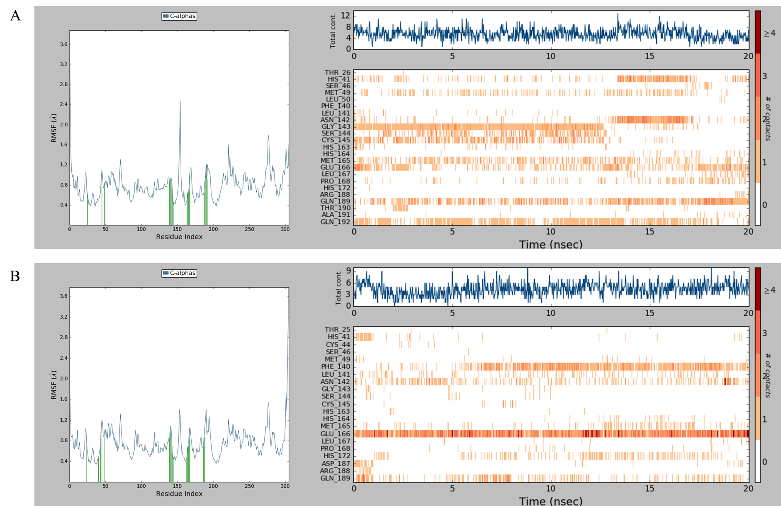
Figure S8. Protein RMSF plot (left) and Protein-Ligand Contacts (right) of V254-M^{pro} complex (A) and V282-M^{pro} complex (B)
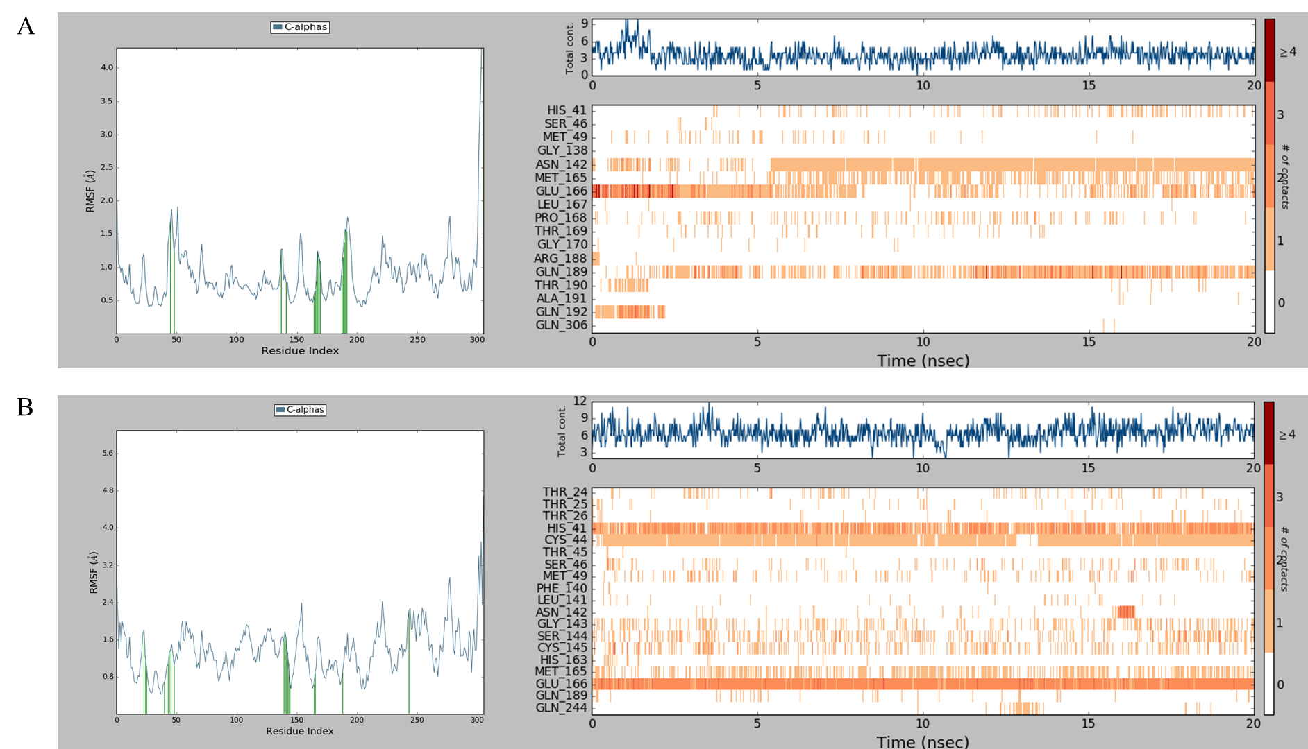
Figure S9. Protein RMSF plot (left) and Protein-Ligand Contacts (right) of V291-M^{pro} complex (A) and V304-M^{pro} complex (B)

