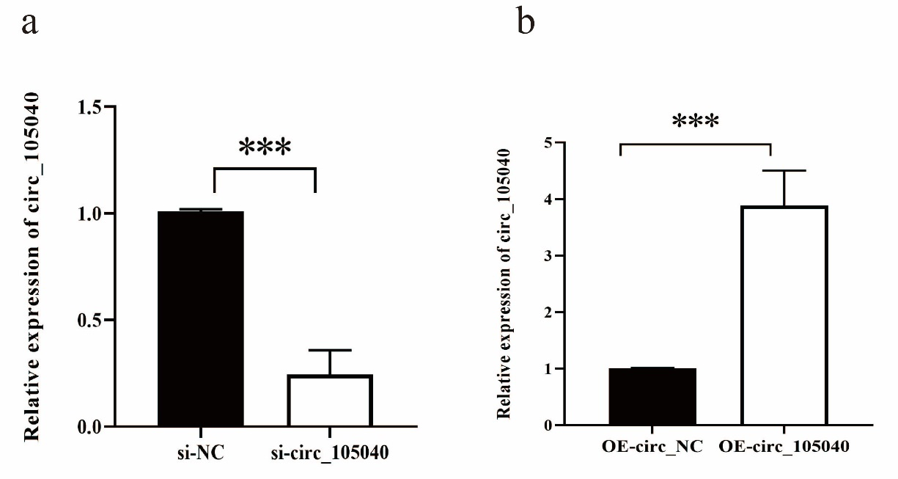
Supplementary Figure 1
Figure S1. Silencing or overexpression of hsa_circ_0105040 in human primary keratinocytes. (a) qRT-PCR analysis of hsa_circ_0105040 expression in human primary keratinocytes transfected with hsa_circ_0105040 or control siRNA. (b) qRT-PCR analysis of hsa_circ_0105040 expression in human primary keratinocytes transfected with hsa_circ_0105040 plasmid or empty control plasmid. si-NC, control siRNA; si-circ_105040, hsa_circ_0105040 siRNA; OE-circ_NC, empty control plasmid; OE-circ_105040, hsa_circ_0105040 overexpression plasmid. Student’s t-test: ***P < 0.001.

Supplementary Figure 2
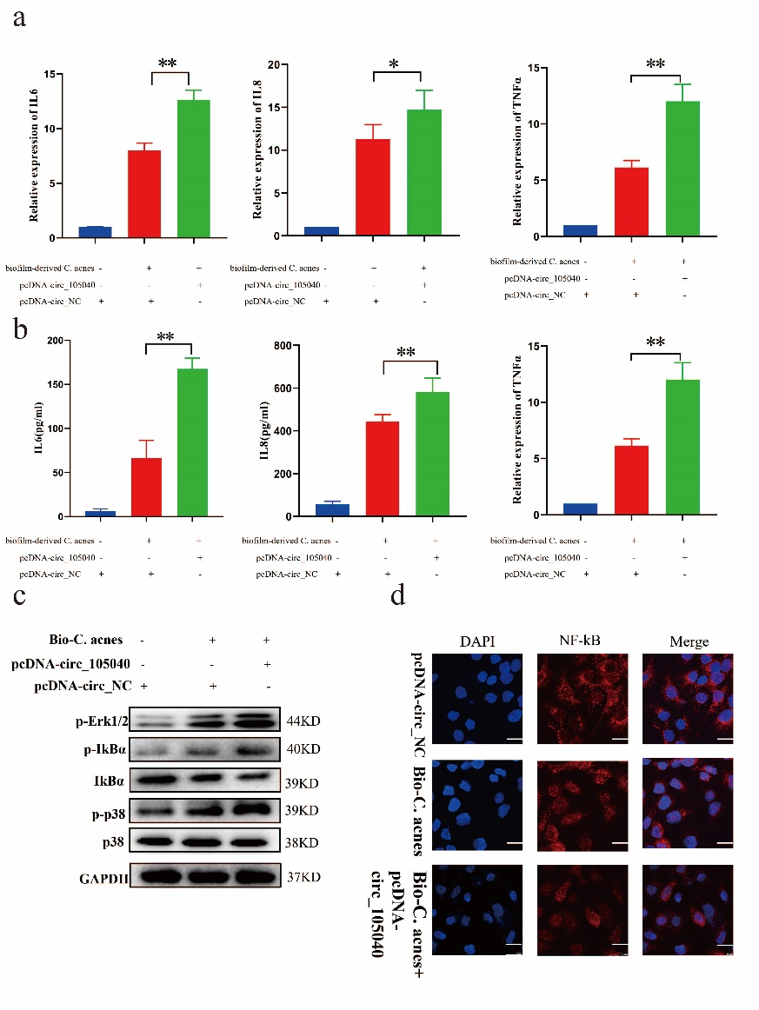
Figure S2. Overexpression hsa_circ_0105040 inhibits inflammatory response induced by C. acnes biofilm in human primary keratinocytes. Relative IL6, IL8 and TNF-α mRNA (a), and protein expression (b) in human primary keratinocytes transfect with hsa_circ_0105040 or control plasmid upon 2×10⁸CFU/ml heat-inactivated C. acnes biofilm. (c) Relative p-IκBα, IκBα, p-P38, P38 and p-ERK1/2 protein expression in human primary keratinocytes transfect with hsa_circ_0105040 or control plasmid upon 2×10⁸CFU/ml heat-inactivated C. acnes biofilm. (d) the staining of immunofluorescence for NF-κB P65 (red) and DAPI (blue) in human primary keratinocytes transfect with hsa_circ_0105040 or control plasmid upon 2×10⁸CFU/ml heat-inactivated C. acnes biofilm. Scale bars:5μm. Bio-C. acnes, C. acnes biofilm; pcDNA-circ_NC, empty control plasmid; pcDNA-circ_105040, hsa_circ_0105040 overexpression plasmid. Student’s t-test: *P < 0.05, **P < 0.01.
Supplementary Table S1:
Table S1. Sequence information for qRT-PCR primers used in described studies
Gene name | Primer Sequences (5’ to 3’)
has-circ_0105040 Forward | GGGATGCAGTGCGAGATGTG
has-circ_0105040 Reverse | CGCTTCACGAATTTGCGTGTCAT
FLNA Forward | CTGTCACAGGTGCTGGCAT
FLNA Reverse | CATTCTCCACCACGTCCACA
IL6 Forward | TTCGGCAAATGTAGCATG
IL6 Reverse | AATAGTGTCCTAACGCTCATAC
IL8 Forward | GGTGCAGAGGGTTGTGGAGAA
IL8 Reverse | GCAGACTAGGGTTGCCAGATT
TNF-α Forward | CGAGTGACAAGCCTGTAGC
TNF-α Reverse | GGTGTGGGTGAGGAGCACAT
TRAF6 Forward | TTTGCTCTTATGGATTGTCCCC
TRAF6 Reverse | CATTGATGCAGCACAGTTGTC
IRAK1 Forward | TGAGGAACACGGTGTATGCTG
IRAK1 Reverse | GTTTGGGTGACGAAACCTGGA
GAPDH Forward | GTCTCCTCTGACTTCAACAGCG
GAPDH Reverse | ACCACCCTGTTGCTGTAGCCAA
miR-146a Forward | ACACTCCAGCTGGGTGAGAACTGAATTCCA
miR-146a Reverse | CTCAACTGGTGTCGTGGAGTCGGCAATTCAGTTGAGAACCCATG
U6 Forward | CTCGCTTCGGCAGCACA
U6 Reverse | AACGCTTCACGAATTTGCGT
URP | TGGTGTCGTGGAGTCG (universal primer)

Supplementary Table S2:
Table S2. Sequences of siRNA used in described studies
Gene | siRNA sequences (5’ to 3’)
si NC sense | UUCUCCGAACGUGUCACGUTT
si NC antisense | ACGUGACACGUUCGGAGAATT
si circ_105040 sense | CUGUCCAGCAGGUGUCGAGCU
si circ_105040 antisense | AGCUCGACACCUGCUGGACAG

Supplementary Table S3:
Table S3. Details information of antibodies used in described studies
Gene | information of antibodies
p-ERK1/2 | Cell Signaling Technology; Ab13840
p-IκBα | Cell Signaling Technology; SC-7974
IκBα | Cell Signaling Technology; 66281-1-Ig
p-P38 | Cell Signaling Technology; 67071-1-Ig
P38 | Cell Signaling Technology; BS9913M
GAPDH | Yeasen; 30202ES60
AGO2 | Abcam; ab32381
IRAK1 | Cell Signaling Technology; #4504
TRAF6 | Cell Signaling Technology; #8028

Supplementary Table S4:
Table S4. Sequences of biotinylated probes used in described studies
Gene | Sequences (5’ to 3’)
Control probes | TTGTACTACACAAAAGTACTG
circ_0105040 probes | AAGCTCGACACCTGCTGGACAGGC
(biotin)miR-146a mimics sense | UGAGAACUGAAUUCCAUGGGUU
(biotin)miR-146a mimics antisense | AACCCAUGGAAUUCAGUUCUCA

