Supplementary Table 1. Search String

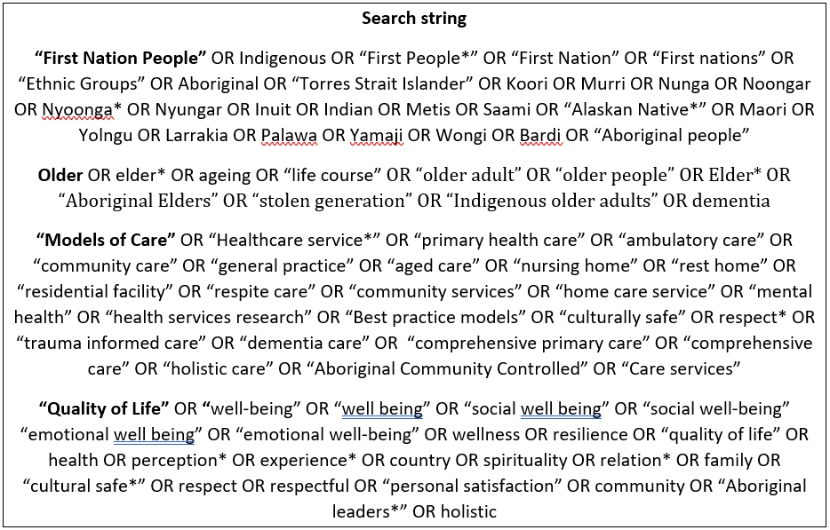

Supplementary Table 2. Inclusion/Exclusion Criteria

Criterion | Inclusion | Exclusion
Publication focus | Perceptions of, attitudes to, concepts of, cultural aspects of, definitions of, aging well and associated terms.  Discussion of domains of aging well.  Implementation of principles of ageing well into practice.  Care provision in either residential or institutional care.  Evidence related to implementation of culturally appropriate care based in community-identified quality of life factors, can be whole service delivery or single program only  Concerned with strategies to improve quality of care based on patient, family, and carer satisfaction. | Perspectives of aging well (and associated concepts) or measures of aging well of First Nations peoples that were incorporated into wider cultural groups.  Focus on specific diseases of aging. Focus on cellular or biological aging. Focus on older age but not perspectives of aging well (or associated terms).  Focussed solely on the  perspectives of health professionals.  No discussion of implementation of principles of ageing well into practice.
Population | Older First nations peoples worldwide and their families and carers
Language | Published in English
 | Original research including qualitative, quantitative and mixed methods*.  Grey literature, government, peak bodies or organisational reports, website information. Full text available. | Literature reviews (relevant articles from these included), commentaries, editorials, book reviews, letters to the editor, or where the full text was not available.
* Given the focus on attitudes, beliefs, expectations, understandings, perceptions and experiences, this systematic review focused on qualitative studies, including qualitative findings within mixed method, case study and case series studies

Supplementary Table 3. Alignment of Reviewed Articles with GSGL Factors

 | 1 | 2 | 3 | 4 | 5 | 6 | 7 | 8 | 9 | 10 | 11 | 12 | Total | Alingment
1. Cairns et al. 2022 (QLD) | 1 | 0 | 9 | 10 | 2 | 2 | 0 | 11 | 2 | 0 | 3 | 1 | 9 | H
2. Carol et al. 2012 (WA) | 7 | 3 | 10 | 3 | 3 | 0 | 1 | 17 | 0 | 1 | 0 | 5 | 9 | H
3. Dawson et al. 2021 (SA) | 1 | 1 | 4 | 4 | 1 | 2 | 1 | 12 | 0 | 0 | 2 | 0 | 9 | H
4. Du Toit et al. 2014 (South Africa) | 1 | 0 | 4 | 5 | 1 | 2 | 1 | 3 | 1 | 0 | 0 | 3 | 9 | H
5. Gidgup et al. 2022 (WA) | 2 | 0 | 2 | 3 | 4 | 3 | 0 | 1 | 3 | 0 | 0 | 0 | 7 | M
6. Harding et al. 2022 (NZ) | 1 | 0 | 4 | 4 | 0 | 1 | 0 | 0 | 0 | 0 | 1 | 1 | 6 | M
7. Hikaka et al. 2021 a (NZ) | 1 | 0 | 0 | 8 | 3 | 3 | 0 | 3 | 2 | 0 | 6 | 1 | 8 | M
8. Hikaka et al. 2021 b (NZ) |  | 0 | 0 | 2 | 1 | 0 | 1 | 4 | 0 | 0 | 3 | 0 | 5 | M
9. Lavrencic et al. 2021 (NSW) | 2 | 1 | 1 | 6 | 4 | 0 | 4 | 7 | 3 | 1 | 3 | 3 | 11 | H
10. Mackell et al. 2022 (WA, NT, QLD) | 2 | 1 | 1 | 6 | 4 | 0 | 4 | 7 | 3 | 1 | 3 | 3 | 11 | H
11. Macnivnen et al. 2021 (NSW, WA, SA) | 2 | 2 | 8 | 7 | 4 | 2 | 2 | 5 | 2 | 0 | 0 | 0 | 9 | H
12. Murphy et al. 2012 (WA) | 5 | 2 | 5 | 7 | 3 | 1 | 0 | 15 | 2 | 0 | 1 | 4 | 10 | H
13. Oetzel et al. 2020 (NZ) | 2 | 2 | 6 | 11 | 7 | 1 | 1 | 7 | 0 | 1 | 1 | 3 | 11 | H
14. Pelcastre et al. 2016 (Mexico) | 1 | 3 | 3 | 4 | 7 | 1 | 1 | 2 | 0 | 2 | 1 | 1 | 11 | H
15. Smith, Grundy & Nelson 2010 (NT) | 9 | 5 | 20 | 21 | 3 | 0 | 1 | 15 | 5 | 0 | 1 | 5 | 10 | H
16. Wettasinghe et al. 2020 (NSW) | 6 | 0 | 13 | 15 | 13 | 4 | 5 | 3 | 8 | 0 | 3 | 0 | 9 | H
Totals | 44 | 21 | 90 | 123 | 65 | 23 | 24 | 111 | 31 | 6 | 33 | 30 | 152
GSGL Factors – 1. Family and friends, 2. Country, 3. Community, 4. Culture, 5. Health, 6. Respect, 7. Elder rolde, 8. Supports and services, 9. Safety and security, 10. Spirituality, 11. Future Planning, 12. Basic needs

Supplementary Table 4. Results of the First Nations Quality Assessment Tool

 | 1 | 2 | 3 | 4 | 5 | 6 | 7 | 8 | 9 | 10 | 11 | 12 | 13 | 14 | Total
1. Cairns et al. 2022 (QLD) | Y | Y | Un | P | Y | Un | Un | P | Y | Y | Un | Y | Y | Y | 9 | H
2. Carol et al. 2012 (WA) | Y | Y | Y | Y | Y | Y | Un | Un | Y | Y | Y | Y | Y | Y | 12 | H
3. Dawson et al. 2021 (South Africa) | Y | Y | Y | Y | Y | Un | Un | Y | Y | Y | Y | Y | Y | Y | 12 | H
4. Du Toit et al. 2014 (South Africa) | Y | Y | N | N | Y | Un | Un | N | P | Y | Y | Y | P | Un | 7 | M
5. Gidgup et al. 2022 (WA) | Y | Y | Y | Y | Y | Un | Un | Y | Y | Y | Y | Y | Y | Y | 12 | H
6. Harding et al. 2022 (NZ) | Y | Y | Y | Y | Y | Un | Un | Un | Y | Y | N | Y | Un | Un | 8 | M
7. Hikaka et al. 2021 a (NZ) | P | Un | P | Un | Y | Y | Y | Y | Un | Un | Y | Y | Y | Un | 8 | M
8. Hikaka et al. 2021 b (NZ) | Y | Y | Y | Y | Y | Y | Y | Y | Y | Un | Un | Y | Y | Y | 12 | H
9. Lavrencic et al. 2021 (NSW) | Y | Y | Y | Y | Y | Un | Un | Un | Y | Y | Y | Y | Un | P | 7.5 | M
10. Mackell et al. 2022 (WA, NT, QLD) | Un | P | Y | Y | P | Un | Un | Un | N | Y | N | Y | Y | Y | 7 | M
11. Macnivnen et al. 2021 (NSW, WA, SA) | Y | Y | Un | Un | Un | Un | Un | P | Y | N | N | Y | Y | Y | 6.5 | M
12. Murphy et al. 2012 (WA) | P | Y | Y | Y | Y | Un | Un | Un | Un | Y | Y | Y | Y | Un | 7.5 | M
13. Oetzel et al. 2020 (NZ) | Y | Y | Y | Y | Y | Y | Y | Y | Y | Y | Un | Y | Y | Y | 13 | H
14. Pelcastre et al. 2016 (Mexico) | Un | P | Un | Un | Y | Y | N | P | Y | Y | Y | Un | N | Un | 6 | M
15. Smith, Grundy & Nelson 2010 (NT) | Y | Y | Y | Y | Y | Y | Un | Y | Y | Y | Y | Y | Y | Y | 13 | H
16. Wettasinghe et al. 2020 (NSW) | Un | Un | Un | Un | Un | Un | Un | Un | No | Un | Y | N | N | N | 1 | L

Supplementary Table 5. Results of the JBI Quality Assessment Tool

 | 1 | 2 | 3 | 4 | 5 | 6 | 7 | 8 | 9 | 10 | Whole service  vs  Single program | Total
1. Cairns et al. 2022 (QLD) | Y | Y | Y | Y | Y | Un | Y | Y | n/a | Y | W | 8 | H
2. Carol et al. 2012 (WA) | Y | Y | Y | Y | Y | N | Y | Y | Y | Y | W | 9 | H
3. Dawson et al. 2021 (South Africa) | Y | Y | Y | Y | Y | Un | Y | Y | Y | Y | W | 9 | H
4. Du Toit et al. 2014 (South Africa) | Y | Y | Y | y | N | Y | Y | Y | Un | Y | W | 8 | H
5. Gidgup et al. 2022 (WA) | Y | Y | Y | Y | Y | Y | Y | Y | Y | Y | S | 10 | H
6. Harding et al. 2022 (NZ) | Y | Y | Y | Y | Y | N | Y | Y | Y | Y | W | 9 | H
7. Hikaka et al. 2021 a (NZ) | Y | Y | Y | Y | Y | Un | Y | n/a | n/a | Y | S | 7 | M
8. Hikaka et al. 2021 b (NZ) | Y | Y | Y | Y | Y | Un | Y | Y | Y | Y | S | 9 | H
9. Lavrencic et al. 2021 (NSW) | Y | Y | Y | Y | Y | Un | Un | Y | Y | Y | S | 8 | H
10. Mackell et al. 2022 (WA, NT, QLD) | Y | Y | Y | Y | Y | Un | Y | Y | Y | Y | S | 9 | H
11. Macnivnen et al. 2021 (NSW, WA, SA) | Y | Y | Y | Y | Y | Un | Un | Y | Y | Un | S | 7 | M
12. Murphy et al. 2012 (WA) | Y | Y | Y | Y | Y | N | N | N | Un | Y | W | 6 | M
13. Oetzel et al. 2020 (NZ) | Y | Y | Y | Y | Y | Un | Y | Y | Y | Y | Y | 9 | H
14. Pelcastre et al. 2016 (Mexico) | Y | Y | Y | Y | Y | No | No | Y | Y | Y | W | 8 | H
15. Smith, Grundy & Nelson 2010 (NT) | Y | Y | Y | Y | Y | Y | Y | N | Un | Y | W | 8 | H
16. Wettasinghe et al. 2020 (NSW) | Un | Un | Un | Y | Un | Un | Un | Y | Y | Y | W | 4 | M

Supplementary Figure 1 – The Family Model of Care
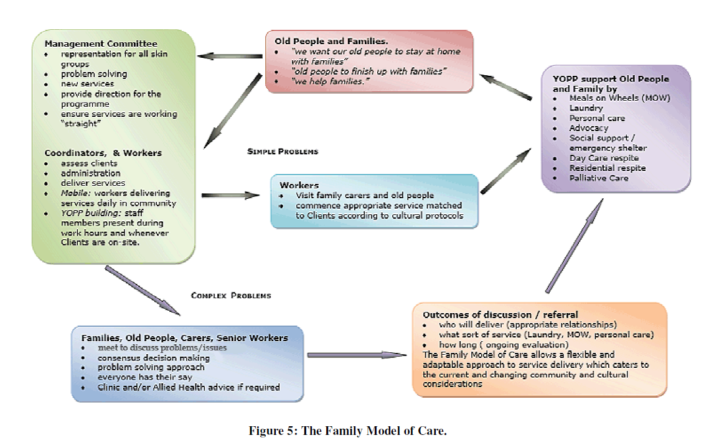

Source: Smith et al. (43)

Supplementary Figure 2 – Lungurra Ngoora Remote Community Model of Care

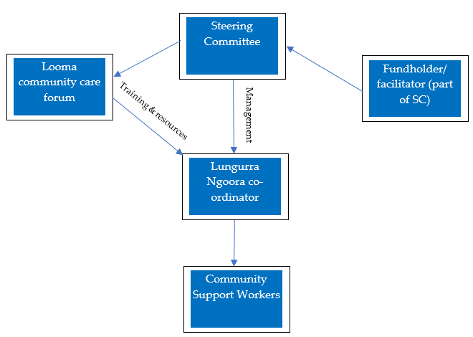
Source: Carroll et al. (39)

Supplementary Figure 3 – Model for a holistic, healthy ageing program

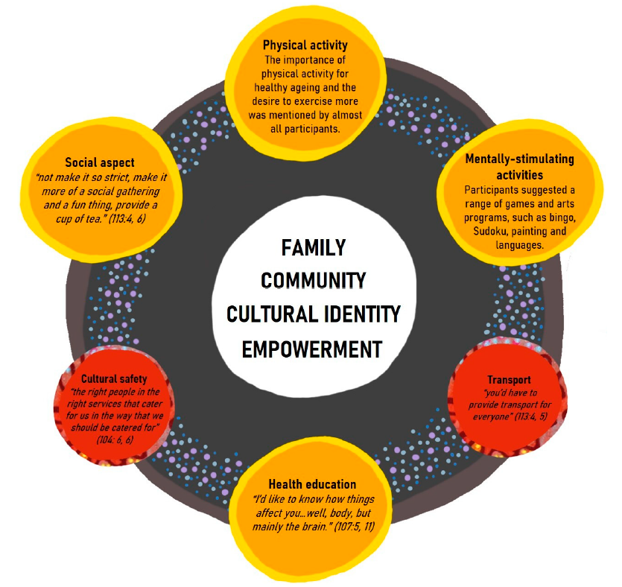

Source: Wettasinghe et al. (44)

