SUPPLEMENTARY MATERIAL

Fig. S1. HR-ESI-MS spectrum of compound 1
Fig. S2. HPLC-UV chromatogram of compound 1
Fig. S3. Ultraviolet full wavelength scanning spectrum of compound 1
Fig. S4. IR spectrum of compound 1
Fig. S5. ¹H-NMR spectrum of compound 1
Fig. S6. ¹³C-NMR spectrum of compound 1
Fig. S7. DEPT-90 spectrum of compound 1
Fig. S8. DEPT-135 spectrum of compound 1
Fig. S9. HSQC spectrum of compound 1
Fig. S10. ¹H-¹H COSY spectrum of compound 1
Fig. S11. HMBC spectrum of compound 1
Fig. S12. NOESY spectrum of compound 1
Fig. S13. ¹H -NMR spectrum of compound 2
Fig. S14. ¹³C-NMR spectrum of compound 2
Fig. S15. ESI-MS spectrum of compound 2
Fig. S16. ¹H -NMR spectrum of compound 3
Fig. S17. ¹³C-NMR spectrum of compound 3
Fig. S18. ESI-MS spectrum of compound 3
Fig. S19. ¹H -NMR spectrum of compound 4
Fig. S20. ¹³C-NMR spectrum of compound 4
Fig. S21. ESI-MS spectrum of compound 4
Fig. S22. ¹H -NMR spectrum of compound 5
Fig. S23. ¹³C-NMR spectrum of compound 5
Fig. S24. ESI-MS spectrum of compound 5
Fig. S25. ¹H -NMR spectrum of compound 6
Fig. S26. ¹³C-NMR spectrum of compound 6
Fig. S27. ESI-MS spectrum of compound 6
Fig. S28. ¹H -NMR spectrum of compound 7
Fig. S29. ¹³C-NMR spectrum of compound 7
Fig. S30. ESI-MS spectrum of compound 7
Fig. S31. ¹H -NMR spectrum of compound 8
Fig. S32. ¹³C-NMR spectrum of compound 8
Fig. S33. ESI-MS spectrum of compound 8
Fig. S34. ¹H -NMR spectrum of compound 9
Fig. S35. ¹³C-NMR spectrum of compound 9
Fig. S36. ESI-MS spectrum of compound 9
Fig. S37. ¹H -NMR spectrum of compound 10
Fig. S38. ¹³C-NMR spectrum of compound 10
Fig. S39. ESI-MS spectrum of compound 10
Fig. S40. ¹H -NMR spectrum of compound 11
Fig. S41. ¹³C-NMR spectrum of compound 11
Fig. S42. ESI-MS spectrum of compound 11
Fig. S43. ¹H -NMR spectrum of compound 12
Fig. S44. ¹³C-NMR spectrum of compound 12
Fig. S45. ESI-MS spectrum of compound 12
Fig. S46. ¹H -NMR spectrum of compound 13
Fig. S47. ¹³C-NMR spectrum of compound 13
Fig. S48. ESI-MS spectrum of compound 13
Fig. S49. ¹H -NMR spectrum of compound 14
Fig. S50. ¹³C-NMR spectrum of compound 14
Fig. S51. ESI-MS spectrum of compound 14
Fig. S52. ¹H -NMR spectrum of compound 15
Fig. S53. ¹³C-NMR spectrum of compound 15
Fig. S54. ESI-MS spectrum of compound 15

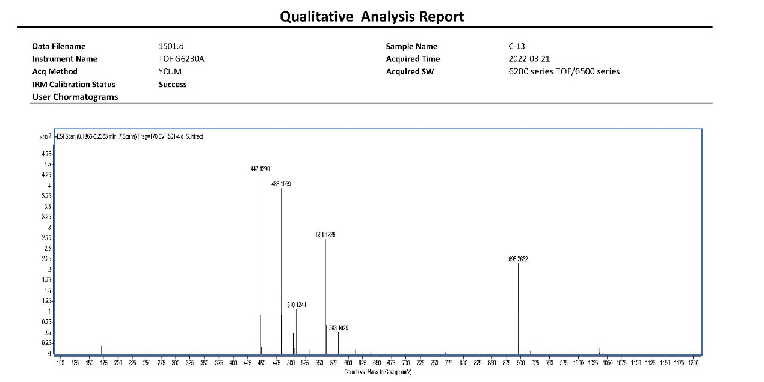
Fig. S1. HR-ESI-MS spectrum of compound 1 (+ESI Scan (0.1863-0.2363min, 7 Scans); Instrument Name=TOF G6230A; frag= 170.0 V; Acq Method=YCL.M;Acquired SW=6200 series TOF/6500 series)

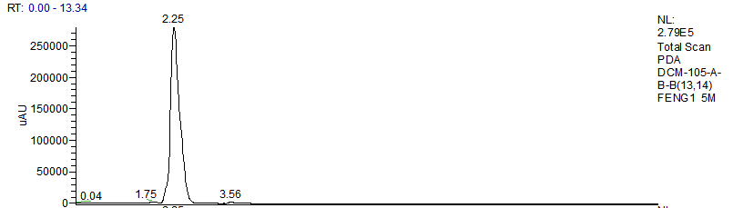
Fig. S2. HPLC-UV chromatogram of compound 1 [Innoval C₁₈ ( 4.6 mm×250 mm, 5 μm) column with temperature at 25℃ was used; the mobile phase was methanol-water (5:95) at a flow rate of 1.0 mL/min]
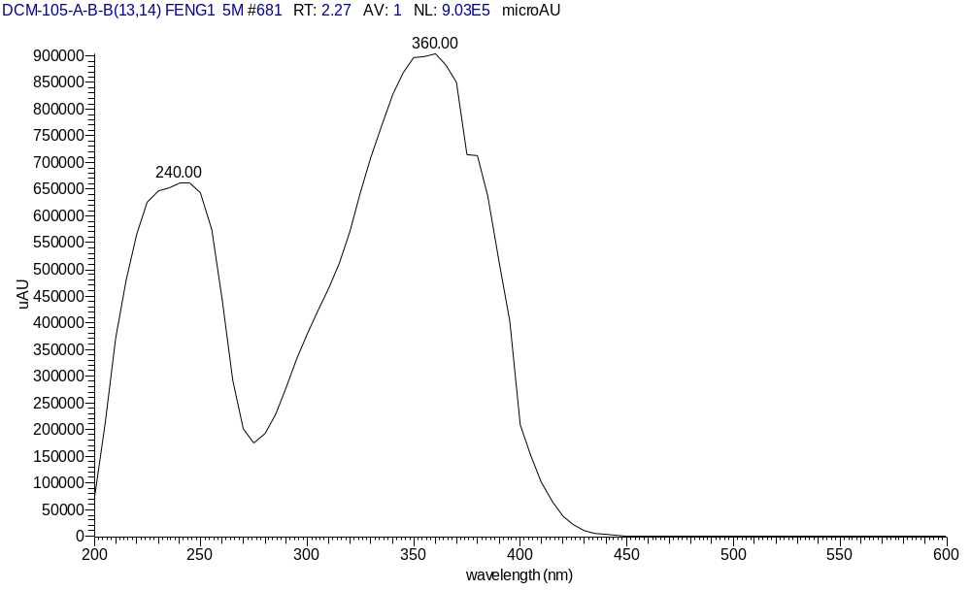
Fig. S3. Ultraviolet full wavelength scanning spectrum of compound 1 [Innoval C₁₈ ( 4.6 mm×250 mm, 5 μm) column with temperature at 25℃ was used; the mobile phase was methanol-water (5:95) at a flow rate of 1.0 mL/min]
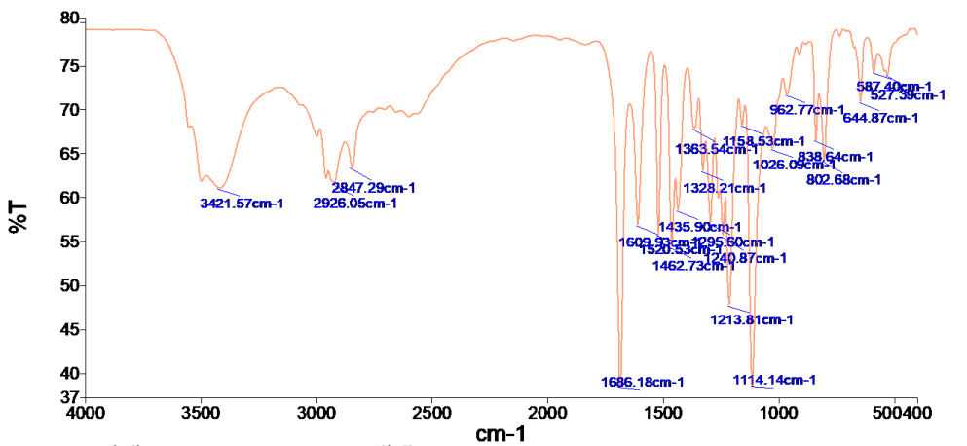
Fig. S4. IR spectrum of compound 1 (Instrument: Frontier FT-IR; scanning range: 4000-400 cm⁻¹)

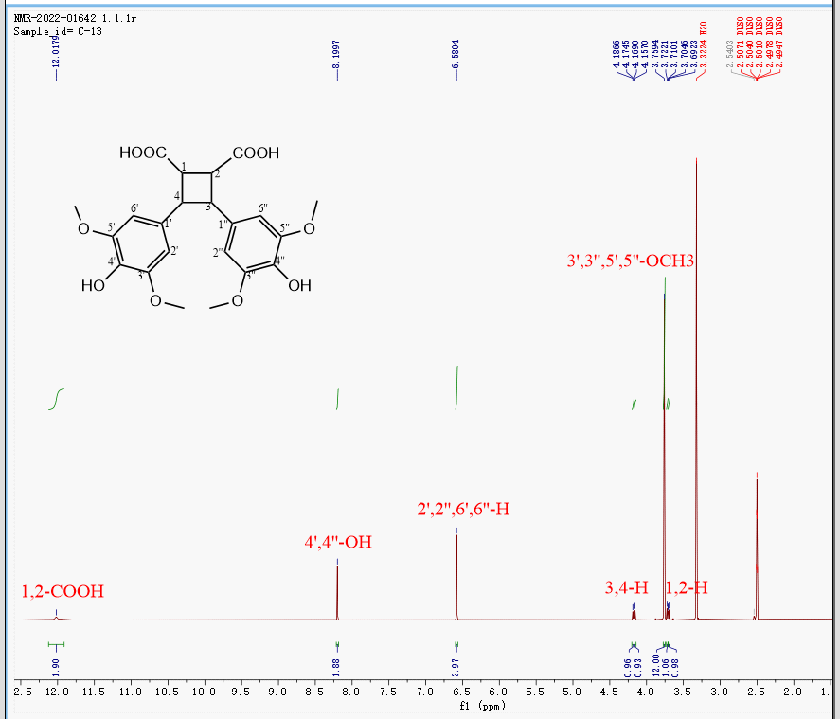
Fig. S5. ¹H-NMR spectrum of compound 1（Origin=Bruker BioSpin GmbH, Instrument=Avance, Temperature=298.2, Pulse Sequence=zg30, Number of Scans=16, Receiver Gain=101.0, Relaxation Delay=1.0000, Pulse Width=12.0000, Acquisition Time=2.7525, Spectrometer Frequency=600.40, Spectral Width=11904.8, Lowest Frequency=-1453.8, Digital Resolution=0.18, Nucleus= 1H）

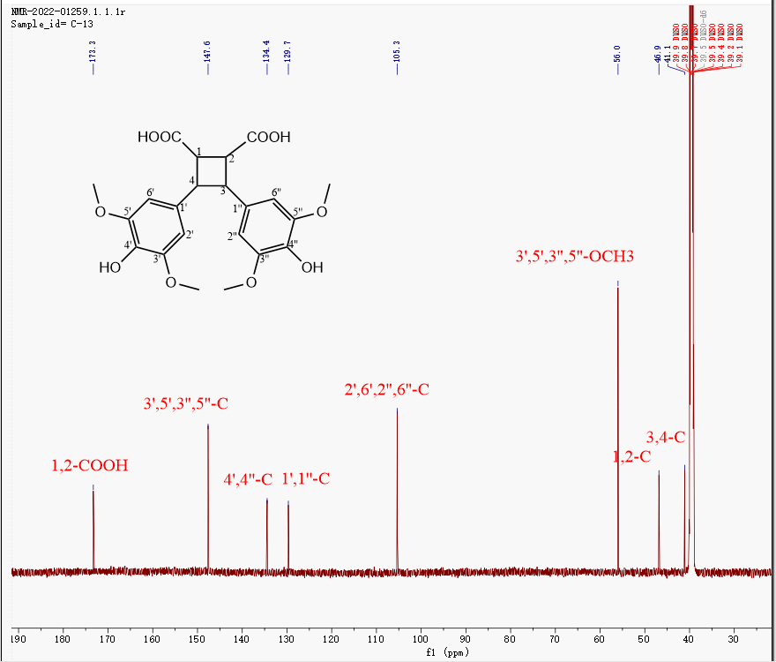

Fig. S6. ¹³C-NMR spectrum of compound 1 (Sampling parameters: Origin=Bruker BioSpin GmbH, Instrument=Avance, Temperature=298.1, Number of Scans=1024, Receiver Gain=101.0, Relaxation Delay= 2.0000, Pulse Width= 10.0000, Acquisition Time= 0.8520, Spectrometer Frequency=150.97, Spectral Width=38461.5, Lowest Frequency=-1941.2, Digital Resolution=1.17)
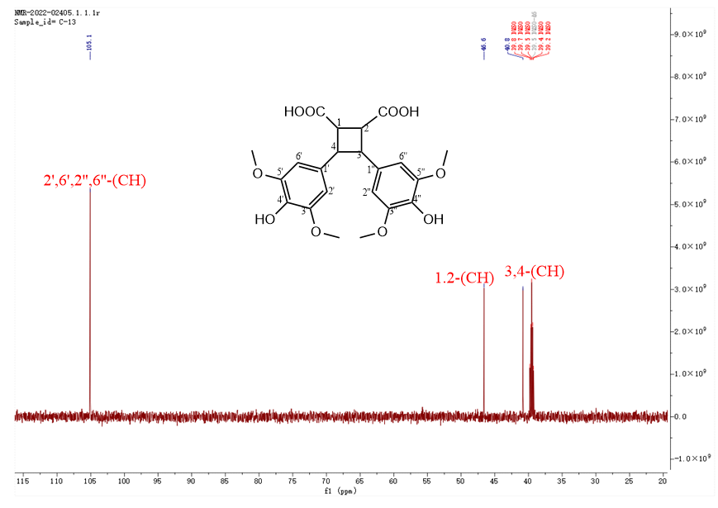
Fig. S7. DEPT-90 spectrum of compound 1 (Origin=Bruker BioSpin GmbH, Instrument=Avance, Temperature=298.2, Pulse Sequence=deptsp90, Experiment=DEPT-90, Probe=Z159656_0023 (CP2.1 BBO 600S3 BB-H&F-D-05 Z XT), Number of Scans=64, Receiver Gain=101.0, Relaxation Delay=2.0000, Pulse Width=10.0000, Acquisition Time=0.8520, Spectrometer Frequency=150.97, Spectral Width=38461.5, Lowest Frequency=-1978.5, Nucleus=13C, Digital Resolution=1.17)
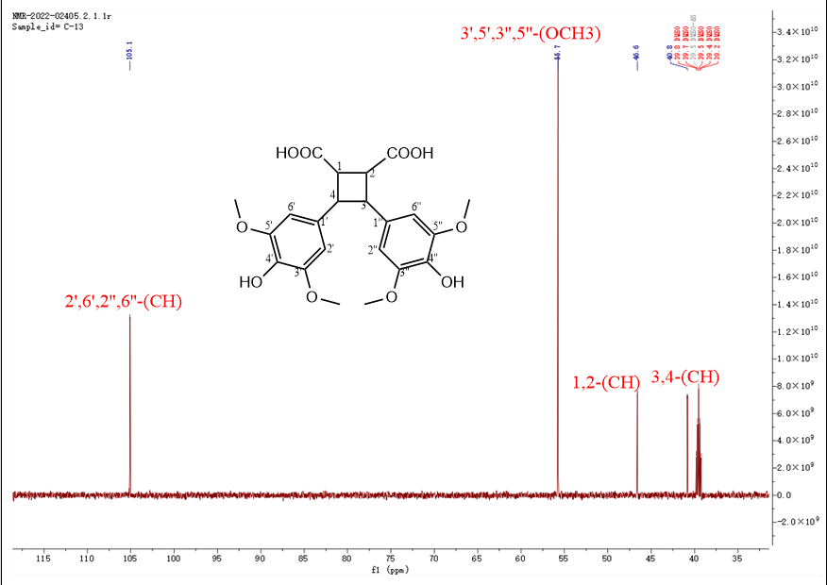
Fig. S8. DEPT-135 spectrum of compound 1 (Origin=Bruker BioSpin GmbH,Instrument=Avance, Temperature=298.1, Pulse Sequence=deptsp135, Experiment=DEPT-135, Probe=Z159656_0023 (CP2.1 BBO 600S3 BB-H&F-D-05 Z XT), Number of Scans=256, Receiver Gain=101.0, Relaxation Delay=2.0000, Pulse Width=10.0000, Acquisition Time=0.8520, Spectrometer Frequency=150.97, Spectral Width=38461.5, Lowest Frequency=-1978.6, Nucleus=13C, Digital Resolution=1.17)

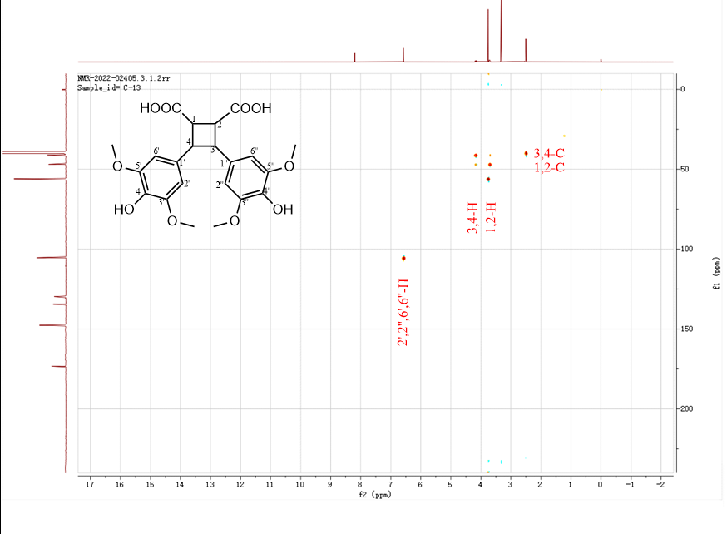
Fig. S9. HSQC spectrum of compound 1 (Origin=Bruker BioSpin GmbH,Instrument=Avance, Temperature=298.1, Pulse Sequence=hsqcetgpsisp2.2, Experiment=HSQC, Probe=Z159656_0023 (CP2.1 BBO 600S3 BB-H&F-D-05 Z XT), Number of Scans=4, Receiver Gain=101.0, Relaxation Delay=1.5000, Pulse Width=12.0000, Acquisition Time=0.0860, Spectrometer Frequency=(600.40,150.97), Spectral Width=(11904.8,37753.7), Lowest Frequency=(-1449.4,-1515.2), Nucleus=(1H,13C), Digital Resolution=(11.63,36.87)
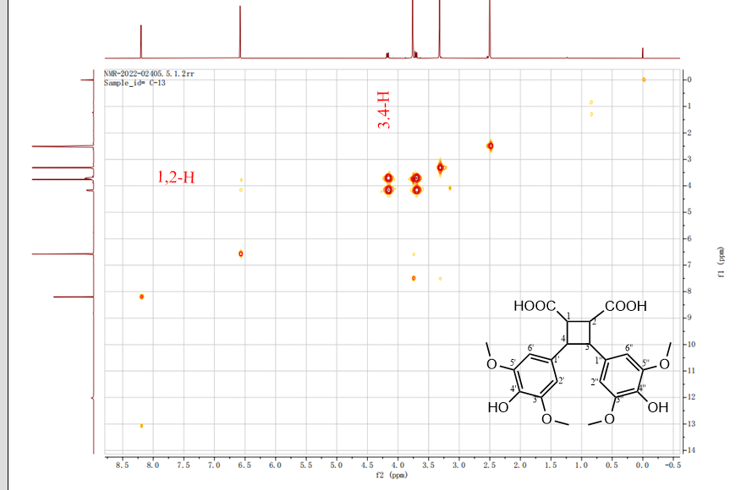
Fig. S10. ¹H-¹H COSY spectrum of compound 1 (Origin=Bruker BioSpin GmbH, Instrument=Avance, Temperature=298.2, Pulse Sequence=cosygpmfqf, Experiment=COSY, Probe=Z159656_0023 (CP2.1 BBO 600S3 BB-H&F-D-05 Z XT), Number of Scans=4, Receiver Gain=64.0,Relaxation Delay=2.0000, Pulse Width=12.0000, Acquisition Time=0.0860, Spectrometer Frequency=(600.40,600.40), Spectral Width=(11904.8,11904.8), Lowest Frequency=(-1449.4,-1449.4), Nucleus=(1H,1H), Digital Resolution=(11.63,11.63)

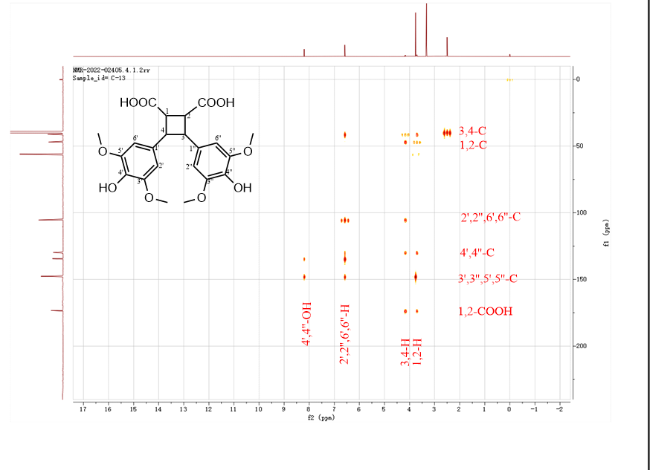
Fig. S11. HMBC spectrum of compound 1 (Origin=Bruker BioSpin GmbH, Instrument=Avance, Temperature=298.2, Pulse Sequence=hmbcgpndqf, Experiment=HMBC, Probe=Z159656_0023 (CP2.1 BBO 600S3 BB-H&F-D-05 Z XT), Number of Scans=8, Receiver Gain=101.0, Relaxation Delay=1.5000, Pulse Width=12.0000, Acquisition Time=0.1720, Spectrometer Frequency=(600.40,150.97), Spectral Width=(11904.8,37753.7), Lowest Frequency=(-1449.4,-1515.2), Nucleus=(1H,13C), Digital Resolution=(2.91,36.87)
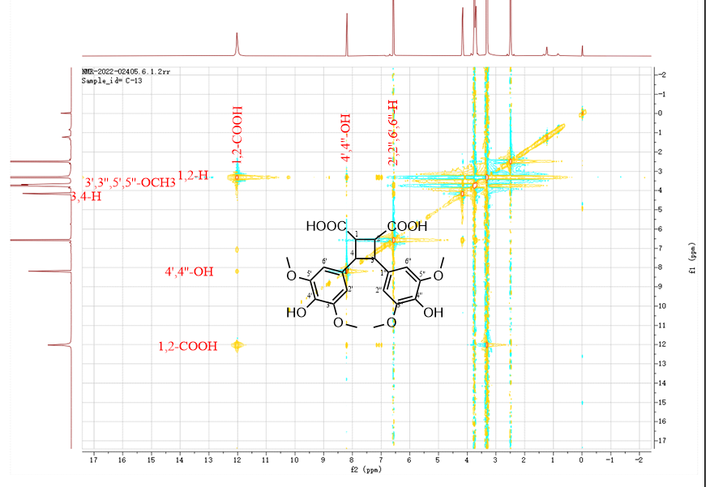
Fig. S12. NOESY spectrum of compound 1 (Origin=Bruker BioSpin GmbH, Instrument=Avance, Temperature=298.2, Pulse Sequence=noesygpphpp, Experiment=NOESY, Probe=Z159656_0023 (CP2.1 BBO 600S3 BB-H&F-D-05 Z XT), Number of Scans=4, Receiver Gain=64.0, Relaxation Delay=2.0000, Pulse Width=12.0000, Acquisition Time=0.0860, Spectrometer Frequency=(600.40, 600.40), Spectral Width=(11904.8, 11904.8), Lowest Frequency=(-1449.4, -1449.4), Nucleus=(1H, 1H), Digital Resolution=(11.63, 11.63)

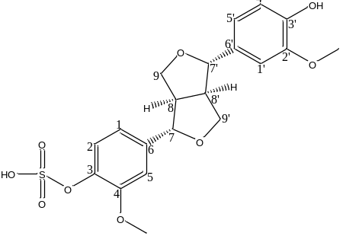
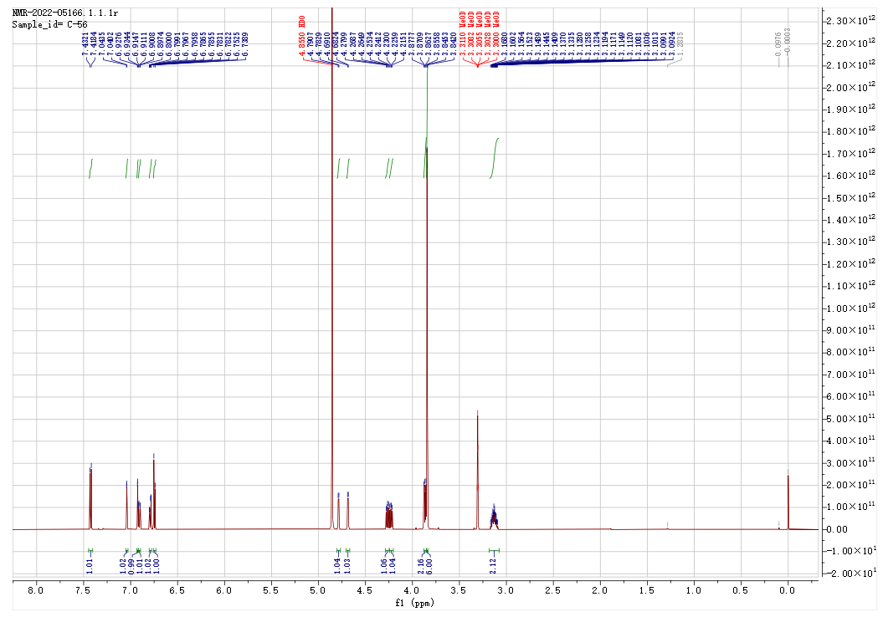
Fig. S13. ¹H -NMR spectrum of compound 2
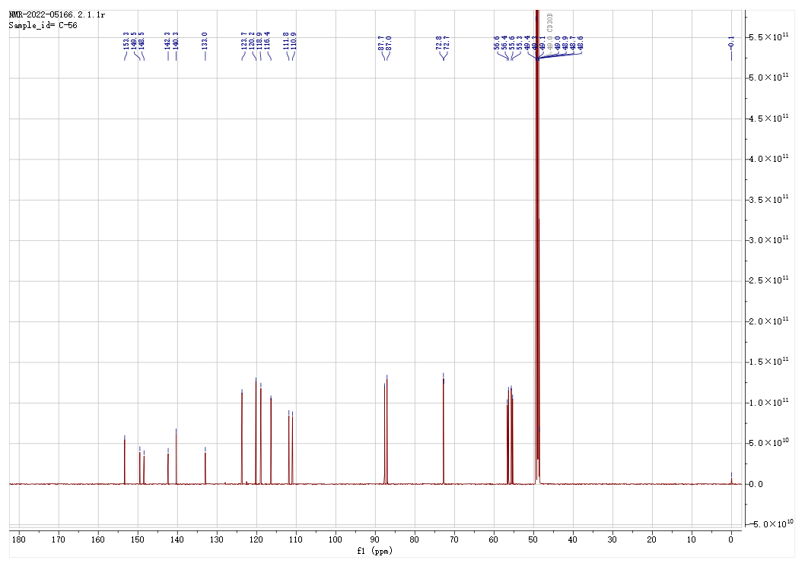
Fig. S14. ¹³C-NMR spectrum of compound 2
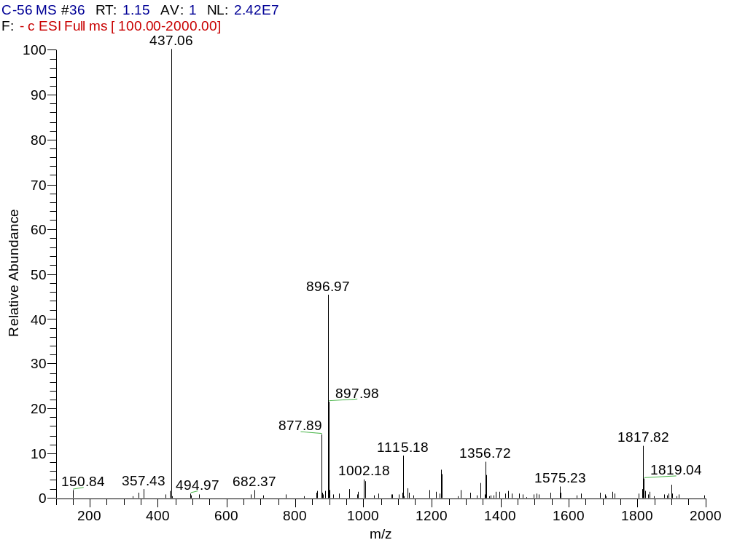
Fig. S15. ESI-MS spectrum of compound 2
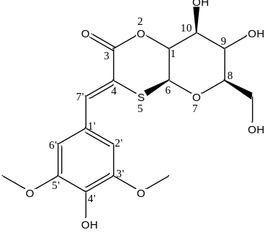
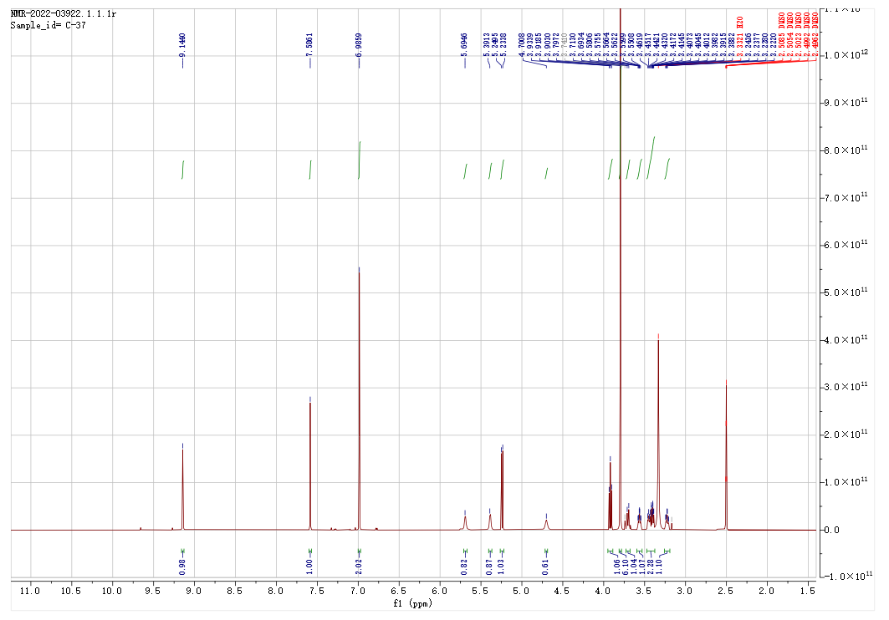
Fig. S16. ¹H -NMR spectrum of compound 3
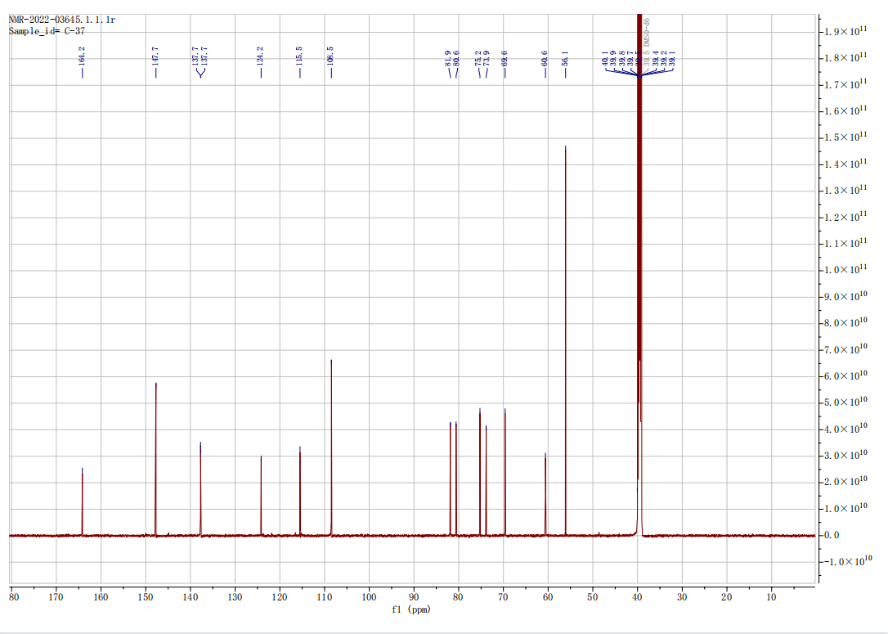
Fig. S17. ¹³C-NMR spectrum of compound 3
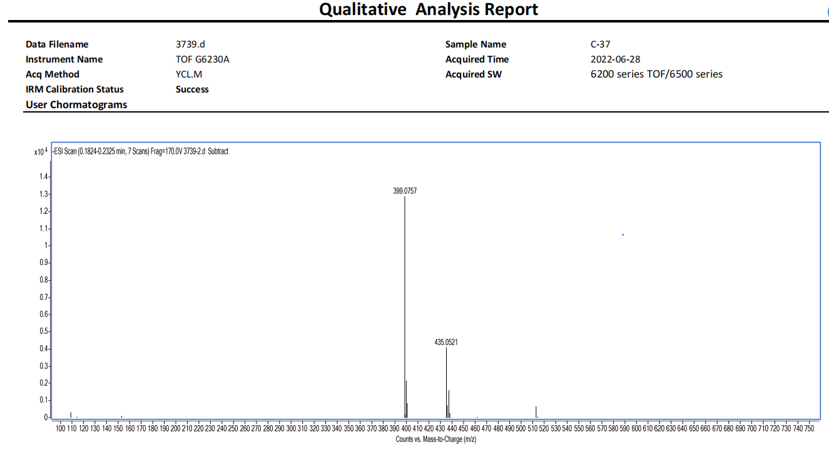
Fig. S18. ESI-MS spectrum of compound 3
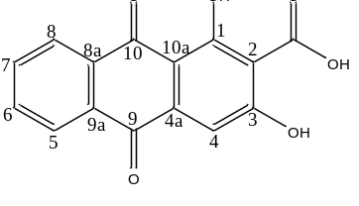
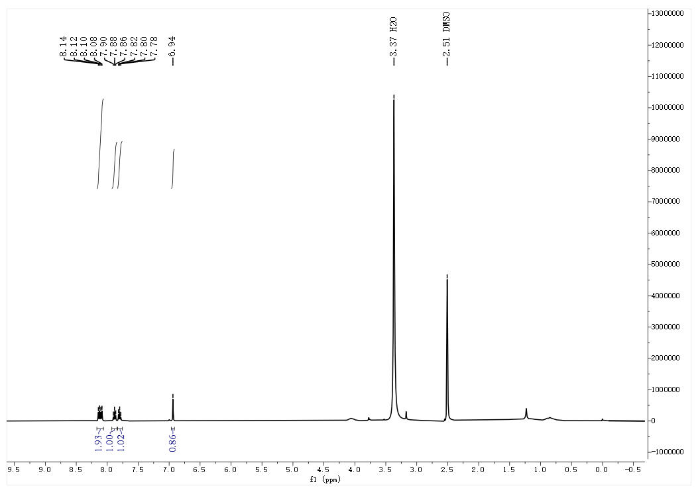
Fig. S19. ¹H -NMR spectrum of compound 4
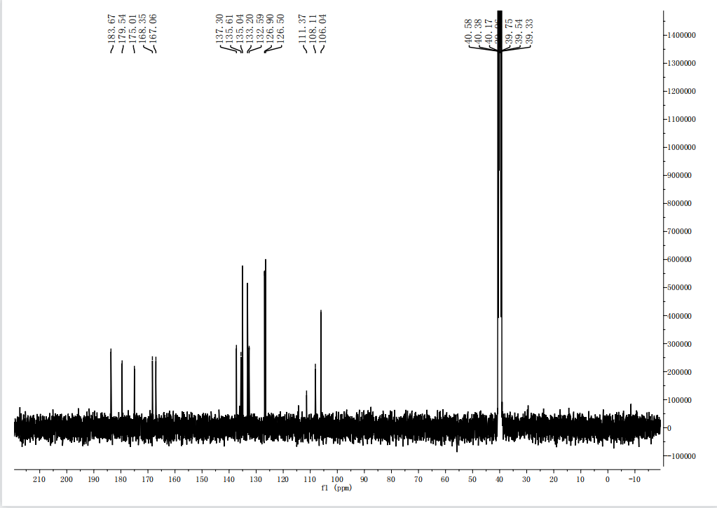
Fig. S20. ¹³C-NMR spectrum of compound 4
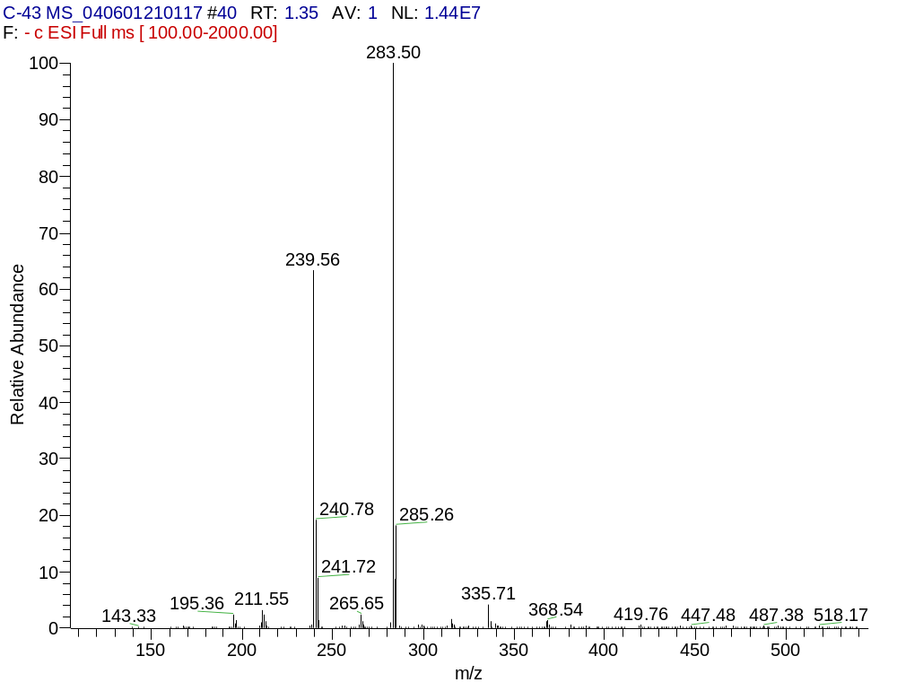
Fig. S21. ESI-MS spectrum of compound 4
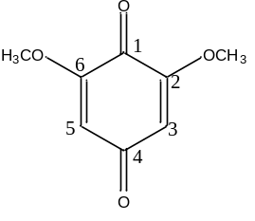
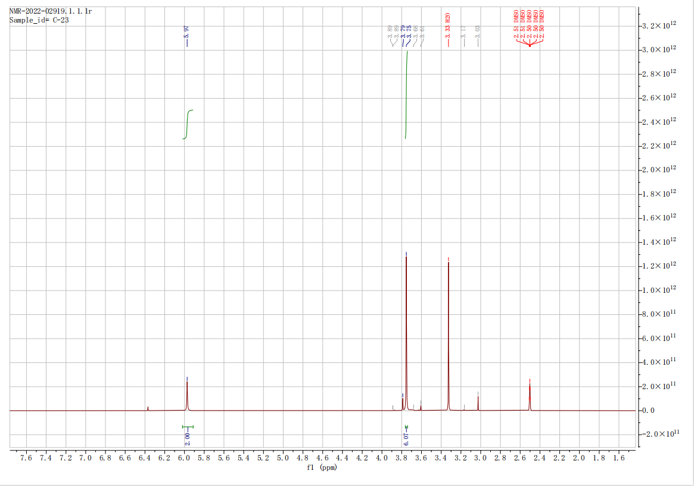
Fig. S22. ¹H -NMR spectrum of compound 5

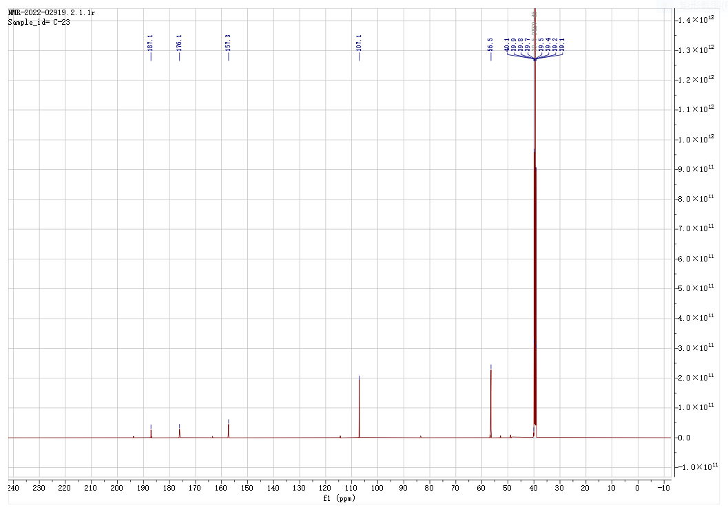
Fig. S23. ¹³C-NMR spectrum of compound 5
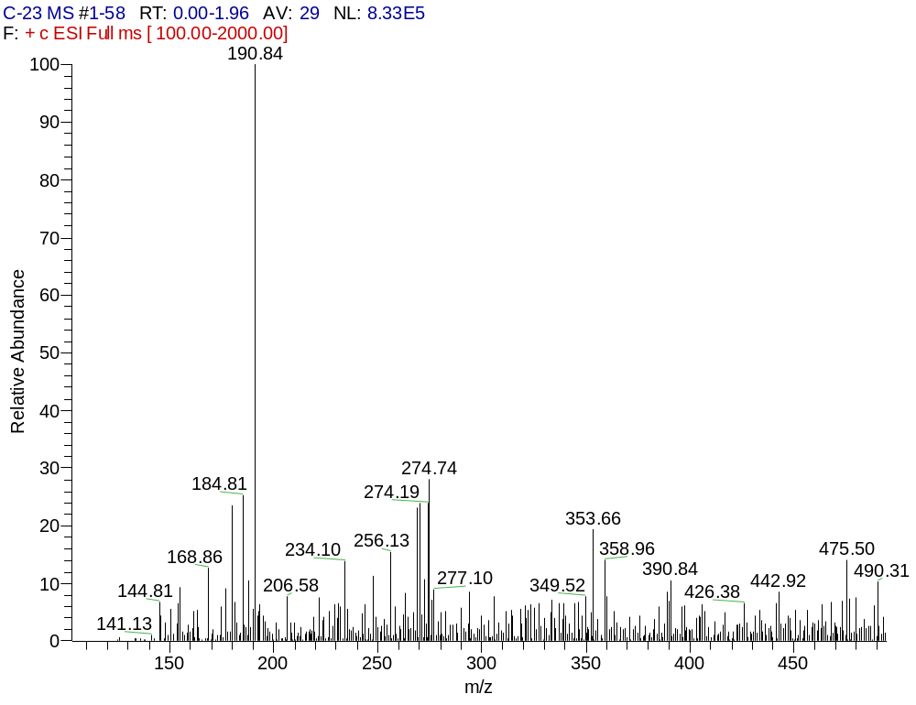
Fig. S24. ESI-MS spectrum of compound 5
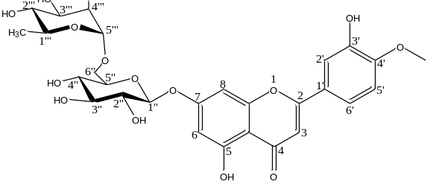
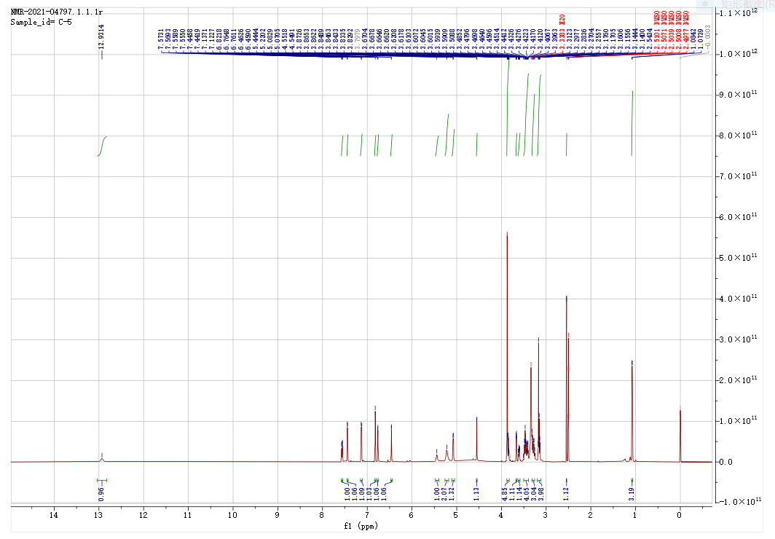
Fig. S25. ¹H -NMR spectrum of compound 6
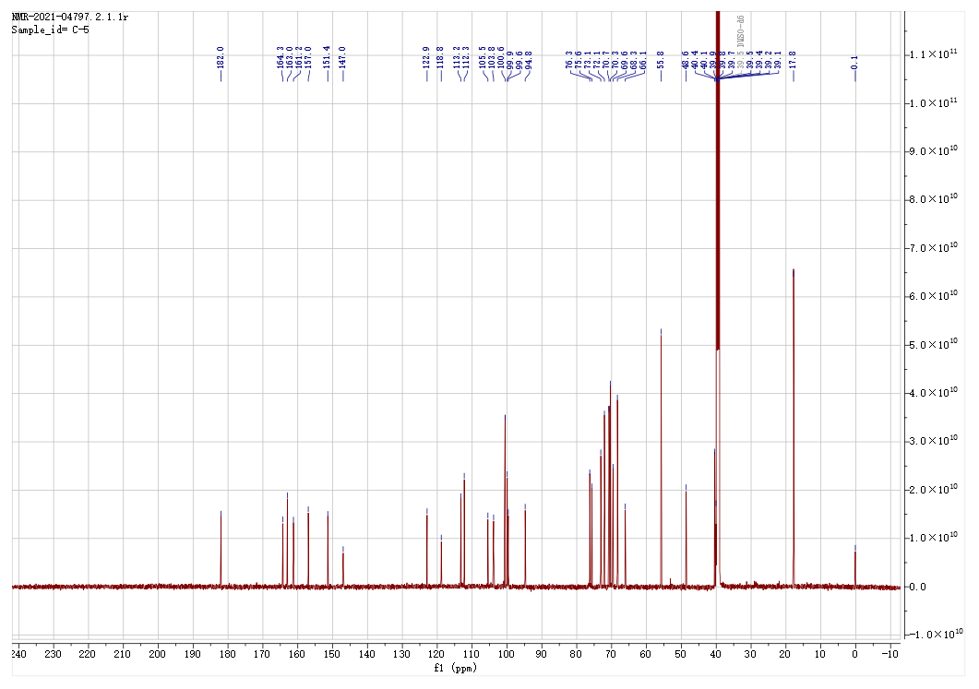
Fig. S26. ¹³C-NMR spectrum of compound 6
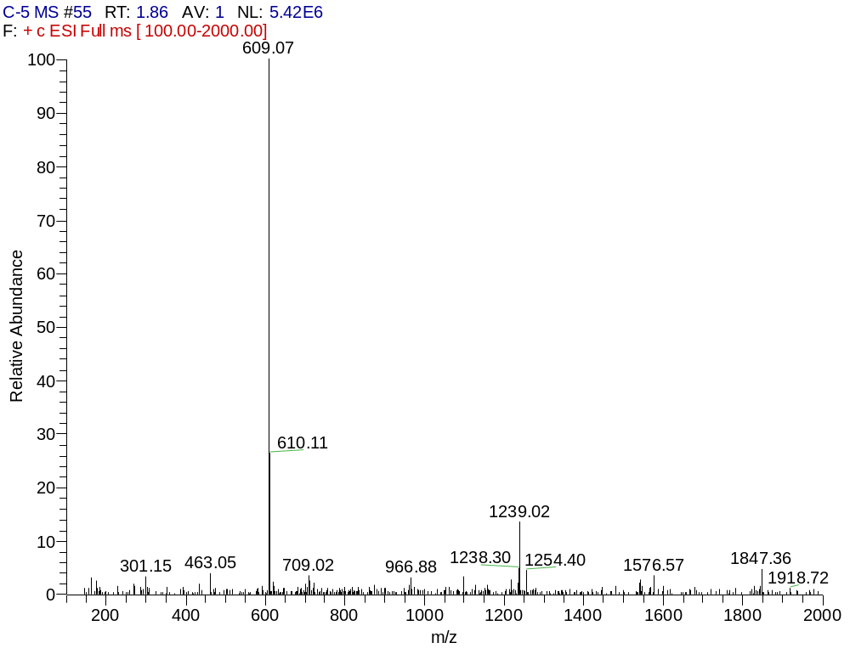
Fig. S27. ESI-MS spectrum of compound 6
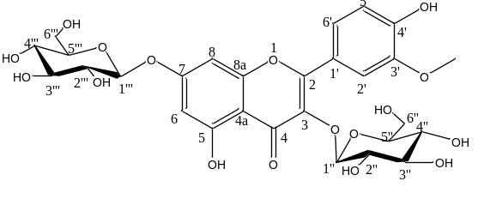
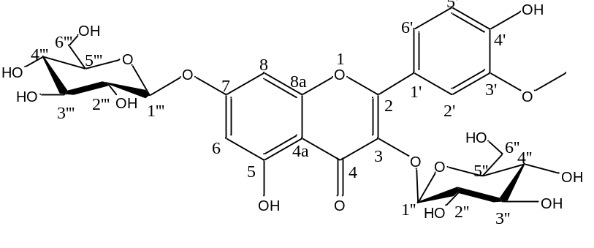
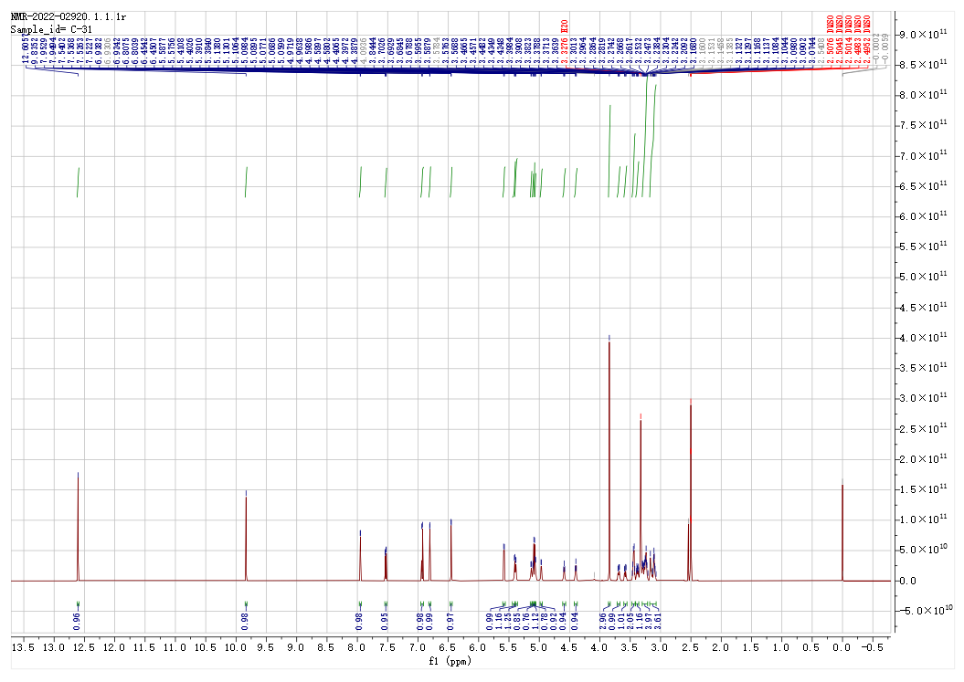
Fig. S28. ¹H -NMR spectrum of compound 7
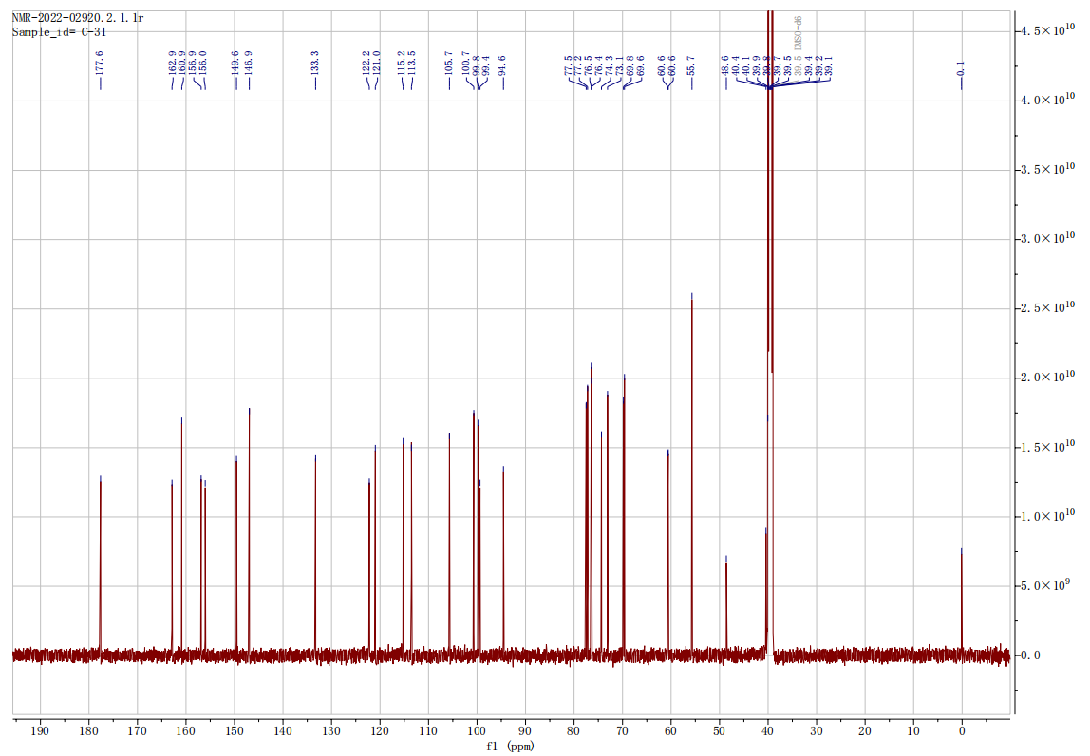
Fig. S29. ¹³C-NMR spectrum of compound 7
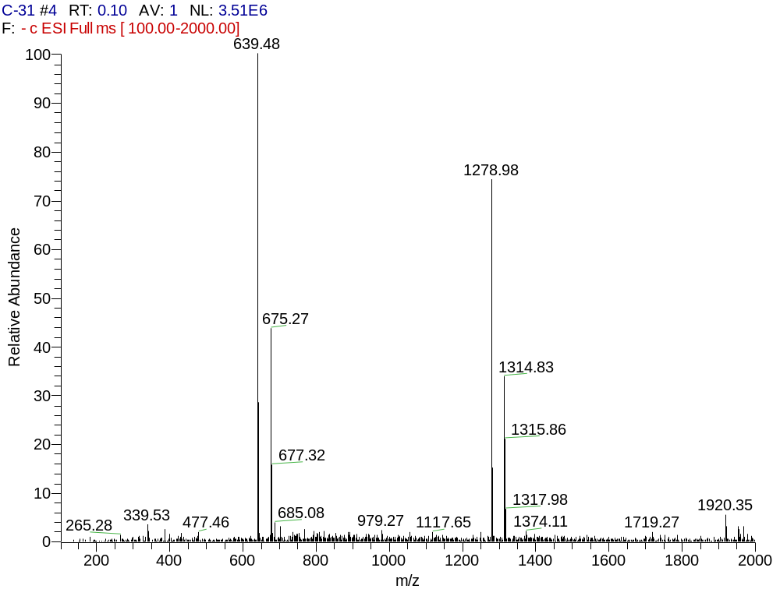
Fig. S30. ESI-MS spectrum of compound 7
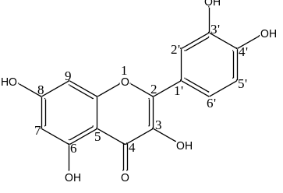
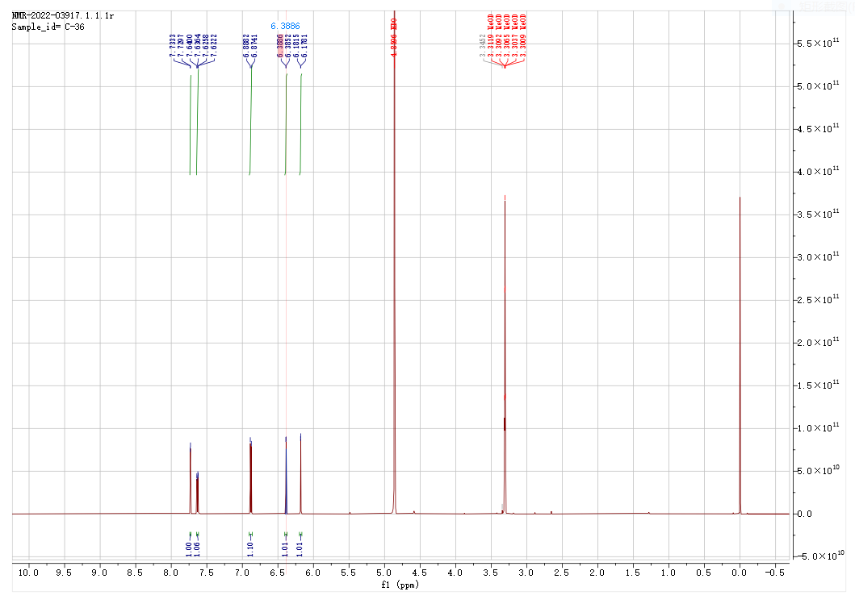
Fig. S31. ¹H -NMR spectrum of compound 8
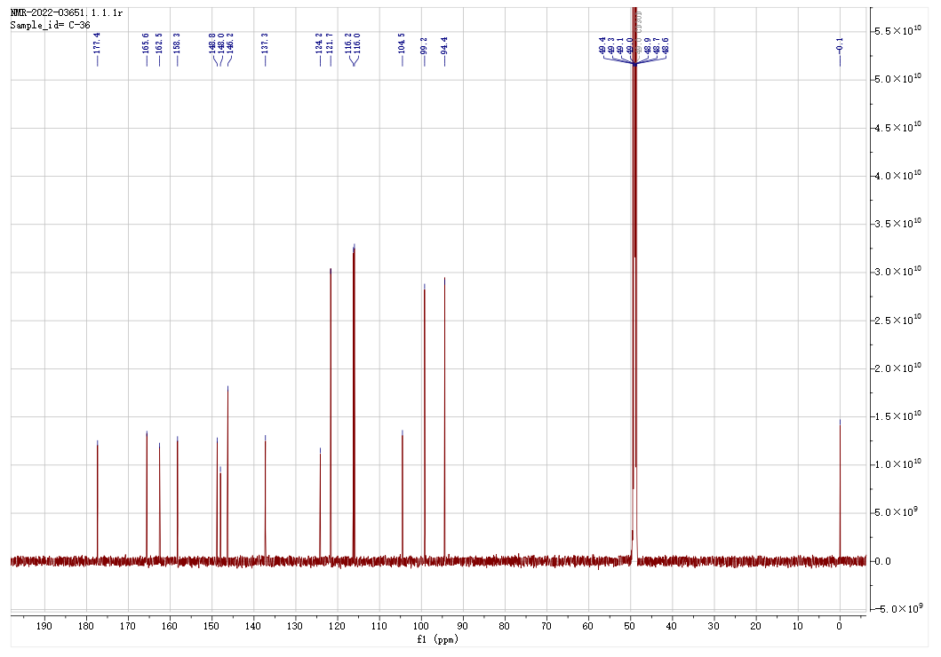
Fig. S32. ¹³C-NMR spectrum of compound 8
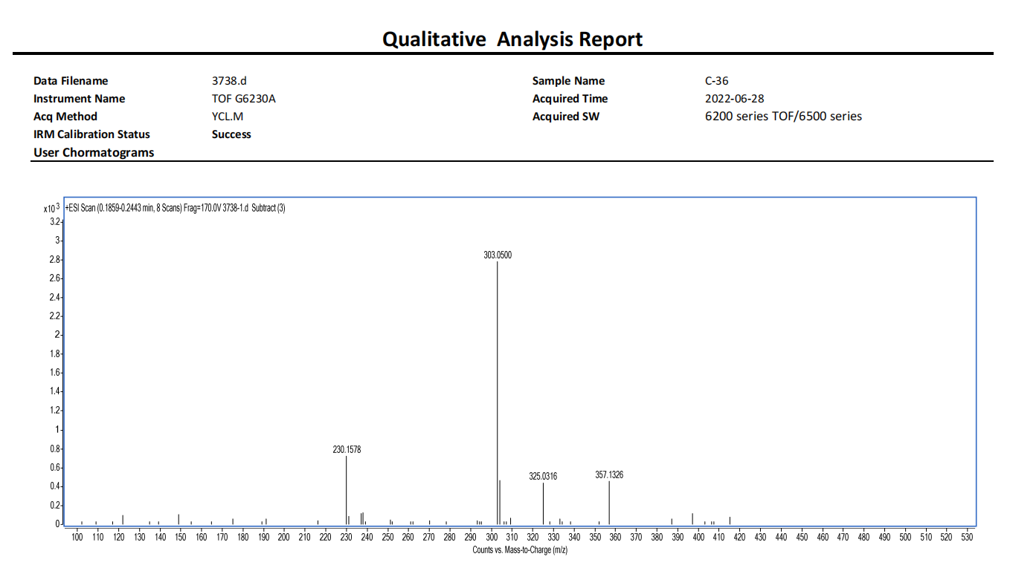
Fig. S33. ESI-MS spectrum of compound 8
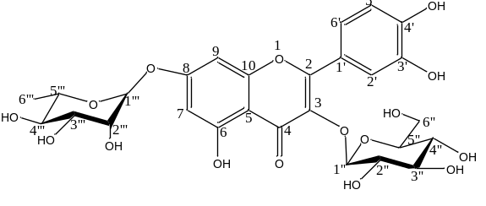
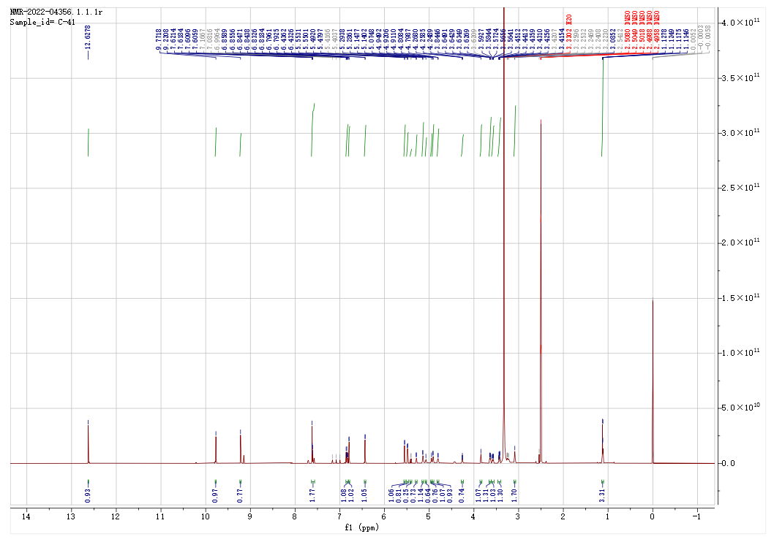
Fig. S34. ¹H -NMR spectrum of compound 9
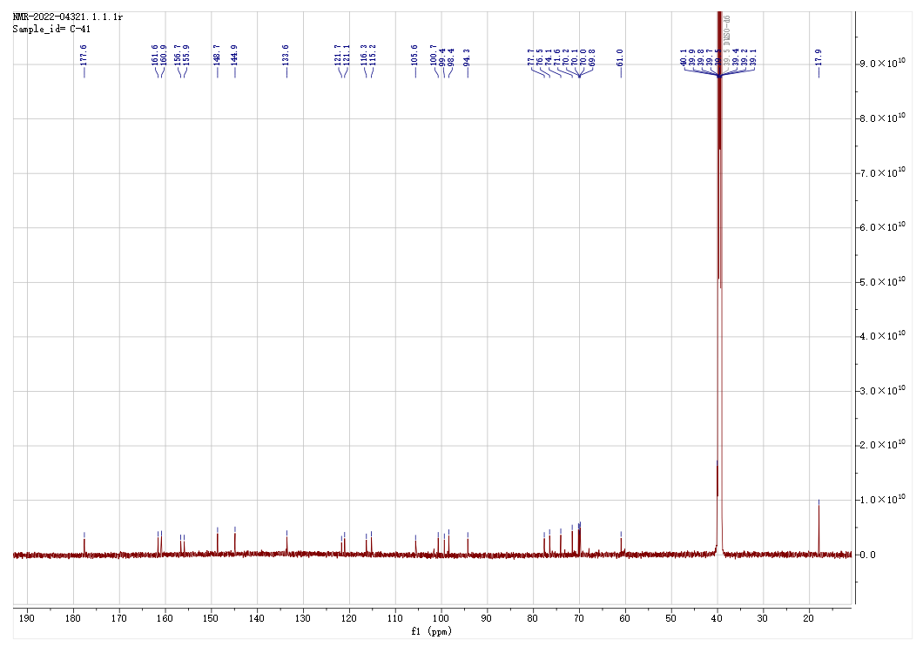
Fig. S35. ¹³C-NMR spectrum of compound 9
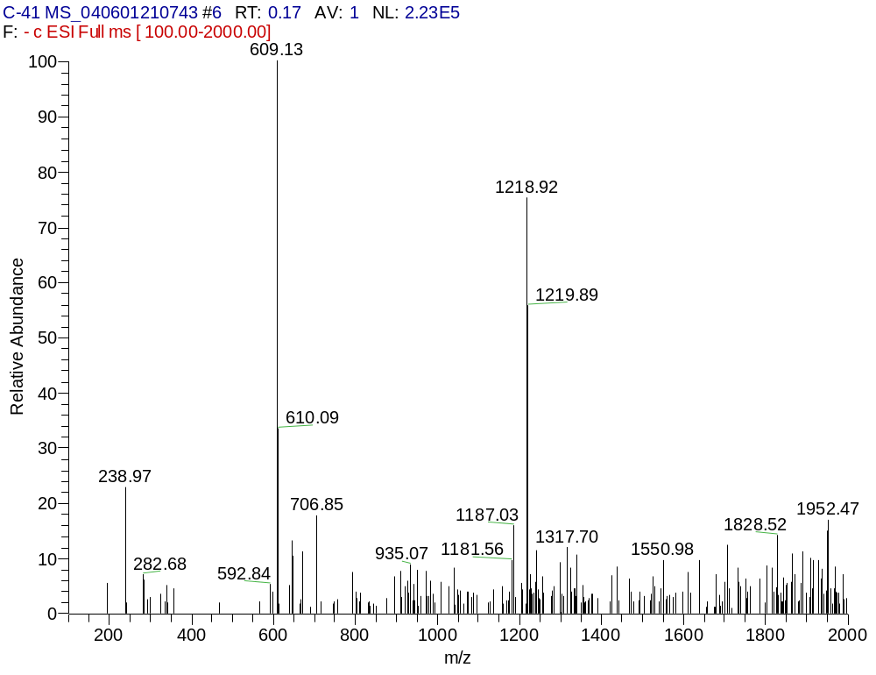
Fig. S36. ESI-MS spectrum of compound 9
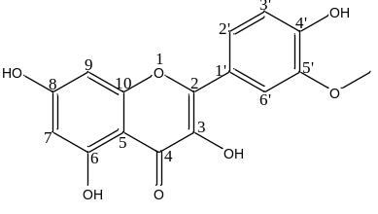
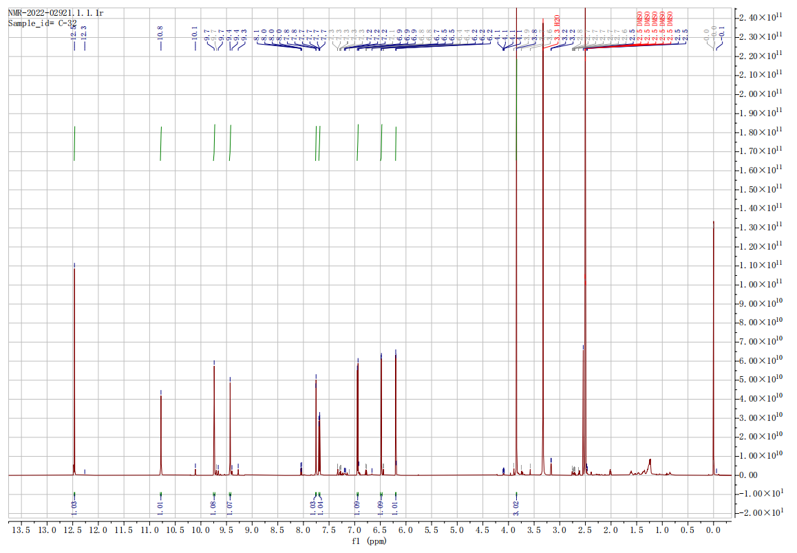
Fig. S37. ¹H -NMR spectrum of compound 10
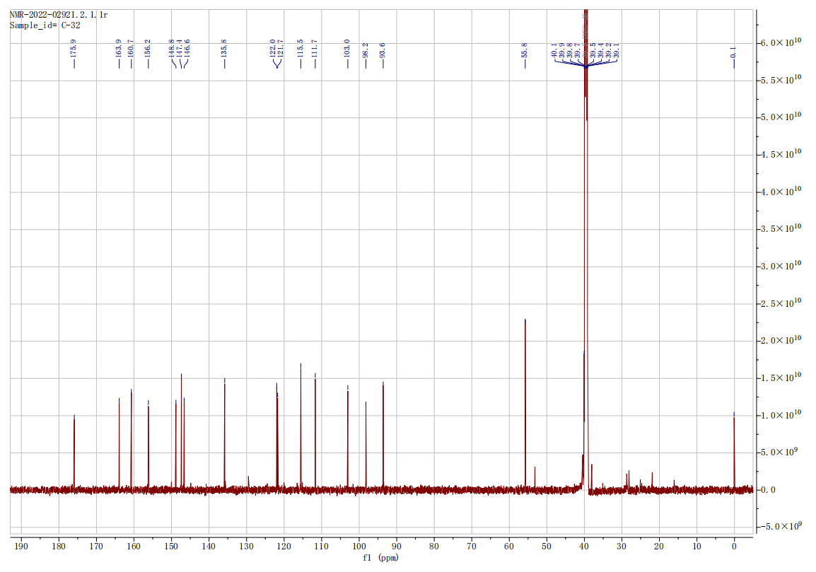
Fig. S38. ¹³C-NMR spectrum of compound 10
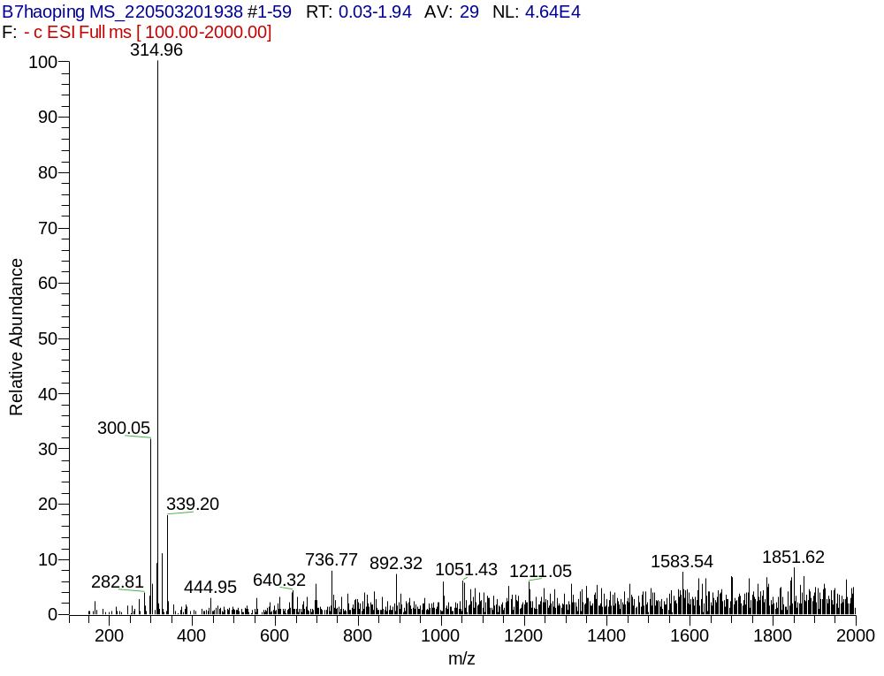
Fig. S39. ESI-MS spectrum of compound 10
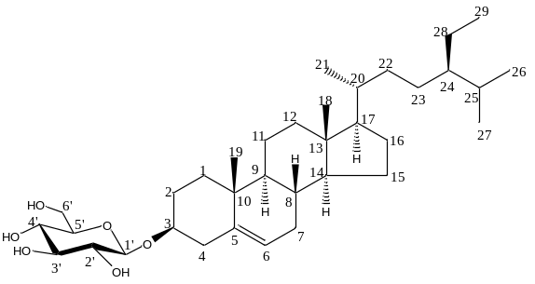
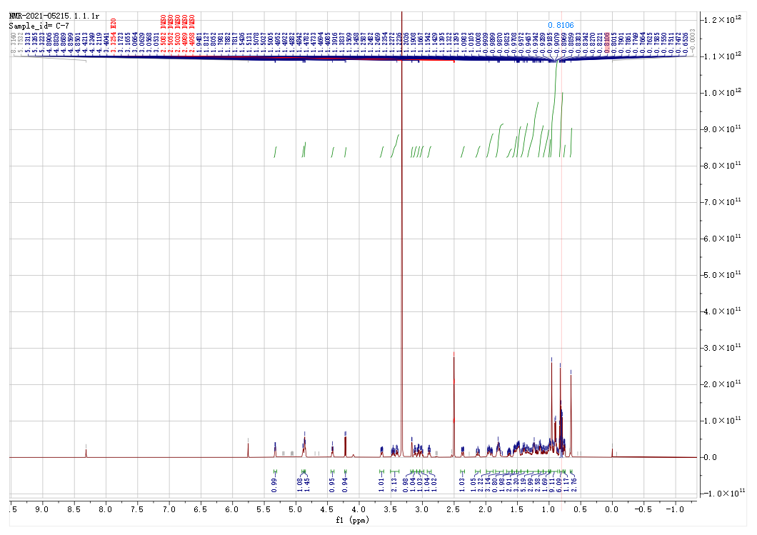
Fig. S40. ¹H -NMR spectrum of compound 11

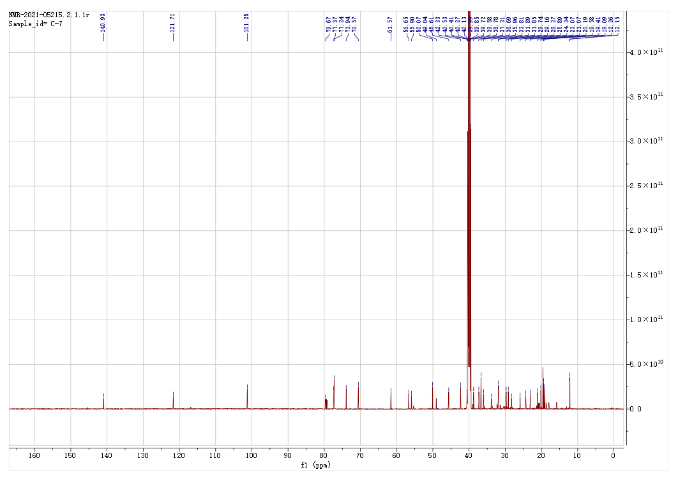
Fig. S41. ¹³C-NMR spectrum of compound 11
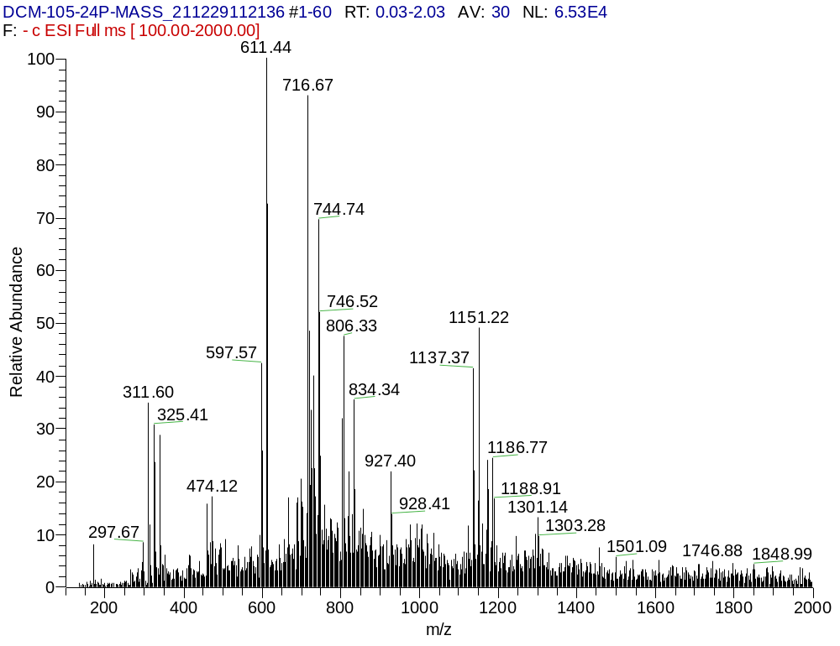
Fig. S42. ESI-MS spectrum of compound 11
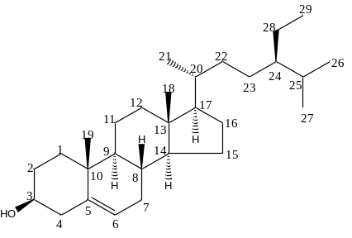
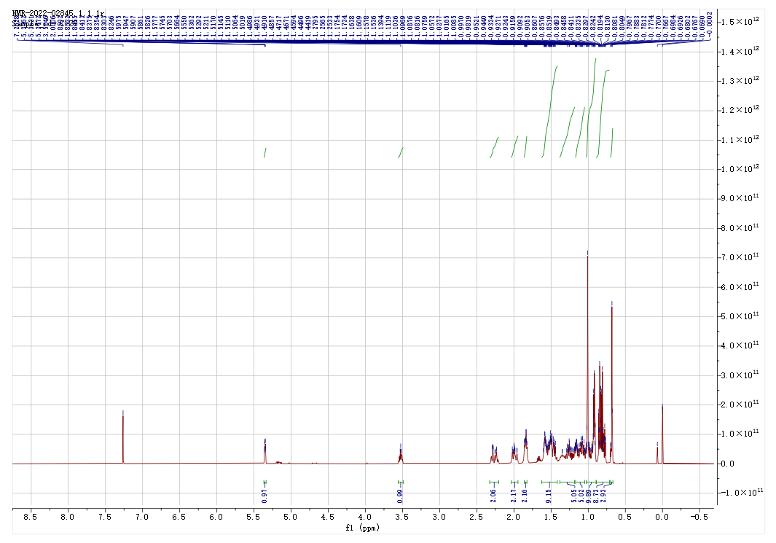
Fig. S43. ¹H -NMR spectrum of compound 12
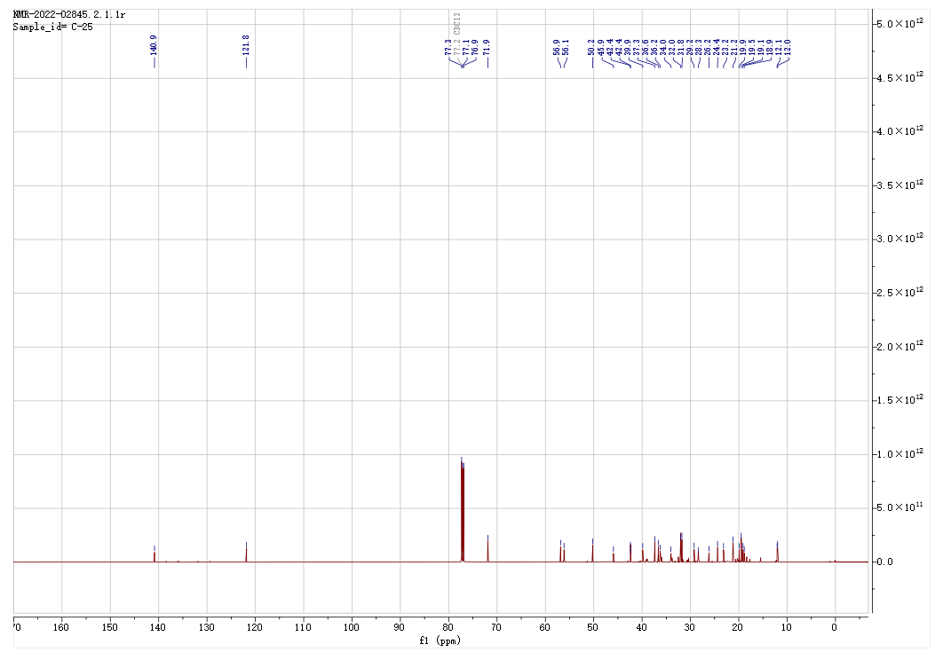
Fig. S44. ¹³C-NMR spectrum of compound 12
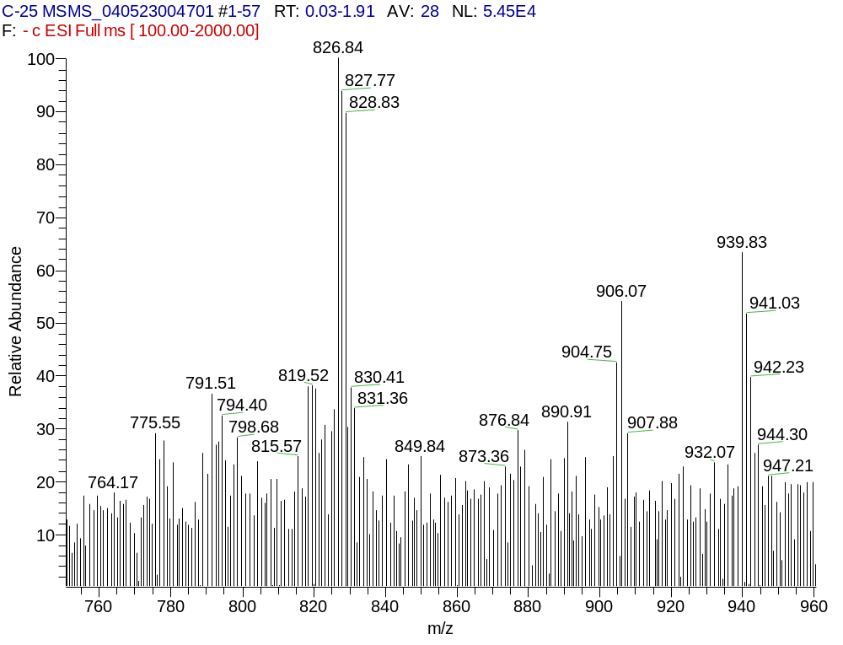
Fig. S45. ESI-MS spectrum of compound 12
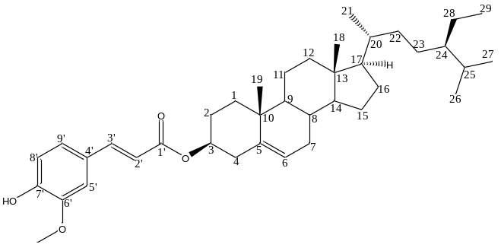
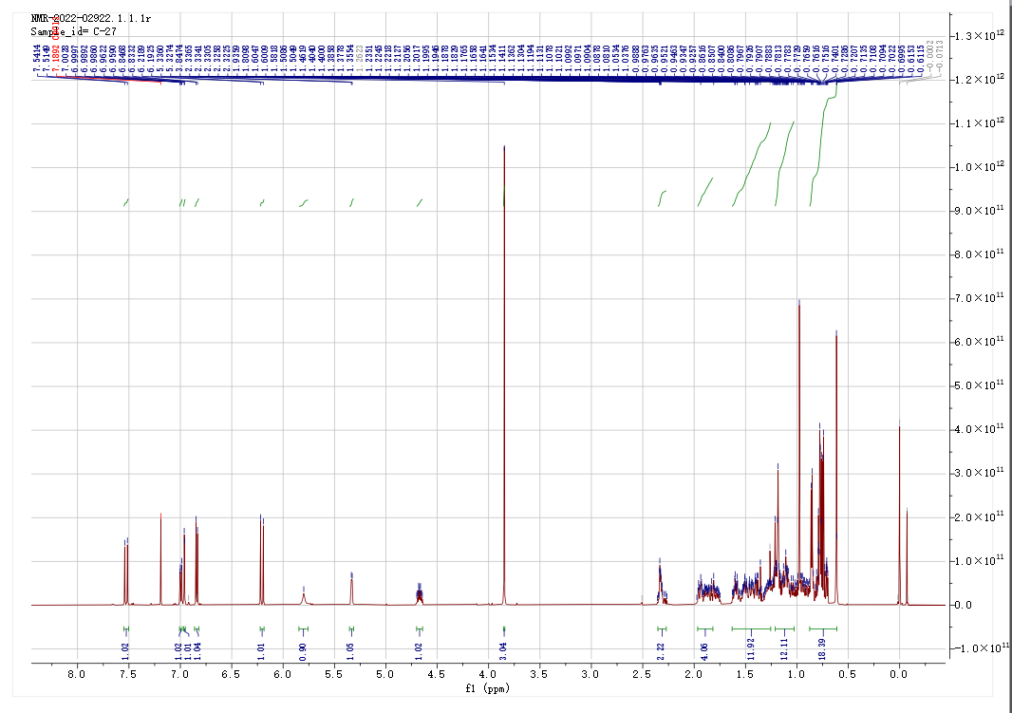
Fig. S46. ¹H -NMR spectrum of compound 13
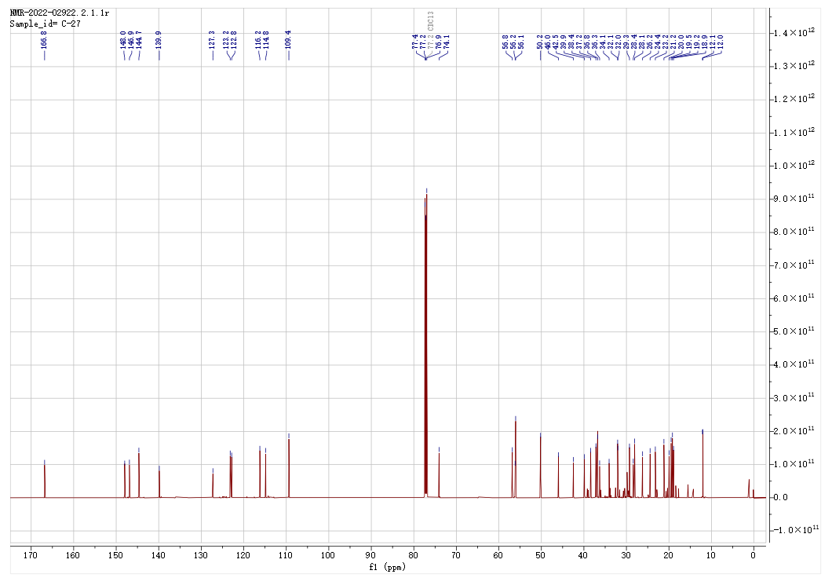
Fig. S47. ¹³C-NMR spectrum of compound 13
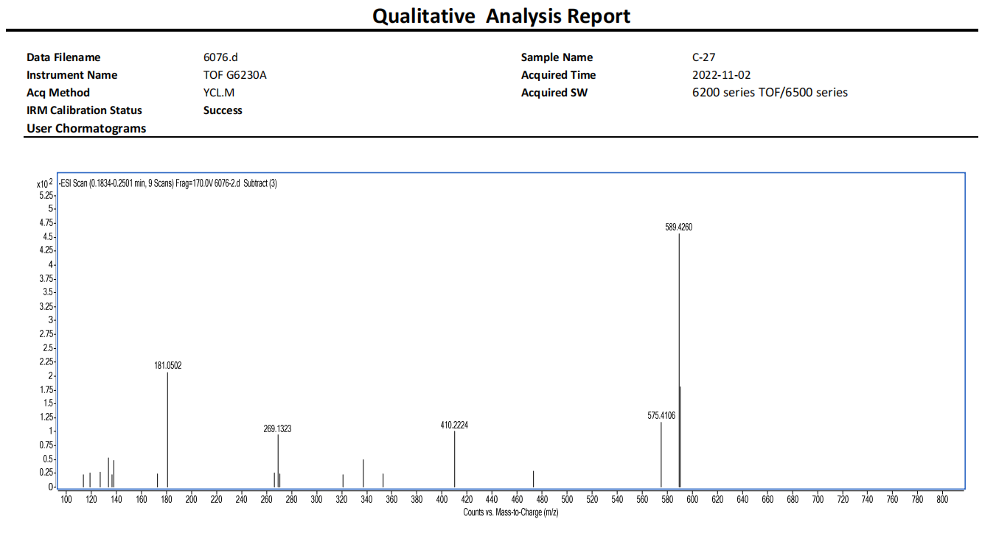
Fig. S48. ESI-MS spectrum of compound 13
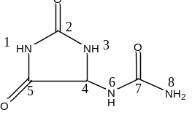
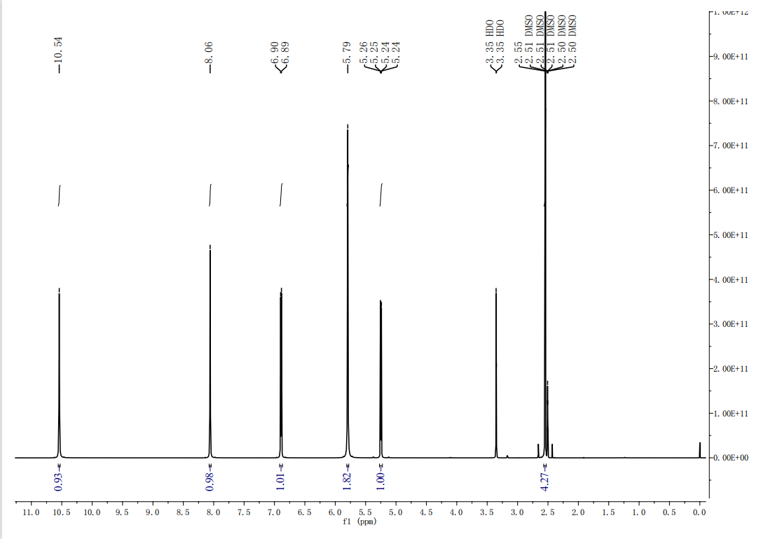
Fig. S49. ¹H -NMR spectrum of compound 14
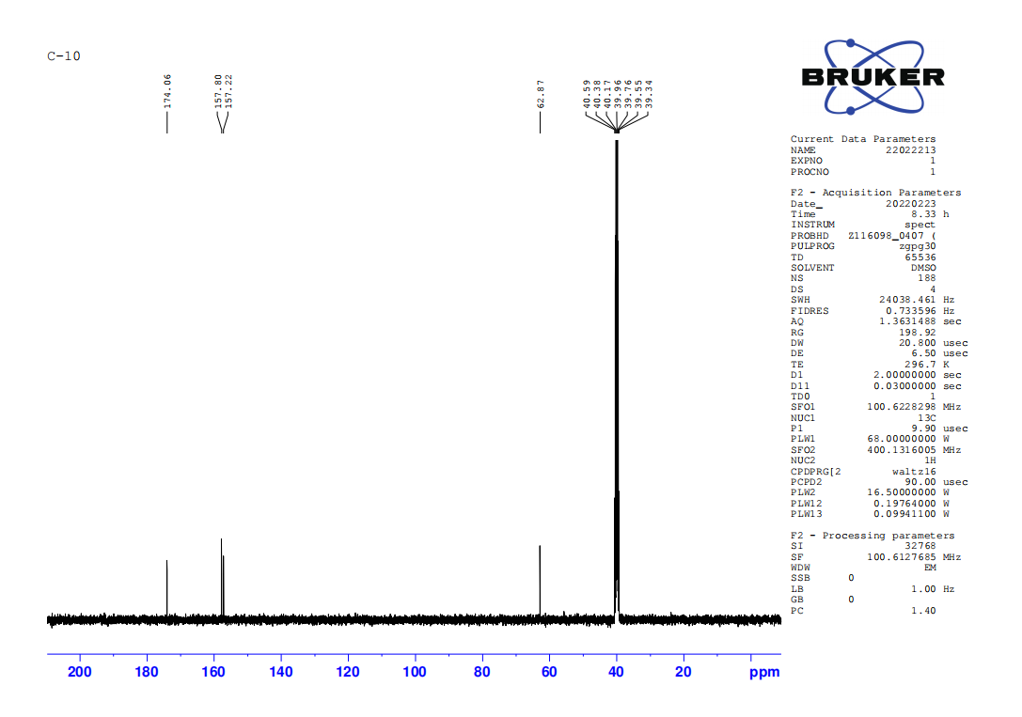
Fig. S50. ¹³C-NMR spectrum of compound 14
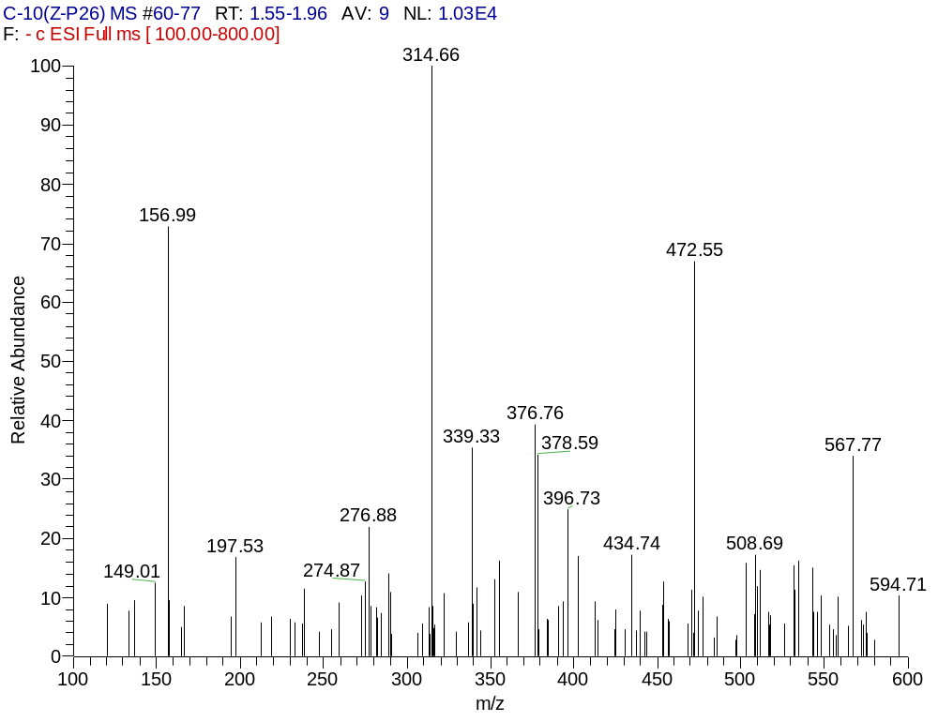
Fig. S51. ESI-MS spectrum of compound 14
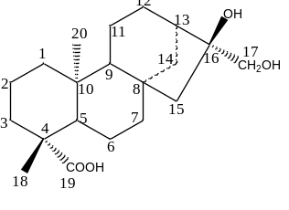
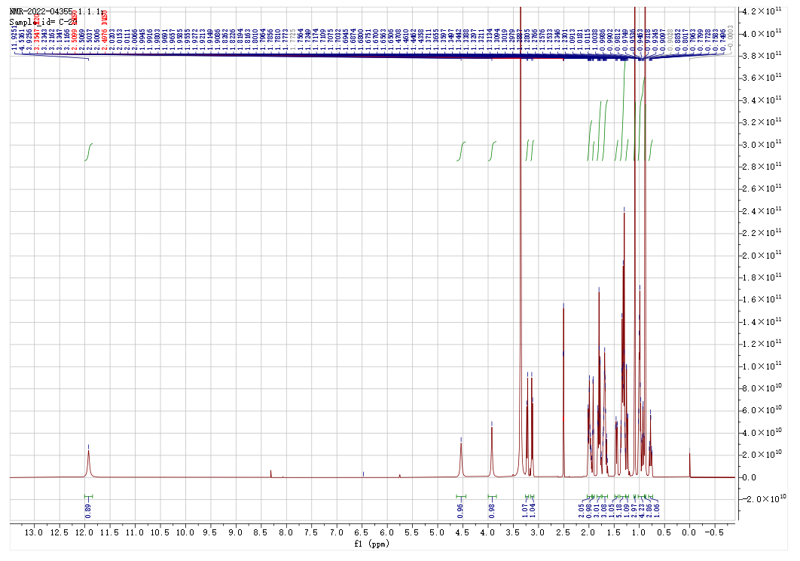
Fig. S52. ¹H -NMR spectrum of compound 15
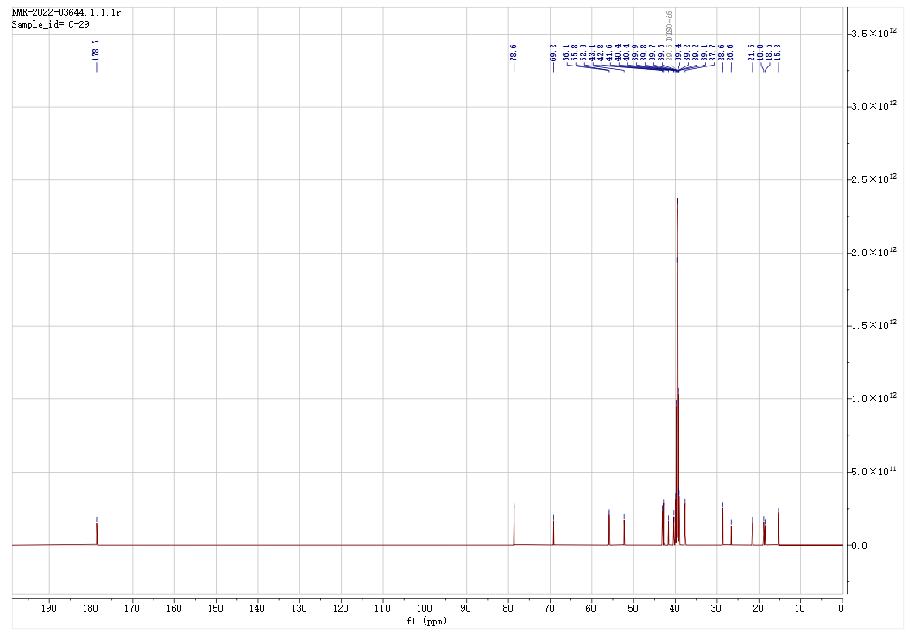
Fig. S53. ¹³C-NMR spectrum of compound 15
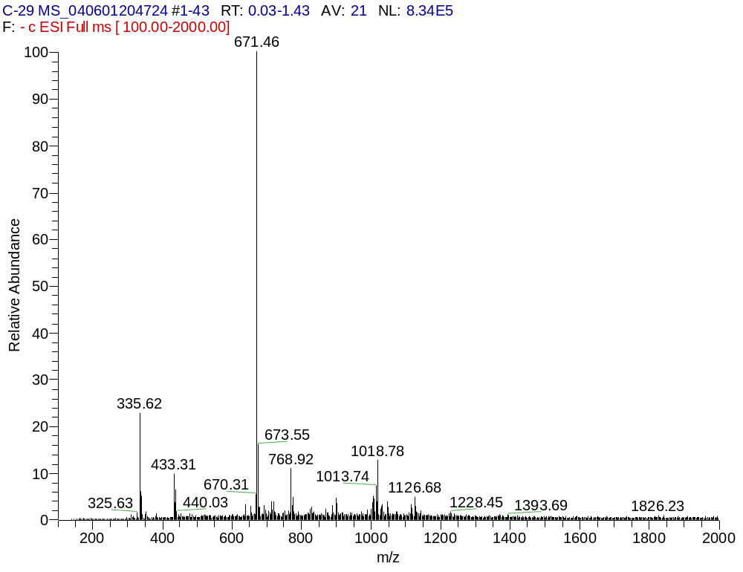
Fig. S54. ESI-MS spectrum of compound 15

