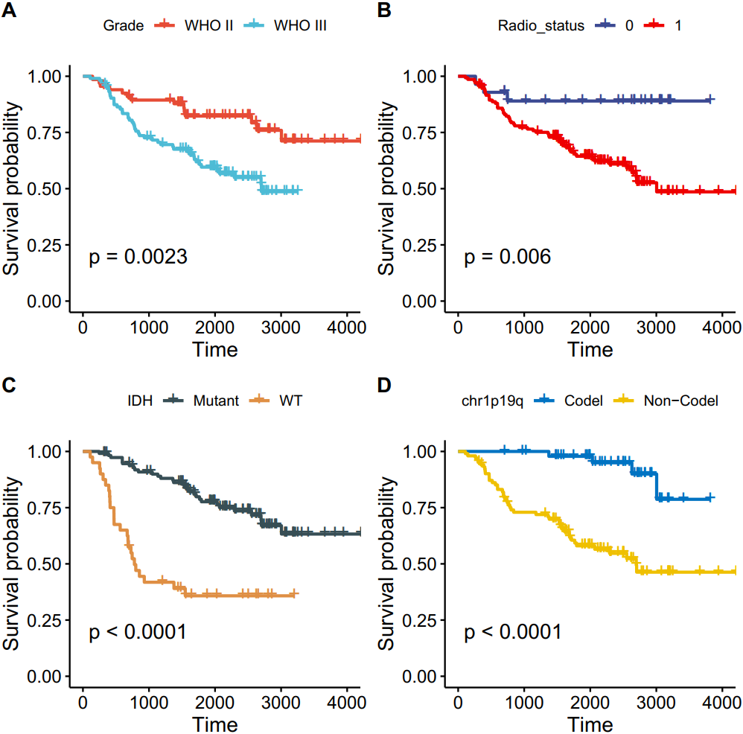
Supplementary Figure 1. Survival analysis of clinical factors associated with prognosis of TMZ treatment.

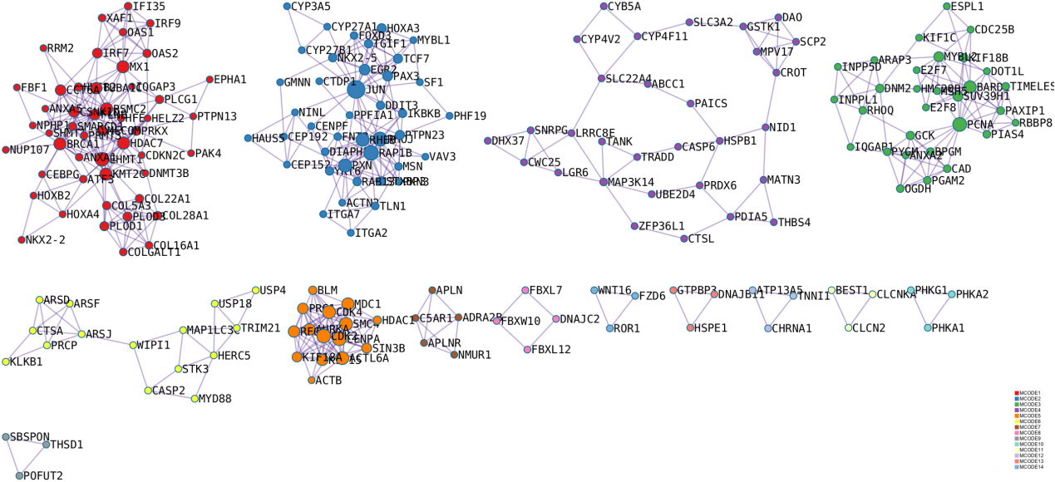
Supplementary Figure 2. Network module analysis for risk genes. Different colors represent different modules.

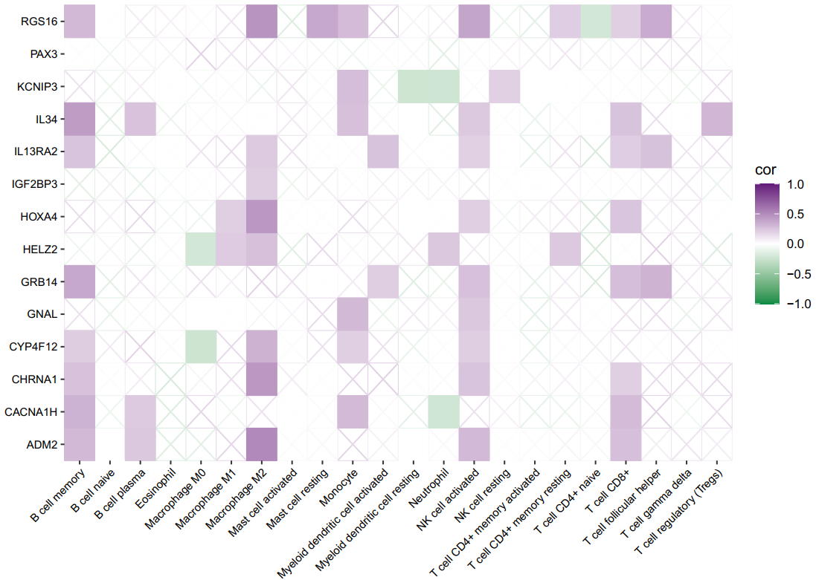
Supplementary Figure 3. The relation between genes in the model and immune score and percentage of immune cell infiltration from the CIBERSORT method.

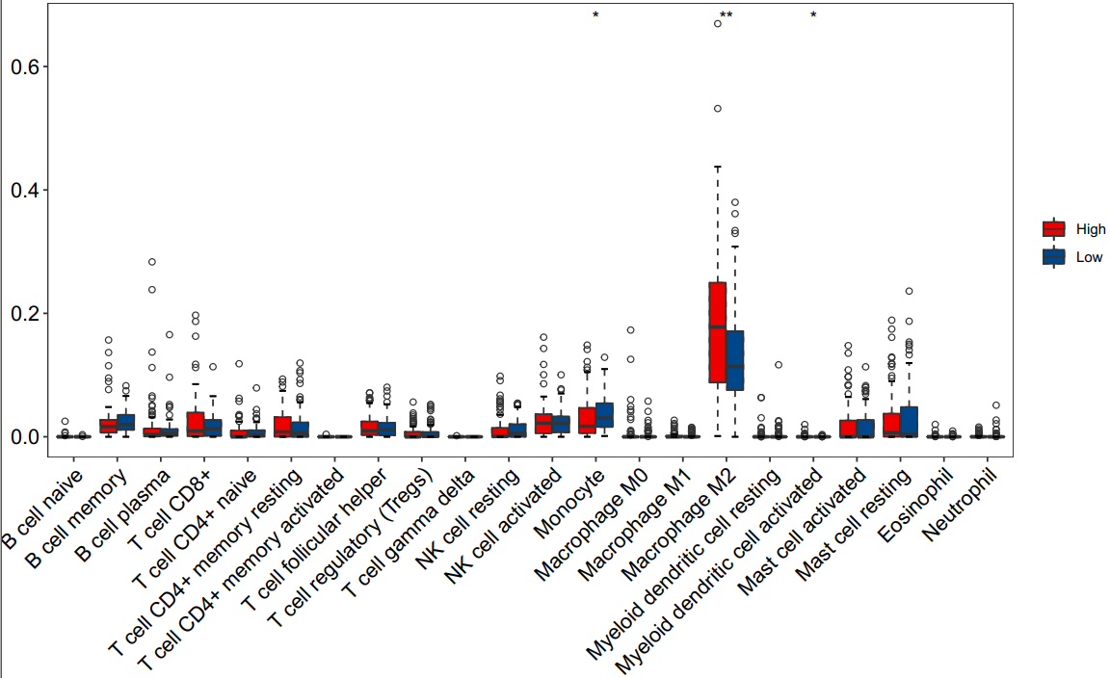
Supplementary Figure 4. Differences in immune cell infiltration from the CIBERSORT method between high and low-risk groups. Red represents the high-risk score group and blue represents the low-risk score group.

