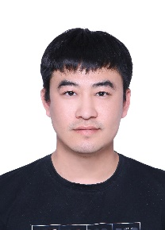
Liang Song Fan, graduated from Changchun University of Technology, China, with a master’s degree in power electronics and electrical transmission in 2013, and is currently pursuing his PhD at Silla University, Korea. I am currently working in Jilin Institute of Chemical Technology, China, as a university lecturer. I am the main leader of 2 China Jilin Foundation projects. Currently, my main research interests are target recognition, target tracking and natural language processing.
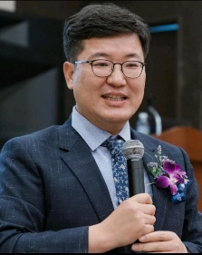
Pyeoungkee Kim received his Ph.D in Computer Engineering in 1995 from Kyungpook National University, South Korea. He is a professor at Silla university of South Korea. He founded the International Association of Convergence Science and Technology and served as the president until 2020.His current research interests include AI application in business, AI education and Metaverse design

