Table S1. primers used for RT-PCR
Transcript | Forward primer (5’-3) | Reverse primer (5’-3)
NCCRP1 | CACGGTCATTGCTCAGCACCAC | GTGCAGGAAGTGGATAAAGCGC
RHCG | GCCATCAACACCTACTGCTCCT | AGCGTGGCATTCTGGATGTGCA
EGFR | AACACCCTGGTCTGGAAGTACG | TCGTTGGACAGCCTTCAAGACC
FAM184A | CAGCAAGAGATTCATGGCAGAAG | TTGCGTAAGCCGCTGTCGTTCT
PLA2G2D | GCTGCTATGACCACCTGAAGAC | TGCTCACACCAGCTTCCCTTGT
CA8 | CTCCACTCTGTTTGGCAGCATTG | GGAGGATTTCAGTCACAGCCTTC
COL22A1 | AAGGTGAACTGGGACTTCCAGG | CATCCGTGGATGTGGTGTGAAC
NAA11 | TGAAGAAGGGCGGGTATGTGGT | CACTGCCACTTTCTTCGGTAGC
CEACAM6 | GCCTCAATAGGACCACAGTCAC | AGGGCTGCTATATCAGAGCGAC
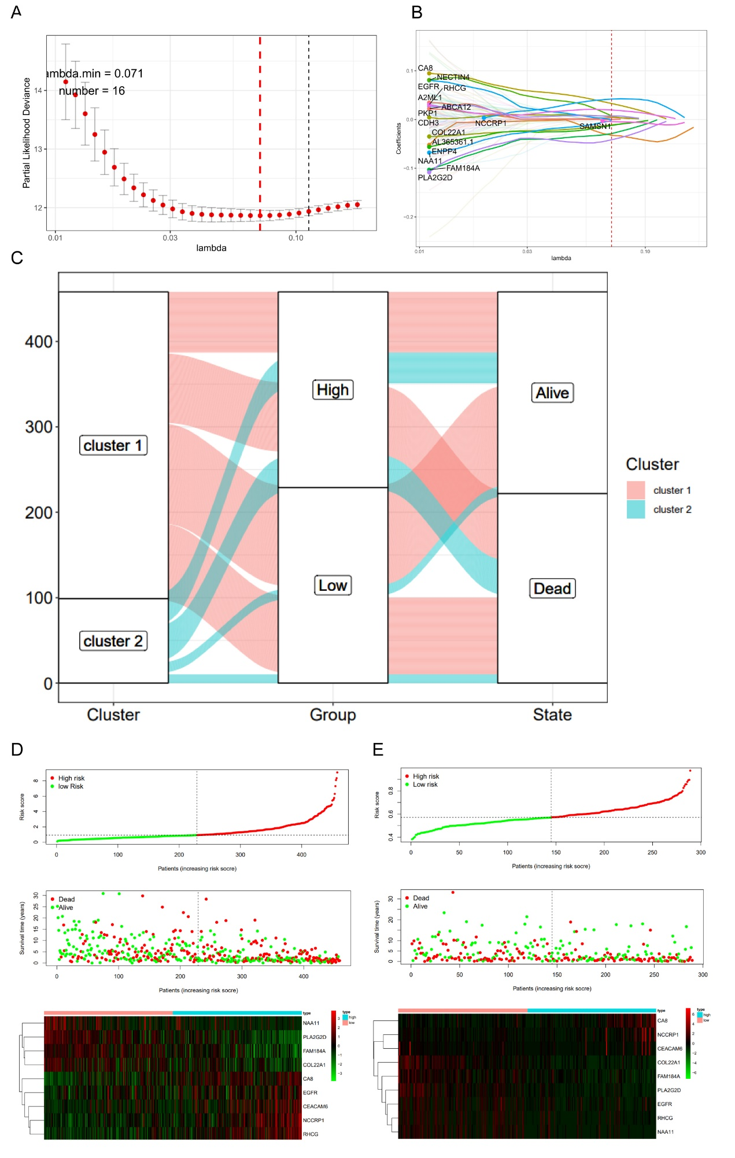
Figure S1.Identification of prognostic features associated with Anoikis. (A, B) The least absolute shrinkage and selection operator (LASSO) method of DEGs between ARG cluster 1 and 2. (C) Alluvial diagram of subtype and living status. (D, E) Distribution of the risk score, survival status, and heatmap of the expression profiles of the nine neutrophil-related genes between the high- and low-risk SKCM patients in the training set (D) and the validation set (E).
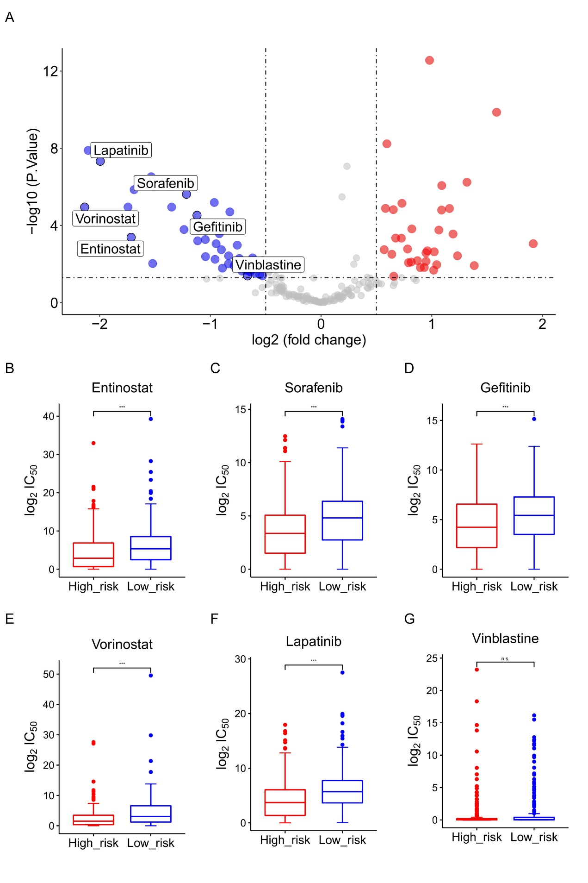
Figure S2. Assessing drug sensitivity of SKCM based on the risk score

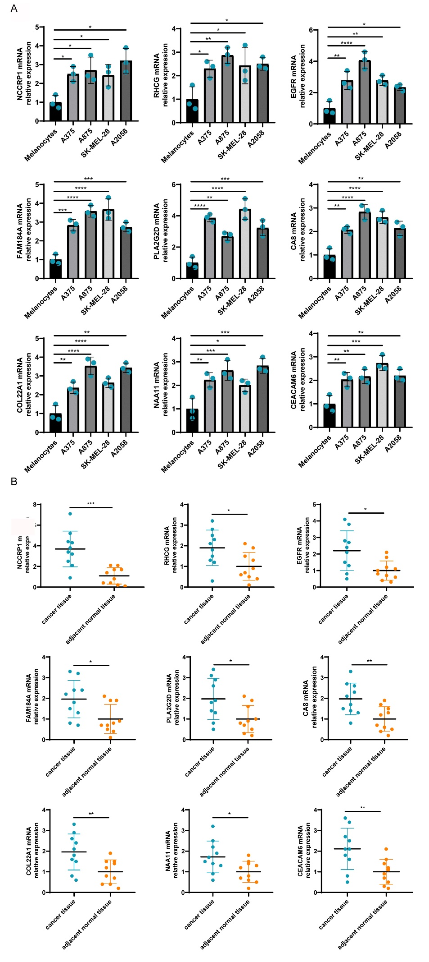
Figure S3. The expression of the ARGs signature related genes
(A) The mRNA expression of NCCRP1, RHCG, EGFR, FAM184A, PLA2G2D, CA8, COL22A1, NAA11, CEACAM6 in melanoma cell lines (A375, A875, SK-MEL-28 A2058) and primary melanocytes. (B) The mRNA expression of NCCRP1, RHCG, EGFR, FAM184A, PLA2G2D, CA8, COL22A1, NAA11, CEACAM6 in melanoma and the adjacent normal tissue. n=10. *P<0.05, **P<0.01, ***P<0.001, ****P<0.0001.

