SUPPLEMENTARY TABLES
Supplementary Table 1. Characteristics of the GEO datasets used in the study.
Dataset | Source | RD | pCR | PAM50 Class |  |  | Neoadjuvant Chemotherapy
 |  |  |  | Luminal A | Luminal B | Other | Neoadjuvant Chemotherapy
GSE20194 | FNA | 133 | 7 | NA | NA | NA | Weekly T × 12 + FAC × 4 or  3-Weekly T × 4 + FAC × 4
GSE20271 | FNA | 37 | 3 | NA | NA | NA | Weekly T × 12 + FAC × 4
GSE25055 | FNA or CBX | 154 | 11 | 92 | 37 | 35 | Weekly T × 12 + FAC × 4 or  3-Weekly T × 4 + FEC × 4 or AC x 4 + T x 4
GSE25065 | FNA or CBX | 94 | 19 | 49 | 31 | 33 | Weekly T × 12 + FAC × 4 or  3-Weekly T × 4 + FEC × 4 or AC x 4 + T x 4
GSE32646 | CBX | 50 | 5 | NA | NA | NA | Weekly T x 12 + FEC x 4
AC: Adriamycin/cyclophosphamide, CBX: core biopsy, FAC: fluorouracil/adriamycin/cyclophosphamide, FEC: fluorouracil/epirubicin/cyclophosphamide, FNA: Fine-needle aspiration biopsy, NA: data not available, T: taxanes (either paclitaxel or docetaxel).

Supplementary Table 2. The gene ontologies enriched in the top 5 clusters of upregulated genes in chemoresistant patients.
Cluster 1 | Enrichment Score: 1.614 | Count | P-Value | Genes
GOTERM_MF | protein serine/threonine kinase activity | 7 | 0.00 | SRPK2, MAP2K4, KSR1, LIMK2, MAST2, HIPK3, CAMKK2
GOTERM_MF | protein kinase activity | 6 | 0.01 | SRPK2, MAP2K4, KSR1, LIMK2, HIPK3, CAMKK2
GOTERM_MF | ATP binding | 12 | 0.01 | SRPK2, MAP2K4, EHD2, AQR, KSR1, LIMK2, MAST2, ITPK1, CLCN3, HIPK3, MLH3, CAMKK2
GOTERM_BP | protein phosphorylation | 6 | 0.02 | SRPK2, KSR1, LIMK2, MAST2, HIPK3, CAMKK2
GOTERM_BP | positive regulation of protein phosphorylation | 4 | 0.03 | MAP2K4, LIMK2, PLA2G6, CAMKK2
GOTERM_MF | protein tyrosine kinase activity | 3 | 0.05 | MAP2K4, HIPK3, CAMKK2
GOTERM_BP | peptidyl-tyrosine phosphorylation | 3 | 0.07 | MAP2K4, HIPK3, CAMKK2
GOTERM_BP | peptidyl-serine phosphorylation | 3 | 0.11 | SRPK2, MAST2, HIPK3
Cluster 2 | Enrichment Score: 1.148 | Count | P-Value | Genes
GOTERM_CC | apical plasma membrane | 5 | 0.02 | CEACAM1, SLC7A8, ITPK1, CLCN3, CD44
GOTERM_CC | cell surface | 5 | 0.11 | CEACAM1, CLCN3, THBS1, CD44, MPZL1
GOTERM_CC | integral component of plasma membrane | 8 | 0.14 | CEACAM1, SLC7A8, ADGRE3, HFE, TNFRSF25, CLCN3, CD44, MPZL1
Cluster 3 | Enrichment Score: 0.871 | Count | P-Value | Genes
KEGG_PATHWAY | Endocytosis | 4 | 0.11 | SH3GLB1, EHD2, SNX1, ZFYVE9
GOTERM_CC | macromolecular complex | 5 | 0.14 | SH3GLB1, SNX1, KSR1, ZFYVE9, RGS11
GOTERM_CC | intracellular membrane-bounded organelle | 6 | 0.15 | EHD2, SNX1, KSR1, ZFYVE9, PTCH1, CLCN3
Cluster 4 | Enrichment Score: 0.810 | Count | P-Value | Genes
GOTERM_MF | transcriptional repressor activity, RNA polymerase II transcription regulatory region sequence-specific binding | 5 | 0.02 | ZEB1, NFX1, LRRFIP1, ZNF224, NFATC4
GOTERM_BP | negative regulation of transcription from RNA polymerase II promoter | 7 | 0.08 | EID1, ZEB1, NFX1, PTCH1, LRRFIP1, ZNF224, NFATC4
GOTERM_BP | regulation of transcription from RNA polymerase II promoter | 10 | 0.09 | ZNF609, ECM1, ZEB1, FOXN3, LRRFIP1, ZNF214, MED16, ZNF224, FOSL2, NFATC4
GOTERM_MF | transcription factor activity, sequence-specific DNA binding | 5 | 0.10 | ZEB1, NFX1, FOXN3, FOSL2, NFATC4
GOTERM_CC | chromatin | 6 | 0.19 | SRPK2, ZEB1, NFX1, FOXN3, FOSL2, NFATC4
GOTERM_BP | regulation of transcription, DNA-templated | 6 | 0.20 | NFX1, ZNF747, FOXN3, LRRFIP1, ZNF214, ZNF224
GOTERM_MF | RNA polymerase II transcription factor activity, sequence-specific DNA binding | 7 | 0.21 | ZEB1, NFX1, FOXN3, LRRFIP1, ZNF214, FOSL2, NFATC4
GOTERM_MF | RNA polymerase II core promoter proximal region sequence-specific DNA binding | 6 | 0.33 | ZEB1, LRRFIP1, ZNF214, ZNF224, FOSL2, NFATC4
GOTERM_MF | DNA binding | 6 | 0.38 | ZEB1, LRRFIP1, MAPT, RBM5, FOSL2, NFATC4
GOTERM_BP | positive regulation of transcription from RNA polymerase II promoter | 5 | 0.53 | ZNF609, ZEB1, ZNF224, FOSL2, NFATC4
Cluster 5 | Enrichment Score: 0.605 | Count | P-Value | Genes
GOTERM_CC | cell surface | 5 | 0.11 | CEACAM1, CLCN3, THBS1, CD44, MPZL1
GOTERM_BP | cell migration | 3 | 0.21 | CEACAM1, THBS1, CD44
GOTERM_BP | cell adhesion | 4 | 0.26 | CEACAM1, ITGA10, THBS1, CD44
GOTERM_CC | extracellular exosome | 7 | 0.63 | EHD2, ECM1, CEACAM1, RPS15A, THBS1, ATP6V1D, CD44
GO: gene ontologies, GOTERM_CC: cellular compartments, GOTERM_MF: molecular functions, and GOTERM_BP: biological processes, KEGG_Pathway: Kyoto Encyclopedia of Genes and Genomes pathways

Supplementary Table 3. The 18 validated genes associated with resistance to taxane-based chemotherapy in ER+/HER2- breast cancer.
Symbol | Gene | Annotation
AP3B2 | AP-3 complex subunit beta-2 | Subunit of non-clathrin- and clathrin-associated adaptor protein complex 3 (AP-3) that plays a role in protein sorting in the late-Golgi/trans-Golgi network and/or endosomes.
ARL2BP | ADP-ribosylation factor-like protein 2-binding protein | Together with ARL2, plays a role in the nuclear translocation, retention, and transcriptional activity of STAT3.
BLOC1S1 | Biogenesis of lysosome-related organelles complex 1 subunit 1 | Component of the BLOC-1 complex, a complex that is required for normal biogenesis of lysosome-related organelles (LRO), such as platelet dense granules and melanosomes.
CAMKK2 | Calcium/calmodulin-dependent protein kinase kinase 2 | Calcium/calmodulin-dependent protein kinase belongs to a proposed calcium-triggered signaling cascade involved in several cellular processes.
ECM1 | Extracellular matrix protein 1 | Stimulates the proliferation of endothelial cells and promotes angiogenesis. Inhibits MMP9 proteolytic activity.
ITGA10 | Integrin alpha-10 | Integrin alpha-10/beta-1 is a receptor for collagen
ITPK1 | Inositol-tetrakisphosphate 1-kinase | A kinase that can phosphorylate various inositol polyphosphates such as Ins(3,4,5,6)P4 or Ins(1,3,4)P3.
NUDT13 | Nucleoside diphosphate-linked moiety X motif 13 | Nudix hydrolase family
PLA2G6 | Phospholipase A2 group VI | Catalyzes the release of fatty acids from phospholipids.
PTCH1 | Protein patched homolog 1 | Acts as a receptor for sonic hedgehog (SHH), indian hedgehog (IHH), and desert hedgehog (DHH).
RAP1GAP | Rap1 GTPase-activating protein 1 | GTPase activator for the nuclear Ras-related regulatory protein RAP-1A (KREV-1).
RGS11 | Regulator of G-protein signaling 11 | Inhibits signal transduction by increasing the GTPase activity of G protein alpha subunits.
RGS12 | Regulator of G-protein signaling 12 | Regulates G protein-coupled receptor signaling cascades. Inhibits signal transduction by increasing the GTPase activity of G protein alpha subunits.
RPS15A | Ribosomal protein S15a | Small subunit ribosomal protein s15a
SLC7A8 | Solute carrier family 7 member 8 | Sodium-independent, high-affinity transport of small and large neutral amino acids
ZFYVE9 | Zinc finger FYVE domain-containing protein 9 | Early endosomal protein that functions to recruit SMAD2/SMAD3 to intracellular membranes and the TGF-beta receptor.
ZNF214 | Zinc finger protein 214 | May be involved in transcriptional regulation.
ZNF609 | Zinc finger protein 609 | Transcription factor, which activates RAG1, and possibly RAG2, transcription.

SUPPLEMENTARY FIGURES

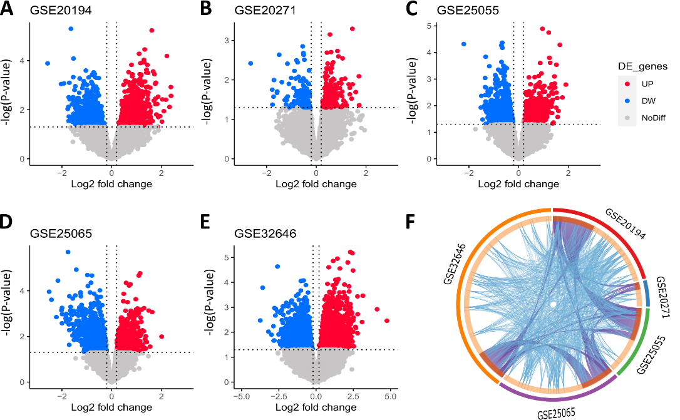
Supplementary Figure 1. Upregulated genes associated with resistance to taxane-based therapy in ER+/HER2- breast cancer. Volcano plots for upregulated genes in chemoresistant patients vs. chemosensitive patients in (a) GSE20194, (b) GSE20271, (c) GSE25055, (d) GSE25065, and (e) GSE32646 datasets. (f) Circos plot that shows the upregulated genes and ontologies shared by GSE20194 (red outer arc), GSE20271 (blue outer arc), GSE25055 (green outer arc), GSE25065 (purple outer arc), and GSE32646 (orange outer arc) datasets. Inner arcs represent spots for each upregulated gene in different datasets. Light orange inner arcs represent spots for genes unique to a single dataset. Dark orange inner arcs represent spots for genes shared by more than one dataset. Purple lines between the arcs link the genes that are upregulated in more than one dataset. Blue lines between the arcs link the different genes which fall into the same gene ontology term (only the ontologies where the enrichment of DEGs was statistically significant are shown in the plot).

