Supplementary Information for
Two styles of Neoarchean slab subduction revealed by mantle oxygen fugacity
Lei Gao¹, Shuwen Liu^{2*}, Wei Wang¹, Peter A. Cawood³, Guozheng Sun⁴, Xin He¹, Yalu Hu⁵
¹ Key Laboratory of Geological Processes and Mineral Resources, School of Earth Sciences and Resources, China University of Geosciences, Beijing 100083, PR China
² Key Laboratory of Orogenic Belts and Crustal Evolution, Ministry of Education, School of Earth and Space Sciences, Peking University, Beijing 100871, PR China
³ School of Earth, Atmosphere and Environment, Monash University, Melbourne, VIC 3800, Australia
⁴ Key Lab of Submarine Geosciences and Prospecting Techniques, MOE and College of Marine Geosciences, Ocean University of China, Qingdao 266100, PR China.
⁵ Development Research Center, China Geological Survey, Beijing 100037, PR China

*corresponding authors
Shuwen Liu (swliu@pku.edu.cn)

Supplementary Figures
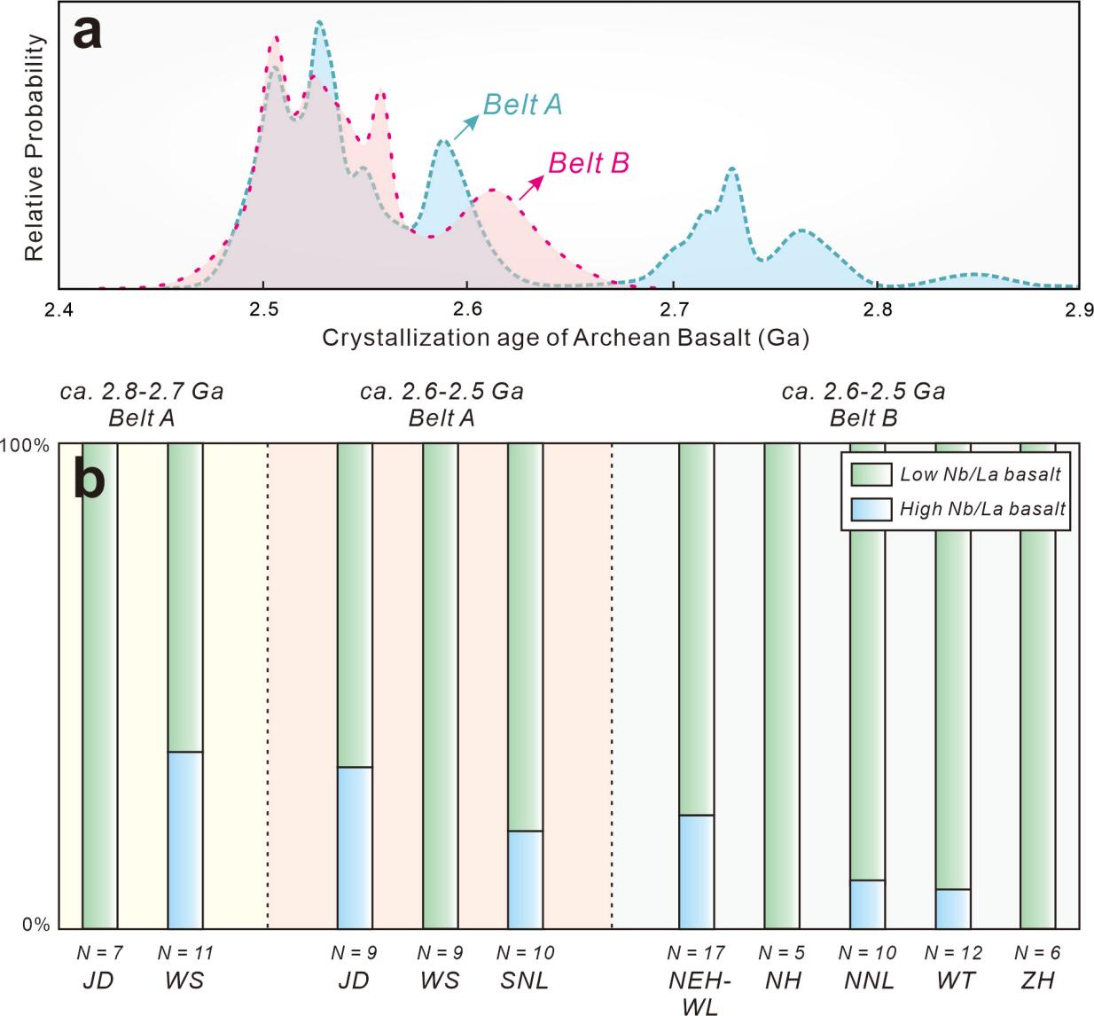
Supplementary Figure 1 Sample distribution of the Neoarchean basalts in the central and eastern North China Craton (NCC). a, Basalt crystallization age of Belts A and B. The reliable age data of Neoarchean basalts were mainly collected from Wang et al¹ and Liu et al². b, Percentage stacking bar chart of the Neoarchean primitive basalts in respective terranes.
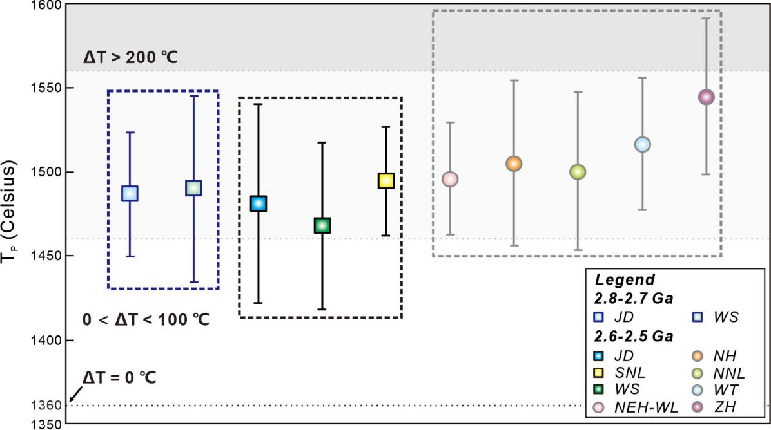
Supplementary Figure 2 Neoarchean mantle potential temperature (T_{P}) of different terranes in the central and eastern North China Craton (NCC). The mantle T_{P} values were calculated by the Herzberg’s function (T_{P} = 1463 + 12.74MgO - 2924/MgO, and here MgO is the contents of primary magma that equilibrated with olivine Fo = 91)³. The present-day T_{P} value is 1360 ℃⁴. Error bars show the 1 standard deviation (SD) of the means. Abbreviations: SNL-South part of Northern Liaoning; WS-Western Shandong; JD-Jiaodong; NNL-North part of Northern Liaoning; NEH-WL-North part of Eastern Hebei-Western Liaoning; NH-Northern Hebei; WT-Wutai; ZH-Zanhuang.

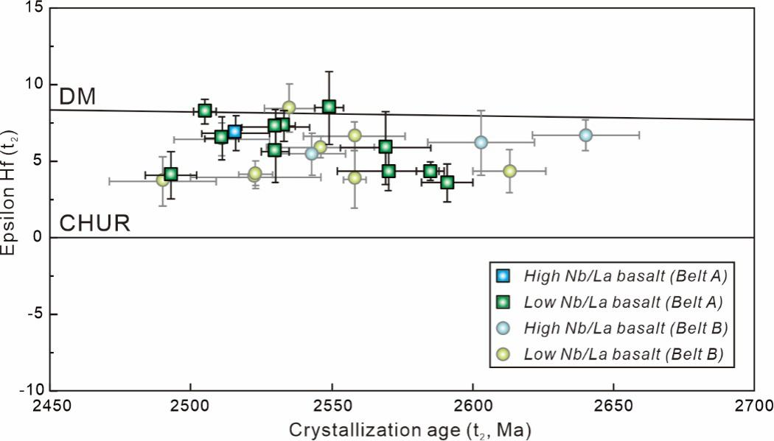
Supplementary Figure 3 Zircon Lu-Hf isotopes for the Neoarchean primitive basalts in the central and eastern North China Craton (NCC).

References
- Wang, X., Zhu, W. B. & Zheng, Y. F. Geochemical constraints on the nature of Late Archean basaltic-andesitic magmatism in the North China Craton. Earth Sci. Rev. 230, 104065 (2022).
- Liu, S.W. et al. Late Neoarchean metavolcanics and geodynamics regime in central and eastern North China Craton. Acta. Petrol. Sinica. 37, 113-128 (2021).
- Herzberg, C., Condie, K. & Korenaga, J. Thermal history of the Earth and its petrological expression. Earth Planet. Sci. Lett. 292, 79-88 (2010).
- Sizova, E., Gerya, T., Brown, M. & Perchuk, L. L. Subduction styles in the Precambrian: Insight from numerical experiments. Lithos 116, 209-229 (2010).

