Isolation of bioactive phytochemicals from Crinum asiaticum along with their cytotoxic and TRAIL-resistance abrogating prospect assessment
Sharmin Ahmed Rakhi¹, Yasumasa Hara², Md. Saiful Islam¹, Teruhisa Manome², Safaet Alam^{3,1}, Nazim Uddin Emon⁴, Muhammad Abdullah Al-Mansur⁵, Md Ruhul Kuddus¹, Md. Raihan Sarkar⁶, Masami Ishibashi² and Firoj Ahmed^{7*}

Supplementary information

- Characterization of Compound 1

Figure S1: ESIMS of 1

Figure S1: ESIMS of 1

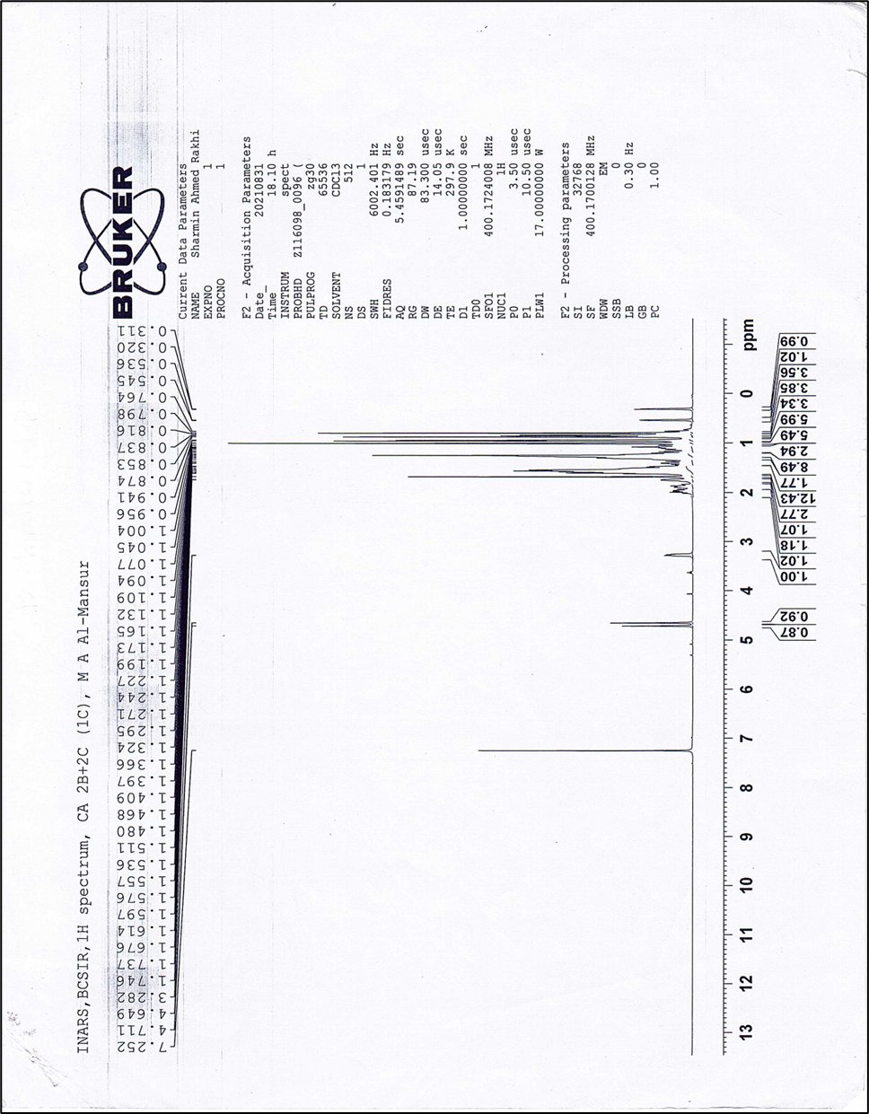
Figure S2: ¹H NMR spectrum (400 MHz, CDCl₃) of 1

Figure S2: ¹H NMR spectrum (400 MHz, CDCl₃) of 1

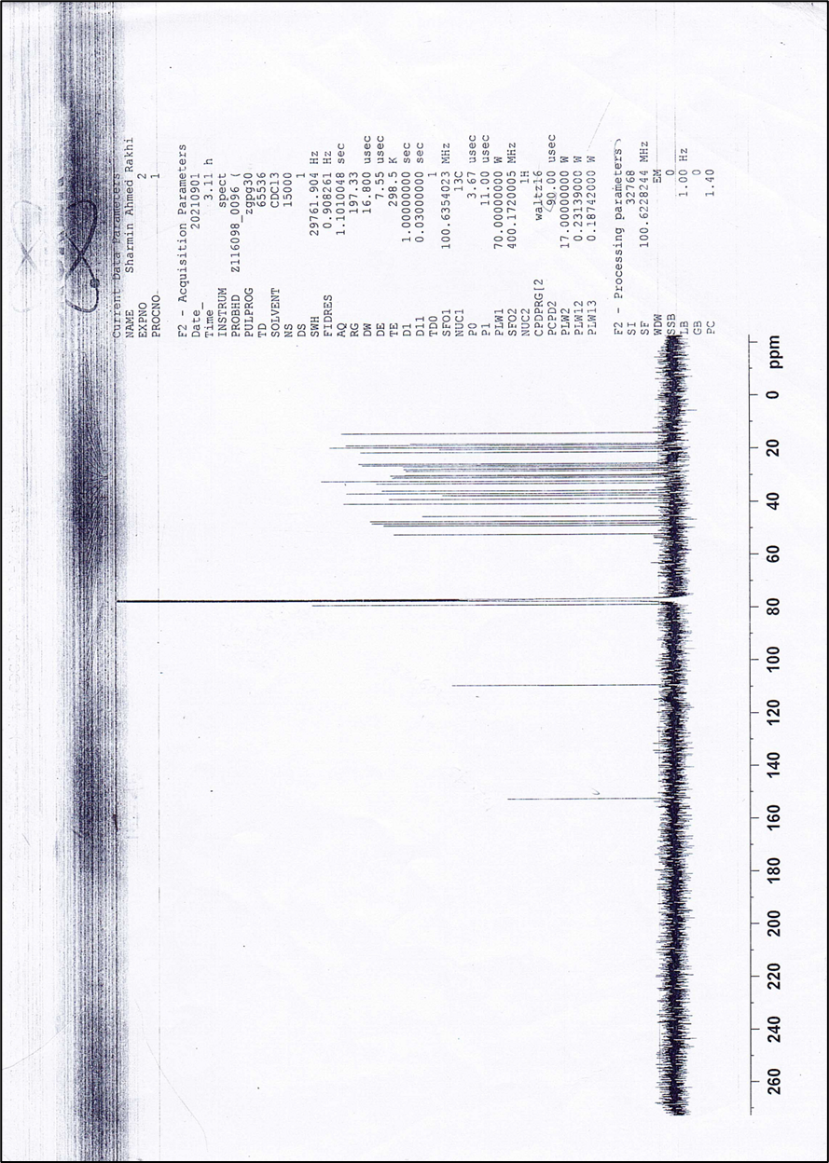
Figure S3: ¹³C NMR spectrum (100 MHz, CDCl₃) of 1

Figure S3: ¹³C NMR spectrum (100 MHz, CDCl₃) of 1

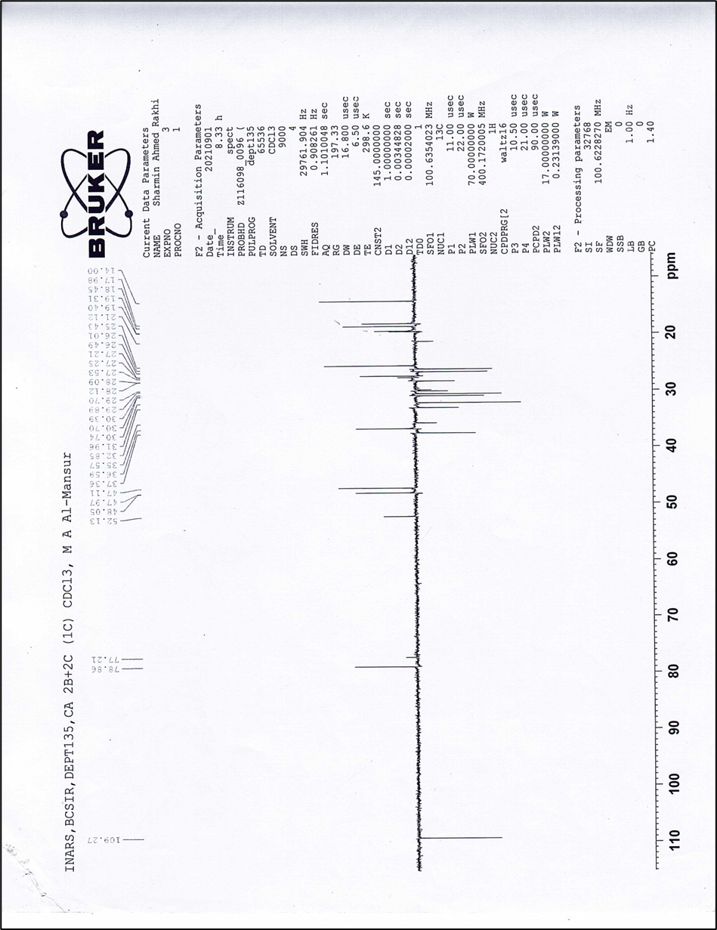
Figure S4: DEPT-135 spectrum (100 MHz, CDCl₃) of 1

Figure S4: DEPT-135 spectrum (100 MHz, CDCl₃) of 1

- Characterization of Compound 2

Figure S5: ESIMS of 2

Figure S5: ESIMS of 2

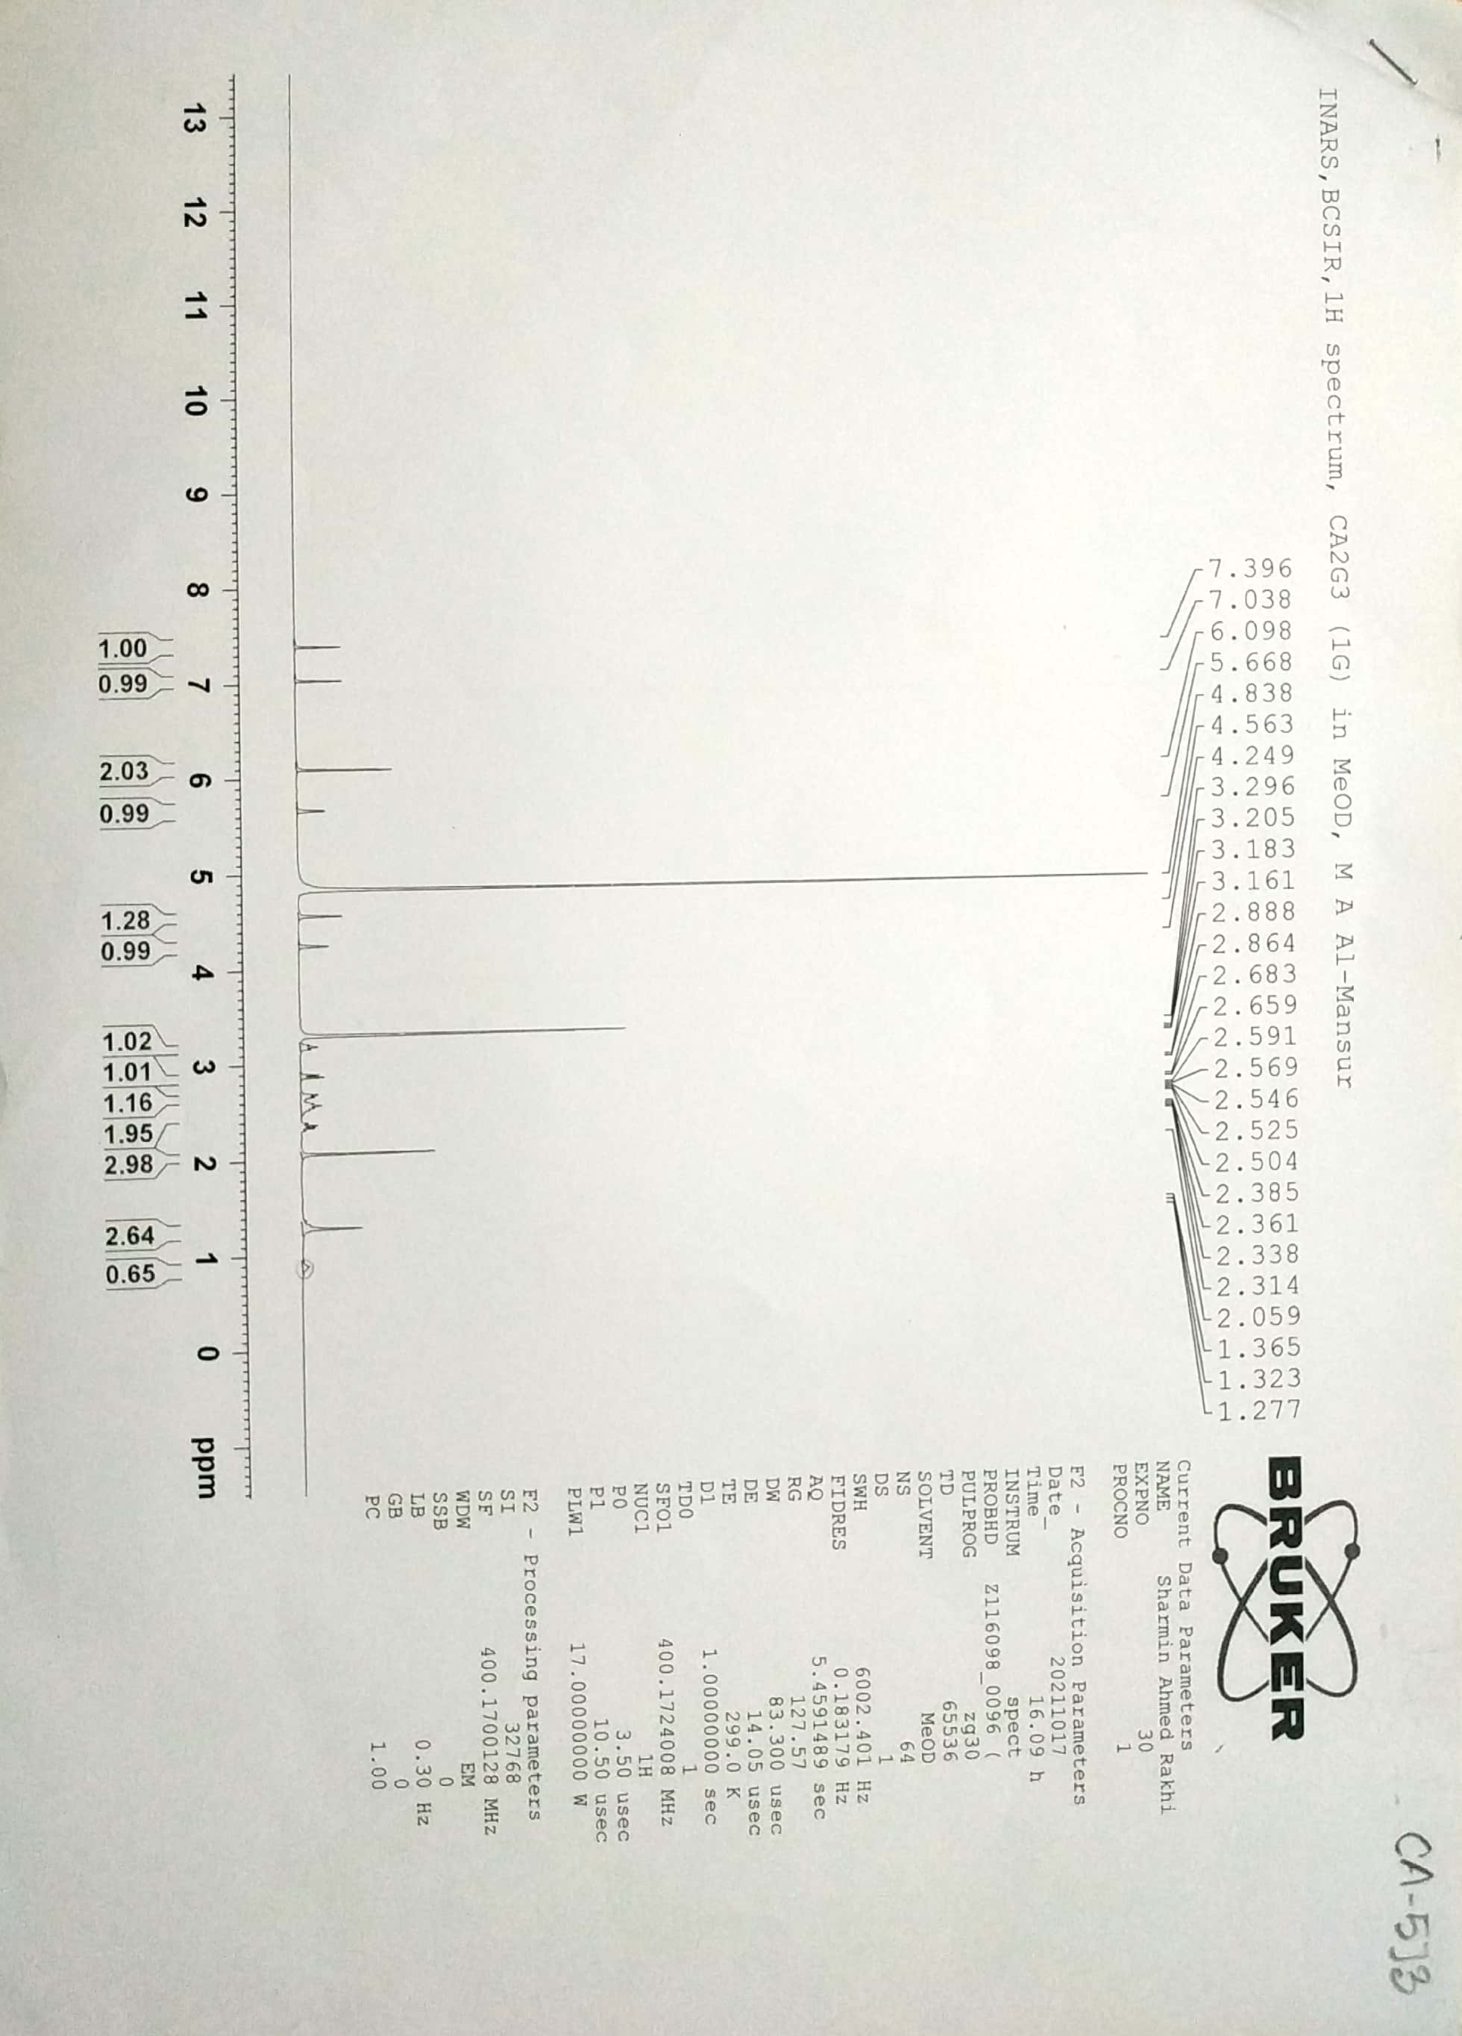
Figure S6: ¹H NMR spectrum (400 MHz, CD₃OD) of 2

Figure S6: ¹H NMR spectrum (400 MHz, CD₃OD) of 2

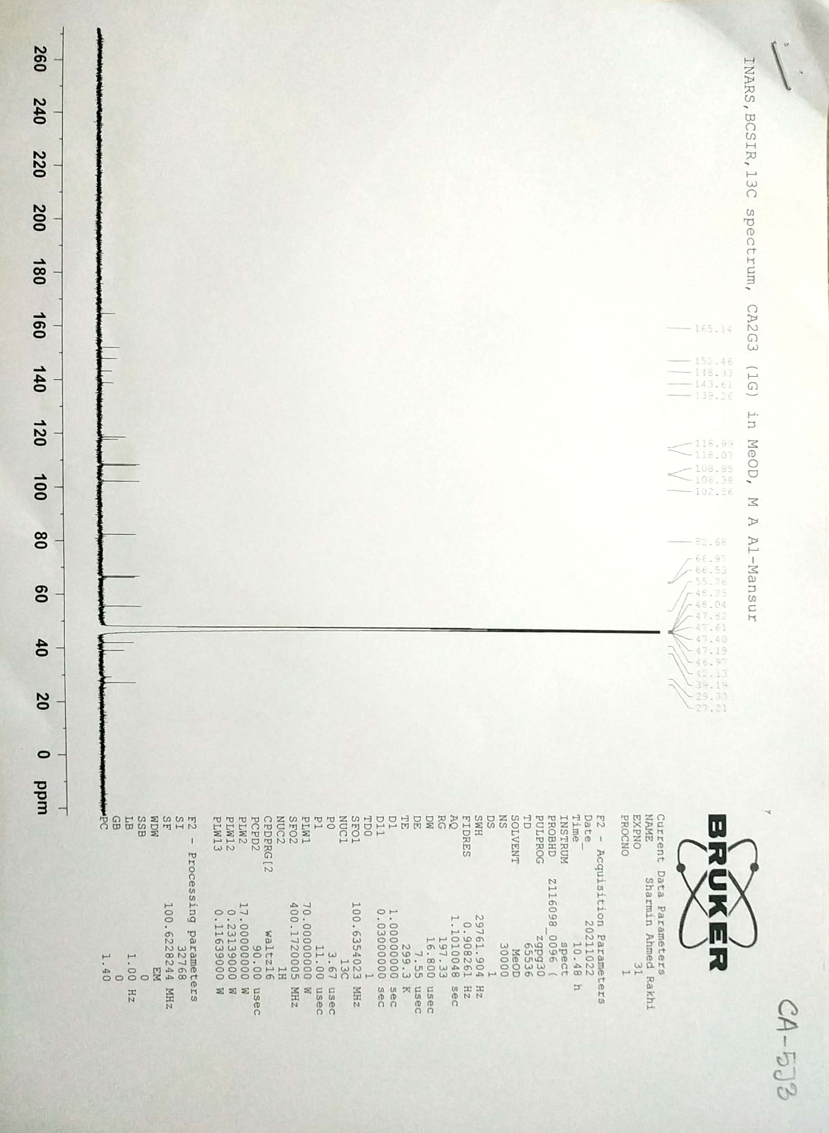
Figure S7: ¹³C NMR spectrum (100 MHz, CD₃OD) of 2

Figure S7: ¹³C NMR spectrum (100 MHz, CD₃OD) of 2

- Characterization of Compound 3

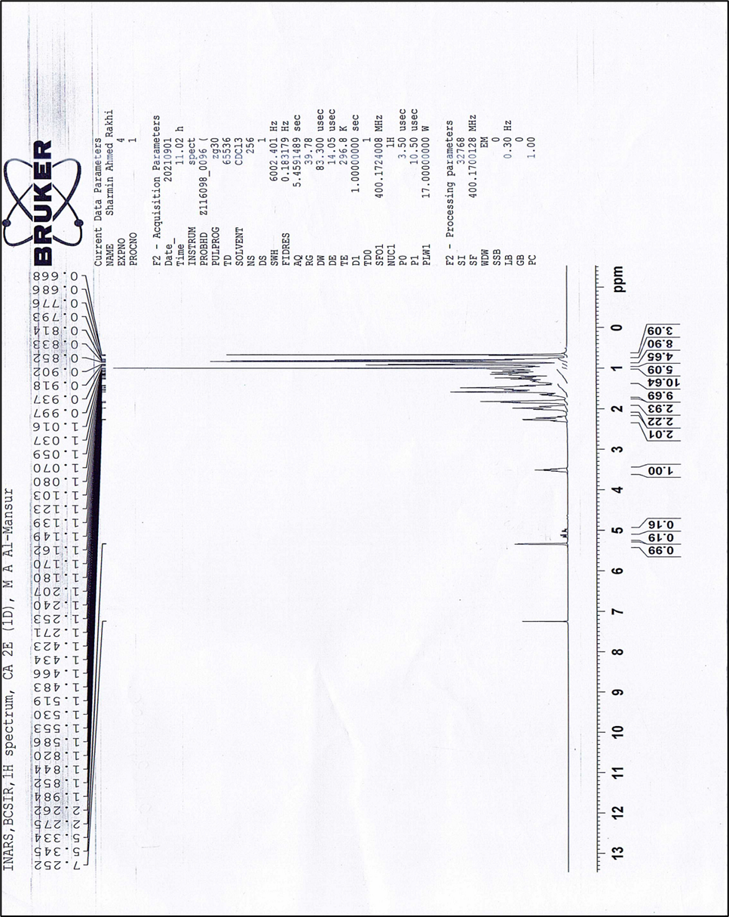
Figure S8: ¹H NMR spectrum (400 MHz, CDCl₃) of 3

Figure S8: ¹H NMR spectrum (400 MHz, CDCl₃) of 3
- Cytotoxicity assay of 1 and 2
Cytotoxicity assay
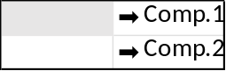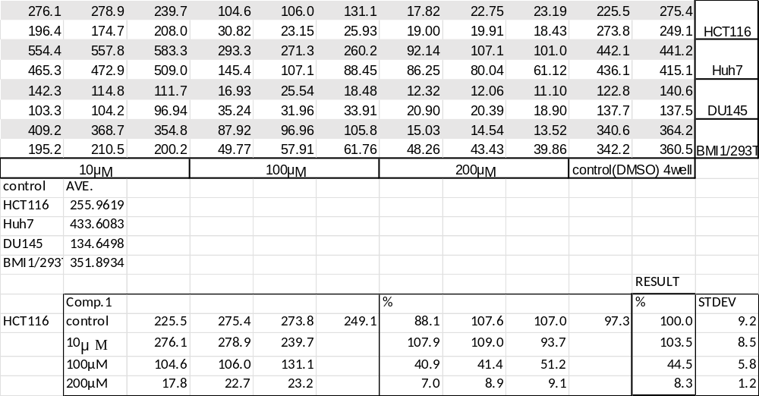
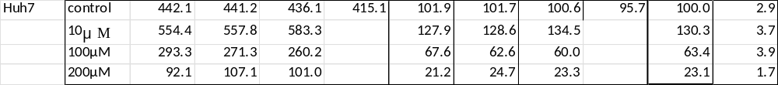
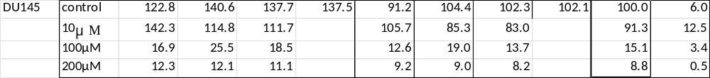
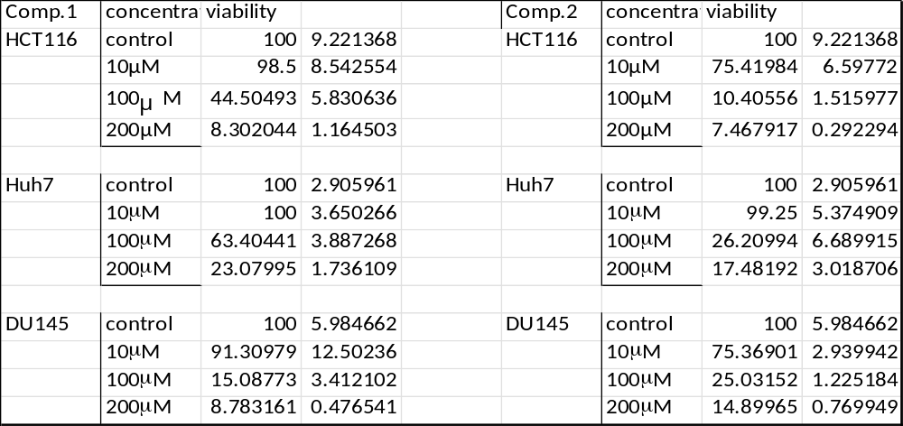
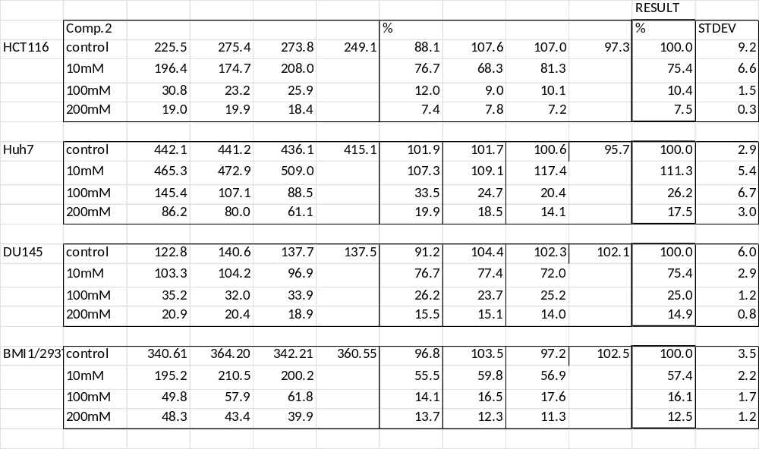

- TRAIL- resistance abrogating effect of 1 and 2

TRAIL-resistance abrogating activity

