Table S1. The expression of the hsa-miR-3613-5p in the TCGA-KIRC cohort based on sample types. The data were provided by the UALCAN database.
Comparison | P-value* | Expression
Normal vs. Primary tumor | 1.62e-12 | Higher in Primary tumor
*A p-value < 0.05 was identified as statistically significant; TCGA: The Cancer Genome Atlas Program; KIRC: Kidney renal clear cell carcinoma; NS: Not Significant.
Table S2. The expression of the hsa-miR-3613-5p in the TCGA-KIRC cohort based on individual cancer stage. The data were obtained from the UALCAN database.
Comparison | P-value* | Expression
Normal vs. Stage 1 | 1.62e-12 | Lower in stage 1
Normal vs. Stage 2 | 4.41e-07 | Lower in stage 2
Normal vs. Stage 3 | 1.67e-12 | Lower in stage 3
Normal vs. Stage 4 | 1.80e-12 | Lower in stage 4
Stage 1 vs. Stage 2 | 8.00e-01 | NS
Stage 1 vs. Stage 3 | 4.06e-01 | NS
Stage 1 vs. Stage 4 | 1.54e-02 | Higher in stage 4
Stage 2 vs. Stage 3 | 3.88e-01 | NS
Stage 2 vs. Stage4 | 5.25e-02 | NS
Stage 3 vs. Stage 4 | 1.48e-01 | NS
*A p-value < 0.05 was identified as statistically significant; TCGA: The Cancer Genome Atlas Program; KIRC: Kidney renal clear cell carcinoma; NS: Not Significant.
Table S3. The expression of the hsa-miR-3613-5p in the TCGA-KIRC cohort based on patient’s race. The data were collected from the UALCAN database.
Comparison | P-value* | Expression
Normal vs. Caucasian | 1.62e-12 | Higher in Caucasian
Normal vs. African-American | 2.05e-10 | Higher in African-American
Normal vs. Asian | 1.53e-10 | Higher in Asian
Caucasian vs. African-American | 1.28e-07 | Higher in Caucasian
Caucasian vs. Asian | 7.68e-01 | NS
African-American vs. Asian | 7.68e-02 | NS
*A p-value < 0.05 was identified as statistically significant; TCGA: The Cancer Genome Atlas Program; KIRC: Kidney renal clear cell carcinoma; NS: Not Significant.
Table S4. The expression of the hsa-miR-3613-5p in the TCGA-KIRC cohort based on patient’s gender. The data were achieved from the UALCAN database.
Comparison | P-value* | Expression
Normal vs. Male | <1e-12 | Higher in Male
Normal vs. Female | 1.62e-12 | Higher in Female
Male vs. Female | 7.10e-01 | NS
*A p-value < 0.05 was identified as statistically significant; TCGA: The Cancer Genome Atlas Program; KIRC: Kidney renal clear cell carcinoma; NS: Not Significant.
Table S5. The expression of the hsa-miR-3613-5p in the TCGA-KIRC cohort based on patient’s age. The data were retrieved from the UALCAN database.
Comparison | P-value* | Expression
Normal vs. Age (21-40Yrs) | 7.41e-04 | Higher in Age (21-40Yrs)
Normal vs. Age (41-60Yrs) | 1.62e-12 | Higher in Age (41-60Yrs)
Normal vs. Age (61-80Yrs) | <1e-12 | Higher in Age (61-80Yrs)
Normal vs. Age (81-100Yrs) | 7.26e-03 | Higher in Age (81-100Yrs)
Age (21-40Yrs) vs. Age (41-60Yrs) | 5.84e-01 | NS
Age (21-40Yrs) vs. Age (61-80Yrs) | 2.29e-01 | NS
Age (21-40Yrs) vs. Age (81-100Yrs) | 9.31e-02 | NS
Age (41-60Yrs) vs. Age (61-80Yrs) | 1.49e-01 | NS
Age (41-60Yrs) vs. Age (81-100Yrs) | 1.17e-01 | NS
Age (61-80Yrs) vs. Age (81-100Yrs) | 1.76e-01 | NS
*A p-value < 0.05 was identified as statistically significant; TCGA: The Cancer Genome Atlas Program; KIRC: Kidney renal clear cell carcinoma; NS: Not Significant.
Table S6. The expression of the hsa-miR-3613-5p in the TCGA-KIRC cohort based on tumor grade. The data were gathered from the UALCAN database.
Comparison | P-value* | Expression
Normal vs. Grade 1 | 4.06e-03 | Higher in Grade 1
Normal vs. Grade 2 | <1e-12 | Higher in Grade 2
Normal vs. Grade 3 | <1e-12 | Higher in Grade 3
Normal vs. Grade 4 | 1.88e-10 | Higher in Grade 4
Grade 1 vs. Grade 2 | 5.66e-01 | NS
Grade 1 vs. Grade 3 | 3.07e-01 | NS
Grade 1 vs. Grade 4 | 1.44e-01 | NS
Grade 2 vs. Grade 3 | 7.35e-02 | NS
Grade 2 vs. Grade 4 | 1.95e-02 | Higher in Grade 4
Grade 3 vs. Grade 4 | 2.10e-01 | NS
*A p-value < 0.05 was identified as statistically significant; TCGA: The Cancer Genome Atlas Program; KIRC: Kidney renal clear cell carcinoma; NS: Not Significant.
Table S7. The promoter methylation levels of the hsa-miR-3613-5p in the TCGA-KIRC cohort based on nodal metastatic status. The data were provided by the UALCAN database.
Comparison | P-value* | Expression
Normal vs. N0 | <1e-12 | Higher in N0
Normal vs. N1 | 7.88e-03 | Higher in N1
N0 vs. N1 | 2.82e-01 | NS
*A p-value < 0.05 was identified as statistically significant; TCGA: The Cancer Genome Atlas Program; KIRC: Kidney renal clear cell carcinoma; NS: Not Significant.
Table S8. The list of putative downstream targets of the hsa-miR-3613-5p. The data were obtained from the miRTarBase 2020 database.
Gene Symbol
AFAP1
ANP32B
ARID1A
CDK6
COG6
CUL3
DDX17
EIF4A1
F11R
FLVCR1
GPR141
H3F3C
HNRNPA1
HNRNPA1L2
KATNAL1
LCOR
LHFPL6
LIMA1
LMNB2
MED10
MMS22L
MT1E
MT2A
MTF2
MTX3
MYO10
NCR3LG1
NHSL1
NREP
NTNG1
NTNG2
PCGF3
PRKAA1
QSER1
RBM41
RORA
RWDD2A
SARAF
SMC3
SOGA3
STRBP
TNFRSF13C
UBBP4
VEZF1
VPS13B
XKR4
YY1

Table S9. The list of putative upstream regulator of the hsa-miR-3613-5p. The data were obtained from the miRNet database.
lncRNA Symbol
CCDC18-AS1
CDKN2B-AS1
FGD5-AS1
HCG18
LINC00885
LINC01372
MZF1-AS1
NEAT1
NORAD
PAXIP1-AS2
PSMA3-AS1
SNHG16
THAP7-AS1
THRB-IT1
TRG-AS1
UBR5-AS1
XIST

Table S10. The list of putative upstream regulator of the hsa-miR-3613-5p. The data were obtained from the ENCORI database.
Pseudogene Symbol
AC002504.1
AC005534.2
AC006210.2
AC008629.2
AC008676.3
AC010531.2
AC015911.1
AC015911.4
AC016700.2
AC020629.1
AC022182.3
AC025161.1
AC026410.2
AC068491.1
AC078817.1
AC090844.1
AC093278.1
AC104978.1
AC116337.2
AC125238.2
AC126755.1
ACTG1P12
ACTG1P9
AL161742.1
AL354872.1
AL355032.1
AL358176.3
AL390729.2
AL590135.1
AL592437.2
AL593851.1
AL645608.4
AL714022.1
AP000812.2
AP001330.4
CCT6P2
CES1P1
EIF4EP1
EIF4EP2
EIF4EP3
ENO1P1
ETF1P3
FAUP1
GAPDHP62
H2AFZP1
HMGN1P35
HS6ST1P1
IL6STP1
MTND2P28
MYL6P5
NOC2LP1
NOC2LP2
OGFOD1P1
OR8Q1P
PDLIM1P1
PKD1P1
RPF2P1
RPL26P19
RPL26P27
RPL26P28
RPL26P6
RPL39P
RPL39P26
RPL39P3
RPL39P38
RPL39P6
RPS11P5
RPS27AP15
RPS4XP22
SBF1P1
SFR1P2
SHMT1P1
SRGAP2C
STIP1P3
TLK1P1
TOB2P1
TPTE2P1
UBE2D3P1
UBE2D3P2
Z86062.1
Z99496.1
ZNF101P2
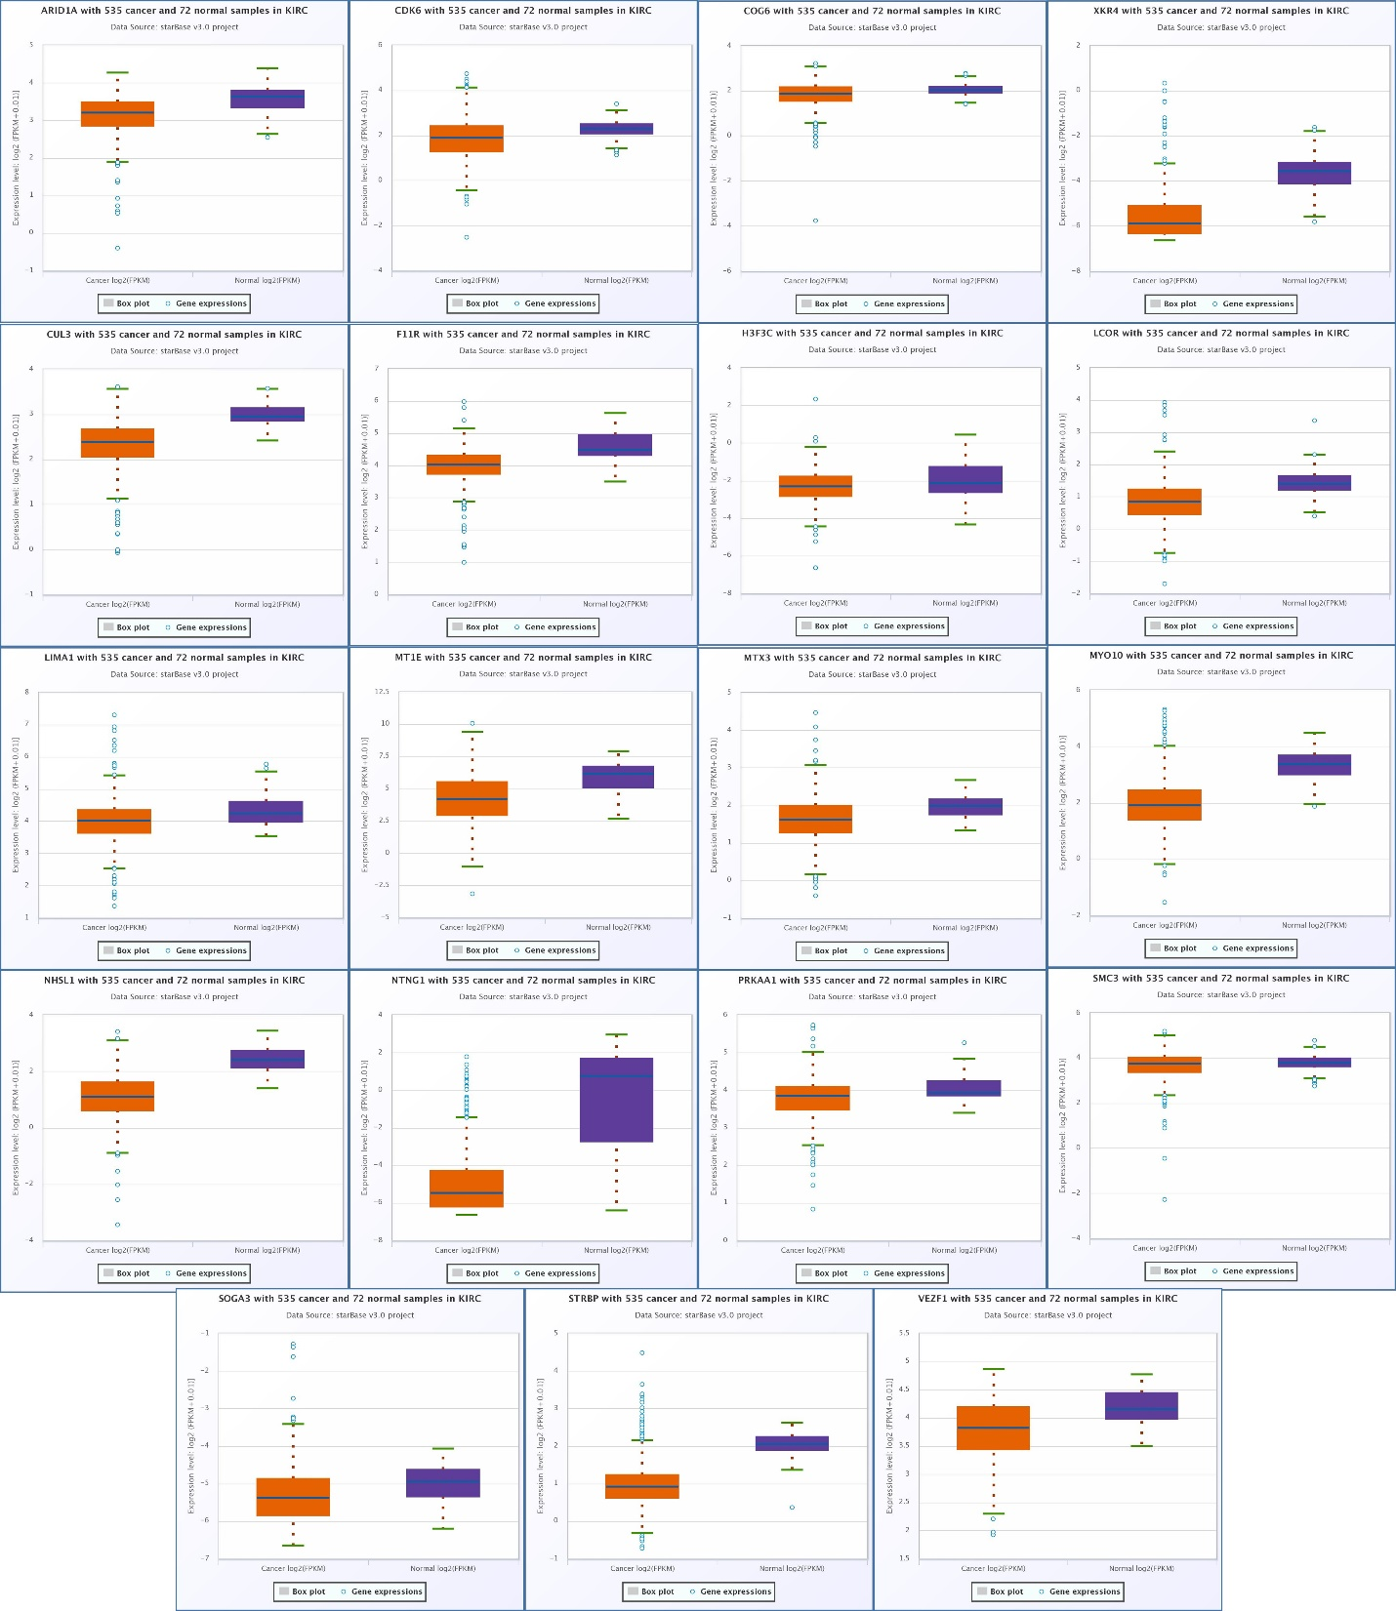
Figure S1. The box plot expression of 19 mRNAs (ARID1A, CDK6, COG6, F11R, H3F3C, LCOR, LIMA1, MT1E, MTX3, MYO10, NHSL1, STRBP, VEZF1, CUL3, NTNG1, XKR4, SOGA3, PRKAA1, and SMC3) in KIRC as potential targets of the hsa-miR-3613-5p. The data were obtained from the ENCORI database. p-value < 0.05 was identified as statistically significant. KIRC: Kidney renal clear cell carcinoma

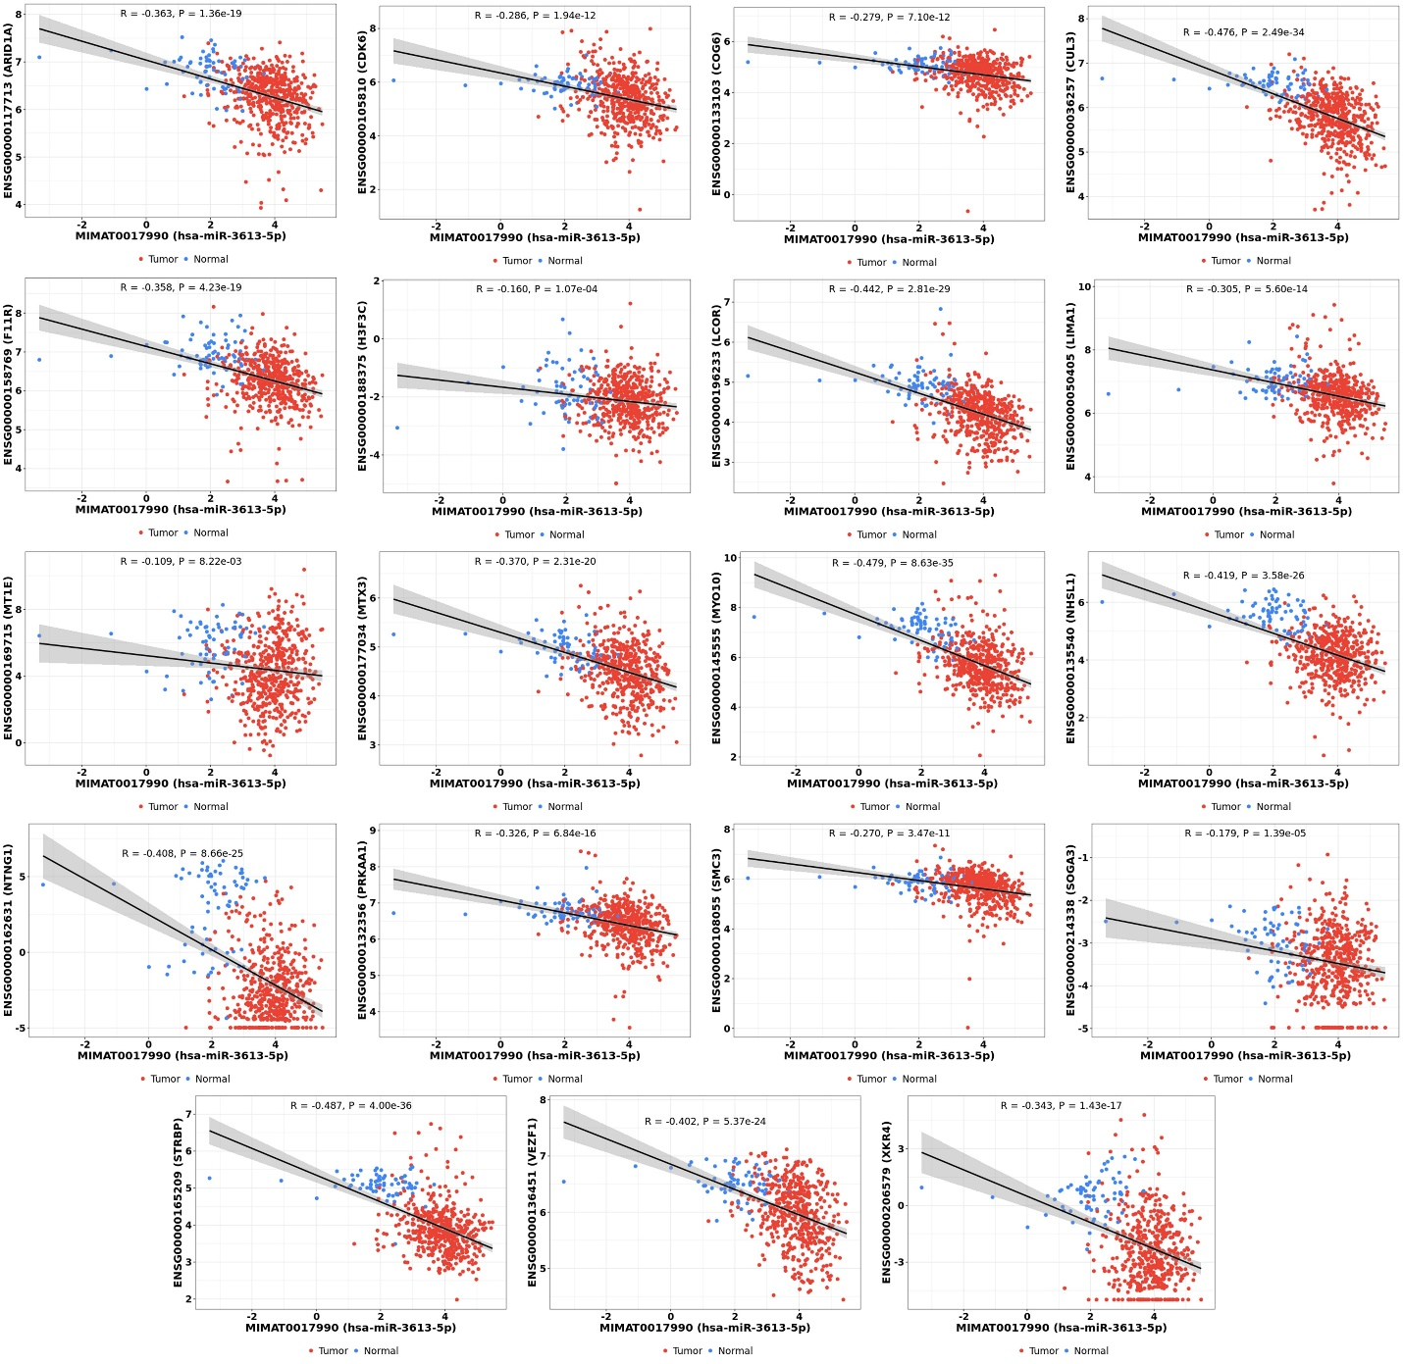
Figure S2. The co-expression analysis of 19 mRNAs (ARID1A, CDK6, COG6, F11R, H3F3C, LCOR, LIMA1, MT1E, MTX3, MYO10, NHSL1, STRBP, VEZF1, CUL3, NTNG1, XKR4, SOGA3, PRKAA1, and SMC3) with hsa-miR-3613-5p in KIRC. The data were obtained from the CancerMIRNome and miRTarBase 2020 databases. p-value < 0.05 was identified as statistically significant. KIRC: Kidney renal clear cell carcinoma

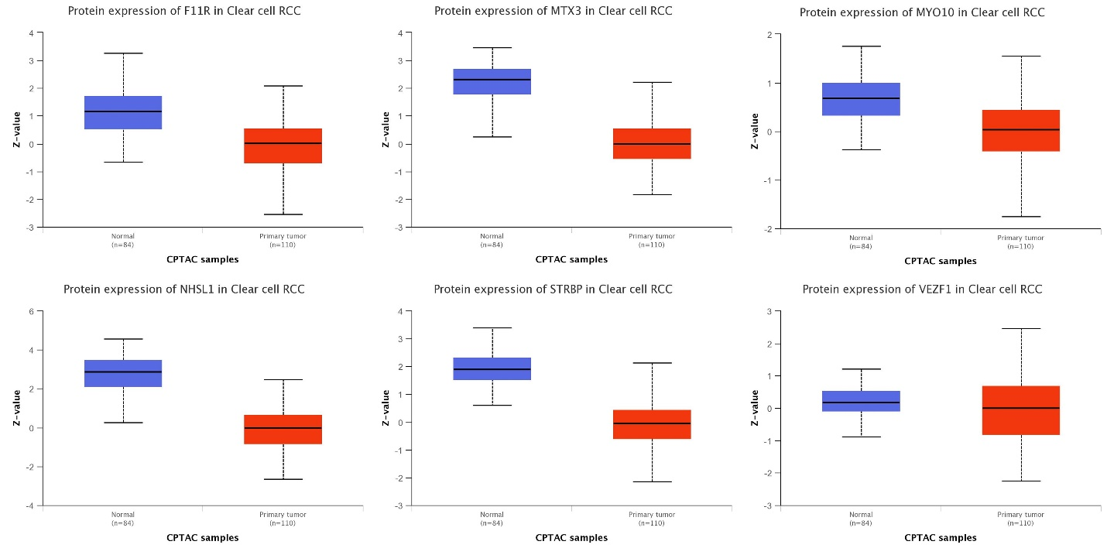
Figure S3. The box plot expression of 6 mRNAs (F11R, MTX3, MYO10, NHSL1, STRBP, and VEZF1) at protein level in KIRC. The data were obtained from the CPTAC project deposited in UALCAN database. p-value < 0.05 was identified as statistically significant. CPTAC: Clinical Proteomic Tumor Analysis Consortium; KIRC: Kidney renal clear cell carcinoma

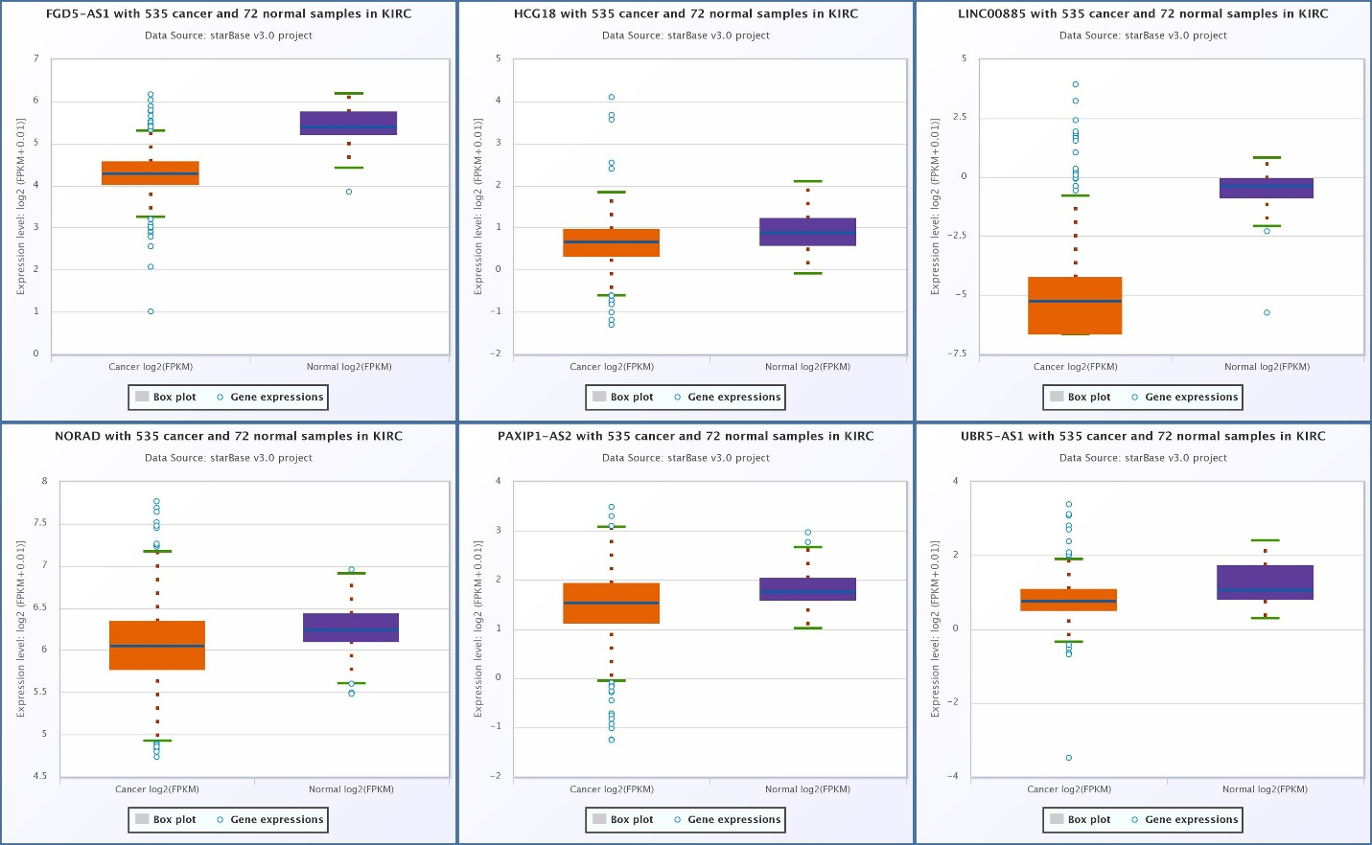
Figure S4. The box plot expression of six lncRNAs (FGD5-AS1, HCG18, LINC00885, NORAD, PAXIP1-AS2, and UBR5-AS1) in KIRC as potential regulator of the hsa-miR-3613-5p. The data were obtained from the ENCORI database. p-value < 0.05 was identified as statistically significant. KIRC: Kidney renal clear cell carcinoma

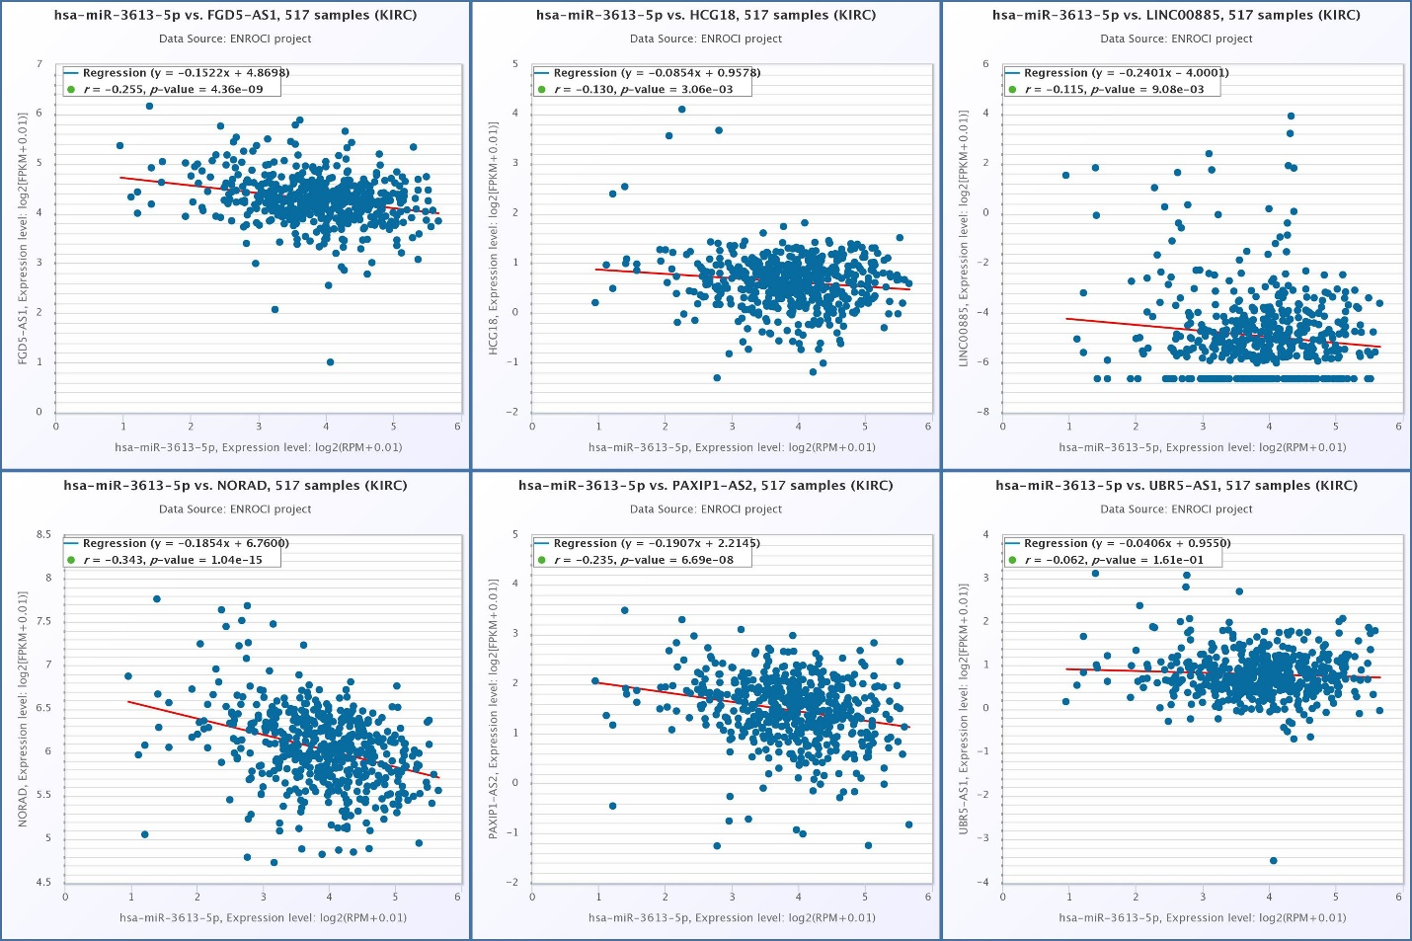
Figure S5. The co-expression analysis of six lncRNAs (FGD5-AS1, HCG18, LINC00885, NORAD, PAXIP1-AS2, and UBR5-AS1) with hsa-miR-3613-5p in KIRC. The data were obtained from the ENCORI database. p-value < 0.05 was identified as statistically significant. KIRC: Kidney renal clear cell carcinoma

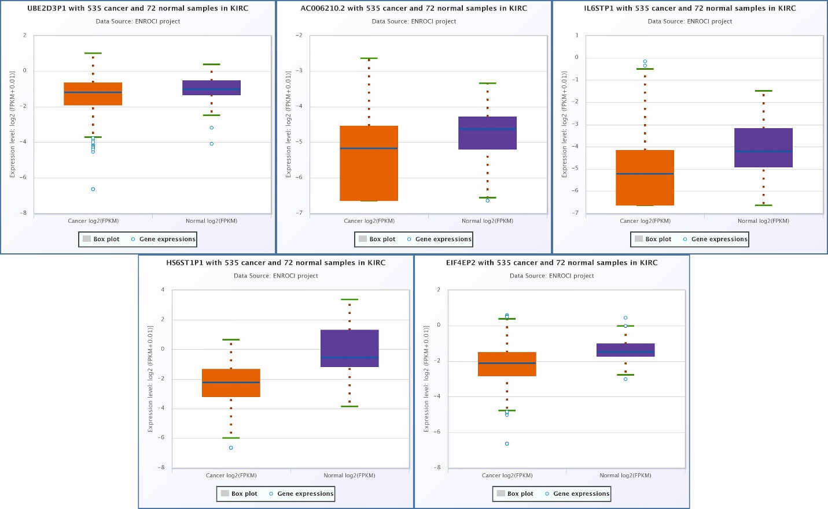
Figure S6. The box plot expression of five pseudogenes (HS6ST1P1, IL6STP1, EIF4EP2, UBE2D3P1, and AC006210.2) in KIRC as potential regulator of the hsa-miR-3613-5p. The data were obtained from the ENCORI database. p-value < 0.05 was identified as statistically significant. KIRC: Kidney renal clear cell carcinoma

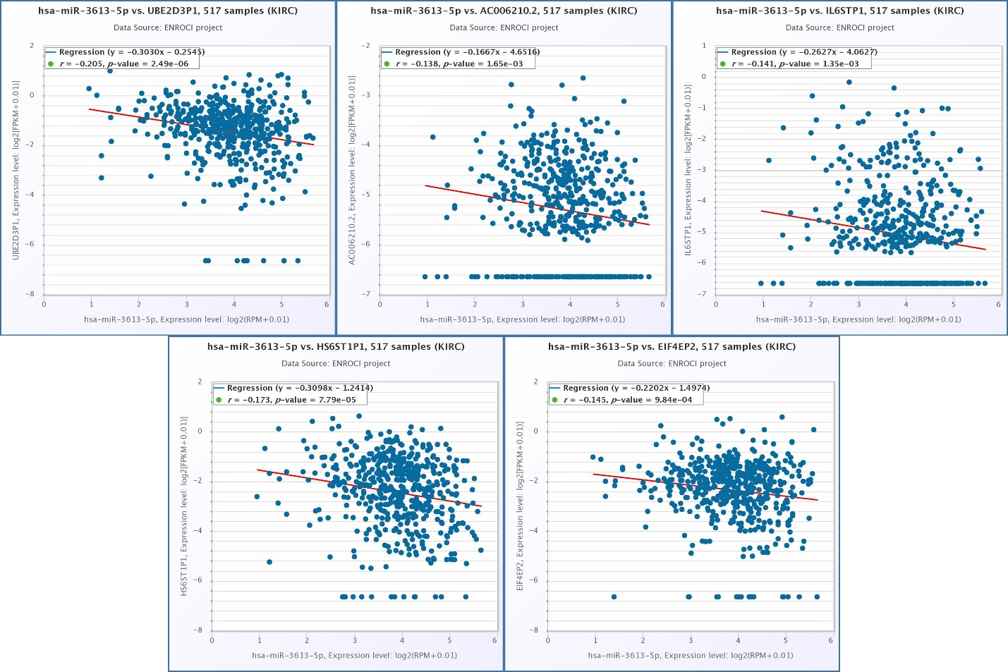
Figure S7. The co-expression analysis of five pseudogenes (HS6ST1P1, IL6STP1, EIF4EP2, UBE2D3P1, and AC006210.2) with hsa-miR-3613-5p in KIRC. The data were obtained from the ENCORI database. p-value < 0.05 was identified as statistically significant. KIRC: Kidney renal clear cell carcinoma

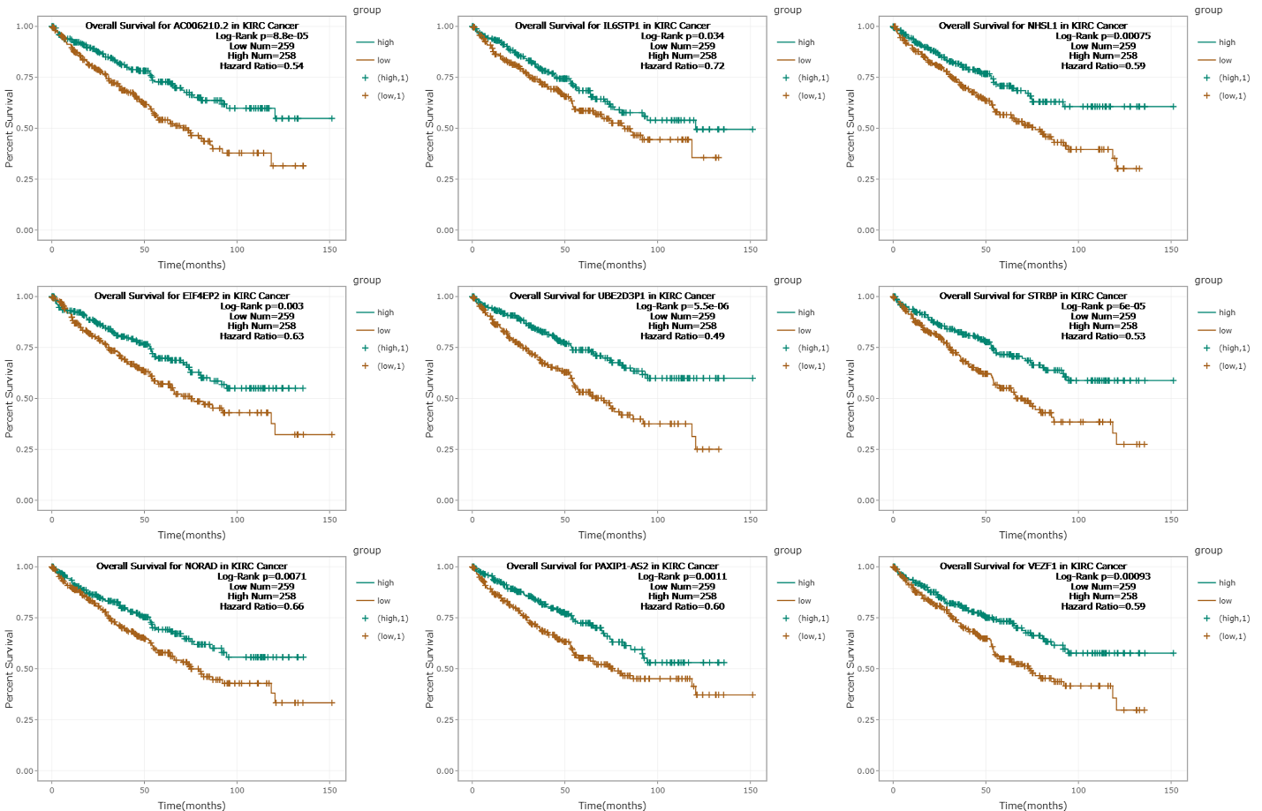
Figure S8. The overall survival curves for four pseudogenes (IL6STP1, EIF4EP2, AC006210.2, and UBE2D3P1), two lncRNAs (NORAD and PAXIP1-AS2), and three mRNAs (NHSL1, STRBP, and VEZF1) in KIRC. The data were obtained from the ENCORI database. Log-Rank p-value < 0.05 was identified as statistically significant. KIRC: Kidney renal clear cell carcinoma

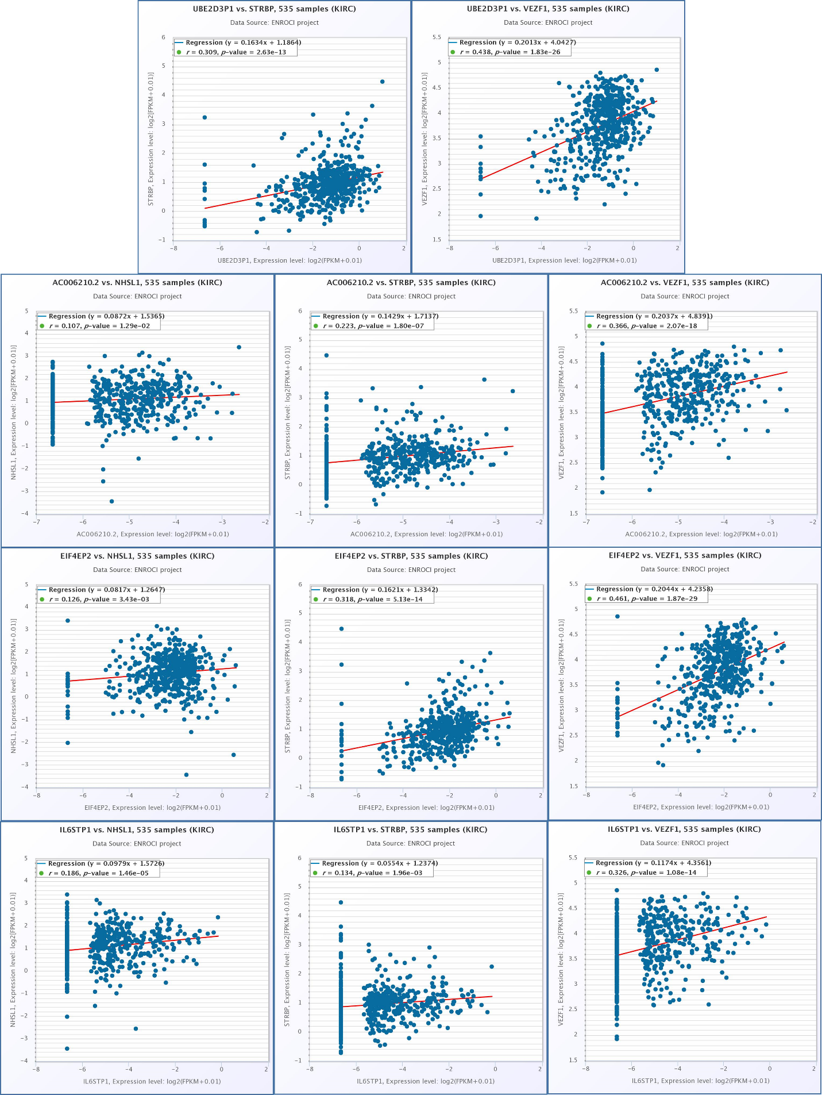
Figure S9. The co-expression analysis of five pseudogenes (HS6ST1P1, IL6STP1, EIF4EP2, UBE2D3P1, and AC006210.2) with three mRNAs (NHSL1, STRBP, and VEZF1) in KIRC. The data were obtained from the ENCORI database. p-value < 0.05 was identified as statistically significant. KIRC: Kidney renal clear cell carcinoma

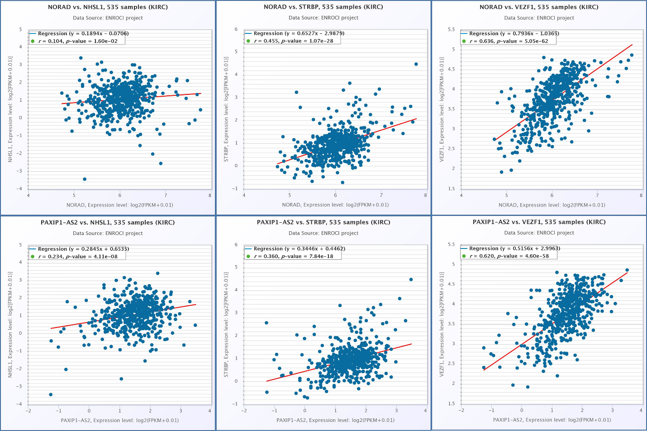
Figure S10. The co-expression analysis of two lncRNAs (NORAD and PAXIP1-AS2)with three mRNAs (NHSL1, STRBP, and VEZF1) in KIRC. The data were obtained from the ENCORI database. p-value < 0.05 was identified as statistically significant. KIRC: Kidney renal clear cell carcinoma

