Supporting materials
Diverse and abundant arbuscular mycorrhizal fungi in ecological floating beds used to treat eutrophic water

Zhouying Xuª, Yichao Lvª, Yinghe Jiangª, Xiaodong Luo^{b}, Xuelin Gui^{b}, Yihui Ban^{c}*

ª School of Civil Engineering and Architecture, Wuhan University of Technology, Wuhan 430070, Hubei, China
^{b} Wuhan Municipal Construction Group Co., Ltd., Wuhan 430070, Hubei, China
^{c} School of Chemistry, Chemical Engineering and Life Sciences, Wuhan University of Technology, Wuhan 430070, Hubei, China

*Corresponding author: Yihui Ban (E-mail address: banyihui@whut.edu.cn)
Tel. /fax: +86-027-87884065.

QIIME (version1.9.1) was used to demultiplex and quality-filter the raw data (FASTQ files) (Caporaso et al., 2010) with the following criteria:
(i) the 300 bp reads were truncated at any site receiving an average quality score <30 over a 10 bp sliding window, discarding the truncated reads that were shorter than 150 bp. (ii) exact barcode matching, two nucleotide mismatch in primer matching, reads containing ambiguous characters were removed. (iii) only sequences that overlap longer than 10 bp were assembled according to their overlap sequence. Reads which could not be assembled were discarded.
The procedure of PCR amplification:
25 μL mixture containing 5 μL of 5 × reaction Buffer, 5 μL 5 × GC buffer, 2 μL of 2.5 mM dNTPs, 1 μL of forward primer (10 μM), 1 μL of reverse primer (10 μM), 0.25 μL of Q5 DNA Polymerase, 2 μL of template DNA, and 8.75 μL ddH₂O. The first round PCR reaction was carried out using the following procedure: 98 °C for 2 min, followed by 30 cycles at 98 °C for 15 s, 55 °C for 30 s, and 72 °C for 30 s and a final extension at 72 °C for 5 min. The procedure of the second round PCR reaction was same as the first round.

Table S1 The assignment results against MaarjAM and NCBI databases
 | Genus | No.  OTU | No. sequences | No. VT | Names of VT
MaarjAM  database | Glomus | 182 | 237273 | 15 | VTX00064, VTX00069, VTX00092, VTX00093, VTX00096, VTX00113, VTX00114, VTX00122, VTX00130, VTX00156, VTX00209, VTX00214, VTX00222, VTX00310, VTX00419
MaarjAM  database | Acaulospora | 34 | 99288 | 2 | VTX00028, VTX00029
MaarjAM  database | Claroideoglomus | 2 | 22 | 2 | VTX00193, VTX00278
 | total | 218 | 336583 | 19
NCBI | Glomus | 8 | 9490 | 1 | MH559174.1
NCBI | Archaeospora | 3 | 2726 | 1 | MH559177.1
 | total | 11 | 12216 | 2

Table S2 Samples, number of obtained sequence reads (total, assigned to known Glomeromycota taxa), Chao index and number of detected AMF taxa
Samplings  with singleton | Total sequences | Known AMF sequences | No. of known AMF OTUs | Chao index | No. of AMF taxa | No. of taxa in NCBI
EA1 | 54345 | 43772 | 93 | 127.20 | 4 | Glomus sp.
EA2 | 53995 | 41690 | 109 | 133.43 | 5 | Glomus sp.
EA3 | 61880 | 52496 | 97 | 126.55 | 4 | Glomus sp., Archaeospora sp.
EB1 | 57115 | 14 | 8 | 10.00 | 4
EB2 | 53041 | 47559 | 41 | 52.25 | 3 | Archaeospora sp.
EB3 | 49672 | 31 | 8 | 18.00 | 5 | Archaeospora sp.
SA1 | 55549 | 108 | 6 | 9.00 | 4
SA2 | 49054 | 281 | 24 | 31.00 | 16 | Glomus sp., unclassified  Glomeromycota
SA3 | 48025 | 5256 | 11 | 14.00 | 3 | Glomus sp.
SB1 | 47035 | 44887 | 50 | 63.00 | 5 | Glomus sp.
SB2 | 61121 | 57551 | 43 | 48.14 | 8
SB3 | 59961 | 55197 | 100 | 117.00 | 9 | Archaeospora sp.
total | 650793 | 348842 | 272 |  | 19 | 3

Table S3 The assignment results against MaarjAM and NCBI databases with singletons.
 | Genus | No.  OTU | No. sequences | No. VT | Names of VT
MaarjAM  database | Glomus | 215 | 245915 | 15 | VTX00064, VTX00069, VTX00092, VTX00093, VTX00096, VTX00113, VTX00114, VTX00122, VTX00130, VTX00156, VTX00209, VTX00214, VTX00222, VTX00310, VTX00419
MaarjAM  database | Acaulospora | 38 | 99292 | 2 | VTX00028, VTX00029
MaarjAM  database | Claroideoglomus | 3 | 23 | 2 | VTX00193, VTX00278
 | total | 256 | 345230 | 19
NCBI | Glomus | 11 | 884 | 1 | MH559174.1
NCBI | Archaeospora | 4 | 2727 | 1 | MH559177.1
NCBI | Unclassified Glomeromycota | 1 | 1 | 1 | FN429368.1
NCBI | total | 16 | 3612 | 3

Table S4 The AM fungi composition of which relative abundance higher than 1% in each community.
AM fungal community | OTU | Taxonomic affiliation | Relative abundance (%)
SB | OTU393 | Acaulospora VTX00028 | 34.96
SB | OTU421 | Acaulospora VTX00028 | 21.77
SB | OTU1005 | Glomus VTX00419 | 17.61
SB | OTU571 | Glomus VTX00093 | 4.50
SB | OTU725 | Acaulospora VTX00028 | 3.54
SB | OTU701 | Glomus VTX00092 | 3.33
SB | OTU960 | Glomus VTX00114 | 1.85
SB | OTU559 | Glomus VTX00114 | 1.85
total |  |  | 89.42
SA | OTU914 | Glomus sp. MH559174.1(NCBI) | 89.79
SA | OTU13 | Glomus sp. MH559174.1(NCBI) | 1.83
SA | OTU1042 | Glomus VTX00209 | 1.60
SA | OTU526 | Glomus VTX00096 | 1.33
total |  |  | 94.54
EB | OTU397 | Glomus VTX00310 | 91.95
EB | OTU737 | Archaeospora sp. MH559177.1(NCBI) | 5.08
total |  |  | 97.02
EA | OTU960 | Glomus VTX00114 | 17.11
 | OTU20 | Glomus VTX00310 | 12.95
 | OTU575 | Glomus VTX00114 | 10.72
 | OTU433 | Glomus VTX00310 | 8.83
 | OTU717 | Glomus VTX00114 | 5.96
 | OTU47 | Glomus VTX00310 | 3.65
 | OTU295 | Glomus VTX00113 | 3.51
 | OTU1004 | Glomus VTX00114 | 3.41
 | OTU397 | Glomus VTX00310 | 2.96
 | OTU765 | Glomus VTX00310 | 2.73
 | OTU914 | Glomus sp. MH559174.1(NCBI) | 2.56
 | OTU1005 | Glomus VTX00419 | 2.56
 | OTU673 | Glomus VTX00310 | 0.20
 | OTU994 | Glomus VTX00419 | 1.50
 | OTU16 | Glomus VTX00114 | 1.43
 | OTU559 | Glomus VTX00114 | 1.39
 | OTU992 | Glomus VTX00113 | 1.31
 | OTU656 | Glomus VTX00310 | 1.16
 | OTU479 | Glomus VTX00419 | 1.12
 | OTU607 | Glomus VTX00114 | 1.03
 | OTU469 | Glomus VTX00310 | 1.01
total |  |  | 88.83

Table S5 The OTU and sequence number of EB1 and EB3
OTU ID | Seq.  No.  of EB1 | Seq.  No. of the whole data | taxonomy | OUT  ID | Seq.  No.  of EB3 | Seq.  No.of the whole data | taxonomy
Otu295 | 1 | 5481 | Glomus intraradices VTX00113 | Otu269 | 1 | 270 | Glomus LES06 VTX00310
Otu397 | 1 | 47849 | Glomus LES06 VTX00310 | Otu393 | 1 | 55120 | Acaulospora Alguacil10 Aca2 VTX00028
Otu987 | 1 | 264 | Glomus LES06 VTX00310 | Otu421 | 1 | 34322 | Acaulospora sp. VTX00028
Otu992 | 1 | 2035 | Glomus sp. VTX00113 | Otu571 | 1 | 7104 | Glomus sp. VTX00093
Otu421 | 2 | 34322 | Acaulospora sp. VTX00028 | Otu607 | 1 | 1416 | Glomus sp. VTX00114
Otu717 | 2 | 8221 | Glomus sp. VTX00114 | Otu1005 | 3 | 31303 | Glomus sp. VTX00419
Otu20 | 3 | 17876 | Glomus LES06 VTX00310 | Otu737 | 4 | 2529 | Archaeospora sp.
Otu960 | 3 | 26543 | Glomus irregulare VTX00114 | Otu397 | 19 | 47849 | Glomus LES06 VTX00310
total | 14 |  |  |  | 31

Table S6 Metastats analysis for the AMF abundance with singletons at genus levels in aquatic plant roots living in the three ecological floating beds based on Illumina Miseq sequencing data
Taxon | EA vs. EB  (P-value/Q-value) | SA vs. SB  (P-value/Q-value) | EA vs. SA  (P-value/Q-value) | EA vs. SB  (P-value/Q-value) | EB vs. SA  (P-value/Q-value) | EB vs. SB  (P-value/Q-value)
Glomus | 0.02/0.16 | 0.02/0.10 | -- | 0.02/0.10 | -- | 0.03/0.26
Acaulospora | -- | 0/0 | -- | 0/0 | -- | 0/0
Archaeospora | -- | -- | -- | -- | 0.04/0.39 | --
Unclassified Glomeromycota | 0.04/0.21 | -- | 0/0 | 0.04/0.14 | -- | --
Claroideoglomus | -- | -- | -- | -- | -- | --
Note: "--" represents the P-value > 0.05 and data now shown here.

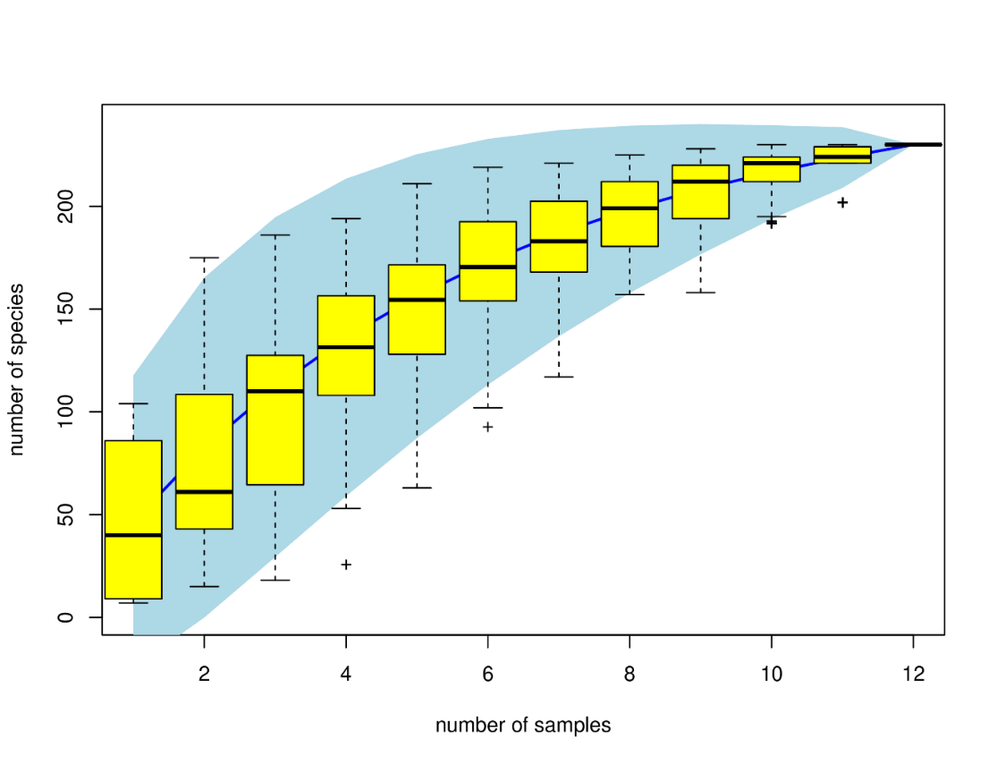
Fig. S1 The species accumulation curves of AMF in the aquatic plants root living in the three ecological floating beds

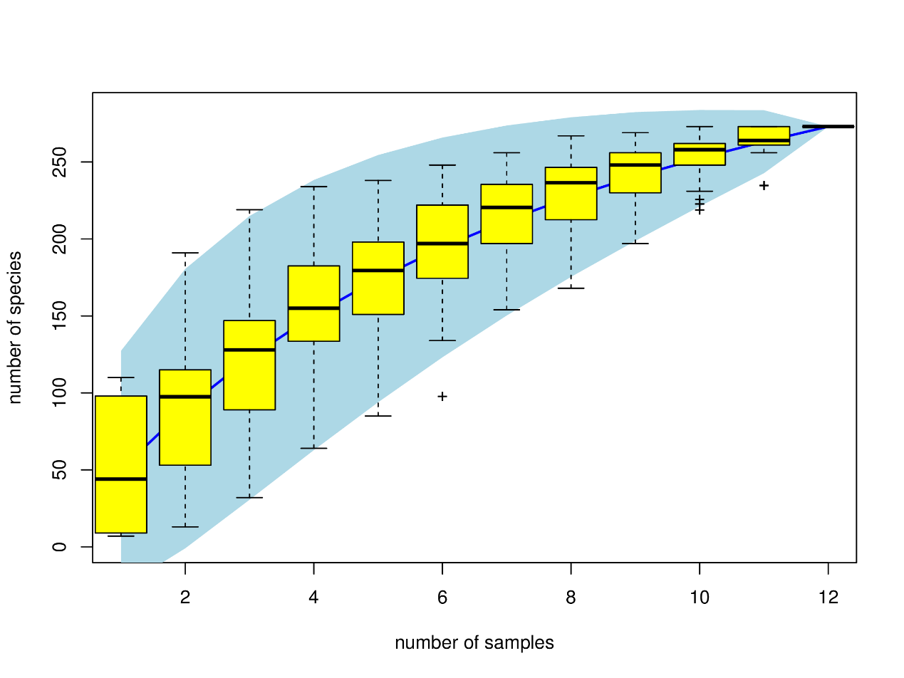
Fig. S2 The species accumulation curves of AMF in the aquatic plants root living in the three ecological floating beds (with singletons)

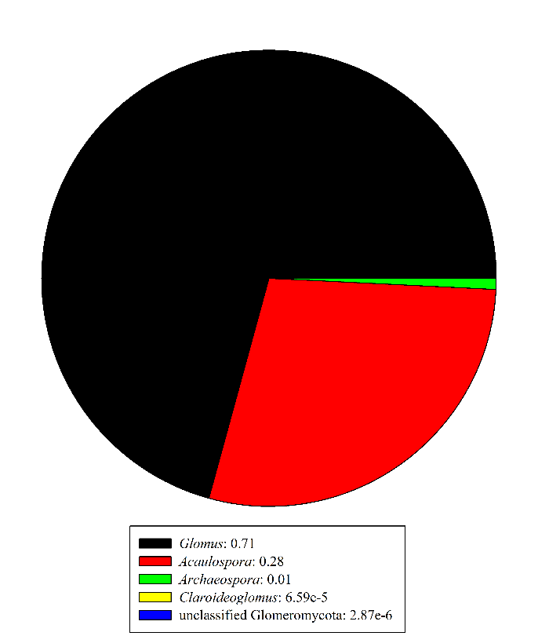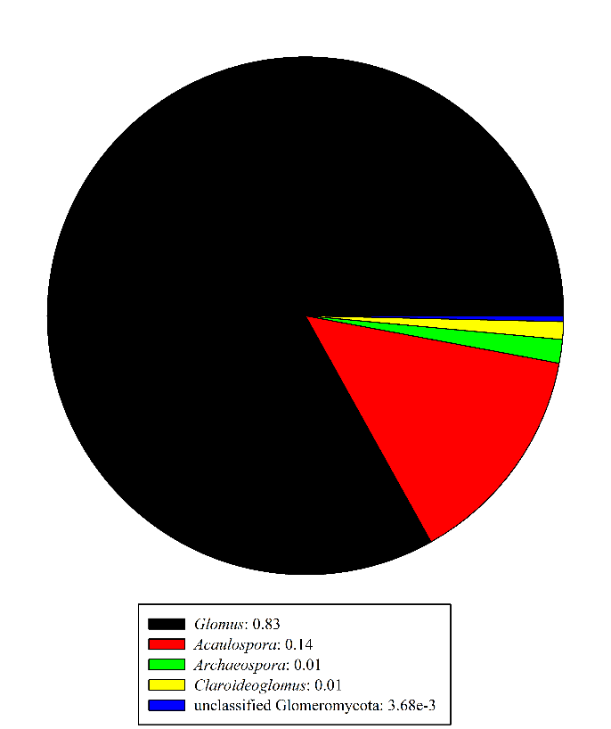
A
B

Fig. S3 The proportional distributions of OTUs (A) and sequences (B) in Glomeromycota phylum detected in the three ecological floating beds based on the data with singletons.

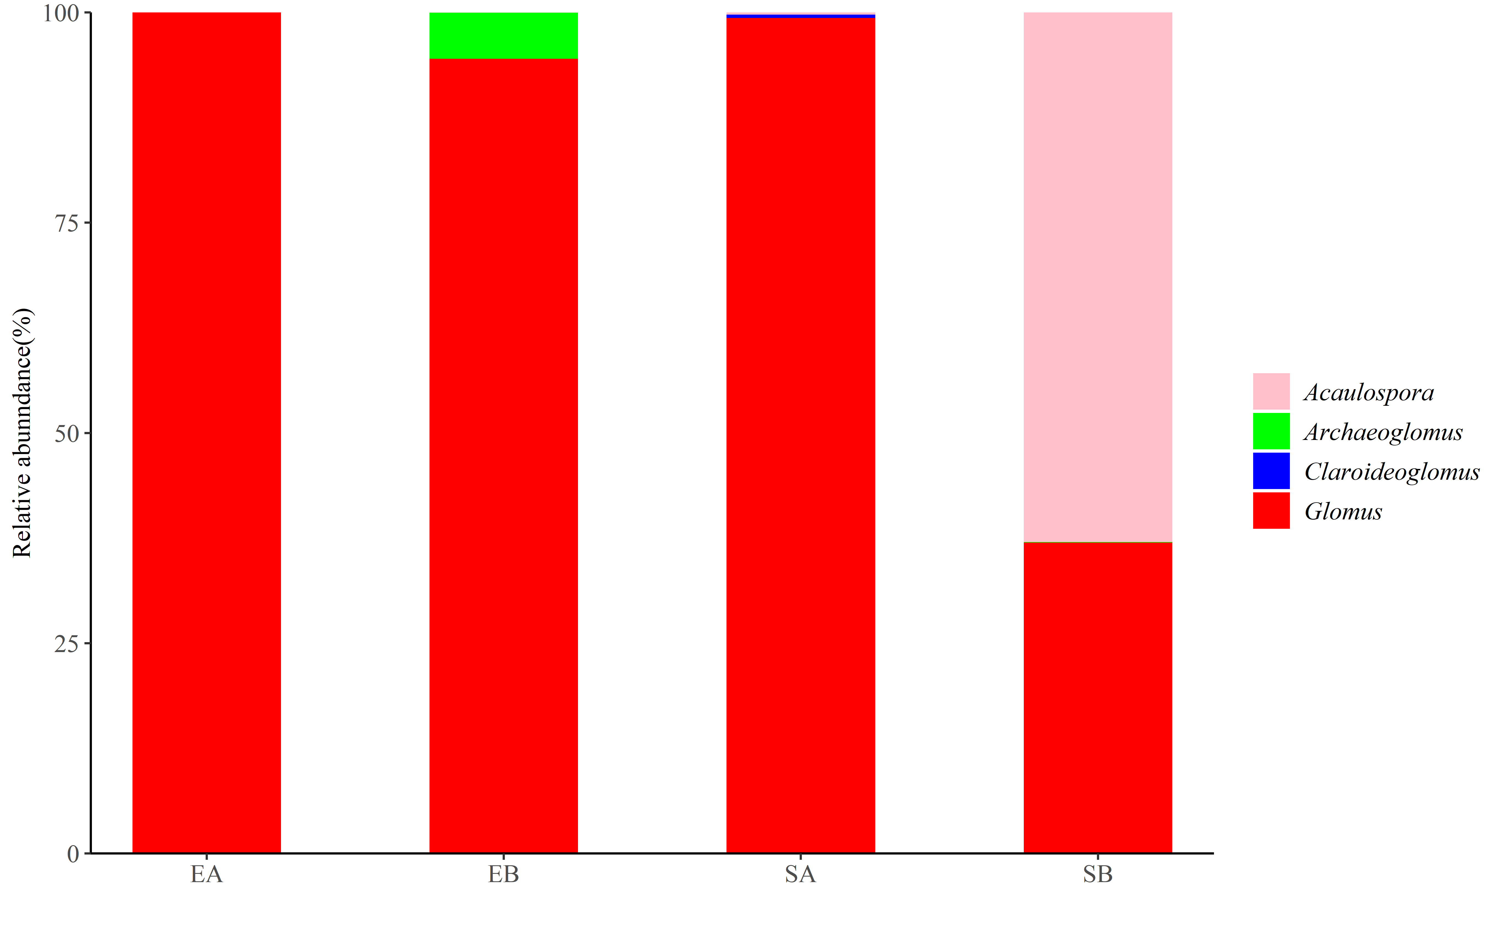
Fig. S4 The proportional distributions of sequences at genus level detected in the 4 groups

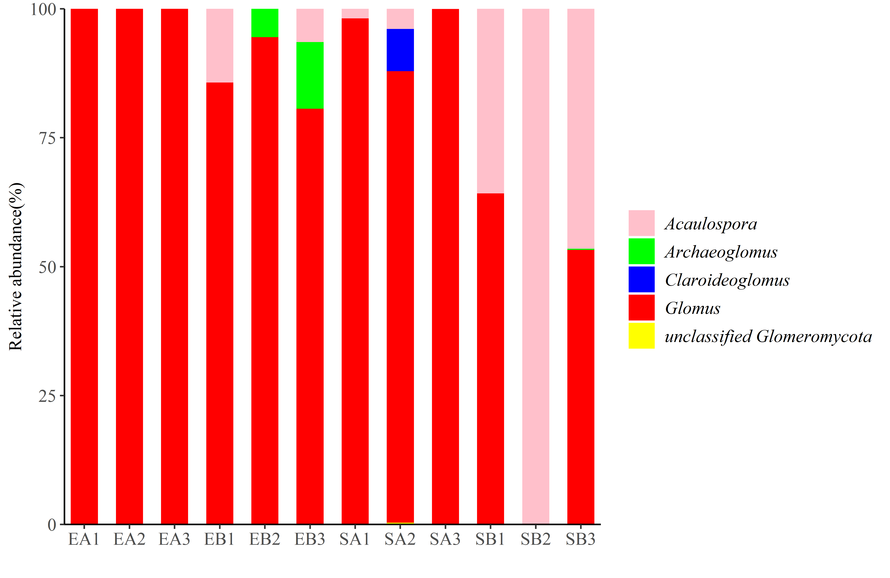
Fig. S5 The proportional distributions of sequences at genus level detected in the 12 samples (with singletons)

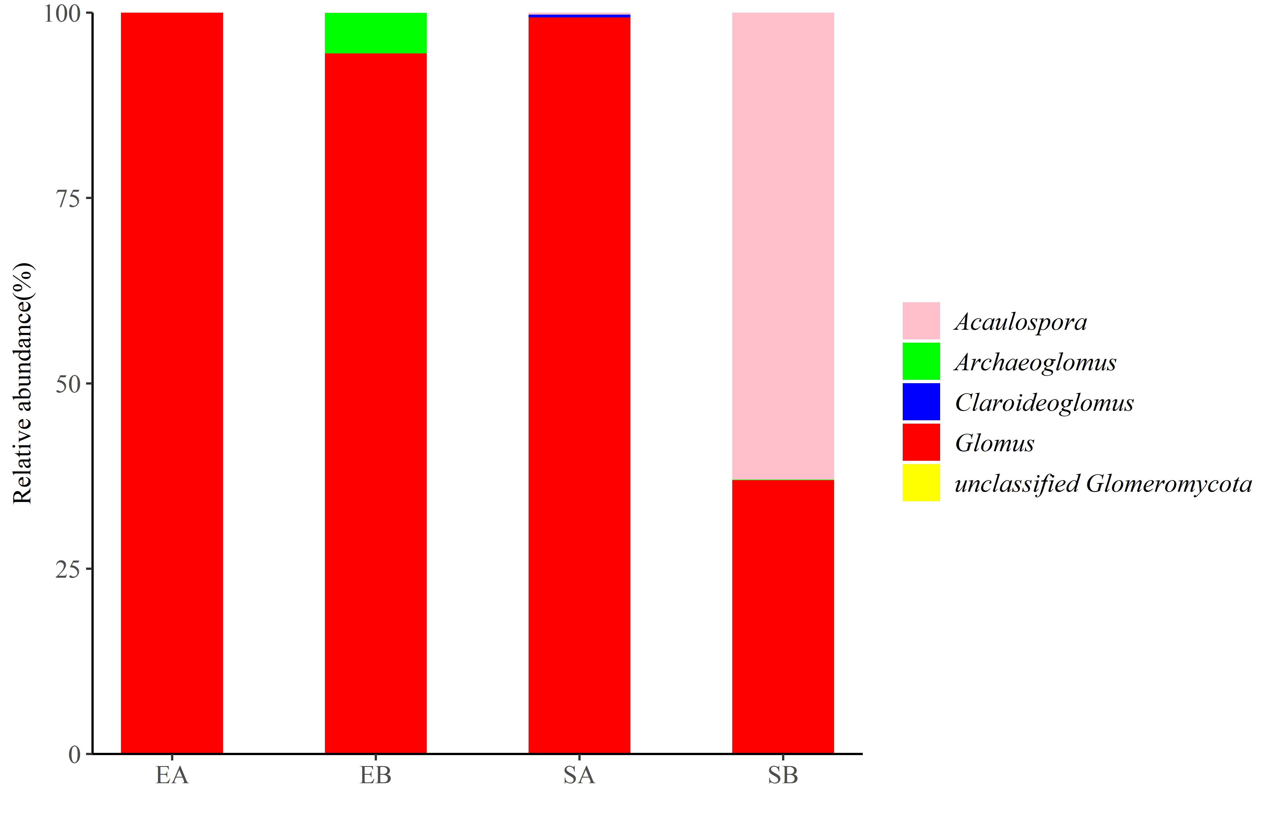
Fig. S6 The proportional distributions of sequences at genus level detected in the 4 groups (with singletons)

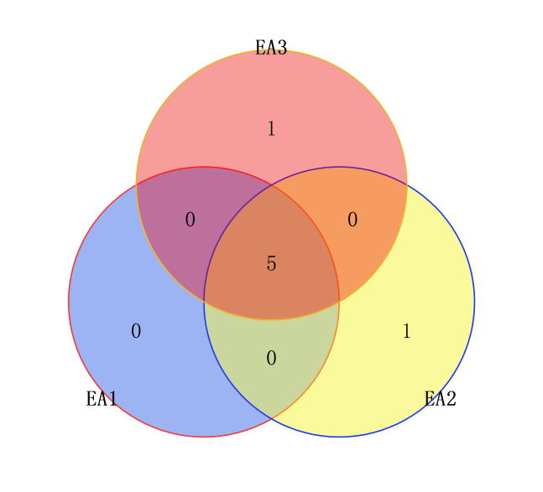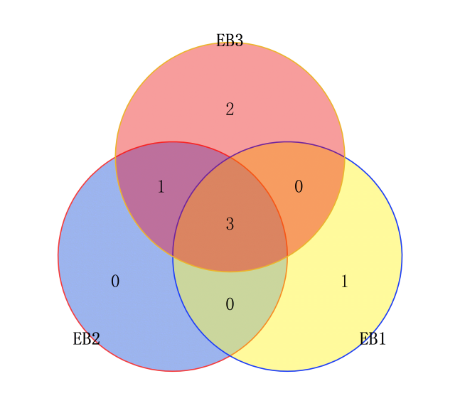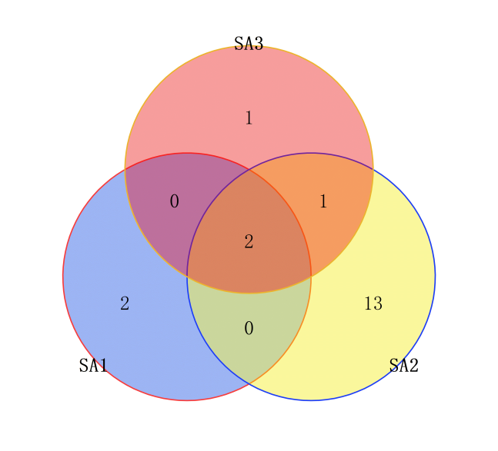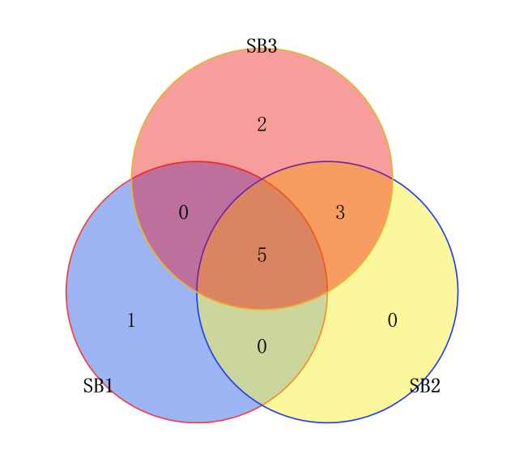

Fig. S7 Venn diagrams of AM fungal VTs of the 12 samples in the three ecological floating beds

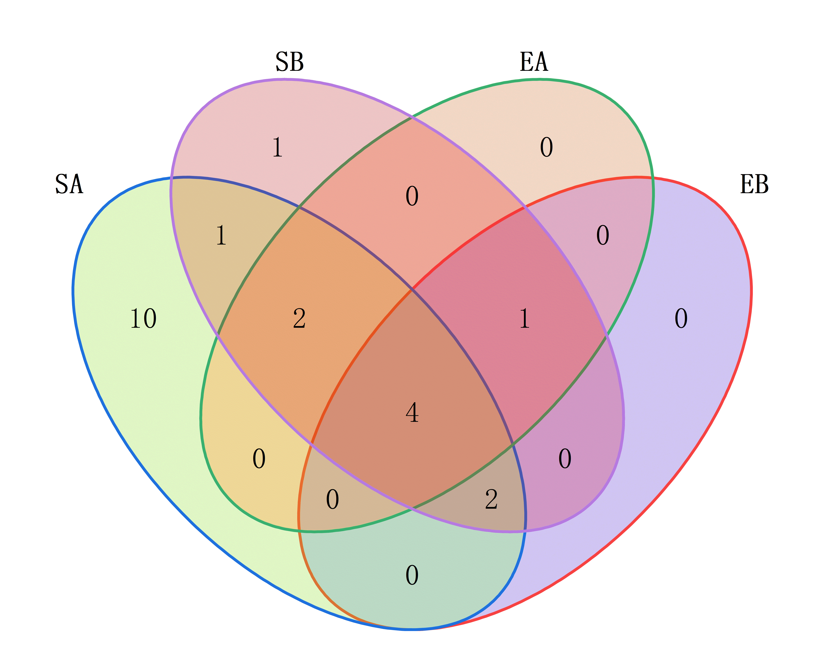
Fig. S8 Venn diagram AM fungal VTs of the 4 groups in the three ecological floating beds

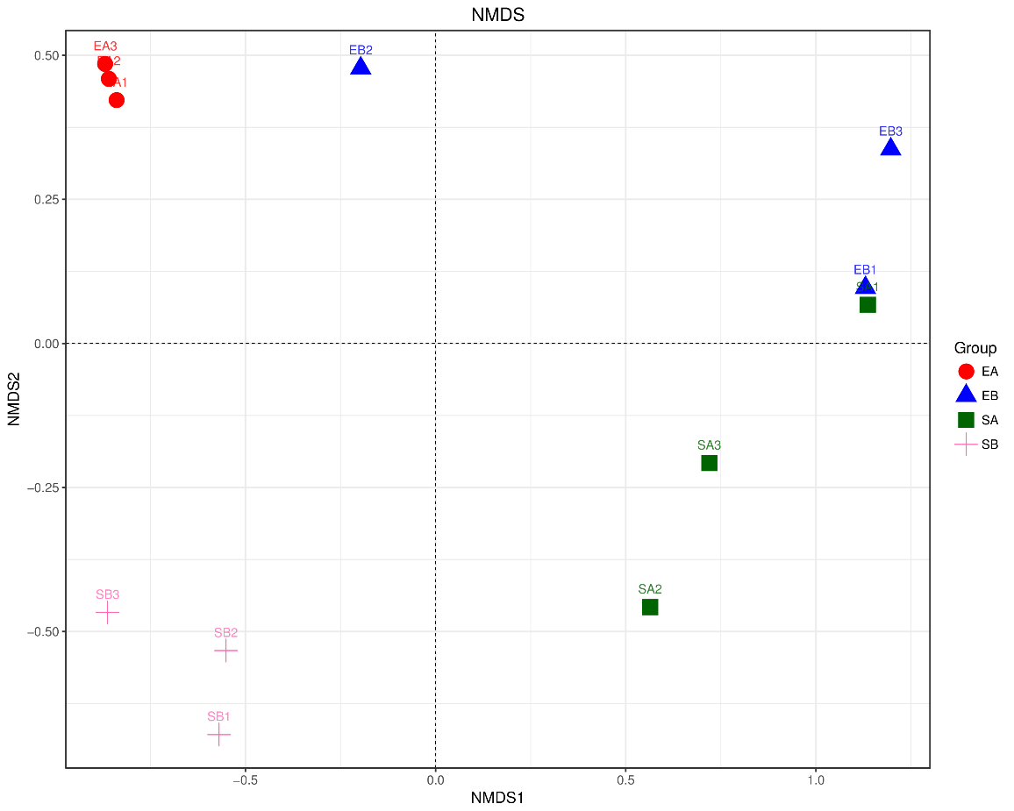
Fig. S9 Two-dimensional non-metric multi-dimensional scaling (NMDS) plots of variation in AM fungal community composition of aquatic plant roots living in the three ecological floating beds (with singletons).

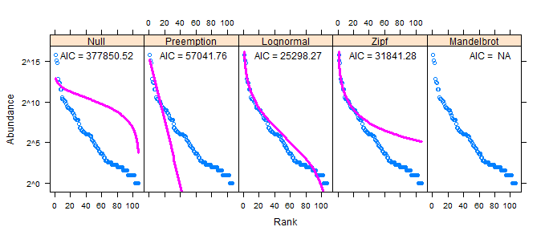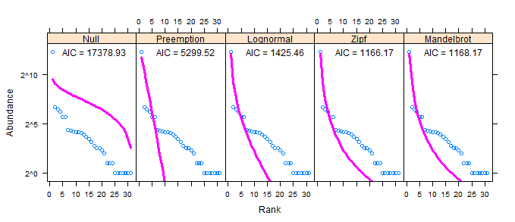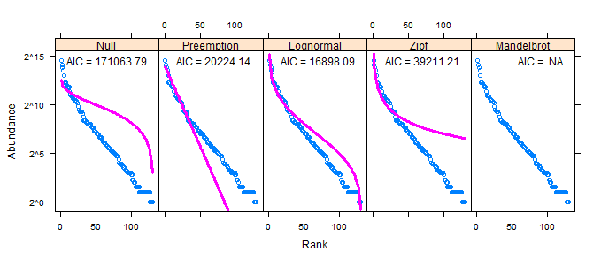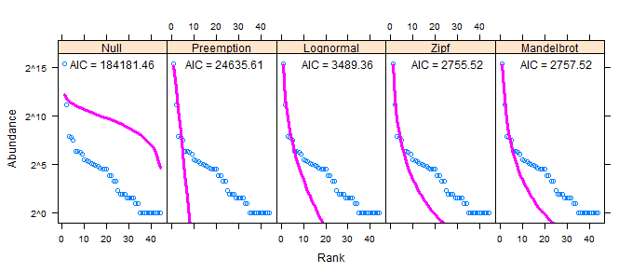
EA
EB
SA
SB

Fig. S10 Statistical comparison of the fit of basic SAD models for the four groups (remove singletons). Akaike's Information Criterion (AIC, lower is better) and model fits for several basic SAD models, including the broken stick (null model), preemption, lognormal, Zipf, and Zipf-Mandelbrot models.
SB
SA

Fig. S11 Statistical comparison of the fit of basic SAD models for the whole AMF community (with singleton). Akaike's Information Criterion (AIC) and model fits for several basic SAD models, including the broken stick (null model), preemption, lognormal, Zipf, and Zipf-Mandelbrot models. AIC (lower is better) indicates that the lognormal model is the best fit.
SB

EA
EB
SA
SB

Fig. S12 Statistical comparison of the fit of basic SAD models (with singletons). Akaike's Information Criterion (AIC, lower is better) and model fits for several basic SAD models, including the broken stick (null model), preemption, lognormal, Zipf, and Zipf-Mandelbrot models.
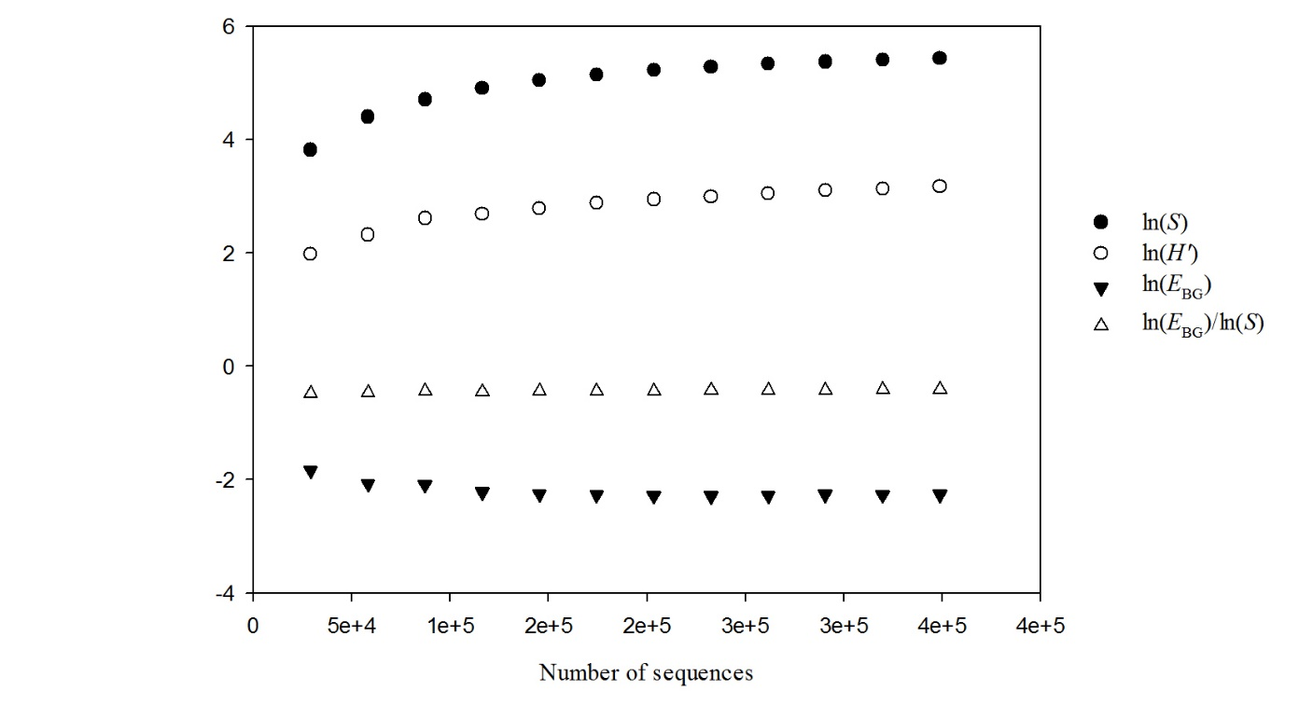
Fig. S13 SHE analysis of AM fungal taxon abundance distribution in the 12 samples (remove singletons).

Fig. S14 SHE analysis of AM fungal taxon abundance distribution in the 12 samples (data with sigletons)

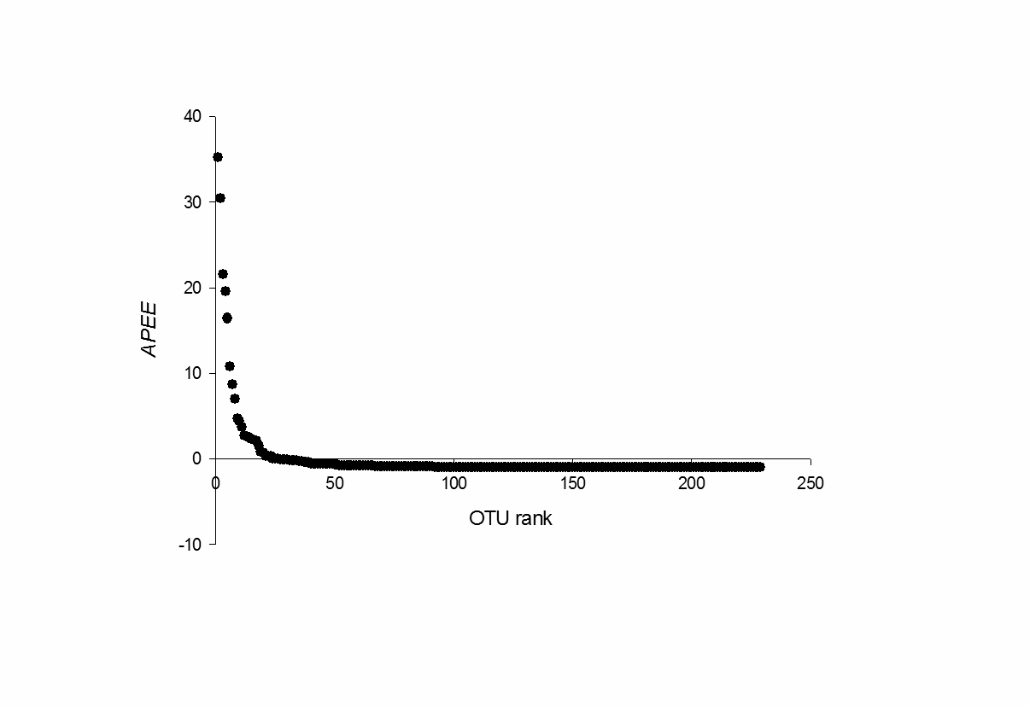
Inequitalility
Overdominance

Fig. S15 Overdominance and inequitability in AM fungal assemblage in the 12 aqatica plant root samples. Proportional abundance in excess of evenness, APEE = (Pi ̶ Pe)/Pe, is plotted across OTU rank. The y value for the top-ranked OTU corresponds to overdominance O; the proportion of points with negative values corresponds to inequitability I.

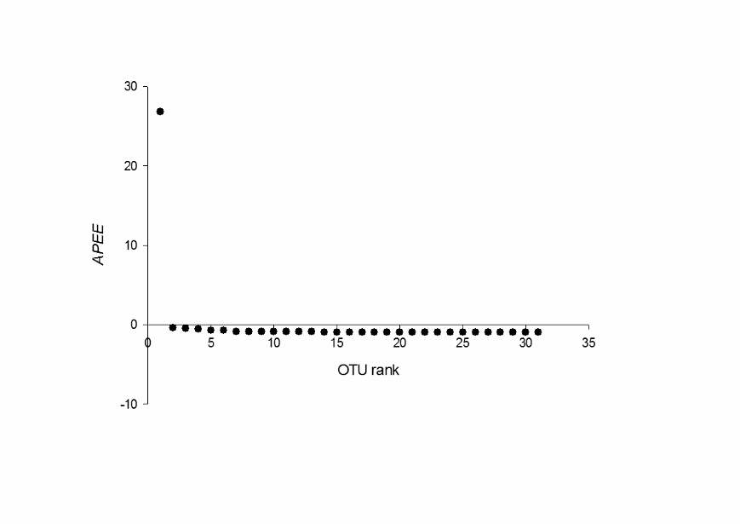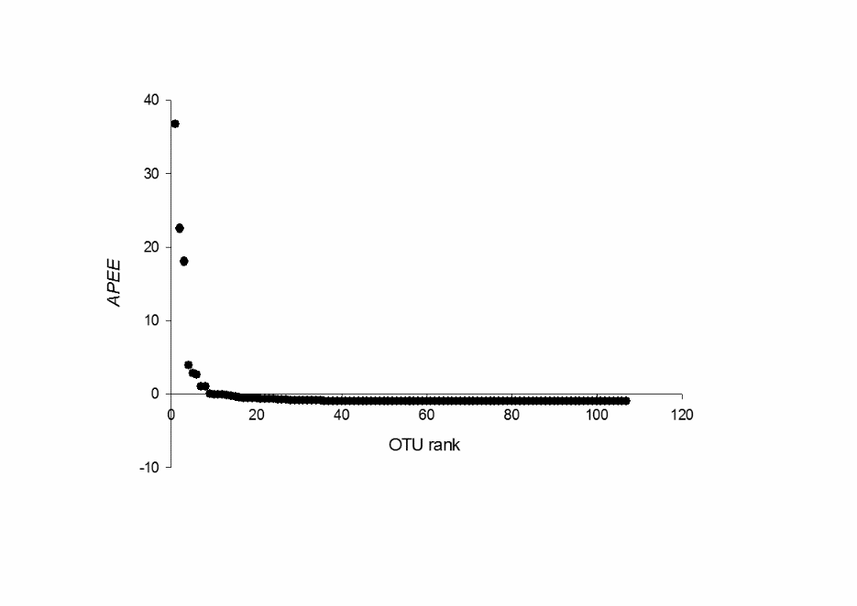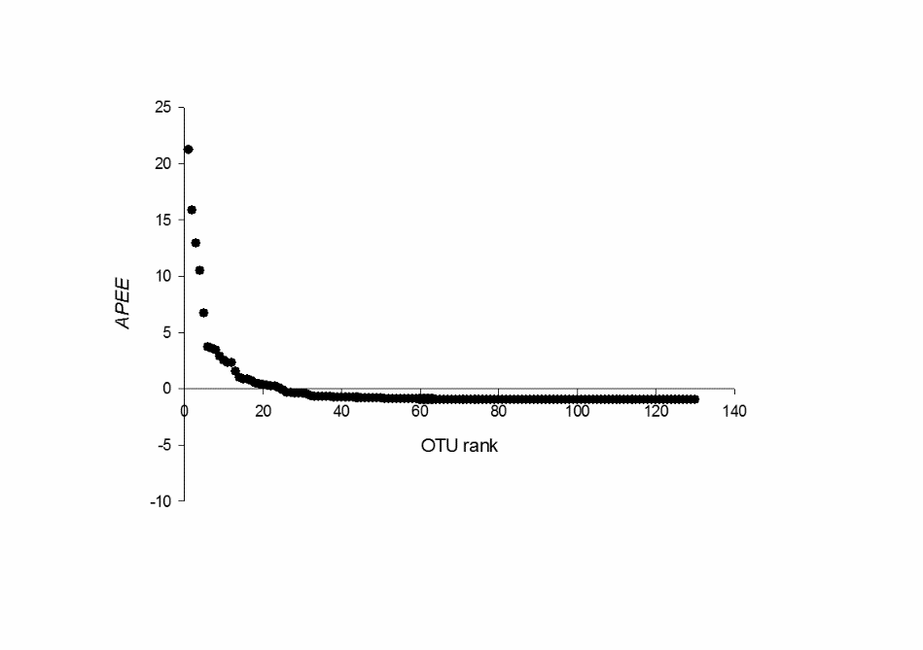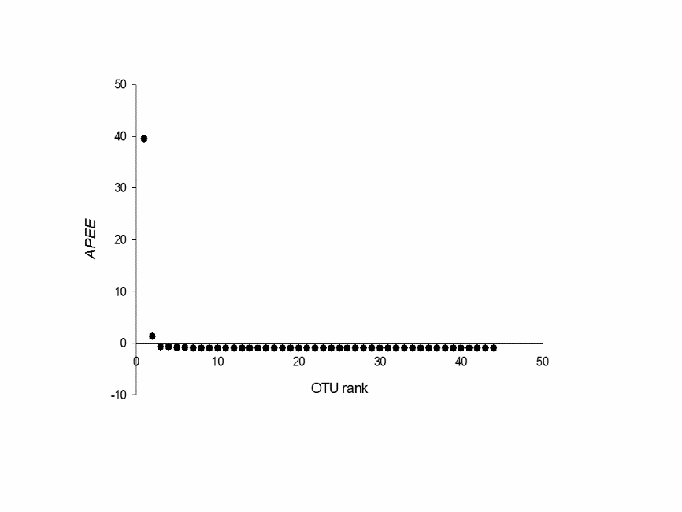
Overdominance
Overdominance
Overdominance
Overdominance
Inequitalility
Inequitalility
Inequitalility
Inequitalility
EA
EB
SA
SB

Fig. S16 Overdominance and inequitability in AM fungal assemblage in the 12 aquatic plant root samples. Proportional abundance in excess of evenness, APEE = (Pi ̶ Pe)/Pe, is plotted across OTU rank. The y value for the top-ranked OTU corresponds to overdominance O; the proportion of points with negative values corresponds to inequitability I.

