3.8 Antimicrobial activity
Escherichia Coli Pseudomonas Aeruginosa
Bacillus Subtilis Staphalococcus Aureces
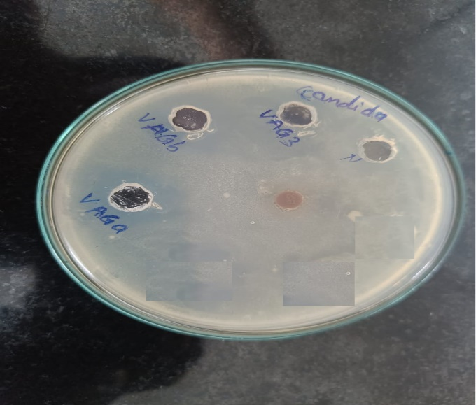
Candida Albicans Aspergillus Niger
Figure 13: Zone of Inhibition Tests for various microorganisms against antimicrobial and antifungal activity
- X = 3, Y = 2.5: VAG a / VAG 1,
- X = 2, Y = 1.5: VAG b / VAG 2,
- X = 1, Y = 0.5: VAG c / VAG 3

