Supplementary figures
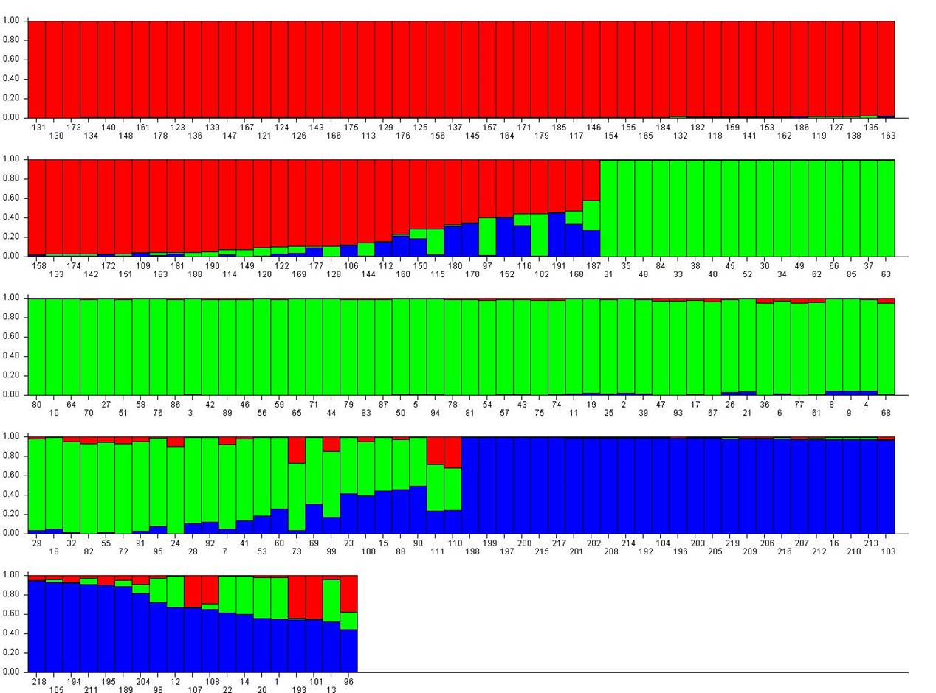
Supplementary Figure 1. Population structure of 219 sorghum accessions from SSR data resulting distinct grouping of accessions based on its geographical origin. Sub-population P1 (red) had most accessions from Ethiopia, Sub-population P2 (green) had most accessions from Central Africa and Sub-population P3 (blue) had most accessions from Cameroon.
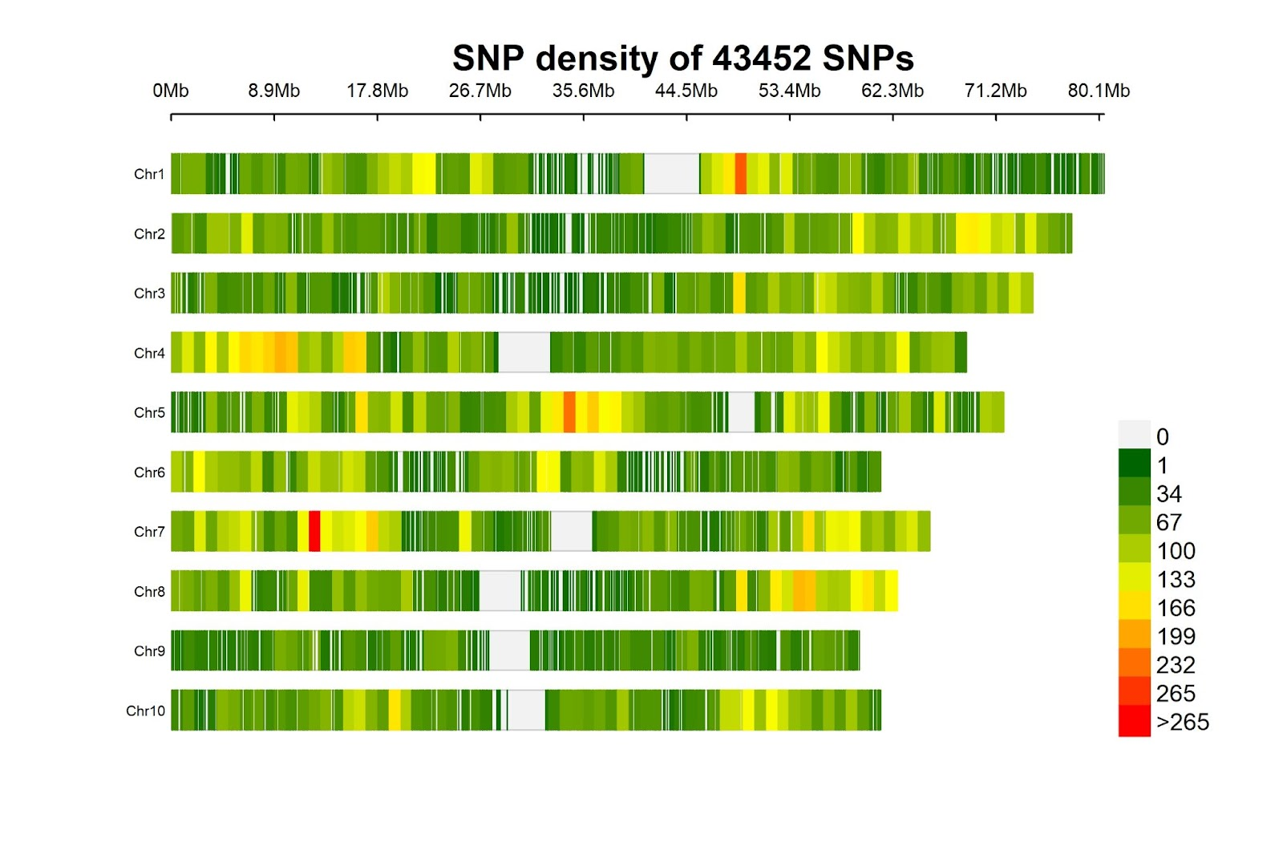Supplementary Figure 2. Chromosome wise distribution and density of filtered SNP set (43,452 SNPs) used in GWAS. Heatmap legend denotes the density of the SNPs present in that physical position.

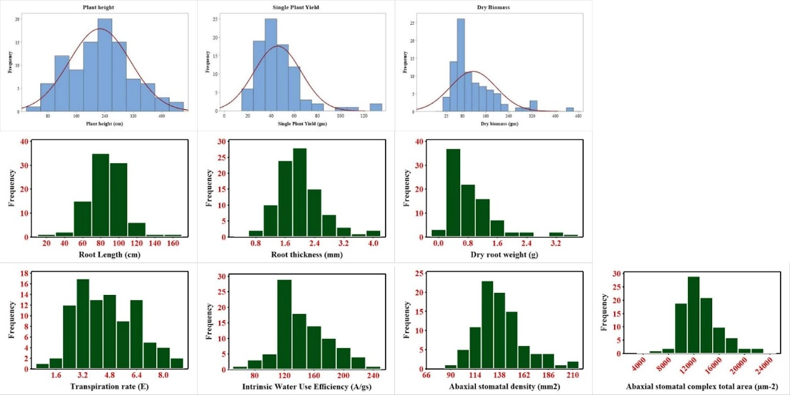
Supplementary Figure 3. Frequency distribution of the constructed subset showing normal distribution with continuous variation for all the traits used in GWAS.
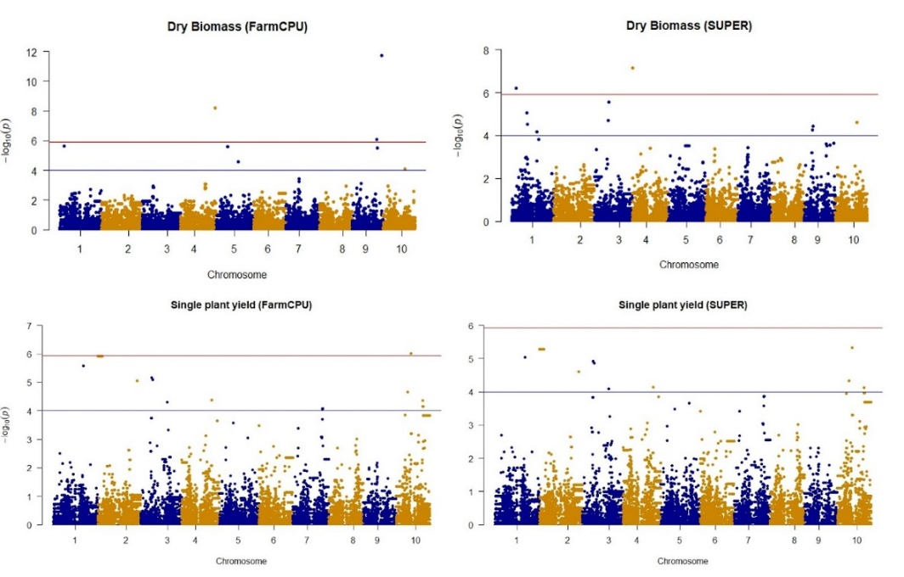
Supplementary Figure 4. Genome-wide association studies for major agronomic traits on the representative subset using FarmCPU and SUPER. Red line represents the Bonferroni threshold ((-log(p)≥5.93) and blue line represents significant threshold kept of this study (-log(p)≥4).
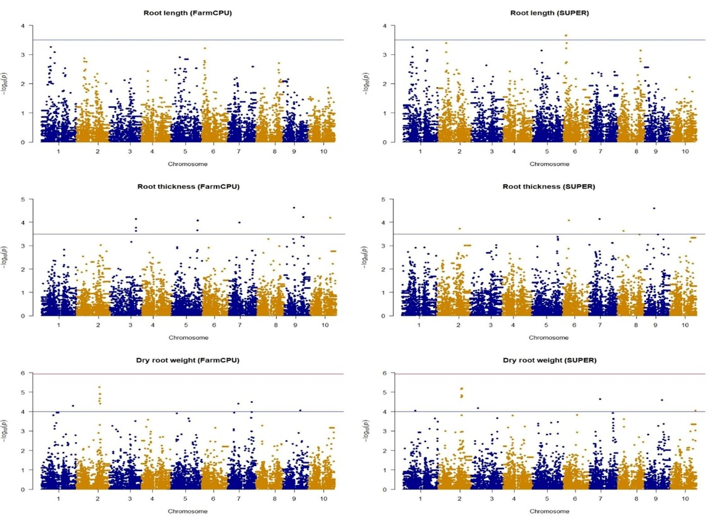
Supplementary Figure 5. Genome-wide association study using FarmCPU and SUPER methods for the root morphological traits.
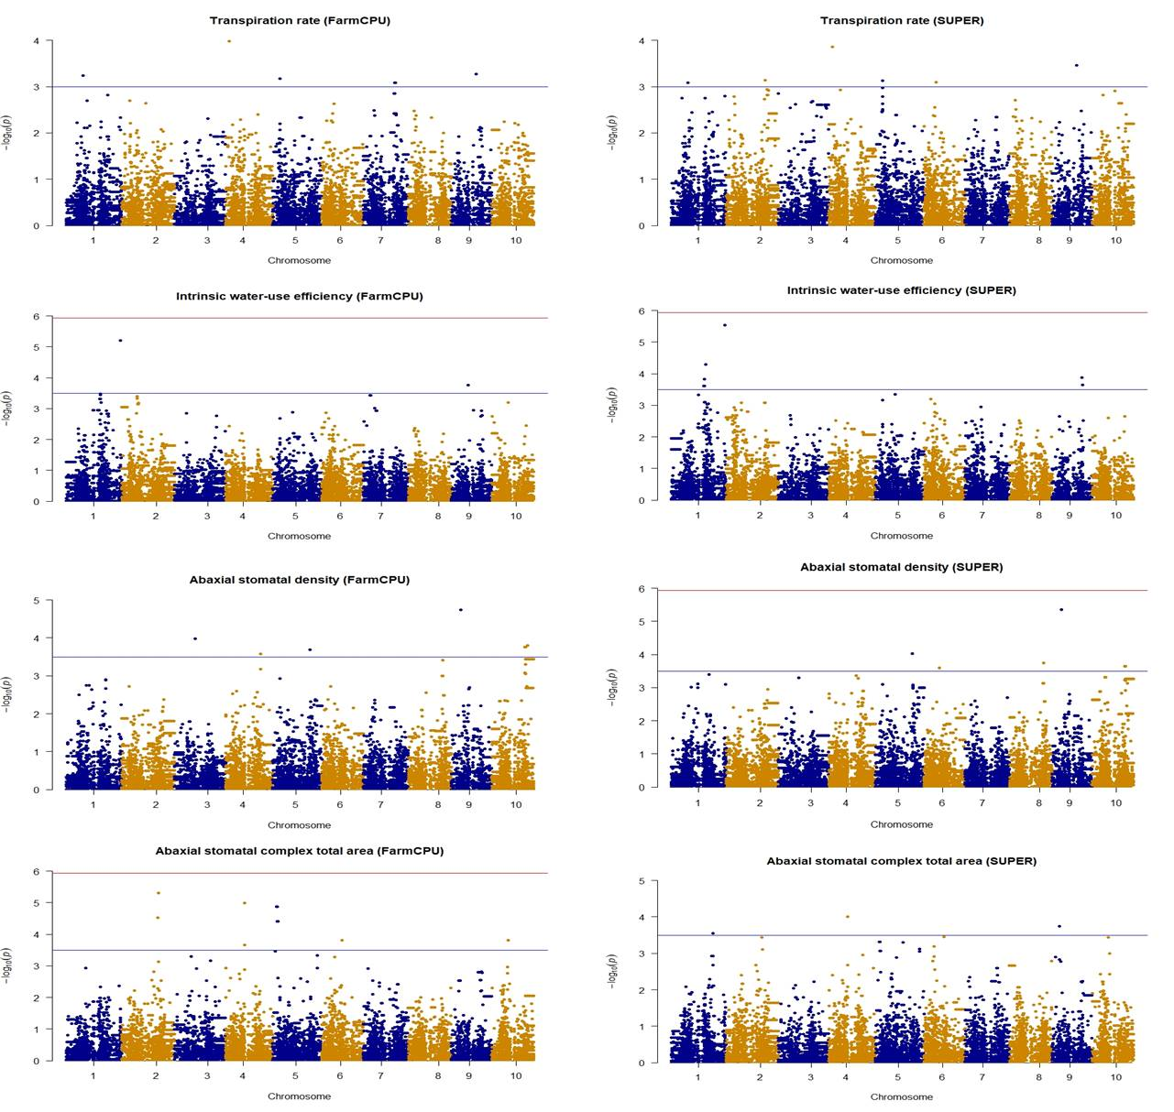Supplementary Figure 6. Genome-wide association studies using FarmCPU and SUPER methods for the physiological traits

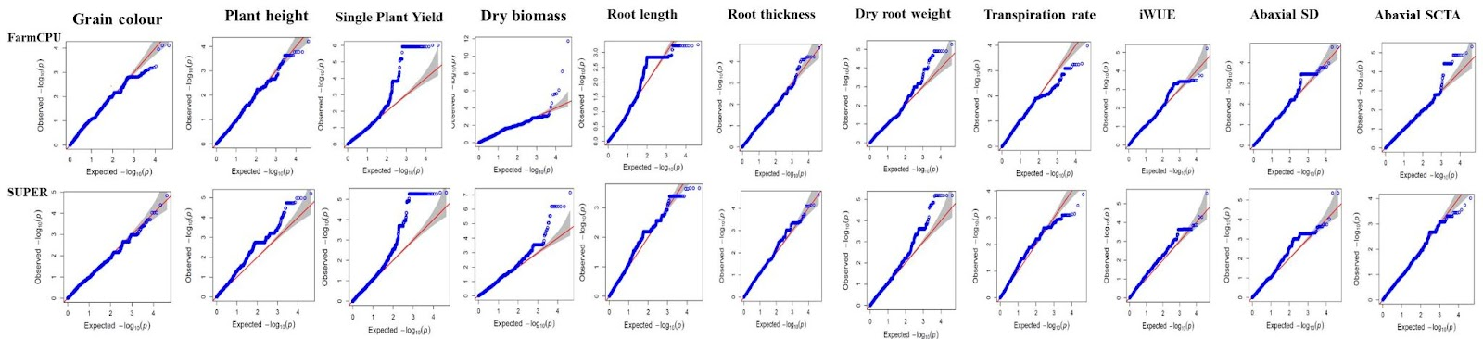
Supplementary Figure 7. Q-Q plot showing less skewness of all the traits in the GWAS

