Supplemental Information

Decarbonization Potential of Electrifying 50% of U.S. Light-Duty Vehicle Sales by 2030

Maxwell Woody¹, Gregory A Keoleian¹, and Parth Vaishnav¹

¹Center for Sustainable Systems, School for Environment and Sustainability, University of Michigan, Ann Arbor, Michigan 48104, USA

9 Pages
6 Figures
1 Table

Automaker Electrification Goals Table S1 p. S2
Vehicle Sales Figure S1 p. S3
Vehicle Stock Figure S2 p. S4
Vehicle Survival Curves Figure S3 p. S5
Vehicle Miles Traveled Figure S4 p. S5
Vehicle Fuel Economies Figure S5 p. S6
Vehicle Production Emissions Figure S6 p. S7
Supplemental Note 1 – Vehicle Production Emissions p. S8
Supplemental References p. S9

Table S1. Electrification and Carbon Reduction Goals of the 10 Largest Automakers by U.S. Sales
Automaker | Electrification Goal(s) | Source
Ford Motor Company | - 50% global sales electric by 2030  - All cars and vans zero emissions by 2040  - Carbon neutrality by 2050 | Integrated Sustainability and Financial Report 2022¹
General Motors | - 40%-50% EV sales (U.S.) by 2030  - All light duty vehicles zero emissions by 2035  - Carbon neutrality by 2040 | 2021 Sustainability Report²
Honda Motor Company | - 40% ZEV sales in major markets by 2030  - 80% ZEV sales in major markets by 2035  - Carbon neutrality by 2040 | Sustainability Report 2022³
Hyundai Kia Auto Group | - 100% EV sales in Europe by 2035  - 100% EV sales in major markets by 2040  - Carbon neutrality by 2045 | 2022 Sustainability Report⁴
Nissan Motor Co | - 100% EV sales in key markets by early 2030s  - Carbon neutrality by 2050 | Sustainability Report 2022⁵
Stellantis-FCA | - 50% EV sales in U.S. by 2030  - 100% EV sales in Europe by 2030  - Carbon neutrality by 2038 | 2021 Corporate Social Responsibility Report⁶
Subaru Corporation | - 40% EV or HEV global sales by 2030  - 100% EV or HEV global sales by early 2030s  - Carbon neutrality by 2050 | Sustainability Report 2022⁷
Tesla | - 100% EV sales | Impact Report 2021⁸
Toyota Motor Corp | - 40% electrified sales by 2025 (North America)  - 70% electrified sales by 2030 (North America)  - Carbon neutrality by 2050 | 2021 North American Environmental Report⁹
Volkswagen Auto Group | - 50% EV sales in major markets by 2030  - Carbon neutrality by 2050 | Sustainability Report 2021¹⁰

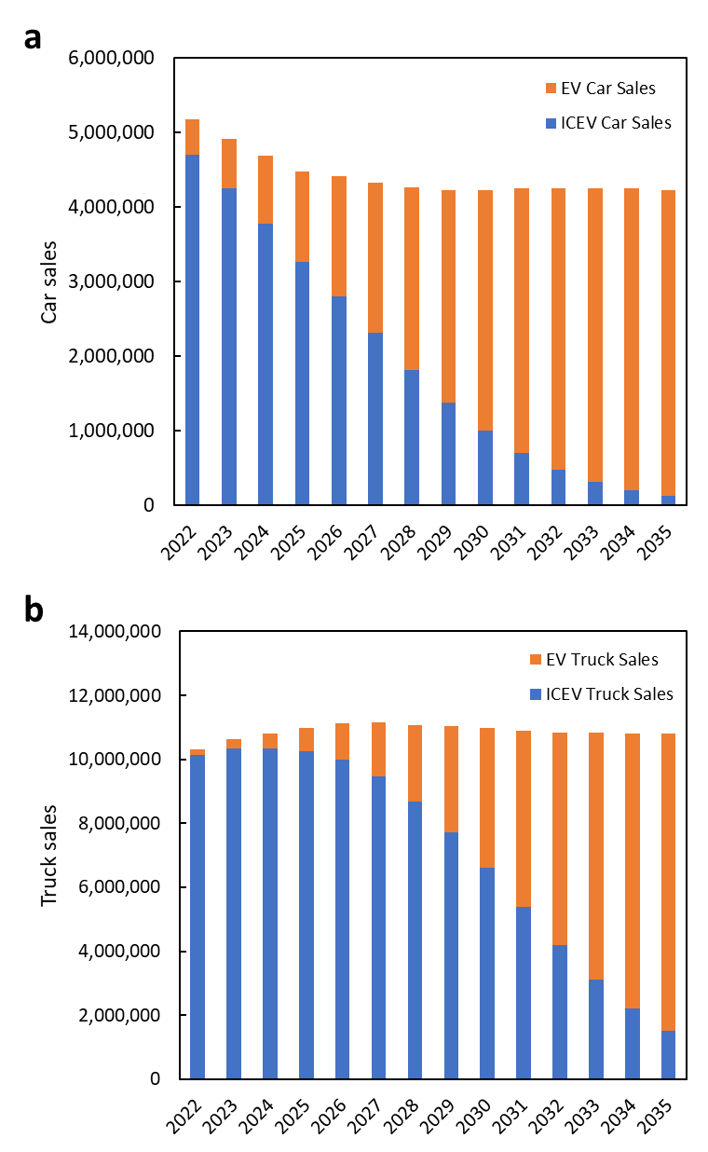
Fig. S1. Projected car (a) and truck (b) sales by year

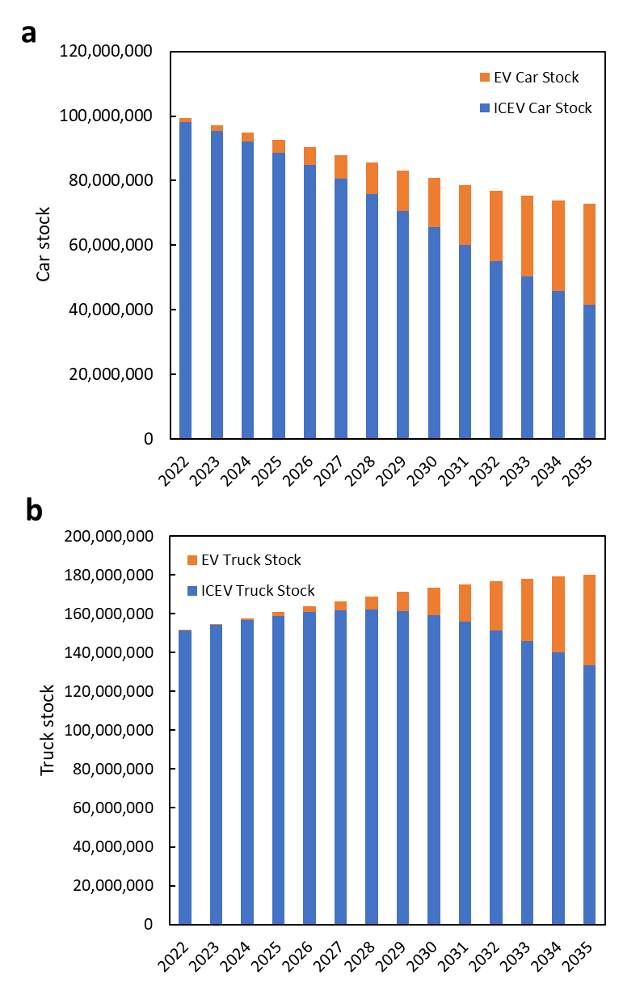
Fig. S2. Projected car (a) and truck (b) stock (vehicles on the road) by year

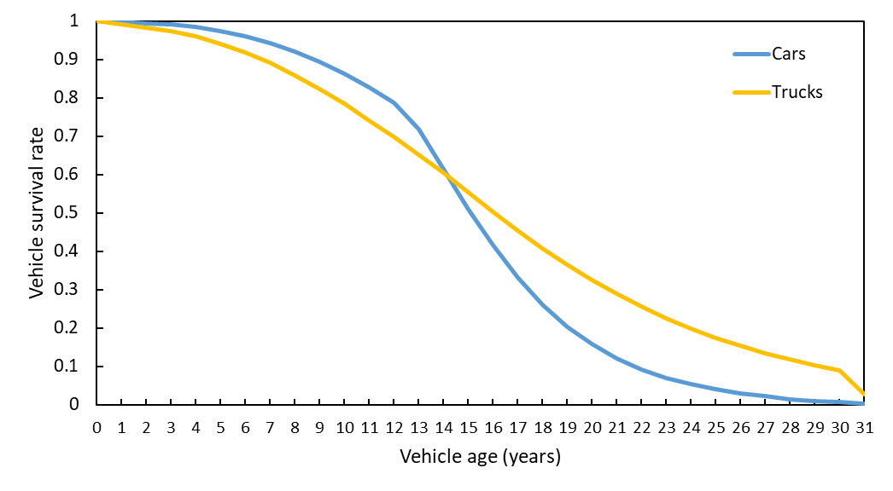
Figure S3. Car and Light Truck Survival Curves from U.S. EPA¹¹

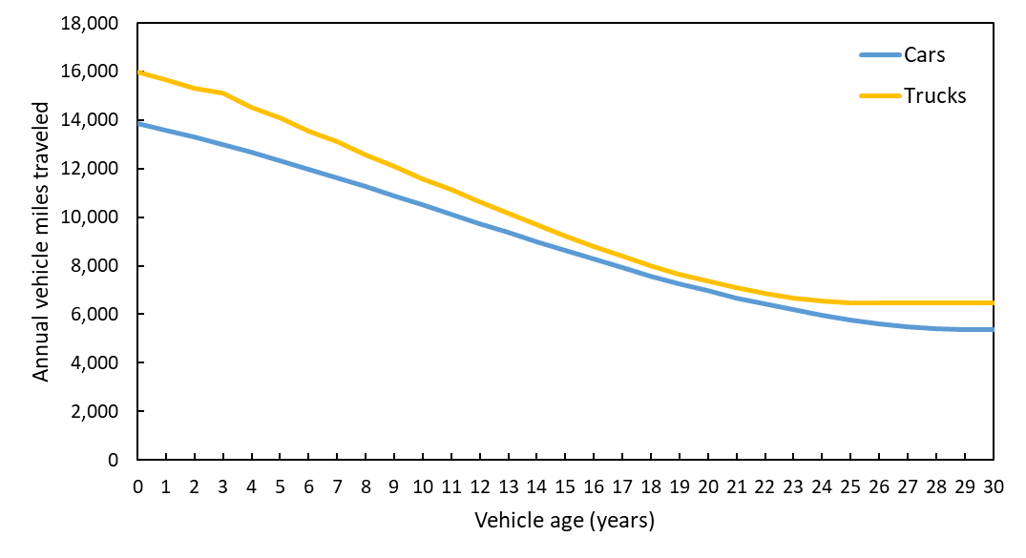
Figure S4. Annual VMT by vehicle age for cars and trucks from the Transportation Energy Data Book¹²

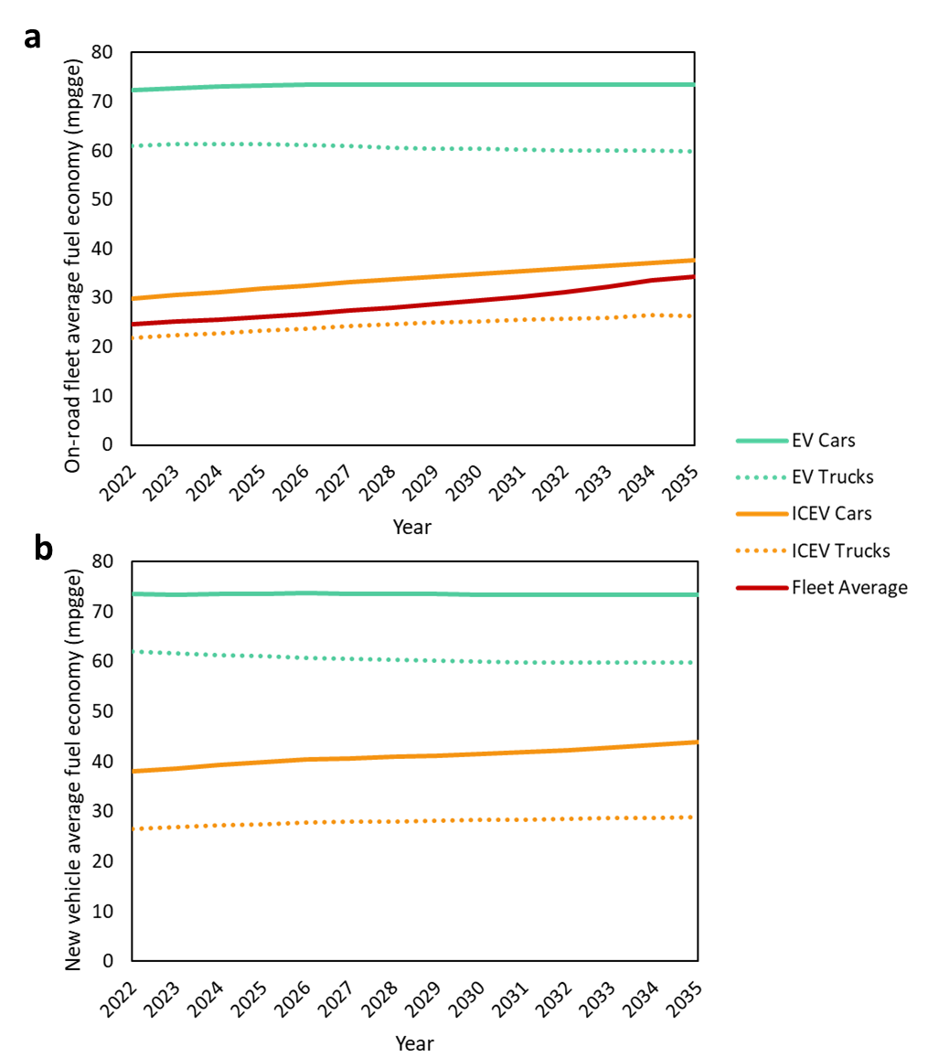
Figure S5. Average fuel economy of a) new vehicles and b) the on-road vehicle fleet. Note that EV fuel economy includes a charger efficiency of 88%.

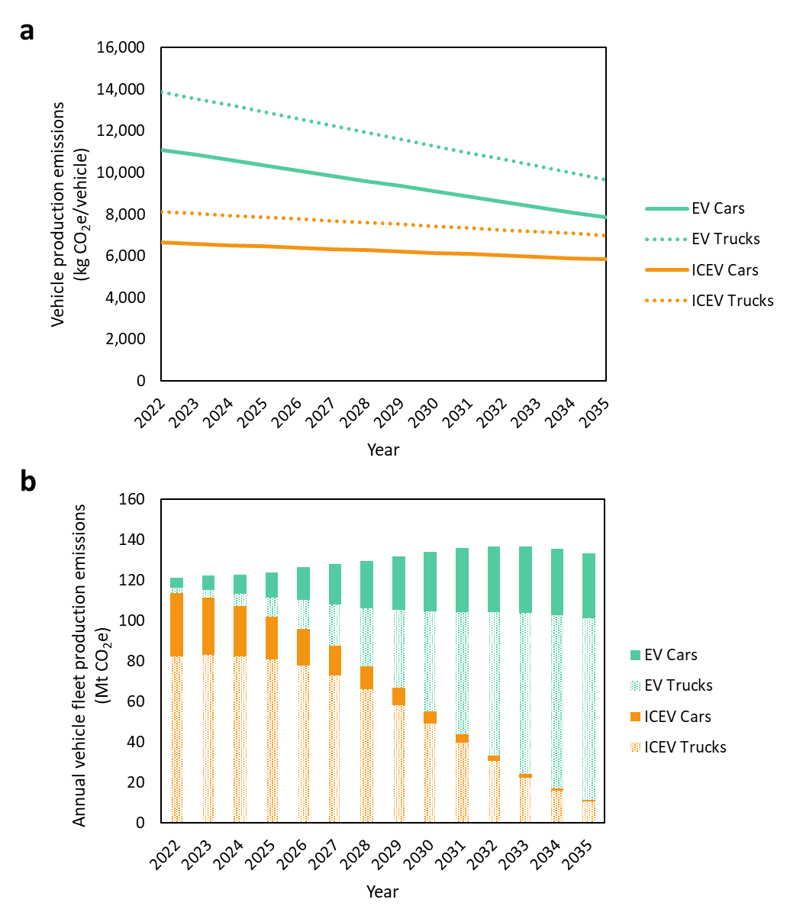
Figure S6. Vehicle production emissions for a) individual new vehicles and b) the vehicle fleet in each year

Supplemental Note 1 – Vehicle Production Emissions
According to the 2021 EPA Automotive Trends Report¹³, car sales in the U.S. in 2021 were approximately 70% sedans and 30% “car SUVs”. Truck sales consisted of 75% minivans or “truck SUVs”, and 25% pickup trucks. Woody et al.¹⁴, provides production phase emissions for ICEVs and EVs in three vehicle classes: sedans, SUVs, and pickup trucks. We use the sales ratios from the automotive trends report along with the emissions values reported in Woody et al., to approximate the emissions for the two vehicle categories used in this study (cars and light trucks), as shown in equations S1 and S2.

$$Car Emissions=70\%*Sedan Emissions+30\%*SUV Emissions (S1)$$

$$Light Truck Emissions=75\% SUV Emissions*25\% Pickup Emissions (S2)$$

Where Sedan Emissions, SUV Emissions, and Pickup Emissions are the production phase emissions for each vehicle powertrain (EV or ICEV) from Woody et al.

Supplemental References
1. Ford Motor Company. Integrated Sustainability and Financial Report 2022. https://corporate.ford.com/content/dam/corporate/us/en-us/documents/reports/integrated-sustainability-and-financial-report-2022.pdf (2022).
2. General Motors. 2021 Sustainability Report. https://www.gmsustainability.com/_pdf/resources-and-downloads/GM_2021_SR.pdf (2022).
3. Honda Motor Co. Honda Sustainability Report 2022. https://global.honda/sustainability/cq_img/report/pdf/2022/Honda-SR-2022-en-all.pdf (2022).
4. Hyundai. Road to Sustainability 2022 Sustainability Report. https://www.hyundai.com/content/hyundai/ww/data/csr/data/0000000050/attach/english/hmc-2022-sustainability-report-en-v7.pdf (2022).
5. Nissan Motor Corporation. Sustainability Report 2022. https://www.nissan-global.com/EN/SUSTAINABILITY/LIBRARY/SR/2022/ASSETS/PDF/SR22_E_All.pdf (2022).
6. Stellantis. 2021 Corporate Social Responsibility Report. https://www.stellantis.com/content/dam/stellantis-corporate/sustainability/csr-disclosure/stellantis/2021/Stellantis_2021_CSR_Report.pdf (2022).
7. Subaru. Sustainability Website 2022. https://www.subaru.co.jp/en/csr/report/pdf/2022/subaru_sustainability_report2022_all.pdf (2022).
8. Tesla. Impact Report 2021. https://www.tesla.com/ns_videos/2021-tesla-impact-report.pdf (2022).
9. Toyota. Toyota North American Environmental Report. https://www.toyota.com/content/dam/tusa/environmentreport/downloads/2021_Toyota_NAER.pdf (2021).
10. Volkswagen AG. Sustainability Report 2021. https://www.volkswagenag.com/presence/nachhaltigkeit/documents/sustainability-report/2021/Nonfinancial_Report_2021_e.pdf (2022).
11. Office of Transportation and Air Quality, U. S. E. P. A. Proposed Determination on the Appropriateness of the Model Year 2022-2025 Light-duty Vehicle Greenhouse Gas Emissions Standards under the Midterm Evaluation: Technical Support Document (EPA-420-R-16-021). https://nepis.epa.gov/Exe/ZyPDF.cgi?Dockey=P100Q3L4.pdf (2016).
12. Davis, S. C. & Boundy, R. G. Transportation Energy Data Book: Edition 40. (2022).
13. US EPA, Office of Transportation and Air Quality, C. D. The 2021 EPA Automotive Trends Report: Greenhouse Gas Emissions, Fuel Economy, and Technology since 1975. https://www.epa.gov/automotive-trends/download-automotive-trends-report (2021).
14. Woody, M. et al. The role of pickup truck electrification in the decarbonization of light-duty vehicles. Environmental Research Letters 17, 034031 (2022).

