Graphical Abstract

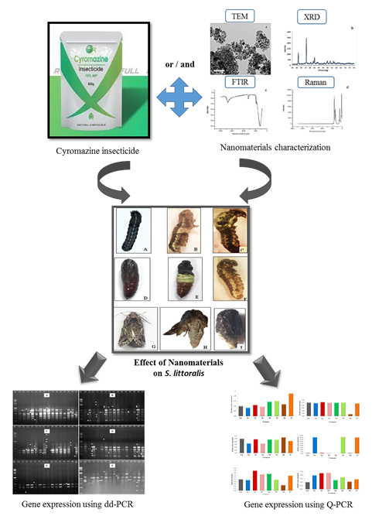
The different effects of tungsten oxide, magnetic nanoparticles, and Cu-doped magnetic nanoparticles in comparison with the insecticide, cyromazine against Spodoptera littoralis stages. Study of insect immune responses against the examined nanomaterials using dd-PCR and Q-PCR. The possibility of using nanoparticles and inserting them as promising control agents within integrated pest management (IPM) exists.

