Table 1 – System failures
Symbology | Element | Definition
 | Logical "AND" gate | Indicates that all input events need to occur for the output event to happen.
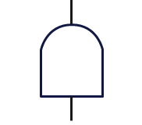 | Logical "OR" gate | Indicates that only one of the input events can be the cause of the output event.
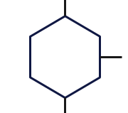 | Inhibition logical gate | Indicates that an output event will only occur if the input event happens accompanied by the restrictive event.
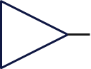 | Transfer "from" logical gate | Indicates that the fault tree has been transferred from another place, representing the input of the system.
 | Transfer "to" logical gate | Indicates that the fault tree will be transferred to another place, representing the output of the system.
 | Basic/primary event | Indicates a failure in the design environment independent of other primary events, not being caused or causing any other primary event.
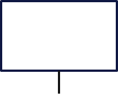 | Top event | Indicates the main undesired event that is the subject of analysis.
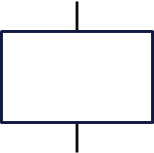 | Intermediate event | Indicates the result of interaction between events, describing the resulting failure in greater detail.
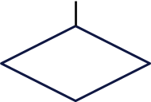 | Secondary event | Indicates events that do not have enough information to be developed or that do not have causes.
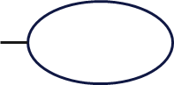 | Restrictive event | Indicates the event associated with the inhibition gate, presenting a condition that must be met for the output to occur.

Table 2 – Proposed Elements
Model | Element | Description
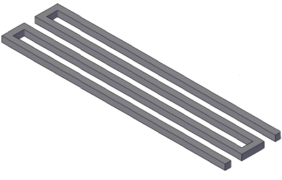 | EX1 | Linear one-layer element aimed at evaluating failures related to extrudability.
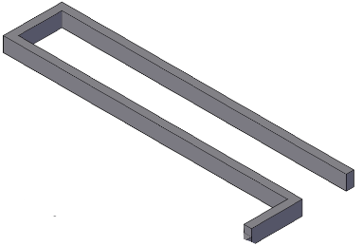 | EX2 | Linear two-layer element aimed at evaluating failures related to extrudability.
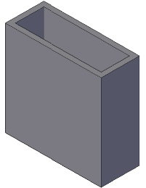 | ED2 | Block element without internal filling aimed at evaluating failures related to constructability in an unstable element under the most unfavorable circumstances.
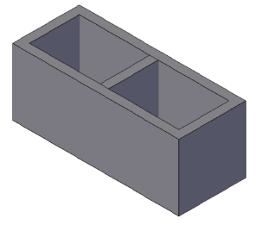 | ED1 | Block element of 20 cm height with internal filling aimed at evaluating failures related to constructability in a stable element under the most favorable circumstances.

The EX1, EX2, and ED2 elements were printed only once, as in this single attempt it was possible to record all the failures related to them. On the other hand, the ED1 element, which aimed to print a stable element, required process adjustments in several print attempts for its completion, being printed over three attempts.

