Conservation Genetics
Supplementary Information

Integrating Genomics into the Genetic Management of the Endangered Mountain Yellow-Legged Frog
Cynthia C. Steiner¹~, Leah Jacobs¹, Emma Choi^{1#}, Jamie Ivy², Aryn Wilder¹, Natalie E. Calatayud¹*, Debra M. Shier¹*

¹San Diego Zoo Wildlife Alliance, Beckman Center for Conservation Research. Escondido, California, United States of America
²Species Conservation Toolkit Initiative, Chicago Zoological Society, Brookfield, Illinois, United States of America
#Current address: Ecology and Evolutionary Biology, University of Connecticut, Connecticut, United States of America
* Both authors contributed equally to the publication.

~Corresponding author:
Cynthia C. Steiner, csteiner@sdzwa.org

Figures
Supplementary Fig. 1 Stack parameter optimization. M represents the maximum distance in nucleotides allowed between stacks (default 2), and m indicates the minimum depth of coverage required to create a stack (default 3)

Supplementary Fig. 2 Proportion of private alleles estimated for the two populations managed at the SDZWA breeding program, after downsampling San Jacinto total number of frogs to 15 by randomization

Supplementary Fig. 3 Structure analysis for K=3 including all mountain yellow-legged frog populations after downsampling the San Jacinto population to 15 individuals by randomization. At K=3, individuals from different populations are assigned to separate clusters represented by gray (San Bernardino), white (San Gabriel) and black (San Jacinto) bars. Admixed individuals are represented by multicolor bars. Every bar shows an individual

Supplementary Fig. 4 Distribution of pairwise comparisons of estimates of the similarity index (allele sharing coefficient) for SJ and SB individuals

SB
SJ

Supplementary Fig. 5 SB (A) and SJ (B) founder’s representation measured as the proportion of each founder’s genes present across the living/descendant populations

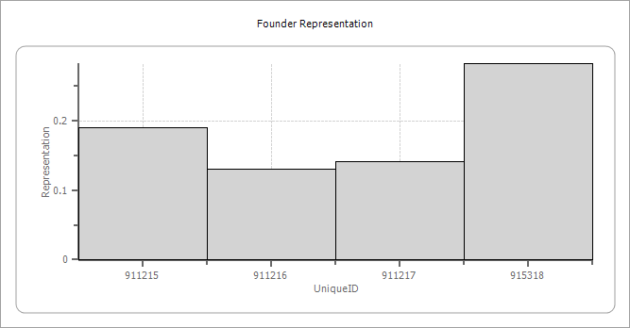
A
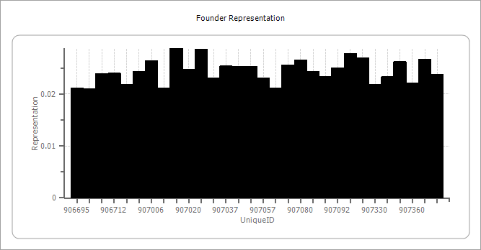
B

Tables
Supplementary Table 1 Sample information. This table is uploaded in the Dryad data repository

Supplementary Table 2 Reads per sample. This table is uploaded in the Dryad data repository

Supplementary Table 3 Summary statistics of all managed individuals at the SDZWA conservation breeding program, including number of individuals (N), average number of alleles (Na), observed (H_{O}) and expected heterozygosity (H_{E}), and inbreeding coefficient (F_{IS})

Pop |  | N | Na | Ho | He | F_{IS}
SJ | Mean | 44 | 1.645 | 0.245 | 0.195 | -0.178
 | SE |  | 0.006 | 0.003 | 0.002 | 0.003
SB | Mean | 13 | 1.361 | 0.166 | 0.119 | -0.290
 | SE |  | 0.006 | 0.003 | 0.002 | 0.004
Total | Mean | 57 | 1.503 | 0.205 | 0.157 | -0.219
 | SE |  | 0.004 | 0.002 | 0.002 | 0.003

Supplementary Table 4 Ranking of the best male and female SB breeders according to mean kinship (MK) values. Reproductive status (ReproStatus) of each ranked individual is shown

Males |  |  |  | Females
Stbk# | MK | MK Rank | ReproStatus | Stbk# | MK | MK Rank | ReproStatus
916320 | 0.1989 | 1 | Fertile | 914486 | 0.1696 | 1 | Fertile
913350 | 0.2253 | 2 | Fertile | 916309 | 0.1989 | 2 | Fertile
913351 | 0.2326 | 3 | Fertile | 913381 | 0.2481 | 3 | Fertile
916267 | 0.2384 | 4 | Fertile | 918093 | 0.2574 | 4 | Fertile
918092 | 0.2574 | 5 | Fertile
918094 | 0.2574 | 5 | Fertile
915318 | 0.2632 | 7 | Fertile
917314 | 0.2735 | 8 | Fertile
917318 | 0.2735 | 8 | Fertile
917381 | 0.2735 | 8 | Fertile

Supplementary Table 5 Ranking of the best male and female SJ breeders according to mean kinship (MK) values. Reproductive status (ReproStatus) of each ranked individual is shown

Males |  |  |  | Females
Stbk# | MK | MK Rank | ReproStats | Stbk# | MK | MK Rank | ReproStats
914560 | 0.0805 | 1 | Fertile | 907077 | 0.0849 | 2 | Fertile
906736 | 0.0880 | 2 | Fertile | 907009 | 0.0852 | 3 | Fertile
907057 | 0.0927 | 3 | Fertile | 907360 | 0.0889 | 6 | Fertile
907034 | 0.0931 | 4 | Fertile | 914502 | 0.0894 | 7 | Fertile
916017 | 0.0954 | 6 | Fertile | 915221 | 0.0904 | 8 | Fertile
906711 | 0.0962 | 7 | Fertile | 907331 | 0.0939 | 9 | Fertile
914515 | 0.0962 | 8 | Fertile | 915139 | 0.0997 | 14 | Fertile
914483 | 0.0970 | 9 | Fertile | 915262 | 0.1093 | 21 | Fertile
906738 | 0.0980 | 11 | Fertile | 915255 | 0.1109 | 22 | Fertile
914540 | 0.0993 | 12 | Fertile
907092 | 0.1007 | 13 | Fertile
907051 | 0.1015 | 14 | Fertile
907006 | 0.1063 | 16 | Fertile
907190 | 0.1119 | 18 | Fertile
907024 | 0.1150 | 19 | Fertile
907011 | 0.1157 | 20 | Fertile

