Additional file 1
Evaluating the relationship between conditional cash transfer programme on preterm births: a retrospective longitudinal study using the 100 Million Brazilian Cohort

Table S1. Sociodemographic, gestational, and household characteristics in relation to preterm birth outcomes and whether or not the mother received Bolsa Familia (BF) during pregnancy.
(In the excel file)

Table S2. Summarized statistics of the propensity score variables of beneficiaries (exposed) and non-beneficiaries (unexposed) before and after the kernel matching, according to preterm birth outcomes.
Propensity score variables | Outcome 1ª |  | Outcome 2^{b} |  | Outcome 3^{c} |  | Outcome 4^{d}
Propensity score variables | Diff before Kernel¹ | Diff after Kernel² | Diff before Kernel¹ | Diff after Kernel² | Diff before Kernel¹ | Diff after Kernel² | Diff before Kernel¹ | Diff after Kernel²
Cohort time (years)
≥ 5 | 13.8 | -1.1 | 14.2 | -0.9 | 12.4 | -1.1 | 8.3 | -6.3
<5 | -13.8 | 1.1 | -14.2 | 0.9 | -12.4 | 1.1 | -8.9 | 6.3
Maternal education (years)
0-7 | 16.4 | -1.3 | 16.4 | -1.2 | 15.5 | -1.7 | 13.9 | -1.9
8-11 | -8.8 | 1.3 | -8.8 | 1.2 | -7.0 | 2.1 | -7.1 | 2.2
≥ 12 | -7.6 | 0.0 | -7.6 | 0.0 | -8.5 | -0.4 | -6.8 | -0.2
Maternal race/skin color
White | -14 | 1.2 | -14.1 | 1.5 | -14.4 | -1.0 | -12.4 | 0.1
Black or mixed-race | 12.7 | -1.2 | 12.8 | -1.5 | 13.1 | 0.0 | 11.7 | 0.0
Indigenous | 1.3 | 0.1 | 1.3 | 0.0 | 1.3 | 1.0 | 0.7 | 0.0
Marital status
Marriage/civil partnership | -4.5 | 0.6 | -4.5 | 0.6 | -6.1 | -1.4 | -1.0 | 2.7
Single/divorced/widow | 4.5 | -0.6 | 4.5 | -0.6 | 6.1 | 1.4 | 1.0 | -2.7
Geographical region
South | -6.7 | 0.1 | -5.8 | 0.2 | -7.0 | -0.1 | -6.2 | 0.2
North | 7.3 | 0.6 | 7.3 | 0.3 | 8.5 | 3.8 | 6.0 | 2.1
Northeast | 17.1 | -0.4 | 17.2 | -0.3 | 15.1 | -2.0 | 17.3 | -1.7
Southeast | -12.9 | -0.1 | -12.9 | 0.1 | -11.7 | -1.7 | -14.0 | -0.3
Midwest | -4.7 | -0.3 | -4.8 | -0.4 | -4.8 | 0.1 | -3.1 | -0.2
Household location
Urban | -15.2 | -1.0 | -15.3 | -0.8 | -14.7 | -1.1 | -13.1 | -1.7
Rural | 15.2 | 1.0 | 15.3 | 1.4 | 14.7 | 1.1 | 13.1 | 1.7
Household conditions
All favorable conditions | -17.0 | -0.1 | -17.1 | 0.0 | -16.6 | -0.8 | -15.6 | -0.5
1 unfavorable condition | -5.5 | -0.5 | -5.7 | -0.7 | -3.5 | 1.3 | -4.5 | -1.5
2 unfavorable conditions | 2.1 | 0.3 | 2.2 | 0.4 | 0.9 | -2.0 | 6.1 | 4.0
3 unfavorable conditions | 5.8 | 0.6 | 5.8 | 0.6 | 5.4 | -0.1 | 5.5 | 0.9
4-5 unfavorable conditions | 14.5 | -0.2 | 14.7 | -0.3 | 13.8 | 1.6 | 8.5 | -2.8
Overcrowding
≤2 people per room | -8.6 | -0.5 | -8.6 | -0.2 | -8.7 | -2.6 | -8.5 | -3.2
>2 people per room | 8.6 | 0.5 | 8.6 | 0.2 | 8.7 | 2.6 | 8.5 | 3.1
ª 1= all preterm births (PTB), 0=at term newborns.
^{b} 1= moderate-to-late PTB, 0=at term newborns.
^{c} 1=severe PTB, 0=at term newborns.
^{d} 1=extreme PTB, 0=at term newborns.
¹ Difference between beneficiaries and non-beneficiaries (BF1-BF0) before kernel matching.
² Difference between beneficiaries and non-beneficiaries (BF1-BF0) after kernel matching
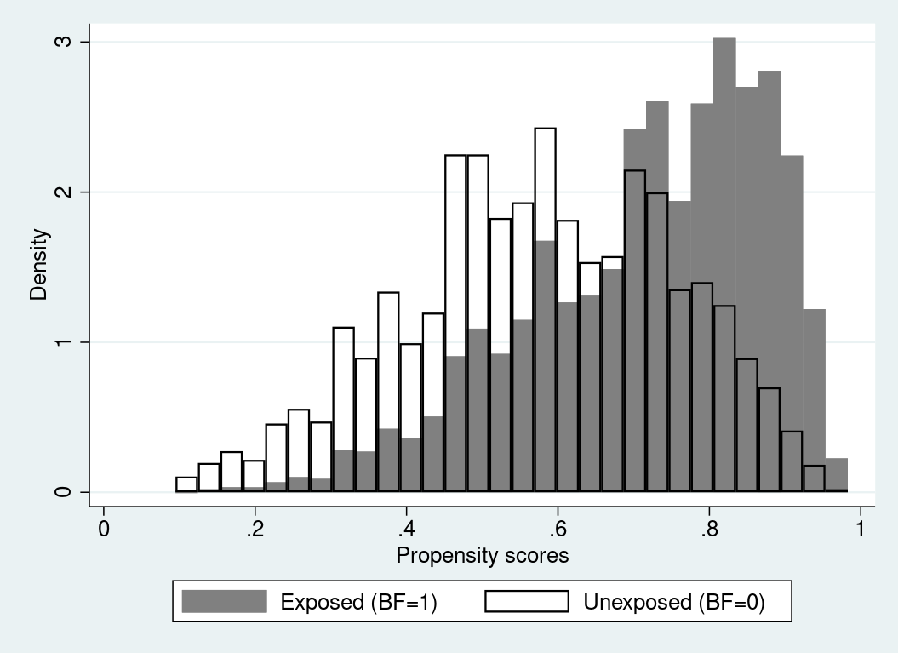
Figure S1. Common support area of the exposed over the unexposed group.

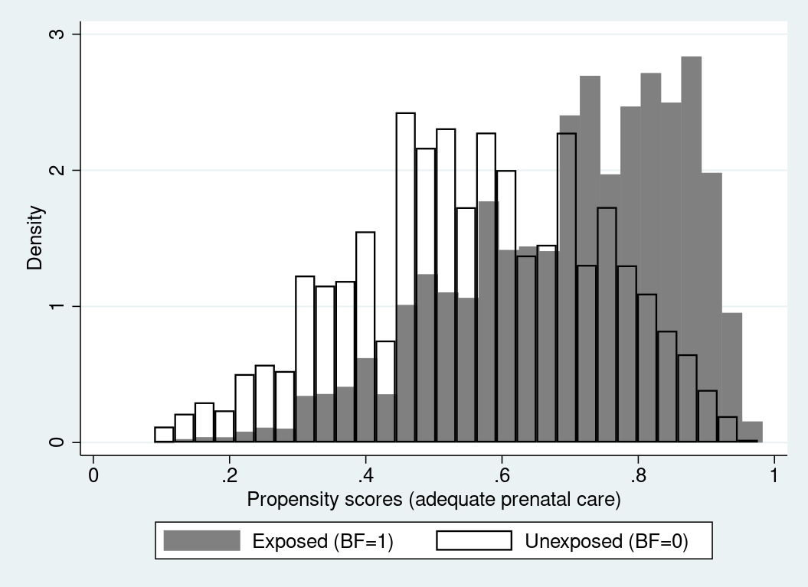
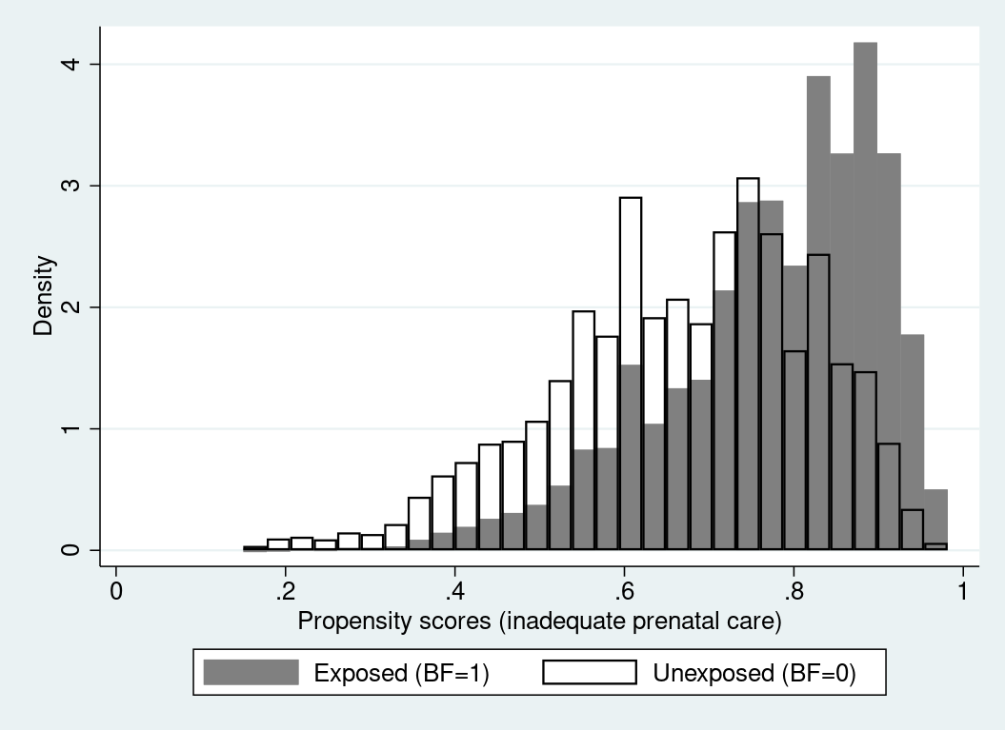Figure S2. Common support area of the exposed over the unexposed group, according to adequacy of prenatal care subgroups.
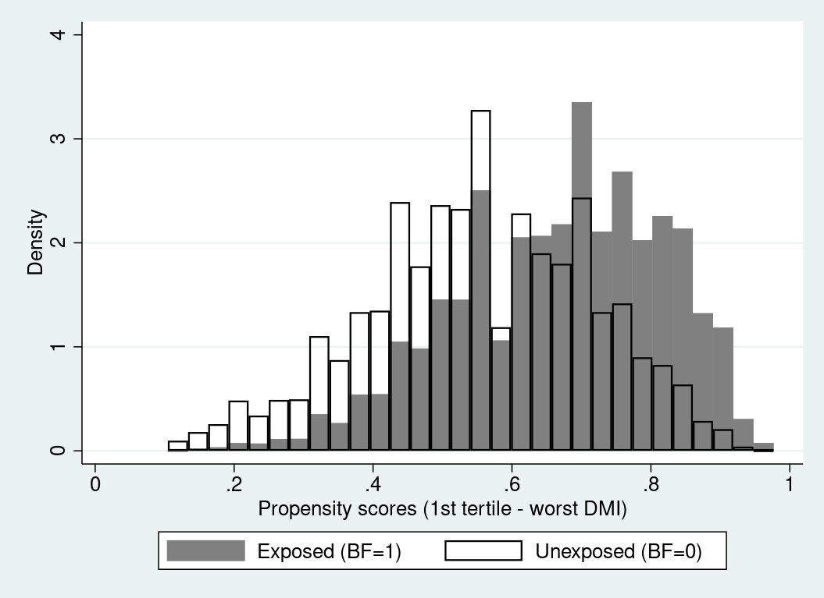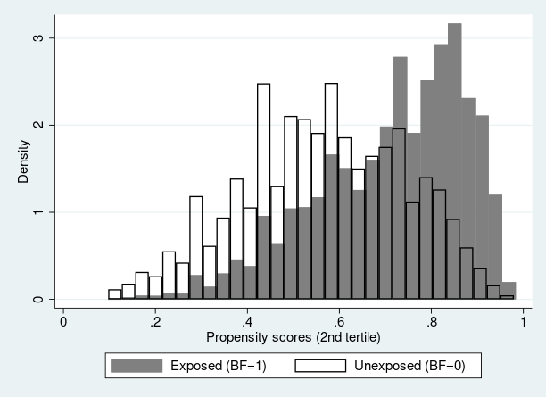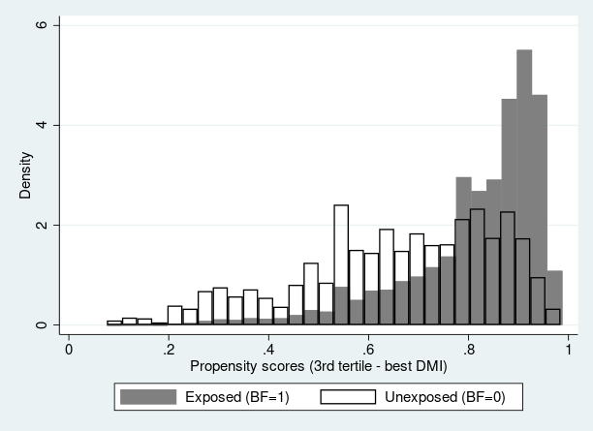
Figure S3. Common support area of the exposed over the unexposed group, according to municipal Bolsa Familia (BF) Programme Decentralized Management Index (DMI) subgroups.
Table S3. Association between Bolsa Familia (BF) Programme benefit during pregnancy and rare preterm birth outcomes.
Rare preterm birth outcome | OR (95% CI)¹
Severe PTB
No (37-42 weeks) | 1.00
Yes (28-31 weeks) | 0.97 (0.89-1.06)
N² | 9,978
Extreme PTB
No (37-42 weeks) | 1.00
Yes (<28 weeks) | 0.72 (0.63-0.83)
N² | 4,336
¹Model adjusted for maternal age (years) and type of delivery.
²Sample size following case-control analysis.

