Novel host plant use by a specialist insect depends on geographic variation in both species
Authors: Michielini, James P.^{1,2}; Yi, Xianfeng³; Brown, Leone M^{1,4}; Gao, Shan Ming⁵; Orians, Colin¹; Crone, Elizabeth E.^{1,2}
Author Affiliations: 1. Department of Biology, Tufts University, Medford, MA USA 02155, 2. Current address: Department of Evolution and Ecology, University of California, Davis, Davis CA USA 95616, 3. College of Life Science, Qufu Normal University, Qufu China, 4. Current address: Biology Department, James Madison University, Harrisonburg VA USA 22807, 5. Biology Department, Pomona College, Claremont CA USA
Corresponding Author: James Michielini
Email: jpmichielini@ucdavis.edu
Telephone: 516-306-7377
Fax: (530) 752- 1449

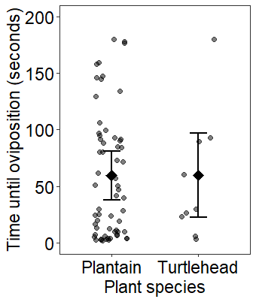
Supplemental Fig. 1 The estimated time (in seconds) until oviposition behavior was observed for Massachusetts Baltimore checkerspot females on all trails of English plantain and on white turtlehead where the female accepted the plant (i.e, any instances where females did not attempt to oviposit are not included). Points indicate the amount of time until the female attempted to oviposit and diamonds the estimated average time to oviposition behavior from the model examining differences between the species. Points are jittered and are opaque for visibility; more points are present for plantain because individual females were given multiple plantain plants while each was only ever tested once on turtlehead (see Methods & Fig. 1 for more information). Error bars show 95% confidence intervals. N = 70 (61 plantain and 9 turtlehead).

