Supplementary Material
- Primary Antibodies
Table S.1: Summary of the Primary antibodies used for immunoblotting and immunofluorescence.
Primary | Product Code | Dilution IB | Dilution IF
Vimentin | Biotechne: 280618MAB2105 | 3/1000 | 3/250
Pan-Cytokeratin | Sigma: SAB5300264 | 1/1000 | 1/500
S100A6 | Biotechne: nbp1-89388 | - | 1/200
CRABP2 | Biotechne: nb100-2590 | - | 1/500
E-cadherin | Sigma: SAB4503751 | - | 1/200
Connexin-43 | Merck: C6219 | - | 1/400
GAPDH | Sigma: SAB530025 | 1/5000 | -

- Secondary Antibodies
Table S.2: Summary of the Secondary antibodies used for immunoblotting and immunofluorescence.
Secondary Immunoblot | Product Code | Dilution
Anti-Rat in Goat | Abcam: ab175778 | 1/10,000
Anti-Mouse in Goat | Invitrogen: A11375 | 1/10,000
Anti-Rabbit in Goat | Invitrogen: A11375 | 1/10,000
Secondary Immunofluorescence | Product Code | Dilution
Anti-Rat in Goat | Invitrogen: A48262 | 1/1000
Anti-Mouse in Goat | Abcam: Ab150115 | 1/1000
Anti-Rabbit in Goat | Abcam: Ab175471 | 1/1000

- Exposure
Table S.3: Summary of exposures used for each protein for mean intensity analysis.
Protein | Magnification | Exposure
Vimentin | 20x | 116.57
Pan-Cytokeratin | 20x | 285.87
S100A6 | 20x | 499.57
CRABP2 | 20x | 499.57
E-cadherin | 20x | 2070.88
Connexin-43 | 20x | 207088

- XCELLigence Raw Data:
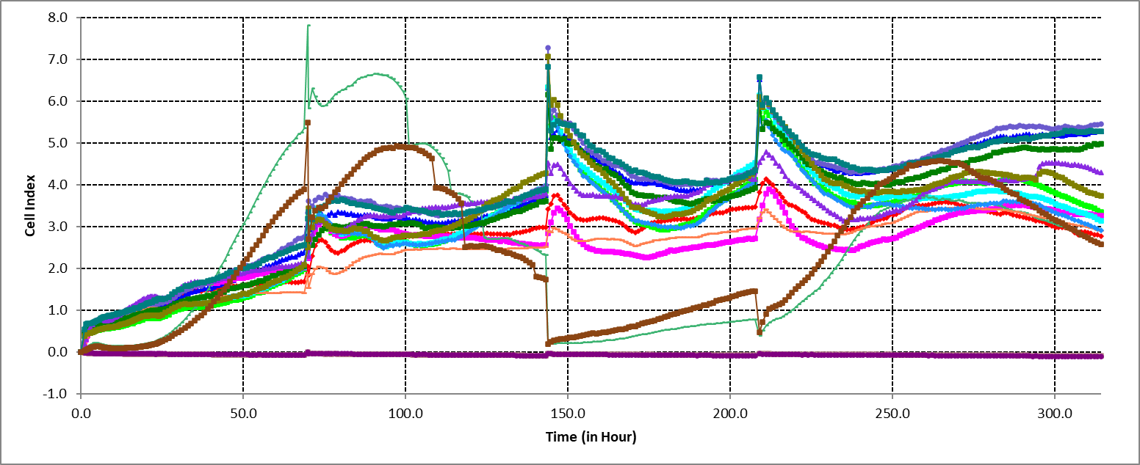
Figure S.1: Raw data from the xCELLigence for e-Plate 1/3 for passage 2, passage 5 and passage 10 seeded on PLL and Plastic

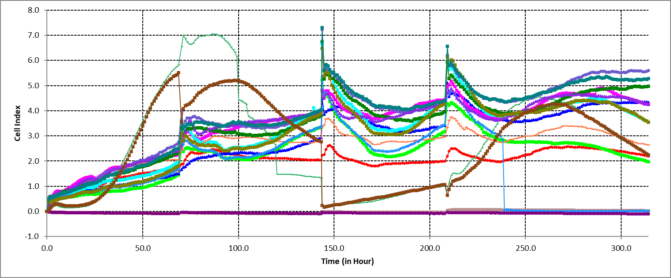
Figure S.2: Raw data from the xCELLigence for e-Plate 2/3 for passage 2, passage 5 and passage 10 seeded on PLL and Plastic

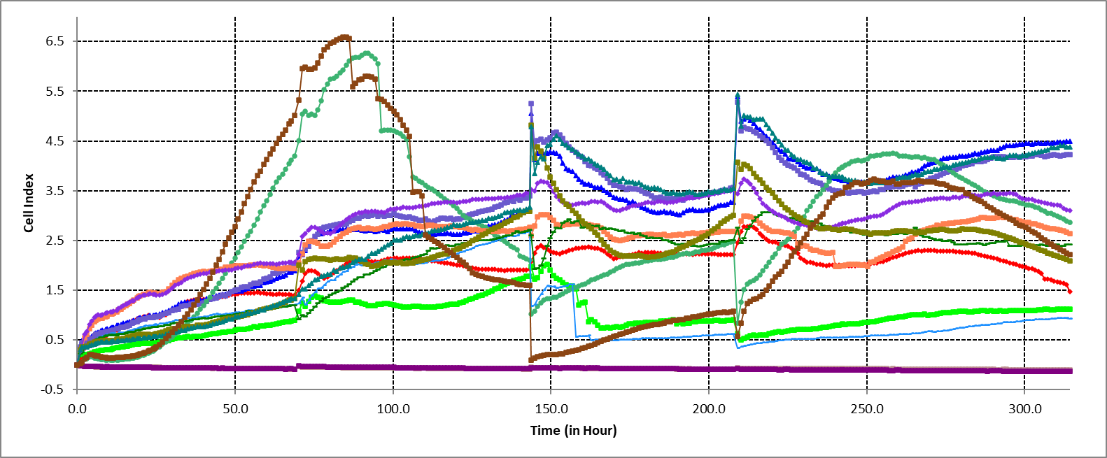
Figure S.3: Raw data from the xCELLigence for e-Plate 3/3 for passage 2, passage 5 and passage 10 seeded on PLL and Plastic

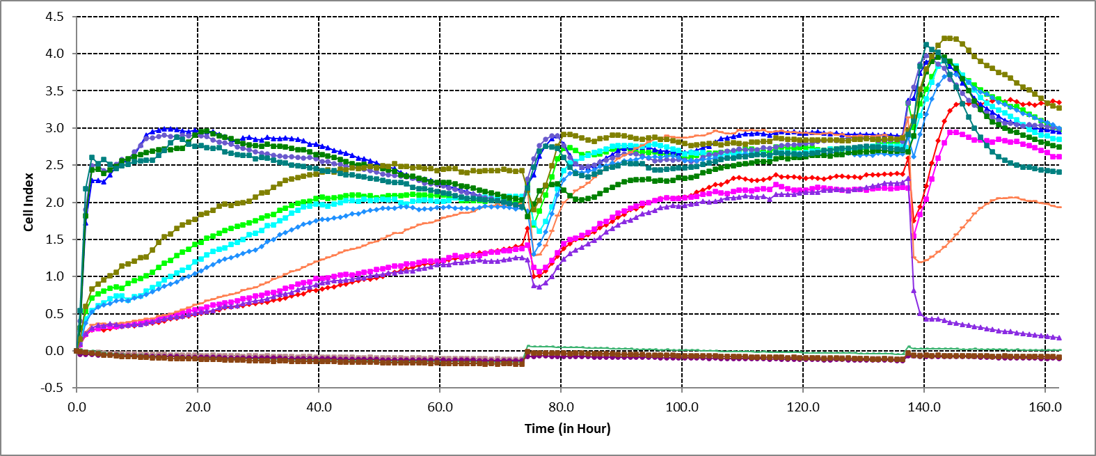
Figure S.4: Raw data from the xCELLigence for e-Plate 1/3 for examining the effect of concentrations 1.5x10⁴ cell/mL , 3x10⁴ cell/mL and 9x10⁴ cell/mL seeded on PLL and Plastic

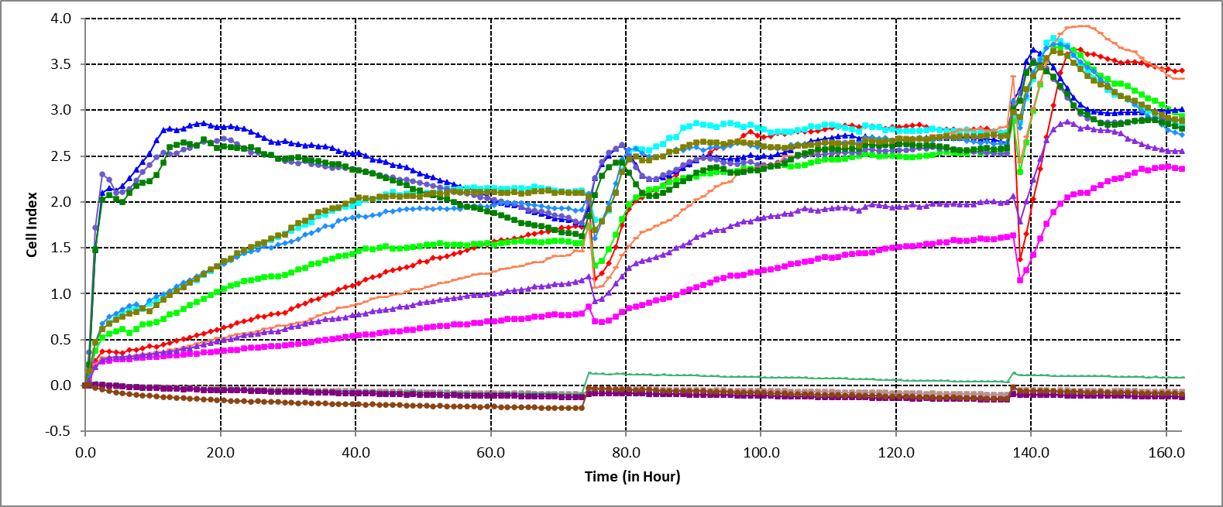
Figure S.5: Raw data from the xCELLigence for e-Plate 2/3 for examining the effect of concentrations 1.5x10⁴ cell/mL , 3x10⁴ cell/mL and 9x10⁴ cell/mL seeded on PLL and Plastic

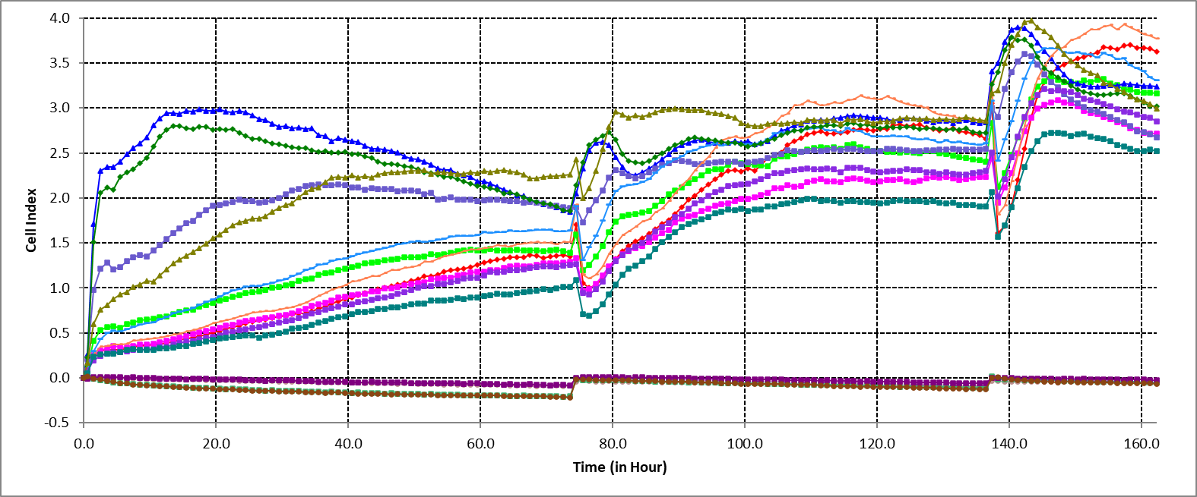
Figure S.6: Raw data from the xCELLigence for e-Plate 3/3 for examining the effect of concentrations 1.5x10⁴ cell/mL , 3x10⁴ cell/mL and 9x10⁴ cell/mL seeded on PLL and Plastic

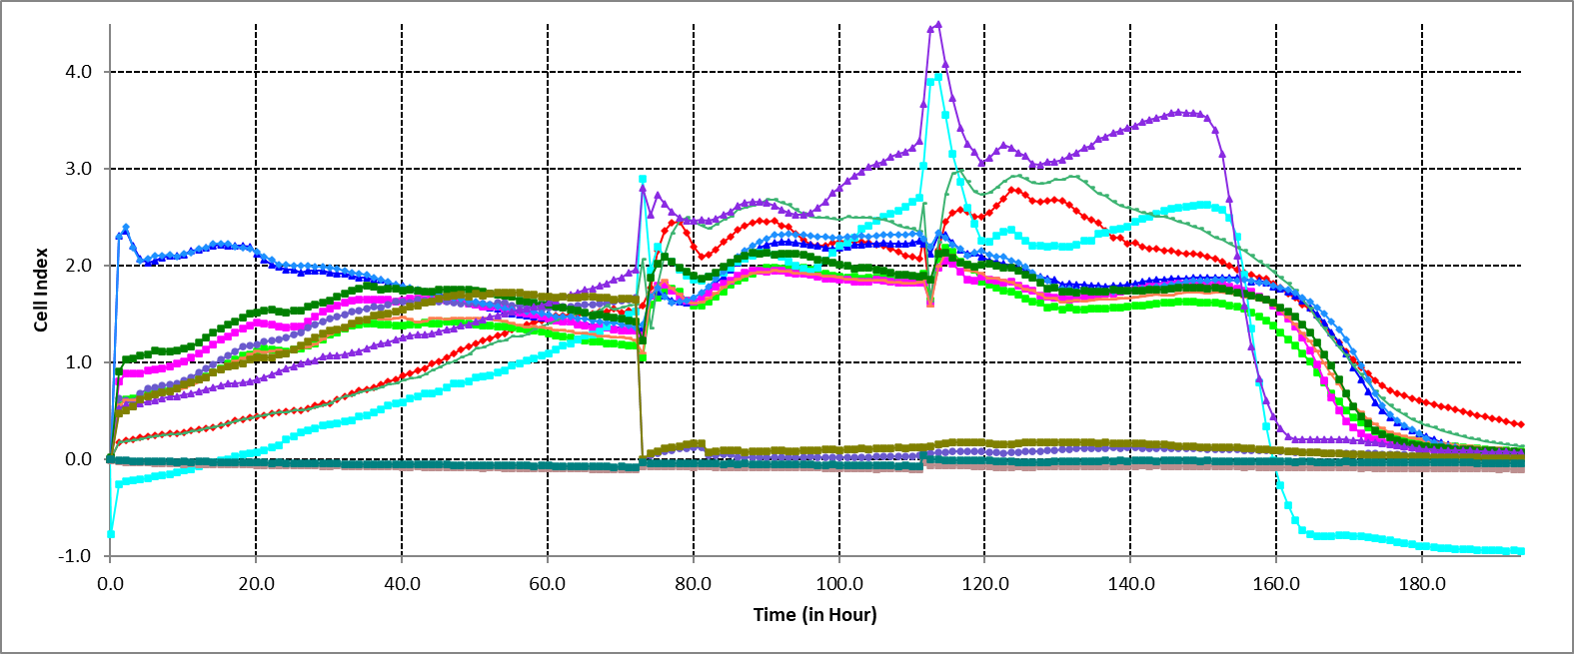
Figure S.7: Raw data from the xCELLigence for e-Plate 1/3 for passage 2, passage 5 and passage 10 and for examining the effect of concentrations 1.5x10⁴ cell/mL , 3x10⁴ cell/mL and 9x10⁴ cell/mL seeded on collagen.

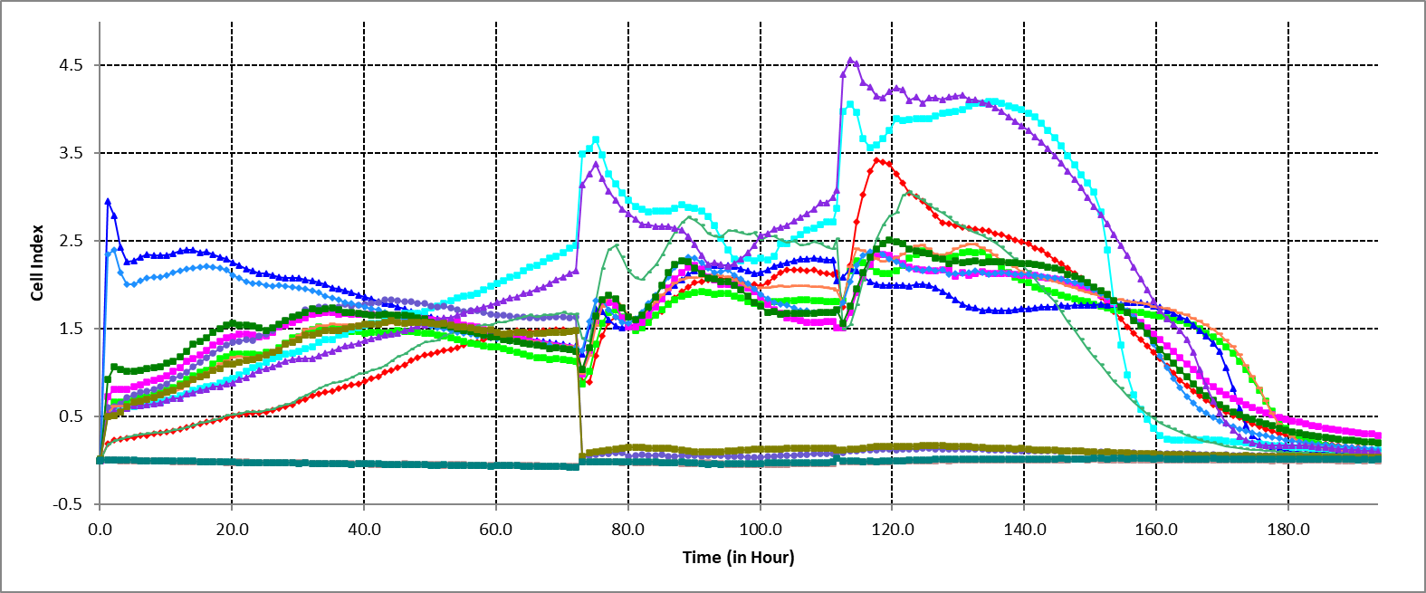
Figure S.8: Raw data from the xCELLigence for e-Plate 2/3 for passage 2, passage 5 and passage 10 and for examining the effect of concentrations 1.5x10⁴ cell/mL , 3x10⁴ cell/mL and 9x10⁴ cell/mL seeded on collagen.

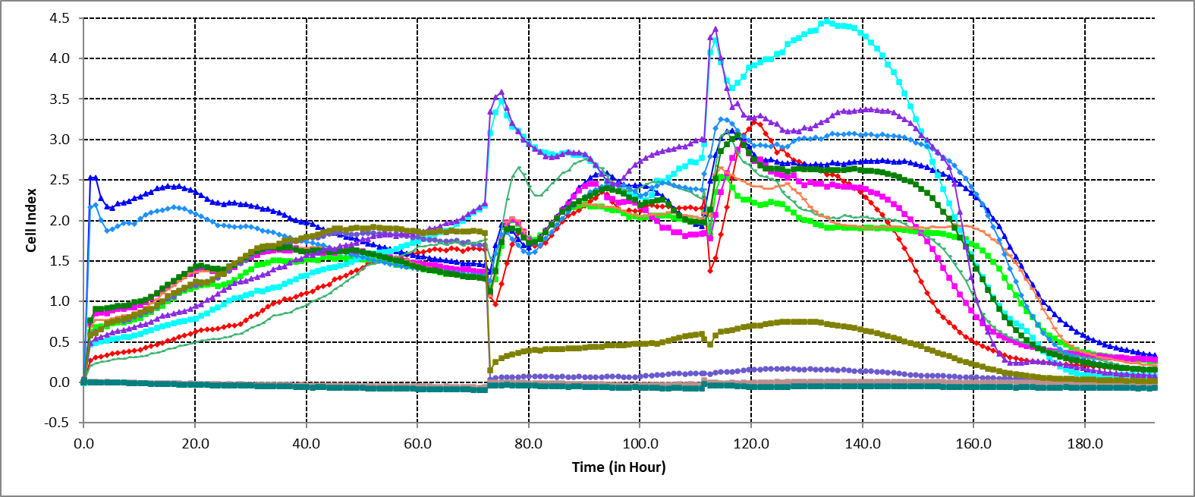
Figure S.9: Raw data from the xCELLigence for e-Plate 3/3 for passage 2, passage 5 and passage 10 and for examining the effect of concentrations 1.5x10⁴ cell/mL , 3x10⁴ cell/mL and 9x10⁴ cell/mL seeded on collagen.

- Western blots:
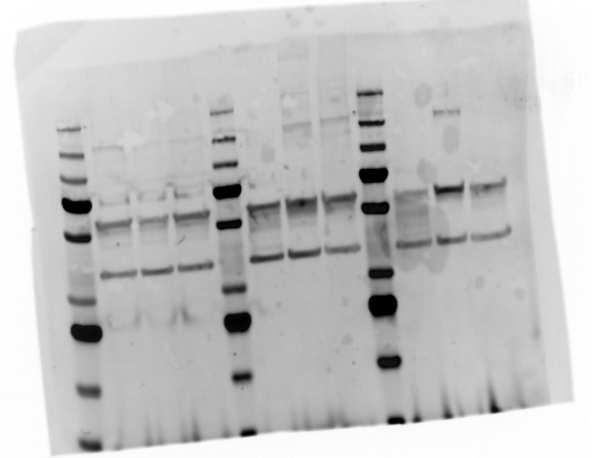
Figure S.10: Vimentin 55 kDAa and GAPDH 35 kDa for P2, P5 and P10 repeated in triplicates.

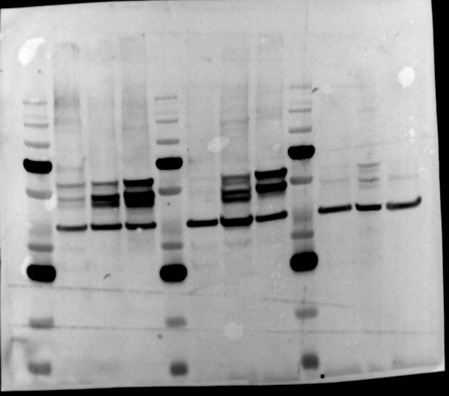
Figure S.11: pan-Cytokeran and GAPDH 35 kDa for P2, P5 and P10 repeated in triplicates.

- Immunofluorescence:

  - Image Acquisition:
All images were acquired using automated confocal imaging on the Molecular Devices ImageXpress
High-Content Microconfocal. Focusing and exposure optimization were carried out on a small subset
of wells across the range of the plate. The sites used to optimize the imaging conditions were not
acquired for image analysis to avoid photobleaching which could affect the images used for
quantitation. Automated imaging uses rapid, plate bottom- and well bottom-based autofocusing to
ensure each individual site is in focus before acquiring the images. Any potential bleaching caused by
autofocusing would be negligible as the DAPI channel is used and it is uniformly applied to all wells
and sites. All images were acquired at the same magnification, exposure, and laser intensity.
  - Image Analysis using CellProfiler
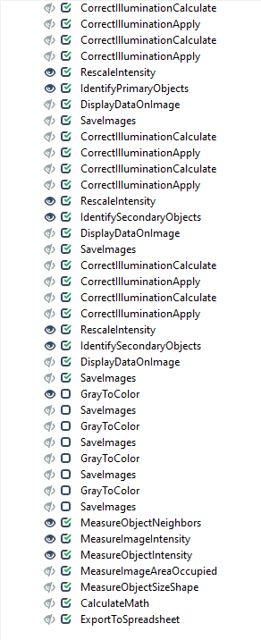
Figure S.12: Cell profiler Pipeline used to obtain mean intensity values for the proteins of interest.

Table S.4: Merged images of Vimentin, S100A6, CRABP2, and E-cadherin (Purple) in LMCs with Phalloidin (Green) and DAPI (Blue).
