Supporting information
Interchannel dimerization of the dissociated voltage-sensor domains of voltage-gated Na⁺ channels in the resting state

Ayumi Sumino^{1,2}*, Takashi Sumikama¹*, Mikihiro Shibata^{1,2}, Katsumasa Irie³*

1 Nano Life Science Institute (WPI-NanoLSI), Kanazawa University, Kanazawa, 920-1192, Japan
2 Institute for Frontier Science Initiative, Kanazawa University, Kanazawa, 920-1192, Japan
3 Department of Biophysical chemistry School of Pharmaceutical Science, Wakayama Medical University, Wakayama, 640-8156, Japan
* Corresponding authors
Correspondence: sumino@staff.kanazawa-u.ac.jp, sumi@staff.kanazawa-u.ac.jp, kirie@wakayama-med.ac.jp

Table of Contents
Figure S1. HS-AFM image of the Na_{v}Ab (KAV) cluster in a lipid bilayer.
Figure S2. Probability of VSD detection around PDs.
Figure S3. E32Q/N49K mutant without a lipid bilayer.
Figure S4. Distance between two particles derived from a single VSD.
Figure S5. Simulated AFM image of a VSD.
Figure S6. Estimation of the maximum distance from the center of the PD to the S1-S2 particle.
Figure S7. Other examples of trajectories and eigenvectors of PCA for the WT.
Figure S8. Other examples of trajectories and eigenvectors of PCA for the N49K mutant.
Figure S9. Other examples of trajectories and eigenvectors of PCA for the E32Q/N49K mutant.
Figure S10. Density dependence of the contact probability between particles mimicking resting Na_{v} channels.
Movie S1. HS-AFM of clustering Na_{v}Ab (KAV) channels
Movie S2. HS-AFM of deforming tetrameric PDs of the Na_{v}Ab (KAV) channel
Movie S3. HS-AFM of the Na_{v}Ab (WT) channel
Movie S4. HS-AFM of the Na_{v}Ab (N49K) channel
Movie S5. HS-AFM of the Na_{v}Ab (E32Q/N49K) channel
Movie S6. MD simulation of VSD dimer

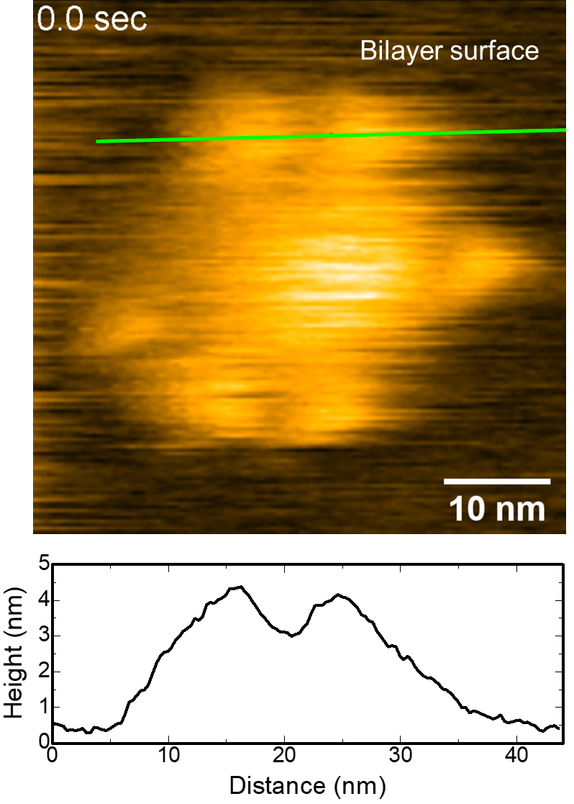
Figure S1. HS-AFM image of the Na_{v}Ab (KAV) cluster in a lipid bilayer.
The height profile along the green line is shown. Particles formed cluster in the bilayer and protruded approximately 3-4 nm from the lipid bilayer surface. The height is too high to consider that the molecule appropriately reconstituted in the lipid bilayer since other clearly observed Na_{v}Ab channels showed only approximately 1 nm protrusion. The corresponding HS-AFM movie is Movie S1.

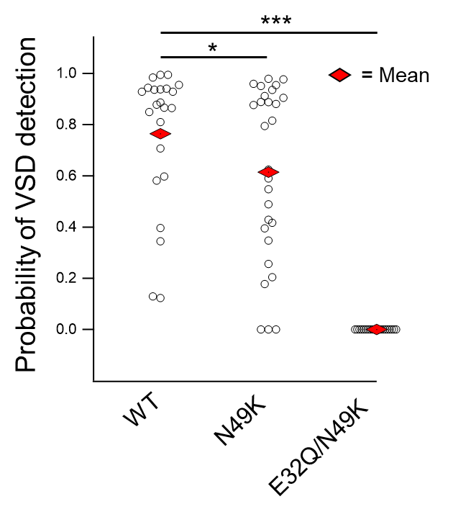
Figure S2. Probability of VSD detection around PDs.
Probability of VSD detection = total frame number detecting VSD/total frame number of the HS-AFM movie. Number of channels; 5, 7, and 5 for the WT, N49K mutant and E32Q/N49K mutant, respectively. Since the Na_{v}Ab channel is a homotetramer, a single channel yields four plots.

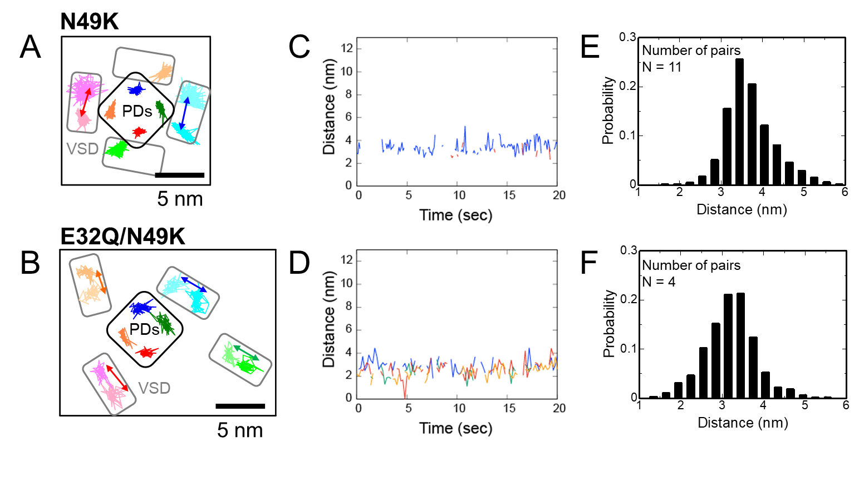

Figure S3. Distance between two particles derived from a single VSD.
(A and B) Trajectories of Na_{v}Ab channels. Trajectories surrounded by black squares and gray rectangles correspond to PDs and VSD, respectively. (C and D) Time series of the distance between two particles derived from the same VSD (S1-S2, S3-S4) indicated by arrows in A and B. (E and F) Histograms of the distance between two particles derived from the same VSD. The numbers of pairs (channels) are 11 (4) and 4 (1) for E and F, respectively. The total data numbers are 2416 and 644 for E and F, respectively. The analyzed constructs are the N49K mutant for (A, C and E) and the E32Q/N49K mutant for (B, D and F). Frame rates: 5 frame/sec for A, 10 frame/sec for B.

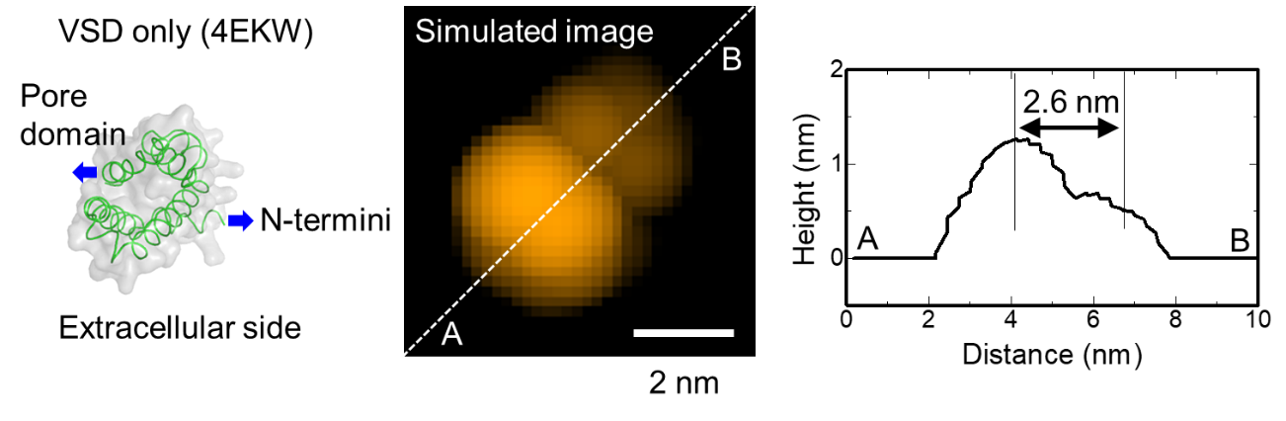
Figure S4. Simulated AFM image of a VSD.
Simulated AFM image of the extracellular surface of the single VSD (4ekw), with the virtual membrane surface placed at a height of 4 nm from the intracellular end. The height profile along the dashed line is shown in the right panel.

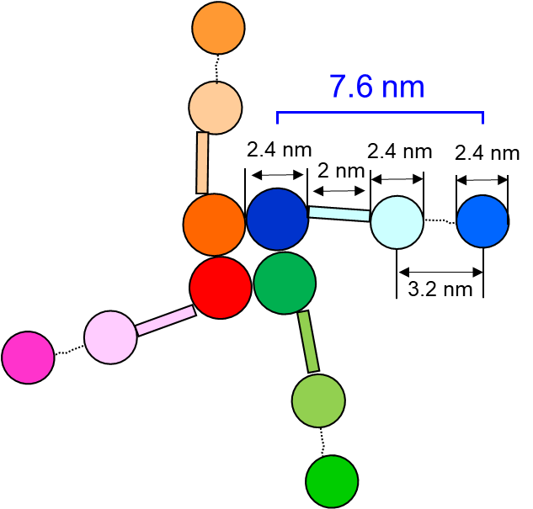
Figure S5. Estimation of the maximum distance from the center of the PD to the S1-S2 particle.
The length of the S4-S5 linker is 2 nm when it forms an α-helix, the distance between the S1-S2 and S3-S4 particles is 3.2 nm as evidenced by the AFM images (Figure S4), and assuming the diameter of each particle is 2.4 nm (a single helix is 1.2 nm, so the long diameter is approximately 2.4 nm for two helices) and the S4-S5 linker is dissociated from the PDs, the maximum distance between PD and S1-S2 is approximately 7.6 nm

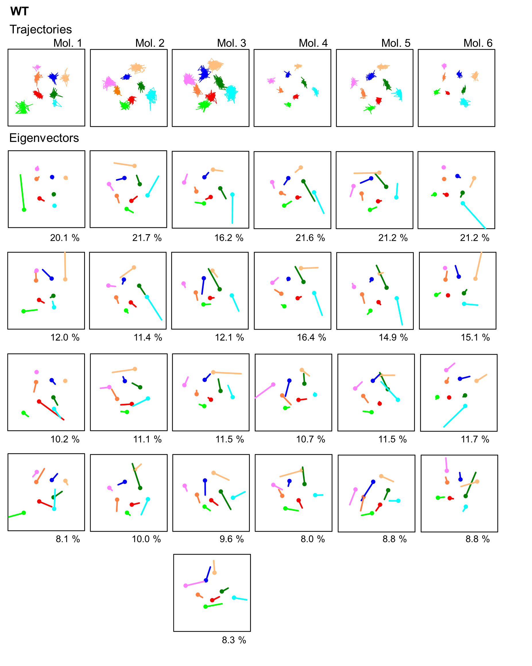
Figure S6. Other examples of trajectories and eigenvectors of PCA for the WT.
Trajectories (upper panels) and their eigenvectors of PCA (lower panels) are shown. Percentages below eigenvectors indicate percentages of that mode in total. Eigenvectors are shown in order of increasing components until the total is 50%. Plot area: 15 nm square.

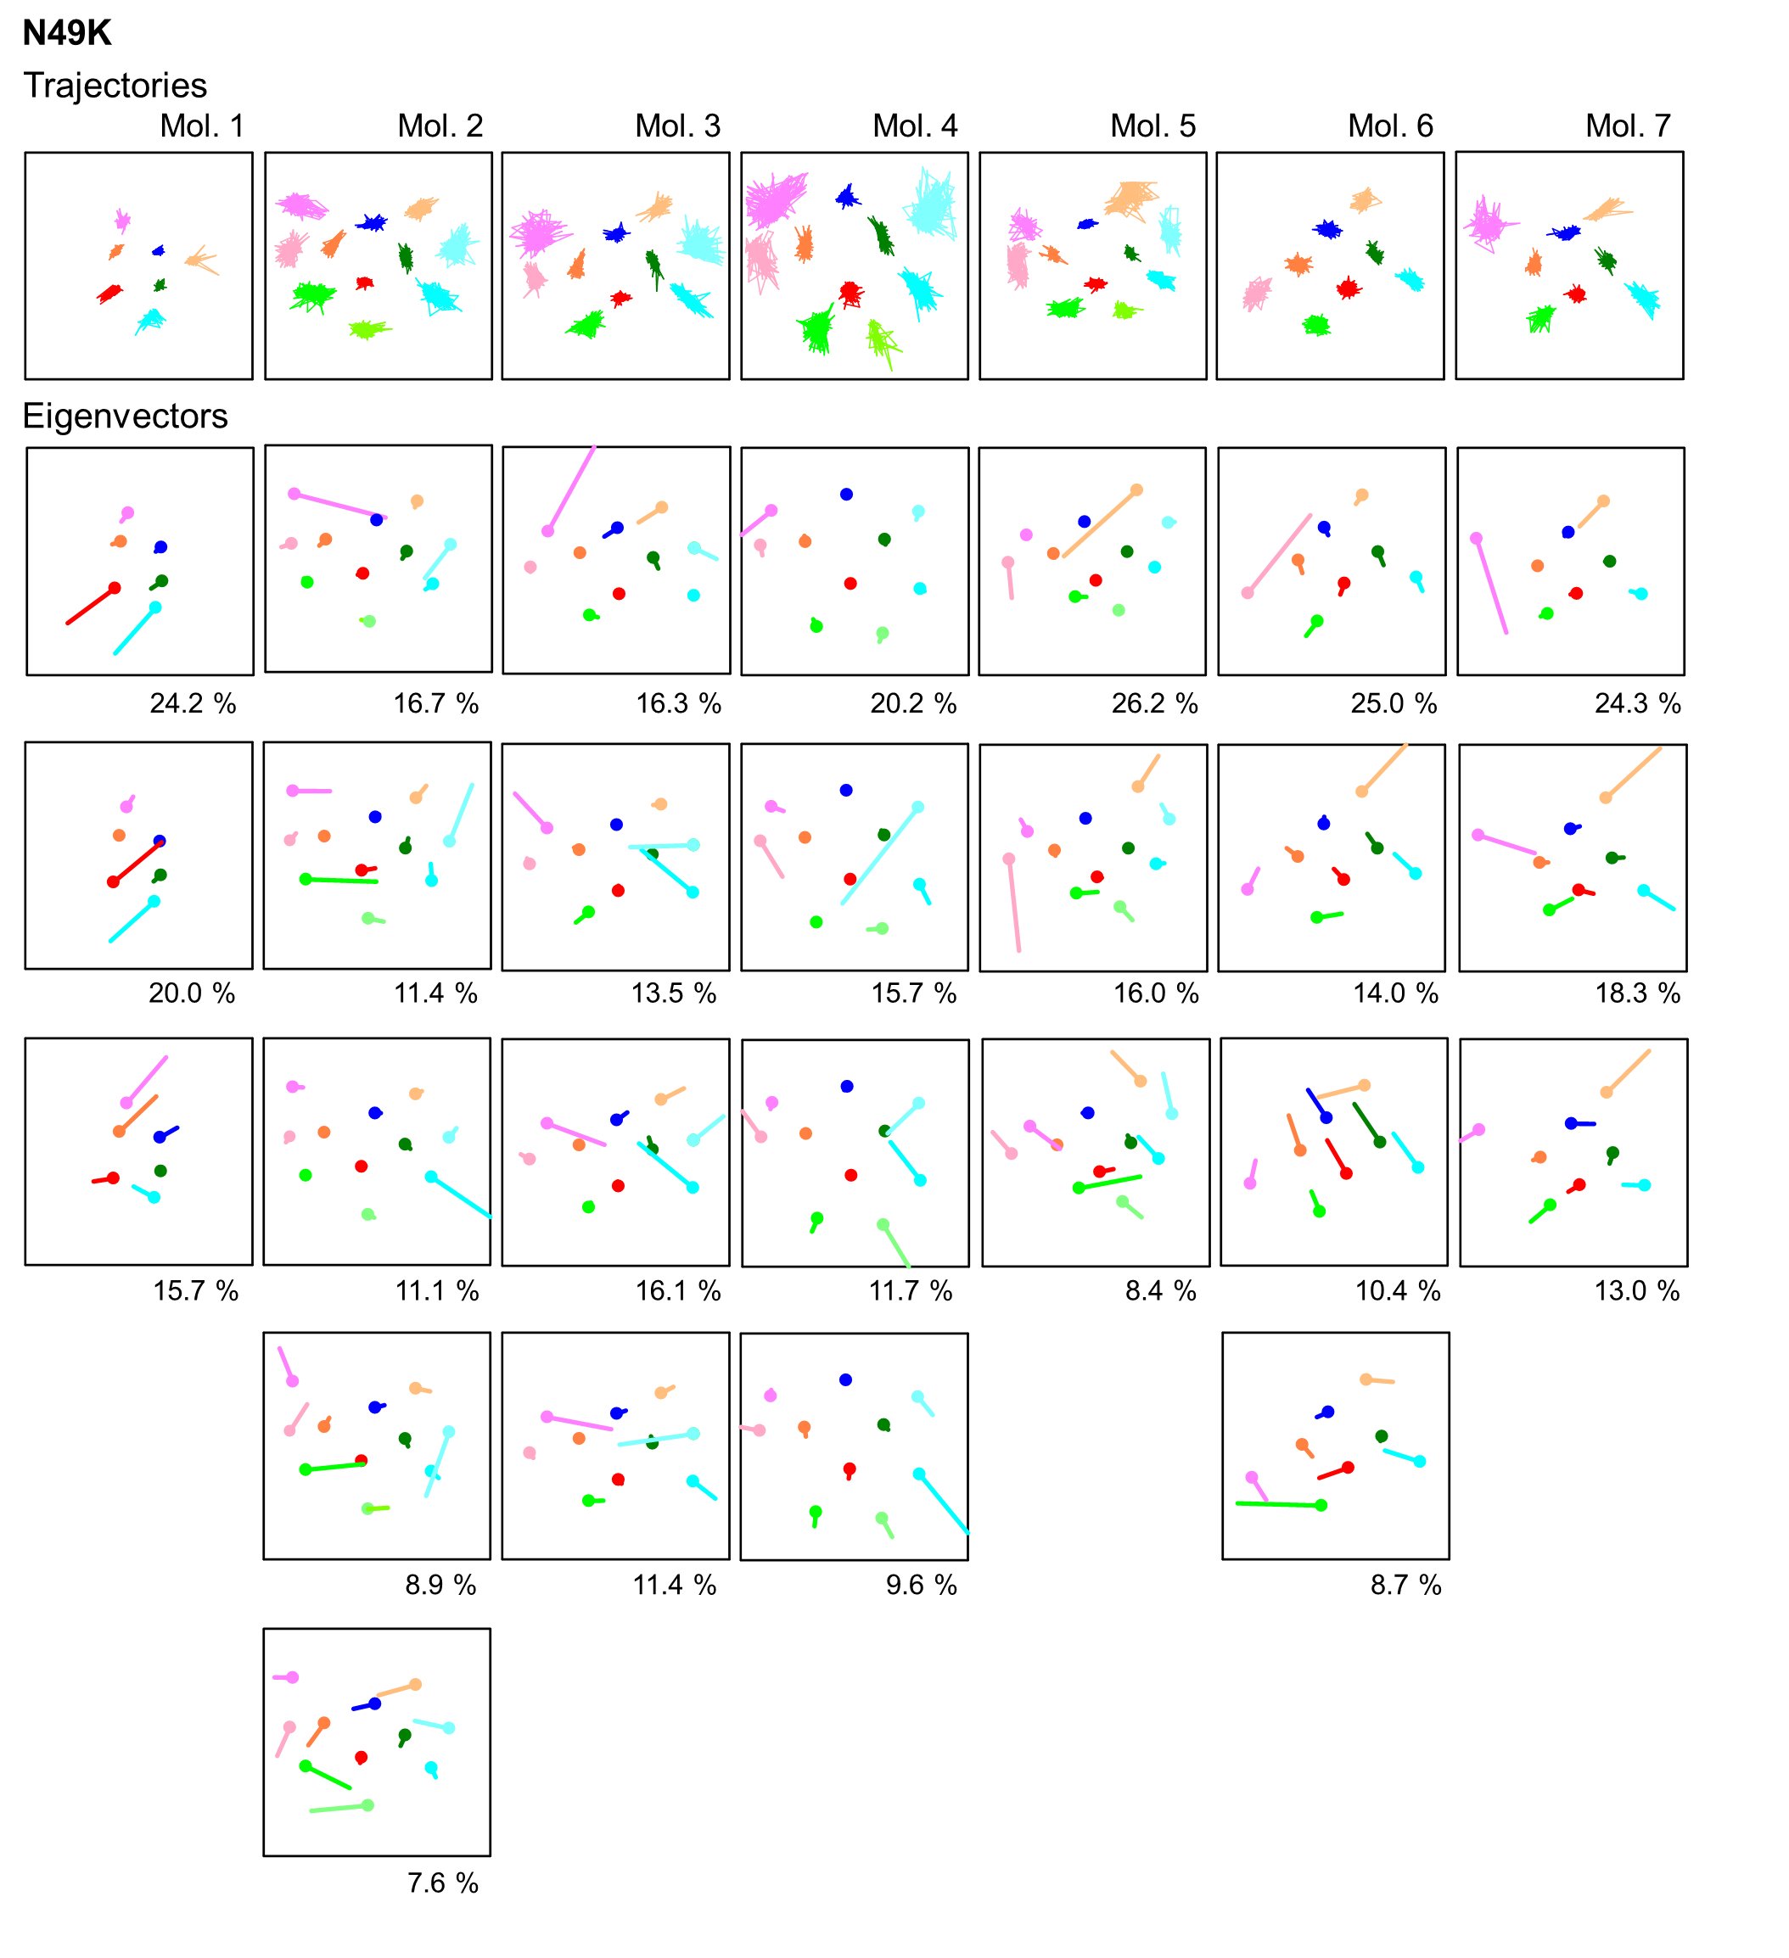
Figure S7. Other examples of trajectories and eigenvectors of PCA for the N49K mutant.
Trajectories (upper panels) and their eigenvectors of PCA (lower panels) are shown. Percentages below eigenvectors indicate percentages of that mode in total. Eigenvectors are shown in order of increasing components until the total is 50%. Plot area: 15 nm square.

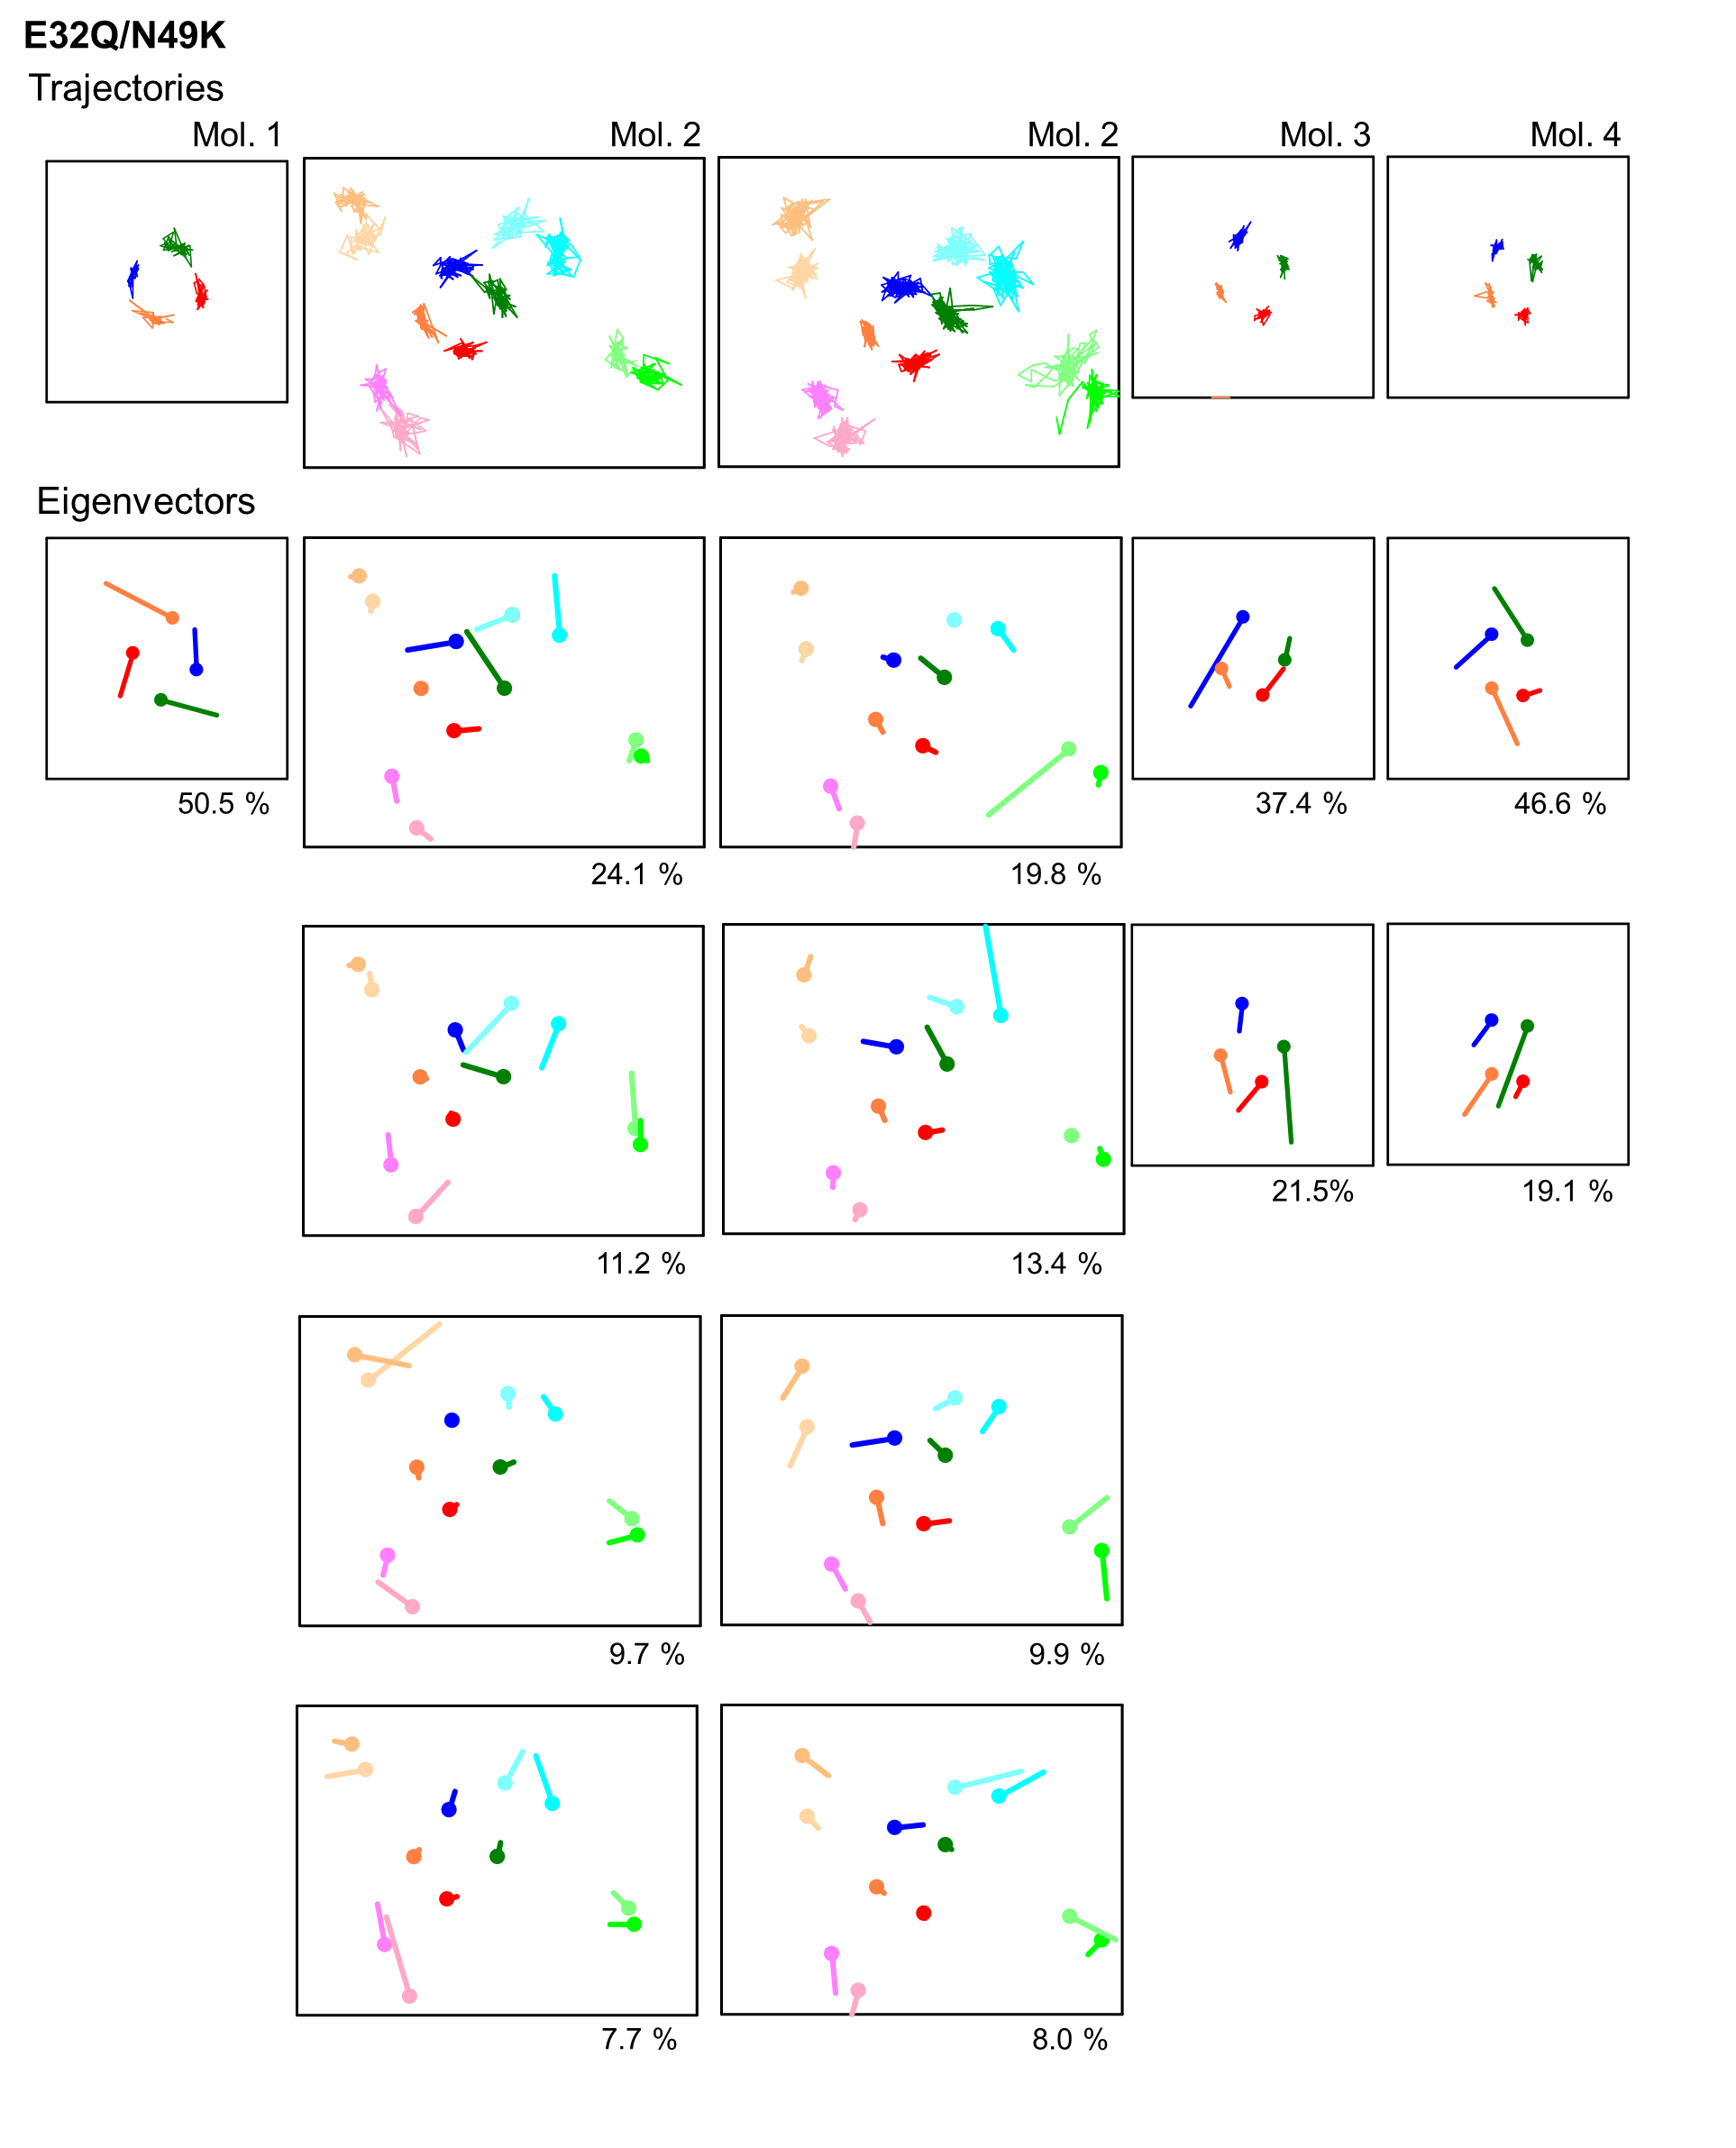
Figure S8. Other examples of trajectories and eigenvectors of PCA for the E32Q/N49K mutant.
Trajectories (upper panels) and their eigenvectors of PCA (lower panels) are shown. Percentages below eigenvectors indicate percentages of that mode in total. Eigenvectors are shown in order of increasing components until the total is 50%. Plot area: 22×17 nm.

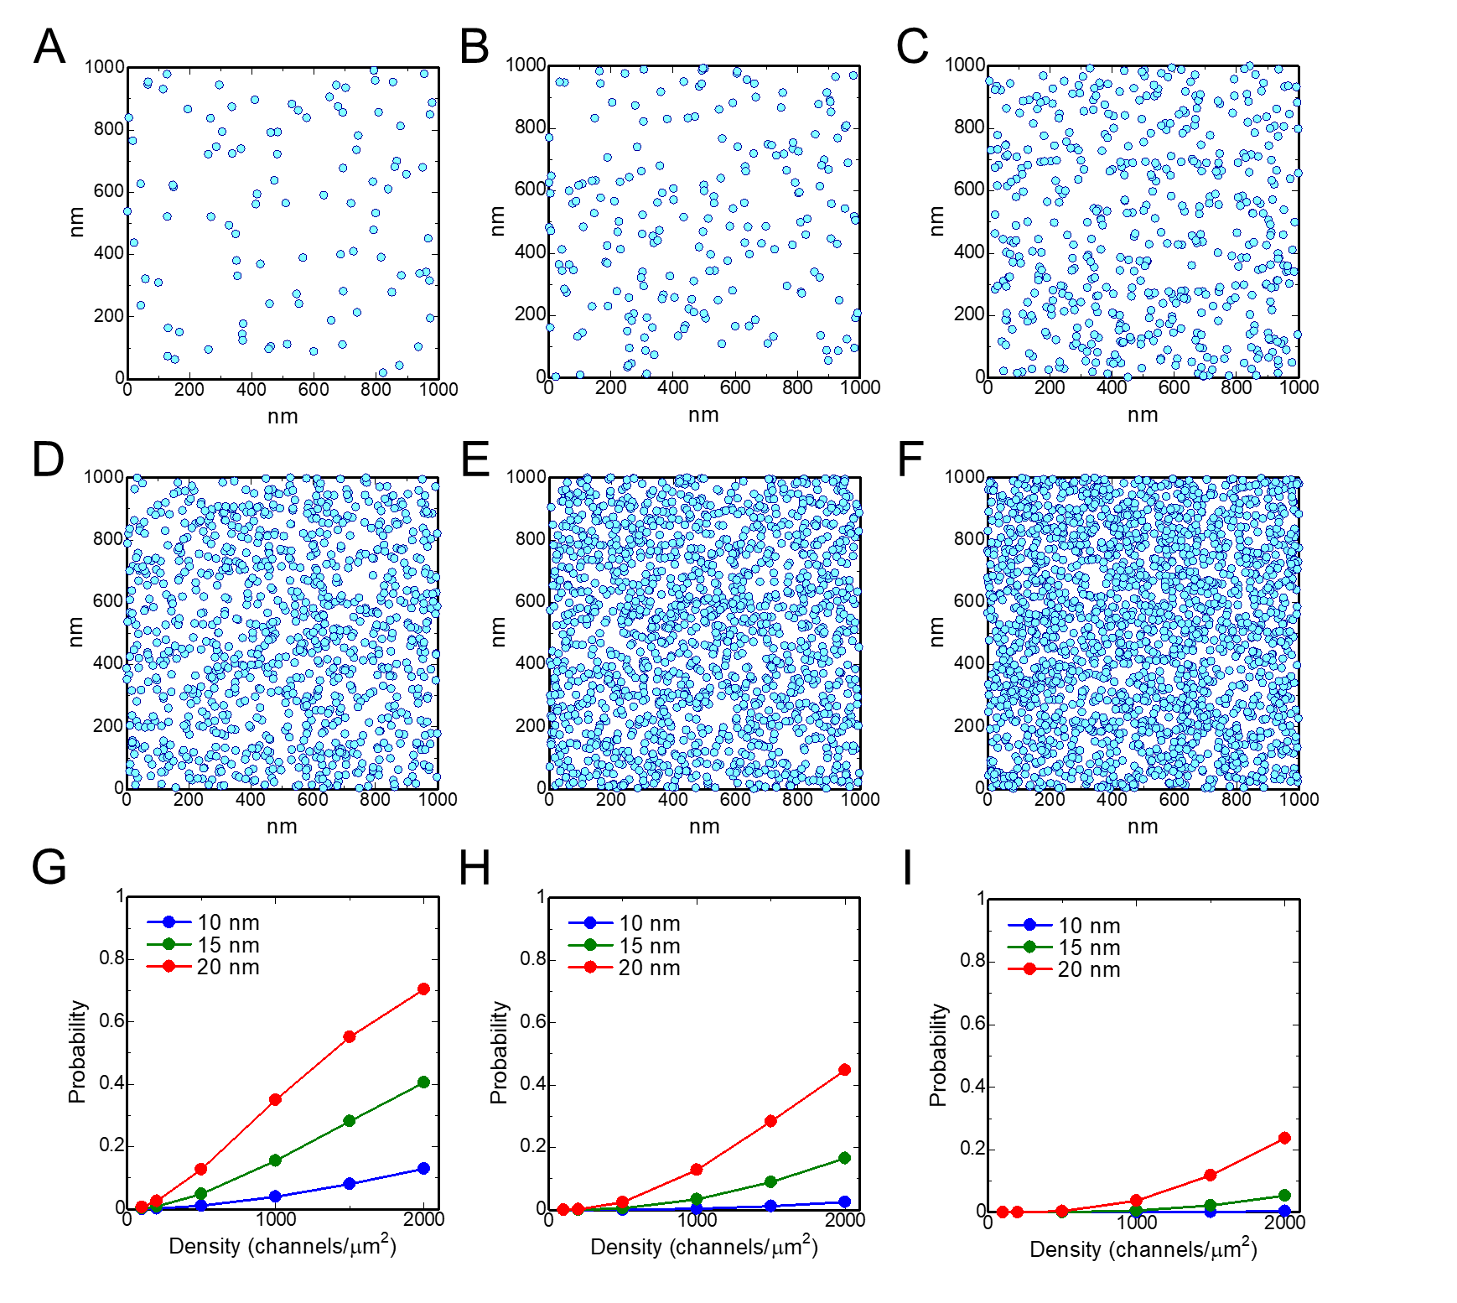
Figure S9. Density dependence of the contact probability between particles mimicking resting Na_{v} channels.
(A-F) Particles 20 nm in diameter were placed randomly in an area of 1 μm². The diameter roughly corresponds to the diameter of the resting Na_{v}Ab channel. The center coordinates of the particles were generated randomly without considering the area of the particles, so the particles were allowed to overlap each other. The densities are 100, 200, 500, 1000, 1500, and 2000 channels/μm² for A, B, C, D, E and F, respectively. (G, H, I) Contact probability at different densities of particles with diameters of 10, 15 and 20 nm. Probabilities were calculated using 10000 sets of randomly generated snapshots including 100-2000 particles in an area of 1 μm². The proportions of particles in contact with at least two (G), three (H) and four (I) other particles were plotted.

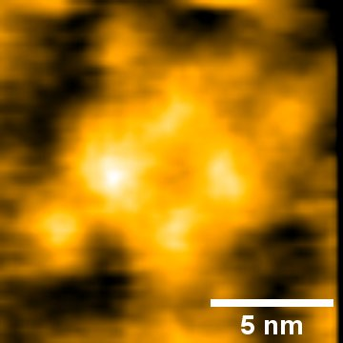

Figure S10. E32Q/N49K mutant without a lipid bilayer.
The Na_{v}Ab channel is attached onto Ni²⁺-coated mica as in the other experiments but coincidentally is outside the lipid bilayer.

