Supplementary Information

Methane emission rate estimate using airborne measurement at offshore oil platforms in Newfoundland and Labrador, Canada

Afshan Khaleghi^{1,2}, Katlyn MacKay^{1,2}, Andrea Darlington³, Lesley A. James², David Risk¹
¹ Department of Earth Sciences St. Francis Xavier University Antigonish, Nova Scotia Canada
²Department of Process Engineering, Memorial University of Newfoundland, Newfoundland and Labrador, Canada
³Air Quality Processes Research Section, Air Quality Research Division, Environment and Climate Change Canada, Toronto, Canada

Table of Contents
Supplementary Information 1
SI. 1 Loop fitting and enclosed volume creation 2
SI. 2 Wind extrapolation below flight level 6
SI. 3 Kriging interpolation and screens 7
SI.4 Plume detection for transect 10
SI. 5 Unfavorable atmospheric conditions 11

SI. 1 Loop fitting and enclosed volume creation
The first step for creating the enclosed volume (cylinder) for mass balance calculation is to fit a shape to the flight path that will be the base of the enclosed volume (cylinder). The cylinder walls needed to be perpendicular to the sea level. For this purpose, two different scripts were used to fit a shape to the flight path two, and their residuals were compared. The first method fits an ellipse on the median loop of the flight path using a covariant matrix for location data while including 35%-45% of flight path inside the fitted loop. This exclusion probability considered the changes in the loop diameter at different altitudes. The second method used the points from the smallest flight loop. A buffer with a constant value was used for each point on this loop to average all nearby points. The buffer value was chosen based on the biggest loop size. The resulting loop of averaged points was closer to a polygon shape than an ellipse. The selected output loop was later smoothed to a regular ellipse and used to represent the flight path. It should be mentioned that any fitted loop could be smoothed into TERRA into a more regular shape, but the oval was a better fit for our average flight paths.
Figure SI.1_ 1 represents both fitted loops over the flight path. The first method made a perfect ellipse, while the second method buffered points to fit a polygon instead and by adding more buffered points it would look like an irregular loop shape.
Figure SI.1_ 1: Fitted loops for flight paths using two different methods. There are steps in TERRA for further smoothing the fitted loop

Considering the standard deviation (sd) of residuals for each fit, it was observed that the oval is a better fit for this study. The oval size was changed by ±sd of residuals to count for the model's sensitivity to oval size. The variation in flight loop size was mainly due to bigger upper loops in the flight pattern compared to the lower ones, which made some of the fits less compatible. (Table S.I.1_ 1)

Table SI.1_ 1: statistical analysis of best-fit oval and polygon. The standard deviation of residuals over an average radius of loops was used to indicate the fit oval. Although most residuals were under 30% of the average radius size, the oval fit showed a better agreement than the polygon fit.
Flight No. | The standard deviation of residuals (sd) |  | Average distance to center (radius) | sd/radius
Flight No. | Oval fit | Polygon fit | Average distance to center (radius) | Oval fit | Polygon fit
SR1 | 273.44 | 460.39 | 1626.39 | 0.16812696 | 0.28307479
HI2 | 144.06 | 240.37 | 1082.73 | 0.13305256 | 0.22200364
HI3 | 267.17 | 410.17 | 1476.43 | 0.18095677 | 0.27781202
HE4 | - | - | - | - | -
SR5 | 184.85 | 310.54 | 1199.36 | 0.15412387 | 0.25892142
HE6 | 107.45 | 138.62 | 958.5 | 0.11210224 | 0.1446218
HE7 | 277.66 | 315.88 | 1154.28 | 0.24054822 | 0.27365977
HI8 | 241.05 | 363.85 | 1213.82 | 0.19858793 | 0.29975614
SR9 | 163.34 | 188.45 | 1093.19 | 0.14941593 | 0.1723854

This fitted loop was used to make the enclosed reference volume (cylinder) for mass balance calculation.
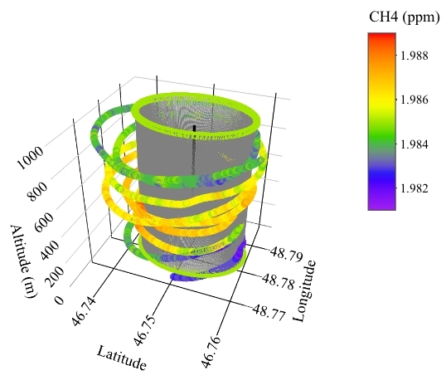
Figure SI.1_ 2: Fitted cylinder over flight paths. The flight path colors represent the concentration of CH₄ during the flight. In the subsequent analysis, the kriging method was applied to interpolate geographical points over the cylinder on a grid of 20 m x 40 m.

SI. 2 Wind extrapolation below flight level
The forecast system combines a model with observation data to create an hourly estimate over a 0.25° x 0.25° grid for any atmospheric resolution, but it also has an uncertainty estimate of 0.5° x 0.5°. The uncertainty involved with this model will mostly be seen in severe weather conditions. Wind components at 10 and 100 m, pressure, and temperature at the sea surface for all flight dates were obtained from ERA5, gridded, and extracted for the points closest to the flight path and fit with an exponential curve. Figure SI.2_ 1 shows the values obtained from the ERA5 reanalysis model and the exponential fit to those values that were used in the analysis for each flight.
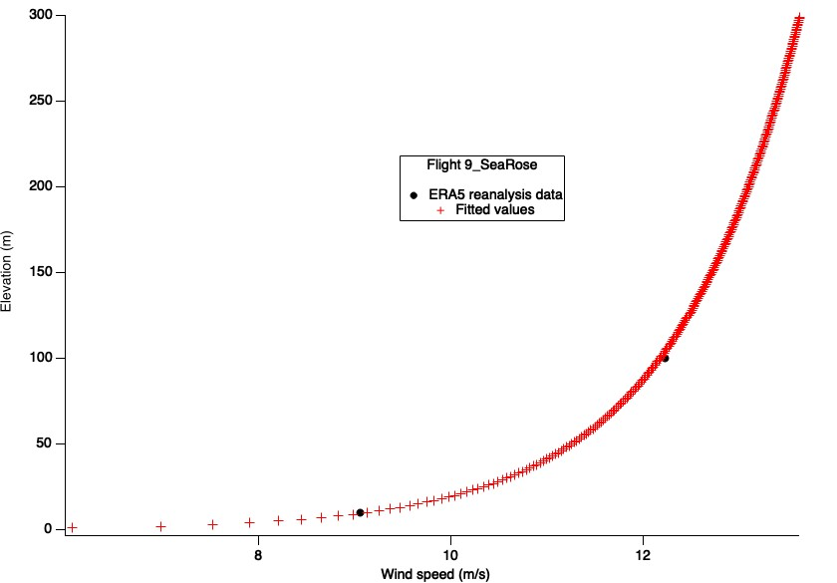
Figure SI.2_ 1: Fitted wind data for below flight level based on ERA 5 reanalysis of meteorological data at 10 m and 100 m in the closest grid point for flight SR5 on the 10th of November 2021

Although measured meteorological data at different altitudes, like data from a wind profiler, would make it easier to create a best fit for the wind speed, ERA5 results were agreeable with data from flight measurements.

SI. 3 Kriging interpolation and screens
All data measured during the flight campaign were extrapolated to create screens using the fitted cylinder shown in SI.1. The location data were transferred to the cylinder with a 20 m x 40 m resolution. Wind data and air flux were interpolated into this screen. The kriging method used in this step was based on a simple kriging with the range, nugget, and sill as 500, 0, and one, respectively. The wind-fitted values for below flight level were also used here to extrapolate below flight level.
Figure S.I.3_ 1 shows plots of wind speed data made using a kriging interpolation with TERRA. This illustrates the walls of the fitted cylinder that were opened to shape wind screens.
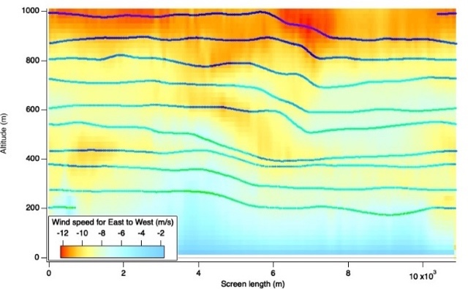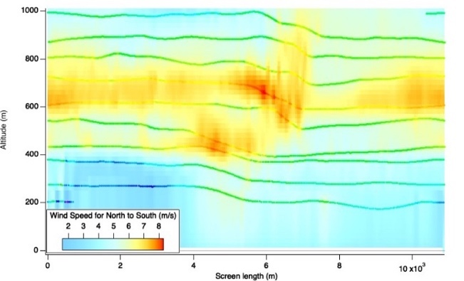
Figure S.I.3_ 1: Example of wind speed plots for flight HI3 on 7th December, left: East-West screen (Negative values indicate the wind is toward east). Right: North-South screen (Positive values indicate the wind is toward the south). The line shows the original flight path.

Figure SI.3_ 2 illustrates the air flux screen for flight HI3 from the Hibernia platform. The flux screen required the meteorological data for below-flight level extrapolation.
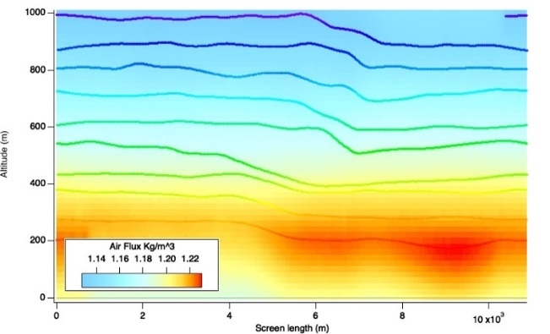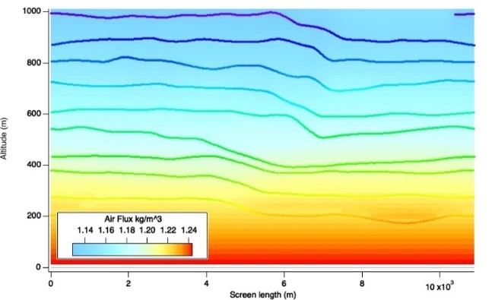
Figure SI.3_ 2: Air flux screens for Flight HI3 7th December 2021. Left: Kriging result before extrapolating below flight level data using ERA5 reanalysis data. Right: results with input data for below flight level. Lines on the graph are measured positions and the color on lines shows a darker shade just for visual purposes.

The final step for mass balance calculation was creating the mixing ratio screen for CH₄. A semivariogram was fitted for each simulation to make a mixing ratio screen instead of using constant kriging values. An example of this fit can be seen in Figure SI.3_ 3 for flight HI2. The fit showed no relation between neighboring points after 800 meters. This lag is higher than the 500-meter constant range of the previous steps, but the mixing ratio has a different characteristic compared to meteorological data, which was expected to be different for the mixing ratio.

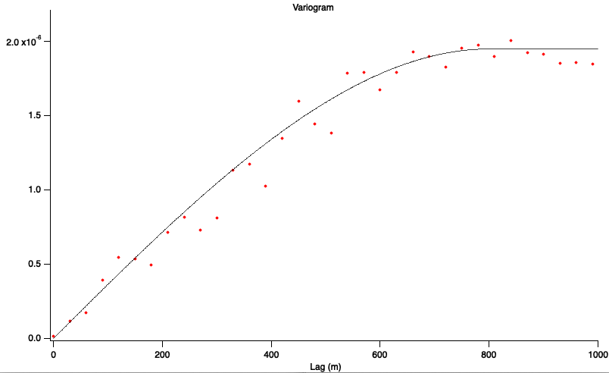
Figure SI.3_ 3: Fitted semivariogram to the mixing ratio residuals for flight HI2. Nugget is still zero, but for this analysis, the range was 800 meters with a sill of 1.95e-6.
The final kriging screen for CH₄ needed another below-flight level extrapolation which was solved using a sensitivity analysis described in the paper. Figure SI.3_ 4
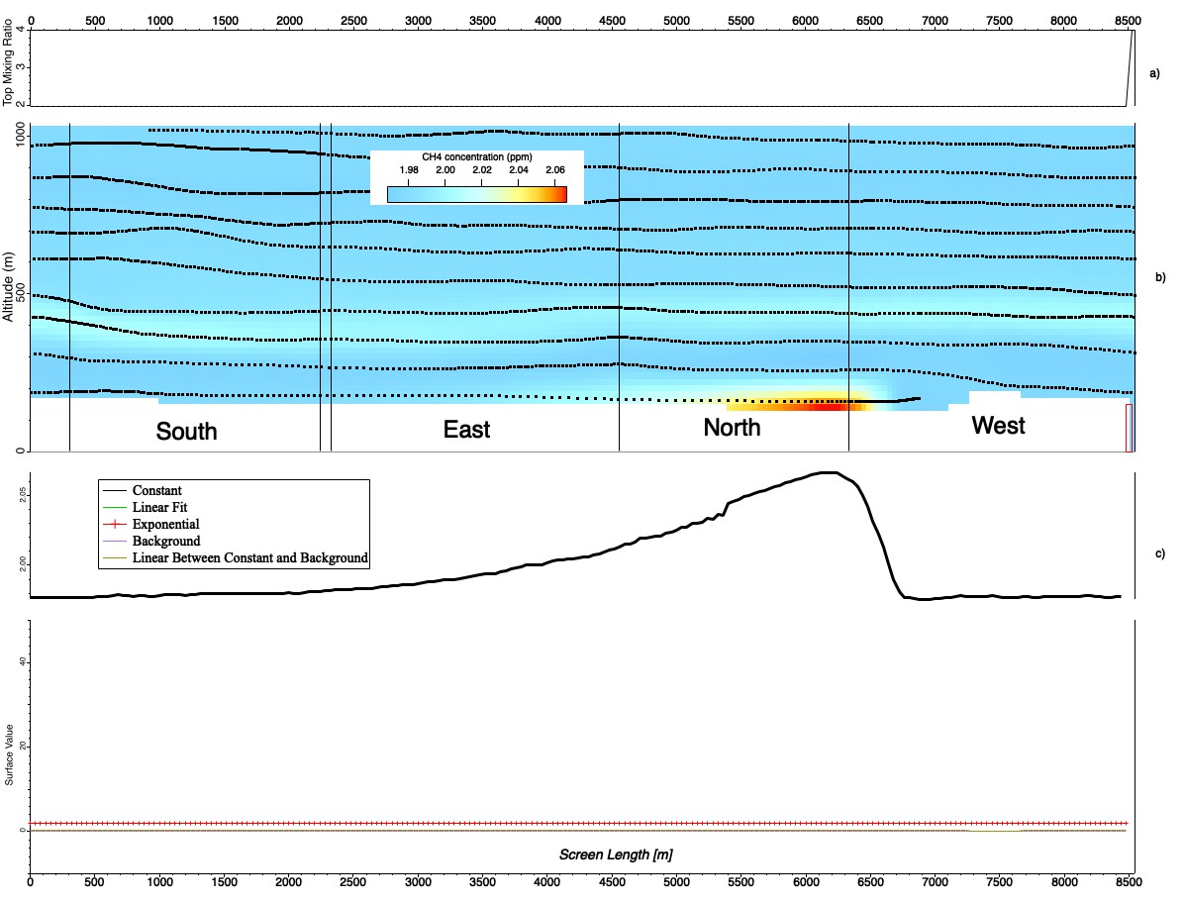
Figure SI.3_ 4: Summary of Kriging interpolation for flight HE3 on 8th November. a): mixing ratio from the top of the cylinder. b): Flight path and the interpolated values for mixing ratio. c): The fitted graph for values below flight level.

SI.4 Plume detection for transect
While some of the transects did not have any detectable plume after applying the criteria of a well-mixed boundary layer, consistent wind speed, and clear CH₄ enhancements, other detected plumes could not be modeled with the Gaussian dispersion method.
Boundary layer conditions during flights HI8 and SR9 created challenges for identifying CH₄ plumes from those measurements. Although downwind transects were completed on HI8, only two plumes were observed. Figure SI.4_ 1 illustrates the timeseries of CH₄ concentration during HI8. The second plume directly overlapped with elevation changes, and therefore we were unable to confirm whether the plume was coming from the platform. As a result, the second plume was excluded, and only the first one was used for emission rate estimates.
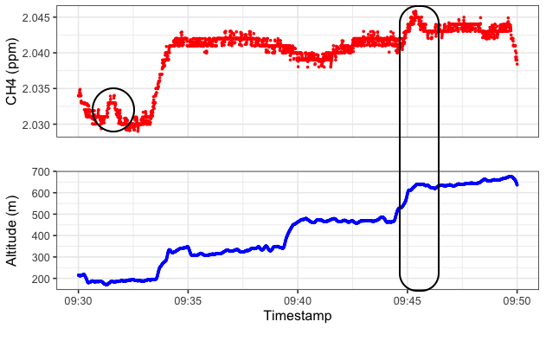
Figure SI.4_ 1: Plumes detected during HI8 transects. There were four transects for this flight but only two plumes were detected. The first plume (shown inside the circle) happened during the first transect but the second plume overlapped with elevation changes (shown inside the polygon).
During SR5, two CH₄ plumes were observed, but both were deemed unsuitable for Gaussian dispersion emission rate calculations for the following reasons. First, both plume shapes did not align with the standard Gaussian curve, and one plume showed two distinct peaks (Figure SI.4_ 2). Second, both plumes were much wider than others that were measured during other flights (with elevated concentrations sustaining for a few minutes). This was especially common because the measured wind speeds were the highest on average out of all flights, so theoretically, we would expect the plumes to be narrower. Third, both plumes overlapped with elevation changes which could be against some of the simplification assumptions of the Gaussian dispersion model like independent dispersion, homogenous conditions, limited height, and constant rate of emission.
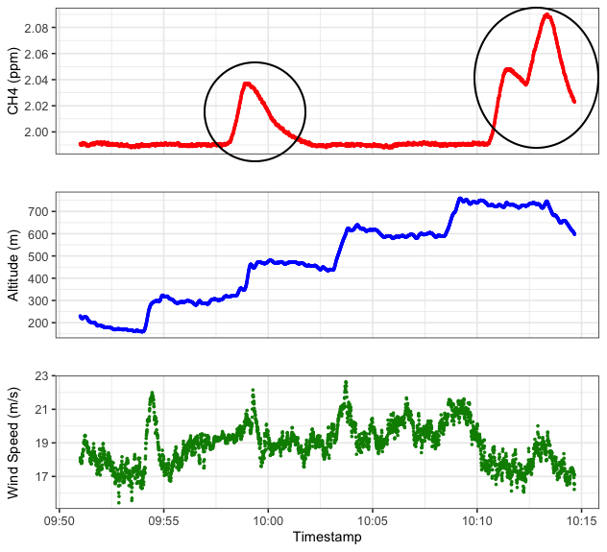
Figure SI.4_ 2: Plumes detected during SR5 transects. There were five transects during this flight but only two plumes were detected (Circles on CH₄ timeseries). Considering the high wind speeds as shown in the bottom graph, it was expected to see narrow plumes. Both plumes overlapped with elevation change and finally, the second plume shows two distinct peaks make which was against Gaussian dispersion assumptions.
The last plume that we excluded was measured on flight HE7. During this flight, three plumes were observed, but like plumes measured on SR5, HE7 was wider than expected and overlapped with altitude changes. The two remaining plumes measured on this flight were included.

SI. 5 Unfavorable atmospheric conditions
During flights HI8 and SR9, which happened on the last day of the flight campaign, the temperature was 0 degrees Celsius during the flight, and the dewpoint temperature could not be adequately calculated. The wind speed was also close to the maximum required (20 m/s). Without a visible emission source (detectable plume), it was not possible to use high levels of CH₄ mixing ratio captured during measurement for mass balance analysis. Figure SI.5_ 1 is an example of mentioned atmospheric condition for HI8.
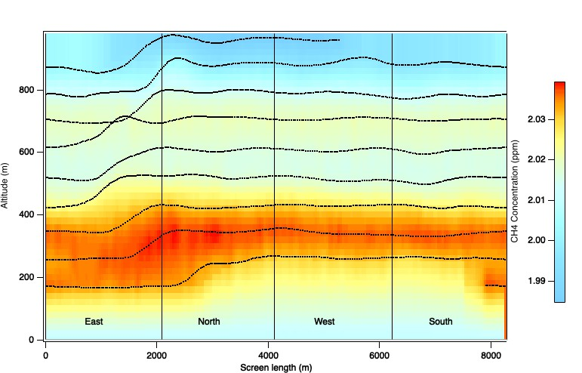
Figure SI.5_ 1: left) Mixing ratio screen for flight SR9, Hibernia, 10th November. right) Temperature time series during the mass balance measurement. This is an example of unfavorable atmospheric conditions. The formula used to calculate dewpoint temperature relied on temperature and relative humidity (RH). RH value was equal to zero for both SR9 and HI8, which made it impossible to apply the same method for this calculation. Although the CH₄ mixing ratio changed by elevation on the left screen shows an enhancement of 0.04 ppm for the mixing ratio, it was all trapped between 200-400 meters. No visible emission sources existed, so the mass balance calculation could not return an accurate estimate.

During flight SR5, the CH₄ enhancement was not detected until the last loop. So, the kriging interpolation for this flight did not agree with the assumption of normal distribution. Consequently, without upward extrapolation, the calculation failed to capture any emission rate, but with an upward extrapolation to higher elevations, it was possible to get values for this measurement. However, this extrapolation added two more areas of uncertainty for this flight (upward extrapolation height and extrapolation method). It is possible that for this specific flight, because of the boundary layer condition, emissions from flaring got trapped in the higher elevations. This condition is shown in Figure SI.5_ 2.
Figure SI.5_ 2: left) CH₄ mixing ratio variation by altitude for flight SR5. right) Wind speed time series for the same flight. The wind speed for this flight was over the maximum of 20 m/s, and although other atmospheric conditions seemed to be agreeable with a detectable plume condition, as shown in the mixing ratio time series, the emission was trapped between 850-950 m altitude. This flight required an upward extrapolation for better visualization of the source.

