- Appendices

Appendix 1: Average hourly temperatures (°C) for each day (24 hour period) of the months of December, January and February, 2013-2018 (i.e. the baseline temperature), and temperatures used in the climate-controlled chambers
Time | Average hourly temp  (°C) | Temperatures used in the chambers (°C)
Time | Average hourly temp  (°C) | Fluctuating temperatures |  |  |  | Constant temperatures |  |  |  | Control temp
 | (Baseline temperature) | FT_19 °C  (+0°C Offset) | FT_21 °C  (+2°C Offset) | FT_23 °C  (+4°C Offset) | FT_24 °C  (+5°C Offset) | C_19°C | C_21 °C | C_23°C | C_24 °C | CT_25°C
0:00:00 | 15.69 | 15.69 | 17.69 | 19.69 | 20.69 | 19 | 21 | 23 | 24 | 25
1:00:00 | 15.74 | 15.74 | 17.74 | 19.74 | 20.74 | 19 | 21 | 23 | 24 | 25
2:00:00 | 14.85 | 14.85 | 16.85 | 18.85 | 19.85 | 19 | 21 | 23 | 24 | 25
3:00:00 | 15.04 | 15.04 | 17.04 | 19.04 | 20.04 | 19 | 21 | 23 | 24 | 25
4:00:00 | 14.77 | 14.77 | 16.77 | 18.77 | 19.77 | 19 | 21 | 23 | 24 | 25
5:00:00 | 14.13 | 14.13 | 16.13 | 18.13 | 19.13 | 19 | 21 | 23 | 24 | 25
6:00:00 | 13.98 | 13.98 | 15.98 | 17.98 | 18.98 | 19 | 21 | 23 | 24 | 25
7:00:00 | 15.2 | 15.2 | 17.2 | 19.2 | 20.2 | 19 | 21 | 23 | 24 | 25
8:00:00 | 15.97 | 15.97 | 17.97 | 19.97 | 20.97 | 19 | 21 | 23 | 24 | 25
9:00:00 | 18.9 | 18.9 | 20.9 | 22.9 | 23.9 | 19 | 21 | 23 | 24 | 25
10:00:00 | 20.62 | 20.62 | 22.62 | 24.62 | 25.62 | 19 | 21 | 23 | 24 | 25
11:00:00 | 22.27 | 22.27 | 24.27 | 26.27 | 27.27 | 19 | 21 | 23 | 24 | 25
12:00:00 | 23.37 | 23.37 | 25.37 | 27.37 | 28.37 | 19 | 21 | 23 | 24 | 25
13:00:00 | 24.15 | 24.15 | 26.15 | 28.15 | 29.15 | 19 | 21 | 23 | 24 | 25
14:00:00 | 24.37 | 24.37 | 26.37 | 28.37 | 29.37 | 19 | 21 | 23 | 24 | 25
15:00:00 | 24.66 | 24.66 | 26.66 | 28.66 | 29.66 | 19 | 21 | 23 | 24 | 25
16:00:00 | 24.42 | 24.42 | 26.42 | 28.42 | 29.42 | 19 | 21 | 23 | 24 | 25
17:00:00 | 23.85 | 23.85 | 25.85 | 27.85 | 28.85 | 19 | 21 | 23 | 24 | 25
18:00:00 | 23.07 | 23.07 | 25.07 | 27.07 | 28.07 | 19 | 21 | 23 | 24 | 25
19:00:00 | 21.66 | 21.66 | 23.66 | 25.66 | 26.66 | 19 | 21 | 23 | 24 | 25
20:00:00 | 19.54 | 19.54 | 21.54 | 23.54 | 24.54 | 19 | 21 | 23 | 24 | 25
21:00:00 | 18.32 | 18.32 | 20.32 | 22.32 | 23.32 | 19 | 21 | 23 | 24 | 25
22:00:00 | 17.47 | 17.47 | 19.47 | 21.47 | 22.47 | 19 | 21 | 23 | 24 | 25
23:00:00 | 16.2 | 16.2 | 18.2 | 20.2 | 21.2 | 19 | 21 | 23 | 24 | 25

Appendix 2: Operation of temperature-controlled chambers
Twenty custom-built climate-controlled chambers were built for this experiment. Each chamber was constructed from PVC pipe (height 20 cm, diameter 15 cm) with a PVC cap lid. The temperature controlled chambers consist of three main components: a thermoelectric cell, control system and heat sinks.
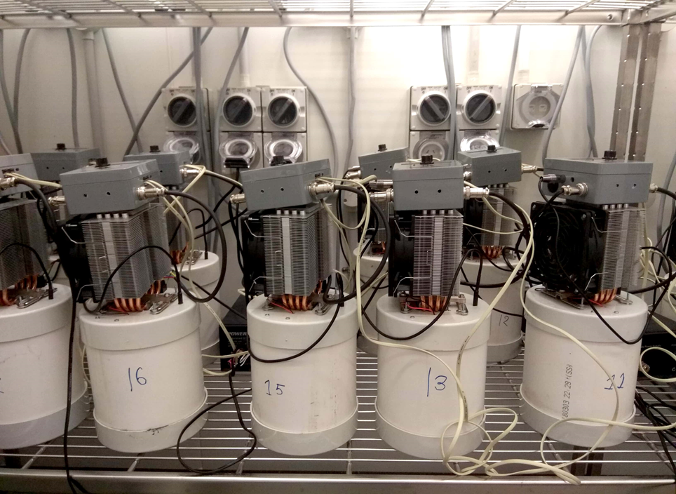
Figure 1: Temperature-controlled chambers
The thermoelectric cell, also known as a Peltier cell (68.09 watts, 40 mm x 40 mm, Techbrands, Rydalmere, NSW, Australia) consists of two plates separated by a semiconductor material. When current is passed through the cell heat is transferred from one plate to the other, creating a temperature differential between the plates. The amount of current passing through the cell and the direction of the current flow determines the amount and direction of heat transfer.

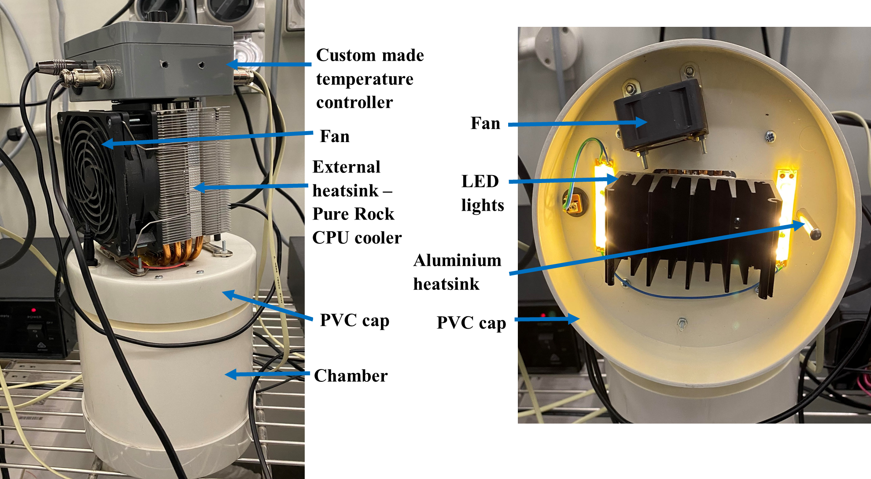
Figure 2: Schematic representation of the temperature controlled chamber with its different parts used in the study
Heatsinks are constructed of aluminium with a number of fins to increase the surface area to transfer heat to the surrounding air. One heatsink (Pure Rock CPU cooler, 150 watts TPD, BeQuiet!, Glinde, Germany) is attached to one plate of the Peltier cell and positioned outside the temperature chamber, and another (84 x 45 x 50 mm aluminium convection heatsink, 9 fins, Techbrands, Rydalmere, Australia) is connected to the other side of the Peltier cell on the inside of the chamber. Both heatsinks have fans (39.5 cfm 80 mm, Sunon, Kaohsiung City, Taiwan) blowing across them to help dissipate the heat from them to the surrounding air. The larger heatsink is mounted on the outside of the chamber and effectively holds the temperature of that side of the Peltier cell at the same temperature as the surrounding room. The temperature of the smaller heatsink inside the chamber is determined by the temperature differential across the Peltier cell and so can heat or cool the air mass inside the chamber.
Control of the chamber temperature is achieved using a custom made microcontroller based temperature controller that measures the temperature inside the chamber (using a DS18B20 temperature probe) and regulates the current flowing through the Peltier cell. Each temperature controller communicates with a central computer running custom software, LabView (National Instruments: http://www.ni.com/newsletter/51141/en/), which allows the target temperature of each chamber to be individually set and continually changed to simulate diurnal fluctuation in temperature. The software allows the temperature of each chamber to be set using one of three methods: the chamber can be set to a single temperature, chamber temperature can be set to track ambient temperature in real-time using a thermometer probe connected to the computer (RS232 serial port), and chamber temperature can be set using a lookup table with predetermined temperature set for certain times of the day. For this experiment the lookup table method (for fluctuating temperatures) and single temperature (for constant temperatures) were used with a set temperature for each hour of the day. The program uses linear interpolation between the current set temperature and the next set temperature to allow for a gradual change in temperature from one hour to the next, emulating natural conditions. The control units polled the chamber temperature every 30 seconds. The software allows for a ±X °C offset to be applied to the base temperature of each chamber. This function was used to create the four fluctuating temperatures for this experiment.
In addition to control of temperature, the chambers are also fitted with internal lights that are controlled by an automatic timer switch. The lights used are LED strip lights with a colour temperature of 2700–3200 K (‘warm white’) and an intensity of approximately 40 lumens. (Each 1 metre strip has 60 LED lights for a total intensity of 400 lumens. Each chamber uses two 50mm lengths of this strip light with a total of 6 LED’s per chamber. See datasheet at the link below for more details.)
https://docs.rs-online.com/a853/0900766b81586ee7.pdf

