Biography

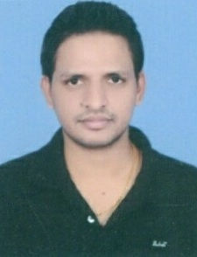
Dr. Prince Rajpoot is currently an assistant professor in REC Ambedkar Nagar, Akbarpur, India. He has completed his PhD from MNNIT Allahabad. He has obtained his M.Tech degree in Information Security from MNNIT Allahabad. He received his B.Tech. Degree in Information Technology from GLA University, Mathura, India. He has published research articles in many reputed international journals & conferences. His research interest includes wireless sensor networks, machine learning, soft computing, and optimization techniques. He has published two patents. He has reviewed many articles many SCI/SCIE journals.

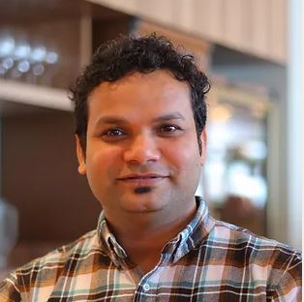
Dr Ram Avtar is working as an Associate Professor at the Faculty of Environmental Earth Science, Hokkaido University, Japan. He got his PhD in Civil Engineering from the University of Tokyo, Japan. He has worked as a research fellow at United Nations University, Institute for the Advanced Study of Sustainability (UNU-IAS) for four years. He developed methods for forest mapping using multi-sensor remote sensing techniques and scenario analysis for sustainable forest management. His research interest lies in applications of Geospatial techniques to monitor terrestrial ecosystems, including forests, agriculture, urban and disasters and disseminating the results to policy-makers. Currently, he is working on the synergistic use of remote sensing and Unmanned Aerial Vehicles (UAVs) techniques to monitor the environment more precisely to solve environmental issues from a global to local scale. He has worked as a Lead Author in the Intergovernmental Science-Policy Platform on Biodiversity and Ecosystem Services (IPBES) expert group on Deliverable 3(c). He is a recipient of the prestigious Green Talents Award by the Federal Ministry of Education and Research (BMBF), Germany. He has published numerous publications in several international peer-reviewed journal articles (110+), two books of international repute, and presented his work at various domestic and international conferences. He led different research projects as a Principal Investigator (PI) as well as a team member, such as Asia-Pacific Network for Global Change Research (APN-GCR), Grants-in-Aid for Scientific Research (KAKENHI), Belmont Forum etc.
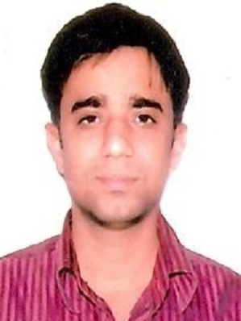
Dr. Amit Kumar Pandey has completed his Ph.D in the area of microelectronics and VLSI from MNNIT Allahabad. He did his M.Tech from NIT Allahabad and B.E in Electronics Engineering from Swami Ramanand Teerth Marathwada University Nanded. He is associated with Rajkiya Enginerng College Ambedkar Nagar from last 4 years as Assistant Professor with total 12 years teaching experience. He has published more than 30 research papers in refereed Springer, Wiley, Emerald etc and conferences. He has also published 3 patents. He has worked as a session chair, conference steering committee member, editorial board member, and peer reviewer in international/nationalSpringer, Wiley etc Journal and conferences. His area of expertise includes microelectronics device modeling and characterization, low power VLSI circuit design, VLSI design of testing.

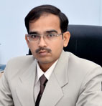
Dr. Vishal Singh Chandel completed his Ph.D. from University of Lucknow in 2006. His area of interest is Liquid Crystals, Nanomaterials, and Alkali Titanates. Presentably he is working as Professor and Head of Applied Science and Humanities Department and Dean, Students Welfare. He has a vast experience of more than 22 years. He has published more than 60 papers in international and national journals and 20 papers in conference proceedings, four books and 2 book chapters, 3 patents. He has organized 4 conferences and 2 workshops. He has supervised 8 Ph.D. scholars and 3 are ongoing. He is life member of Materials Research Society of India, Indian Liquid Crystal Society, Indian Physics Association, Indian Laser Association, Purvanchal Academy of Sciences, Indian Society for Technical Education, International Association of Engineers (IAENG), Singapore, Senior Member International Society for Research and Development.

Ritika Yadhuvanshi, she has done M.Tech from NIT Allahabad in computer science engineering department, he published more than 10 papers in reputed journals and conference. She is presently working as assistant professor in Department of Computer Science and Engineering, Mahamaya College of Agricultural Engineering and Technology, Ambedkar Nagar, India.
Vikas Srivastava, he is pursuing phd from AKTU university. He published papers in more than 10 SCIE journals. He is working as assistant professor in Department of Applied Science, R.R. Institute of Modern Technology, Lucknow, India

