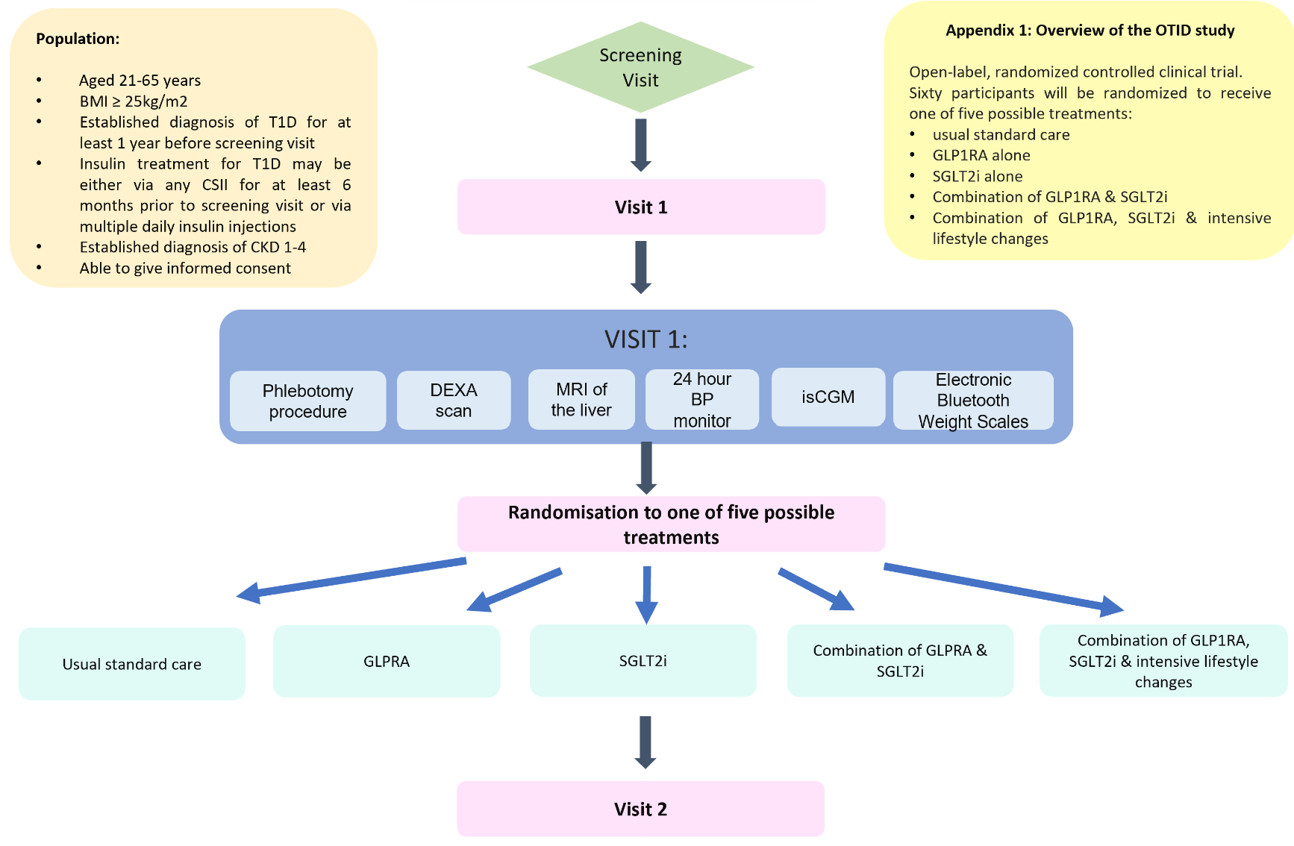
Appendix 1 : Overview of the OTID trial.

