Extended Data Figures and Tables
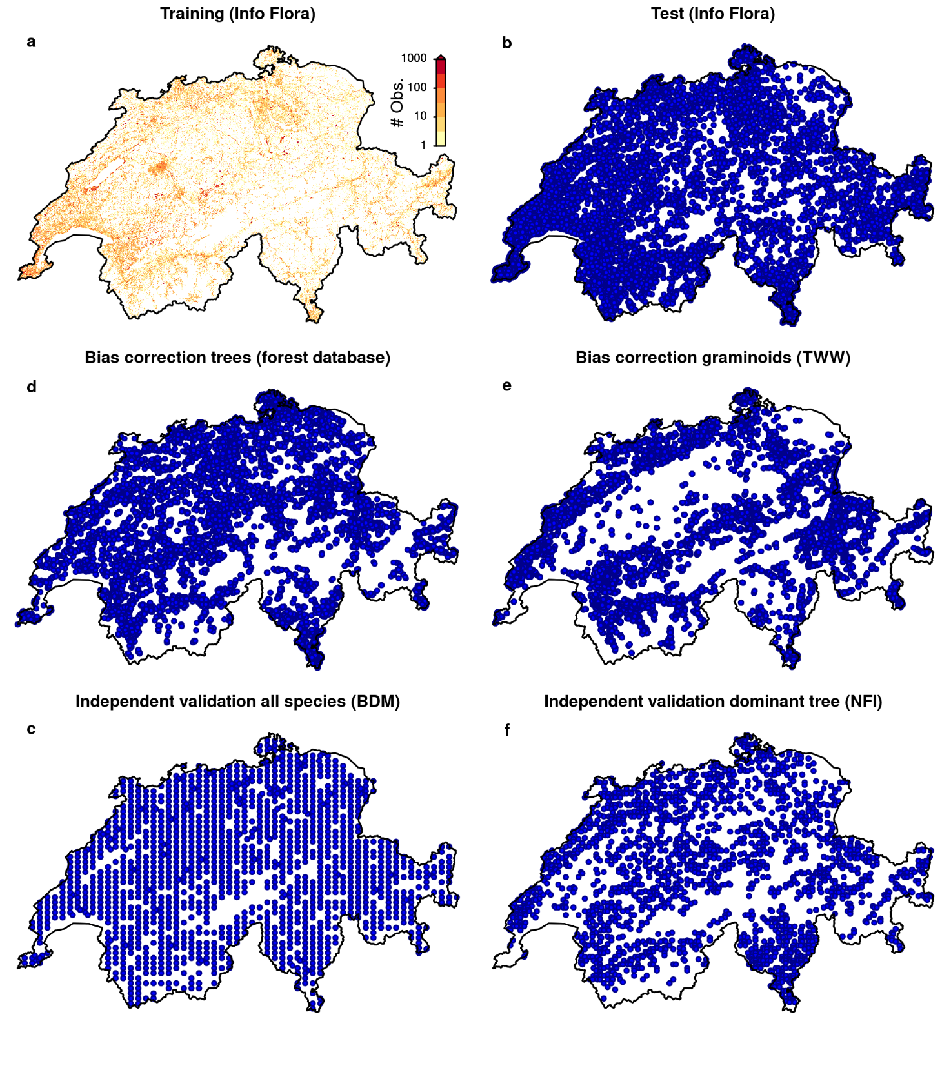
Extended Data Fig. 1 | Spatial distributions of the observational data sets used in this study. a, number of quality-filtered training observations per 200×200 m pixel taken from the Info Flora database. b, locations of quality-filtered left-out test observations taken from the Info Flora database. c, locations of plant community observations for independent validation, taken from the Biodiversity Monitoring Program. d, locations of forest tree community observations for taxonomic bias correction, taken from the forest database. e, locations of grassland community plots for taxonomic bias correction, taken from the Dry Meadows and Pastures initiative. f, locations of forest tree community observations to validate model predictions taken from the National Forest Inventory.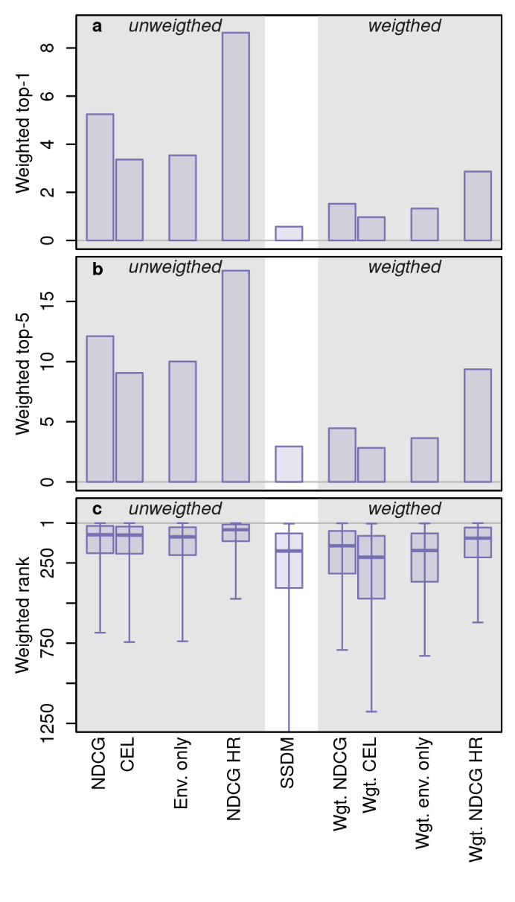
Extended Data Fig. 2 | Overall performance of the trained deep neural networks and comparison to stacked species distribution models (SSDMs). Weighted versions were obtained by upsampling observations from rare taxa during training to obtain balanced taxon representation (see Methods). Top-1 accuracy in percent (a), top-5 accuracy in percent (b), and weighted ranks (c) are shown for various combinations of cost functions and predictor sets, as well as for predictions deduced from SSDMs. Central lines in the boxplots of panel (c) indicate weighted medians, boxes indicate weighted interquartile ranges, and whiskers indicate weighted 2.5 and 97.5 percentiles. Env. represents environmental predictors; NDCG represents the normalized discounted cumulative gain cost function; Wgt. represents weighted; CEL represents the cross-entropy loss cost function; and HR represents high resolution.

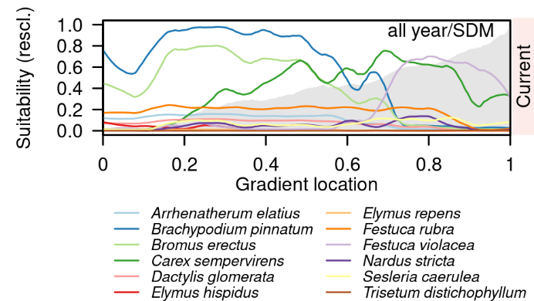
Extended Data Fig. 3 | Reporting bias-corrected observation probabilities of graminoid taxa along an elevational gradient in the canton of Vaud (see Fig. 4). All-year habitat suitability under current conditions as derived from reporting-bias corrected predictions of stacked species distribution models. Gray shading in the background represents the elevation profile ranging from 400 to 2900 m asl. Illustrated are the twelve taxa with the most frequent potential dominance according to multispecies DNNs.

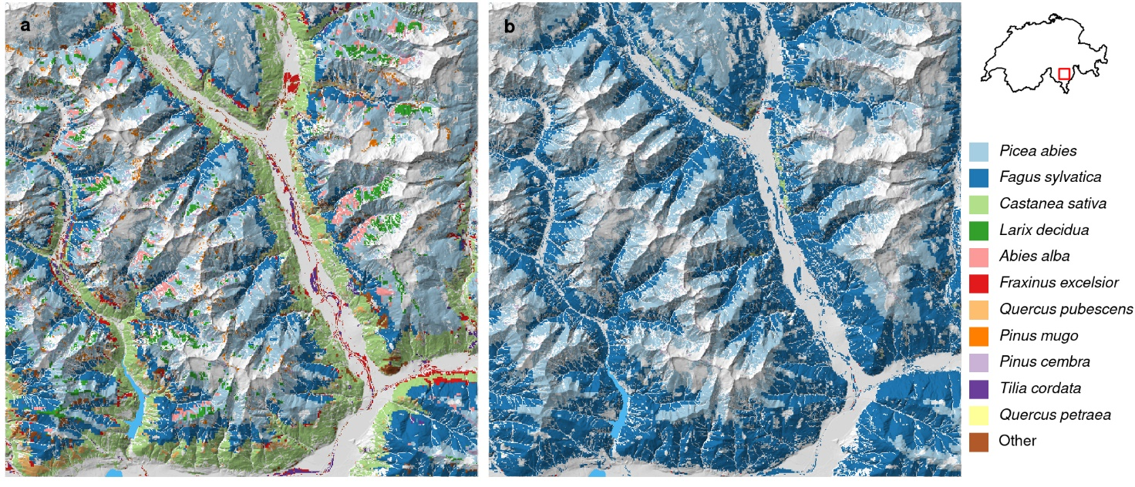
Extended Data Fig. 4 | Potentially dominant canopy-forming tree species in wooded areas in Ticino. a, estimates according to reporting-bias corrected predictions of the low-resolution multispecies DNN with NDCG loss; b, estimates according to reporting-bias corrected predictions of stacked species distribution models. Colors represent species with the highest observation probability averaged from February to November (see legend). We compared observation probabilities of 37 tree species and tree species aggregates, as distinguished by the Walddatenbank (REF), and masked pixels with land cover classes with no expected trees (see methods).
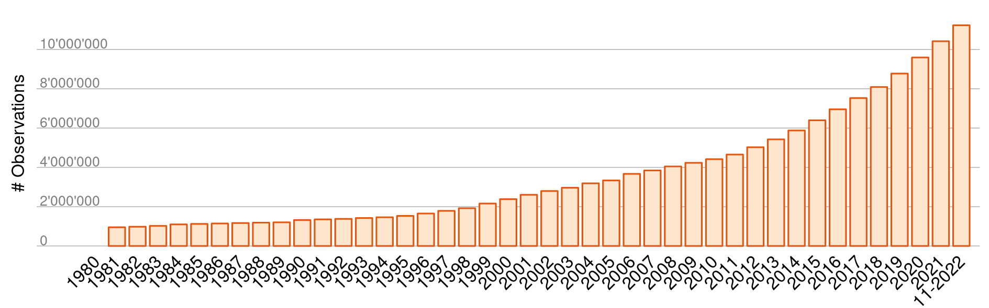
Extended Data Fig. 5 | Increase of Info Flora observations for the period 1980-2019. Depicted are raw data before the filtering steps mentioned in the methods.

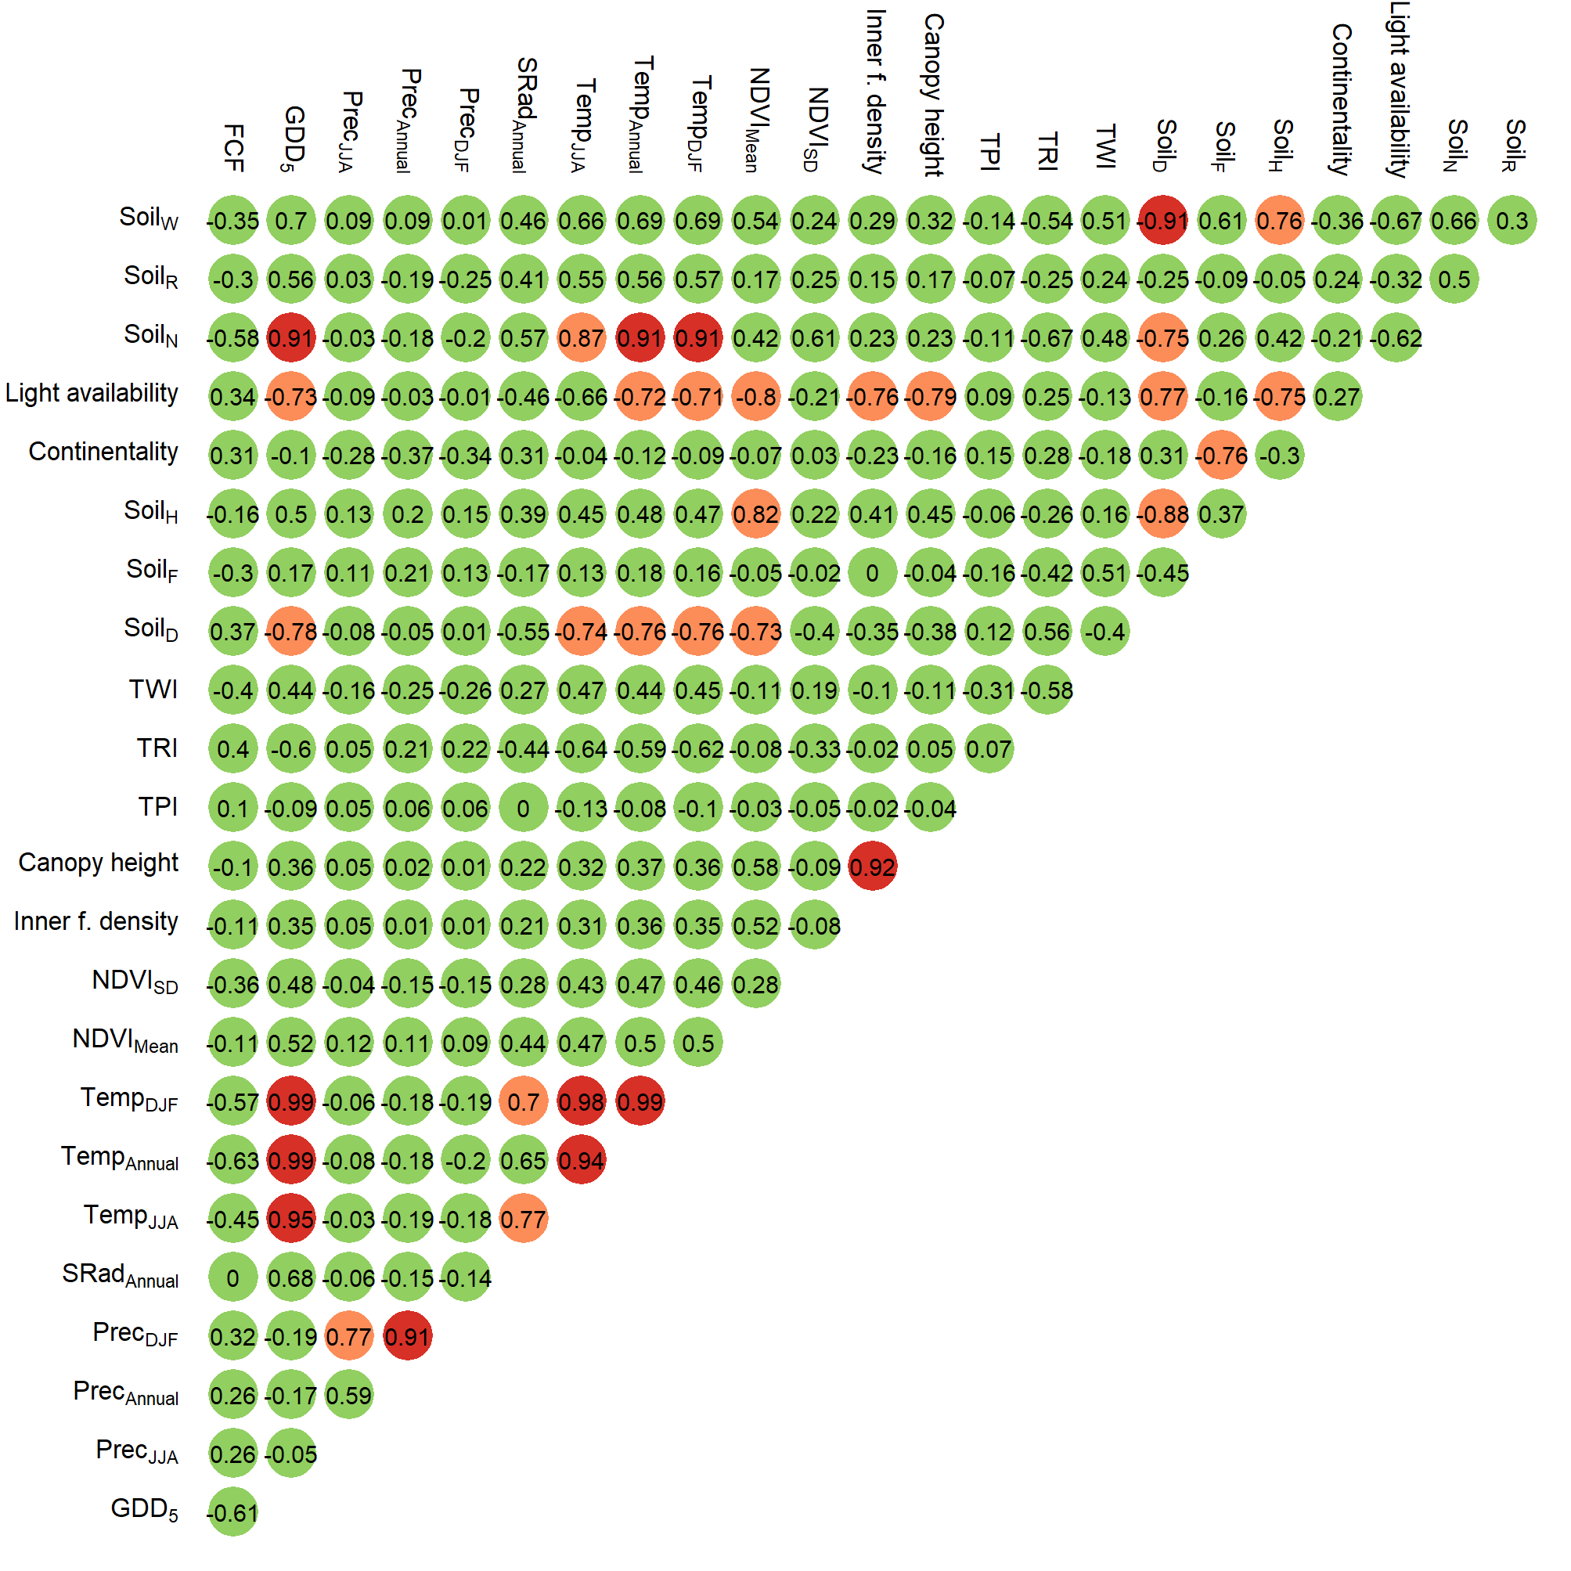
Extended Data Fig. 6 | Pearson correlation coefficients between low-resolution environmental predictors across Switzerland. Green circles represent absolute Pearson correlation coefficients <0.7; orange circles represent absolute Pearson correlation coefficients between 0.7 and 0.9; and red circles represent absolute Pearson correlation coefficients higher than 0.9. Soil_{W}, Soil_{R}, Soil_{N}, Soil_{H}, Soil_{F}, and Soil_{D}, represent moisture variability, pH, nutrients, humus, moisture, and aeration; NDVI represents normalized difference vegetation index, Temp represents temperature, SRad represents solar radiation (direct and diffuse), Prec represents precipitation, GDD₅ represents growing degree days above five degrees Celsius, and FCF represents frost change frequency. SD represents standard deviation, DJF represents December, January, February, and JJA represents June, July, August.

Extended Data Table 1 | Selection of low-resolution environmental predictors. “Times selected in SDMs“ refers to the species-specific variable selection procedure described in the subsection “Species distribution models” of the methods and is a proxy for variable importance; “Correlation cluster #” gives a rough but imperfect indication of groups of predictors with absolute Pearson correlation coefficients > 0.7; “Selected” indicates the low-resolution predictors selected for DNNs (with “1”). Soil_{W}, Soil_{R}, Soil_{N}, Soil_{H}, Soil_{F}, and Soil_{D}, represent moisture variability, pH, nutrients, humus, moisture, and aeration; NDVI represents normalized difference vegetation index, Temp represents temperature, SRad represents solar radiation (direct and diffuse), Prec represents precipitation, GDD₅ represents growing degree days above five degrees Celsius, and FCF represents frost change frequency. SD represents standard deviation, DJF represents December, January, February, and JJA represents June, July, August.
Name | Times selected in SDMs | Correlation cluster # | Selected
TRI | 2224 | 10 | 1
Soil_{R} | 2103 | 13 | 1
NDVI_{SD} | 1794 | 7 | 1
NDVI_{Mean} | 1602 | 6 | 1
SRad_{Annual} | 1582 | 5 | 0
Canopy height | 1577 | 8 | 1
Prec_{JJA} | 1496 | 4 | 1
FCF | 1352 | 1 | 1
Prec_{DJF} | 1313 | 3 | 1
Soil_{F} | 1276 | 12 | 1
TPI | 1185 | 9 | 0
Soil_{N} | 1117 | 2 | 0
Soil_{W} | 1056 | 2 | 0
Continentality | 999 | 12 | 0
TWI | 948 | 11 | 0
Inner forest density | 642 | 8 | 0
Temp_{JJA} | 628 | 2 | 1
GDD₅ | 524 | 2 | 0
Soil_{D} | 524 | 2 | 0
Soil_{H} | 501 | 6 | 0
Prec_{Annual} | 438 | 3 | 0
Light availability | 412 | 6 | 0
Temp_{Annual} | 411 | 2 | 0
Temp_{DJF} | 365 | 2 | 0

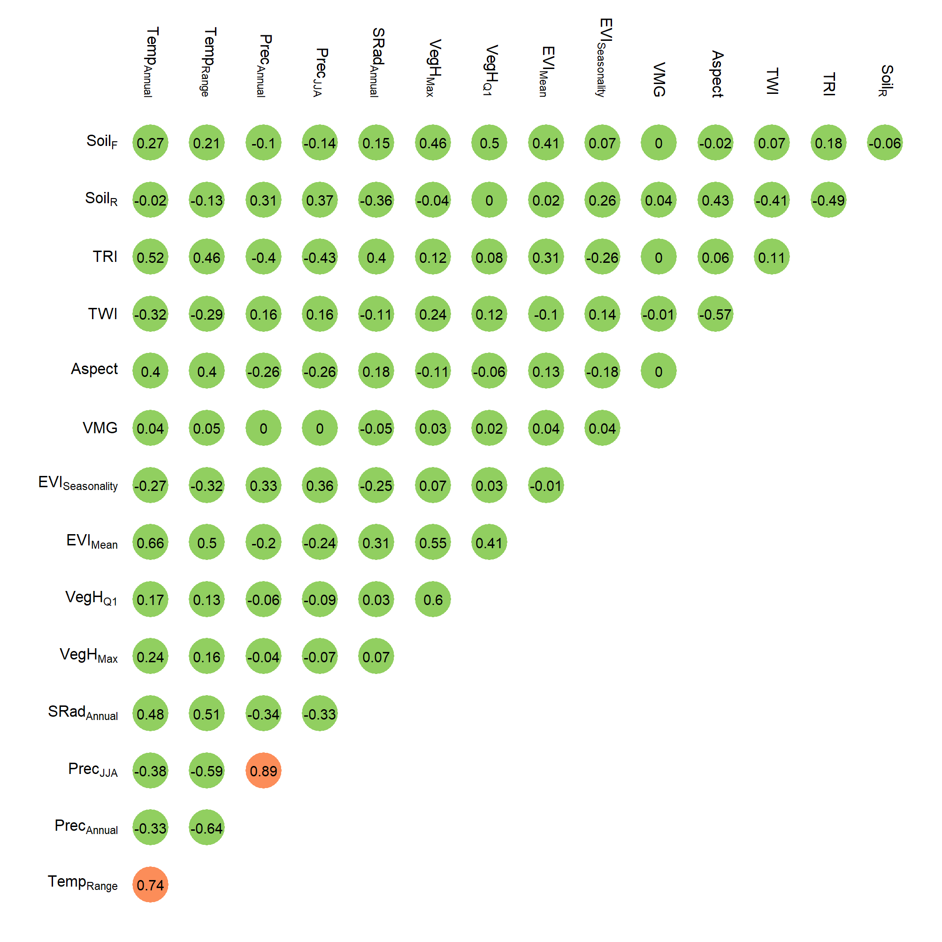
Extended Data Fig. 7 | Pearson correlation coefficients between high-resolution environmental predictors across Switzerland. Green circles represent absolute Pearson correlation coefficients <0.7; orange circles represent absolute Pearson correlation coefficients between 0.7 and 0.9. Soil_{R} and Soil_{F} represent pH and nutrients, and respectively; EVI represents enhanced vegetation index, Temp represents temperature, Prec represents precipitation, SRad represents solar radiation (direct and diffuse), VegH represents vegetation height, and VMG represents forest canopy mixture (deciduous versus evergreen). Q1 represents first quartile, Max represents maximum, and JJA represents June, July, August

