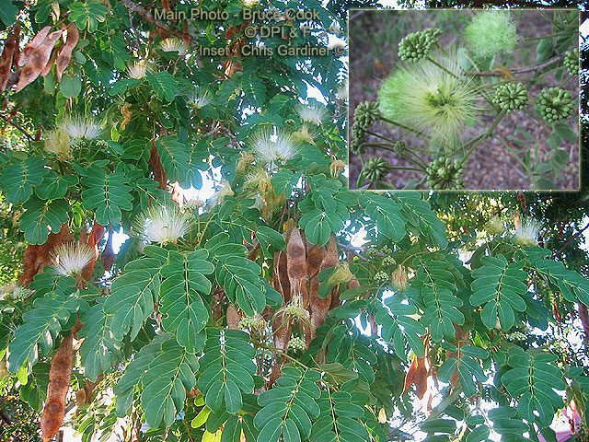
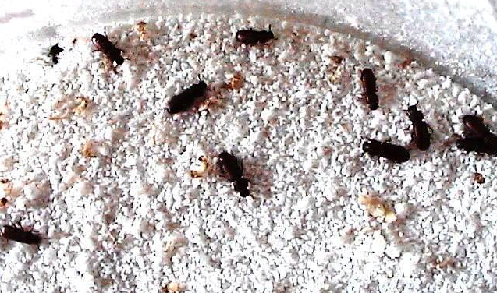

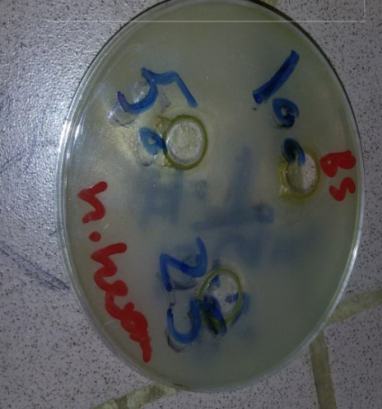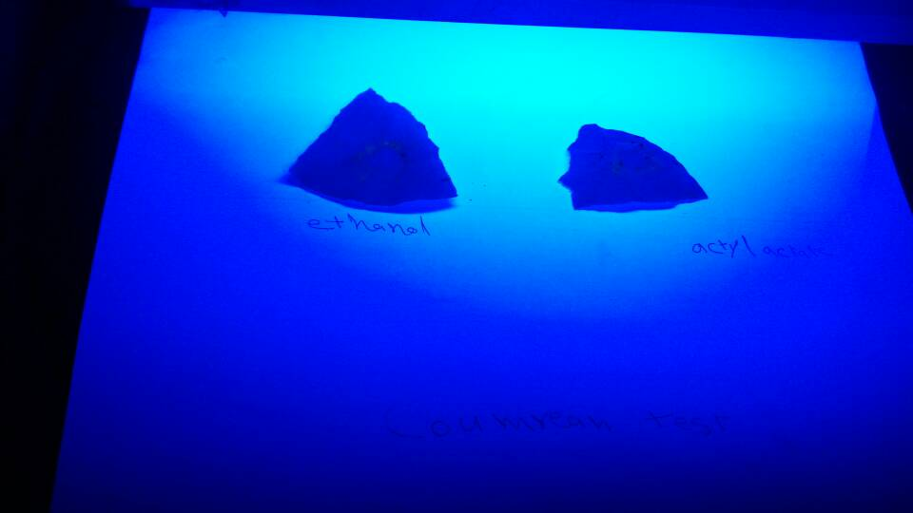

Table 2. Proximate Composition (% dry matter) of Albizia anthelmintica of leaves and stem bark
 | leaves |  |  | Stem bark
 | Nutrient Analyzed | % Composition |  | Nutrient Analyzed | % Composition
Ash |  |  | 6.75 | Ash |  | 3.1
Moisture |  |  | 2.5 | Moisture |  | 5
Crude protein |  |  | 8.95 | Crude protein |  | 6.2
Crude fibre |  |  | 16.15 | Crude fibre |  | 9.5
Crude fat (ether extract) |  |  | 2.6 | Crude fat |  | 2.5
Nitrogen free extract (carbohydrate by difference) |  |  | 63.05 | Nitrogen free extract (carbohydrate by difference) |  | 82.5
 | Values are means of duplicate determinations.

Table (4-1a): The effect of umtacherniI powder and Ethanolic Extract on Mortality of T.castaneum Adults after 3 Days:
Treatments | No. of adults exp.Unit | Mortality |  |  |  | Total |  | Mean±  0.707 |  | Duncan Test F  Pr.<0.05
Treatments | No. of adults exp.Unit | Replicates |  |  |  |  |  |  |  | Duncan Test F  Pr.<0.05
Treatments | No. of adults exp.Unit | R1 | R2 |  | R3 |  |  |  |  | Duncan Test F  Pr.<0.05
Control | 20 | 0 | 0 | 0 |  | 0 | 0 |  | A
Neem leaves powder 4% | 20 | 4 | 2 | 5 |  | 11 | 3.67 |  | C
umtacherni leaves powder 4% | 20 | 1 | 2 | 2 |  | 5 | 1.67 |  | B
umatcherni leaves ethanol extract 4% | 20 | 1 | 0 | 1 |  | 2 | 0.66 |  | B

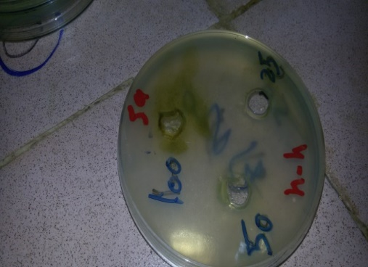
Figure (4-2c): Antibacterial activity of umtacherkni leaves hexane extract (100mg/ml) against Staphylococcus aureus.

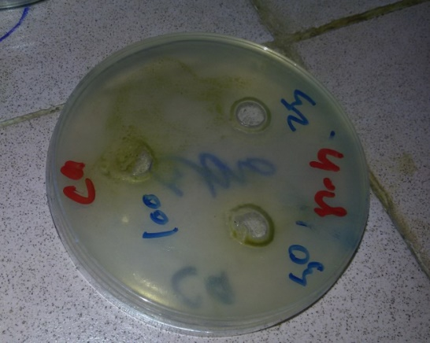
Figure (4-2d): Antifungal activity of umtacherni leaves of hexane extract against candida albicans.

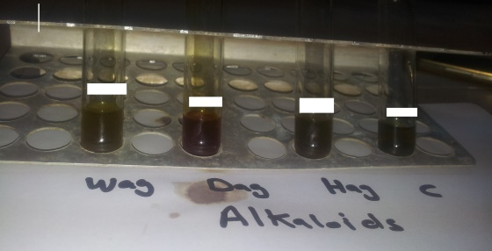
Fig (4-3a): photochemical screening of Alkaloid test leaves of ethanol and ethyl acetate extracts by (Drogndroff ,Wagner’s , Hager’s)
Ethanol
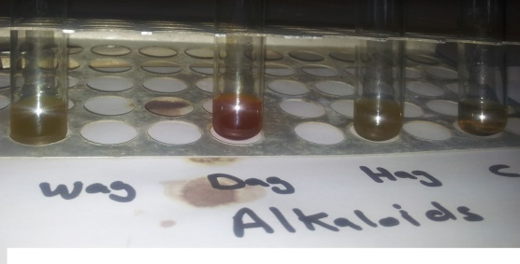
Ethyl acetate
Wag=Wagner’s Dag=Drogndroff Hag=Hager’s
Fig (4-3_{b}) photochemical screening of Cardiac Glycosides test of different leaves organic extracts by Glacical acetic acid:

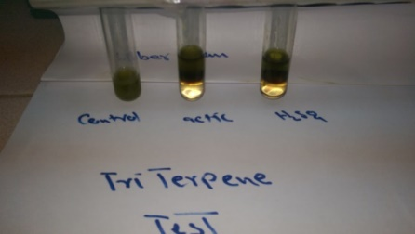
Control acetic HSO₄
ethanol extract
Fig (4-3f): photochemical screening of Triterpenes test by (Liebermann’s test and Shaslkowski

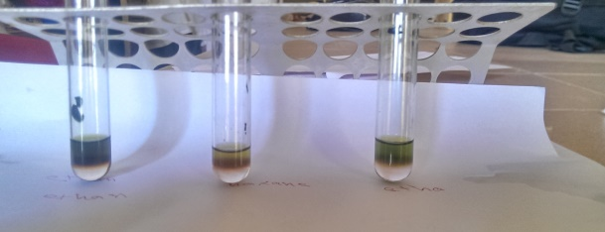
Ethyl acetate extract hexane extract ethanol extract
, Fig (4-3f): photochemical screening of Triterpenes test by (Liebermann’s test and Shaslkowski

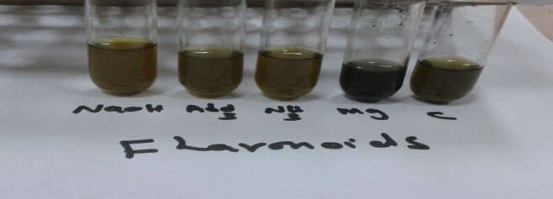
Hexane extract
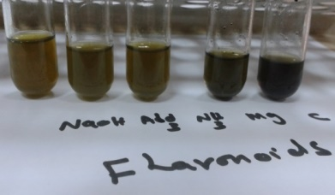
ethanol extract
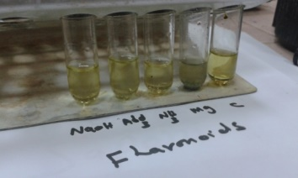
ethyl acetate extract
Fig (4-3c) photochemical screening of Flavonoids of leaves organic extracts by (NaoH ,Al Cl₃ ,Mg/H₂so_{4/} c=control )

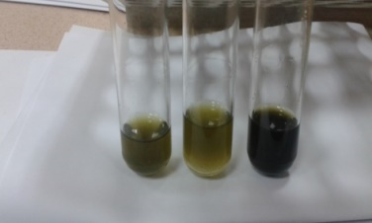
Control gelatin ferric chloride

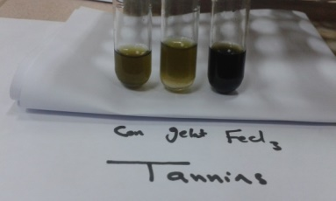
control gelatin ferric chloride
Ethanol extract
Fig (4-3d): photochemical screening of Tannins of leaves by (ferric chloride and Gelatin):

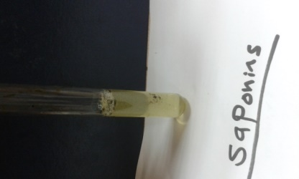
Saponnins
Fig (4-3e): photochemical screening of Saponins test of leaves organic extracts by Foam

