Renewable Energy from Livestock Waste Valorization:
Amyloid-Based Feather Keratin Fuel Cells
Supplementary Information
Wei Long Soon^{1,2}, Mohammad Peydayesh², Tym de Wild³, Felix Donat⁴, Rinku Saran¹, Christoph R. Müller⁴, Lorenz Gubler³, Raffaele Mezzenga^{1,2,5,*}, Ali Miserez^{1,6,*}

¹ Center for Sustainable Materials (SusMat), School of Materials Science and Engineering, Nanyang Technological University, 639798 Singapore
² ETH Zurich, Department of Health Sciences and Technology, 8092 Zurich, Switzerland
³ Electrochemistry Laboratory, Paul Scherrer Institut, 5232 Villigen PSI, Switzerland
⁴ Laboratory of Energy Science and Engineering, Department of Mechanical and Process Engineering, ETH Zürich, Leonhardstrasse 21, 8092 Zürich, Switzerland
⁵ ETH Zurich, Department of Materials, Wolfgang-Pauli-Strasse 10, 8093 Zurich, Switzerland
⁶ School of Biological Sciences, Nanyang Technological University, 60 Nanyang Drive, 637551 Singapore

* Correspondence to: raffaele.mezzenga@hest.ethz.ch and ali.miserez@ntu.edu.sg

Table of Contents
A. Materials and Methods 4
I. Protein extraction and isolation 4
II. Amyloid fibril formation 4
III. Membrane fabrication 4
IV. In-situ fuel cell measurements 5
V. Fuel cell assembly 5
VI. Transistor fabrication 6
B. Protein Characterization 6
Sodium dodecyl sulfate polyacrylamide gel electrophoresis (SDS-PAGE) 6
Amino Acid Analysis 7
Atomic Force Microscopy (AFM) 7
Transmission Electron Microscopy (TEM) 7
Fibrillization tracking 7
C. Membrane Characterization 8
Fourier transform infrared spectroscopy (FTIR) 8
Raman Spectroscopy 8
Thermogravimetric analysis (TGA) 8
Scanning electron microscopy (SEM) 8
Mechanical properties 9
X-ray diffraction (XRD) 9
X-ray Photoelectron Spectroscopy (XPS) 9
Ion-exchange capacity (IEC) and water uptake (Q) 9
Methanol permeability 10
Kelvin Probe Force Microscopy (KPFM) 11
D. Membrane Electrochemical Characterization 11
Electrochemical measurements 11
H+-FET Characterization 11
Supplementary Figure S1. 13
Supplementary Figure S2. 14
Supplementary Figure S3. 15
Supplementary Figure S4. 15
Supplementary Figure S5. 16
Supplementary Figure S6. 17
Supplementary Figure S7. 17
Supplementary Figure S8. 18
Supplementary Figure S9. 18
Supplementary Figure S10. 19
Supplementary Figure S11. 19
Supplementary Figure S12. 20
Supplementary Figure S13. 20
Supplementary Figure S14. 21
Supplementary Figure S15. 21
Supplementary Figure S16. 22
Supplementary Figure S17. 22
Supplementary Figure S18. 23
Supplementary Figure S19. 24
Supplementary Figure S20. 25
Supplementary Figure S21. 25
Supplementary Figure S22. 26
Supplementary Figure S23. 26
Supplementary Figure S24. 27
Supplementary Tables 28
Supplementary Table 1. 28
Supplementary Table 2. 28
Supplementary Table 3. 28
References 29

A. Materials and Methods

I. Protein extraction and isolation
Chicken feathers obtained from a local farm were washed and added to a keratin extraction solution (8 M urea containing 5 wt.% ammonium thioglycolate, pH adjusted to 9.8) at a ratio of 1:30 (w/v). The mixture was heated at 60°C for 6 h, after which it was centrifuged to remove insoluble components. The supernatant was adjusted to pH 4 and added to ammonium sulfate solution to precipitate the proteins. The isolated protein was washed thrice with water and freeze-dried to obtain keratin protein powder. Freeze-dried regenerated keratin was redissolved in ammonium hydroxide, after which ammonium thioglycolate was added, and the reaction was left to proceed for 30 min. Then, the pH was adjusted to 4 to precipitate the proteins, centrifuged at 5000 rpm for 5 min, and the pellet was washed thrice with water and freeze-dried to obtain keratin protein isolate.
II. Amyloid fibril formation
Feather keratin amyloid fibrils were prepared by heating 2.5 wt.% keratin isolate solutions in 10% (v/v) acetic acid with 10 mM TCEP at 90°C for 5 h. After fibrillization, amyloid fibril solutions were centrifuged at 10,000 rpm for 20 min to remove any aggregates.

III. Membrane fabrication
To fabricate the membranes, feather keratin amyloid fibrils were typically mixed with glyoxal and mercaptosuccinic acid (MSA), cast onto a polystyrene surface, and allowed to dry. Membranes were then heat treated at 150°C for 50 min to facilitate crosslinking, after which they were immersed in a peracetic acid solution and incubated at 37°C for 5 h. Membranes were then immersed in 0.5 M H₂SO₄ to fully protonate the sulfonic acid groups, washed with distilled water, and stored in water before further use.
IV. In-situ fuel cell measurements
Membranes were acidified in 0.5 M sulfuric acid before assembly and thoroughly washed with milli-Q water. Wet membranes were placed inside a 1 cm² cell between two platinum-coated commercial GDE’s (JM ELE0244, Johnson Matthey, United Kingdom) with a nominal loading of 0.4 mg Pt/cm². The GDL compression was set to 25 ± 1%. The cells were directly tested after assembly to prevent drying of the membranes. Fuel cell tests were performed using a custom fuel cell test bench at PSI. LabVIEW was used to control and monitor the cell voltage, flow rates, and temperatures. A constant flow rate of 0.4 ln/min was used for all gasses. An SP-300 potentiostat (Biologic systems, USA) was used for all electrochemical measurements. The cell temperature was controlled by two 100 W heating cartridges in the endplates.
Polarization curves were recorded 1) potentiometrically from OCV to 0.1 V with a sweep rate of 10 mV/s or 2) galvanostatically by holding the current for 60 seconds and increasing stepwise. Measurements were performed at 100% RH and a pressure of 1.5 bar.
Hydrogen crossover currents were measured using staircase voltammetry. The potentiometric measurements was performed from 0.7 to 0.2 V in steps of 0.1 V. Each step was held for 60 seconds and the average stable current of each step was plotted as a function of cell voltage. All measurements were performed with H2 on the CE and N2 on the WE at a flow of 0.4 ln/min, 100% RH and a pressure of 1 bar.
V. Fuel cell assembly
The commercial Flex-Stak Electrochemical cell (Fuel Cell Store, USA) was used to test the keratin membranes. Wet membranes were placed between two platinum-coated carbon paper electrodes of 0.5 mg/cm² (Fuel Cell Store, USA) to form the membrane electrode assembly. Pure hydrogen gas and air were supplied at the anode and cathode, respectively. The metal tabs were connected to a mini DC/DC (LiPower, Sparkfun) converter with an output of 3.3 V.
VI. Transistor fabrication
Field-effect transistor devices were fabricated by depositing gold metal electrodes on top of hafnium oxide (50 nm) coated silicon substrate. Substrates were first cleaned by ultrasonication in acetone, isopropyl alcohol and deionized water for 10 min and dried using nitrogen gas. Metal electrodes were then deposited using electron-beam evaporation. An adhesion layer of chromium (10 nm) was deposited first followed by deposition of 100 nm gold on top of hafnium oxide through a shadow mask. The device has a channel length of 100 μm and width of 1 mm. 1 μL of amyloid fibril mixed with glyoxal and MSA was deposited onto the device and air-dried. The substrate was then cured at 150°C for 50 min and immersed in peracetic acid solution at 37°C for 5 h. The device was then immersed in 0.5 M sulfuric acid for 1 h and then rinsed thoroughly with water.

B. Protein Characterization

Sodium dodecyl sulfate polyacrylamide gel electrophoresis (SDS-PAGE)
Freeze-dried protein isolates were prepared at 2 mg/ml dissolved in 8 M urea. 10 μL Laemmli buffer was added to 10 μL protein solution. To reduce the disulfide bonds, an additional 1 μL of 1 M TCEP was added. SDS-PAGE was performed with a homogenous 12% gel using MW markers 2 kDa to 250 kDa at 150 V for 65 min. The gel was then fixed with MeOH/EtOH/AcOH solution and subsequently stained with Coomassie Blue Silver Staining buffer.

Amino Acid Analysis
10 μL of feather keratin protein solutions were oxidized with 500 μL performic acid (9:1 formic acid: hydrogen peroxide) at 0°C for 18 h. 100 μL of hydrobromic acid was added to the solution, after which solvents were removed by speed vacuum. Samples were then hydrolyzed in 500 μL of 6 M HCl solution with 0.5% phenol under vacuum at 110°C for 24 h. Solvents were removed by speed vacuum, after which hydrolysates were washed twice with water and kept at -20°C prior to the analysis. Composition analysis was performed with an amino acid analyzer (Sykam). The initial cysteine concentration was calculated using a conversion factor of 95% of cysteine into cysteic acid ¹.
Atomic Force Microscopy (AFM)
20 μL of fivefold-diluted amyloid fibril solution was deposited on a freshly cleaved mica surface and incubated for 3 min. The surface was then washed with Milli-Q water and dried under nitrogen. Imaging with the Atomic Force Microscope (AFM) (NX10, Park Systems) was performed in non-contact mode with a scan rate of 1 Hz and scan size of 10 μm by 10 μm.
Transmission Electron Microscopy (TEM)
Amyloid fibrils were diluted to 0.2 wt.%, prepared on a copper grid and stained with uranyl acetate before imaging using transmission electron microscopy (TFS Morgagni 268) with an operating voltage of 100 kV.
Fibrillization tracking
To determine the optimal heat treatment duration for amyloid fibril formation, 100 μL of protein solutions sampled at different heating time intervals were diluted twice with water, after which thiazole orange was added to a final concentration of 10 μM. The solutions were excited with a wavelength of 421 nm and the fluorescence emission was measured at a wavelength of 455 nm (Tecan Spark). Fluorescent intensities were normalized to the intensities measured at 0h.

C. Membrane Characterization

Fourier transform infrared spectroscopy (FTIR)
Membranes before and after oxidation were oven dried and scanned over a range from 4000 to 600 cm⁻¹ (Varian 640) with a resolution of 2 cm⁻¹.
Raman Spectroscopy
To obtain the Raman spectrum of the membranes, samples were placed on a gold-coated glass slide (Platypus Technologies, LLC). The sample surface was focused through a 100X objective lens, after which a laser of 785 nm wavelength was applied. The spectrum was obtained with a Raman spectrometer (Horiba LabRAM HR Evolution UV-VIS-NIR) with a range from 400 to 2850 cm⁻¹ with 5 accumulations of 10 s acquisition time each.
Thermogravimetric analysis (TGA)
The TGA experiment was carried out using a Mettler Toledo TGA/DSC 3+/HT with a total flowrate of 150 ml/min of nitrogen. The temperature was increased from 25°C to 900°C at a rate of 10°C/min.
Scanning electron microscopy (SEM)
Supercritical CO₂-dried keratin membranes were fractured and mounted onto an SEM stub with conductive carbon cement. Membranes were imaged with an accelerating voltage of 2 kV (Zeiss LEO 1530) (TFS Magellan 400).

Mechanical properties
The mechanical properties of the membranes were evaluated by tensile testing (Zwick Z010) with an applied stress of 10 kN and strain rate of 5 mm/min. Young’s moduli of the membranes were determined by the slope of the plotted stress-strain curves before the yield point. The membranes were further analyzed with dynamic mechanical analysis (MCR 702e, Anton Paar) to assess their performance with temperature. Samples of width 10 mm and 70 mm thickness were mounted between two tensile clamps at a fixed distance of 2 mm and enclosed in a chamber containing a wet cloth for humidity. After temperature equilibration, samples were tested at a fixed frequency of 1 Hz and 70 kPa stress with increasing temperature from 25°C to 60°C.
X-ray diffraction (XRD)
X-ray diffractograms of the materials were collected by using a PANalytical Empyrean X-ray powder diffractometer equipped with an X’Celerator Scientific ultrafast line detector and Bragg-Brentano high-density incident beam optics using Cu Kα radiation (45 kV and 40 mA). The 2θ range was 4°–70°, the step size was 0.016° and each measurement lasted 1 h.
X-ray Photoelectron Spectroscopy (XPS)
Supercritical CO₂ dried membranes were analyzed for their surface elemental composition using XPS (ESCALAB™ Xi+, ThermoFisher USA). Samples were placed in an analysis chamber evacuated to 8 × 10⁻¹⁰ Pa, to which samples were irradiated with Al kα (hv = 1486.6 eV) and an applied voltage of 1 V.
Ion-exchange capacity (IEC) and water uptake (Q)
Membranes were protonated in 0.5 M H₂SO₄ overnight and rinsed thoroughly with MilliQ water and soaked in MilliQ water to remove residual H₂SO₄. Membranes were then soaked in 1 M KCl overnight and titrated with 0.05 M KOH until the pH reached 7. The membranes were then washed with water, weighed, and dried. The ion exchange capacity (IEC) and water uptake (Q) were calculated based on the following equation:
$IEC=\frac{n(H^{+})}{m_{0}}$ (1)
where
$n\left(H^{+}\right)=c_{KOH}{∙V}_{KOH}$ (2)
and
$m_{0}=m_{0,K^{+}}-38.1\text{g/mol}∙c_{KOH}∙V_{KOH}$ (3)
The latter correction of the membrane dry mass is necessary to account for the difference in molar mass of K⁺ and H⁺ as counter-ions.
$Water uptake \left(Q\right)=\frac{m_{wet}-m_{0}}{m_{0}}∙100\%$ (4)
Methanol permeability
The permeability of methanol was assessed by determining the concentration of methanol diffused through the membrane clamped between two chambers – one containing 5 M methanol and the other containing pure water. The methanol permeability (P) was calculated based on the following equation ²:
$P=\frac{1}{C_{a}}\left(\frac{{ΔC}_{b}\left(t\right)}{Δt}\right)\left(\frac{L{∙V}_{b}}{A}\right)$ (5)
where P is the membrane diffusion permeability for methanol, C_{a} is the methanol concentration in the feed chamber, ∆C_{b}(t)/∆t is the methanol molar concentration in the permeate chamber as a function of time, V_{b} is the volume of each diffusion reservoir, A is the membrane area, and L is the membrane thickness.
Kelvin Probe Force Microscopy (KPFM)
KPFM was used to probe the presence of anionic functional groups on the membrane after modification. 100 μL of amyloid fibril mixed with glyoxal and MSA was deposited on a bare freshly cleaved HOPG substrate and incubated for 10 min for protein adsorption, after which the excess solution was removed, and the substrate was air-dried. The substrate was then cured at 150°C for 20 min and immersed in peracetic acid solution at 37°C for 5 h. The substrate was then immersed in 0.5 M sulfuric acid for 1 h, rinsed thoroughly with water, and mounted onto a steel disc with carbon tape.

D. Membrane Electrochemical Characterization
Electrochemical measurements
Through plane conductivity measurements were performed with electrochemical impedance spectroscopy (EIS) using the SP-100 potentiostat (Biologic systems, USA). Wet membranes were placed in between two circular platinum electrodes with a diameter of 15mm. PEIS was used to measure the resistance as a function of frequency from 1Mhz to 100 Hz with a 10 mV perturbation. The high frequency intercept was used to calculate the membrane resistance. Samples without the addition of MSA were measured from 7 MHz to 100 Hz. Proton conductivity (σ) was calculated using equation (6):
$σ=\frac{L}{R∙A}$ (6)
Where L is the thickness of the membrane, R is the resistance of the membrane, and A is the contact area of the electrodes.
H+-FET Characterization
Devices were measured at a relative humidity level of 90 % in a custom-built dry box chamber wherein relative humidity was varied using humidifier (BioAire Lifestyle) and continuously monitored using a digital hygrometer (RS PRO RS-91, ±3% RH Accuracy, 100% RH Max). The maximum source to drain voltage was restricted to 1.5 volts (thermoneutral voltage of water ≈ 1.25 V at 25°C) to prevent electrolysis of water.

Supplementary Figures
Supplementary Figure S1. Amino acid composition of isolated feather keratin.

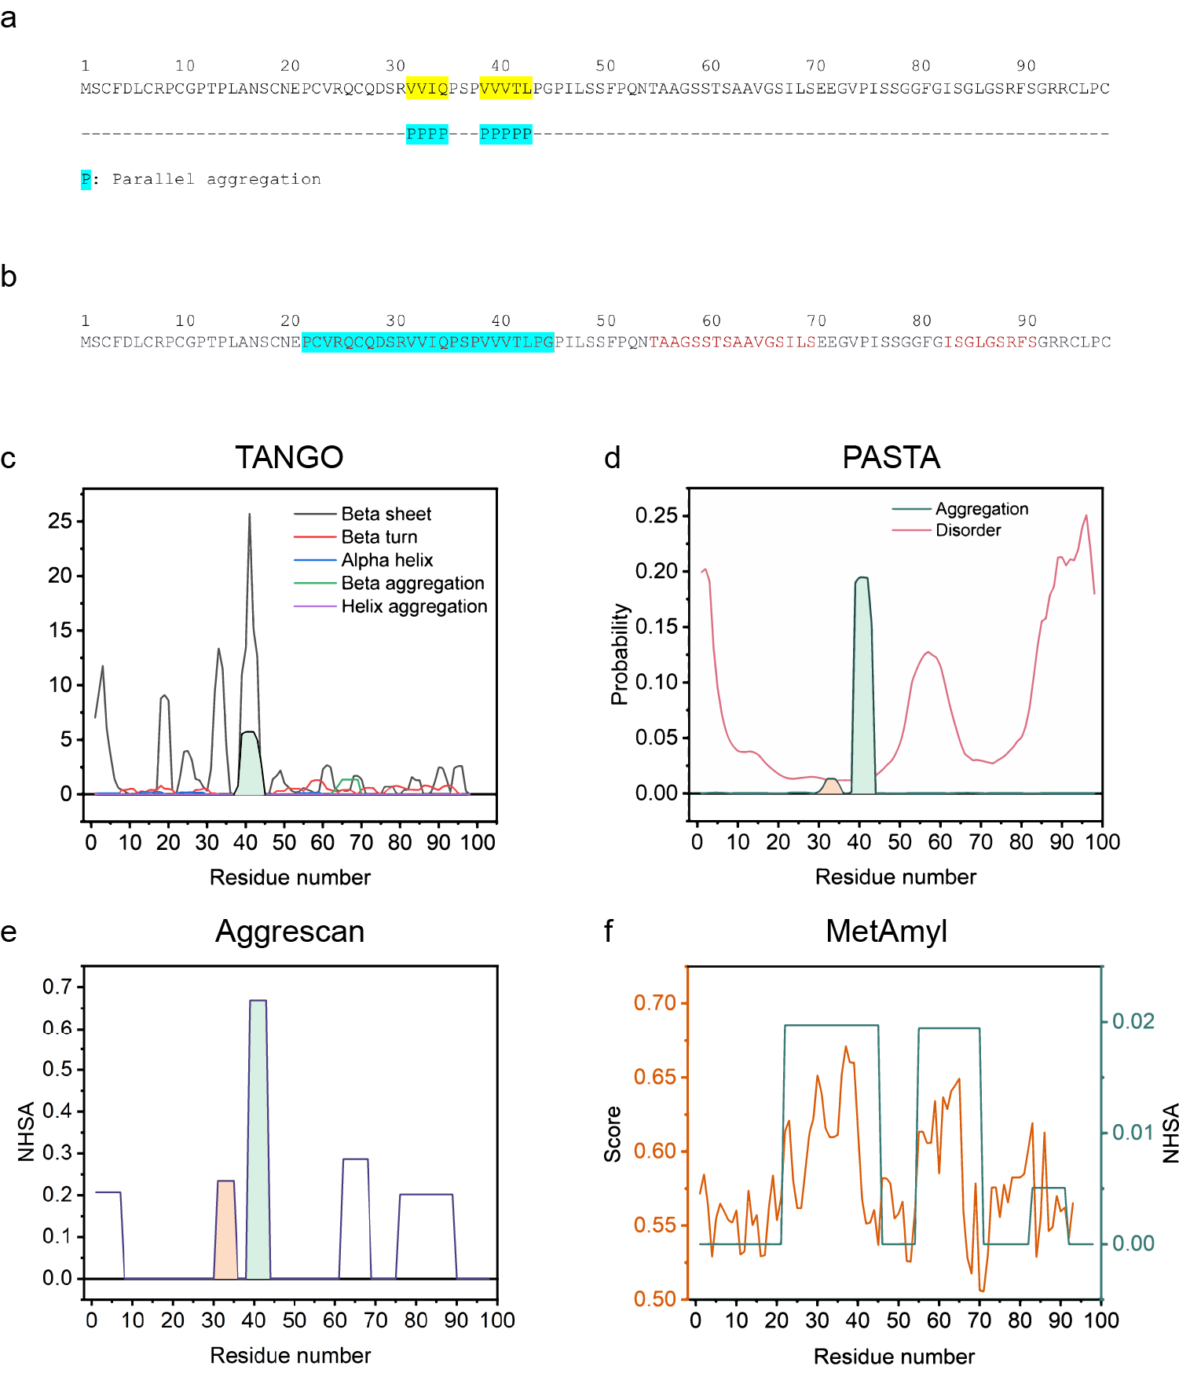
Supplementary Figure S2. Prediction of amyloidogenic aggregation behavior of feather keratin. a, b, Sequence of feather keratin with parallel aggregation regions in blue and red. c-e, Aggregation prediction sites using TANGO ³⁻⁵, PASTA ⁶, and Aggrescan ⁷ algorithms, respectively. f, Amyloidogenic sites based on normalized hotspot area (NHSA) using MetAmyl ⁸.

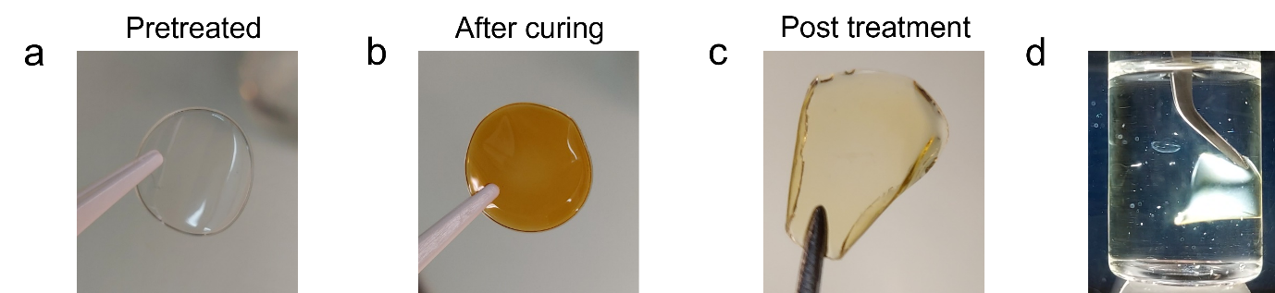
Supplementary Figure S3. Images of keratin-M membranes during fabrication. a, After solvent casting before treatment. b, After thermal curing. c, After post treatment. d, Post-treated membranes under cross-polarized light.

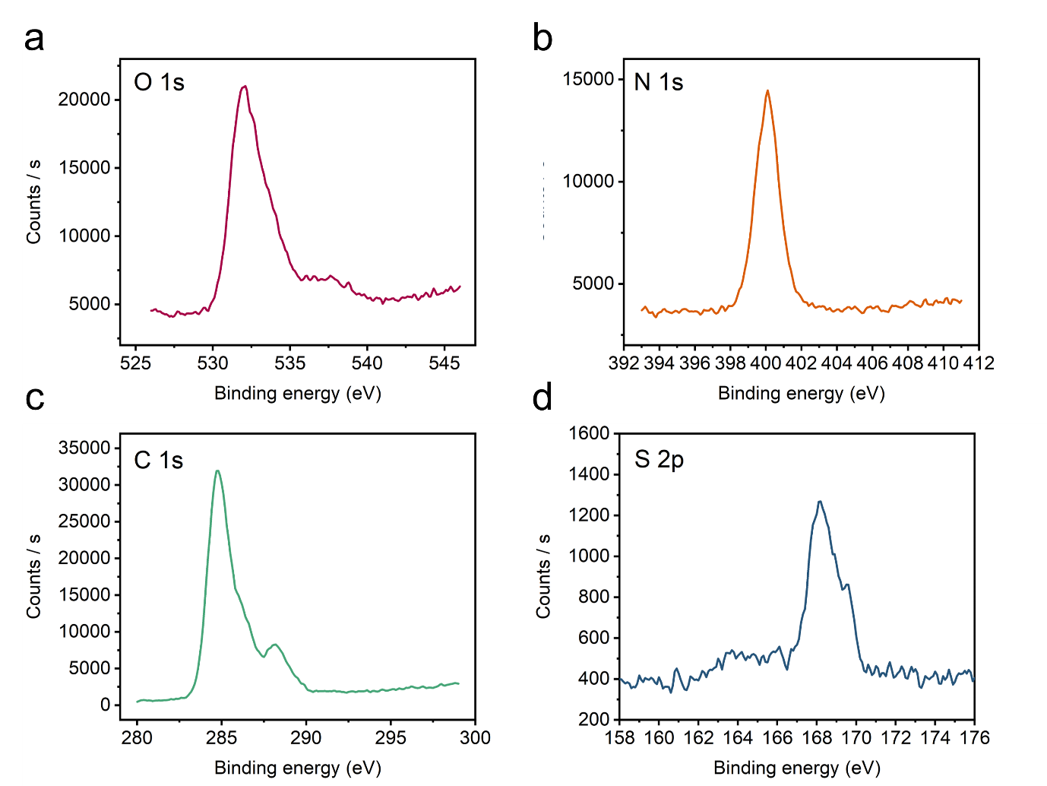
Supplementary Figure S4. XPS spectra of keratin-M membranes. a, O 1s. b, N 1s. c, C 1s. d, S 2p.
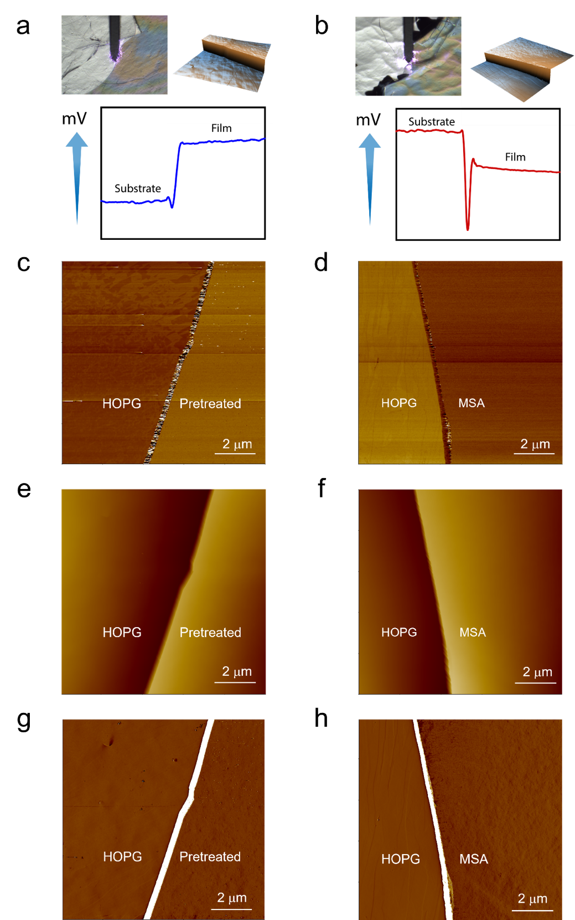
Supplementary Figure S5. a, b, Keratin membrane on HOPG before treatment and after treatment, respectively. In each image, (upper left) AFM probe on HOPG-Membrane interface, (upper right) 3D height profile of interace, (bottom) surface potential across interface. c, d, AFM potential image. e, f, AFM height image. g, h, AFM amplitude image.
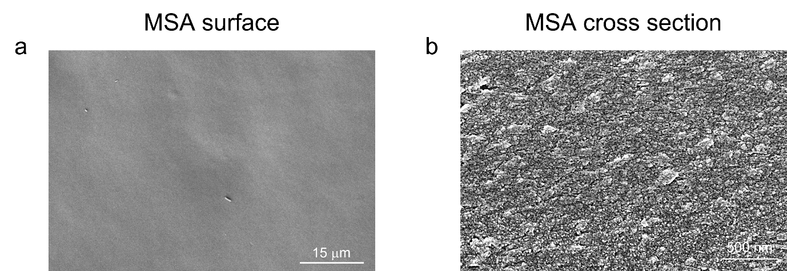
Supplementary Figure S6. Cross section of keratin-M membranes. a, surface (low magnification). b, cross section.

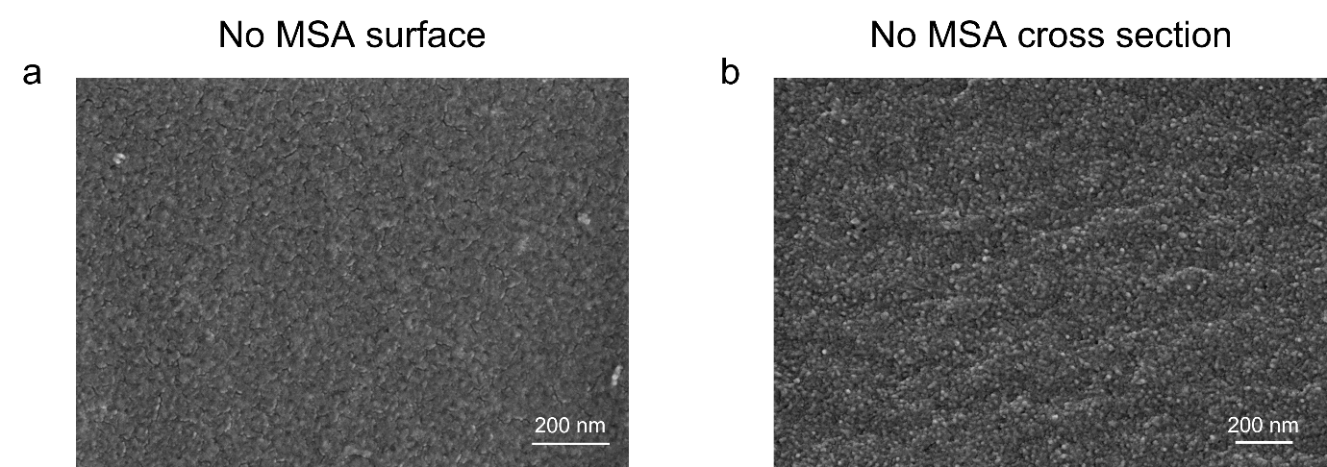
Supplementary Figure S7. Cross section of neat keratin membranes. a, surface. b, cross section.
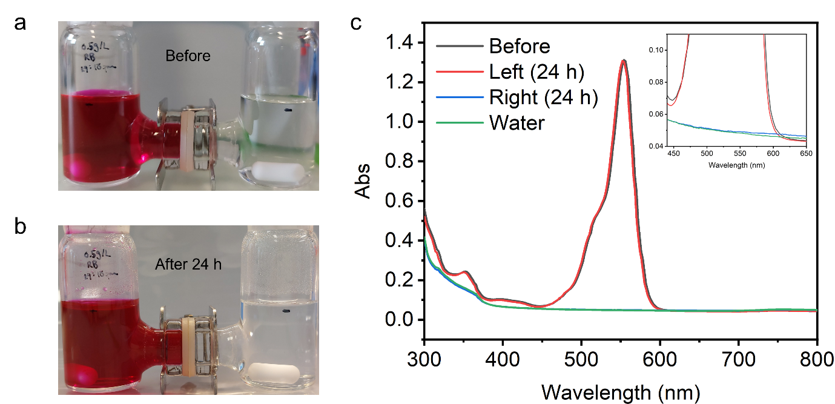
Supplementary Figure S8. Rhodamine B rejection of keratin-M membrane at a, 0 h and b, 24 h. c, Absorbance spectrum of solutions in each chamber.

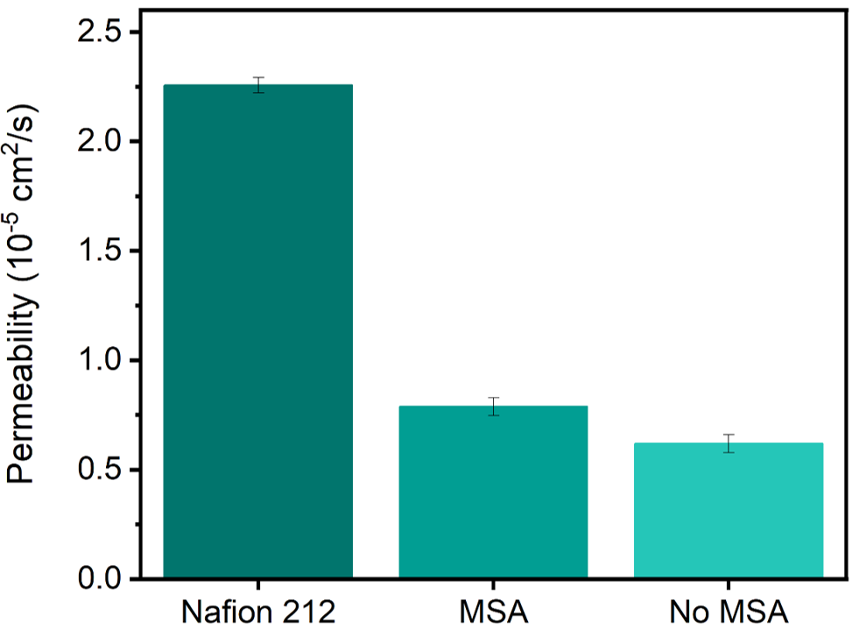
Supplementary Figure S9. Methanol permeability of keratin membranes in comparison with Nafion 212.

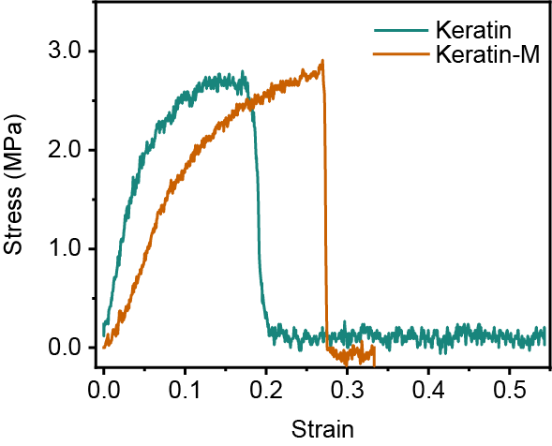
Supplementary Figure S10. Tensile test measurement of keratin membranes.

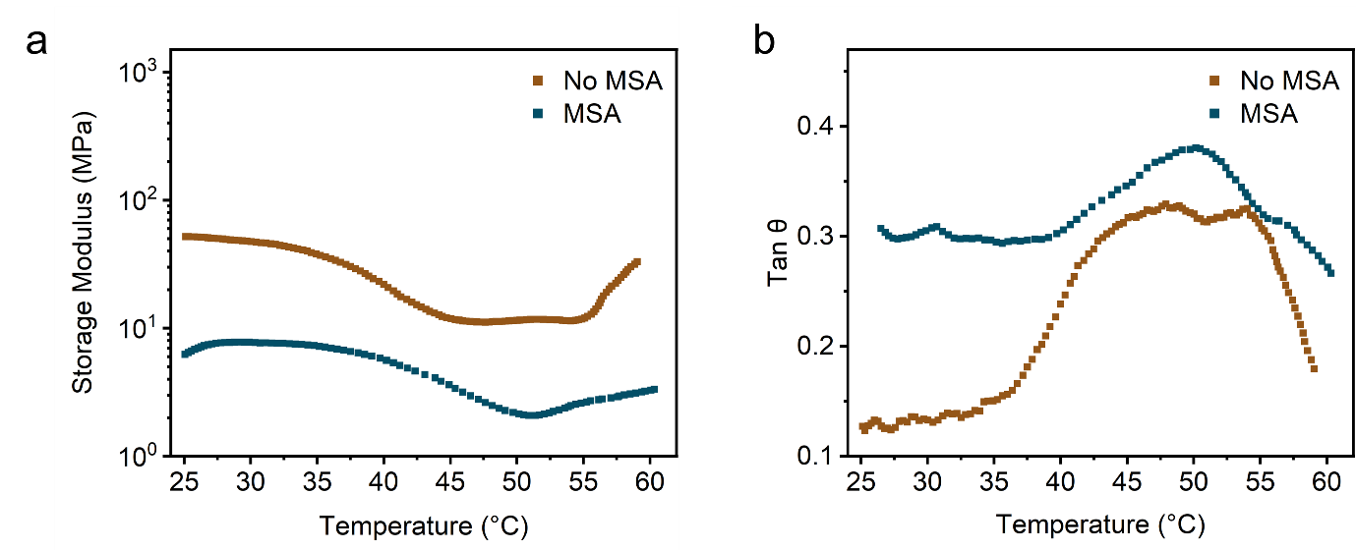
Supplementary Figure S11. Dynamic mechanical analysis of keratin membranes with temperature. a, Storage modulus. b, tan θ

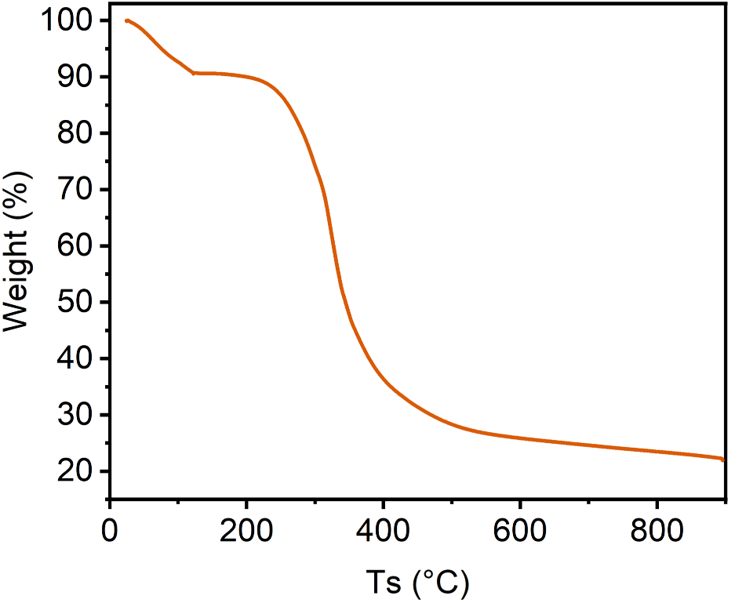
Supplementary Figure S12. Thermogravimetric analysis of keratin-M membrane.

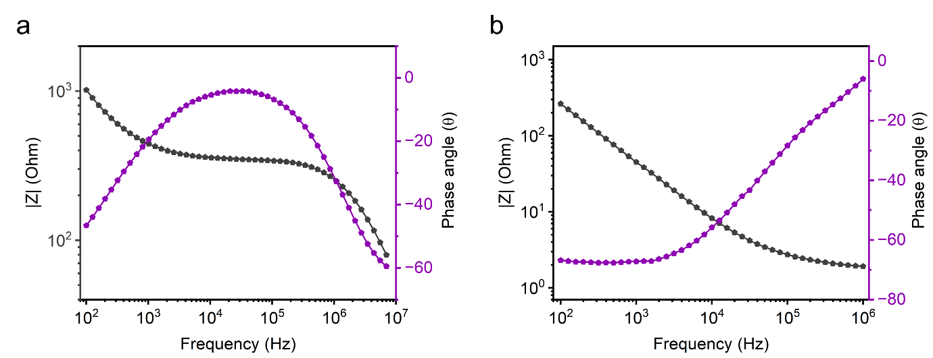
Supplementary Figure S13. Bode plots of keratin membranes. a, neat keratin. b, keratin-M.

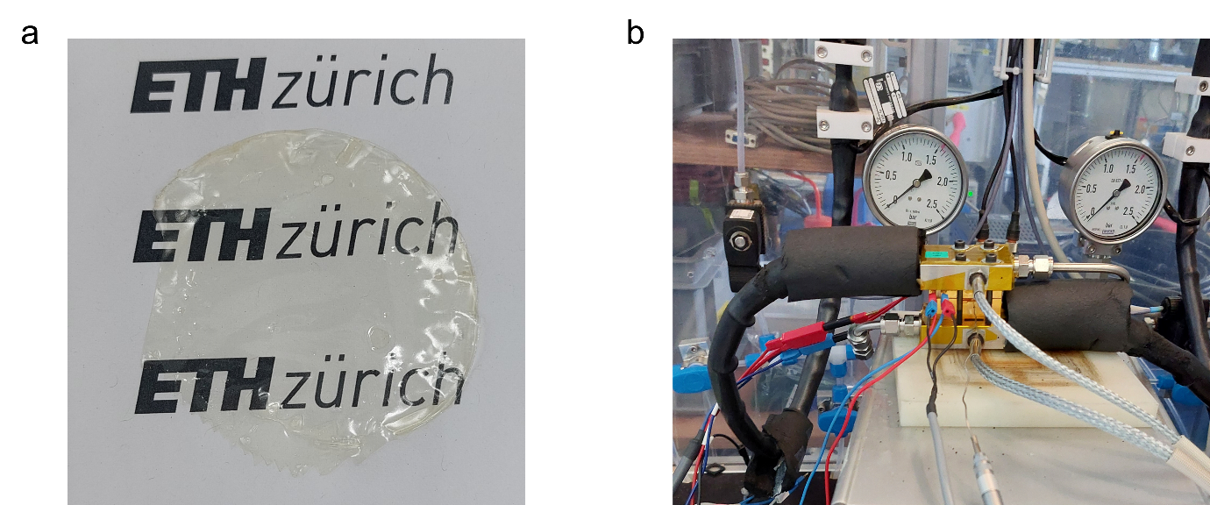
Supplementary Figure S14. a, Keratin-M membrane used in setup. b, In-situ measurement setup.

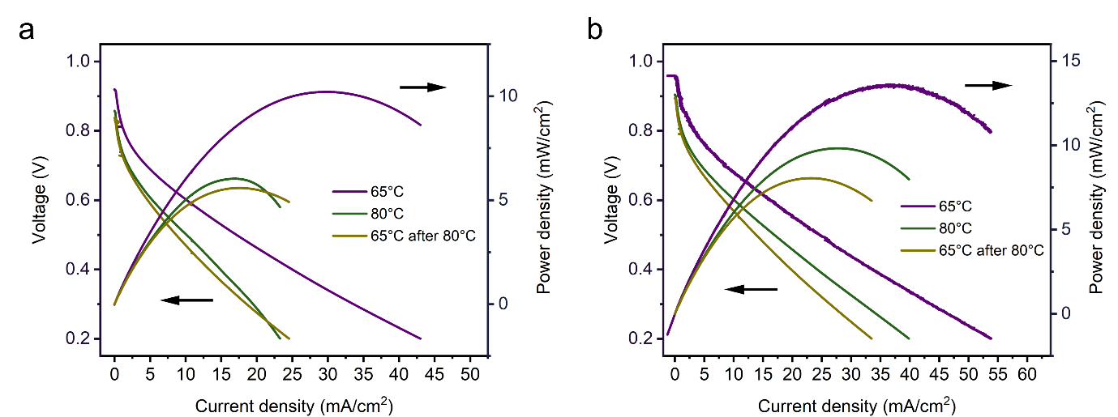
Supplementary Figure S15. In-situ performance of keratin membranes at 65°C, followed by 80°C, and cooling down to 65°C. a, air as cathode. b, oxygen as cathode.

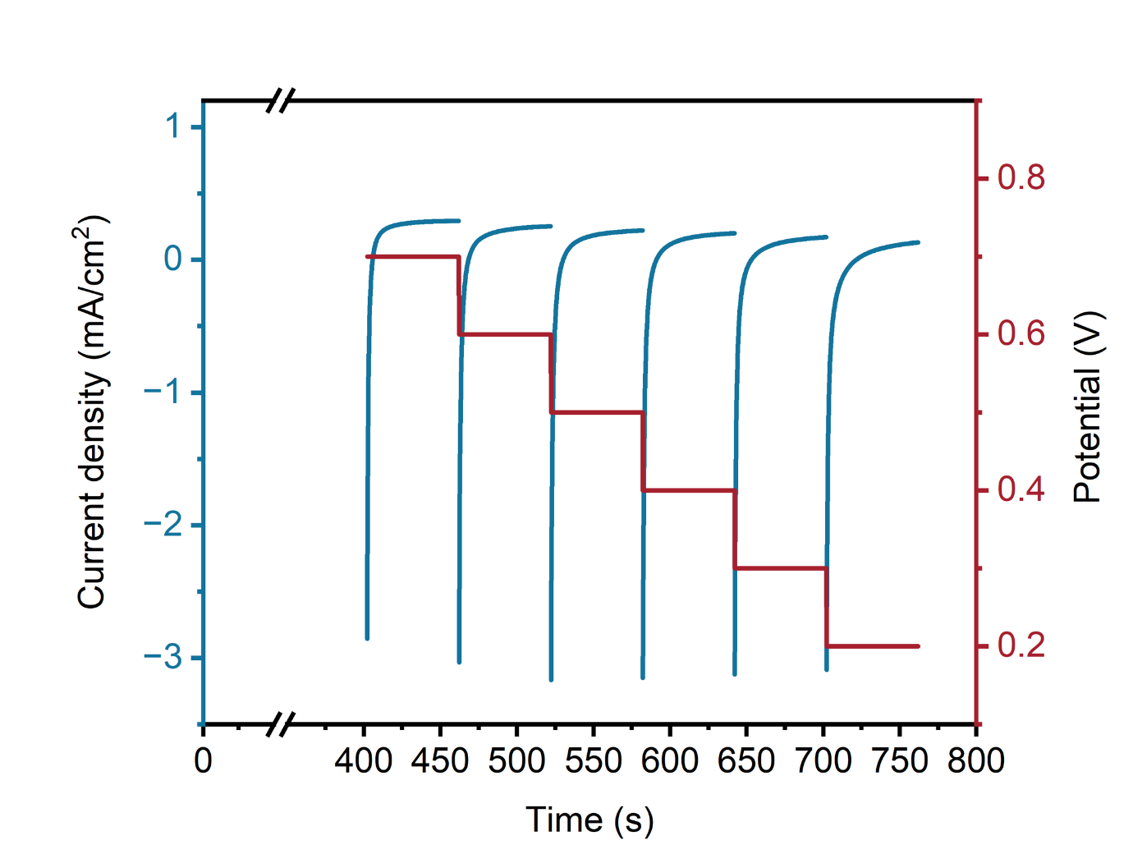
Supplementary Figure S16. Staircase voltammetry of hydrogen crossover experiment.

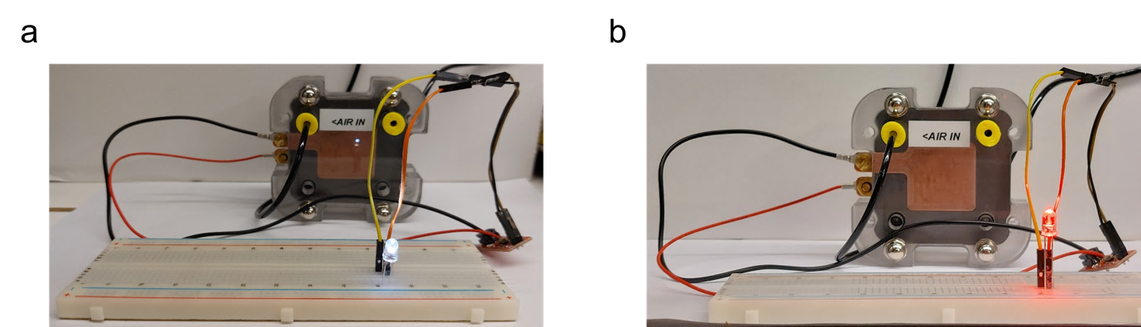
Supplementary Figure S17. Keratin-M fuel cell device powering of a, White and b, Red LED lamp.

Supplementary Figure S18. Current density profile with voltage for hydrogen crossover assessment.
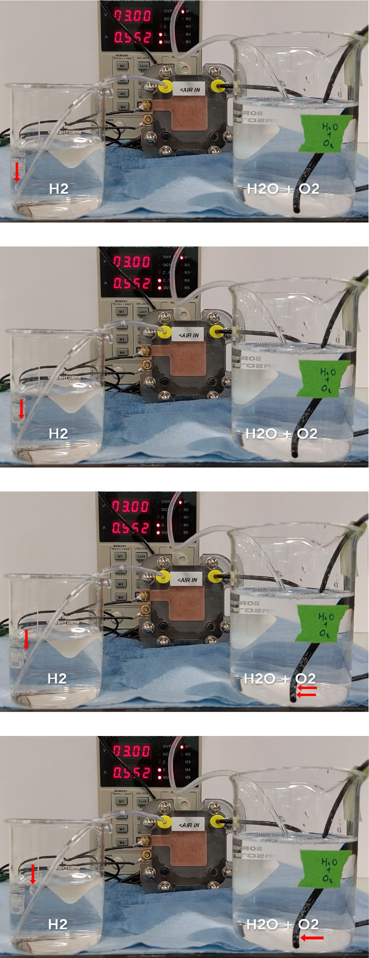
Supplementary Figure S19. Electrolysis with keratin-M membrane. (Left) H₂ production. (Right) H₂O and O₂ production. Red arrows indicate bubble formation at the respective outlets.
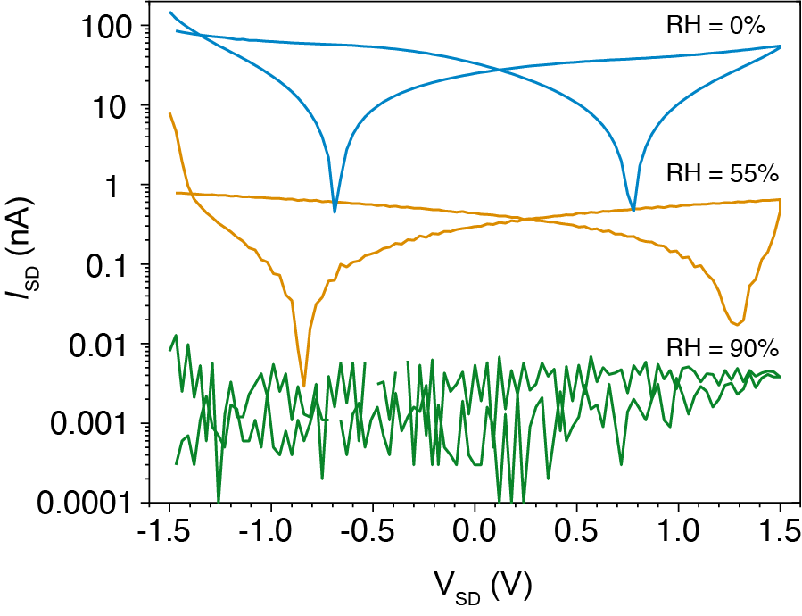
Supplementary Figure S20. I-V plot of keratin-M on Au electrodes with increasing relative humidity.

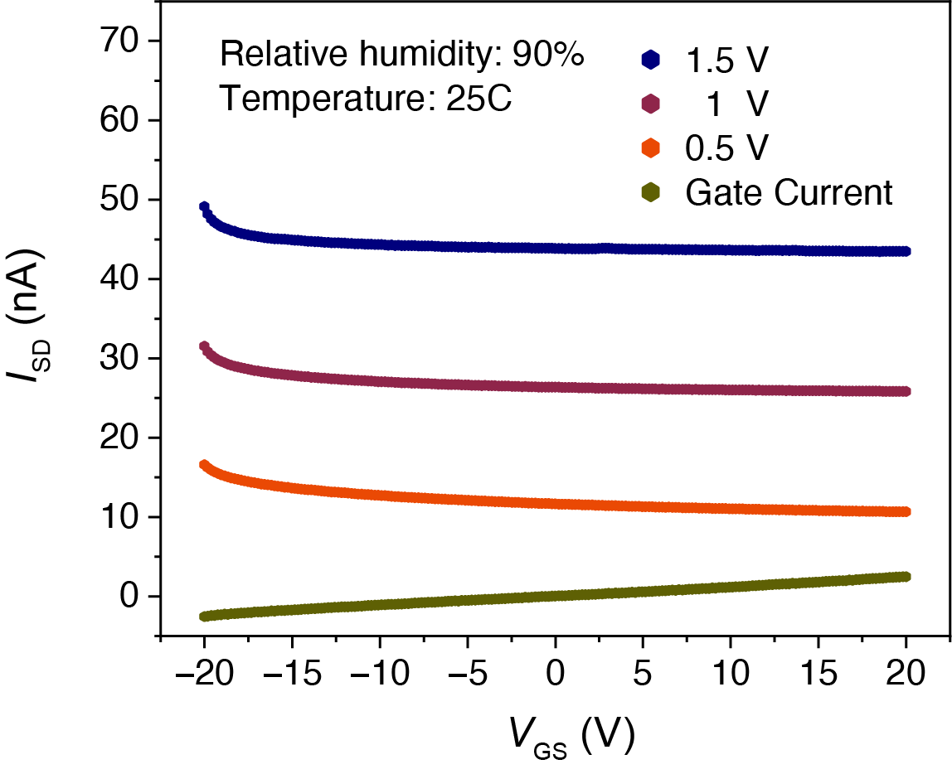
Supplementary Figure S21. Transfer characteristics of keratin-M bioprotonic FET device at 90% RH on PdH_{x} electrodes.

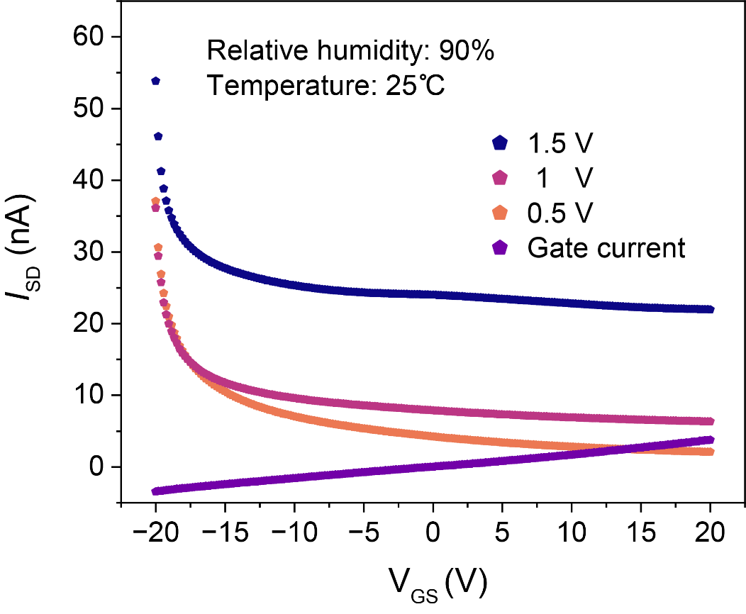
Supplementary Figure S22. Transfer characteristic of keratin-M bioprotonic FET device at 90% RH on Au electrodes displaying gate leakage current.

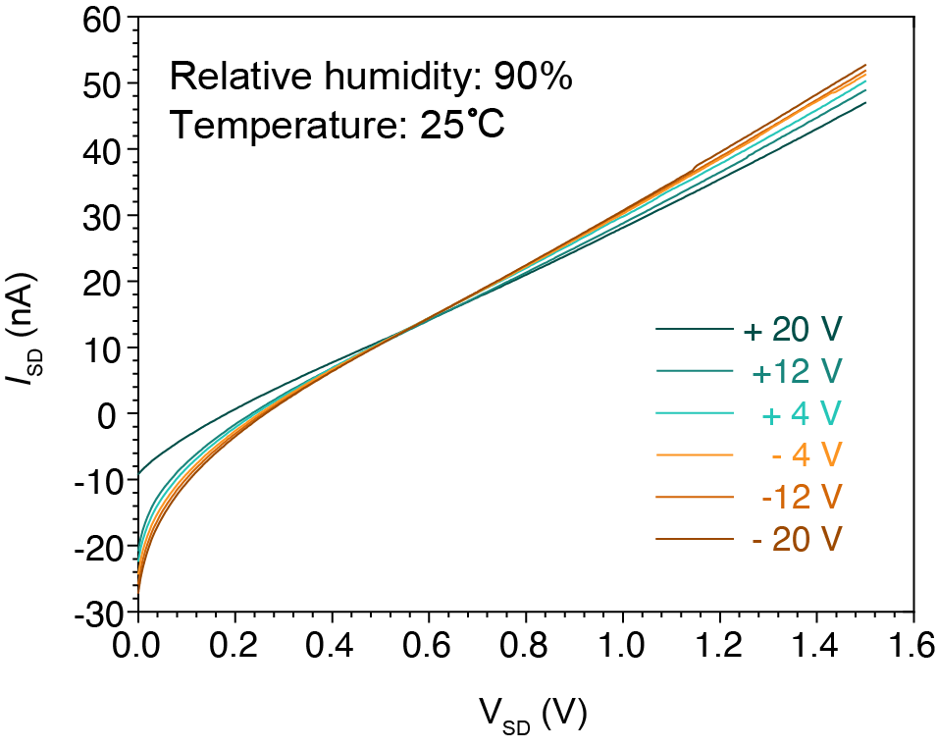
Supplementary Figure S23. Output behavior of keratin membrane transistors on PdH_{x} electrodes from negative to positive gate voltage.

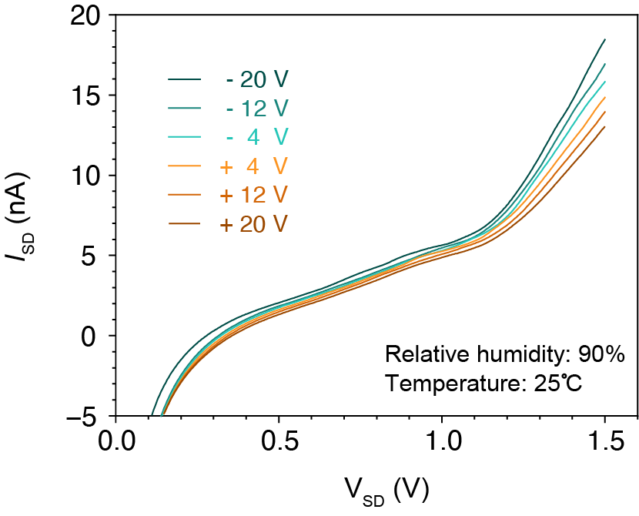
Supplementary Figure S24. Output behavior of keratin membrane transistors on Au electrodes from negative to positive gate voltage.

Supplementary Tables

Supplementary Table 1. Mechanical properties of keratin membranes.
Membrane | Young’s modulus (MPa) | Yield strength (MPa) | Ultimate Tensile Strength (MPa)
Keratin | 35.5 | 2.35 | 3.33
Keratin-M | 25.6 | 1.61 | 2.21

Supplementary Table 2. Proton conductivities of natural biomaterials
Natural biomaterials | Proton conductivity (mS/cm) | Relative humidity (%) | Ref
SRT motifs | 3.5 | 100 | ⁹
Ampullae of Lorenzini | 1.8 | 90 | ¹⁰
Chitosan | 1.5 | - | ¹¹
Carrageenan | 0.9 – 1.1 | - | ^{12,13}
Squid Reflectin A1 | 0.1 | 90 | ¹⁴

Supplementary Table 3. Proton conductivities of engineered biomaterials
Engineered biomaterials | Proton conductivity (mS/cm) | Relative humidity (%) | Ref
Tyrosine-rich peptide | 18.6 | 90 | ¹⁵
Chimera polypeptide | 18.5 | 90 | ¹⁶
Keratin-M | 6.3 | 95 | This work
BSA film | 5.3 | 75 | ¹⁷
CNF | 1.2 - 1.5 | 95 | ¹⁸
Maleic chitosan | 0.7 | 75 | ¹⁹

References
1 Moore, S. On the Determination of Cystine as Cysteic Acid. Journal of Biological Chemistry 238, 235-237, doi:https://doi.org/10.1016/S0021-9258(19)83985-6 (1963).
2 Shaari, N. et al. Enhanced Proton Conductivity and Methanol Permeability Reduction via Sodium Alginate Electrolyte-Sulfonated Graphene Oxide Bio-membrane. Nanoscale Research Letters 13, 82, doi:10.1186/s11671-018-2493-6 (2018).
3 Rousseau, F., Schymkowitz, J. & Serrano, L. Protein aggregation and amyloidosis: confusion of the kinds? Current Opinion in Structural Biology 16, 118-126, doi:https://doi.org/10.1016/j.sbi.2006.01.011 (2006).
4 Fernandez-Escamilla, A.-M., Rousseau, F., Schymkowitz, J. & Serrano, L. Prediction of sequence-dependent and mutational effects on the aggregation of peptides and proteins. Nature Biotechnology 22, 1302-1306, doi:10.1038/nbt1012 (2004).
5 Linding, R., Schymkowitz, J., Rousseau, F., Diella, F. & Serrano, L. A Comparative Study of the Relationship Between Protein Structure and β-Aggregation in Globular and Intrinsically Disordered Proteins. Journal of Molecular Biology 342, 345-353, doi:https://doi.org/10.1016/j.jmb.2004.06.088 (2004).
6 Walsh, I., Seno, F., Tosatto, S. C. & Trovato, A. PASTA 2.0: an improved server for protein aggregation prediction. Nucleic Acids Res 42, W301-307, doi:10.1093/nar/gku399 (2014).
7 Conchillo-Solé, O. et al. AGGRESCAN: a server for the prediction and evaluation of "hot spots" of aggregation in polypeptides. BMC Bioinformatics 8, 65, doi:10.1186/1471-2105-8-65 (2007).
8 Emily, M., Talvas, A. & Delamarche, C. MetAmyl: A METa-Predictor for AMYLoid Proteins. PLOS ONE 8, e79722, doi:10.1371/journal.pone.0079722 (2013).
9 Pena-Francesch, A. et al. Programmable Proton Conduction in Stretchable and Self-Healing Proteins. Chemistry of Materials 30, 898-905, doi:10.1021/acs.chemmater.7b04574 (2018).
10 Josberger, E. E. et al. Proton conductivity in ampullae of Lorenzini jelly. Science Advances 2, e1600112, doi:doi:10.1126/sciadv.1600112 (2016).
11 Shukur, M. F., Yusof, Y. M., Zawawi, S. M. M., Illias, H. A. & Kadir, M. F. Z. Conductivity and transport studies of plasticized chitosan-based proton conducting biopolymer electrolytes. Physica Scripta 2013, 014050, doi:10.1088/0031-8949/2013/T157/014050 (2013).
12 Perumal, P. & Selvin, P. C. Red algae-derived k-carrageenan-based proton-conducting electrolytes for the wearable electrical devices. Journal of Solid State Electrochemistry 24, 2249-2260, doi:10.1007/s10008-020-04724-w (2020).
13 Karthikeyan, S. et al. Proton-conducting I-Carrageenan-based biopolymer electrolyte for fuel cell application. Ionics 23, 2775-2780, doi:10.1007/s11581-016-1901-0 (2017).
14 Ordinario, D. D. et al. Bulk protonic conductivity in a cephalopod structural protein. Nature Chemistry 6, 596-602, doi:10.1038/nchem.1960 (2014).
15 Lee, J. et al. Proton Conduction in a Tyrosine-Rich Peptide/Manganese Oxide Hybrid Nanofilm. Advanced Functional Materials 27, 1702185, doi:https://doi.org/10.1002/adfm.201702185 (2017).
16 Ma, C. et al. De novo rational design of a freestanding, supercharged polypeptide, proton-conducting membrane. Science Advances 6, eabc0810, doi:doi:10.1126/sciadv.abc0810 (2020).
17 Nandi, R., Agam, Y. & Amdursky, N. A Protein-Based Free-Standing Proton-Conducting Transparent Elastomer for Large-Scale Sensing Applications. Advanced Materials 33, 2101208, doi:https://doi.org/10.1002/adma.202101208 (2021).
18 Guccini, V. et al. Highly proton conductive membranes based on carboxylated cellulose nanofibres and their performance in proton exchange membrane fuel cells. Journal of Materials Chemistry A 7, 25032-25039, doi:10.1039/C9TA04898G (2019).
19 Zhong, C. et al. A polysaccharide bioprotonic field-effect transistor. Nature Communications 2, 476, doi:10.1038/ncomms1489 (2011).

