Additional file 1
Isosceles Trapezoidal Spiral Microchannel for Separation of Large particles and Giant Cancer cells
Chanyong Park,^{1†} Wanyoung Lim,^{2†} Ryungeun Song,¹ Jeonghun Han,¹ Daeun You,³ Sangmin Kim,⁴ Jeong Eon Lee,^{3,5} Danny van Noort,⁶ Carl-Fredrik Mandenius,⁶ Jinkee Lee,^{1,7} Kyung-A Hyun,⁸ Hyo-Il Jung,⁸ and Sungsu Park^{1,2,7}*

¹School of Mechanical Engineering, Sungkyunkwan University (SKKU), Suwon 16419, Korea
² Department of Biomedical Engineering, Sungkyunkwan University (SKKU), Suwon 16419, Korea
³Department of Health Sciences and Technology, SAIHST, Sungkyunkwan University (SKKU), Korea
⁴Department of Breast Cancer Center, Samsung Medical Center, Sungkyunkwan University School of Medicine, Seoul 06351, South Korea
⁵ Division of Breast Surgery, Department of Surgery, Samsung Medical Center, Sungkyunkwan University School of Medicine, Seoul 06351, Korea
⁶Division of Biophysics and Bioengineering, IFM, Linköping University, Linköping 58183, Sweden
⁷Institute of Quantum Biophysics, Sungkyunkwan University (SKKU), Suwon 16419, Korea
⁸Department of Mechanical Engineering, Yonsei University, Seoul 03722, Korea

†These authors contributed equally to this work.
*Corresponding author: S. Park. School of Mechanical Engineering, Sungkyunkwan University (SKKU), 2066 Seobu-ro, Jangan-gu, Suwon 16419, Korea/E-mail: nanopark@skku.edu/Tel: +82-31-290-7431/Fax: +82-31-290-5889

Table S1 Primer sequences for qRT-PCR.
Gene name | 5’-3’ primer sequences
IL-6 | GTACATCCTCGACGGCATCT (F)
IL-6 | GTGCCTCTTTGCTGCTTTCA (R)
CD133 | GCATTGGCATCTTCTATGGTT (F)
CD133 | CGCCTTGTCCTTGGTAGTGT (R)
SOX2 | TTGCTGCCTCTTTAAGACTAGGA (F)
SOX2 | CTGGGGCTCAAACTTCTCTC (R)
GAPDH | AGGTGGTGAAGCAGGCGTCGGAGGG (F)
GAPDH | CAAAGTGGTCGTTGAGGG (R)

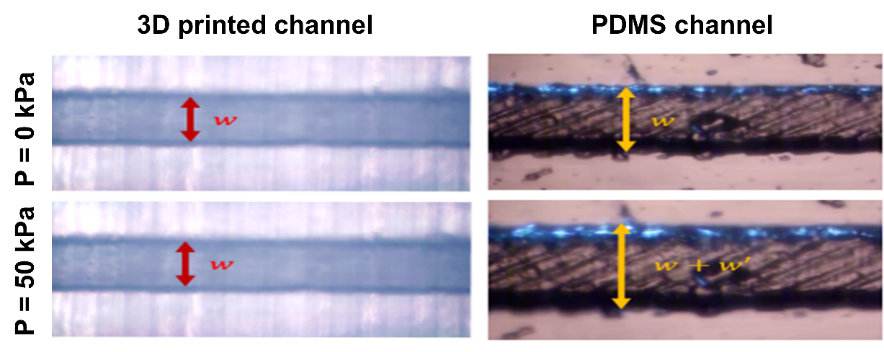
Fig. S1 Comparison of deformation between the 3D printed spiral microchannels (SμCs) and PDMS SμCs. w: 500 μm.

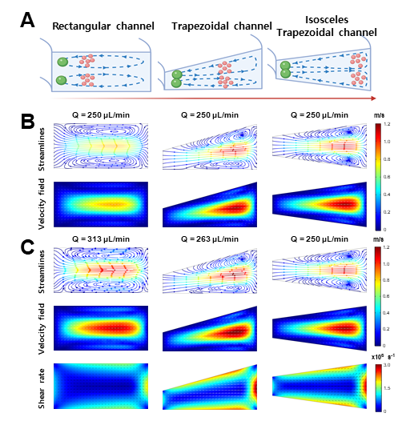
Fig. S2 Numerical simulations were performed to compare the fluid flow and particle behavior in SμCs with different cross-sectional shapes: rectangular, trapezoidal, and isosceles trapezoidal. (A) Schematics describing the position of particles/cells with different size in the SμCs. (B) Streamline and velocity gradient inside the SμCs with the same flow rate (Q = 250 μL/min). (C) Streamline, velocity gradient, and shear rate SμCs at the same maximum velocity. Theoretical modeling of the devices was performed by COMSOL MultiPhysics 5.4. The simulation environment was set up for incompressible, laminar flows. The physical properties of water were (density ρ = 1000 kg/m³ and dynamic viscosity µ = 10⁻³ kg/ms) applied to the simulation.

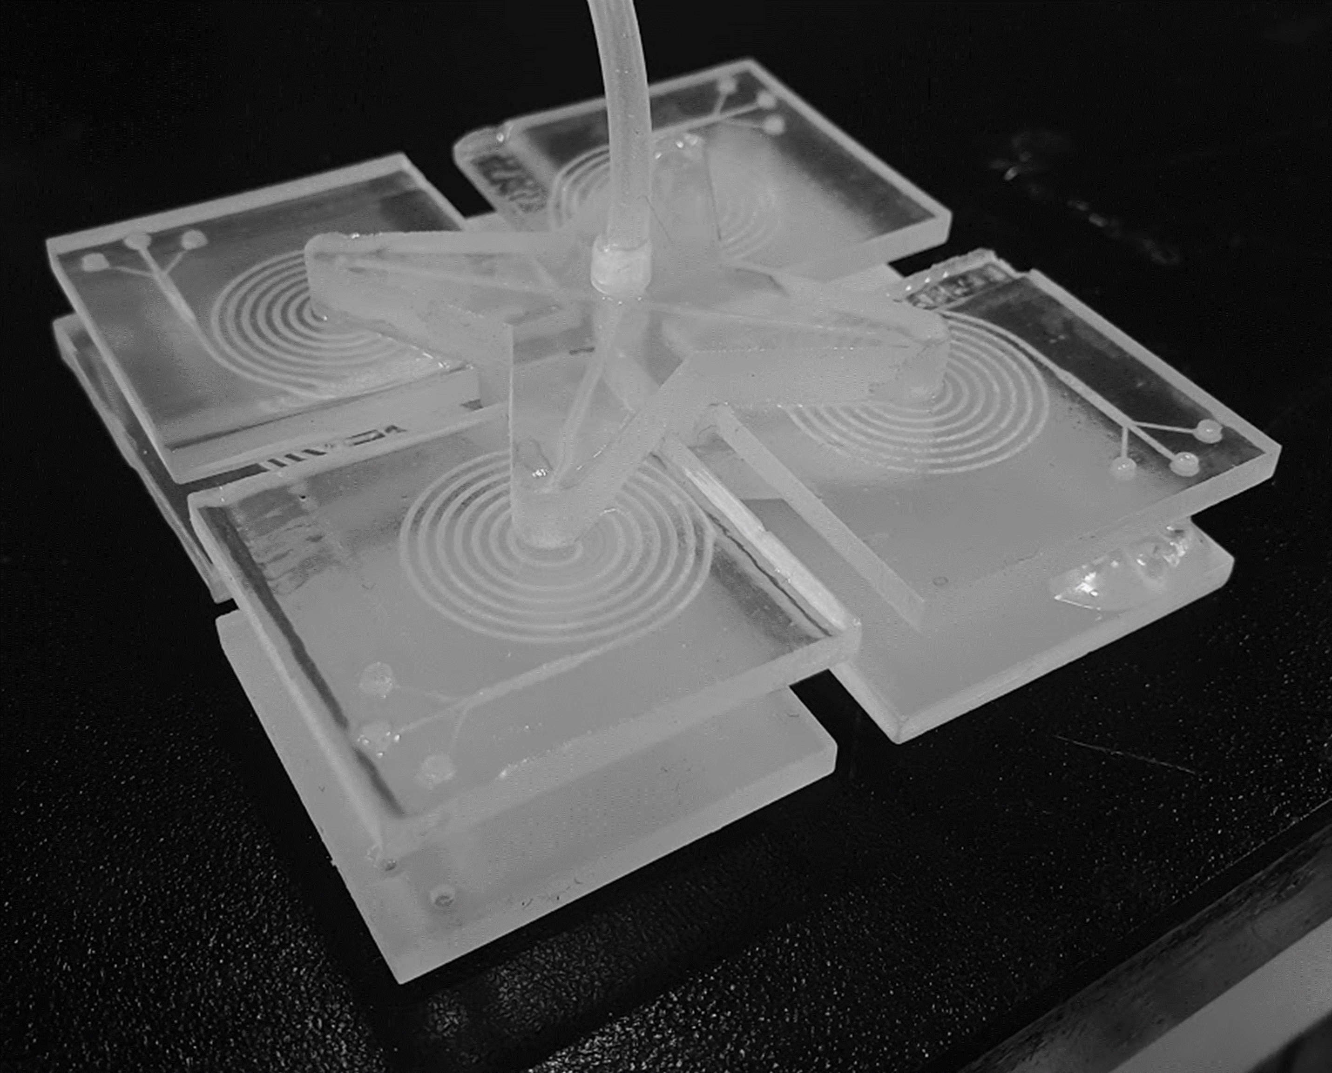
Fig. S3 3D Printed lego-like modular device by connecting 3DPSµFD.

